Exercise 5. Answer Sheet

Student's Name: _______________________ Student's ID: _____________________

Problem 1. (15 points) Consider the graph below.

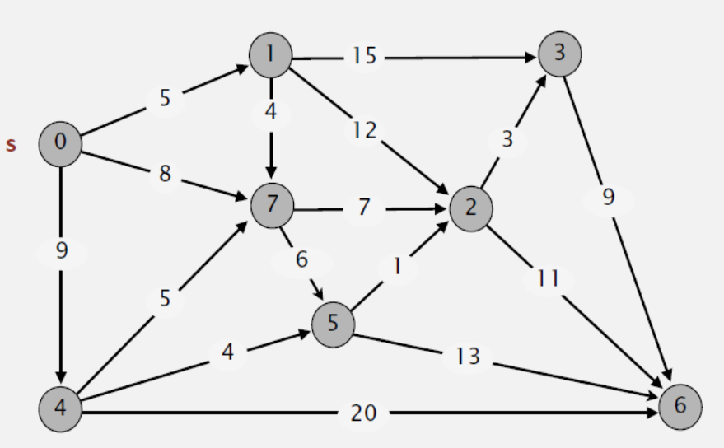

Draw a shortest path spanning tree with root at vertex s. Show the cost (weight) of paths to each vertex.

Put your answer here.

Problem 2. (15 points) Dijksta's algorithm cannot handle negative weights. Show an example and explain what happens.

Put your answer here.

Problem 3. (20 points) Extend the pseudocode of the Bellman-Ford algorithm given at the lecture so it can detect negative cycles.

def Bellman-Ford-modified (G,s,w):
Init-SS (G,s)
for i=1 to |G.V|-1
for each edge (u,v) in G.E
RELAX (u,v,w)
Add your code here.

Problem 4. (50 points) Write a program implementing Dijksta's algorithm. Upload your source code. Show your input graph and the obtained shortest path spanning tree in the space below.

Put your answer here.

