Exercise 6. Answer Sheet

Student's Name: _______________________ Student's ID: _____________________

Problem 1. Given the graph below

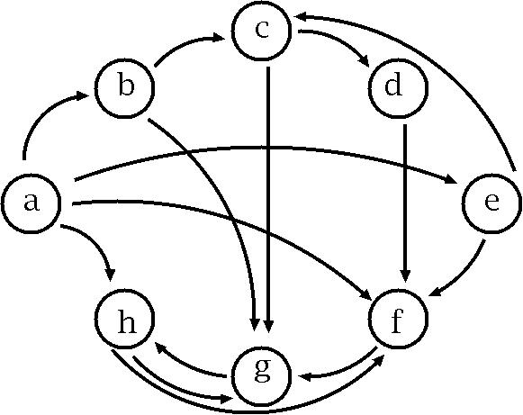

a) (10 points) Fill the following matrix by putting 1 if there is an edge between nodes. Put 0 otherwise.

 | a | b | c | d | e | f | g | h
a
b
c
d
e
f
g
h

b) (40 points) Write a program implementing Warshal's algorithm. Upload your code. Use your program to create a transitive closure G* of the graph above and show it in the space below.

Transitive closure defined by adjacency table
 | a | b | c | d | e | f | g | h
a
b
c
d
e
f
g
h

Problem 2. (50 points) Consider the following weight adjacency matrix.

 | a | b | c | d | e | f | g | h
a | 0 | 48 | ∞ | 8 | 20 | ∞ | 20 | ∞
b | ∞ | 0 | 24 | ∞ | 9 | ∞ | 76 | 29
c | 97 | ∞ | 0 | ∞ | ∞ | ∞ | 18 | 1
d | ∞ | 52 | 34 | 0 | 29 | ∞ | ∞ | ∞
e | ∞ | ∞ | ∞ | ∞ | 0 | 10 | ∞ | ∞
f | ∞ | 10 | 85 | 43 | ∞ | 0 | 41 | 29
g | ∞ | ∞ | ∞ | 76 | 38 | ∞ | 0 | ∞
h | 28 | 42 | ∞ | 77 | 21 | ∞ | 11 | 0

Write a program implementing Floyd's algorithm. Upload your code. Given the matrix above, calculate all pairs shortest paths using your program and fill the table below:

All pairs shortest path table
 | a | b | c | d | e | f | g | h
a
b
c
d
e
f
g
h

