DESIGN DOCUMENT FOR
Flashcard Software

For course: Software Engineering
*** Group 1:
- Nguyễn Việt Anh
- Bùi Thị Phương Anh
- Trần Thị Thoa
- Phạm Nguyên Khánh Phong
- Trần Vũ Hải

1. Requirement Specification :
Flash card is a method that combining English word and a corresponding image to help people remembering words more easily and having fun with learning English.
Main feature:
+ Visualize flashcards, Flashcard collections on the computer screen so that people can use to learning without buying their paper collections.
+ Can be used in multiple platform (firstly on web and PC application) to learn every where.
+ Help people in using available Flashcard collections, creating/editing their own collections.

2. Design diagram

2.1. Use-case diagram

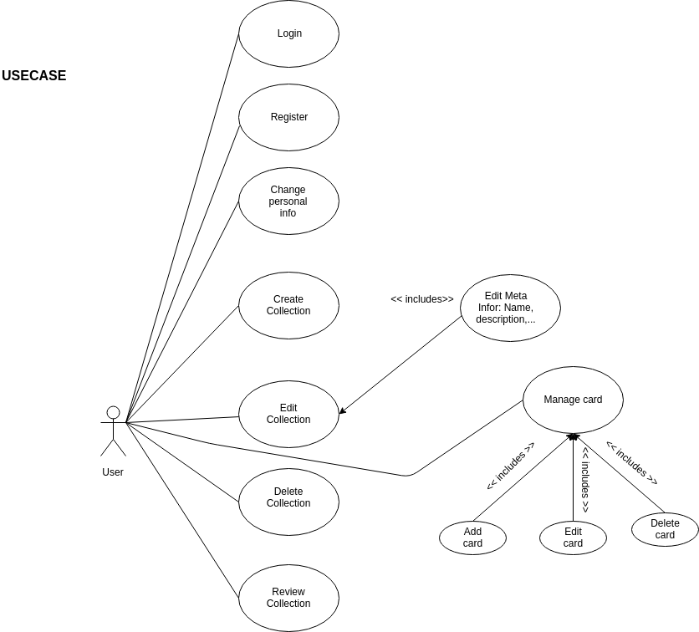

2.2. Activity diagrams

LOGIN
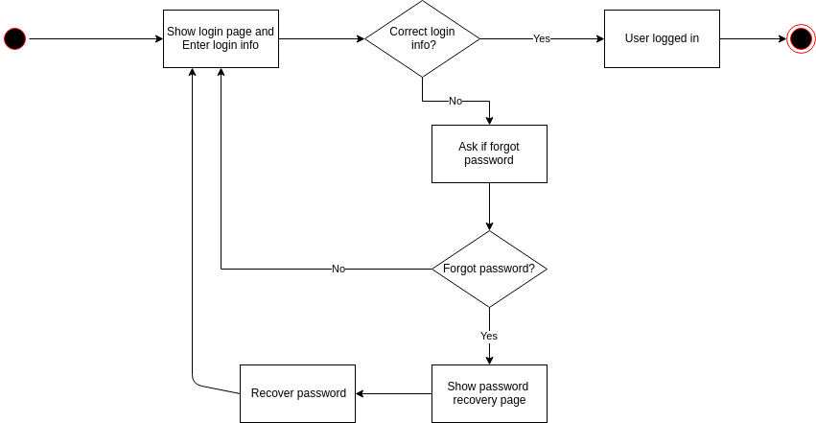
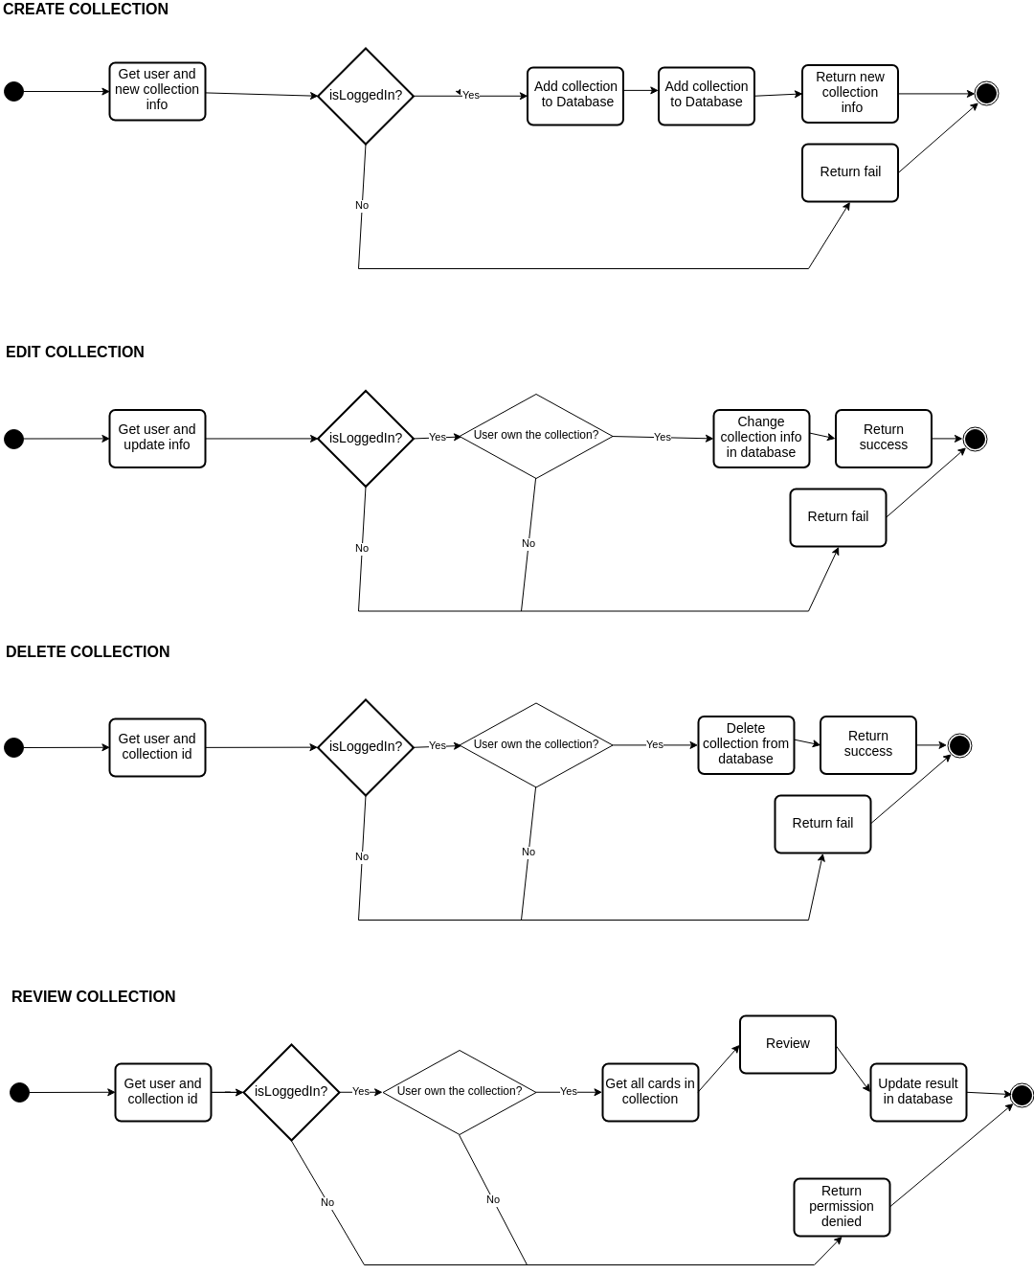
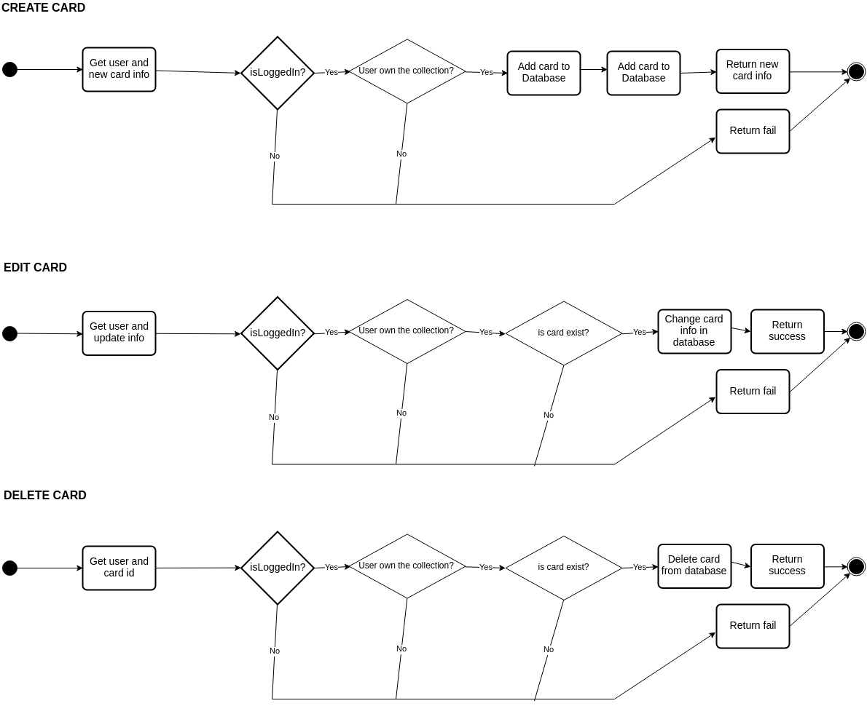
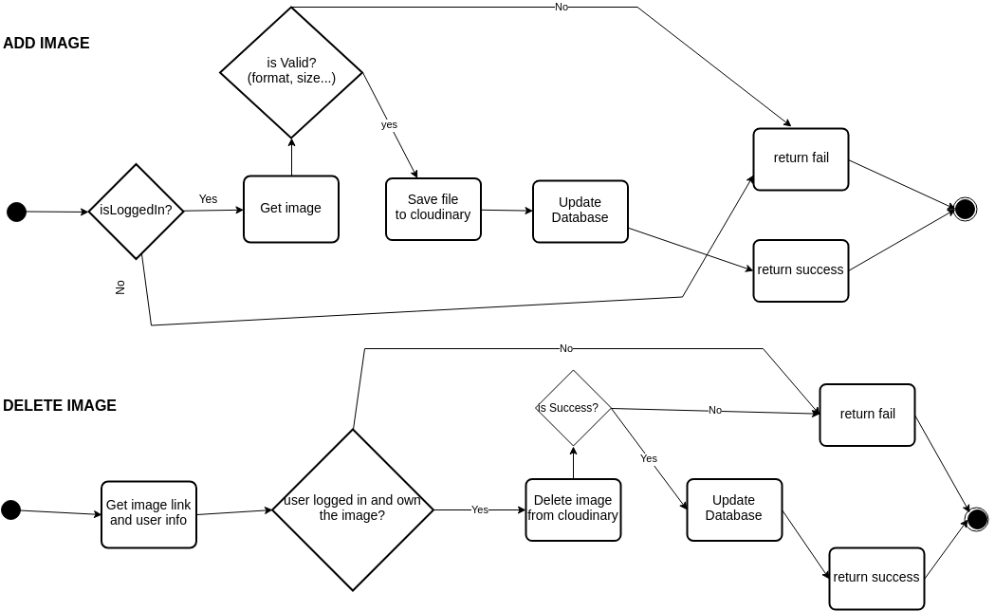

2.3. Entity diagram
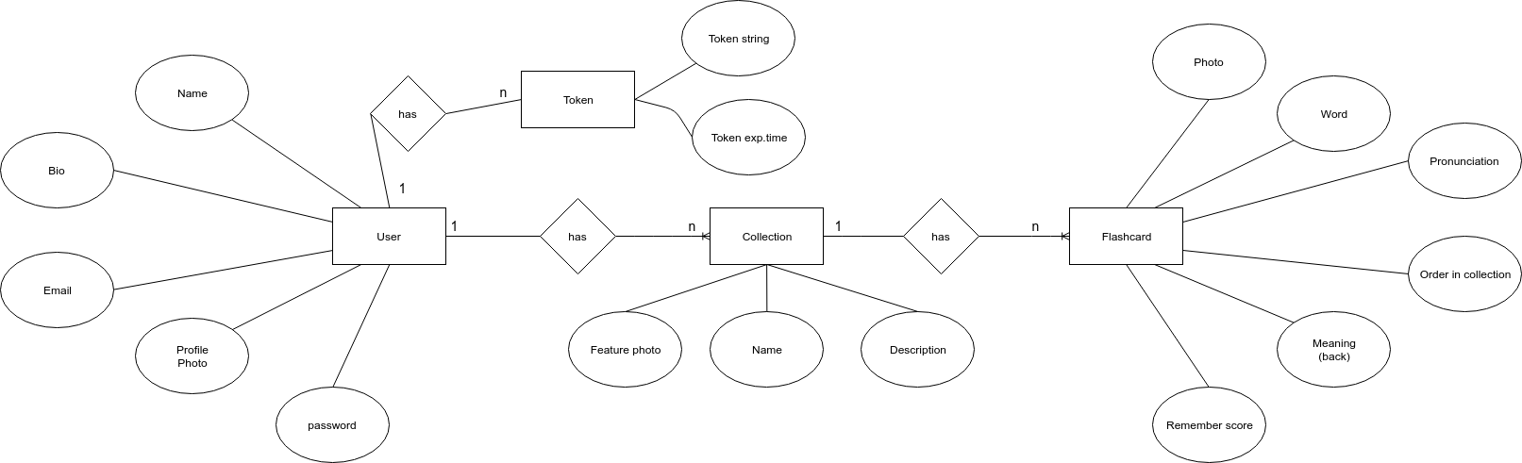

3. Web APIs
The APIs in this part are used in communication between server (Node.js) and clients (Web frontend and PC application).

3.1. Dictionary

- E-V Dictionary Lookup:
GET: /api/dictionary/ev?lookup=<word>

3.2. User management

- User Register
POST: /api/user/register
params: username, password, email, fullname
success: return {'success': true}
fail: return {'sucess': false, 'message': '<why fail?>'}

- User Login
POST: /api/user/login
params: {
'username': '<username>',
'password': '<password>'
}
success: return {'success': true, 'token': '<token>'}
fail: return {'success': false}

- User Logout
POST: /api/user/logout
params: {'username': '<username>', 'token', '<token>'}
success: return {'success': true}
fail: return {'success': false}

- Check login state
POST: /api/user/islogin
params: {'username': '<username>', 'token': '<token>'}
success: return {'success': true, 'isLoggedIn': true}
fail: return {'success': false}
or: return {'success': true, 'isLoggedIn': false}

- Update user info
POST: /api/user/updateinfo
params: {'username': '<username>', 'token': '<token>',
'oldPassword': '<oldPassword>'
'newUserInfo': {
'email' : '<email>',
'bio' : '<bio>',
'fullname' : '<fullname>',
'newPassword' : '<newPassword>',
}
}
=> 'oldPassword', 'newPassword' are used when user wants to change their password
=> all properties of 'newUserInfo' are optional
success: return {'success': true}
fail: return {'success': false}

- Get user info
POST: /api/user/getinfo
params: username, token
success: return {'success': true, 'data':{<email, bio, fullname, username, phofile_photo>} }

3.3. Image mamangement

- Upload image
Params: {
'user': '<username>',
'token', '<token>',
'image': <image-base64>
}
success: return {'success': true, 'imageUrl': '<image-address>'}
fail: return {'success': false}

- Delete image
Params: {
'user': '<username>',
'token', '<token>',
'imageUrl': '<image-address>'
}
success: return {'success': true}
fail: return {'success': false}

