**HANOI UNIVERSITY OF SCIENCE AND TECHNOLOGY**

**SCHOOL OF INFORMATION AND COMMUNICATION TECHNOLOGY**

**DESIGN DOCUMENT FOR**

**Flashcard Software**

**\*\*\***

**For course: Software Engineering**

**\*\*\* Group 1:**

- Nguyễn Việt Anh

- Bùi Thị Phương Anh

- Trần Thị Thoa

- Phạm Nguyên Khánh Phong

- Trần Vũ Hải

# 1. Requirement Specification :

Flash card is a method that combining English word and a corresponding image to help people remembering words more easily and having fun with learning English.

**Main feature:**

+ Visualize flashcards, Flashcard collections on the computer screen so that people can use to learning without buying their paper collections.

+ Can be used in multiple platform (firstly on web and PC application) to learn every where.

+ Help people in using available Flashcard collections, creating/editing their own collections.

# 2. Design diagram

## 2.1. Use-case diagram

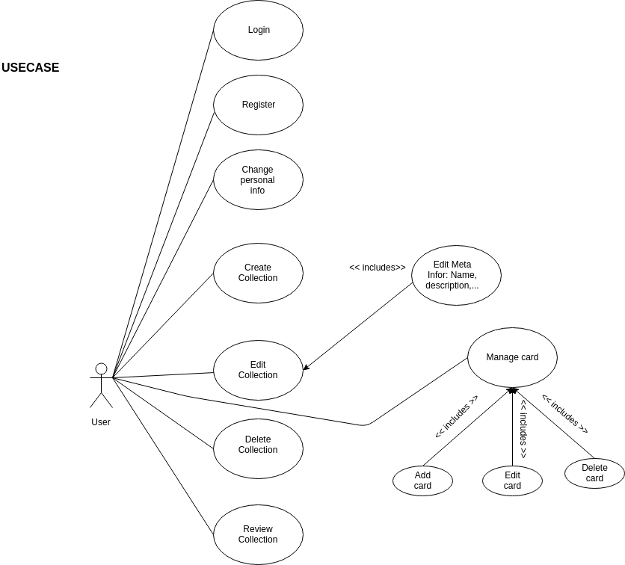

## 2.2. Activity diagrams

**LOGIN**

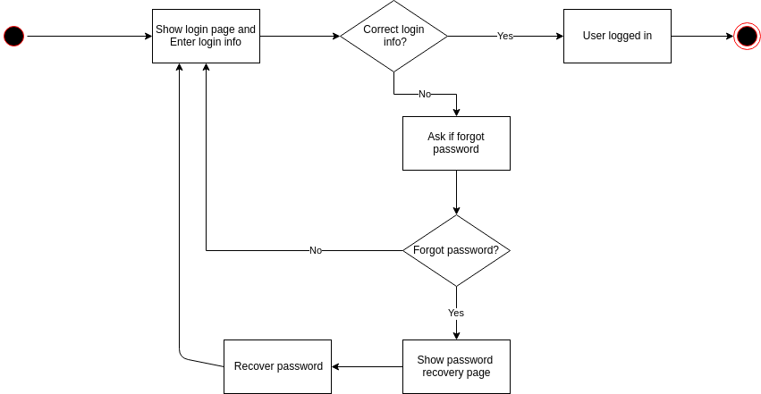

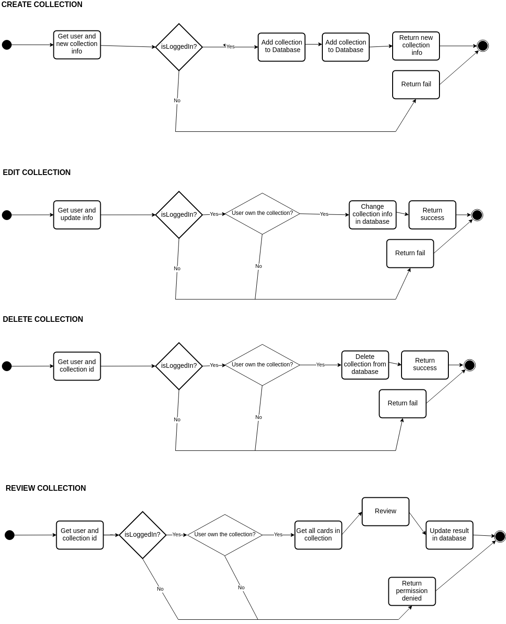

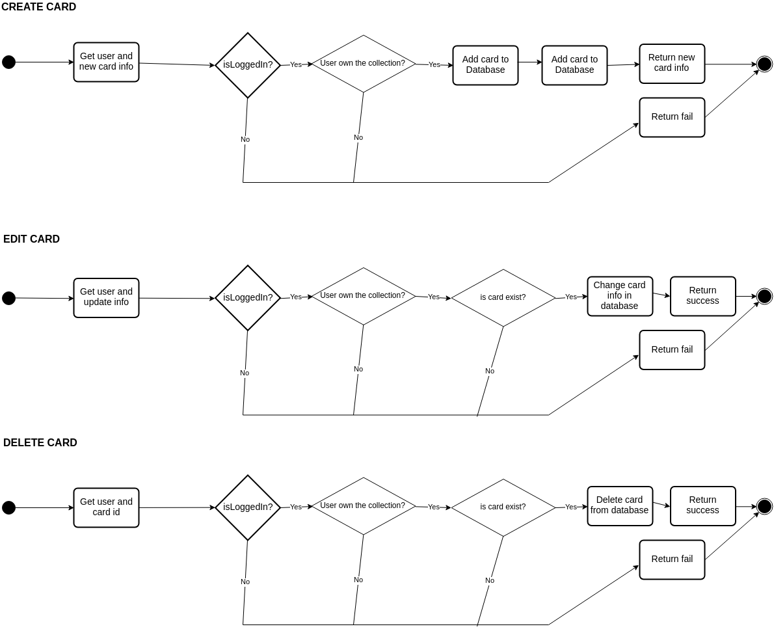

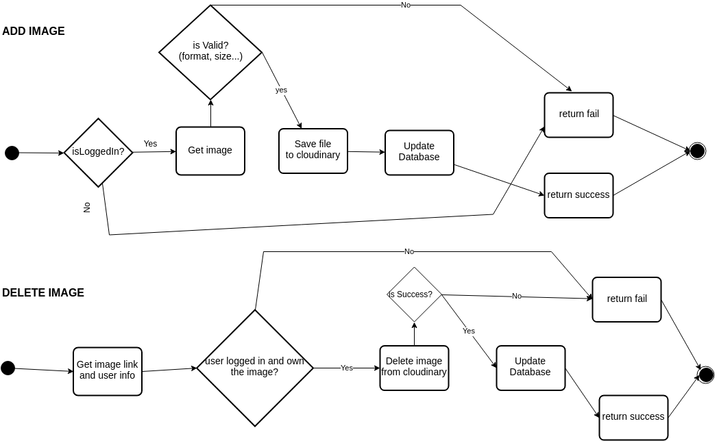

## 2.3. Entity diagram

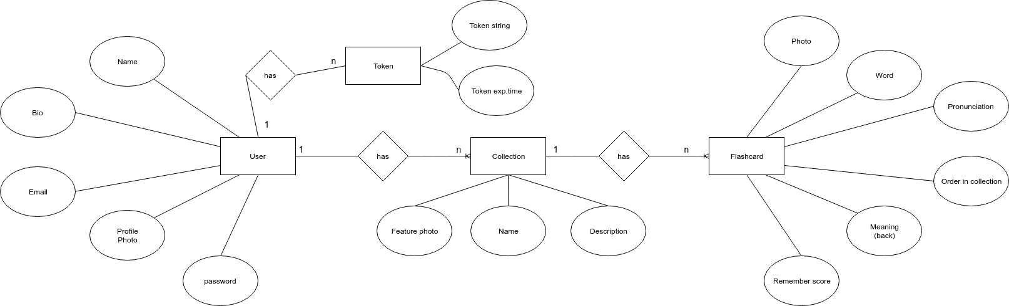

## 3. Web APIs

The APIs in this part are used in communication between server (Node.js) and clients (Web frontend and PC application).

## 3.1. Dictionary

### - E-V Dictionary Lookup:

**GET:** /api/dictionary/ev?lookup=<word>

## 3.2. User management

### - User Register

**POST:** /api/user/register

**params:**

{

'username': '<username>',

'password': '<password>',

'email': '<password>',

'fullname': '<password>'

}

**success:** return {'success': true}

**fail:** return {'success': false, 'message': '<why fail?>'}

### - User Login

**POST:** /api/user/login

**params:**

{

'username': '<username>',

'password': '<password>'

}

**success:** return {'success': true, 'token': '<token>'}

**fail:** return {'success': false}

### - User Logout

**POST:** /api/user/logout

**params:** {'username': '<username>', 'token', '<token>'}

**success:** return {'success': true}

**fail:** return {'success': false}

### - Check login state

**POST:** /api/user/islogin

**params:** {'username': '<username>', 'token': '<token>'}

**success:** return {'success': true, 'isLoggedIn': true}

**fail:** return {'success': false}

or: return {'success': true, 'isLoggedIn': false}

### - Update user info

**POST:** /api/user/updateinfo

**params:** {'username': '<username>', 'token': '<token>',

'oldPassword': '<oldPassword>'

'newUserInfo': {

'email' : '<email>',

'bio' : '<bio>',

'fullname' : '<fullname>',

'newPassword' : '<newPassword>',

}

}

=> 'oldPassword', 'newPassword' are used when user wants to change their password

=> all properties of 'newUserInfo' are optional

**success:** return {'success': true}

**fail:** return {'success': false}

### - Get user info

**POST:** /api/user/getinfo

**params:** {

'user': '<username>',

'token', '<token>'

}

**success:** return

{

'success': true,

'data': {

'email': '<email>',

'fullname': '<fullname>',

'bio': '<bio>',

'username': '<username>',

'phofile_photo', '<phofile_photo>'

}

}

## 3.3. Image mamangement

### - Upload image

**POST:** /api/image/upload

**Params:** {

'user': '<username>',

'token', '<token>',

'imageURI': <image-base64>

}

**success**: return {'success': true, 'imageUrl': '<image-address>'}

**fail:** return {'success': false}

### - Delete image <not implemented>

**Params:** {

'user': '<username>',

'token', '<token>',

'imageUrl': '<image-address>'

}

**success**: return {'success': true}

**fail:** return {'success': false}

## 3.4. Collection mamangement

### - Create collection

**POST:** /api/collection/create

**Params:** {

'username': '<username>',

'token', '<token>',

'photo': '<photoUrl>',

'name': '<name>',

'description': '<description>',

}

**success**: return

{

'success': true,

'collection_id': '<collection_id>',

}

**fail:** return {'success': false}

### - Update collection

**POST:** /api/collection/update

**Params:** {

'username': '<username>',

'token', '<token>',

'collection_id': '<collection_id>',

'photo': '<photoUrl>',

'name': '<name>',

'description': '<description>',

'remember_score': '<remember_score>'

}

**success**: return

{ 'success': true }

**fail:** return

{ 'success': false }

### - Delete collection

**POST:** /api/collection/delete

**Params:** {

'username': '<username>',

'token', '<token>',

'collection_id': '<collection_id>'

}

**success**: return

{ 'success': true }

**fail:** return

{ 'success': false }

### - Get collection info

**POST:** /api/collection/get

**Params:** {

'username': '<username>',

'token', '<token>',

'collection_id': '<collection_id>',

}

**success**: return

{ 'success': true,

'data' : {

'id': '<collection_id>',

'photo': '<photoUrl>',

'name': '<name>',

'description': '<description>',

'remember_score': '<remember_score>',

'flashcards': [<list of ids of flashcard in the collection>]

}

}

**fail:** return

{ 'success': false }

### - Get all collection

**POST:** /api/collection/getall

**Params:** {

'username': '<username>',

'token', '<token>'

}

**success**: return

{ 'success': true,

'data' : [{

'id': '<collection_id>',

'photo': '<photoUrl>',

'name': '<name>',

'description': '<description>',

'user_id': '<user_id>'

},...]

}

**fail:** return

{ 'success': false }

## 3.5. Flashcard mamangement

### - Create flashcard

**POST:** /api/flashcard/create

**Params:** {

'username': '<username>',

'token', '<token>',

'collection_id': '<collection_id>',

'word': '<word>',

'pronunciation': '<pronunciation>',

'meaning': '<meaning>',

'image': '<image>',

'order': '<order in collection>',

}

**success**: return

{

'success': true,

'flashcard_id': '<flashcard_id>',

}

**fail:** return {'success': false}

### - Update flashcard

**POST:** /api/flashcard/update

**Params:** {

'username': '<username>',

'token', '<token>',

'flashcard_id': '<flashcard_id>',

'word': '<word>',

'pronunciation': '<pronunciation>',

'meaning': '<meaning>',

'image': '<image>',

'order': '<order in collection>',

}

**success**: return

{

'success': true

}

**fail:** return {'success': false}

### - Delete flashcard

**POST:** /api/flashcard/delete

**Params:** {

'username': '<username>',

'token', '<token>',

'flashcard_id': '<flashcard_id>',

}

**success**: return

{ 'success': true }

**fail:** return

{ 'success': false }

### - Get flashcard info

**POST:** /api/flashcard/get

**Params:** {

'username': '<username>',

'token', '<token>',

'flashcard_id': '<flashcard_id>',

}

**success**: return

{

'success': true,

'data': {

'collection_id': '<collection_id>',

'id': '<flashcard_id>',

'word': '<word>',

'pronunciation': '<pronunciation>',

'meaning': '<meaning>',

'image': '<image>',

'order': '<order in collection>'

}

}

**fail:** return {'success': false}

### - Get all flashcards

**POST:** /api/flashcard/getall

**Params:** {

'username': '<username>',

'token', '<token>',

'collection_id': '<flashcard_id>',

}

**success**: return

{

'success': true,

'data': [{

'collection_id': '<collection_id>',

'id': '<flashcard_id>',

'word': '<word>',

'pronunciation': '<pronunciation>',

'meaning': '<meaning>',

'image': '<image>',

'order': '<order in collection>'

}, ...]

}

**fail:** return {'success': false}

### - Update all flashcards

**POST:** /api/flashcard/updateall

**Params:** {

'username': '<username>',

'token', '<token>',

'collection_id': '<collection_id>',

'data': [{

'collection_id': '<collection_id>',

'id': '<flashcard_id>',

'word': '<word>',

'pronunciation': '<pronunciation>',

'meaning': '<meaning>',

'image': '<image>',

'order': '<order in collection>'

}, ...]

}

**success**: return

{

'success': true,

'data': [

{

'collection_id': '<collection_id>',

'id': '<flashcard_id>',

'word': '<word>',

'pronunciation': '<pronunciation>',

'meaning': '<meaning>',

'image': '<image>',

'order': '<order in collection>'

}, ...]

}

**fail:** return {'success': false}