

BBS 415 – The Johannine and General Writings
Tutorial Letter

COURSE DESCRIPTION

This course focuses on the Johannine and General Writings of the New Testament. The Johannine Writings encompass the Gospel, the Letters, and the Revelation of John; while the General Writings are made up of the Letter to the Hebrews, the Letter of James, the First and Second Letters of Peter, and the Letter of Jude. The disciplines of introduction, theology and exegesis will be applied to these writings; with the learner being required to demonstrate an ability to work critically and independently. Contemporary hermeneutics will be considered.

OUTLINE AND CONTENTS

The course is made up of the following components and sections:
1. Critical introduction, as applied to the Johannine and General Writings.
2. Theological themes, derived from the Johannine Writings.
3. A detailed exegesis of a passage from 1 and 2 Peter.

OBJECTIVES

The objectives of this course are as follows:
1. To critical examine and evaluate the main introductory issues related to the Johannine and General Writings.
2. To consider the theological themes of the Johannine Writings.
3. To master the exegetical methodology given below, and to apply it to the exegesis of selected passages from 1 and 2 Peter.

OUTCOMES

On completion of this course, learner will be expected to:
1. Demonstrate knowledge of the main introductory issues related to the Johannine and General Writings through an examination.
2. Demonstrate knowledge of the key theological themes of the Johannine Writings through an examination.
3. Demonstrate a working knowledge of the methodology given below in the exegesis of selected passages from 1 and 2 Peter.

REQUIRED RESOURCES

In order to complete the course, the learner will be required to have access to the following textbooks [or any other (good enough) equivalent]:

*Carson and Moo. 2005. An Introduction to the New Testament. Leicester: IVP.

Schreiner, T. R. 2003. 1, 2 Peter, Jude. (Series: The New American Commentary). USA: Broadman and Holman Press.

*Ladd, G. E. 1993. A Theology of the New Testament (Revised). Grand Rapids: Eerdmans.

These prescribed books are worthy of purchase for your personal library and will be useful to you in your future study and ministry. * This book is useful for all New Testament courses at BTC.

Ensure you access materials that will enable the satisfactory completion of the course requirements. In order to prepare for the examination, you are expected to work through the appropriate sections of one New Testament Introduction for Background and Introduction and Theology. In addition, see the list of typical examination questions appended hereto, from which we are to select the actual examination questions at the end of the semester.

ASSESSMENT AND EVALUATION REQUIREMENTS

The learner shall be expected to satisfactorily complete the following course requirements:

- Requirement 1: A 2000 word exegetical assignment. 25% 3 credits
- Requirement 2: A 2000 word exegetical assignment. 25% 3 credits
- Examination – 2 hours. 50% 4 credits
- Class Attendance / self study (2 periods) ----- 2 credits
100% 12 credits

Due Dates & Deadlines

The due dates for the requirements in this course are as follows:

Requirement 1 – Exegetical Paper Monday 21 March 2016.
Requirement 2 – Exegetical Paper Monday 02 May 2016.

General Comments

Learners should be aware that this is a fourth level course of studies; which requires learners to display a very definite ability to work critically and independently.

To assist learners new to studies at BTC, relevant lecture notes are included at the end of this material for reference.

A. While the requirements presented below may be adjusted by the allocated lecturer, the normal requirements of the course are as presented below.

The learner should remember that the following rules apply to all College courses:
- All course requirements are to be satisfactorily completed.
- The pass mark for a course is 50%.

B. In completing the assignments, learners should remember:

- To follow the College’s Assignment Writing Guide, as marks will be deducted for incorrect and poor presentation.
- Regarding length, learners should note that they will be penalized for length that falls outside of the allocated parameters as indicated (1% per 100 words under or over the stipulated length).
- With respect to the bibliography:
a. Where a minimum number of references are stipulated, this must be adhered to; each reference short will be penalized by 1%.
b. Any Bible (including study Bibles), basic dictionaries and devotional guides will not be counted toward the total references.
c. Electronic sources are not to number more than half the required number of references.
- The due date is non-negotiable and learners will be penalized as follows for late submission:
a. 5% per day (including holidays and weekends) to a maximum of 4 days.
b. Thereafter, the assignment will not be accepted.

5. Assignment saving label: All assignments must be submitted electronically via Sharepoint
through office 365.
a. There will be a standard labeling format to save the document.
b. Assignments must be saved by labeling as follows:

COURSE CODE – YEAR – ASSIGNMENT NUMBER – STUDENT SURNAME STUDENT NUMBER

e.g. BPS215-2013-ASSIGNMENT 1 – BOND 007

NO SPACES SPACING

Requirement Details

Requirement 1: Exegetical Assignment

The Learner is to present a critical exegetical paper on 1Pet. 2:4-12. You are to:

- Briefly consider Genre and Structure
- Briefly consider Context (historical and textual)
- Do appropriate Words-study (not separately, but MUST be included in the commentary)
- Commentary - Explain the text (include word study and context in your observation and interpretation). This is the major part of your exegesis paper.
- Do a fairly detailed Sermon outline for preaching this text.

Length: 2000 words (max. 10% over word count)
Bibliography: not less than twelve (12) meaningful references

Due date: Monday 21 March 2016

Requirement 2: Exegetical Assignment

The Learner is to present a critical exegetical paper on 2Pet. 1:3-11. You are to:

- Briefly consider Genre and Structure
- Briefly consider Context (historical and textual)
- Do appropriate Words-study (not separately, but MUST be included in the commentary)
- Commentary - Explain the text (include word study and context in your observation and interpretation). This is the major part of your exegesis paper.
- Do a fairly detailed Sermon outline for preaching this text.

Length: 2000 words (max. 10% over word count)
Bibliography: not less than twelve (12) meaningful references
Due date: Monday 02 May 2016
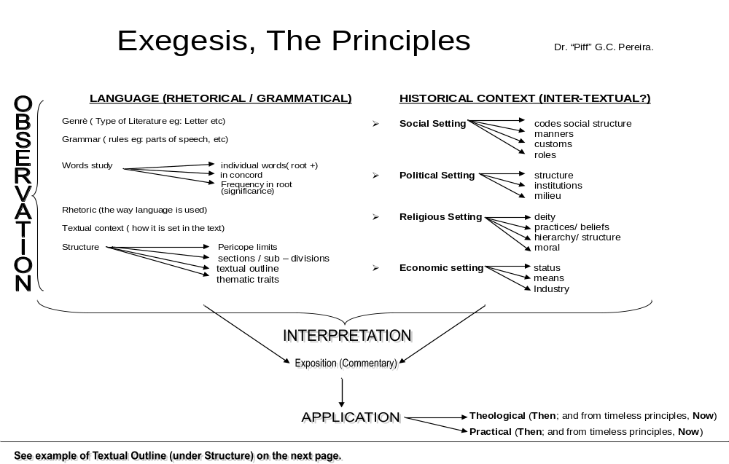

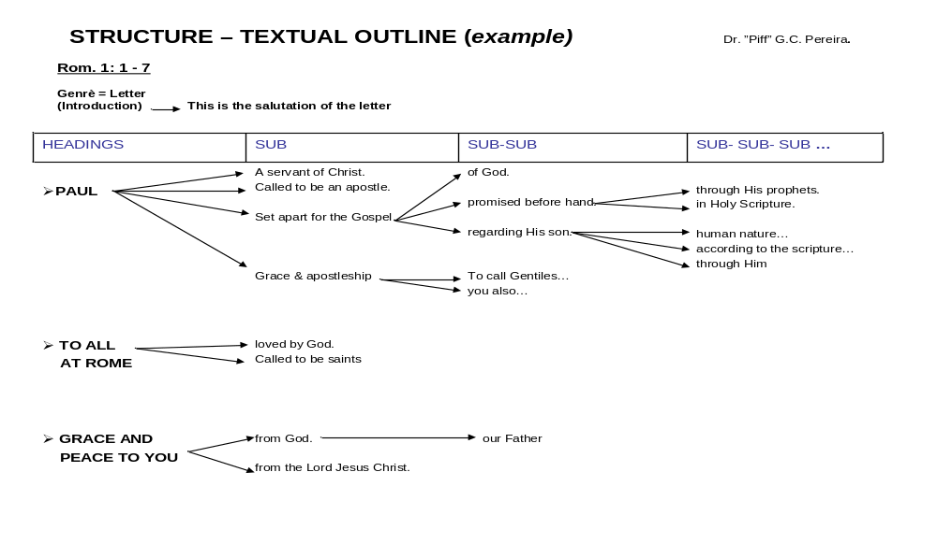

The suggested outline of an exegesis paper should include the following:

1. Introduction
- Write a brief statement on the intention of this paper.
- Make a brief statement on the main idea of the text under consideration.
- Make a brief statement on the genre of the text and textual context. The textual context is the context of the text under consideration (how does it fit within the writing as a whole and immediately?).
- Write briefly on the historical context, also stating the writing occasion of text. The historical context is about what was happening in THEIR world – political, social, religious, etc. – AS IT IMPACTS THE TASK OF EXPLAINING the text under consideration.

2. Outline (of the text)
- This outline must serve as the outline for your commentary.

3. Commentary (according to the outline)
- The commentary may have its own introduction (here you may show the structure within which the text appears).
- There must be an integration of the Historical contextual issues with the Grammatical observations (words-study and rhetorical issues) in your interpretation and explanation of the text. The commentary must therefore include observation and interpretation.

4. Applicatio.
- For the original readers, and
- the contemporary reader/s, identifying timeless principles from the text.

5. Additional Requirements for this assignment
- e.g. Sermon outline; the Author’s theology; a particular theological outlook; applying a particular hermeneutical methodology; etc.

THE EXEGESIS PROCESS - Dr. Piff’s method for the benefit of his Students

This process outline applies for any biblical text.

- Think what you would entitle your text.
(Taking Exodus 24:1-18 as an example – we will work through this text in class)

Ex. 24:1–18. The Present God Establishes a Relationship with His People.

- If you have Biblical Languages proficiency, do a translation with translation footnotes. Your translation will influence your exegesis. If you do not have biblical language/s proficiency, use a few trusted translations.

- Identify the literary genre to inform the basic interpretation approach. The genre would influence your interpretation and structural considerations.

- Do the task of observation, asking the interrogatives and following the graphic outline of EXEGESIS, THE PRINCIPLES, in the areas both grammatical (here you will do word-studies, which may also be done under F below) and historical (the social, political, economic and religious settings).

- Now for the structural considerations of the text.

  - Your discussion will start on the issue of the unity of the text. What is the pericope; that which naturally mark the beginning and the ending of the text as it belongs together as a unit?
  - What are the inherent characteristics of the text? Is it chiastic; is it acrostic; is it symmetrical; is it argumentative; are there contrasts, comparisons; etc.? Genre identification may help here.
  - Do a text outline, to follow for doing your (anticipated) commentary.
  - Do linguistic, grammatical and rhetorical characteristics identified in the recurring use of words (verbs, nouns, etc.) to express emphasis through repetition, doubling, etc.
  - Is there any trace of thematic progression?

- Select key data (grammatical and historical - phenomena, words and concepts) from the text to explore inter-textually, using sources outside the text; first in the Bible and then outside it. Sources will include books (Concordances, Bible - and other Dictionaries, Wordbooks, Encyclopedias, Historical books, Commentaries, etc.), journals, internet, and the like. Your selection must seek to inform the knowledge about and in your text.

- Do a commentary on the text following the text outline you have constructed under E above. The commentary will integrate the information gained in tasks A to F above in a systematic discussion that interacts with what is anticipated and with what has been mentioned. The aim of the commentary is to explain the meaning of the text as it was originally intended. What did it mean to its original audience? This is the major part of your exegesis paper.

- Do a theological reflection, derived from your commentary. Theological reflection connects the then with the now. Here you seek to find the abiding principles that may be used in our present-day context. Theological reflection may be assisted by a canonical approach, which takes into account how other parts of Scripture interprets this text (if it does so). The principle, “let Scripture interpret Scripture” is always a good one.

CONSIDERATIONS WHEN DOING WORD-STUDIES Dr. Piff.

The purpose for doing word-studies of a biblical text is to help with the interpretation of the text where it appears. That word, however, must be understood in its present textual context. How it is used in the present textual context will even override its general use if it is meant to be different. Sometimes it will have various possible translations, and therefore different possible meanings. You would have to decide which translation and meaning is most appropriate within its particular context. Every word in the text must be considered for word-study, but it might not be necessary to consider some words because they are a matter of language necessity (words like “the”).

So, the general approach to doing a word-study would be as follows:
- Decide on the word to be studied.
- Find its original Hebrew or Greek word.
- What type of word is it in the original? The parsing will tell you the grammatical characteristics, e.g. if it is a verb, noun, active, passive, singular, plural, etc.
- What are the possible translations?
- Describe the possible meanings in the original language. This includes the grammatical characteristics of the word.
- See the number of occurrences of its root-word in the text, and then in the book, and then by the same author, then in that Testament, and then in the Bible. The most important meaning is the one in the text and/or closest to the text. Frequent occurrence may reflect emphasis in some way.
- Find its historical characteristics; that is, its meaning within its historical context.
- Does it have a theological significance within its present textual context and within its broader context?
- Check its relationship with other words in the present text. These relationships are important as it may enhance or modify the word’s meaning.
- The textual context may demand a single and particular meaning; it may be open to different possible meanings. Decide which translation and meaning you will apply, supplying the reasons for your decision. See how others have translated it – it is usually safe to go with the majority translation.

A SAMPLE EXEGESIS PAPER IS APPENDED TO THIS TUTORIAL FOR YOUR BENEFIT.

RECOMMENDED READING

The listed below provides the learner with references that relate to various parts of the course material and topics under consideration. The learner is not required to purchase or study these books for the purposes of the course.

New Testament introduction

Carson, DA; Moo, DJ & Morris, L 2005. An Introduction to the New Testament (2nd Edition). Grand Rapids: Zondervan.
Gromacki, Robert G 1974. New Testament Survey. Grand Rapids: Baker.
Guthrie, Donald 1990. New Testament Introduction (Revised). Downers Grove: IVP.
Harrison, Everett F 1971. Introduction to the New Testament. Grand Rapids: Eerdmans.
Metzger, Bruce M 1983. New Testament: Its Background, Growth and Content. Nashville: Abingdon.

New Testament Theology

Bock, Darrell & Zuck, Roy B 1994. A Biblical Theology of the New Testament. Chicago: Moody.
Du Toit, AB (ed) 1983. Guide to the New Testament IV: The Synoptic Gospels and Acts -– Introduction and Theology. Pretoria: NGK.
Hays, Richard 1996. The Moral Vision of the New Testament. San Francisco: Harper Collins.
Ladd, George E 1993. A Theology of the New Testament (Revised). Grand Rapids: Eerdmans.
Morris, Leon 1990. New Testament Theology. Grand Rapids: Zondervan.

The Johannine Writings

Burge, Gary M 1992. Interpreting the Gospel of John. Grand Rapids: Baker.
Du Toit, AB (ed) 1988. Guide to the New Testament: The Gospel of John; Hebrews to Revelation – Introduction and Theology. Halfway House: N.G. Kerkboekhandel.
Harrington, Wilfrid 1999. John: Spiritual Theologian. n.p.: Columba.
Kysar, Robert 1976. John: The Maverick Gospel. Louisville: John Knox.
Kuyper, Abraham 1999. The Revelation of St John. n.p.: Wipf & Stock.
Michaels, J Ramsey 1992. Interpreting the Book of Revelation. Grand Rapids: Baker.
Smith, D Moody & Smith, Moody D 1999. John. Nashville: Abingdon.

The General Writings

Because of their nature, numerous books abound on the General Writings and learners should carefully evaluate what is available, before making any purchases.

Contemporary Hermeneutics

Fee, Gordon D. & Stuart, Douglas 1993. How to Read the Bible for All Its Worth (Second Edition). Grand Rapids: Zondervan.
Larkin, William J 1993. Culture and Biblical Hermeneutics. New York: University Press of America.
Lundin, Roger; Walhout, Clarence & Thiselton, Anthony C 1999. The Promise of Hermeneutics. Grand Rapids: Eerdmans.
Maimela, Simon & König, Adrio 1998. Initiation into Theology: The Rich Variety of Theology and Hermeneutics. Pretoria: Van Schaik.
McKnight, Scot (ed) 1989. Introducing New Testament Interpretation. Grand Rapids: Baker.
Sanders, Stanley P & Campbell, Charles L 2000. The Word on the Street. Grand Rapids: Eerdmans.
Tate, W. Randolph 1991. Biblical Interpretation: An Integrated Approach. Peabody: Hendrikson.
West, Gerald 1993. Contextual Bible Study. Pietermaritzburg: Cluster.
Available from: Cluster Publications, P.O. Box 2400, Pietermaritzburg 3200.
Tel: (033) 345-9897 E-mail: cluster@futurenet.co.za
Internet: www.hs.unp.ac.za/theology/cluspub.htm

COURSE ASSISTANCE

If you need to be in touch with me with reference to this course, please feel free to contact me at:

Telephone: 011 886-0421
e-mail: piff@btc.co.za
Postal: P.O. Box 50710, Randburg 2125.

Yours truly,
Dr. “Piff” G. C. Pereira

ANSWERS TO THE TYPICAL EXAM QUESTIONS ARE FOUND IN THE PRESCRIBED BOOKS AND THE COURSE NOTES.
BBS 415 - TYPICAL EXAMINATION QUESTIONS

- What is the purpose of the Gospel according to John? Give the text reference. (3)
- What is the prologue (text reference) of John’s Gospel? (2)
- What is the epilogue (text reference) of John’s Gospel? (2)
- The Johannine text 1:19 – 12:50 is known as the Book of ----- ? (1)
- Give an alternative name for the Book of Glory with reference to John’s Gospel. (2)
- What is a geographic inclusio often referred to in Johannine Gospel studies? (3)
- The Gospel of John is formally anonymous. True or false? (1)
- Briefly explain the significance of Polycarp in the authorship identity of John’s Gospel (10)
- From the internal evidence, name four facts that are true about the author of the Gospel of John. (4)
- Briefly describe the possible identity of the Beloved Disciple in John’s Gospel. (10)
- Who are the sons of thunder? (2)
- Name three proposals for the place of writing of John’s Gospel. (3)
- Write brief notes on the relation of John’s Gospel to the Synoptics. (20)
- Write briefly on the date of the fourth Gospel under the headings, before A.D.70, towards the end of the first century. (20)
- Write briefly on the purpose of the fourth Gospel. (10)
- Write briefly on the destination of the letter to the Hebrews. (10)
- Write briefly on the purpose of the letter to the Hebrews. (15)
- Write briefly on the authorship of the Epistle of James. (15)
- Write briefly on the date of James’ letter. (10)
- To whom is the Epistle of James addressed? (2)
- From the internal evidence, make a case for Peter as the author of 1Peter. (10)
- Name and explain three reasons why the Petrine authorship of 1Peter is rejected. (10)
- Write briefly on the destination of 1Peter. (10)
- Holding to Petrine authorship, briefly answer to the fact of writing-stylistic differences between 1 & 2 Peter. (5)
- How might the reference to Paul’s writings in 2Peter pose as an obstacle to Petrine authorship? (10)
- Is there a relationship between 2Peter and Jude? Explain. (15)
- Write on the (common) authorship of 1John showing the relation to the fourth Gospel. (10)
- What are the differences between 1John and the fourth Gospel in terms of authorship? (10)
- Briefly write on the destination of 2John. (10)
- Briefly describe Gnosticism and Docetism as is suggested by some with reference to John’s writings. (20)
- Write briefly on the authorship of Jude’s Epistle. (10)
- Briefly argue for John the Apostle, as the author of Revelation using internal evidence. (10)
- What are the arguments against apostolic authorship of Revelation, and how may these be answered? (20)
- Write briefly on the genre of Revelation. (15)
- Give another name commonly used for the book of Revelation. (1)
- Explain John’s dualism under the heading, darkness and light. (5)
- Explain John’s dualism under the heading, the two worlds. (10)
- Explain John’s dualism under the heading, flesh and spirit. (10)
- Explain the concept, Kosmos in John’s writings. (10)
- Discuss sin as unbelief in John’s writings. (5)
- Discuss John’s Logos-theology under the headings, pre-existence, deity, creator, and incarnation. (20)
- Describe the mission of Jesus in John’s Gospel under headings, to give eternal life, to reveal the Father, to lay down his life, and to take away sins. (20)
- Enumerate the “I AM” sayings of Jesus in John’s Gospel. (10)
- Demonstrate briefly the humanity of Jesus in John’s Gospel. (10)
- Discuss the concept, eternal life in the present and in the future in John’s Gospel. (20)
- Discuss the theology of truth in John’s writings. (20)
- Describe John’s theology on the Holy Spirit. (20)
- Discuss the concept, Christ as High Priest in the letter to the Hebrews. (20)
- Explain Peter’s understanding of Christian suffering. (10)
- Write briefly on the Coming Kingdom from the point of view of the Apocalyptist. (20)
APPENDIX

SAMPLE EXEGESIS PAPER ON 2 Pet. 2:1–10a (NOTE: This is also an example of the required format)

WARNING TO THE CHURCH OF THE PERENNIAL THREAT OF FALSE TEACHERS

by: Dr. Sampson S. Ndoga.

BTC Southern Africa

Randburg 2125
- INTRODUCTION
Gnosticism had emerged as a major threat to the first century Christianity. Like Jude (4-18), the Peter writes his second epistle as a warning to the church whom he addresses as “those who through the righteousness of our God and Savior Jesus Christ have received a faith as precious as ours” (1:1). The address was intended to remind them of the true value of their original faith in view of emerging false teachings. Gnosticism, as a heresy was at the early stages of its development as Peter wrote AD62-67 (cf. Gardener 1998:10-14).

At the time of Peter’s writing, Christianity faced opposition from the political office of the day. In AD64, Nero the fifth Roman Emperor, known for his brutality and as a fun-loving and attention-seeking ruler, persecuted Christians with his sponsored wild chariot races, combat between gladiators and the gory spectacle of prisoners torn apart by wild dogs (Barton 1995:150). Historians allege that Nero himself ordered the fire in order to make room for a new palace. But things went out of hand, and the fire destroyed a large part of Rome. Because Christians refused to worship the Emperor, he expediently accused them as the arsonists which sparked the persecution that Peter addresses in his first epistle (1 Pt. 1:1).

Peter, wrote to a church that faced the external political pressure that brought about State sponsored persecution, and the internal pressure of false teachers. This is the central concern raised in Peter’s second epistle which is resolved through the believers becoming strong in their faith (2 Peter 1:1-11), secondly, in subscribing to the final authority of scripture (2 Peter 1:12-21) and thirdly, in averting the fallacies that are raised in 2 Peter 2:1-22. This passage is divided into a description of the false teachers as given in 2:1-10a and the determination of the false teachers in 2:10b-22. Our study we will confine itself to the former aspect where we will consider the dangers that the false teachers pose (2:1-3a), and the destiny of the false teachers (2:3b-10a.

However, we cannot avoid mentioning the closing sentiments in 2 Peter 3:1-18 where the fourth suggestion to avert false teachers is given under the call to remain hopeful in the sure return of the Lord. That eschatological motif in Muriithi’s words “is a deeply personal and pastoral” appeal that calls for wholesome thinking as “the best antidote to false teachings and bogus claims” (2006:1527). We will now turn our attention to the warning against the false teachers.

1.1 The Text – 2Pet. 1-10a
But there were also false prophets among the people, just as there will be false teachers among you. They will secretly introduce destructive heresies, even denying the sovereign Lord who bought them--bringing swift destruction on themselves. 2 Many will follow their shameful ways and will bring the way of truth into disrepute. 3 In their greed these teachers will exploit you with stories they have made up. Their condemnation has long been hanging over them, and their destruction has not been sleeping. 4 For if God did not spare angels when they sinned, but sent them to hell, putting them into gloomy dungeons to be held for judgment; 5 if he did not spare the ancient world when he brought the flood on its ungodly people, but protected Noah, a preacher of righteousness, and seven others; 6 if he condemned the cities of Sodom and Gomorrah by burning them to ashes, and made them an example of what is going to happen to the ungodly; 7 and if he rescued Lot, a righteous man, who was distressed by the filthy lives of lawless men 8 (for that righteous man, living among them day after day, was tormented in his righteous soul by the lawless deeds he saw and heard)-- 9 if this is so, then the Lord knows how to rescue godly men from trials and to hold the unrighteous for the day of judgment, while continuing their punishment. 10 This is especially true of those who follow the corrupt desire of the sinful nature and despise authority.

1.2 Analytical Outline

I. DANGERS THAT FALSE TEACHERS POSE 2:1-3a

- False Teachers operate from within not without (2:1a)
- False Teachers secretly introduce destructive heresies (2:1b)
- False Teachers command popular support despite their shameful ways (2:2)
- False Teachers are exploitative towards financial gains (2:3a)
II. DESTINY OF THE FALSE TEACHERS 2:3b-10a
A. The punishment of the unrighteous is indisputable (2:3b)
B. The protection of the righteous is guaranteed (2:4-10a)

- COMMENTARY
I. THE DANGERS THAT FALSE TEACHERS POSE 2:1-3a
A close analysis of the opening statements in 2 Peter 2:1-3a reveals that the tone is intended to signal a warning. We can derive the following four warnings:

A. False Teachers Operate From Within Not Without 2:1a
The opening statement to our passage reads, “But there were also false prophets among the people, just as there will be false teachers among you”. In that statement we observe that “False Teachers” are paralleled to “False Prophets” perhaps as a way to equate their detrimental operatives. The latter are spoken of negatively in various Old Testament passages (see Jer. 23:16-17; 14:14; Eze. 13:1-12; Zec. 13:2-5) and similarly in the New Testament (Matt. 7:15; 24:11, 24). In our passage, “False Prophets” are antithetical to the God-given foundational and scriptural contribution of true prophecy (2 Peter 1:19-21). Our English translations commence with the adversative particle “but” to contrast the contribution of true prophets to that of the false. In the Greek text, however, the word order begins with the verb translated “there were” to place emphasis on the apparent reality.

Like birds of the same feather, ψευδοπροφηται (False Prophets) who operated among the people of God in the Old Testament, as indicated above, find their partners in ψευδοδιδασκαλοι (False Teachers) who equally operate among Peter’s readers. We find Watson’s comment at this point a bit misleading when he writes:
The switch within the prophecy from “false prophets” to “false teachers” (v.1) indicates that the opponents did not claim prophetic inspiration for their teaching (1998:344).

The stylistic switch here serves as an indication that “in some respects times do not change” (Hillyer 1992:182). Hillyer explains:
[J]ust as in the period of OT there were false prophets … whose activities threatened to poison spiritual life among the people of God, so Peter cautions his readers that in their own day there will be false teachers operating among them (1992:182).

Fallacies are as much a reality and a threat of the present as of the past. For that reason, God’s people cannot afford to be complacent since the preposition εν (which occurs twice in this verse and is translated “among” in the NIV) indicates that the false teachers operate from within.

B. False Teachers secretly introduce destructive heresies 2:1b
In an attempt to register the fact that God’s people could not afford to be complacent, the next statement in our passage is enlightening, “They will secretly introduce destructive heresies, even denying the sovereign Lord who bought them bringing swift destruction on themselves”. The Apostle employs a concept that depicts the subtlety of the threat that False Teachers present. The concept παρεισαξουσιν (secretly introduce) means to “operate stealthily” (Perschbacher 1990:312) or to “introduce surreptitiously” (Meyers 2005). Watson (1998:344) is correct in surmising that the concept connotes “upper handedness”. Similarly, Hillyer (1992:182) says that there is the idea of “bringing alongside” which reinforces the first warning of operating within, and, thus, introduces an alternative to authentic teaching.

Beyond the idea of the secretive introduction of alternative teachings is the grave danger of the nature of the teachings themselves. Peter describes them as “destructive heresies”. The word “destructive” (used thrice in this passage 2:1 and 3 and also reiterated in 3:16), has an injurious nuance (Perschbacher 1990:50) while “heresies” connote “variant teaching” (Gardner1998:61). Gardner explains:
The word “heresy” does not carry with it the fully developed meaning it has in modern English of a set of teachings that are wrong and pitted against orthodoxy. Rather the word can simply refer to a particular, perhaps variant teaching (1998:61).

However, we cannot deny the severity of the threat here since the very heart of the gospel is jeopardized by their “denying the sovereign Lord who bought them. Watson (1998:345) brings their denial into the perspective of the first century world realities:
The height of erroneous teaching is explained in a common Christian metaphor: The false teachers even “deny the Master” (NRSV) or “sovereign Lord” (NIV) who bought them (v.1). A master … was the head of a household (or ruler) who was due great honour (I Tim 6:1; 2 Tim 2:21; Titus 2:9; 1 Pt 2:18). Like masters who acted as patrons and purchased slaves out of slavery in order to set them free … Christ offered his blood as a purchase price to buy sinners from slavery to sin and death to set them free to serve him (1 Cor 6:20; 7:23; 1 Pt 1:18-19; Rev 5:9; 14:3-4).

This effectively maligned the truth or what in the second century Christianity was at the core of the Apostles’ Creed, perhaps the oldest doctrinal statement that is still endorsed today among Evangelicals. Because of this blatant denial it follows that the false teachers would bring “swift destruction on themselves” (2:1b), a matter we will discuss in more detail below.

C. False Teachers Command Support Despite their Shameful Ways 2:2
The statement “Many will follow their shameful ways” is rather paradoxical. Ασελγειαις (shameful ways) can mean among other things “sexual debaucheries” (Blum 1991:276), a description which, if correct, ought to impose a repulsive effect (cf. KJV “pernicious ways”; NRSV “licentious ways”; NKJ “destructive ways” NAS “sensuality”). Hillyer (1992:185) includes “licentiousness, wantonness, unbridled lust and excess” to epitomize the shameful ways. Not only is there a verbal denial of the Master who bought them (2:1b), the denial is equally visual and perhaps ought to be obvious to the average eye (see Jude 4).

These false teachers enjoy popular support despite their shameful ways. Therefore, we need to realize that “Popularity [is] certainly not the right criterion for the truth” (Barton 1995:186). To bring that point home, Peter completes the statement “Many will follow their shameful ways” with the appellation “and will bring the way of truth into disrepute”. The phrase “way of truth” was a recognized label for the early Church (see Acts 9:2; 19:9, 23; 22:4; 24:14, 22). It is that central truth (orthodoxy) that these false teachers would bring into “disrepute”. The Greek concept for “disrepute” is one from which we get the English word “blaspheme” which means to “slander or speak profanely of sacred things” (Meyers 2005). We already know from gospel accounts that blasphemous statements invited a death sentence (see Mt. 9:3; Mk. 2:7; Jn. 8:57-59). In employing this concept, it seems that the Apostle wanted to reveal the magnitude of the damage to bona fide efforts.

D. False Teachers are exploitative towards financial gains (2:3a)
The damage that Peter has so far spoken of was, firstly, to the Church (2:1b “destructive heresies” and 2:2 “will bring the way of truth into disrepute”), and secondly, to the false teachers themselves (2:1c “bringing swift destruction on themselves”). The exploitative tendencies of the False Teachers, will particularly affect those who choose to follow them (2:3a). The generic motivation of these False Teachers, “in their greed”, suggests that they consider ministry as an opportunity towards financial gains. “Only money, not truth mattered to them” (Barton1995:186). That is the precise warning given here.

Peter also reveals their modus operandi which is that “these teachers will exploit you with stories they have made up”. The concept “exploit” means “to traffic in” (Perschbacher 1990:139) which is loaded with commercial overtones and at the same time suggests an insatiable appetite. By the same token, the phrase “they have made up” comes from a single Greek concept πλαστοις from which we get the English word “plastic”. It envisages the verb “to mould” which according to Hillyer (1992:186) is related to wax or clay works, hence the idea of cleverly invented stories to suite the given audience mould. Barton (1995:186) arrives at the following conclusion:
Students ought to pay their teachers, but these false teachers were attempting to make money by exploiting their followers with stories they have made up. In other words, they were distorting the truth and saying what people wanted to hear. Such teaching encourages financial support because these ideas were very popular.

These false teachers presented popular ideas. With such, it was invariably easy for them to realize financial gains. Therefore, of the internal operations of false teachers (2:1a), the subtlety of their operatives (2:1b), the popularity that they command (2:2), and their drive towards monetary returns (2:3a) cannot go unchallenged. Peter spares no words to disclose and denounce these False Teachers. We now turn our attention to the fate of the False Teachers themselves initially raised in 2:1c and reiterated in 2:3b.

- DESTINTY OF THE FALSE TEACHERS 2:3b-10a
The fate of the False Teachers is dealt with in two ways:

A. The Punishment of the Unrighteous is indisputable 2:3b
The statement in 2:3b is a juxtaposition of “their condemnation has long been hanging over them” and “and their destruction has not been sleeping”. The first statement suggests a long overdue insinuation with the idea that judgment is “of old or long since” (Perschbacher 1990:129). The second statement has the idea of imminence or suddenness since the concept “sleeping” employed here includes sinking into a deep sleep or inactivity (Perschbacher 1990:286). In this regard Barton (1995:186) comments:
The end of the false teachers will be “swift destruction” (2:1). This destruction may not arrive immediately, but when it comes, it will be swift and certain. The teachers may get away with their exploitation for a while, but all the time condemnation was hanging over them and destruction would be their end.

Barton’s comment here draws attention on the frequency of the word “destruction” in this passage (in 2:1 twice, 3). The repetition is emphatic, their condemnation is certain, and their destruction is definite. But, there is hope for the righteous.

B. The Protection of the righteous is guaranteed 2:4-10a
Verses 4-9 form a single sentence sustained by the repeated protases “if’ (2:4, 5, 6, 7, 9) and the apodosis “then” (2:9). Syntactically, these verses serve to make one point that while the wicked false teachers will be punished as established by the historical precedence from the cited accounts, the righteous, on the contrary, will be rescued.

Without getting lost in the illustrative details, we need to note, firstly, the angels who sinned and were cast into hell (2:4), Noah’s contemporaries were not spared by the flood (2:5) and the cities of Sodom and Gomorrah were annihilated (2:6). These underline the historical certainty of divine judgment. The “angels who sinned” seems to be an allusion to Genesis 6:1-4 (see Hillyer 1992:187 and Muriithi 2006:1527). This would not only play a precursory role to Noah’s account as in the Genesis narrative, but also situate all cited accounts within the same book. It also seems that the other angels who sinned along with Satan remain free agents until the final judgment (see Rev. 12:1-9; Eph. 6:12; 1 Tim 4:15 and 1 Pt. 5:8). The concept used for “hell” (2:4) here is the Greek concept τηρουμενους which Wheaton describes as the “lowest and most terrible part of hell, reserved especially for those superhuman beings who rebelled against the supreme God” (1994:1392). That is the eternal dwelling place for the angels who sinned.

Secondly, Noah and Lot are “examples of how God preserves His own when their ungodly contemporaries are destroyed” (Wheaton 1994:1392). Our passage makes the emphatic statement, “then the Lord knows how to rescue godly men from trials” which stands in direct opposition to the statement which ensues “and to hold the unrighteous for the day of judgment, while continuing their punishment” (2:9). Interestingly, the closing statement in 2:10a reiterates the second clause in verse 9 “This is especially true of those who follow the corrupt desire of the sinful nature and despise authority”.

- CONCLUSION
The passage is a warning to the church of the perennial threat of false teachers. From our discussion the following applicable principles are worth noting; firstly, the internal operations of false teachers (2:1a) indicate that the biggest threat that the church will suffer is from within. Secondly, the subtlety of their operatives (2:1b) means that it is possible for many to be deceived. Thirdly, the popularity that they command (2:2) should remind us that “success”, (humanly speaking), is not always an indication of authenticity. Fourthly, the drive towards monetary returns (2:3a) should be an indication of misplaced motives. In so doing, can we take comfort that while the punishment of the false teachers is indisputable (2:3b), and our protection as God’s righteous people is guaranteed (2:4-10a), we however, have to be on the alert. There is no place for complacency.

BIBLIOGRAPHY
Barton, B. B. 1995 The Life Application Bible Commentary 1 & 2 Peter and Jude.
Wheaton : Tyndale.

Blum, E. A. 1991 2 Peter in The Expositors Bible Commentary : with The New
International Version of the Holy Bible in Twelve Volumes.
F R Gaebelein (ed). Grand Rapids: Zondervan.

Ferguson, E. 2003 Backgrounds of Early Christianity (Third Edition). Grand Rapids: Eerdmans.

Gardener, P. 1998 2 Peter and Jude (Focus on the Bible). Fearn: Christian Focus.

Hillyer, N. 1992 1 and 2 Peter, Jude (New International Biblical Commentary).
Peabody: Hendrickson.

Meyers, R. 2005 E-Sword ©(Electronic Resource).

Muriithi, W. 2006 2 Peter in Africa Bible Commentary. Adeyemo, T (ed.). Nairobi:
Word Alive.

Perschbacher, W J. 1990 The New Analytical Greek Lexicon. Peabody: Hendrickson.

Walls, A. F. 1976 Gnosticism. in The Zondervan Pictorial Encyclopedia of the Bible.
Tenney, M C (ed). Grand Rapids : Zondervan Publishing House.

Watson, D. F. 1998 2 Peter (The New Interpreter’s Bible) Nashville: Abingdon.

Wheaton, D. H. 1994 2 Peter in The New Bible Commentary (21st Century Edition). DA
Carson et al (eds). Leicester : IVP.

Gnosticism is derived from the Greek concept “gnosis” (knowledge) as it was applied to various movements within early Christianity. The concept initially applied to second century Christianity as a reference to teachings that were rejected by the main stream Christianity represented by such figures as Irenaeus, Hippolytus and Epiphanius (see Walls 1976:737-739 and Ferguson 2003:300-15).

