# Specification to upgrade the HEQC-online system

## Background

The HEQC-online system will be used for the next 3 years or maybe longer to process applications for accreditation pending the development of a new system based on the new accreditation framework.

The following questions were posed to the service provider Praxis:

*What versions of PHP and MYSQL are currently running?*

*What versions should we upgrade to?*

*Are there any other hardware or software requirements we should be considering e.g. new disk to contain the documents*

*If we don’t upgrade do you think the system will run successfully for the next 3 years?*

With the following response from Praxis:

*You are currently on the following versions:*

*PHP: 5.3.3*

*MySQL: 5.1.73*

*The latest versions are:*

*PHP: 7.1.2*

*MySQL: 5.7*

*As far as I know there is disk space available on the virtual machine, it’s just a matter of allocating it to the Linux partitions. This means that you probably would be able to continue to run for the next 3 years if you allocate enough space to contain both the increased size of the database and the documents and wouldn’t need to purchase a new disk.*

*As long as the server remains stable and enough space can be allocated I think you should be ok using the system but may find that it doesn’t suit your needs or perform as well as it should in 3 years time. I would suggest you look at upgrading sooner than 3 years.*

If the system is to be used for the next 3 years or longer it is recommended to upgrade the system.

The system has been running for 12 years and has evolved over time as business requirements changed. Thus there are templates and functionality in the system that are no longer used. A list of processes (based on menu options) and flows are attached to define the scope of what needs to be upgraded.

## Request

Upgrade the HEQC-online system to the latest stable versions of PHP and MySQL.

Investigate whether the system can run using Workflow engine 2.0. It is currently running using Workflow engine 1.0.

If it can run on Workflow engine 2.0 then improve security by using prepared statements instead of mysql_query for the processes in the list in Appendix A.

Allocate disk space to accommodate the increase in size in database and documents for the next 3 years.

The current system is in use daily. The upgrade must not affect normal operations.

## Process list

| Location | Menu | Submenu | Role |
| --- | --- | --- | --- |
| Actions | Accreditation Information |  | Institutional administrator |
| Actions | Change Password |  | All |
| Actions | Delete selected programmes (info) |  | Institutional administrator |
| Actions | Help getting started |  | Institutional administrator |
| Actions | New Accreditation Application |  | Institutional administrator / CHE user |
| Actions | Update Evaluator Profile |  | Evaluator |
| Main | AC_Meeting | AC Meetings | AC members |
| Main | AC_Meeting | Accreditation reference (blue book) | All |
| Main | AC_Meeting | Add/edit AC outcomes | CHE user |
| Main | AC_Meeting | Manage AC meetings | AC administrator |
| Main | AC_Meeting | Manage AC Members | AC administrator |
| Main | Accreditation | Process Accreditation application | CHE user |
| Main | Admin | Assign process to user | CHE user |
| Main | Admin | Change Institutional Administrator | CHE administrator |
| Main | Admin | Change title | CHE administrator |
| Main | Admin | Edit Flow screens | System administrator |
| Main | Admin | Edit processes | System administrator |
| Main | Admin | List all active processes | CHE user |
| Main | Admin | Manage institutions | CHE administrator |
| Main | Admin | Manage security groups | CHE administrator |
| Main | Admin | Manage users | CHE administrator |
| Main | Admin | Regenerate recommendations | System administrator |
| Main | Admin | Settings | System administrator |
| Main | Help | Browser information | Institutional administrator |
| Main | Help | General Help | Institutional administrator |
| Main | HEQC_Meeting | Manage HEQC Meetings | HEQC administrator |
| Main | HEQC_Meeting | View HEQC Meetings | HEQC members |
| Main | Payments | Configure payment reminders | Payment administrator |
| Main | Payments | Send payment reminders | Automated by system |
| Main | Reaccreditation | Background | Institutional administrator |
| Main | Reaccreditation | Edit re-accreditation outcomes | Re-accreditation administrator |
| Main | Reaccreditation | Flag applications for re-accreditation | Re-accreditation administrator |
| Main | Reaccreditation | Process re-accreditation application | CHE user |
| Main | Reports | AC Meeting attendance | obsolete |
| Main | Reports | AC Reports outside system | CHE user |
| Main | Reports | Accreditation Application Overview | CHE user |
| Main | Reports | Accreditation Recommendations and Decisions | CHE user |
| Main | Reports | Application conditions report | CHE user |
| Main | Reports | Application History | CHE user |
| Main | Reports | Application Status | Institutional administrator |
| Main | Reports | Audit Trail | CHE user |
| Main | Reports | CHE Active Processes (detailed) | CHE user |
| Main | Reports | CHE Active Processes (summary) | CHE user |
| Main | Reports | Evaluator statistics | CHE user |
| Main | Reports | Evaluator/Auditor Search | CHE user |
| Main | Reports | Generate Reports | CHE user / SAQA / DHET |
| Main | Reports | Institutional Administration Report | CHE user / DHET / SAQA |
| Main | Reports | Re-accreditation application progress | Institutional administrator |
| Main | Reports | Site visits report | CHE user |
| Main | Reports | Sites and programmes offered | CHE user |
| Main | Reports | Submitted applications | CHE user / DHET / SAQA |
| Main | Reports | Usage of evaluators | CHE user |
| Main | Tools | Add colleague details | Institutional administrator |
| Main | Tools | Add welcome alerts | System administrator |
| Main | Tools | Add/Edit evaluators/auditors | Evaluator administrator |
| Main | Tools | Application Evaluations | Evaluator |
| Main | Tools | Directorate recommendation applications | Recommendation user |
| Main | Tools | Directorate recommendation site visits | Recommendation user |
| Main | Tools | Downloads | Institutional administrator |
| Main | Tools | Flag institutions for evaluation | CHE administrator |
| Main | Tools | Institutional Profile | Institutional administrator |
| Main | Tools | List institutions for evaluation | CHE administrator |
| Main | Tools | Programme withdrawals | CHE administrator |
| Main | Tools | Re-accreditation evaluations | Evaluator |
| Main | Tools | Site evaluations | Evaluator |
| Main | Reaccreditation | Apply for re-accreditation | Institutional administrator |

## Site visit process flows

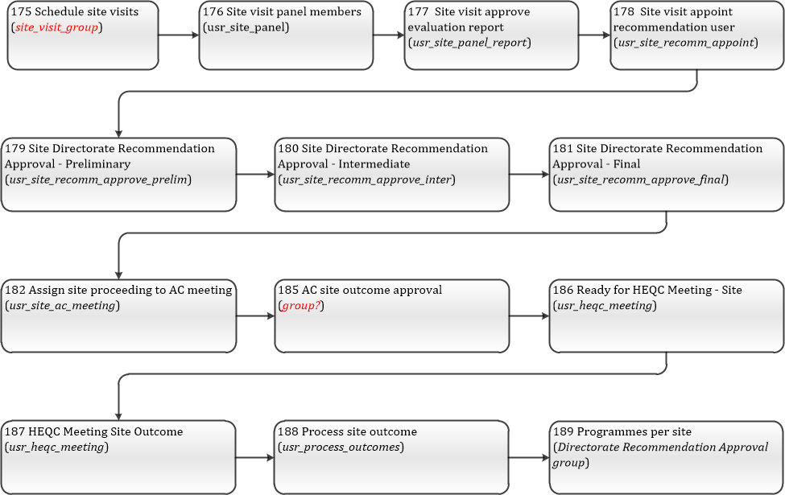

## Accreditation and re-accreditation process flows

