

**Bid No : DST 04/2018-19**

**Appointment of a Service Provider to  
Develop and Implement Enterprise Architecture**

**Closing Date : 26 November 2018  
 Closing Time : 11:00**

 Submitted By:  
 esOFTWARE SOLUTIONS (PTY) lTD

|  |  |  |  |  |
| --- | --- | --- | --- | --- |
| **Description** | **:** | **Appointment of a service provider to Develop and Implement Enterprise Architecture** | | |
| **Number** | **:** | **DST 04/2018-19** | | |
| **Issue** | **:** | **Version 1.0** | | |
| **Date** | **:** | **26 November 2018** | | |
| **Classification** | **:** | **Confidential** | | |
|  |  |  | | |
|  |  |  |  |  |
| **Approved by** | **:** | **\_\_\_\_\_\_\_\_\_\_\_\_\_\_\_\_\_\_\_\_** |  | **26 November 2018** |
|  |  | **Tiledi Kekana** |  | **Date** |

eSoftwareSolutions (Pty) Limited  
P O Box 4260 Rietvleirand 0174  
Tel: (012) 665 1752  
Fax: (012) 665 5061

Mobile: 0836520702

Email:tiledi.kekana@esoftwaresolutions.co.za

Copyright © of this work is reserved under the Copyright Act of the  
Republic of South Africa (No 98 of 1978) and the provisions of the Berne Convention.  
This work or any part thereof may not be reproduced in any form or by any  
means without prior permission in writing of  
eSoftware Solutions (Pty) Limited  
unless in pursuance of the recommendations contained herein.

table of contents

[table of contents 3](#_Toc529887067)

[1 Executive Summary 4](#_Toc529887068)

[1.1 eSoftware Solutions (Pty) Ltd 4](#_Toc529887069)

[1.2 Why Us 6](#_Toc529887070)

[2 Our Understanding of Your Requirements 7](#_Toc529887071)

[3 Our Approach and Methodology 8](#_Toc529887072)

[**3.1** **Methodology Overview** 11](#_Toc529887073)

[**3.2** **Business Architecture** 12](#_Toc529887074)

[**3.3** **Information Architecture** 13](#_Toc529887075)

[**3.4** **Technology Architecture** 14](#_Toc529887076)

[**3.5** **Project Management Track** 15](#_Toc529887077)

[**3.6** **Work Plan** 16](#_Toc529887078)

[4 High level Project Plan 28](#_Toc529887079)

[5 Quality Assurance 30](#_Toc529887080)

[5.1 Quality Management (ExPECT) 30](#_Toc529887081)

[**5.2** Setting Expectations 32](#_Toc529887082)

[5.3 Planning for Quality 32](#_Toc529887083)

[5.4 Execution 33](#_Toc529887084)

[**5.5** Checking Process and Results 33](#_Toc529887085)

[5.6 Tailoring for Continuous Improvement 33](#_Toc529887086)

[6 Skills Transfer 34](#_Toc529887087)

[6.1 Guiding Principles 34](#_Toc529887088)

[6.2 Competency Transfer Approach 35](#_Toc529887089)

[7 Our Proposed Project Team 36](#_Toc529887090)

[**7.1** **Supa Chabula** 36](#_Toc529887091)

[**7.2** **Munakumpande “Kas” Kaswaya** 37](#_Toc529887092)

[**7.3** **Lebogang Boikhutso** 37](#_Toc529887093)

[8 Company Credentials of Similar Work 39](#_Toc529887094)

[9 Standard Bid documents 41](#_Toc529887095)

[9.1 Tax Certificates 41](#_Toc529887096)

[9.2 BEE Certificate 41](#_Toc529887097)

[9.3 CSD Certificate 41](#_Toc529887098)

[9.4 Company Registration Forms 41](#_Toc529887099)

[9.5 Company Profile 41](#_Toc529887100)

[9.6 Financial Statements 41](#_Toc529887101)

[9.7 Reference Letters 41](#_Toc529887102)

[9.8 Curricula Vitae 41](#_Toc529887103)

# Executive Summary

This document is a detailed response by eSoftware Solutions, to the invitation to tender document **DST 04/2018-19**, issued by Department of Science and Technology (DST), requesting the **appointment of a Service Provider to Develop and Implement Enterprise Architecture**.

We have provided DST with a comprehensive proposal, detailing our methodology and approach to Enterprise Architecture (EA). Our consulting experience has provided with us with the appropriate skills and knowledge of delivering comprehensive EA, through a methodical and detailed approach. Our methodology and approach is built on our experience of consulting in both the public and private sector in the South African environment.

Our proposal is further supported by Quality Assurance Process, to ensure that we deliver our deliverables in accordance with globally accepted standards. Our Skills Transfer Approach ensures that there is continuity and that DST Information Technology staff have the appropriate skills to maintain the appropriate Enterprise Architecture, when our consulting team is no longer on site.

Our consulting team has the experience to ensure that DST achieves the required strategic business benefits from an appropriate Enterprise Architecture.

Our proposal provides the following added advantages to the DST:

* Our project teams has a good understanding of Enterprise Architecture for South African public entities and financial services institutions;
* Adherence to global standards, our team has worked with some of the large global consulting firms; and
* We understand Information Technology.

### eSoftware Solutions (Pty) Ltd

eSoftware Solutions a division of eSoftware Solutions was established by individuals with many years of experience in different fields of business: Information Technology, Business Consulting, Project Management and Software Development. We have business operations in Gauteng and Kwazulu-Natal.

The group provides specialist services in the Information Technology industry. The figure below provides an overview of the group.

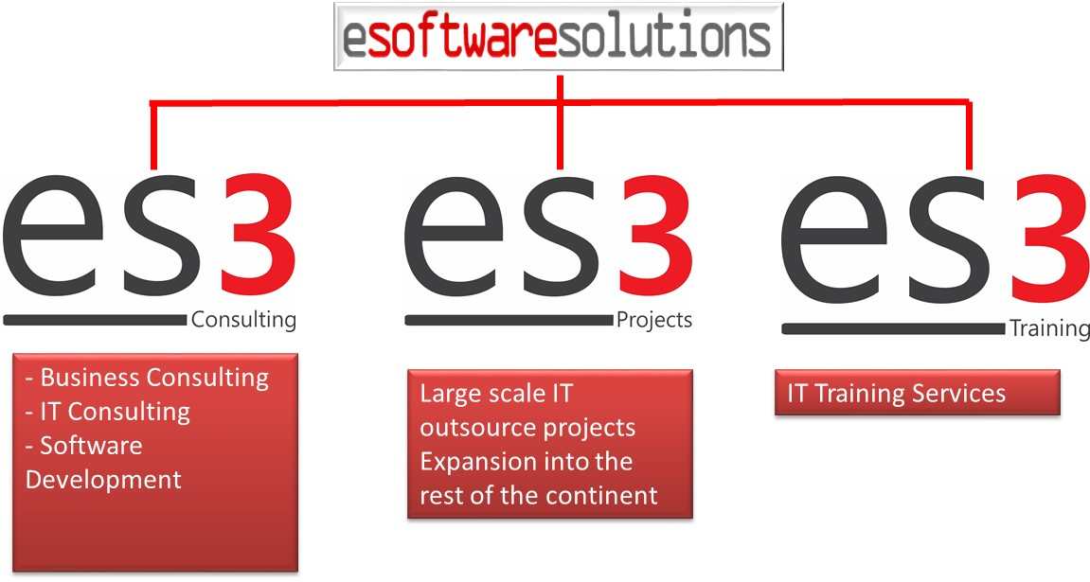

Our services include:

* the development of Information Technology Strategies;
* the design and development of business solutions;
* information technology infrastructure management;
* the hosting of business applications, to support you in the operational needs of your business;

Our business model is based on partnerships, we will partner with your organisation to create a mutually successful relationship. Our clients leverage off our existing infrastructure and knowledge of particular business applications and markets.

Our services are required and utilized by both large and small organizations in the private and public sector.

Clients come to us because:

* they would rather concentrate on their core business and not Information Technology;
* they lack the skills to support their business application;
* of the high cost of developing or purchasing a business application;
* they would like to penetrate new markets;

eSoftware Solutions is changing the way business is conducted in the Information Technology sector. Information Technology should be seen as a value added service to businesses and not a large operational cost. eSoftware Solutions is a Gold Oracle Certificate and Microsoft partner.

### Why Us

eSoftware Solutions sees itself as a shining light in providing effective services to customers. Our consultants are experienced and have worked some of the large international consulting firms. Our customers continually speak highly about the quality of our work. We believe strongly in the development of skills for the previously disadvantaged communities. We are passionate about the support of other emerging enterprises and we continue to support them.

# Our Understanding of Your Requirements

**Development of an Enterprise Architecture (EA)**

1. Give direction for t he development of the EA and setting up interactive workshops with all unit managers and other key role players.
2. Revise the DST processes as they are (“As Is”), the existing interoperations and interactions and how they are currently supported by existing process or system dependencies and conflicts.
   * Deficiencies of the processes
   * Adequacy of interoperations or interactions or weaknesses thereon including process or system dependencies and conflicts
   * Interoperations and interactions must include process dependencies and set up of process predecessors and successors.
   * Consistency and efficiency of the processes and the systems supporting them including data including system input methods, processing, output and reporting in relation to internal data entry ad output and data entry and output requirements of key current and future stake holders.
3. In consultation with the relevant unit managers, prepare a roadmap to get to a future state (“To Be”) in respect of 2. and make recommendations to address all process and system deficiencies, inconsistencies, inefficiencies, inadequacies in streamlining dependencies, process and system conflicts, data input in relation to key stakeholders.
4. Develop EA blueprints, standards, and specifications based on the findings.
5. Develop an EA Roadmap for the DST.
6. On approval of recommendations, develop the enterprise architecture for the DST.
7. Identify EA domains that need to be prioritised.
8. Review the existing IT strategy, IT Operational Plan and Organisational Structure for alignment to the Enterprise Architecture and revise where gaps are identified.
9. Identify and Develop an EA communication strategy for the DST to ensure adoption.
10. Identify and develop EA enabling tools that will best suit the DST needs.

# Our Approach and Methodology

Given this background we understand that the overall objective of this request for bid is to perform the following key activities:

* 1. Mini Assessment: Do a high level audit and structural analysis of the business system capabilities currently within DST. It is expected that this will include an assessment of the architecture, system functionality, IT Governance and expectations from business.
  2. Business Strategy: A thorough analysis of the DST strategy, including any transformation plans to identify what must be delivered from an IT perspective to add value to the DST business process and enable value.
  3. Technology Strategy: Review the current technology strategy and prepare an integrated enterprise architecture to deliver what business wants. This will include: application architecture, information management, infrastructure architecture, tools requirement and make recommendations as to the most applicable IT methodology to be utilised, given the environment.
  4. IT Operational Strategy: Review the current processes followed to deliver services to the rest of the business. Here we look at the DST organizational structure of IT, governance and technology processes, project management and tools used to priorities and allocate resources to the delivery of information technology services.
  5. Action plans: Create a short / medium / long term execution plan (3 year plan) to achieve the goals determined for the following: design of quick and efficient business and technology processes, comprehensive risk management plan, recommendations in terms of training of staff and knowledge transfer / mentoring to current staff, and the harvesting of quick wins.
  6. Continuous Advice: Develop a mechanism whereby additional continuous assessments and reviews of the architecture will be reviewed over a period of three years.

We believe that in partnership with the DST, eSoftware Solutions has the depth of skill, capability and experience to meet your expectations and deliver exceptional professional service.

To achieve the goals of the project, we will work with DST, on four concurrent tracks

* + The Business Track
  + The Information Track
  + The Technology Track
  + Project Management Track

1. **The Business Track**

The business track surfaces the business problems and opportunities. Additionally, it drives the creation of business requirements, to determine the real current and future needs of business in accordance to its business strategy.

1. **The Information Track**

Here we examine what information and data is accessible within a reasonable time frame. By balancing the “wishes” for information of the business with the “realities” of data availability, we are better able to develop an appropriate data model for DST.

1. **The Technology Track**

The technology track provides the “technical” answers. Our end goal is appropriate technology architecture for DST. This track looks at both the applications and technology needs of DST. To achieve this architecture, we need to bring together four elements:

* + The existing technology infrastructure of the organization
  + The current Information Center
  + The business and functional requirements of the applications
  + The overall technology direction of the organization

1. **The Project Management Track**

The project management track provides guidance to the delivery of the project. Here we ensure we perform the following key activities:

* Coordination of the project, thus ensuring that we meet our deadlines
* Regular reporting to the appropriate stakeholders of DST, on the progress of the project
* Review of current governance structure of DST; determine best practice
* Provide an executive summary of the of the proposed Enterprise Architecture

To perform the various activities required along the four tracks specified above, eSoftware Solutions Consultants together with DST shall execute four sequential sub-phases:

* Project Initiation sub-phase
* Business and System Analysis sub-phase
* Business Use and System Vision sub-phase
* Planning and Definition Design sub-phase

All along the execution of these four sub-phases, eSoftware Solutions shall provide, with the help of DST, project management and quality assurance as needed for the successful completion of the project.

At the end of each sub-phase there will be management and quality assurance checkpoints to provide DST management with an insight into the project and its deliverables.

The section below provides an overview of the methodology, each work stream is further decomposed and detailed work-plan is also provided for each of the steps in the methodology.

### **Methodology Overview**

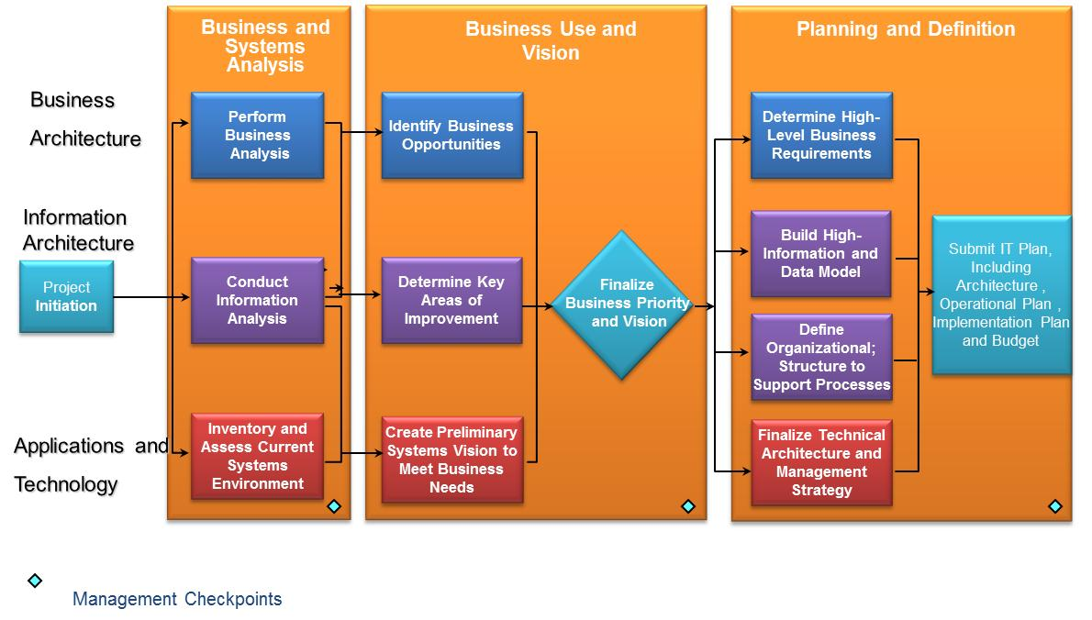

### **Business Architecture**

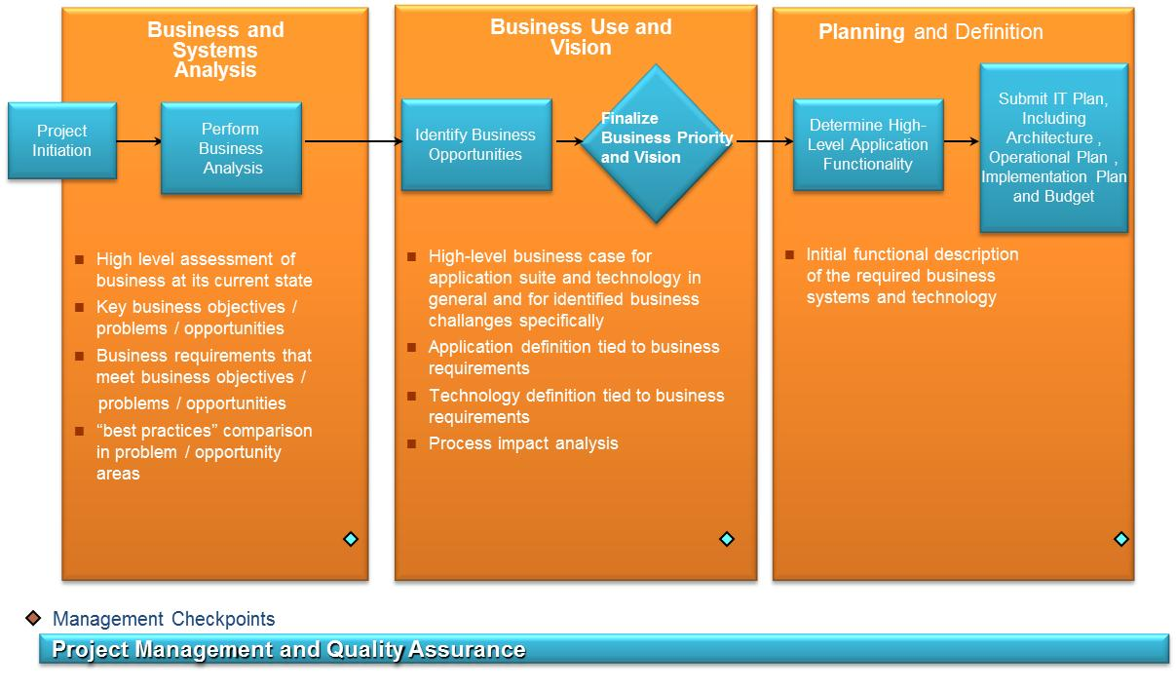

### **Information Architecture**

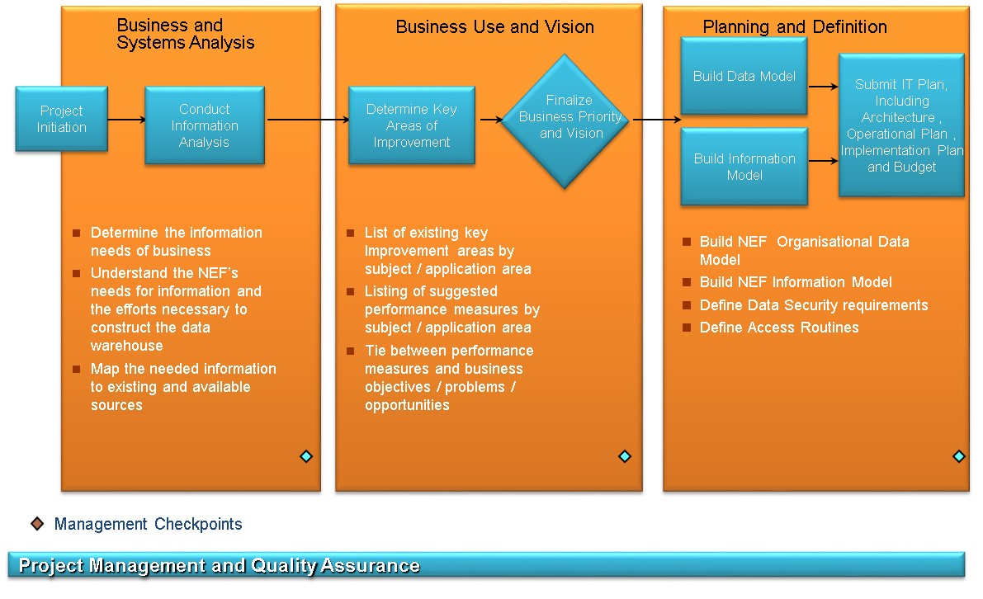

### **Technology Architecture**

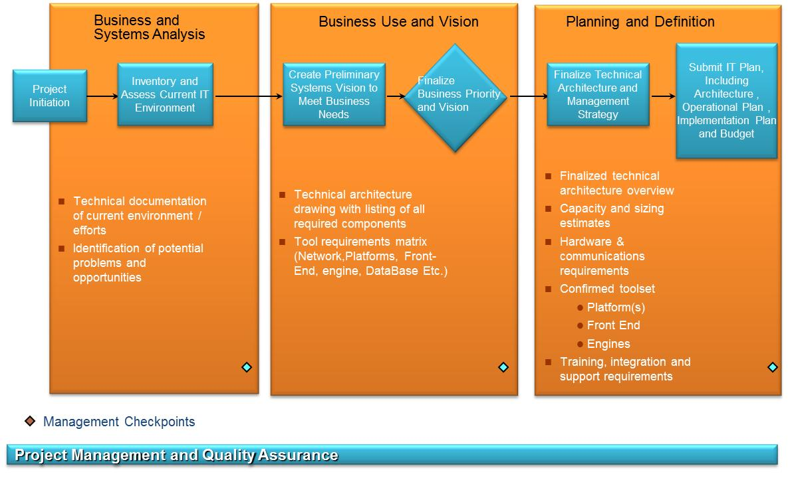

### **Project Management Track**

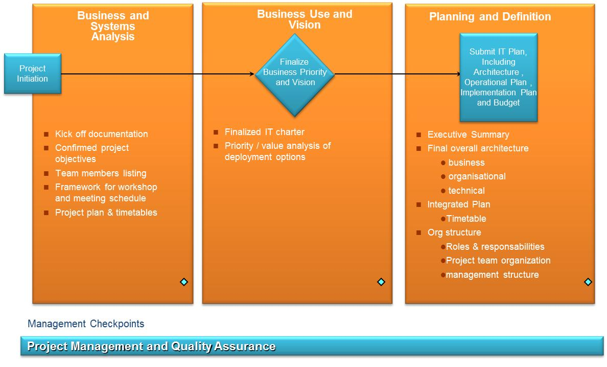

### **Work Plan**

This section follows the methodology, each step, is provided a detailed work plan. Clearly defining what DST can expect.

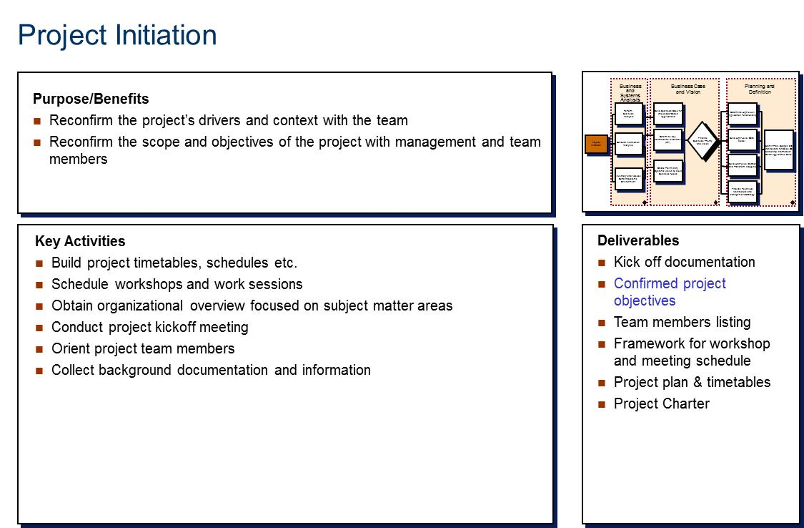

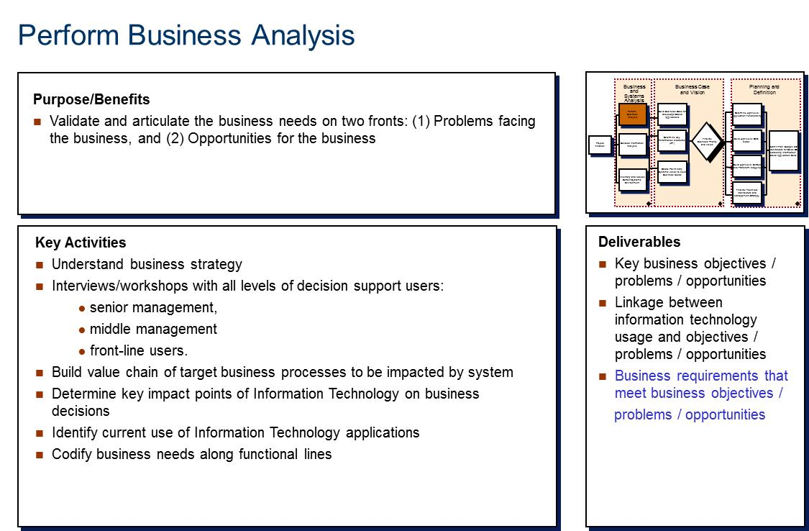

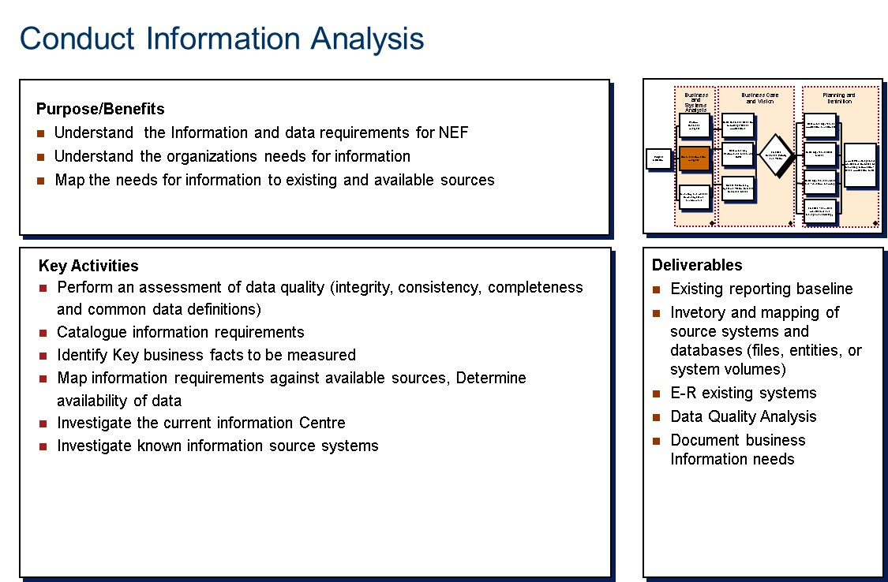

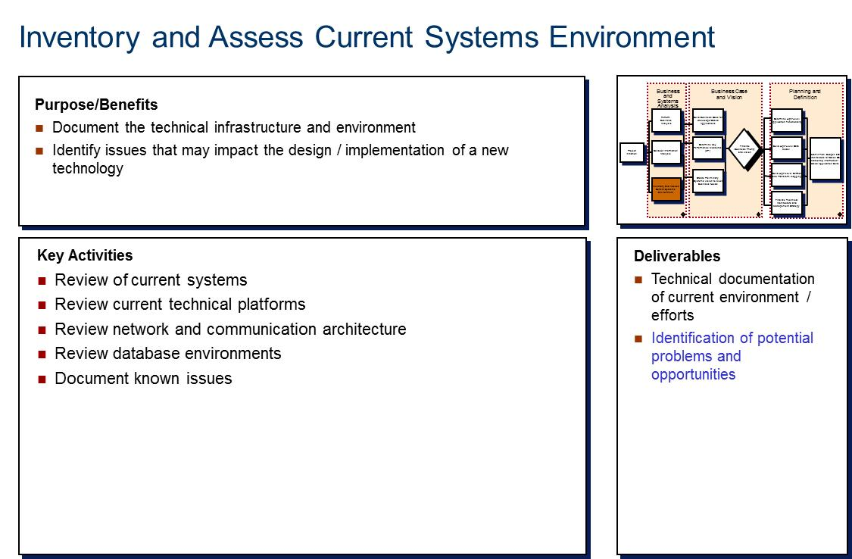

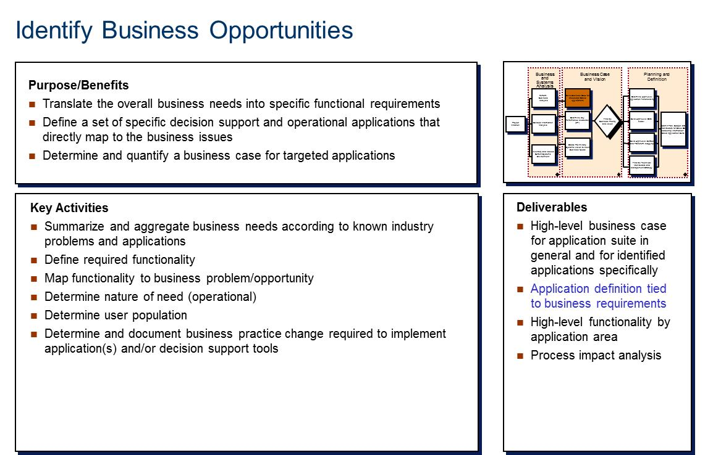

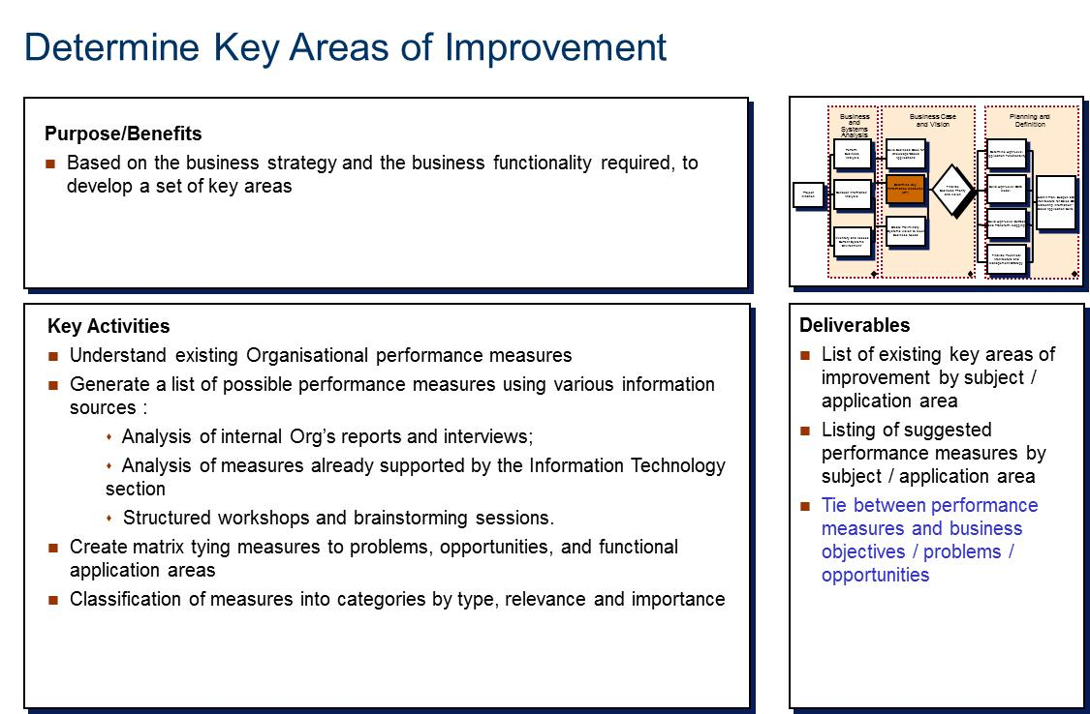

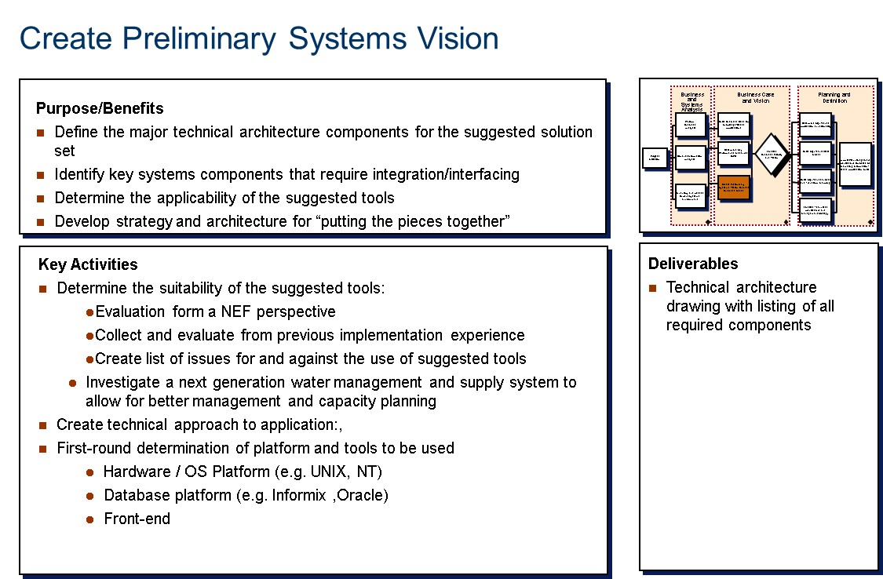

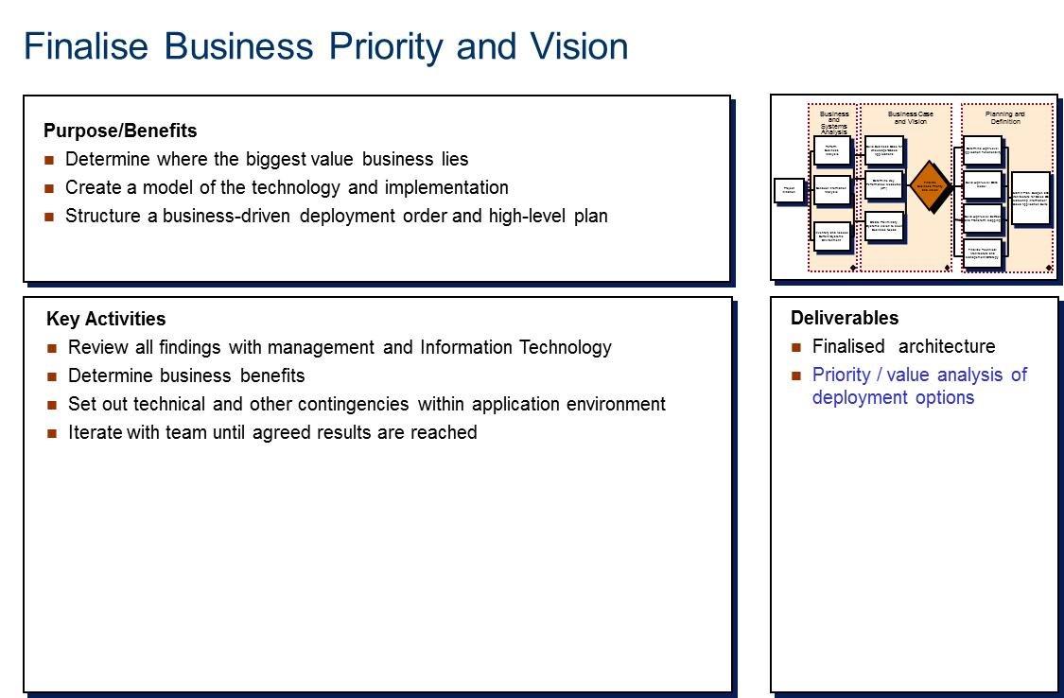

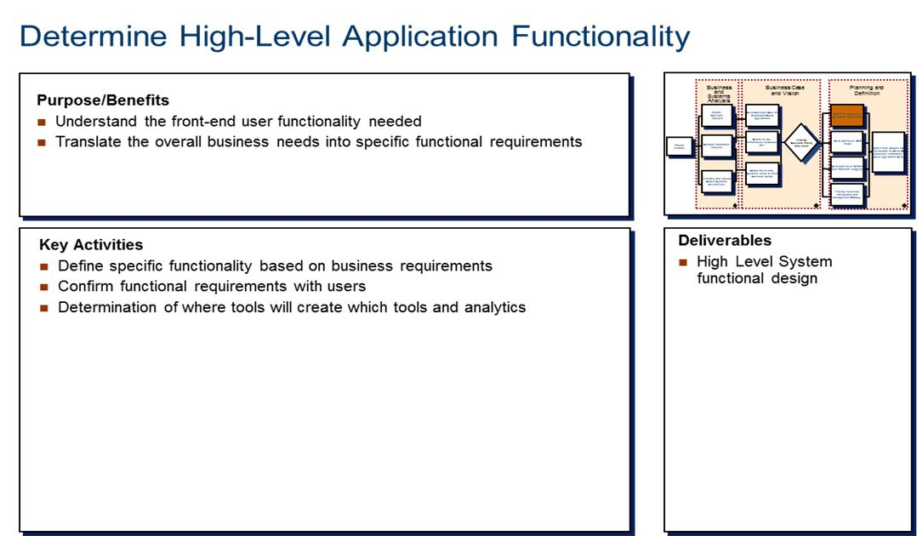

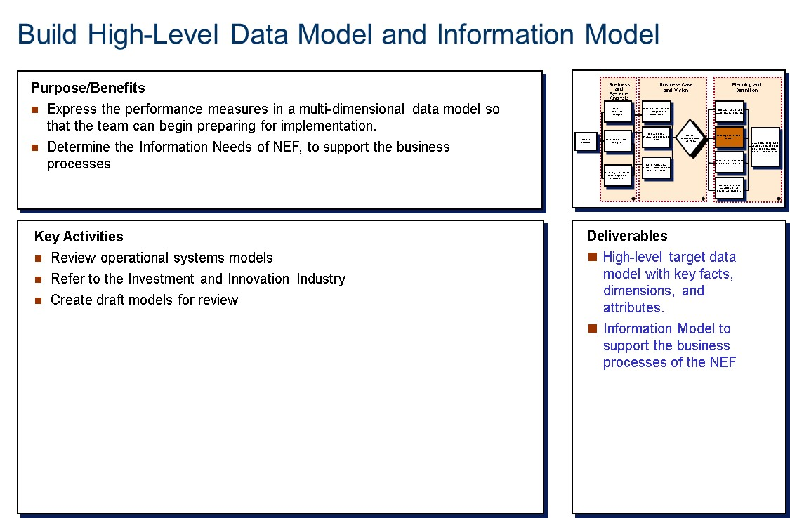

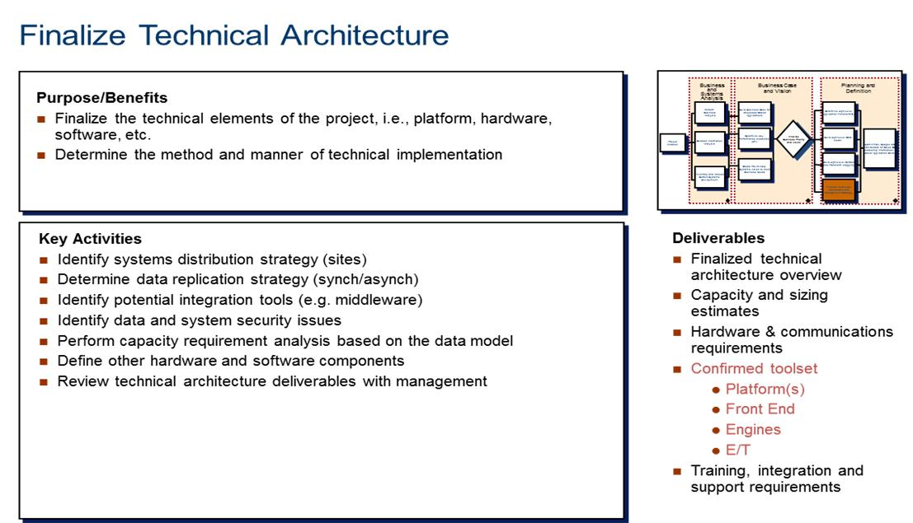

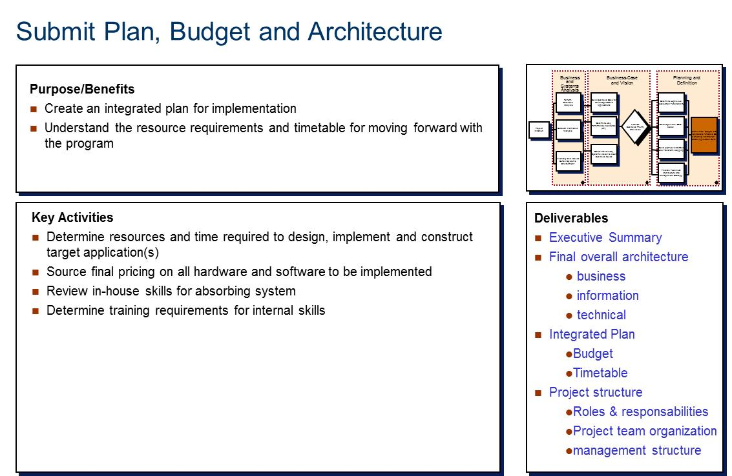

# High level Project Plan



The above figure provides a high level project plan. The project will be delivered to DST over a period of 12 weeks. The following deliverables will be delivered as per requirement:

* Project Charter
* Weekly Progress Reports
* Enterprise Architecture
* Policy
* Vision
* Business Architecture
* Information Architecture
* Technology Architecture
* Enterprise Architecture Implementation Roadmap
* Executive Summary of Architecture

# Quality Assurance

To ensure that we deliver as per the expectation of DST, we have a quality assurance framework. The overall framework for delivering quality is shown below:



The framework starts with quality principles. This means that the quality management approach is principle driven. The quality principles are what drive the programme’s approach to quality management. Next, various quality management approaches and techniques are utilised to achieve the programme’s quality principles. The quality management approaches and techniques are the means for achieving quality results. Quality management approaches and techniques are only utilised when they support a quality principle. Next, specific quality goals and objectives must be identified in order to ensure that quality is defined in concrete terms. Quality goals and objectives can range from very specific goals to general expectations of the programme customers. Finally, specific metrics and measurements must be identified as the way to measure quality.

### Quality Management (ExPECT)

Various initiatives will be used together with various techniques to enable management of the quality process. The Methodology is centred around the ExPECT model described below. The traditionally accepted practice for quality management is to Inspect, Reject and Rework.

We have a comprehensive framework, the ExPECT model, to ensure that quality management is built into every activity rather than being reactive after the event. The ExPECT model provides guidelines, tools and techniques to facilitate quality management within a single project as well as beyond the project for future ongoing improvement work.

Some of the rationale behind the ExPECT model is:

* ExPECT is based on commonly used TQM (Total Quality Management) principles and practices;
* It is a “management” methodology (it cannot be delegated);
* It is stakeholder driven (not schedule and budget);
* It is aimed at maximising “value” (maximum results/minimum cost);
* It focuses on “planning and prevention” (not “detection and correction”); and
* ExPECT is our current “best practice” for managing client service quality.

The ExPECT model identifies five stages to manage quality and uses advanced techniques to plan and monitor the quality management process. The five stages of the ExPECT model are as follows:

* Identify stakeholder Expectations;
* Plan the quality management framework;
* Execute the work and collect appropriate metrics;
* Check that the quality management framework is working effectively; and
* Tailor the framework by planning, piloting and implementing process improvements.

The figure below presents a graphic representation of this ExPECT model, which is a cycle of ongoing and continuous activity.



### Setting Expectations

During this phase, team members work with clients to document expectations. They document, categorise, and prioritise these expectations. These expectations become the basis for future evaluation. The main tasks are:

* Identify customers;
* Identify expectations; and
* Communicate expectations.

### Planning for Quality

Here, the team documents the processes and approach for meeting client expectations. The Quality Plan defines standards, performance metrics, and measurement procedures for key processes and end results. Through training, communication and recognition programmes, the Quality Plan ensures that everyone is well prepared and motivated to contribute towards the success of the project. The main tasks are:

* Develop an expectation matrix;
* Develop an issues matrix; and
* Develop a communication programme.

### Execution

As the project progresses, the team members collect data measuring achievement of the expectations. The main tasks are:

* Execute work;
* Collect metrics or findings; and
* Execute the communication programme.

Some of the important techniques used in large development and maintenance projects are:

* **V-model of Verification**, Validation and Testing -A framework for ensuring each stage of a project implements the specification produced by the stage preceding it. The V-model helps ensure a project does things right (verification) and that it does the right thing (validation); and
* **Stage Containment** -Detects and fixes errors in the stage in which they occur. This prevents the occurrence of defects (errors that go undetected until a later stage) and faults (errors that are not detected until the solution is in production).

### Checking Process and Results

The quality assurance partner conducts a Quality Assessment to analyse quality performance. In addition, team members conduct gap analyses and identify improvement opportunities and strategies to address any gaps. The main tasks are:

* Perform quality assessment; and
* Recommend process improvements.

### Tailoring for Continuous Improvement

The team prioritises recommendations, creates and executes an implementation plan, communicates improvements, and recognises contributors. The main tasks are:

* Plan and pilot recommendations;
* Implement process improvements; and
* Communicate improvements.

# Skills Transfer

The transfer of skills and knowledge is an area of enterprise architecture to the DST staff is of the utmost importance to us. Over the years we have developed skills transfer plans which not only focus on the transfer of skills, but look at the broader scenario of transferring competencies, which encompass skills and knowledge as well as attitudes required for clients to sustain themselves even after we have completed our assignment.

We will ensure that sustainable competency transfer takes place throughout the duration of this engagement. The objective will be to ensure that competencies transferred continue to be used even after the team has completed its assignment with DST.

We have managed to successfully apply competency transfer programmes on numerous, engagements with clients in the area of Enterprise Architecture. The process of competency transfer will take place both formally and informally, as a component of the work between DST and us. It may take the form of a number of interventions, such as:

* Coaching;
* Mentoring;
* Formal Training;
* Workshops;
* Information sharing sessions etc.

The entire competency transfer approach will be agreed to and consolidated during the project initiation phase. This will be documented and included in the project planning phase. In setting out the approach the following issues will be considered:

* how the relevant competencies will be selected;
* how the competencies will be transferred between the parties; and
* how the process will be regularly reviewed and monitored.

### Guiding Principles

The following guiding principles underpin the development and implementation of the Competency Transfer Program:

* **Quality:** To ensure that existing standards and processes are not impaired and that new standards are followed.
* **Schedule:**  Precise time-lining, follow up and progress reporting.
* **Flexibility:** A process that can be adapted to suit different situations.
* **Continuous improvement:** By defining and analysing the roles, there is an opportunity to identify areas for process improvements.
* **Competency transfer:** Focus on capturing functional and technical knowledge.
* Assign Specific Responsibilities and ensure accountability: Mentor and successor roles and responsibilities
* **Objective documentation:**  Formal documentation of the tasks and competencies required for each position
* **Repeatable process:** Generic process that can be re-used as required.

### Competency Transfer Approach

The primary objective of the Competency Approach is to formalise the transfer of competencies to DST personnel. Among other things, the approach will focus on:

* targeting selected personnel for specific competency development;
* ensuring that specialised consulting staff work alongside employees of the DST;
* transferring competencies which have a direct relevance to the individual’s current and/or future role; and
* monitoring the progress and success of the competency transfer approach.

Attainment of these objectives will ensure that employees of DST have sufficient skills to use the system effectively after the implementation.

# Our Proposed Project Team

The project organogram above provides an overview of each project stream of work. The section below provides summary profiles of our proposed consultants; we have also included other consultants that are available for the project if required.

### **Supa Chabula**

**Role: Project Manager**

**Qualifications:** Bsc (Computer Sciences), Togaf 9 Certified, Prince 2 Project Manager

Supa is an accomplished IT professional, with over 20 years detailed, hands on experience in business analysis, business systems integration, IT Strategy, Enterprise Architecture and IT Portfolio, Programme and Project Management - having worked extensively, at senior management levels, in a variety of major world-class successful information systems implementation and consulting projects.

Supa provides strong management and leadership, backed by many years of experience in Information Technology at a senior level.

### **Munakumpande “Kas” Kaswaya**

**Role:** Applications and Technology Architect (Lead)

**Institution:** The Copperbelt University, Kitwe, Zambia, 1990 to 1995.

Qualification: BSc Degree in Building Science

**Institution:** Hamburg University of Applied Sciences, Germany 09/2001 to 2004.

**Qualification:** BEng Degree in Information / Electrical Engineering

(Digital engineering and DBMS courses pending)

‘Kas’ is an accomplished architect TOGAF9 Certified with over 18 years of experience. He has worked on number of architecture projects in the public sector some of which include:

* Magalies Water Enterprise Architecture
* Polokwane Municipality Master Systems Plan
* Department of Trade Industry Enterprise Architecture
* Gauteng Departments of Education Enterprise Architecture
* SITA Master Systems Plan for Local Governments
* Limpopo Province Capacity Building, eGovernment and MSP pilot
* Department of Correction Services Master System Plan
* National Department of Public Works ITIL, COBIT, SAM assessment and implementation
* North West Department of Agriculture, Conservation and Environment Master Systems Plan

### **Lebogang Boikhutso**

**Role: Business Analyst (Lead)**

**Qualifications:** BTech Business Applications; Diploma (IT)

Lebogang has 12 years of experience in information technology. Most of years were spent working as a Business Analysts. He has consulted to organisation such as Telkom, Vodacom, SARS, QCTO and FNB. Some of his skills include:

* Data Processing Concepts
* Application Business and Process Flow
* Software Process Documentation
* MS Project Management
* Generally Accepted Project Management Principles
* Business Systems Analysis & Design
* Software Development Life-Cycle
* UML
* Workshop facilitation (JAD Sessions)

Lebogang brings a lot business expertise and IT experience

# Company Credentials of Similar Work

|  |  |  |
| --- | --- | --- |
| **Client** | **Engagement Description** | **Contact Person** |
| **Quality Council for Trades and Occupations** | Compilation of an Enterprise Architecture for the quality council. | Mr Tafadzwa Ramhewa  Director IT  Tel : 012 003 1800  [Ramhewa.t@QCTO.org.za](mailto:Ramhewa.t@QCTO.org.za) |
| **Magalies Water** | Development of a 5 ICT Strategy for the Water Utility. Programme management services for the implementation of core business applications. | Ms Fhatuwani Marwala ICT Manager  Tel : 014 597 4636  [Fhatuwanim@magalieswater.co.za](mailto:Fhatuwanim@magalieswater.co.za) |
| **Land Bank of South Africa**  Logoc | Developed a strategy and architecture of an implementation of a Treasury Management Solutions. | Mr Aubrey Mongale Manager: Technical Application Support  Tel : 012 686 0625  [Ammongale@landbank.co.za](mailto:Ammongale@landbank.co.za) |
| **Bojanala Municipality**  image002 | Defined strategy, business requirements and implementation plan for a Document and Records Management Solution. Provided Records and Document Management Training. | Ms Mabatho Tshukudu  Records Manager  Tel: 014 590 4500 |
| **National Home Builders Registration Council**  C:\Users\Rubashnim\Desktop\nhbrc.jpg | Facilitated the development of a Information Technology Strategy for the implementation of an Enterprise Solution. Further work was given to us on the strategy for outsourcing of sections of IT. | Mr Donald Matlou  IT Manager  Tel : 011 317 0000 |
| **Polokwane Municipality**  polokwane_logo.gif | eSoftware Solutions developed a three year IT strategy for the Polokwane Municipality. We continue to oversee the implementations and review the strategy on an annual basis | Mr Alex Maholela  IT Manager  Tel : 015 290 2229 |
| **Cross Boarder Roads and Transport**  cb2 | eSoftware Solutions was appointed to provide an enterprise wide architecture. We currently oversee the architecture and the project office. | Mr Brett Holding  Chief Information Officer  Tel : 012 471 2173  [Brett.Holding@cbrta.co.za](mailto:Brett.Holding@cbrta.co.za) |
|  | As part of the Umnombo Consortium, which has been appointed improve performance of the municipality. eSoftware Solutions compiled an IT strategy and architecture for the municipality. | Mr Mninawa Mketo  Umnombo Consortium Director  Tel : 011 802 0580 |

# Standard Bid documents

### Tax Certificates

### BEE Certificate

### CSD Certificate

### Company Registration Forms

### Company Profile

### Financial Statements

### Reference Letters

### Curricula Vitae