

Attention: P. K. Matlala Phokontsi

3671 Nandi Street Hillsview Kagiso

Krugersdorp Gauteng 1754

30 January 2023 Dear Sirs

Pheladi Matlala Phokontsi, a director of Radiant Home Lifestyle (Pty) Ltd **(Registration number: 2016/448951/07)**, hereby certify that a company pay an amount of R75 000 per month to a director, however a director withdraw amount from the business account when the company is in health cash flow in that month.

Yours faithfully,

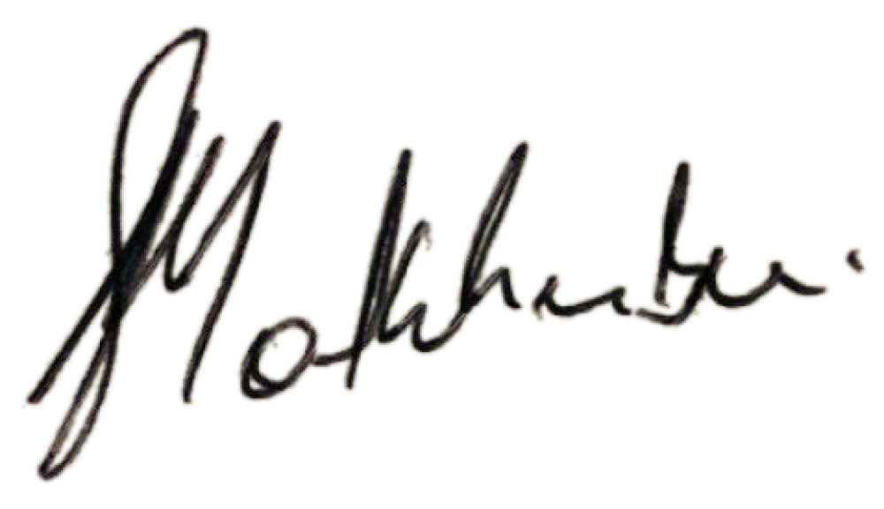

X. Makhubu Director

Sanaca Services Group (Pty) Ltd

