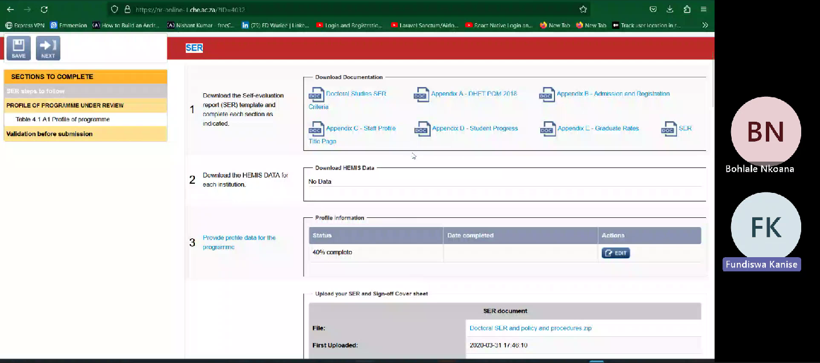

* Remove all appendix documents.
* Replace Doctoral studies SER criteria with Standard documents.
* Replace SER with Template for BSW

Instead of SER is going to be *National Standard Alignment Report*

*Profile of Qualification stays the same.*

*Validation stays the same.*