VIETNAM NATIONAL UNIVERSITY HO CHI MINH CITY
UNIVERSITY OF TECHNOLOGY
Faculty of Electrical and Electronics Engineering
---------------o0o---------------


SENIOR DESIGN PROJECT
FPGA-Based PAM-4 Communication System with CLT-Based AWGN Generator and LMS Decision Feedback Equalizer

Student Author: Nguyen Hung Minh
Student ID: 2251030
Supervisor: Assoc. Prof, PhD. Truong Quang Vinh

HO CHI MINH CITY, May 15th, 2026
VIETNAM NATIONAL UNIVERSITY, HO CHI MINH CITY UNIVERSITY OF TECHNOLOGY
SOCIALIST REPUBLIC OF VIETNAM
Independence – Freedom – Happiness

FACULTY OF ELECTRICAL AND ELECTRONICS ENGINEERING |  |  |  |  | SENIOR DESIGN PROJECT  ASSIGNMENT
(Note: Students must paste this sheet onto the first page of the
report.)
 | FULL NAME: |  | Nguyen Hung Minh |  |  | Student ID: | 2251030
 | MAJOR: |  | Circuits – Hardware System Area |  |  | CLASS: | TT22HSA1
1. | Project title:
 | Thiết kế và triển khai hệ thống truyền thông PAM-4 trên FPGA sử dụng bộ tạo nhiễu AWGN dựa trên định lý giới hạn trung tâm và bộ cân bằng phản hồi quyết định LMS
 | FPGA-Based PAM-4 Communication System with CLT-Based AWGN Generator and LMS Decision Feedback Equalizer
2. | Assignment (requirements on content and initial data):
 | - | Study of digital communication and adaptive equalization theory.
 | - | Development of a communication system model including channel distortion and AWGN.
 | - | Algorithm simulation and performance evaluation.
 | - | Hardware-oriented design of the equalizer architecture.
 | - | Implementation and verification on an FPGA platform.
3. | Date of thesis assignment: |  |  | 30 / 01 / 2026
4. | Date of completion: |  |  | 10 / 05 / 2026
5. | Supervisor’s full name: |  |  |  |  |  | Guidance section:
5. | - | Truong Quang Vinh |  |  |  |  | Overall project
The content and requirements of the senior design project have been approved by the Program Chair.

…/ …/ …
PROGRAM CHAIR
(Signature and full name)
SECTION FOR FACULTY
Reviewer (preliminary grading):
Unit: Date of defense: …. / …. / ….
Final grade:
Thesis storage location:

MAIN SUPERVISOR
(Signature and full name)

ACKNOWLEDGEMENT
First and foremost, I would like to express my deepest gratitude to my instructor, Assoc. Prof. Dr. Truong Quang Vinh. He has supported me greatly throughout the process of completing this thesis, not only in terms of technical knowledge but also in the logical presentation of ideas. His dedication, guidance, and encouragement over the past period have helped me improve my work significantly. He provided many valuable directions and different approaches, allowing me to address the problems in this thesis more thoroughly and effectively.
Secondly, I would like to express my sincere gratitude to the Faculty of Electrical and Electronics Engineering, Ho Chi Minh City University of Technology, Vietnam National University Ho Chi Minh City, for providing me with a solid academic foundation, a professional learning environment, and valuable opportunities to develop my knowledge and engineering skills throughout my undergraduate studies.
I would also like to sincerely thank the senior engineers at Marvell Technology Vietnam, especially Mr. Quoc, Mr. Lap, Mr. Duc, Mr. Tu, Mr. Chuong, and Mr. Hieu, for providing valuable materials, technical insights, and ideas that helped me complete this project more comprehensively.
In addition, I would like to extend my appreciation to the members of the Pay It Forward Club for their support, companionship, and encouragement throughout my journey in the club. I am especially grateful to Ms. Phuong, Mr. Toan, Mr. Tinh, Truc, Duy, and Mai for their valuable support in various activities. In particular, I would like to express my deepest gratitude to Mr. Nguyen Huynh Long Nhi for his constant guidance, support, and companionship throughout my work and personal development.
Finally, I would like to express my sincere gratitude to my family. Thank you for always being my strongest support and a reliable foundation throughout my academic journey. Their constant encouragement has allowed me to focus on pursuing my passion and completing this final thesis.
Ho Chi Minh City, 15th May 2026.

ABSTRACT
The rapid growth of data-intensive applications and high-speed communication systems has increased the demand for reliable and hardware-efficient digital signal processing solutions. Modern communication interfaces, such as optical interconnects, SerDes links, and memory systems often operate under channel impairments including inter-symbol interference (ISI) and additive white Gaussian noise (AWGN). These impairments require adaptive equalization and realistic channel emulation for accurate system evaluation. Field Programmable Gate Arrays (FPGAs) are well suited for this purpose due to their parallel processing capability, reconfigurability, and efficient support for custom signal processing architectures.
This thesis presents the design and implementation of a hardware-oriented communication test chain for FPGA-based evaluation of channel impairments and adaptive equalization. The proposed system consists of an ISI channel model, a fixed-point AWGN generator, and a Least Mean Square (LMS) Decision Feedback Equalizer (DFE), supporting Pulse Amplitude Modulation with four levels (PAM-4).
The AWGN generator is implemented using a multi-lane uniform random number generator based on the Taus88 algorithm. Independent uniform variables are combined using a Central Limit Theorem (CLT) approach to approximate a Gaussian distribution. The generated noise is scaled according to the desired signal-to-noise ratio and injected into the communication channel. The entire datapath is implemented using fixed-point arithmetic to ensure FPGA compatibility.
To compensate for ISI, a fixed-point adaptive equalizer based on the LMS algorithm is implemented using a DFE structure with a three-tap feed-forward filter and a one-tap feedback filter. During the training phase, known symbols are used to update the equalizer coefficients, after which the equalizer operates in decision-directed mode. A clipped-LMS adaptation strategy is introduced to limit large error updates, improving stability while preserving low hardware complexity.
System performance is evaluated using both statistical and communication-level metrics. The AWGN generator is validated through histogram analysis, cumulative distribution comparison, autocorrelation, power spectral density, and tail probability evaluation. Communication performance is measured using symbol error rate and bit error rate under different signal-to-noise ratio conditions. For visualization, equalized samples are transmitted via UART to an ESP32-S3 microcontroller and displayed on a web-based interface as eye diagrams.
The system is implemented in hardware description language and synthesized using Intel Quartus Prime on the DE10 FPGA platform, providing a practical framework for FPGA-based communication channel emulation and adaptive equalization evaluation.
Table of Contents
CHAPTER 1: INTRODUCTION 1
1.1. Overview 1
1.2. Related work 3
1.3. Thesis objectives 7
1.4. Thesis organization 8
CHAPTER 2: THEORY AND BACKGROUND 9
2.1. Pulse Amplitude Modulation 9
2.2. Inter-symbol Interference (ISI) 11
2.3. Additive White Gaussian Noise (AWGN) 13
2.4. Decision feedback equalizer 16
2.5. Central limit theorem 20
2.6. Least Mean Square algorithm 22
CHAPTER 3: DESIGN METHODOLOGY OF THE MODIFIED HARDWARE GAUSSIAN NOISE GENERATOR 26
3.1. Design Requirements and Method Selection 26
3.2. Proposed AWGN Generator Algorithm 28
3.3. Proposed Hardware architecture 32
3.4. Validation Methodology 36
CHAPTER 4: DESIGN OF THE PROPOSED LMS ADAPTIVE EQUALIZER 38
4.1. Overview and Design selection 38
4.2. Proposed algorithm 40
4.3. Proposed Hardware architecture 44
4.4. Validation methodology 47
CHAPTER 5: SYSTEM INTEGRATION 50
5.1. System Integration overview 50
5.2. Hardware–Software Architecture 51
5.3. FPGA Hardware Implementation of Channel Transmitter and Receiver 52
5.4. ESP32-S3 Communication software 53
5.5. PC-Side Visualization Software 54
CHAPTER 6: EXPERIMENTS AND RESULTS 55
6.1. MATLAB Simulation Results 55
6.2. SystemVerilog Implementation and Verification Results 62
6.3. FPGA Demonstration 65
CHAPTER 7: CONCLUSION AND FUTURE WORK 68
7.1. Conclusion 68
7.2. Future work 70
REFERENCES 71
Appendix A. Derivation of the excess kurtosis under CLT Gaussianization 76
Appendix B. Weak-Limit Analysis and Frozen-State ODE Validation 78

LIST OF FIGURES
Figure 1.1. Block diagram of the communication system. 2

Figure 2.1. PAM-4 signal waveform. 9
Figure 2.2. General baseband model of a transmission system. 10
Figure 2.3. Eye diagrams of PAM signals with different modulation orders. 11
Figure 2.4. BER performance comparison of PAM-2, PAM-4, and PAM-8 under different SNR values. 11
Figure 2.5. Pulse spreading caused by channel distortion in a binary transmission system. 12
Figure 2.6. Inter-symbol interference caused by limited channel bandwidth. 12
Figure 2.7. Additive noise model for the received signal. 14
Figure 2.8. Power spectral density of white noise. 14
Figure 2.9. Unit impulse signal. 15
Figure 2.10. Gaussian distribution of AWGN samples with zero mean and symmetric probability around zero. 16
Figure 2.11. (a) The dispersion of random data in lossy channel, (b) The channel frequency response showing attenuation of high-frequency components, and (c) The use of high-pass filter to equalize the channel. 17
Figure 2.12. Impulse response of a lossy channel. 18
Figure 2.13. (a) The use of an FF as a delay element and a slicer, (b) The resulting waveform 19
Figure 2.14. Central Limit Theorem approximation of a Gaussian distribution using uniform random variables. 21
Figure 2.15. Gradient Descent on the Mean-Squared Error Surface. 22

Figure 3.1. Overall architecture of the CLT-based AWGN generator. 33
Figure 3.2. Block diagram of the internal structure of the parallel Tausworthe random number lane and XOR combining stage. 34
Figure 3.3. Block diagram of Bit-mixing and 12-bit extraction stage for random lane decorrelation. 35
Figure 3.4. Block diagram of the adder tree. 35

Figure 4.1. Overall system block diagram and signal flow. 40
Figure 4.2. Flowchart of the proposed adaptive equalizer algorithm. 44
Figure 4.3. RTL architecture of the proposed 3-FFE + 1-DFE robust LMS equalizer. 45
Figure 4.4. Block diagram of Adaptive Tap Unit datapath for a single FFE/DFE coefficient. 46
Figure 4.5. Block diagram of Coefficient Adaptation in the LMS algorithm. 47

Figure 5.1. Data flow transmission 50
Figure 5.2. System integration architecture for FPGA-based PAM-4 processing and ESP32-S3 web visualization 51
Figure 5.3. FPGA Hardware Implementation of Channel Transmitter and Receiver. 52
Figure 5.4. UART transmission interface in FPGA. 52
Figure 5.5. ESP32-S3 UART-to-HTTP bridge architecture 53
Figure 5.6. ESP32-S3 firmware flow for UART data acquisition and HTTP transmission 53
Figure 5.7. PC-side post-processing architecture for browser-based eye-diagram visualization 54
Figure 5.8. PC-side software flow for eye-diagram visualization 54

Figure 6.1. Autocorrelation and PSD flatness validation of the proposed AWGN generator. 55
Figure 6.2. Tail probability comparison of CLT-based noise samples for different numbers of summed random lanes. 56
Figure 6.3. Distribution validation of CLT-based noise samples 57
Figure 6.4. BER and SER performance comparison of LMS-based equalizers under Gaussian noise. 59
Figure 6.5. Learning curve and tap-coefficient spread of LMS-based equalizers under Gaussian noise 60
Figure 6.6. BER and SER performance under clipping-threshold sweep 61
Figure 6.7. Eye-diagram comparison before and after equalization under no-AWGN and AWGN conditions 61
Figure 6.8. Simulation waveform of the pipelined AWGN generator. 63
Figure 6.9. Simulation waveform of the pipelined adaptive equalizer. 63
Figure 6.10. Simulation waveform of the full FPGA-based system. 64
Figure 6.11. Verification testbench architecture with MATLAB golden model and scoreboard. 64
Figure 6.12. Experimental setup for the FPGA-based PAM-4 equalizer demonstration. 66
Figure 6.13. FPGA and ESP32-S3 hardware prototype. 66
Figure 6.14. Initial web interface of the FPGA equalizer visualization system before data acquisition. 67
Figure 6.15. Web-based eye-diagram visualization after receiving FPGA equalizer data 67

Appendix B.1. SA mean versus ODE mean under frozen states 84
Appendix B.2. Frozen-state ODE sanity check for the adaptive equalizer 85

LIST OF TABLES
Table 3.1. Comparison of Gaussianization Methods. 27
Table 3.2. Comparison of Uniform Random Backbones (URNG Stage). 27
Table 3.3. Signal description of CLT-based AWGN generator. 34
Table 3.4. Signal description of parallel Tausworthe random number lane and XOR combining stage. 34
Table 3.5. Signal description of parallel Bit-mixing and 12-bit extraction stage for random lane decorrelation. 35
Table 3.6. Signal description of adder tree. 35

Table 4.1. Comparison of different equalization methods. 39
Table 4.2. Signal description of the robust LMS equalizer. 46
Table 4.3. Signal description of the Adaptive Tap Unit. 46
Table 4.4. Signal description of the coefficient adaptation LMS algorithm. 47

LIST OF ABBREVIATIONS
AWGN | Additive White Gaussian Noise
BER | Bit Error Rate
BRAM | Block RAM
CLT | Central Limit Theorem
DSP | Digital Signal Processing / DSP Block
DFE | Decision Feedback Equalizer
FFE | Feed-Forward Equalizer
FPGA | Field Programmable Gate Array
HDL | Hardware Description Language
HTTP | Hypertext Transfer Protocol
ISI | Inter-Symbol Interference
LMS | Least Mean Square
LUT | Look-Up Table
MSE | Mean Square Error
PAM-4 | Pulse Amplitude Modulation with Four-Levels
PDF | Probability Density Function
PRBS | Pseudo-Random Binary Sequence
PSD | Power Spectral Density
RTL | Register Transfer Level
SER | Symbol Error Rate
SNR | Signal-to-noise ratio
UART | Universal Asynchronous Receiver-Transmitter
UI | Unit Interval

CHAPTER 1: INTRODUCTION

1.1. Overview
Digital signal processing (DSP) has experienced significant development over the past several decades, driven by continuous advances in digital computing and semiconductor technologies. Early digital systems were limited by computational speed and hardware complexity, restricting their applications to offline scientific calculations. However, the evolution of integrated circuit technologies—from medium-scale integration (MSI) to very-large-scale integration (VLSI)—has enabled the realization of compact and high-performance digital hardware platforms. These technological advances have made it possible to implement complex signal processing algorithms in real time, which has significantly expanded the range of applications of DSP in modern communication systems.
In digital communication systems, the reliable recovery of transmitted information is a fundamental requirement. However, practical communication channels are rarely ideal. Band-limited channels, multipath propagation, and hardware imperfections often introduce distortions into transmitted signals. One of the most significant forms of distortion is inter-symbol interference (ISI), which occurs when adjacent symbols overlap due to channel memory effects. ISI degrades the detection performance of the receiver and increases the probability of symbol errors.
To compensate for these distortions, equalization techniques are widely employed at the receiver. An equalizer is a signal processing module designed to counteract the effects of channel distortion such that the overall channel–equalizer cascade approximates an ideal transmission path. Among various equalization techniques, the Decision Feedback Equalizer (DFE) has been widely adopted due to its ability to suppress post-cursor interference without significantly enhancing noise. The DFE utilizes previously detected symbols to estimate and cancel the interference introduced by earlier transmitted symbols, thereby improving detection accuracy in channels affected by ISI.
In addition to channel distortion, digital communication systems are also affected by noise generated by electronic components and the transmission medium. A widely used statistical model for representing such disturbances is additive white Gaussian noise (AWGN). AWGN represents thermal noise and other random disturbances that follow a Gaussian distribution and affect the received signal independently of the transmitted symbols. Accurate modeling of AWGN is essential for evaluating the performance of communication systems and signal processing algorithms.
Modern high-speed communication systems increasingly adopt multi-level modulation schemes such as Pulse Amplitude Modulation with four levels (PAM-4). Compared with traditional binary signaling, PAM-4 doubles the data rate within the same bandwidth by transmitting two bits per symbol. However, PAM-4 signals have reduced noise margins, which makes them more sensitive to channel distortion and noise. As a result, effective equalization techniques become even more important for maintaining reliable communication performance.
To address these challenges, adaptive filtering techniques are widely used in equalization systems. One of the most widely adopted algorithms is the Least Mean Square (LMS) algorithm. LMS is an adaptive filtering method that iteratively updates filter coefficients in order to minimize the mean square error between the desired signal and the filter output. The algorithm is computationally efficient and requires minimal prior knowledge of signal statistics, which makes it suitable for real-time implementations in communication receivers.
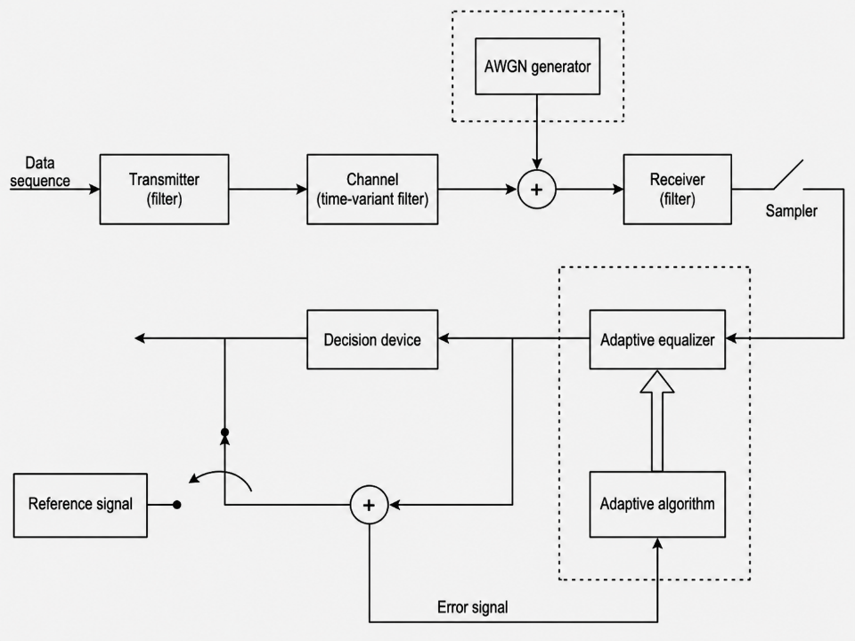
Figure 1.1. Block diagram of the communication system.
Figure 1.1. illustrates a typical adaptive equalization structure in a digital communication system. The transmitted signal passes through a communication channel that introduces distortion and noise. An adaptive equalizer is then employed at the receiver to compensate for channel effects. The equalizer coefficients are continuously updated by an adaptive algorithm based on the error signal generated between the equalizer output and a reference signal.
In recent years, Field Programmable Gate Arrays (FPGAs) have become an attractive platform for implementing communication signal processing systems due to their high parallel processing capability, configurability, and relatively low development cost. FPGA-based implementations enable real-time testing and evaluation of communication algorithms under practical hardware constraints. Consequently, many communication system components, including equalizers and noise generators, have been implemented on FPGA platforms for research and prototyping purposes.

1.2. Related work
The theoretical basis of this thesis is rooted in digital signal processing, adaptive filtering, and stochastic iterative methods. Standard DSP principles, signal models, and discrete-time system analysis are well established in the literature and provide the mathematical foundation for communication receiver design [1]. The behavior of adaptive algorithms can also be studied through the framework of stochastic approximation, which is particularly relevant when the coefficient update law is driven by noisy observations and random data streams [2]. In addition, practical receiver design is strongly influenced by circuit-level considerations, especially in high-speed communication systems where implementation constraints and design trade-offs must be carefully balanced [3].
Research related to adaptive equalization and Gaussian noise generation has been extensively conducted in the fields of digital communications and signal processing. Existing studies generally fall into three main categories: adaptive equalization algorithms, hardware implementation of adaptive equalizers, and hardware-based Gaussian noise generation techniques for communication system emulation.
Adaptive Equalization Algorithms
Adaptive equalization has long been studied as a solution for mitigating channel distortion and inter-symbol interference in communication systems. Among the classical approaches, the Decision Feedback Equalizer (DFE) remains a widely used structure because it suppresses post-cursor ISI without the strong noise enhancement associated with some linear equalizers. Early work on self-structured adaptive DFE showed that not only the coefficients, but also the equalizer structure itself, can be adaptively adjusted to improve performance under varying channel conditions [4].
The Least Mean Square (LMS) algorithm is one of the most widely adopted adaptive algorithms due to its low complexity and ease of implementation. Many subsequent studies have proposed improved variants of LMS and NLMS to obtain better convergence speed, robustness, or tracking performance. Variable step-size NLMS and affine projection algorithms were introduced to improve convergence behavior and better adapt to input signal conditions [5]. A DFE based on affine projection and normalized LMS algorithms was later studied to compare adaptive equalization performance in DFE structures [6]. An NLMS-like affine projection algorithm using iterative hyperplane projection was also developed for decision-directed equalization in more complex adaptive scenarios [7].
Beyond conventional LMS/NLMS methods, several works investigated enhanced adaptive criteria. A recursive least-squares-based normalized adaptive minimum symbol error rate equalizer was proposed to directly improve symbol decision performance while maintaining adaptive behavior [8]. Blind equalization under Gaussian and impulsive noise was also addressed through a fast-converging algorithm designed to improve equalization efficiency under more challenging noise environments [9]. Robust sparsity-aware RLS algorithms with jointly optimized parameters were later developed to improve resilience against impulsive noise [10].
Another important line of research focuses on fractional-order adaptive algorithms. Fractional-order complex LMS methods were proposed to modify the adaptation law using fractional calculus in order to improve convergence properties and steady-state performance [11]. Fractional-order variants of complex LMS and NLMS were also developed for adaptive channel equalization, showing that fractional-order adaptation is an important extension of conventional gradient-based filtering [12].
Recent studies have further expanded adaptive equalization toward more advanced optimization frameworks. A Bayes-Adam MIMO equalizer was proposed to combine adaptive Bayesian inference and Adam-type optimization for faster convergence and higher accuracy [13]. An ADMM-based MIMO equalization algorithm was later developed to improve tolerance to severe channel impairments such as mode-dependent loss in space-division multiplexed systems [14]. For recently introduced PAMN contingent decision equalizers, different adaptation approaches including zero-forcing and LMS-based realizations were studied to support real-time coefficient adaptation [15]. Stochastic modeling has also been applied to analyze the behavior of set-membership sign-NLMS algorithms, providing useful insight into stability and performance in adaptive filtering under uncertainty [16]. More recently, machine-learning-based nonlinear equalizers have also been investigated for optical interconnects, showing that equalizer design is increasingly moving toward data-driven multi-objective optimization in addition to classical adaptive filtering approaches [17].
Hardware Implementation of Adaptive Equalizers
Real-time communication systems require adaptive equalizers to be implemented on practical digital hardware platforms. Early work on hardware realization showed that adaptive signal processing pipelines could be implemented efficiently using dynamically pipelined architectures, as demonstrated in the case study of a delayed LMS equalizer for read-channel systems [18]. This line of work established the importance of balancing adaptation speed, hardware timing, and structural complexity.
With the rise of FPGA-based prototyping, more recent works have addressed equalizers for high-speed serial and optical communication systems. A jointly adaptive CTLE and DFE receiver was implemented for video interface applications, demonstrating the practical integration of multiple adaptive equalization blocks within a high-speed receiver front-end [19]. For PAM-4 systems, a real-time parallel loop-unrolled DFE was implemented on FPGA for IM/DD optical links, showing that hardware-oriented restructuring of the DFE loop is critical for real-time operation at high speed [20]. Nonlinear equalization has also been brought into FPGA implementation. A low-complexity Volterra equalizer based on pruning and non-uniform quantization was deployed in real time for PAM-4 systems, demonstrating that complexity reduction techniques can make nonlinear equalizers more hardware feasible [21]. Similarly, real-time deployment of a pruned Volterra algorithm for PAM-4 signals in a wireless system showed that nonlinear equalization can be implemented in practice when suitable pruning strategies are adopted [22].
Additional research has considered adaptive filters for specific noise environments and hardware cost reduction. An FPGA implementation of an MRMN adaptive filter with a step-size scaler was proposed for impulsive noise reduction, highlighting how algorithmic modifications can improve robustness in hardware adaptive filtering [23]. Integrated equalization and coding strategies have also been investigated. For example, FPGA-based implementation of FEC-assisted equalization in bandwidth-efficient IM/DD optical interconnection demonstrated that equalization can be effectively combined with forward error correction in hardware receiver pipelines [24]. In low-power memory interfaces, partial DFE and decision-feedback power-saving schemes were explored for MTA-coded PAM-4 receivers, showing that DFE-related receiver design remains a major topic not only in optical links but also in memory and short-reach interconnect systems [25].
Hardware Gaussian Noise Generation
One important building block for Gaussian noise generation is the pseudorandom uniform number generator. Combined Tausworthe generators with strong equidistribution properties were proposed by L’Ecuyer and remain an important reference for efficient uniform random number generation in hardware-oriented simulation systems [26]. On top of such uniform generators, several hardware Gaussian random number generation techniques have been proposed. The Wallace method was implemented as a hardware Gaussian noise generator using transformation-based arithmetic operations [27]. The Box–Muller method was also implemented in hardware and analyzed in detail, particularly with regard to transformation accuracy and numerical error [28]. Improved Ziggurat-based Gaussian random number generation was later proposed to obtain efficient hardware realization through piecewise approximation and table-based sampling [29].
These architectures and their trade-offs were comprehensively reviewed in a survey on hardware Gaussian random number generation, which compared methods such as Box–Muller, Wallace, and Ziggurat from the perspectives of complexity, throughput, and suitability for hardware platforms [30]. Additional work has refined Box–Muller implementations for communication applications, including FPGA-optimized architectures and reconfigurable AWGN generators based on CORDIC-assisted computation [31], [32].
In the context of high-speed communication emulation, FPGA-based configurable PAM-4 SerDes simulation systems have demonstrated the importance of integrating channel impairment models, including noise generation and equalization, into a flexible hardware platform for design validation and testing [33]. Recent research has also explored more flexible hardware Gaussian random number generator architectures for communication system simulation. For example, a flexible FPGA Gaussian random number generator capable of producing Gaussian noise with reconfigurable variance was proposed in [34]. The architecture allows the variance parameter of the generated Gaussian distribution to be dynamically adjusted without redesigning the hardware structure, which is particularly useful for communication system emulation where different signal-to-noise ratio conditions must be evaluated. Such designs demonstrate the importance of hardware-efficient and configurable Gaussian noise generators in FPGA-based communication testing platforms.

1.3. Thesis objectives
The main objective of this thesis is to design and implement an adaptive equalization system for digital communication channels affected by inter-symbol interference and additive white Gaussian noise. The system aims to improve symbol detection performance by employing a Decision Feedback Equalizer (DFE) based on the Least Mean Square (LMS) adaptive algorithm, implemented on the DE10-Standard FPGA board for PAM-4 communication.
The specific tasks of this thesis are summarized as follows:
Task 1: Study of digital communication and adaptive equalization theory.
This task involves reviewing the fundamental principles of digital communication systems, channel distortion mechanisms, and adaptive filtering techniques. Particular attention is given to the LMS algorithm and the structure of decision feedback equalizers.
Task 2: Development of a communication system model including channel distortion and AWGN.
A baseband communication model is constructed to represent realistic transmission conditions. The model incorporates channel effects and additive Gaussian noise, allowing the performance of the equalizer to be evaluated under different signal-to-noise ratio conditions.
Task 3: Algorithm simulation and performance evaluation.
The LMS-based decision feedback equalizer is simulated to verify algorithmic behavior and convergence performance. Performance metrics such as bit error rate (BER) and eye diagram analysis are used to evaluate the effectiveness of the equalizer.
Task 4: Hardware-oriented design of the equalizer architecture.
Based on the validated algorithm model, a hardware-friendly architecture is developed with consideration for fixed-point implementation, computational complexity, and real-time processing requirements.
Task 5: Implementation and verification on an FPGA platform.
The proposed design is implemented using hardware description language and verified through simulation and FPGA prototyping. The hardware implementation is evaluated in terms of functionality, timing behavior, and system performance.

1.4. Thesis organization
The remainder of this thesis is organized as follows.
Chapter 2 presents the theoretical background of digital communication systems and adaptive equalization. The baseband communication model, PAM-4 modulation scheme, and the mathematical formulation of the Decision Feedback Equalizer are introduced. Fundamental adaptive filtering algorithms including LMS and its variants are also discussed.
Chapter 3 describes the design of the Gaussian noise generation module used in the communication system model. The principles of uniform random number generation and Gaussian noise approximation based on the Central Limit Theorem are presented. The architecture of the proposed AWGN generator based on the combined Tausworthe random number generator is also introduced.
Chapter 4 focuses on the adaptive equalization algorithm used in the proposed system. The conventional LMS-based decision feedback equalizer is first presented, followed by the proposed clipped-LMS approach designed to improve stability and convergence performance. The algorithm behavior is analyzed using stochastic approximation concepts.
Chapter 5 presents the overall system integration and FPGA demonstration platform. It describes the digital prototype implemented on the FPGA, the interfacing with the ESP32-S3 microcontroller, and the PC-based visualization flow used to display the eye diagram.
Chapter 6 provides simulation and experimental results for evaluating the performance of the proposed system. The statistical properties of the AWGN generator, convergence behavior of the adaptive equalizer, and communication performance metrics such as bit error rate are analyzed.
Finally, Chapter 7 concludes the thesis by summarizing the main contributions and discussing possible directions for future work.

CHAPTER 2: THEORY AND BACKGROUND

2.1. Pulse Amplitude Modulation
Pulse Amplitude Modulation (PAM) is a modulation technique in which the amplitude of the pulsed carrier signal is adjusted in response to the amplitude of the message signal which corresponds to binary. More precisely, data is sent by changing the amplitude of the pulse in response to the modulating signal.
Pulse amplitude modulation is a type of modulation in which the amplitudes of regularly spaced rectangular pulses vary according to the instantaneous value of the modulating or message signal. In fact, the pulses in a PAM signal may be of flat top type or natural type or ideal type. The reason for using flat top PAM is that during the transmission, the noise interferes with the top of the transmitted pulses and this noise can be easily removed if the PAM pulse has flat top. However, in case of natural samples PAM signal, the pulse has varying top in accordance with the signal variation. Now, when such type of pulse is received at the receiver, it is always contaminated by noise. Then it becomes quite difficult to determine the shape of the top of the pulse and thus amplitude detection of the pulse is not exact. Due to this, errors are introduced in the received signal.
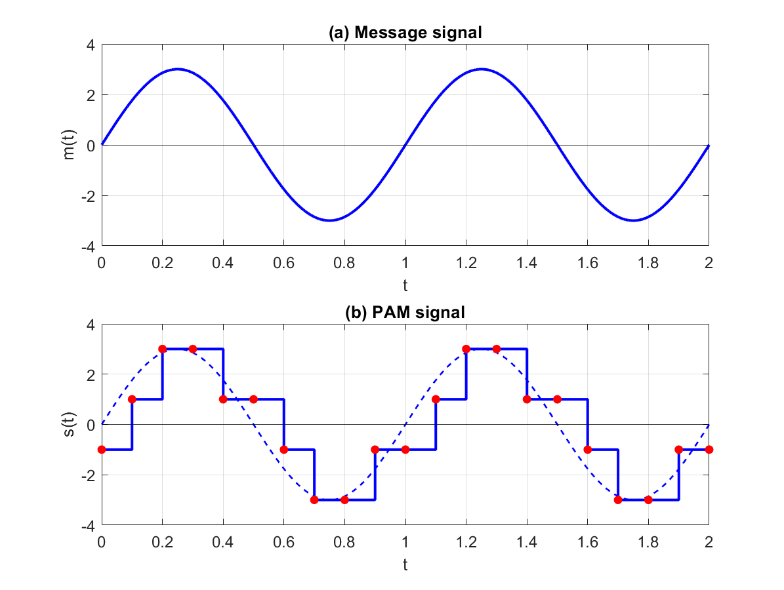
Figure 2.1. PAM-4 signal waveform.
There are two operations for generating the PAM signal. First, a sampling process is applied to the message signal. The sampling process samples the message signal at uniformly spaced time instants in an instantaneous and time-uniform manner, resulting in a sequence of discrete-time samples. And These operations can be implemented in real world by digital circuit technology, specifically, “sample-and-hold” circuits. In terms of applications, the digital version of PAM appears quite frequently in the communication system such as telephone lines, Ethernet or local area network (LAN) lines for computer communication.
Based on the above description, in order to express the equation and understanding more about digital signal processing we will have the system model as the figure below.
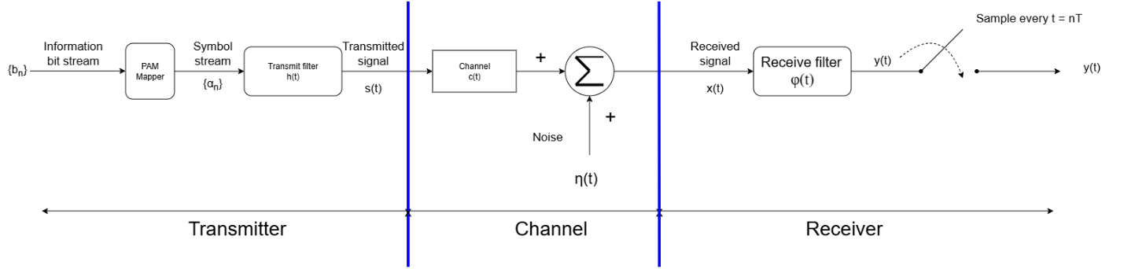
Figure 2.2. General baseband model of a transmission system.
Let us define,
$$s\left(t\right)=\sum_{k=-∞}^{∞}{a_{k}h(t-kT)}$$ | 2.1
Where is called the sampling period, 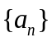 is the symbol stream and 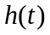 denotes the pulse. The pulse takes the form.
$$h\left(t\right)=\left\{\begin{aligned}1, 0<t<T \\ 0, otherwise\end{aligned}\right.$$ | 2.2
The reason for using multiple bits per symbol is to increase the data rate. For example, in PAM-4, the bit rate is twice the symbol rate, because each symbol carries two bits. This effectively doubles the data capacity without increasing the transmitter speed or worsening insertion loss. As a result, fewer lanes are needed in optical transceivers, cables, and interconnects; for instance, an 800GE network can be transmitted over eight 100 Gb/s (50 GBaud PAM-4) lanes instead of sixteen 50 Gb/s NRZ lanes.
However, there are disadvantages. PAM-4 devices are more susceptible to noise than NRZ devices because four signal levels are packed into the same amplitude range as two-level NRZ. Each level has a specific voltage threshold that a receiver uses to interpret a symbol. Since PAM-4 thresholds are inherently smaller, any vertical noise or timing jitter can cause the signal to cross the wrong threshold, reducing the signal-to-noise ratio (SNR) by approximately 9.5 dB compared to NRZ signals.
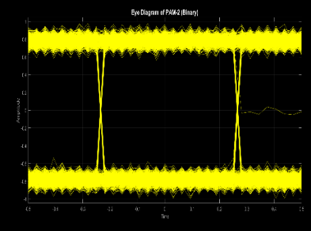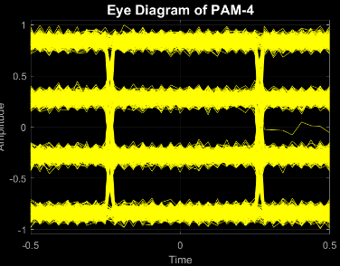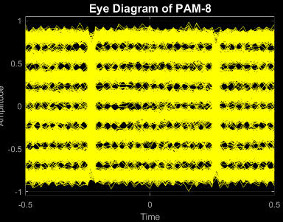
Figure 2.3. Eye diagrams of PAM signals with different modulation orders.
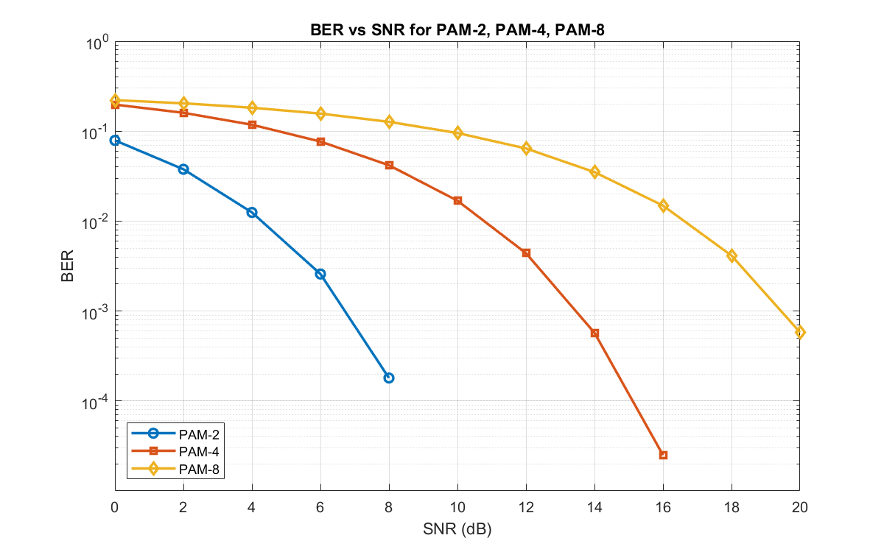
Figure 2.4. BER performance comparison of PAM-2, PAM-4, and PAM-8 under different SNR values.

2.2. Inter-symbol Interference (ISI)
When digital waveforms propagate through a physical medium such as cables, PCB traces, fiber optics, or wireless channels, the pulses inevitably become distorted. Whether the link is a short inter-chip or inter-board connection or a long-distance optical fiber, real channels exhibit bandwidth limitations and dispersion. As a result, the sharp transitions of the transmitted pulse are smeared or spread out over time.
This spreading causes the energy of one symbol to overlap with the energy of the following symbols, producing inter-symbol interference (ISI), as illustrated in the figure below.
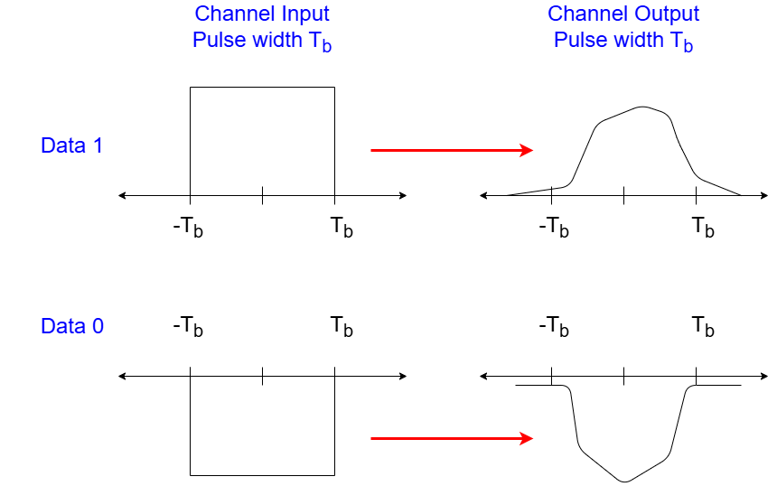
Figure 2.5. Pulse spreading caused by channel distortion in a binary transmission system.
Inter-symbol interference occurs when a pulse becomes sufficiently distorted such that, at the sampling instant, residual energy from previous pulses modifies the value of the current symbol. ISI directly reduces the eye opening and increases the probability of symbol errors.
ISI appears when the channel bandwidth is insufficient relative to the symbol rate. In this case, the transmitted pulse spreads beyond its intended symbol interval, causing energy from previous or subsequent symbols to overlap with the current symbol at the sampling instant.
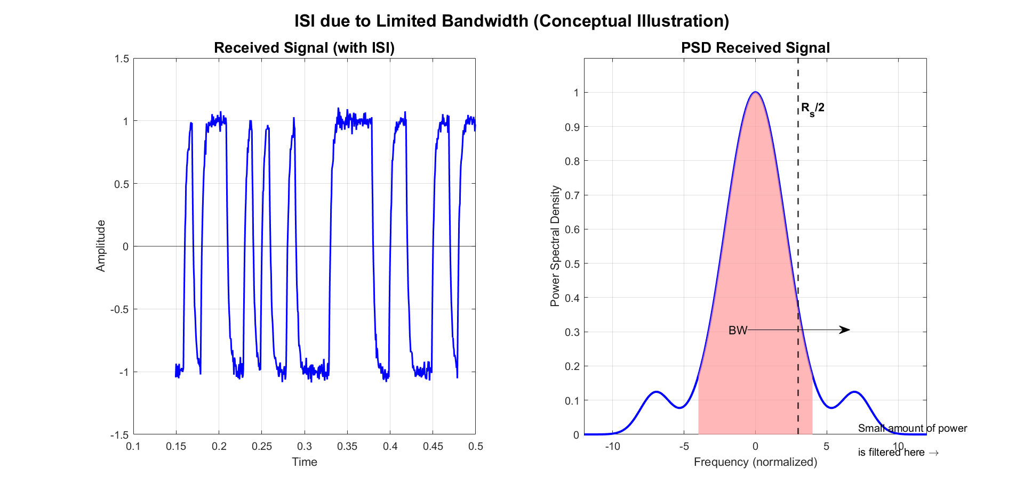
Figure 2.6. Inter-symbol interference caused by limited channel bandwidth.
For the figure of the system model before, we have the received signal is modeled as.
$$x\left(t\right)=\int_{-∞}^{∞}{c\left(τ\right)s\left(t-τ\right)dτ+η(t)}$$ | 2.3
Where c(t) is the channel impulse response, and 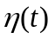 is noise. Then the received signal 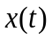 first passes through a receive filter 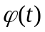. The signal after receive filtering is
$$y\left(t\right)=\int_{-∞}^{∞}{φ\left(τ\right)x\left(t-τ\right)dτ}$$ | 2.4
Then, sampling is performed to obtain signal samples and we can express the sample sequence above the equation.
$$y\left(n\right)=y\left(nT\right)=\sum_{k=-∞}^{∞}{a_{k}h\left(nT-kT\right)+v(nT)}$$ | 2.5
With the discrete-time received signal model as expressed in the figure above, we can define more precisely the equation that includes ISI as express below:
$$y\left(n\right)=a_{n}h_{0}+\underset{ISI term}{\underbrace{\sum_{k=-∞, k≠n}^{∞}{a_{k}h\left(nT-kT\right)}}}+v\left(nT\right)$$ | 2.6
So, as we see that the equation $\sum_{k=-∞, k≠n}^{∞}{a_{k}h\left(nT-kT\right)}$ is defined as symbol interference, it is interference from other symbols transmitted at different intervals as shown in the figure below. This sluggishness of the channel also makes the zero-crossing times of the data become a function of the bit amplitudes, causing significant jitter.

2.3. Additive White Gaussian Noise (AWGN)
Additive White Gaussian Noise (AWGN) is a widely used noise model in communication-system analysis. It represents random disturbances that are added linearly to the transmitted signal and are commonly used to model thermal noise and other independent noise sources.
AWGN is often used as a channel model in which the received signal is impaired by the addition of wideband white noise with a constant power spectral density. This model provides a simple and tractable reference for evaluating the performance of communication systems.
AWGN stands for Additive White Gaussian Noise. Each part of this term is explained as follows.
Additive: This means that the noise gets added to the signal. The received signal is equal to the transmitted signal plus the noise component. This gives the most widely used equality in communication systems.
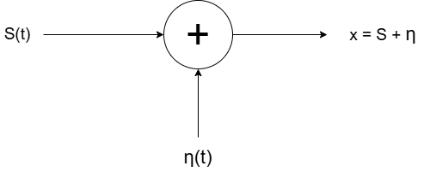
Figure 2.7. Additive noise model for the received signal.
The figure above shows the additive property of AWGN. And this figure also expresses the equation of the AWGN when implementing where 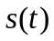is the message signal, 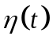is AWGN and 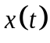is the received signal.
$$s\left(t\right)+η(t)=x(t)$$ | 2.7
White: This means that the noise has the same intensity across all frequencies. It is like the white color which is composed of all frequencies in the visible spectrum, white noise refers to the idea that it has uniform power across the whole frequency band. As a consequence, the Power Spectral Density (PSD) of white noise is constant for all frequencies ranging from to , which is shown as the figure below.
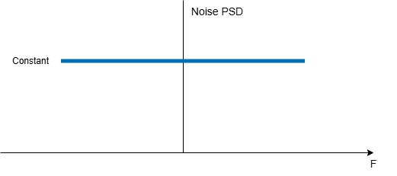
Figure 2.8. Power spectral density of white noise.
Nyquist investigated the properties of thermal noise and showed that its power spectral density is equal to 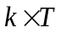, where is a constant and is the temperature in Kelvin. As a consequence, the noise power is directly proportional to the equivalent temperature at the receiver front end and hence the name thermal noise. Historically, this constant value indicated in Figure above is denoted as 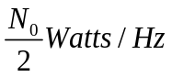.
When we view the constant spectral density as a rectangular sequence, it must be a unit impulse. Furthermore, we saw that the spectral density is the auto-correlation function of the signal. Combining these two facts, an implication of a constant spectral density is that the auto-correlation of the noise in time domain is a unit impulse as shown in the figure below.
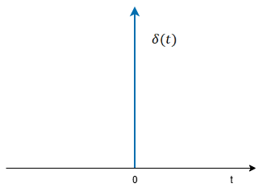
Figure 2.9. Unit impulse signal.
In words, each noise sample in a sequence is uncorrelated with every other noise sample in the same sequence. Therefore, mean value of white noise is zero.
Gaussian: It is the probability distribution of the noise samples is Gaussian with a zero mean in time domain, the samples can acquire both positive and negative values and in addition, the values close to zero and have a higher chance of occurrence while the values far away from zero are less likely to appear. This is shown in the figure below. As a result, the time domain average of a large number of noise samples is equal to zero.
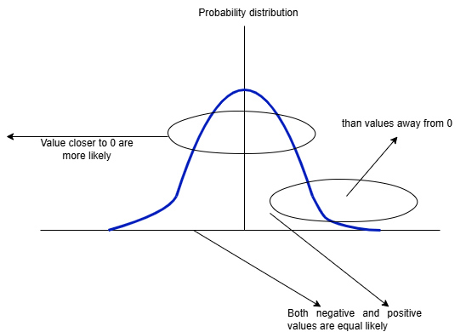
Figure 2.10. Gaussian distribution of AWGN samples with zero mean and symmetric probability around zero.
So, the zero mean white Gaussian process with autocorrelation will express the equation below.
$$E\left[z\left(t\right)z\left(t-τ\right)\right]=\frac{N_{0}}{2}δ\left(τ\right)$$ | 2.8
When relating SNRs, the linear value is obtained from decibels via
$$EX_{lin}={10}^{X_{dB}/10}$$ | 2.9
With symbol energy $E_{s}$, modulation order $M$, the energy per information bit is $E_{b}=E_{s}/(\log_{2}M)$. Given a target $E_{b}/N_{0}$, one computes $N_{0}=E_{b}/(X_{lin})$.

2.4. Decision Feedback Equalizer
As high-speed random data propagates through a medium with a limited bandwidth (also called a “lossy” medium), it is dispersed. That is, the data edges become slower, possibly disallowing full transition if a 010 or 101 sequence occurs in the figure below. This sluggishness of the channel also makes the zero crossing times of the data a function of the bit amplitudes, causing significant jitter.
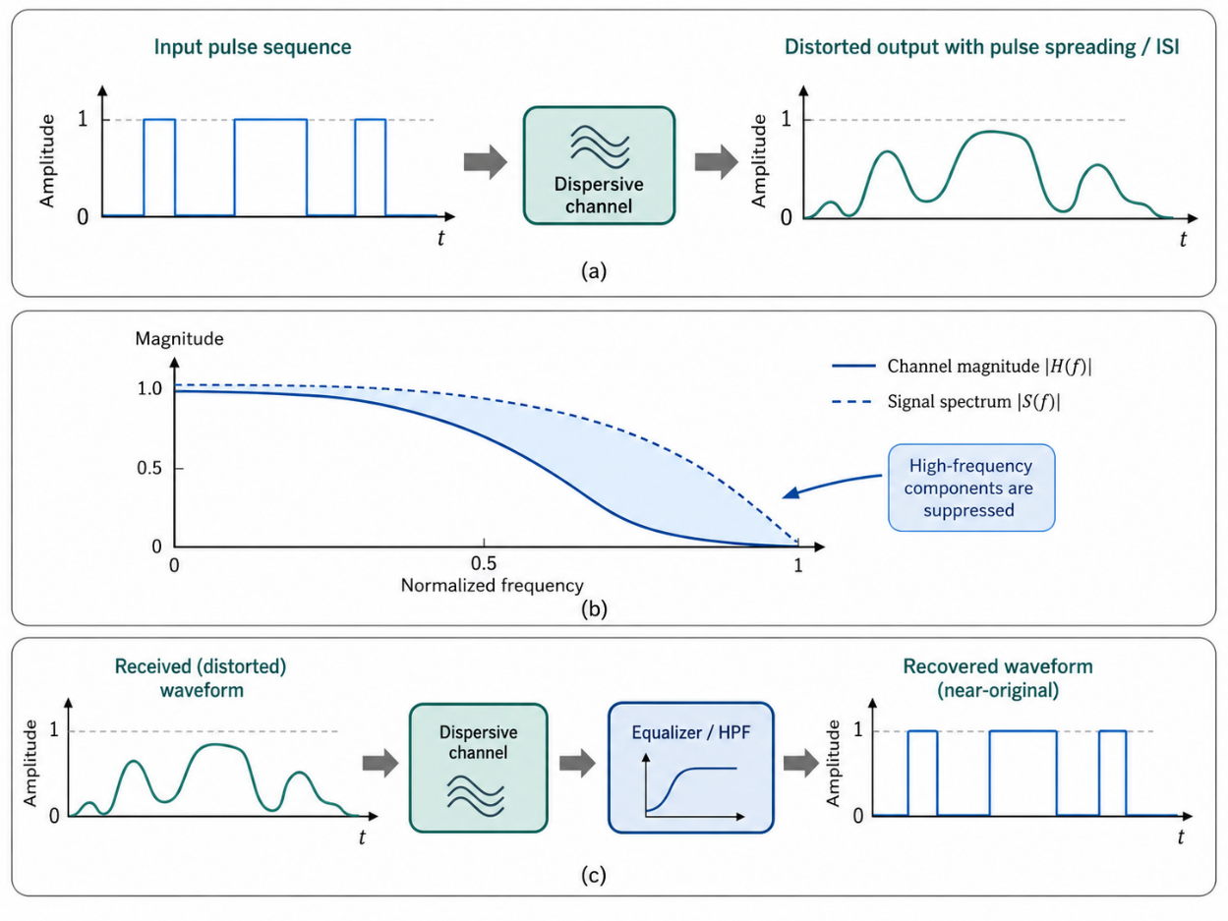
Figure 2.11. (a) The dispersion of random data in a lossy channel, (b) The channel frequency response showing attenuation of high-frequency components, and (c) The use of high-pass filter to equalize the channel.
Both degradations increase the bit-detection error rate. In the frequency domain, the channel attenuates the high-frequency content of the data as the figure can be undone by means of a circuit having the inverse response, a high-pass filter as illustrated in figure , if subjected to such a response, the received data assumes its original, undispersed shape and more easily lends itself to detection. This high-pass filter exemplifies a “linear” equalizer as it can be approximated by a finite impulse response filter incorporating only linear stages (delay units and scaling coefficients). We say the equalizer provides a high-frequency “boost” to compensate for the channel loss.
To appreciate the beauty of DFEs, we first return to the time domain and view the data waveform as the superposition of random steps shifted in time by integer multiples of 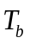 as shown in Fig. 2.12.
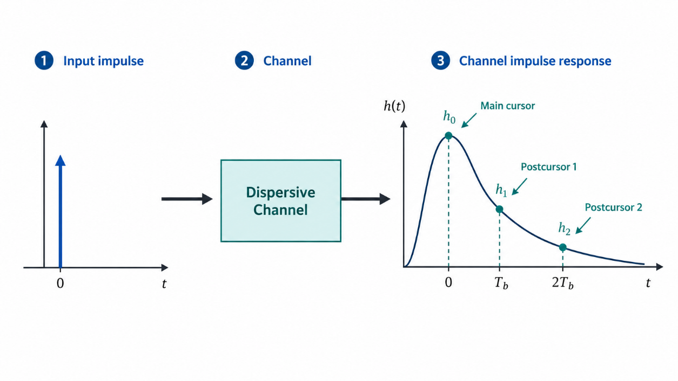
Figure 2.12. Impulse response of a lossy channel.
Due to the channel imperfections, each output bit is broadened, exhibiting a tail that interferes with the next bit or the inter-symbol interference (ISI) we have discussed before. This phenomenon is more clearly seen in the impulse response of the channel shown in figure above. We observe that the tail values at ,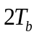,etc., (called the “postcursors”) respectively represent the ISI. In general, energy removal from a signal’s spectrum causes ISI, whether it occurs as wideband loss or as narrowband rejection. We surmise that ISI can be suppressed if we reconstruct the tail values and subtract them from the next bits.
Implementing this idea for canceling the first postcursor. We must delay the present bit by one bit period, scale this result by a factor equal to 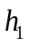, and subtract it from the next bit. The figure below shows such an arrangement.
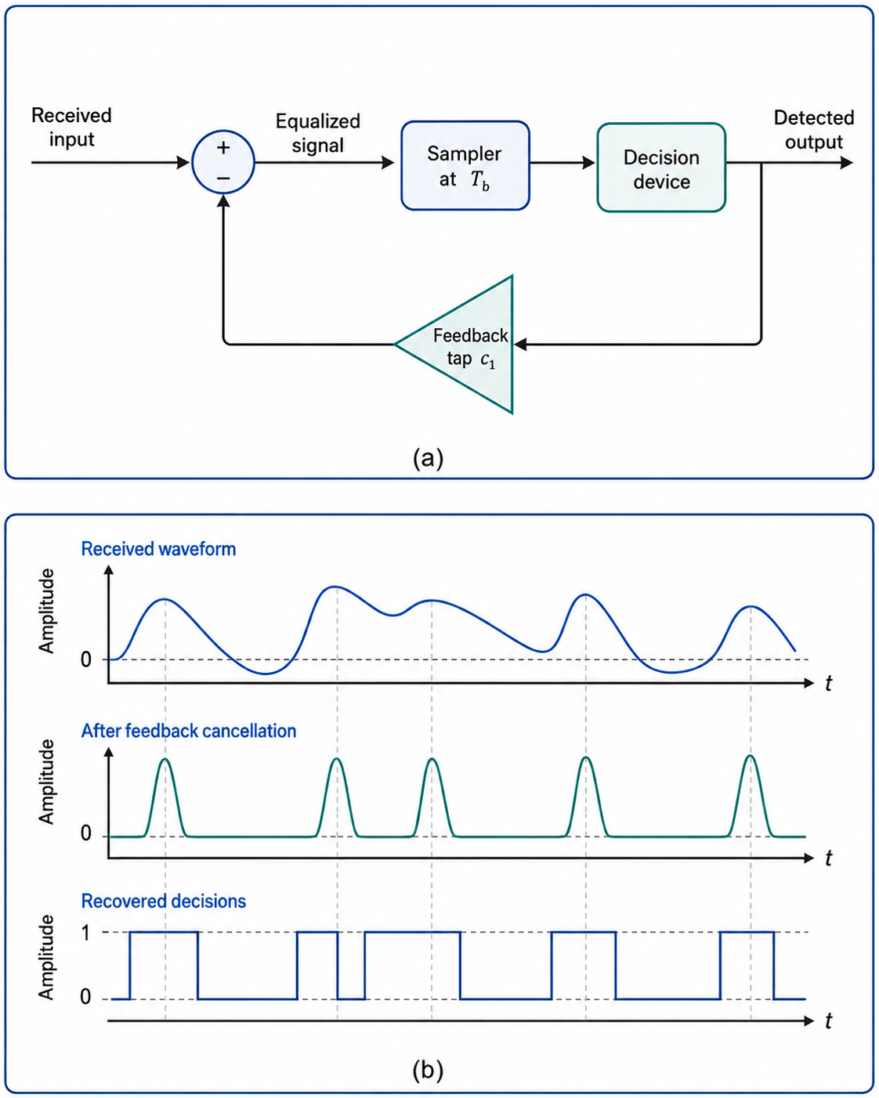
Figure 2.13. (a) The use of an FF as a delay element and a slicer, (b) The resulting waveform
If we consider 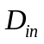as the present bit, 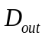 holds the previous bit and 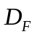 a scaled copy thereof. Thus 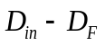 is free from the first postcursor, whether it is created by wideband loss or impedance discontinuities. With a linear delay element, this loop is still a “linear” equalizer. A side effect is that the amplitude noise at the output is scaled by a factor of and added to the input data, degrading the signal-to-noise ratio of each bit.
This issue can be remedied if the delay element is followed by a limiter, also known as a “slicer”, so as to remove the amplitude noise. The loop thus stops the noise from circulating and acts as a nonlinear equalizer. As illustrated in Figure b, the summer output, 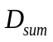, is free from the first postcursor, making greater voltage excursions with less jitter and allowing better detection. Sensed by the flip-flop, this output is the most critical node in the circuit.

2.5. Central Limit Theorem
The central limit theorem states that whenever a random sample of size n is taken from any distribution with mean and variance, then as n becomes large, the sample mean will be approximately a normal distribution with mean and variance. The larger the value of the sample size, the better approximation of the normal. Suppose that 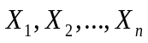 are random variables with expected values 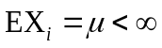and variance 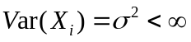. Thus, the formula for the central limit theorem is given below
$$Z=\frac{\overline{X}-μ}{\frac{σ}{\sqrt{n}}}$$ | 2.10
Where:
$\overline{X}$ is the sample mean with express formula $\overline{X}$ $=\frac{X_{1}+X_{2}+…+X_{n}}{n}$
$μ$ is the mean of population
$σ$ is the standard deviation of the population
$n$ is the sample size
Assumptions of the Central limit theorem:
- The sample should be drawn randomly following the condition of randomization.
- The sample drawn should be independent of each other. They should not influence the other samples.
- When the sampling is done without replacement, the sample size shouldn’t exceed 10% of the total population.
- The sample size should be sufficiently large.
Hence, the normalized random variable has mean is 0 and variance is 1. And an interesting thing about the CLT is that it does not matter what the distribution of the 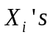is. Or the can be discrete, continuous or random variables making it suitable for simulating in AWGN.
AWGN is a distribution noise with no correlation has said being before that. We assume that this is a Uniform so we have the formula with expected value 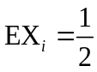 and the variance is 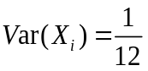. In this case we will have the formula below:
$$Z=\frac{X_{1}+X_{2}+…+X_{n}-\frac{n}{2}}{\sqrt{\frac{n}{12}}}$$ | 2.11
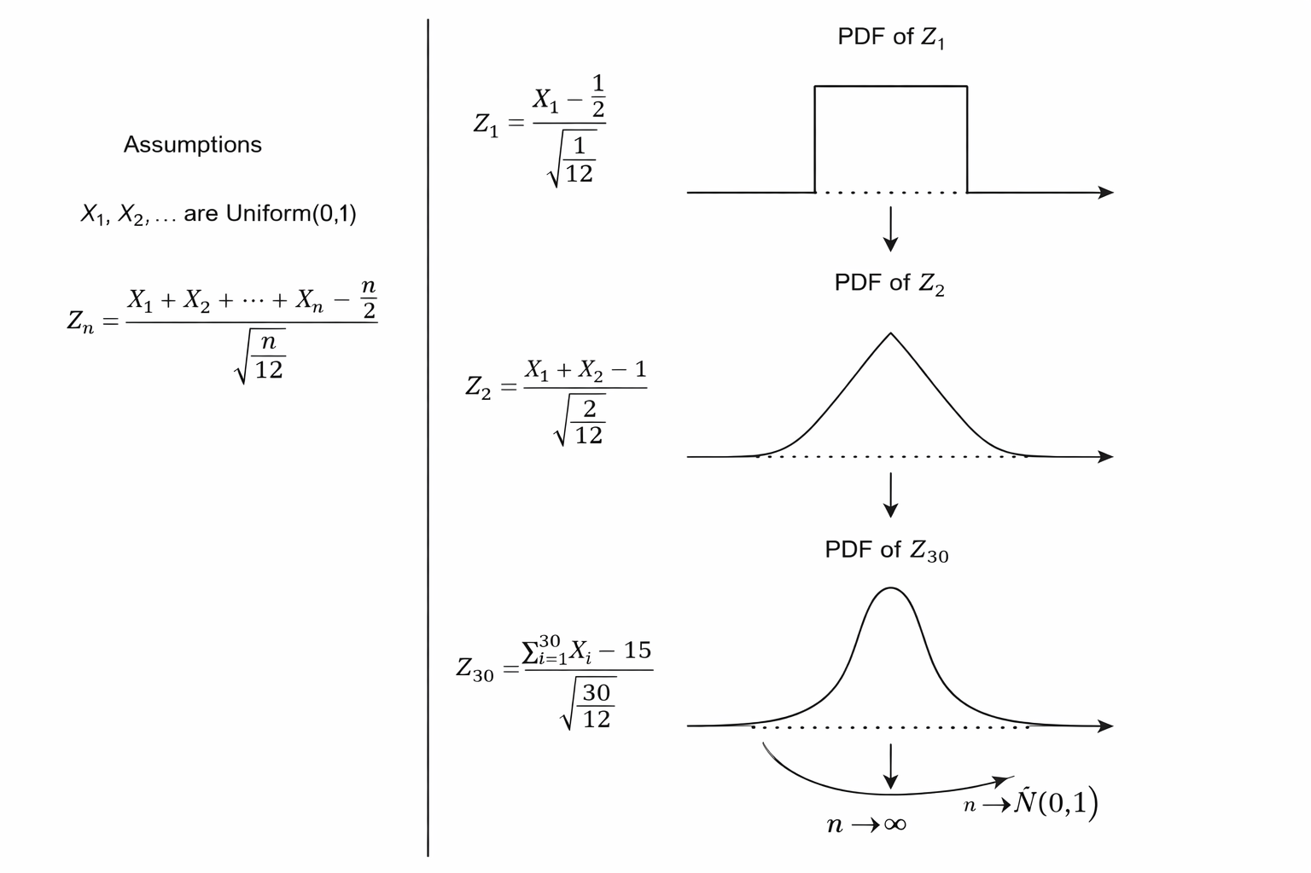
Figure 2.14. Central Limit Theorem approximation of a Gaussian distribution using uniform random variables.
We can see that as the number of independent Uniform (0,1) random variables n increases. The shape of its PDF gets closer to the normal curve. This is also the key point when simulating AWGN as choosing the correct n is important.

2.6. Least Mean Square Algorithm
The LMS algorithm was first proposed by Bernard Widrow and his PhD student Ted Hoff. Due to its simplicity and robustness, it has been the most widely used adaptive filtering algorithm in real applications. An LMS equalizer communication system design is just one of those beautiful examples and its other applications include noise, echo cancellation, beamforming, neural network and so on.
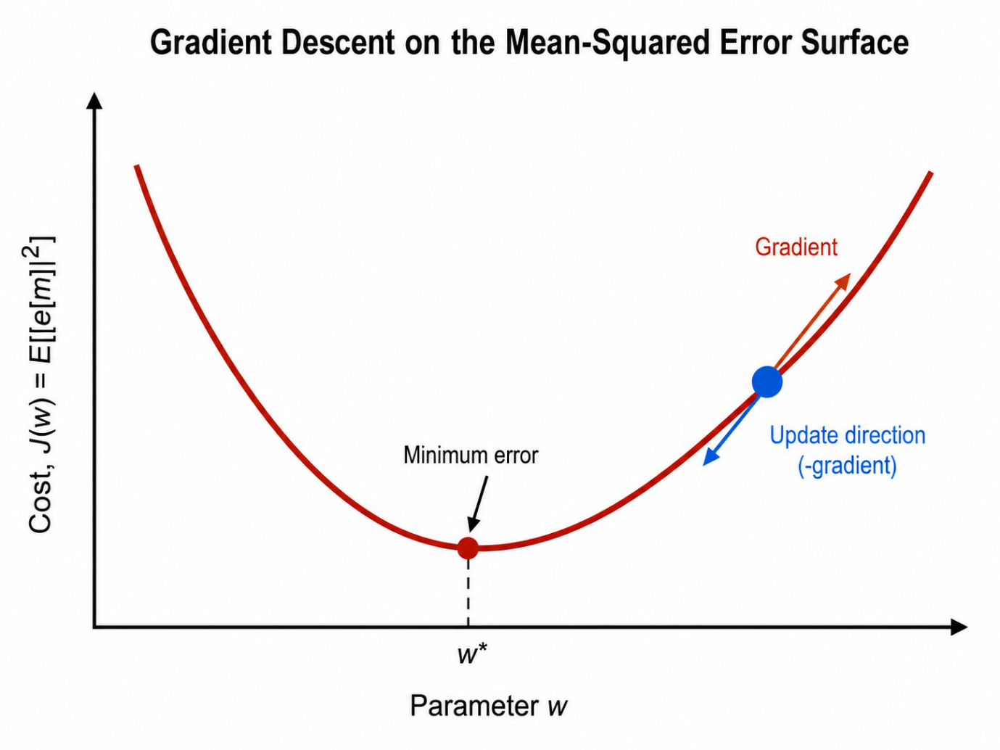
Figure 2.15. Gradient Descent on the Mean-Squared Error Surface.
The LMS algorithm that is described in the following subsection is mostly easily obtained by formulating the optimization of the coefficients as an estimation problem based on the minimization of the mean-square error. Let us assume that we have available from a stationary random process with autocorrelation sequence.
$$y_{xx}\left(m\right)=E[x\left(n\right)x^{*}(n-m)]$$ | 2.12

From these samples, we form an estimate of the desired sequence $d(n)$ by passing the observed data $x(n)$ through an equalizer with coefficient $h(n)$. The output of the equalizer can be expressed as
$$\hat{d}\left(n\right)=\sum_{k=0}^{M-1}{h\left(k\right)x(n-k)}$$ | 2.13
Where $\hat{d}\left(n\right)$ represents an estimate of $d(n)$. The estimation error is defined as
$$e\left(n\right)=d\left(n\right)-\hat{d}\left(n\right) \\ =d\left(n\right)-\sum_{k=0}^{M-1}{h\left(k\right)x(n-k)}$$ | 2.14
The mean-square error as a function of coefficients is
$$ε_{M}=E\left[{\left|e\left(n\right)\right|}^{2}\right] \\ =E\left\{{\left|d\left(n\right)\right|}^{2}-2Re\left[\sum_{k=0}^{M-1}{h^{*}\left(l\right)d\left(n\right)x^{*}\left(n-l\right)}\right]+\sum_{k=0}^{M-1}{\sum_{k=0}^{M-1}{h^{*}\left(l\right)h\left(k\right)x^{*}\left(n-l\right)x\left(n-k\right)}}\right\} \\ =σ_{d}^{2}--2Re\left[\sum_{k=0}^{M-1}{h^{*}\left(l\right)y_{dx}\left(l\right)}\right]+\sum_{k=0}^{M-1}{\sum_{k=0}^{M-1}{h^{*}\left(l\right)h\left(k\right)y_{xx}\left(l-k\right)}}$$ | 2.15
Where $σ_{d}^{2}=E\left[{\left|d\left(n\right)\right|}^{2}\right]$.
We observe that the MSE is a quadratic function of the equalizer coefficients. Consequently, the minimization of $ε_{M}$ with respect to the coefficients leads to the set of M linear equations
$$y_{dx}=\sum_{k=0}^{M-1}{h\left(k\right)y_{xx}\left(l-k\right), l=0,1,…,M-1}$$ | 2.16
Denoting that the vector of coefficients is $h_{M}$, 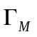is an $M×M$ (Hermitian) Toeplitz matrix with elements ${}_{lk}=y_{xx}(l-k)$, and $y_{d}$ is an $M×1$ cross correlation vector with elements $y_{dx}(l)$. The complex-conjugate of $h_{M}$ is denoted as $h_{M}^{*}$ and the transpose as $h_{M}^{t}$. The equation can be expressed below
$${}_{M}h_{M}=y_{d}$$ | 2.17
The solution for the optimum coefficient is
$$h_{opt}={}_{M}^{-1}y_{d}$$ | 2.18
And the resulting minimum MSE achieved with the optimum coefficients given by is
$$ε_{Mmin}=σ_{d}^{2}-\sum_{k=0}^{M-1}{h_{opt}\left(k\right)y_{dx}^{*}\left(k\right)} \\ =σ_{d}^{2}-y_{d}^{H} {}_{M}^{-1}y_{d}$$ | 2.19
Where the exponent H denotes the conjugate transpose.
According to the orthogonality principle, the mean-square estimation error is minimized when the error $e\left(n\right)$ is orthogonal, in the statistical sense, to the estimate $\overline{d}\left(n\right)$, that is
$$E\left[e(n){\hat{d}}^{*}(n)\right]=0$$ | 2.20
The condition is implied that
$$E\left[\sum_{k=0}^{M-1}{h\left(k\right)}e(n)x^{*}(n-k)\right]=\sum_{k=0}^{M-1}{h\left(k\right)}E\left[e(n)x^{*}(n-k)\right]=0$$ | 2.21
Or we can find that
$$E\left[e(n)x^{*}(n-l)\right]=0$$ | 2.22
For the moment, let assume that the autocorrelation matrix and the cross-correlation vector $γ_{d}$ are known. Hence, $ε_{M}$ is a known function of the coefficients $h\left(n\right)$. Algorithms for recursively computing the filter coefficients and, thus, searching for the minimum of $ε_{M}$, have the form.
$$h_{M}\left(n+1\right)=h_{M}\left(n\right)+\frac{1}{2}∆\left(n\right)S(n)$$ | 2.23
Where $h_{M}\left(n\right)$ is the vector of filter coefficients at the $n th$ iteration, $∆(n)$ is a step size at the $n th$ iteration, and $S(n)$ is a direction vector for $n th$ iteration. The initial vector $h_{M}\left(0\right)$ is chosen arbitrarily. In this treatment, we exclude methods that require the computations of 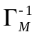, such as Newton’s method and consider only search methods based on the use of gradient vectors $S\left(n\right)=-g(n)$ is the gradient vector at the $n th$ iteration, defined as
$$g\left(n\right)=\frac{dε_{M}\left(n\right)}{dh_{M}\left(n\right)} \\ =2[h_{M}\left(n\right)-γ_{d}]$$ | 2.24
Hence, we compute the gradient vector at each iteration and change the values of $h_{M}\left(n\right)$ in a direction opposite the gradient. Thus, the recursive algorithm based on the method of steepest descent is
$$h_{M}\left(n+1\right)=h_{M}\left(n\right)-\frac{1}{2}∆\left(n\right)g\left(n\right)$$ | 2.25
We note that the gradient vector given may also be expressed in terms of the orthogonality conditions which can be expressed equivalently
$$E\left[e(n)X_{M}^{*}(n)\right]=γ_{d}-h_{M}\left(n\right)$$ | 2.26
Where $X_{M}(n)$ is the vector with element $x\left(n-l\right)=0, l=0,1,2,…, M-1$. Therefore, the gradient vector is simply
$$g(n)=-2E\left[e(n)X_{M}^{*}(n)\right]$$ | 2.27
Clearly the gradient vector $g(n)=0$ when the error is orthogonal to the data in the estimate. Thus, the update of equation can be rewritten.
$$h_{M}\left(n+1\right)=h_{M}\left(n\right)+∆\left(n\right)\left[e(n)X_{M}^{*}(n)\right]$$ | 2.28
This recursive update is the LMS algorithm, which is widely used in many adaptive equalizer applications.

CHAPTER 3: DESIGN METHODOLOGY OF THE MODIFIED HARDWARE GAUSSIAN NOISE GENERATOR

3.1. Design Requirements and Method Selection
This thesis targets an FPGA-friendly AWGN generator intended for channel emulation and equalizer validation under a moderate-tail requirement. The design goal is deterministic throughput and low arithmetic complexity under fixed-point constraints, rather than deep-tail generation for ultra-low-BER qualification.
A hardware Gaussian random number generator (GRNG) is typically evaluated along five axes: Distribution fidelity (central region + tails); Whiteness (temporal correlation / spectrum flatness); Throughput (sample/cycle; latency); Hardware cost (logic, memory, DSP usage); Fixed-point suitability (quantization, saturation, scaling).
The design requirements are stated in measurable form:
R1. Throughput and determinism
The generator should sustain one noise sample per cycle
$$T_{out}≥1 sample/cycle$$ | 3.1
Latency must be deterministic (no data-dependent retries):
$$L_{pipe}=constant$$ | 3.2
R2. Fixed-point compatibility
The output is required in signal 16-bit fixed-point (e.g., Q4.12)
$$y_{fx}\left[n\right] ∈ Z ∩ \left[{-2}^{15},2^{15}-1\right], y[n]≈2^{-12}y_{fx}\left[n\right]$$ | 3.3
R3. Statistical correctness for the intended scope
For standardized output $z\left[n\right]$, central-region moment targets are:
$$\hat{μ} ≈ 0, \hat{σ} ≈ 1$$ | 3.4
R4. Explicit moderate-tail scope
The thesis does not claim deep-tail accuracy. Tail evaluation focuses on moderate thresholds.
R5. Resource-oriented constraints
Avoid transcendental functions and large LUT-based inversion in the baseline.
Method | Hardware ops / blocks | Throughput & latency | Fixed-point burden | Tail fidelity
Box-Muller | Transcendentals or CORDIC, multipliers, control | Deterministic if fully pipelined, but deeper pipeline | High (range handling, approximation error) | Strong
Inverse-CDF | Large LUT or polynomial approximation + control | Deterministic, pipeline-friendly | Medium-High (LUT quantization, PMF effects) | Potentially strong if LUT is large
Ziggurat | Comparators, LUT, control branching | Variable (data-dependent), difficult 1 sample/clock, guarantee | Medium (branching + tail handling) | Strong
Wallace | Matrix transforms buffering, normalization | Can be high, but needs pools / buffers | Medium (correlation management) | Good if tuned
Central limit theorem (selected) | Adders + constant multipliers | Deterministic; natural 1 sample / clock | Low (shift/add + const multipliers) | Moderate
Table 3.1. Comparison of Gaussianization Methods.
Selection rationale (Gaussianization): CLT best matches the thesis constraints: deterministic data path, minimal arithmetic blocks, and straightforward fixed-point implementation.
URNG class | Ops / hardware cost | Period scale | Statistical robustness
Single LFSR | Very low | Limited by chosen polynomial | Can show lattice artifacts; sensitive to design
Single Tausworthe (trinomial) | Very low (shift/XOR) | Depends on degree, may be insufficient for long runs | Known weaknesses under fast constraints
Combined Tausworthe (taus88, selected) | Low (shift/mask/XOR only) | $≈2^{88}$ for 3 component class | More robust than isolated components; well-known instantiation
Xorshift family | Very low | Large (variant-dependent) | Mixed quality; must be justified carefully
LCG family | Very low | Large (variant-dependent) | Can exhibit correlation in higher dimensions
Table 3.2. Comparison of Uniform Random Backbones (URNG Stage).
Selection rationale (URNG): taus88 provides a concrete, literature-grounded combined-Tausworthe instantiation, suitable resource usage and a large period scale appropriate for long simulation runs. Lane separability is supported by nonzero seed constraints and validated via lane correlation checks.

3.2. Proposed AWGN Generator Algorithm
This section presents the proposed Gaussian noise generator algorithm. Section 3.2.1 specifies the modified Taus88-based uniform random backbone, including the per-lane output-mixing step. Section 3.2.2 develops the CLT Gaussianization stage with explicit treatment of finite-m and discrete-uniform corrections, leading to the calibrated normalization gain used in the implementation.
3.2.1 Modified Uniform Random Number Backbone
Continuous-uniform reference
For theoretical reference, let $\left\{U_{i}\left[n\right]\right\}$ be independent and identically distributed continuous uniforms.
$$\left\{U_{i}\left[n\right]\right\} \sim U\left(0,1\right), i=1,…,m$$ | 3.5
Moments of $U\left(0,1\right)$
$$E\left[U_{i}\right]=\frac{1}{2}, Var\left(U_{i}\right)=\frac{1}{12}$$ | 3.6
Define the centered sum
$$S_{m}\left[n\right]≜\sum_{i=1}^{m}{U_{i}\left[n\right]}-\frac{m}{2}$$ | 3.7
Then
$$E\left[S_{m}\right]=0, Var\left(S_{m}\right)=\frac{m}{12}$$ | 3.8
Combined Tausworthe generator (Taus88)
The implemented uniform backbone is the combined Tausworthe generator Taus88 of L'Ecuyer [26]. A combined Tausworthe generator XOR-combines the outputs of J component LFSRs:
$$u_{n}=u_{1,n}⊕u_{2,n}⊕…⊕u_{J,n}$$ | 3.9
For component degrees $\left\{k_{j}\right\}$, periods scale as:
$$p=lcm\left(2^{k_{1}}-1,…,2^{k_{j}}-1\right)$$ | 3.10
In this design, the Taus88 generator proposed by L’Ecuyer is adopted with the following component degrees:
$$J=3, k_{1}=31, k_{2}=29, k_{3}=28$$ | 3.11
With period length reported as
$$\left(2^{31}-1\right)(2^{29}-1)(2^{28}-1)≈2^{88}$$ | 3.12
Each lane maintains three 32-bit unsigned states:
$$\left(s_{1}\left[n\right],s_{2}\left[n\right],s_{3}\left[n\right]\right)∈{\left\{0,1,…,2^{32-1}\right\}}^{3}$$ | 3.13
After state updates the lane produces one 32-bit word
$$w_{32}[n]≜s_{1}[n]⊕s_{2}[n]⊕s_{3}[n]$$ | 3.14
The taus88 step uses only shifts, masks, and XOR. In “implementation form”:
$$b_{1}\left[n\right]=({(s}_{1}\left[n\right]≪13)⊕s_{1}[n])≫19$$ | 3.15
$$s_{1}\left[n+1\right]=\left({(s}_{1}\left[n\right] \& 0xFFFFFFFE)≪12\right)⊕b_{1}[n]$$ | 3.16
$$b_{2}\left[n\right]=({(s}_{2}\left[n\right]≪2)⊕s_{2}[n])≫25$$ | 3.17
$$s_{2}\left[n+1\right]=\left({(s}_{2}\left[n\right] \& 0xFFFFFFF8\right)≪4)⊕b_{2}[n]$$ | 3.18
$$b_{3}\left[n\right]=({(s}_{3}\left[n\right]≪3)⊕s_{3}[n])≫11$$ | 3.19
$$s_{3}\left[n+1\right]=\left({(s}_{3}\left[n\right] \& 0xFFFFFFF0\right)≪17)⊕b_{3}[n]$$ | 3.20
The three updated states are the XOR-combined to produce the 32-bit lane word:
$$w_{32}\left[n+1\right]=s_{1}[n+1]⊕s_{2}[n+1]⊕s_{3}[n+1]$$ | 3.21
In addition, as the seed constraint before first use, the three states must be nonzero.
$$s_{1}\left[0\right]≠0, S_{2}\left[0\right]≠0, S_{3}\left[0\right]≠0$$ | 3.22
Then the current implementation does not feed the combined lane word $u_{i}\left[n\right]$, directly into the CLT stage. Instead, it first applies a lightweight output-mixing step:
$$v_{i}\left[n\right]=w_{i}\left[n\right]⨁(u_{i}\left[n\right]≫r_{1})⨁ rotl32\left(w_{i}\left[n\right],r_{2}\right)$$ | 3.23
After mixing, each lane contributes one $W_{u}$-bit word to the Stage-2 accumulator. The extraction rule is
$$R_{i}\left[n\right]=\left(v_{i}\left[n\right]≫b_{i}\right) mod 2^{W_{u}}, R_{i}\left[n\right]∈\left\{0,…,2^{W_{u}}-1\right\}$$ | 3.24
This modification helps decorrelate the extracted bits and reduces repeated lane patterns.
3.2.2 CLT Gaussianization
The CLT stage retains the top $W_{u}$ bits of $v_{i}\left[n\right]$:
$$R_{i}\left[n\right]≜\left[\frac{v_{i}\left[n\right]}{2^{32-W_{u}}}\right], R_{i}\left[n\right]∈\left\{0,…,2^{W_{u} - 1}\right\}$$ | 3.25
The corresponding normalized uniform is
$$U_{i}\left[n\right]≜2^{-W_{u}}R_{i}\left[n\right]$$ | 3.26
The standardized finite-m CLT output is defined in this thesis at the equation below:
$$Z_{m}\left[n\right]≜\sqrt{\frac{12}{m}}\left(\sum_{i=1}^{m}{U_{i}\left[n\right]-\frac{m}{2}}\right)=\sqrt{\frac{12}{m}}S_{m}\left[n\right]$$ | 3.27
Lemma 1 (Mean and variance normalization)
If $U_{i}∽U(0,1)$ are independent and identically distributed and $Z_{m}$ is defined by (3.25), then
$$E\left[Z_{m}\right]=0, Var\left(Z_{m}\right)=1$$ | 3.28
Proof sketch. From equation 3.8, $E\left[S_{m}\right]=0$ and $Var\left(S_{m}\right)=m/12$. Multiplying yields $\sqrt{12/m}$ yields in 3.27.
Let us define the uncentered sum as the equation below
$$T_{M}≜\sum_{i=1}^{m}{U_{i}}$$ | 3.29
Then $T_{M}∈\left[0,m\right]$ and follows the Irwin-Hall law. For $t∈\left[0,m\right]$, the probability density function (PDF) and cumulative distribution function (CDF) can be expressed as
$$f_{T_{m}}\left(t\right)=\frac{1}{\left(m-1\right)!}\sum_{k=0}^{t}{{(-1)}^{k}\left(\begin{matrix}m \\ k\end{matrix}\right){(t-k)}^{m-1}}, t∈[0,m]$$ | 3.30
$$F_{T_{m}}\left(t\right)=\frac{1}{\left(m\right)!}\sum_{k=0}^{t}{{(-1)}^{k}\left(\begin{matrix}m \\ k\end{matrix}\right){(t-k)}^{m}}, t∈[0,m]$$ | 3.31
The standardized $Z_{m}$ is an affine transform of $T_{M}$. Define
$$x=\sqrt{\frac{m}{12}}z+\frac{m}{2}$$ | 3.32
Then the finite-m reference CDF and PDF for $Z_{m}$ are
$$F_{Z_{m}}\left[z\right]=F_{T_{m}}(x)$$ | 3.33
$$f_{z_{m}}\left[z\right]=\sqrt{\frac{m}{12}}f_{T_{m}}\left(x\right)$$ | 3.34
These expressions define the finite-m exact reference used in thesis validation. From that we have the proposition below.
Proposition 1 (Finite-m excess kurtosis)
For finite m, the standard $Z_{m}$ in (3.25) has excess kurtosis:
$$γ_{2}\left[Z_{m}\right]=\frac{-6}{5m}$$ | 3.35
Proof sketch. Let $X=U-\frac{1}{2}$. Then $X$ is symmetric with $E[X]=0$, $Var[X]=1/12$. For independent and identically distributed sums, the standardized fourth cumulant scales as $1/m$. For a centered uniform variable, this yields $γ_{2}\left[Z_{m}\right]=-\frac{6}{5m}$. As $m→∞,γ_{2}→0$. The full equation will be expressed in Appendix A.
Let the signed fixed-point format be $Q(I,F)$ with $F$ fractional bits and total width $TB$. The thesis prototype uses
$$TB=16, F=Q=12$$ | 3.36
Let us define saturation bounds
$$x_{max}=2^{TB-1}-1, x_{min}=-2^{TB-1}$$ | 3.37
And define rounding-to-nearest quantization below
$$Q_{Q,TB}\left(x\right)={sat}_{TB}\left(x2^{Q}\right)$$ | 3.38
Where ${sat}_{TB}(.)$ saturates into $\left[x_{min},x_{max}\right]$.
A standard quantization bound (round-to-nearest) is:
$$\left|x-2^{-Q}Q_{Q,TB}\left(x\right)\right|≤2^{-(Q+1)}$$ | 3.39
Let $R_{i}[n]$ be the $W_{u}$-bit extracted word from lane i. The unsigned sum is
$$S_{R}\left[n\right]≜\sum_{i=1}^{m}{R_{i}\left[n\right], R_{i}\left[n\right]∈\left\{0,1,…,2^{W_{u}}-1\right\} }$$ | 3.40
The correct centered integer accumulator is then
$$\tilde{S}\left[n\right]≜S_{R}\left[n\right]-\frac{m}{2}\left(2^{W_{u}}-1\right)$$ | 3.41
For a discrete uniform alphabet of size $2^{W_{u}}$
$$Var\left(R_{i}\left[n\right]\right)≜\frac{2^{2W_{u}}-1}{12}$$ | 3.42
As a result, the ideal real-valued normalization gain for the discrete fixed-point CLT stage is not simply $\sqrt{12/m}$ but
$${g_{m}}^{*}=\sqrt{\frac{12}{m(1-2^{-2W_{u}})}}$$ | 3.43
Let $Q$ denote the number of fractional bits in the CLT normalization data path. The initial quantized multiplier is
$$G_{m}^{(0)}=\left[2^{Q}g_{m}^{*}\right]$$ | 3.44
Because the realized data path is bit-true and includes truncation and saturation, the nearest quantized gain is not always the one that yields the best unit-variance output. Therefore, the implementation performs a small local integer search around $G_{m}^{(0)}$ and selects the final gain.
$$G_{m}=arg\min_{G∈\left\{G_{m}^{(0)}-∆,{ G}_{m}^{\left(0\right)}-∆+1,…,G_{m}^{\left(0\right)}+∆\right\}}\left|Var\left(Z_{G}\right)-1\right|$$ | 3.45
Where $∆$ is a small integer search radius, and the candidate set consists of all integer gain values in the interval. The final gain $G_{m}$ is selected as the candidate that makes the variance of the bit-true output $Z_{G}$ closest to unity.
Using the tuned integer multiplier $G_{m}$, the normalized fixed-point CLT output is implemented by multiply and shift.
$$z_{fx}\left[n\right]={sat}_{TB}\left(\left[\frac{G_{m}\tilde{S}\left[n\right]}{2^{Q}}\right]\right)$$ | 3.46
This implementation contains no divider and no transcendental operator in the runtime data path. In the present design, $W_{u}=Q=12$ and the final output uses a signed 16-bit format, which makes the CLT lane contribution, normalization stage, and downstream variance scaling naturally compatible.

3.3. Proposed Hardware Architecture

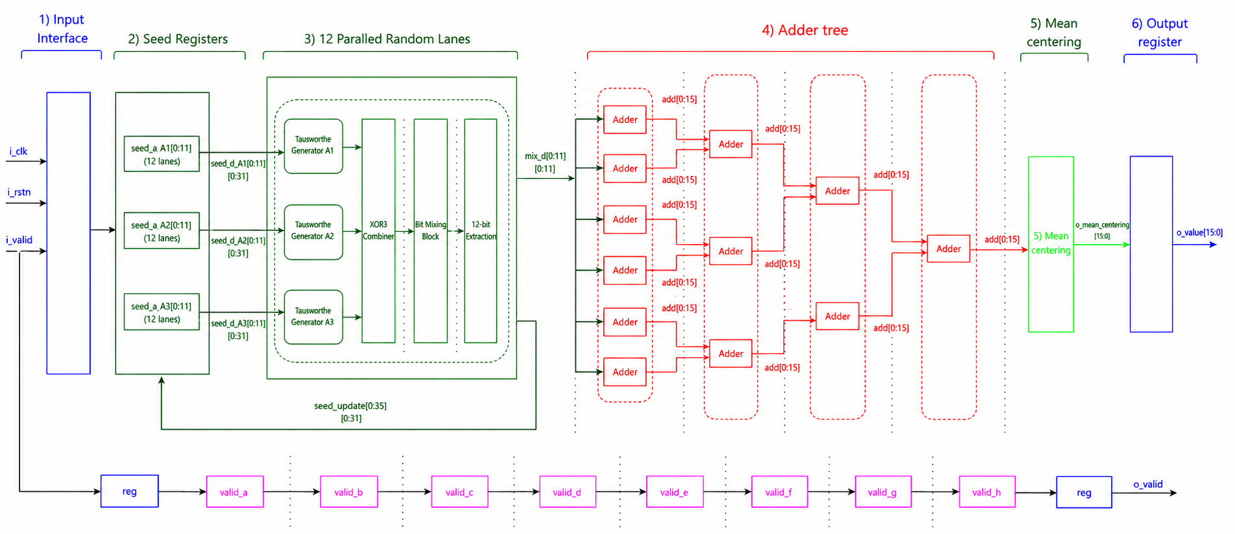
Figure 3.1. Overall architecture of the CLT-based AWGN generator.

Name | Side | Width | Description
i_clk | input | [0:0] | Clock signal.
i_rstn | input | [0:0] | Active low reset signal.
i_valid | input | [0:0] | Indicate input data is meaningful or not
o_value | output | [15:0] | Generated AWGN sample after CLT summation and mean-centering.
o_valid | output | [0:0] | Indicates whether o_value is valid.
Table 3.3. Signal description of CLT-based AWGN generator.
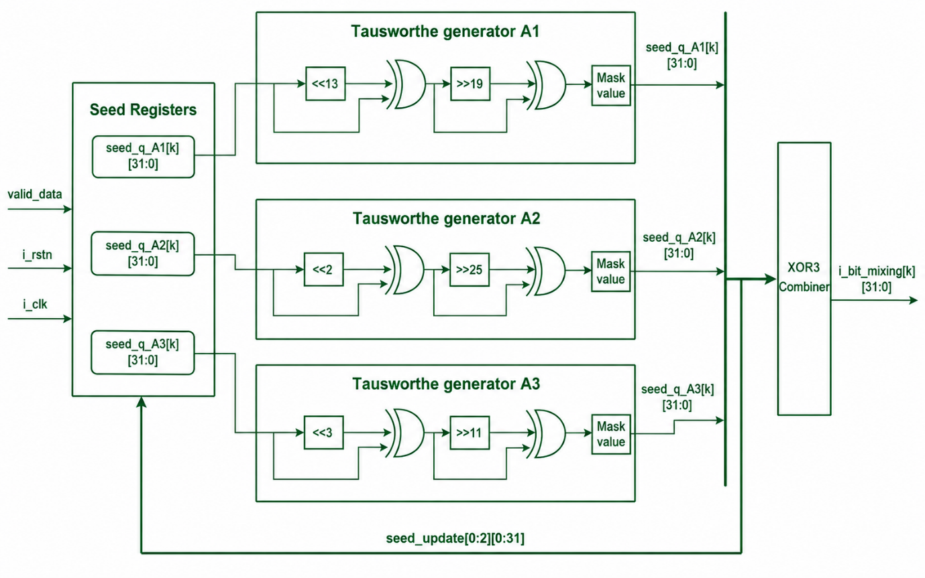
Figure 3.2. Block diagram of the internal structure of the parallel Tausworthe random number lane and XOR combining stage.
Name | Side | Width | Description
i_clk | input | [0:0] | Clock signal.
i_rstn | input | [0:0] | Active low reset signal.
valid_data | input | [0:0] | Indicates whether the input seed/control data is valid.
i_bit_mixing | output | [31:0] | 32-bit random value generated by the Tausworthe lanes and XOR combiner, used as the input to the bit-mixing block.
Table 3.4. Signal description of parallel Tausworthe random number lane and XOR combining stage.

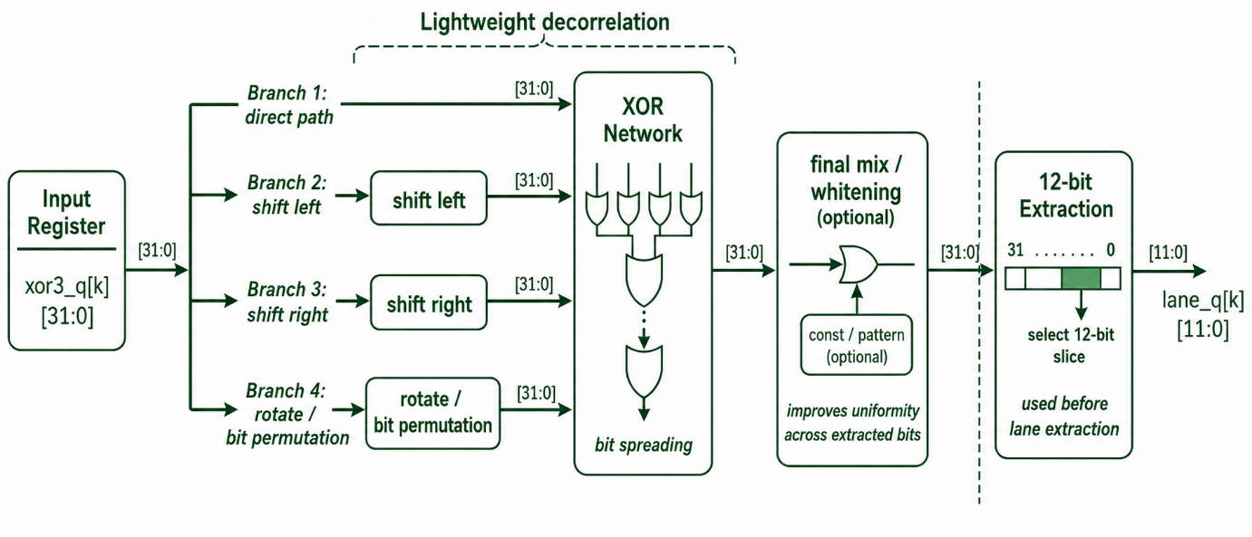
Figure 3.3. Block diagram of Bit-mixing and 12-bit extraction stage for random lane decorrelation.
Name | Side | Width | Description
xor3_q | input | [31:0] | 32-bit output from the Tausworthe random-number lane and XOR combining stage.
lane_q | output | [11:0] | 12-bit random lane value after bit mixing and extraction.
Table 3.5. Signal description of parallel Bit-mixing and 12-bit extraction stage for random lane decorrelation.
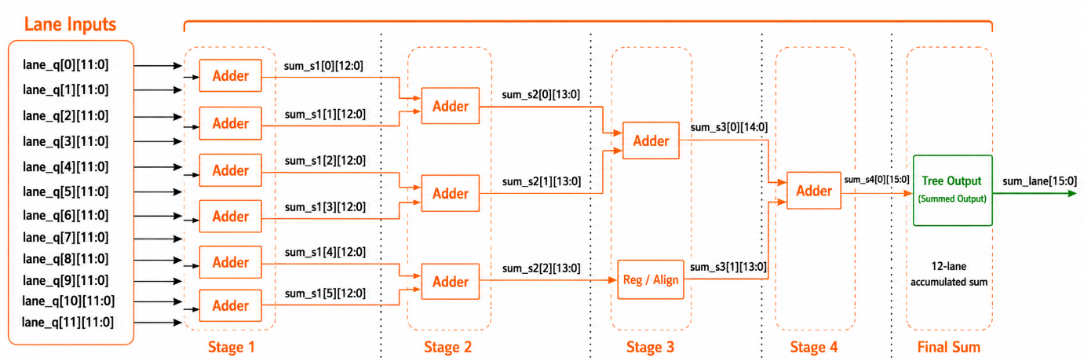
Figure 3.4. Block diagram of the adder tree.
Name | Side | Width | Description
lane_q | input | [11:0][11:0] | Twelve 12-bit random lane values from the uniform random generation stage.
sum_lane | output | [15:0] | Sum of the twelve uniform random lane values.
Table 3.6. Signal description of adder tree.

3.4. Validation Methodology
This section defines validation targets and the corresponding references.
For moment validation, given ${\left\{z\left[n\right]\right\}}_{n=1}^{N}$
$$\hat{μ}=\frac{1}{N}\sum_{n=1}^{N}{z[n]}$$ | 3.47
$${\hat{σ}}^{2}=\frac{1}{N}\sum_{n=1}^{N}{{\left(z\left[n\right]-\hat{μ}\right)}^{2}}$$ | 3.48
Skewness and excess kurtosis estimates:
$${\hat{γ}}_{1}=\frac{\frac{1}{N}\sum_{n=1}^{N}{{\left(z\left[n\right]-\hat{μ}\right)}^{3}}}{{\hat{σ}}^{3}+ε}$$ | 3.49
$${\hat{γ}}_{2}=\frac{\frac{1}{N}\sum_{n=1}^{N}{{\left(z\left[n\right]-\hat{μ}\right)}^{4}}}{{\hat{σ}}^{4}+ε}-3$$ | 3.50

For the empirical CDF
$$\hat{F}(z)=\frac{1}{N}\sum_{n=1}^{N}{1\{z[n]≤z\}}$$ | 3.51
Kolmogorov-Smirnov distance to a reference CDF $F_{0}$
$$D_{ks}=\sup_{z}\left|\hat{F}\left(z\right)-F_{0}(z)\right|$$ | 3.52
In this thesis, there are two references are used
$$F_{0}\left(z\right)=Φ(z)$$ | 3.53
$$F_{0}\left(z\right)=F_{z_{m}}(z)$$ | 3.54
For whiteness check, after mean removal, define $x\left[n\right]=z\left[n\right]-\hat{μ}$. The normalized sample autocorrelation estimate:
$$\hat{p}=\frac{\frac{1}{N-k}\sum_{n=1}^{N-k}{x\left[n\right]x[n+k]}}{\frac{1}{N}\sum_{n=1}^{N}{x^{2}\left[n\right]+ϵ}}$$ | 3.55
A practically white sequence satisfies $\hat{p}[k]≈0$ for $k≠0$
A simple periodogram-based PSD estimate uses the FFT
$$X\left[ω\right]=\sum_{n=0}^{N-1}{x\left[n\right]e^{-jωn}}$$ | 3.56
$$\hat{P}\left[ω\right]={\left|X\left[ω\right]\right|}^{2}$$ | 3.57
A normalized “flatness check” compares $\hat{P}\left[ω\right]$ to its mean level over frequency.
For tail-count validation. We get the thresholds $t∈\{3,4,5\}$, empirical two-sided tail probability
$${\hat{p}}_{tail}(t)=\frac{1}{N}\sum_{n=1}^{N}{1\{\left|z\left[n\right]>t\right|\}}$$ | 3.58
Gaussian reference
$${\hat{p}}_{N}\left(t\right)=2Q\left(t\right)=erfc\left(\frac{t}{\sqrt{2}}\right)$$ | 3.59
Finite-m reference
$$p_{m}\left(t\right)=1-(F_{Z_{m}}(t)-F_{Z_{m}}(-t))$$ | 3.60
This tail validation checks consistency with finite-m behavior and reasonableness.

CHAPTER 4: DESIGN OF THE PROPOSED LMS ADAPTIVE EQUALIZER

4.1. Overview and Design selection
This chapter presents the fixed-point adaptive equalizer used together with the AWGN generator developed in Chapter 3. The objective is to establish a compact, implementation-consistent, and hardware-oriented baseline for PAM-4 symbol-rate equalization under dominant first-postcursor ISI and fixed-point arithmetic. In the current implementation, the application-level testbench uses a three-tap feed-forward equalizer (FFE) followed by a one-tap decision-feedback equalizer (DFE), with decision delay $D=1$, training length $N_{train}=1500$. The adaptive core is explicitly LMS only.
The chapter is organized around a design-for-implementation viewpoint. More precisely, the proposed equalizer is intended to satisfy the following practical goals:
- Recover dominant symbol-rate ISI with minimal structural complexity
- Maintain deterministic throughput and deterministic latency
- Remain compatible with a 16-bit fixed-point signal path
- Avoid per-sample normalization and runtime division in the adaptive loop
- Keep the adaptive trajectory bounded and more robust in decision-directed operation
- Provide a simple baseline that can later be interpreted within a stochastic-approximation framework with endogenous noise.
Accordingly, the design targets are stated in measurable form.
R1. Throughput and determinism
The equalizer should sustain one processed symbol per cycle
R2. Fixed-point compatibility
The signal path is required to remain in signed 16-bit fixed-point format
$$q_{fx}\left[n\right] ∈ Z ∩ \left[{-2}^{15},2^{15}-1\right]$$ | 4.1
R3. Compact equalizer structure
The equalizer should remain short and hardware-friendly while still providing a meaningful local ISI-cancellation capability around the decision instant. For this reason, the adopted structure is:
$$N_{f}=3, N_{b}=1, D=1$$ | 4.2
Where $N_{f}$ is the number of feed-forward taps, $N_{b}$ is the number of feedback taps, and $D$ is the decision delay.
R4. Practical equalization benefit
The proposed equalizer should provide measurable post-equalization improvement relative to the unequalized received sequence.
These targets show that the present chapter is driven by a practical design: short structure, fixed-point consistency and bounded robust adaptation. The selected DFE architecture is particularly suitable when the dominant distortion is postcursor ISI, because such interference is generated by previously detected symbols and can be canceled through feedback.
The table below compares various equalizer methods.
Method | Main update idea | Main strength | Main limitation | Suitability
Least mean square (LMS) | Uses instantaneous error and current regressor | Very simple update, low arithmetic cost, easy fixed-point realization | Sensitive to step-size selection; not the fastest in all scenarios | Selected baseline
Normalized least mean square (NLMS) | LMS with regressor energy normalization | Better scale robustness than plain LMS | Requires online normalization/division | Not selected
Variable step size NLMS | NLMS with adaptive step size control | Faster convergence and lower misadjustment in many cases | Additional control logic and adaptive-step mechanism | Not selected
Recursive least mean square (RLS) | Minimizes weighted sum of squared errors using inverse correlation matrix | Convergence is independent of the input signal's eigenvalue spread (spectral dynamic range). | Potential numerical instability due to the recursive update of the covariance matrix. | Not selected
Affine Projection Algorithm | Use multiple recent regressors | Often better for colored inputs | Higher arithmetic and storage cost | Not selected
Table 4.1. Comparison of different equalization methods.
The choice of LMS is therefore not based on a claim of universal superiority. It is chosen because it is the most appropriate baseline for the present design objective: a short, hardware-friendly, fixed-point adaptive equalizer that can later be strengthened by clipping, gating, and projection without abandoning the simplicity of the core recursion. This is also fully consistent with the code-level implementation, which is explicitly LMS-only and avoids NLMS normalization in the adaptive path

4.2. Proposed algorithm
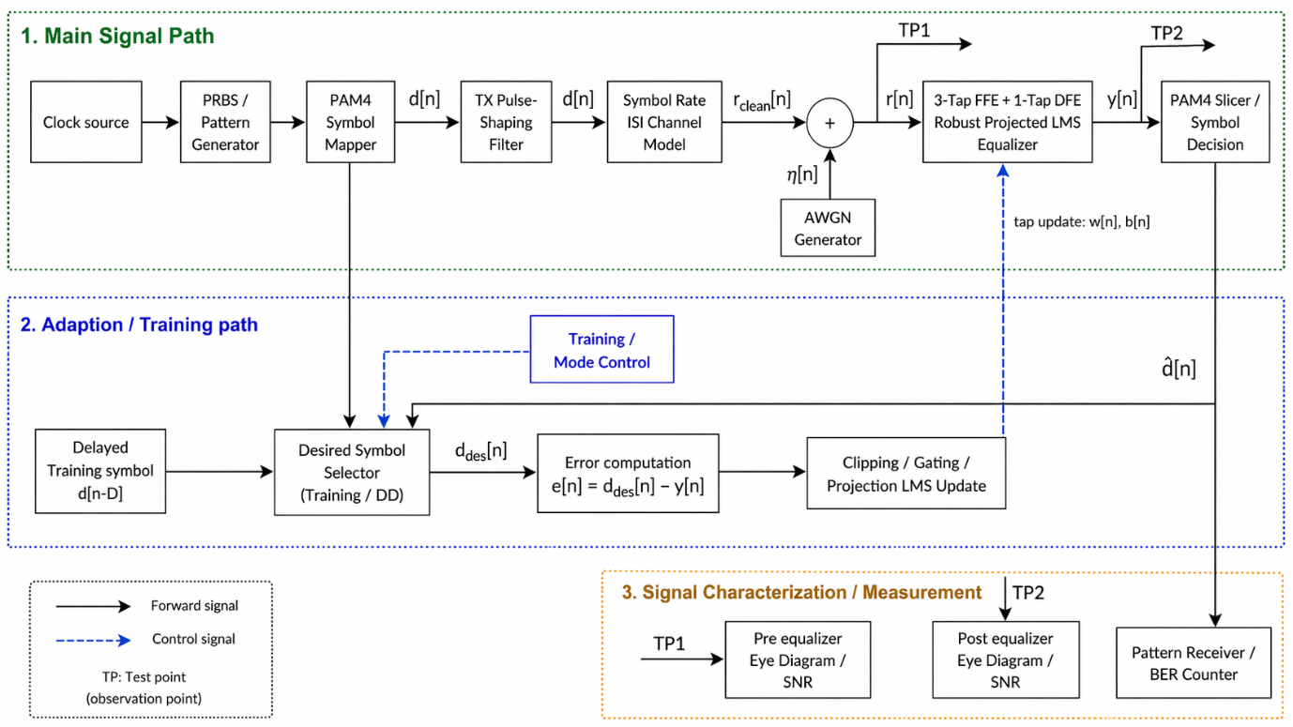
Figure 4.1. Overall system block diagram and signal flow.
4.2.1. Symbol-rate PAM-4 channel model
Let $d\left[n\right]$ denote the transmitted PAM-4 symbol sequence drawn from an ordered four-level alphabet.
$$S=\left\{a_{1},a_{2},a_{3},a_{4}\right\}, a_{1}<a_{2}<a_{3}{<a}_{4}$$ | 4.3
At symbol rate, the clean received sample is modeled by a dominant first-postcursor channel:
$$r_{clean}\left[n\right]=h_{0}d\left[n\right]+h_{1}d\left[n-1\right]$$ | 4.4
Where $h_{0}$ is the main cursor coefficient and $h_{1}$ is the dominant first postcursor coefficient. This general model instantiated by a symbol rate first postcursor mentioned by Razavi [3]. After that it will be added by the AWGN and the received noisy sample becomes.
$$r\left[n\right]=r_{clean}\left[n\right]+η\left[n\right]$$ | 4.5
4.2.2 Equalizer structure
At each symbol time, the feed-forward equalizer (FFE) regressor is formed from the most recent received samples.
$$x\left[n\right]=\left[\begin{matrix}r[n] \\ \begin{matrix}r\left[n-1\right] \\ ⋮\end{matrix} \\ r\left[n-N_{f}+1\right]\end{matrix}\right]$$ | 4.6
And the DFE feedback regressor is constructed from past hard decisions:
$$u\left[n\right]=\left[\begin{matrix}\hat{d}[n-1] \\ \begin{matrix}\hat{d}\left[n-2\right] \\ ⋮\end{matrix} \\ \hat{d}\left[n-N_{b}\right]\end{matrix}\right]$$ | 4.7
Denoting that the number of taps of FFE is $w[n]$ and the number of taps of DFE is $b[n]$. For compactness, define the stacked parameter vector and stacked regressor.
$$θ\left[n\right]=\left[\begin{matrix}w[n] \\ b[n]\end{matrix}\right], ϕ\left[n\right]=\left[\begin{matrix}x[n] \\ -u[n]\end{matrix}\right]$$ | 4.8
So, we have the equation of the equalizer output is
$$y\left[n\right]=w^{T}\left[n\right]x\left[n\right]-b^{T}\left[n\right]u\left[n\right]$$ | 4.9
Equivalently
$$y\left[n\right]=θ^{T}\left[n\right]ϕ\left[n\right]$$ | 4.10
Then the equalizer output is sliced to nearest PAM-4 level:
$$\hat{d}\left[n\right]=Q_{s}(y\left[n\right])$$ | 4.11
The desired symbol used in adaptation depends on the operating phase. During training,
$$d_{des}\left[n\right]=d\left[n-D\right], n≤N_{train}$$ | 4.12
After training, the equalizer switches to decision-directed operation:
$$d_{des}\left[n\right]=\hat{d}\left[n\right], n>N_{train}$$ | 4.13

4.2.3. Modeling and theoretical Assumptions
Now we consider the adaptation of the system. First, we have the adaptation error is defined by equation below:
$$e\left[n\right]=d_{des}\left[n\right]-y\left[n\right]$$ | 4.14
We got the baseline stacked LMS recursion is
$$θ\left[n+1\right]=θ\left[n\right]+μ_{n}e\left[n\right]ϕ\left[n\right]$$ | 4.15
In separated form,
$$w\left[n+1\right]=w\left[n\right]+μ_{n}e\left[n\right]x\left[n\right]$$ | 4.16
$$b\left[n+1\right]=b\left[n\right]-μ_{n}e\left[n\right]u\left[n\right]$$ | 4.16
Then we have the raw error replace by a clipped proposed:
$$ψ\left(e\left[n\right]\right)=clip\left(e\left[n\right],-τ,τ\right)$$ | 4.17
The adaptive taps are constrained to remain inside a box set:
$$H=\left\{\left(w,b\right):w_{k}∈\left[w_{k}^{min},w_{k}^{max}\right],b_{l}∈\left[b_{l}^{min},b_{l}^{max}\right]\right\}$$ | 4.18
Hence, the recursion becomes
$$θ\left[n+1\right]=Π_{H}\left(θ\left[n\right]+μ_{n}ψ\left(e\left[n\right]\right)ϕ\left[n\right]\right)$$ | 4.19
The proposed practical design can be interpreted as a stochastic approximation recursion. In decision-directed mode, the equalizer forms a stochastic recursive system with endogenous state-dependent noise because the current update depends on previous hard decisions generated by the receiver itself. The full argument is deferred to Appendix B. This chapter presents only the main assumptions and proposition.
Assumption A1. Bounded stacked regressor
The receive buffer and feedback buffer generate a bounded stacked regressor.
$$ϕ\left[n\right]∈Φ⊂R^{N_{f}+N_{b}}, Φ compact.$$ | 4.20
Assumption A2. Compact projected parameter set
When projection is enabled, the adaptive tap vector evolves in a compact feasible set
$$θ\left[n\right]∈H⊂R^{N_{f}+N_{b}}, H compact and convex$$ | 4.21
Assumption A3. Bounded Lipschitz update nonlinearity
$$\left|ψ\left(e\right)\right|≤τ, \left|ψ\left(e_{1}\right)-ψ\left(e_{2}\right)\right|≤L_{ψ}\left|e_{1}-e_{2}\right|$$ | 4.22
Assumption A4. Frozen state ergodicity
For each frozen $θ∈H$, the internal state process admits an invariant distribution $π_{θ}$, and the corresponding frozen-state dynamics are ergodic.
Assumption A5. Poisson equation regularity
For each frozen $θ∈H$, the centered field $H\left(θ,ξ\right)-\overline{h}\left(θ\right)$ admits a bounded Poisson corrector.
Proposition 1: Endogenous noise representation, averaged ODE and PTF correction.
Consider the robust projected decision-directed equalizer recursion
$$θ\left[n+1\right]=Π_{H}\left(θ\left[n\right]+μ_{n}ψ\left(e\left[n\right]\right)ϕ\left[n\right]\right)$$ | 4.23
Where,
$$e\left[n\right]=d_{des}\left[n\right]-θ^{T}\left[n\right]ϕ\left[n\right], d_{des}\left[n\right]=\hat{d}\left[n\right]=Q_{s}(θ^{T}\left[n\right]ϕ\left[n\right])$$ | 4.24
Under Assumptions A1-A5, this recursion can be presented as a stochastic approximation with endogenous Markovian noise:
$$θ\left[n+1\right]=Π_{H}\left(θ\left[n\right]+μ_{n}\left[\overline{h}\left(θ\left[n\right]\right)+ζ_{n+1}+r_{n+1}\right]\right)$$ | 4.25
Where $\overline{h}\left(θ\right)$ is the averaged drift under the frozen invariant law $π_{θ}$, $ζ_{n+1}$ is the fluctuation term after suitable Poisson correction and $r_{n+1}$ is higher order remainder induced by state dependence and discretization.
Moreover, the interpolated tap trajectory is formally associated with the projected mean ODE.
$$\dot{θ}\left(t\right)=Π_{T_{H}\left(θ\left(t\right)\right)}\overline{h}\left(θ\left(t\right)\right)$$ | 4.26
The key point is that the disturbance driving the decision-directed equalizer is endogenous, not exogenous. The current update depends on the past hard decisions, and those decisions are themselves generated by past equalizer states. Hence, the correct interpretation is a state-dependent stochastic approximation with feedback induced Markovian structure. In such settings, the ODE method provides the averaged deterministic limit, while a perturbed test function or Poisson-equation correction is used to absorb the state-dependent fluctuation and isolate the drift $\overline{h}\left(θ\right)$. Full derivation and proof are deferred to Appendix B. The full flow of algorithm can be summarized in the figure below.
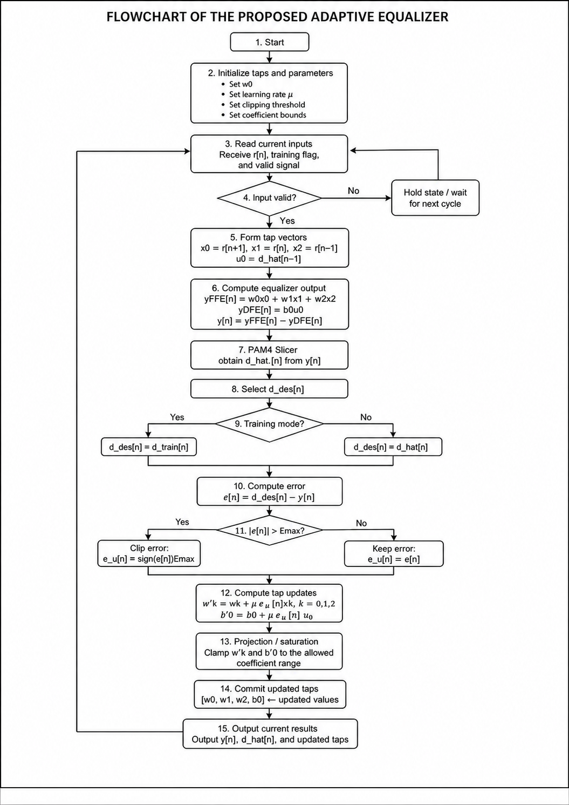
Figure 4.2. Flowchart of the proposed adaptive equalizer algorithm.

4.3. Proposed Hardware Architecture

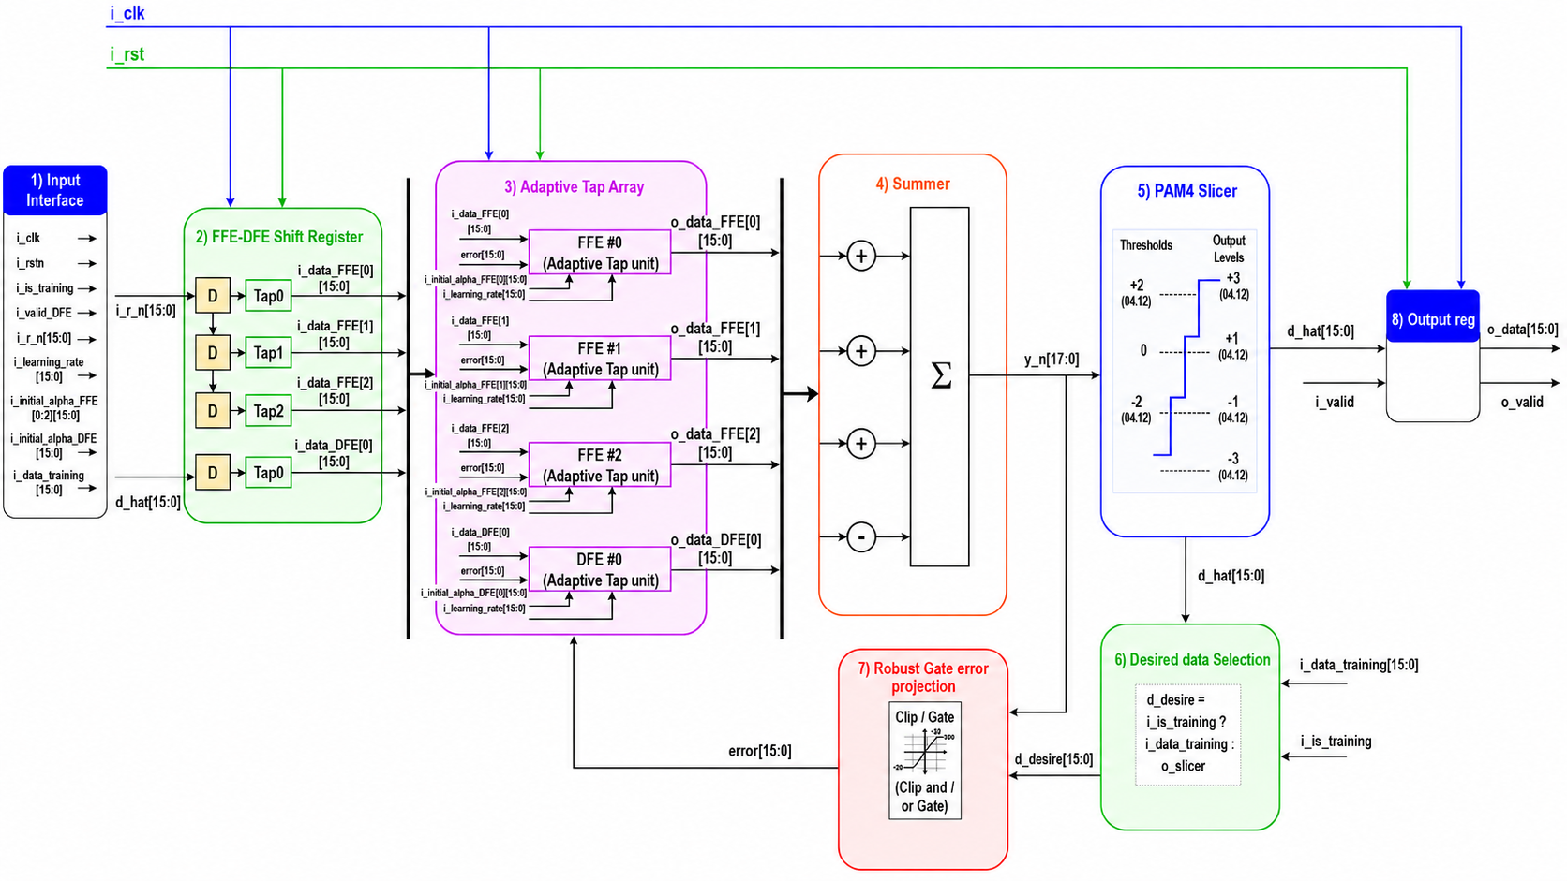
Figure 4.3. RTL architecture of the proposed 3-FFE + 1-DFE robust LMS equalizer.
Name | Side | Width | Description
i_clk | input | [0:0] | Clock signal.
i_rstn | input | [0:0] | Active low reset signal.
i_valid | input | [0:0] | Indicates whether the input data is valid.
i_r_in | input | [15:0] | Received input sample.
i_init_alpha_DFE | input | [15:0] | Initial DFE tap coefficient.
i_init_alpha_FFE | input | [2:0][15:0] | Initial FFE tap coefficients.
i_learning_rate | input | [15:0] | Learning-rate coefficient used for LMS adaptation.
i_is_training | input | [0:0] | Selects training or decision-directed mode.
i_data_training | input | [15:0] | Reference symbol used in training mode.
o_data | output | [15:0] | Registered PAM-4 slicer output data.
o_valid | output | [0:0] | Indicates whether the output data is valid.
Table 4.2. Signal description of the robust LMS equalizer.
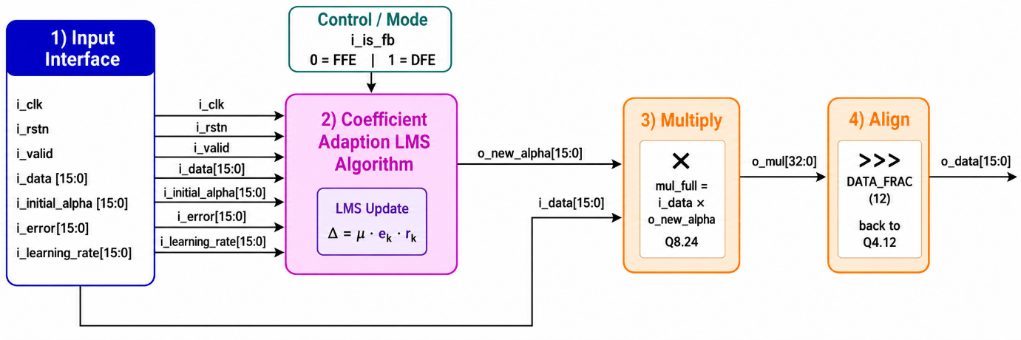
Figure 4.4. Block diagram of Adaptive Tap Unit datapath for a single FFE/DFE coefficient.
Name | Side | Width | Description
i_clk | input | [0:0] | Clock signal.
i_rstn | input | [0:0] | Active low reset signal.
i_valid | input | [0:0] | Indicates whether the input data is valid.
i_data | input | [15:0] | Input data sample used by the tap unit.
i_init_alpha | input | [15:0] | Initial tap coefficient.
i_error | input | [15:0] | Error value used to update the tap coefficient.
i_learning_rate | input | [15:0] | Learning-rate coefficient used for LMS adaptation.
o_data | output | [15:0] | Tap output after multiplying the input data by the updated coefficient.
Table 4.3. Signal description of the Adaptive Tap Unit.

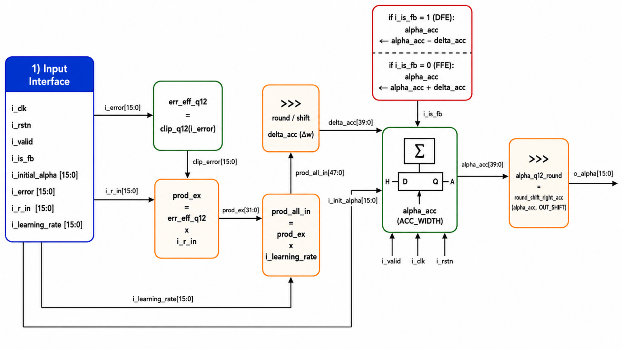
Figure 4.5. Block diagram of Coefficient Adaptation in the LMS algorithm.
Name | Side | Width | Description
i_clk | input | [0:0] | Clock signal.
i_rstn | input | [0:0] | Active low reset signal.
i_valid | input | [0:0] | Indicates whether the input data is valid.
i_is_fb | input | [0:0] | Selects the coefficient-update direction for FFE or DFE adaptation.
i_data | input | [15:0] | Input sample used in the LMS update computation.
i_init_alpha | input | [15:0] | Initial tap coefficient.
i_error | input | [15:0] | Error value used for coefficient adaptation.
i_learning_rate | input | [15:0] | Learning-rate coefficient used for the LMS update.
o_alpha | output | [15:0] | Updated tap coefficient after LMS adaptation, rounding, and fixed-point alignment.
Table 4.4. Signal description of the coefficient adaptation LMS algorithm.

4.4. Validation Methodology
4.4.1. System-level performance metrics
For each simulation run, the code evaluates the received PAM-4 decisions before and after equalization. The main error rate metrics are the symbol error rate and bit error rate before and after the equalizer. The symbol error rate is computed by comparing the detected PAM-4 symbols with the transmitted PAM-4 symbols over the valid decision interval.
$$SER=\frac{1}{N_{val}}\sum_{n∈L_{val}}{1\left\{\hat{d}\left[n\right]≠d\left[n\right]\right\}}$$ | 4.27
Here $L_{val}$ denotes the valid evaluation index set after accounting for the decision delay.
The bit error rate is computed after mapping the PAM-4 symbol decisions into their corresponding bit labels:
$$BER=\frac{1}{N_{bit}}\sum_{i=1}^{N_{bit}}{\left\{{\hat{b}}_{i}≠b_{i}\right\}}$$ | 4.28
This metric is included because symbol-level improvement does not always translate linearly into bit-level improvement under PAM-4 labeling. The primary system-level validation condition is:
$${SER}_{DFE}<{SER}_{noEQ}, {BER}_{DFE}<{BER}_{noEQ}$$ | 4.29
This condition verifies whether the DFE provides practical detection improvement relative to direct slicing of the received waveform.
The main system-level validation is performed over the injected SNR range.
$$SNR∈\left\{15,16,…,30\right\}dB$$ | 4.30
This range is used to observe the receiver behavior from a stronger noise regime to a higher SNR regime where residual ISI and decision-directed adaptation effects become more visible and it is inspired by IEEE 802.3-style evaluation. This SNR-sweep experiment is the main evidence used to show why equalization is necessary for the PAM-4 link under the dominant first postcursor ISI.
4.4.2. Eye diagram construction
Because PAM-4 performance is strongly affected by residual ISI and eye closure, the validation includes explicit eye diagram analysis.
When eye analysis is enabled, the code constructs oversampled pre-equalizer and post-equalizer waveforms:
$$y_{b,os}\left[m\right], y_{a,os}\left[m\right]$$ | 4.31
Where the subscripts b and a denote before equalization and after equalization, respectively.
Let sps denote the number of samples per symbol used for eye reconstruction. The eye diagram is formed over a two UI window. Therefore, the segment length is
$$L=2sps$$ | 4.32
For an oversampled waveform $x_{os}\left[m\right]$, the number of complete two-UI segments is
$$N_{seg}=\left[\frac{length\left(x_{os}\right)}{L}\right]$$ | 4.33
The waveform is then truncated to an integer number of two UI windows:
$$x_{trim}=x_{os}\left[1:N_{seg}L\right]$$ | 4.34
The truncated waveform is reshaped into a matrix whose columns are individual two UI traces:
$$X=reshape\left(x_{trim},L,N_{seg}\right)$$ | 4.35
The horizontal eye axis is expressed in unit intervals:
$$t_{k}=\frac{k}{sps}, k=0,1,…,L-1$$ | 4.36
The eye diagram is obtained by superimposing the columns of $X$
$$ε=\left\{\left(t_{k},X_{k,j}\right):k=0,…,L-1,j=1,…,N_{seg}\right\}$$ | 4.37
Thus, the eye diagram is not generated directly from the symbol rate sequence. Instead, an oversampled reconstructed waveform is first formed and then folded into consecutive two-UI segments. This construction provides a visual representation of eye opening, residual ISI, transition spread and timing uncertainty before and after equalization.

CHAPTER 5: SYSTEM INTEGRATION

5.1. System Integration overview
This chapter describes the integration architecture of the proposed FPGA-based PAM-4 digital baseband prototype with an ESP32-S3 communication bridge and a PC-side visualization interface. The objective of this chapter is to explain how the hardware and software components are connected, how selected internal FPGA samples are transferred outside the FPGA, and how these samples are prepared for eye-diagram visualization on a PC. The integrated system consists of three major components.
The first is FPGA processing: The FPGA implements the PAM-4 baseband chain, including symbol generation, PAM-4 mapping, channel/noise modeling, adaptive FFE-DFE equalization, demapping, and debug-sample selection.
The second is ESP32-S3 communication: The ESP32-S3 receives the selected FPGA debug samples through UART, reconstructs the sample stream, stores the samples in a buffer, and serves the buffered data through an HTTP interface.
The third is PC visualization: The PC requests sample data from the ESP32-S3 through HTTP, decodes the received samples, reconstructs the signal sequence, and performs eye-diagram windowing.
The overall data flow is summarized in the figure below.
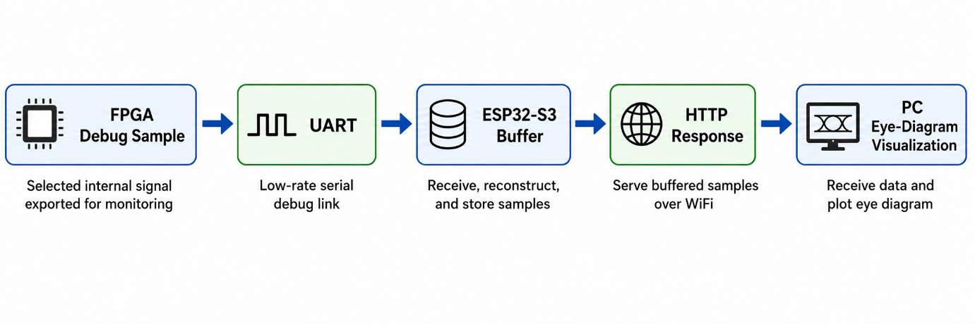
Figure 5.1. Data flow transmission.
The proposed integration path is not the main high-speed communication path of the PAM-4 receiver. It is a monitoring and visualization path used to observe selected internal signals from the FPGA prototype.

5.2. Hardware–Software Architecture
The figure below shows the complete integration architecture from the FPGA prototype to the PC visualization interface.
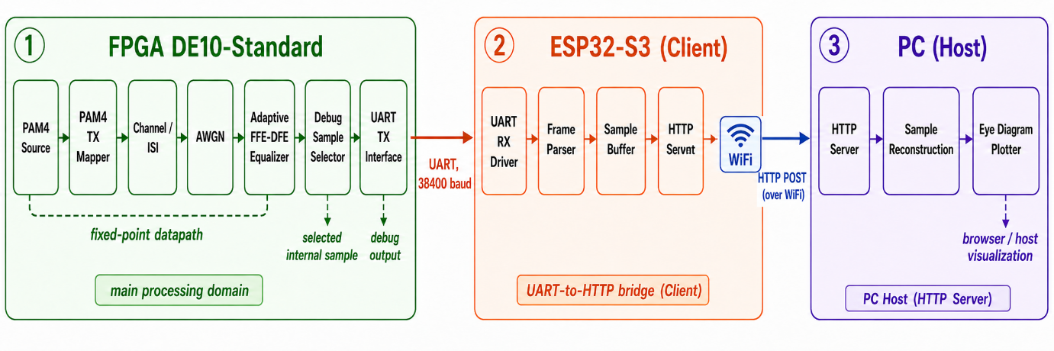
Figure 5.2. System integration architecture for FPGA-based PAM-4 processing and ESP32-S3 web visualization.
The system is divided into three hardware/software layers. The first layer is the FPGA DE10-Standard board. The FPGA performs PAM-4 symbol processing and equalization. The second layer is the ESP32-S3 module. It acts as a UART-to-HTTP bridge. The third layer is the PC. It performs HTTP data acquisition and software-based eye-diagram reconstruction.
At the FPGA side, the PAM-4 source generates input symbols. The PAM-4 TX mapper converts the symbol stream into fixed-point PAM-4 amplitudes. The channel and AWGN blocks distort the signal to emulate a practical transmission condition. The adaptive FFE-DFE equalizer then processes the distorted signal and generates equalized samples. A debug selector chooses selected internal signals, such as the equalizer output before slicer, for external observation.
The selected debug samples are transmitted from the FPGA to the ESP32-S3 through a UART link. The UART interface is configured as a low-speed monitoring interface. In this prototype, the UART baud rate is set to 38400 baud.
The ESP32-S3 receives the UART byte stream, parses the byte order, reconstructs the original sample values, and stores the samples in an internal buffer. The ESP32-S3 then exposes these samples through an HTTP server. The PC sends an HTTP request to the ESP32-S3 and receives the buffered sample stream through WiFi.

5.3. FPGA Hardware Implementation of Channel Transmitter and Receiver
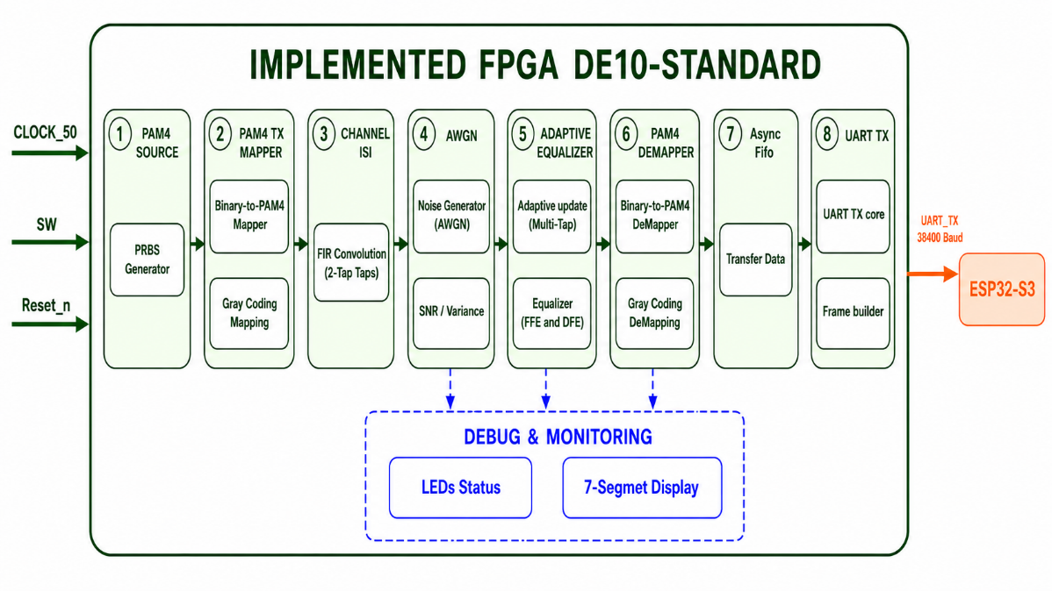
Figure 5.3. FPGA Hardware Implementation of Channel Transmitter and Receiver.
Figure 5.3 shows the FPGA baseband evaluation chain implemented on the DE10-Standard board. The main data path consists of the board-level symbol source, PAM-4 TX mapper, channel emulator, adaptive 3-FFE/1-DFE LMS equalizer, and PAM-4 RX demapper. In parallel with the recovered-output path, the debug/observation interface collects selected internal signals and exports them to the LED/HEX display or UART stream for ESP32-S3 and PC monitoring.
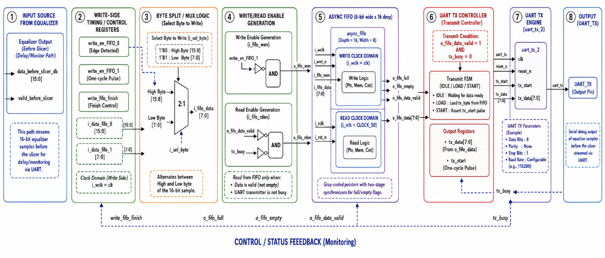
Figure 5.4. UART transmission interface in FPGA.
Figure 5.4 shows the UART debug transmission interface used to export selected FPGA observation samples. The selected 16-bit pre-slicer equalizer output is split into low and high bytes, written into an asynchronous FIFO, and then read by the UART TX controller. The UART engine serializes each byte and sends it through the UART_TX pin to the ESP32-S3 for external visualization.

5.4. ESP32-S3 Communication software
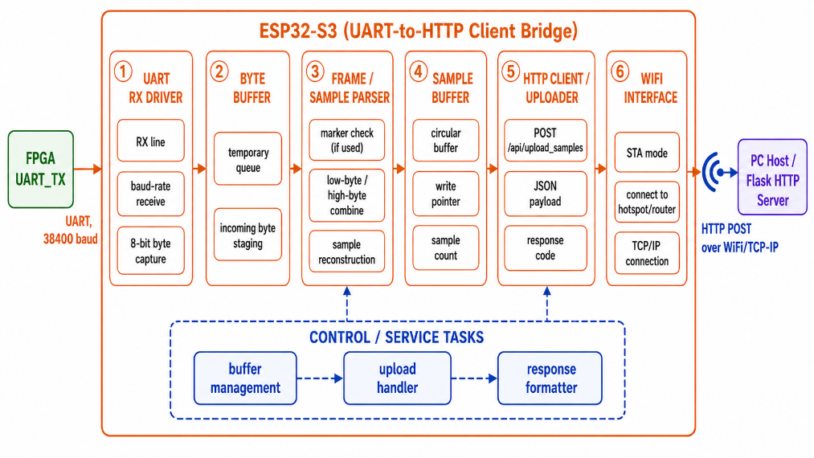
Figure 5.5. ESP32-S3 UART-to-HTTP bridge architecture
Figures 5.5 and 5.6 describe the ESP32-S3 communication layer used to bridge the FPGA UART output and the PC visualization interface. The corresponding firmware operation, including UART initialization, packet reception, sample buffering, HTTP request handling, and buffer/status update, is shown in the flow diagram below.
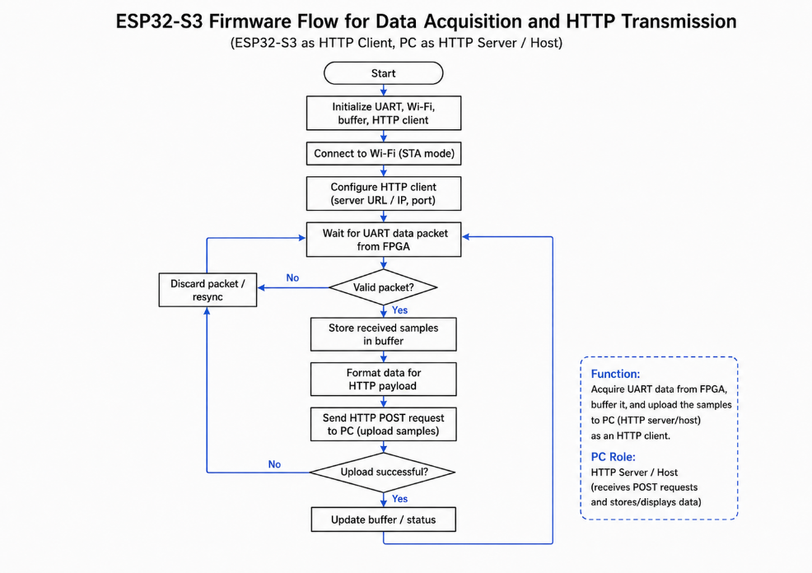
Figure 5.6. ESP32-S3 firmware flow for UART data acquisition and HTTP transmission

5.5. PC-Side Visualization Software
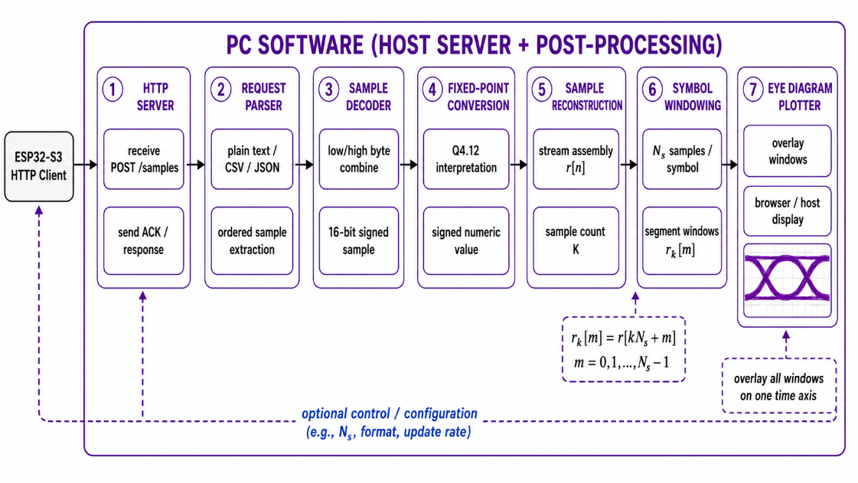
Figure 5.7. PC-side post-processing architecture for browser-based eye-diagram visualization
Figures 5.7 and 5.8 describe the PC-side post-processing layer used to convert the HTTP sample stream into an eye-diagram visualization. The reconstructed waveform is then divided into symbol-length windows and overlaid on a common time axis to form the eye diagram. The corresponding PC-side operation, including HTTP acquisition, response validation, sample decoding, symbol windowing, eye-diagram plotting, and refresh/update control, is shown in the flow diagram below.
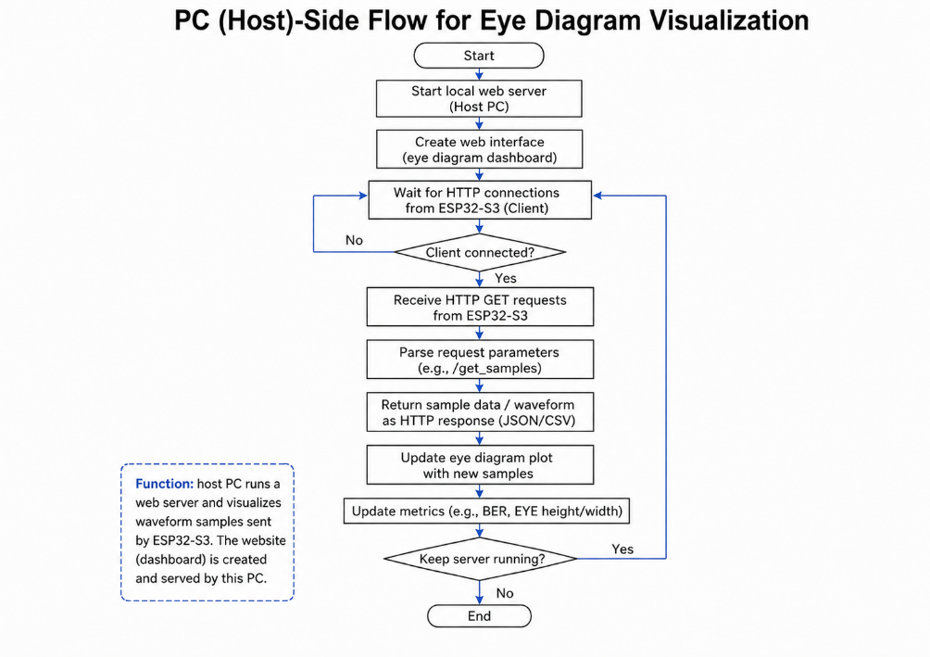
Figure 5.8. PC-side software flow for eye-diagram visualization

CHAPTER 6: EXPERIMENTS AND RESULTS

6.1. MATLAB Simulation Results
6.1.1. Statistical validation of the AWGN generator
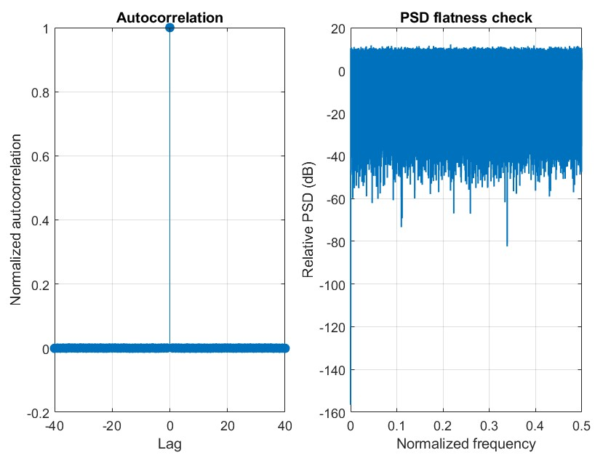
Figure 6.1. Autocorrelation and PSD flatness validation of the proposed AWGN generator.
The whiteness validation indicates acceptable noise quality for communication-level evaluation. The autocorrelation is concentrated at the zero-lag spike, while the remaining lags stay near zero. In addition, the estimated power spectral density is approximately flat over the normalized frequency range. Hence, the generated sequence is sufficiently white for use in the subsequent equalizer experiments.
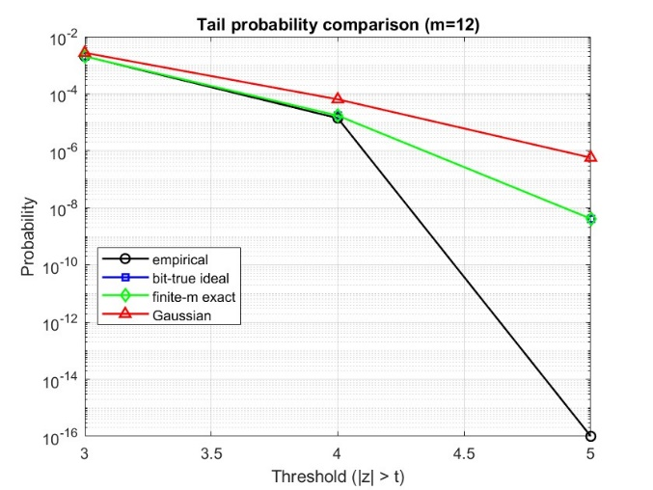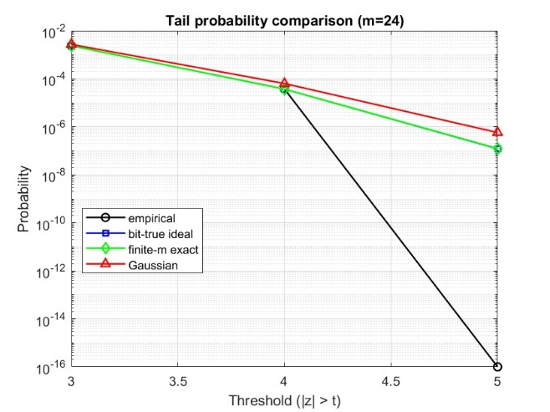
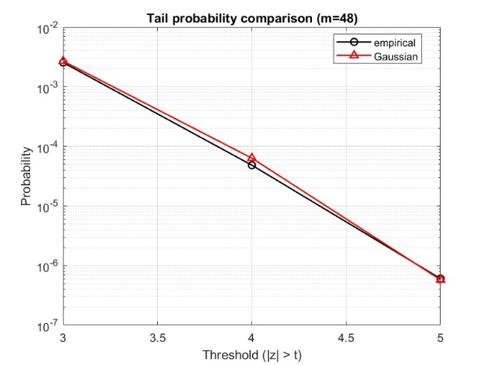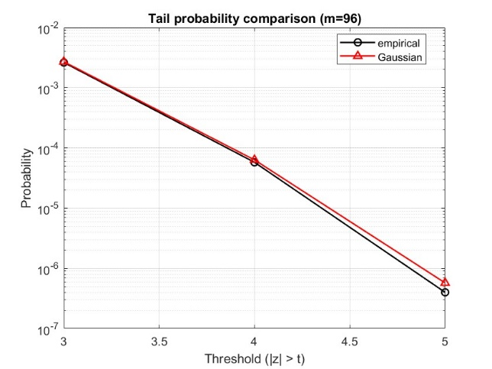
Figure 6.2. Tail probability comparison of CLT-based noise samples for different numbers of summed random lanes.
These figures evaluate the two-sided tail probability $p_{tail}=Pr\left\{\left\lceil Z\right\rceil >t\right\}$ for the standardized CLT output at thresholds $t∈\left\{3,4,5\right\}$, using $N={10}^{7}$ samples. For $m=12$ and $m=24$, the empirical tail probabilities match the finite-m exact reference well up to $4σ$, confirming moderate tail consistency with the intended finite-m CLT law. The empirical collapse at $5σ$ in these cases corresponds to a zero-hit regime at the given sample budget, rather than a true probability near the plot floor. For $m=48$ and $m=96$, the empirical tail probabilities closely follow the Gaussian reference from $3σ$ to $5σ$, indicating that increasing the number of CLT lanes improves Gaussian-like tail behavior, consistent with the fact that the finite-m excess kurtosis approaches zero as $m$ grows.
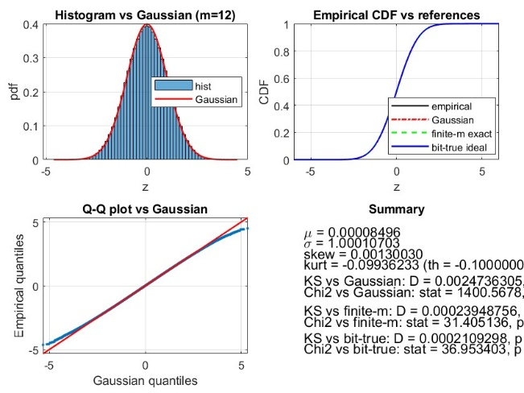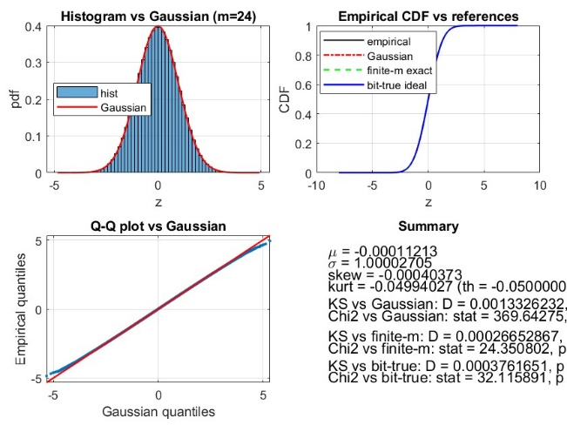
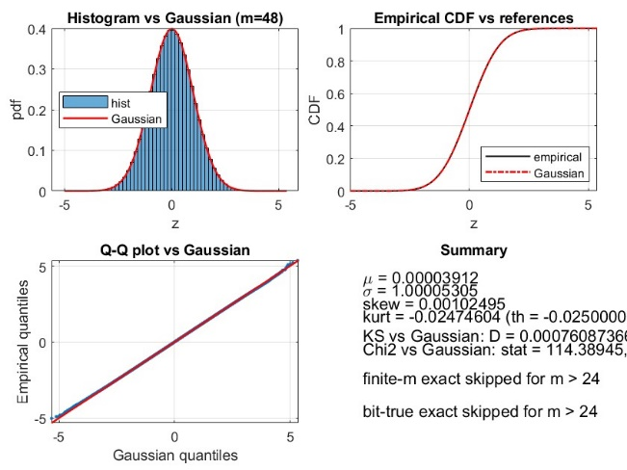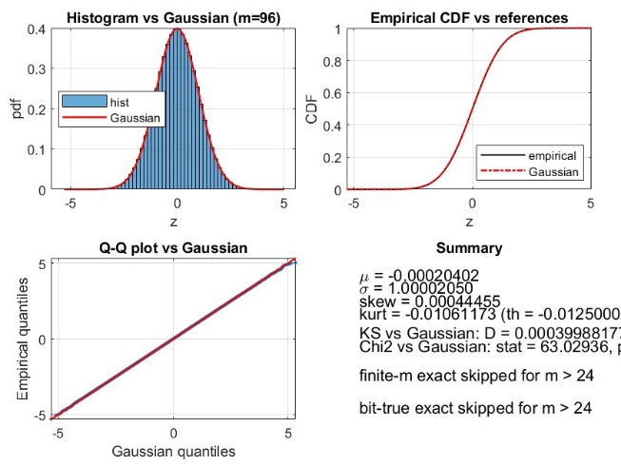
Figure 6.3. Distribution validation of CLT-based noise samples
The four validation panels jointly indicate that the proposed fixed-point CLT generator produces a standardized output with near zero mean, near unit standard deviation and near zero skewness, while exhibiting the expected negative finite-m excess kurtosis that becomes closer to zero as m increases. Specifically, the summary statistics report $μ$ close to 0 and $σ$ close to 1 for all m and the measured excess kurtosis closely follows the finite-m theoretical target $γ_{2}\left(Z_{m}\right)=\frac{-6}{5m}$ (−0.09936233 vs −0.1 at $m=12$, −0.04994027 vs −0.05 at $m=24$, −0.02474604 vs −0.025 at $m=48$, −0.01061173 vs −0.0125 at $m=96$). The histogram overlays and empirical CDF curves visually agree with the Gaussian reference in the central region, while the Q-Q plots remain close to the $y=x$ line with increasing alignment as $m$ grows. Consistently, the KS distance versus the finite-m reference is substantially smaller than versus Gaussian, which supports the thesis framing that the correct statistical target is the finite-m law rather than an exact $N(0,1)$ model. A comparison with related works is shown below.

Case | $$σ_{target}$$ | Std. $\hat{σ}$ | $$\left|μ\right|$$ | Relative. std. error (%)
Proposed generator (m=12) | 1 | 1.00010703 | 0.00008496 | 0.010703
Proposed generator (m=24) | 1 | 1.00002705 | 0.00011213 | 0.002705
Proposed generator (m=48) | 1 | 1.00005305 | 0.00003912 | 0.005305
Proposed generator (m=96) | 1 | 1.00002050 | 0.00020402 | 0.002050
CLT, 12 RNG [35], seed set 1 (m=12) | 1 | 1.0617 | 0.0158 | 6.17
CLT, 12 RNG [35], seed set 2 (m=12) | 1 | 0.9947 | 0.0937 | 0.53
CLT, 12 RNG [35], seed set 3 (m=12) | 1 | 1.0134 | 0.0547 | 1.34
CLT, 24 RNG [35], seed set 1 (m=24) | 1 | 0.9794 | 0.0311 | 2.06
CLT, 48 RNG [35], seed set 1 (m=48) | 1 | 1.0171 | 0.0508 | 1.71
CLT, 48 RNG [35], seed set 2 (m=48) | 1 | 1.0040 | 0.0311 | 0.4
CLT, 96 RNG [35], seed set 1 (m=96) | 1 | 0.9688 | 0.0939 | 3.12
CLT, Numerical Recipes [36] (m=12) | 1 | 0.96005208 | 0.0075 | 3.994792
CLT, Borland C/C++ [36] (m=12) | 1 | 0.9579144 | 0.002 | 4.20856
CLT, glibc [36] (m=12) | 1 | 0.95911417 | 0.0044 | 4.0885283
CLT, Numerical Recipes [36] (m=24) | 1 | 0.97851929 | 0.0065 | 2.148071
CLT, Borland C/C++ [36] (m=24) | 1 | 0.97887691 | 0.0018 | 2.112309
CLT, glibc [36] (m=24) | 1 | 0.97688279 | 0.0056 | 2.311721
CLT, Numerical Recipes [36] (m=48) | 1 | 0.98888826 | 0.0066 | 1.111174
CLT, Borland C/C++ [36] (m=48) | 1 | 0.98838252 | 0.0018 | 1.161748
CLT, glibc [36] (m=48) | 1 | 0.98979796 | 0.0056 | 1.020204
CLT, Numerical Recipes [36] (m=96) | 1 | 0.99609236 | 0.0031 | 0.390764
CLT, Borland C/C++ [36] (m=96) | 1 | 0.99322706 | 0.002 | 0.677294
CLT, glibc [36] (m=96) | 1 | 0.99538937 | 0.005 | 0.461063
Piecewise CLT Gen. A [34] | 50 | 49.990599 | - | 0.0188
Piecewise CLT Gen. B [34] | 10 | 10.005948 | - | 0.0595
Piecewise CLT Gen. B [34] | 20 | 20.007923 | - | 0.0396
Piecewise CLT Gen. B [34] | 30 | 30.000217 | - | 0.0007
Piecewise CLT Gen. B [34] | 40 | 40.007949 | - | 0.0199
Piecewise CLT Gen. B [34] | 50 | 50.006130 | - | 0.0123
Table 6.1. Standard-deviation accuracy comparison of CLT-based Gaussian noise generators.
6.1.2. Statistical validation of the equalizer
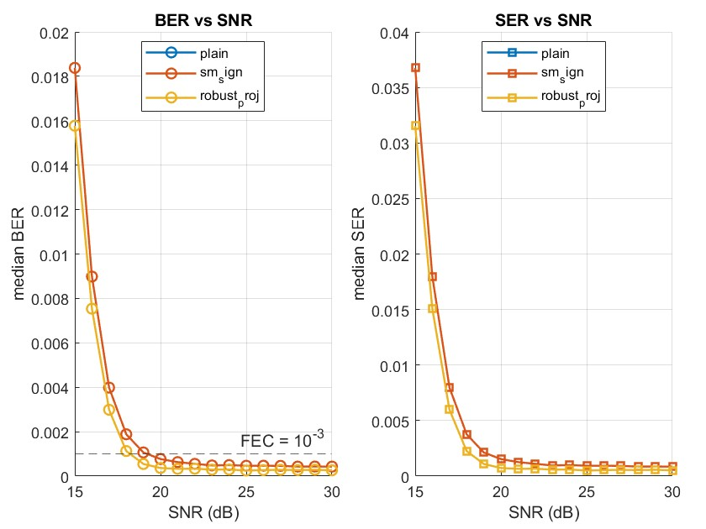
Figure 6.4. BER and SER performance comparison of LMS-based equalizers under Gaussian noise.
This experiment evaluates the detection performance over an SNR sweep using the same 3-FFE/1-DFE receiver structure. The left plot reports the median BER, while the right plot reports the median SER. The dashed line in the BER plot indicates the target reference level for the equalizer ($BER= {10}^{-3}$). At low SNR, both BER and SER are high because the receiver is affected by AWGN and residual ISI. As SNR increases, both metrics decrease rapidly, showing that the PAM-4 clusters become easier to separate after equalization. The proposed design remains below the SM-sign baseline in [16], indicating better detection performance under the tested conditions.
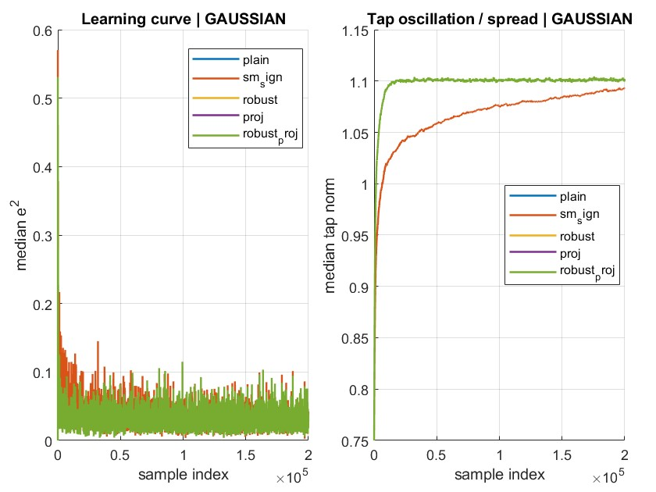
Figure 6.5. Learning curve and tap-coefficient spread of LMS-based equalizers under Gaussian noise
This experiment evaluates the adaptation behavior of several LMS-based equalizer variants under Gaussian noise. All variants use the same compact 3-FFE/1-DFE structure. At the beginning of the run, the median squared error decreases sharply, showing that the equalizers quickly move toward a useful compensation state. After the transient phase, the error fluctuates around a low steady-state level because of AWGN, residual ISI, fixed-point effects, and decision-directed adaptation.
The experiment is conducted to evaluate the sensitivity of the proposed robust update to the clipping threshold. In the implemented configuration, the burst probability is 1%, and each selected burst sample is amplified by a factor of 8. Under this noise model, the clipping threshold is swept over 0.75, 1.0, 1.5, 2.0, 2.5, 3.0, and 4.0 to examine whether the proposed update remains stable when the received signal contains rare but strong impulsive disturbance. The results are shown in the table below.
SNR(dB) | Best clip | Best median BER | Plain BER (LMS without clip) | BER gain vs Plain
15 | 2.5 | 2.1027e-02 | 2.1229e-02 | +0.95%
16 | 2.5 | 1.2511e-02 | 1.2711e-02 | +1.57%
17 | 2.5 | 7.9542e-03 | 8.0522e-03 | +1.22%
18 | 2.5 | 5.7334e-03 | 5.8500e-03 | +1.99%
19 | 2.5 | 4.8521e-03 | 4.9313e-03 | +1.61%
20 | 2.5 | 4.2688e-03 | 4.3417e-03 | +1.68%
21 | 2.5 | 3.8042e-03 | 3.9396e-03 | +3.44%
22 | 2.5 | 3.4334e-03 | 3.5209e-03 | +2.49%
23 | 2.5 | 3.0875e-03 | 3.1334e-03 | +1.46%
24 | 2.5 | 2.6834e-03 | 2.7292e-03 | +1.68%
25 | 2.5 | 2.2834e-03 | 2.3021e-03 | +0.81%
26 | 2.5 | 1.9729e-03 | 2.0021e-03 | +1.46%
27 | 2.5 | 1.6833e-03 | 1.7167e-03 | +1.94%
28 | 2.5 | 1.4271e-03 | 1.4508e-03 | +1.66%
29 | 2.0 | 1.1063e-03 | 1.1208e-03 | +1.30%
30 | 2.0 | 8.8751e-04 | 8.9334e-04 | +0.65%
Table 6.2. BER improvement of the optimized clipping threshold compared with plain LMS.
The clipping-threshold sweep results are illustrated in the figure below, where the left plot shows the median BER versus SNR and the right plot shows the median SER versus SNR. As the SNR increases from 15 dB to 30 dB, both BER and SER decrease consistently for the plain LMS case and all clipping-threshold settings. The curves are very close to each other, indicating that the clipping operation preserves the main equalization performance while providing a slightly more robust behavior.
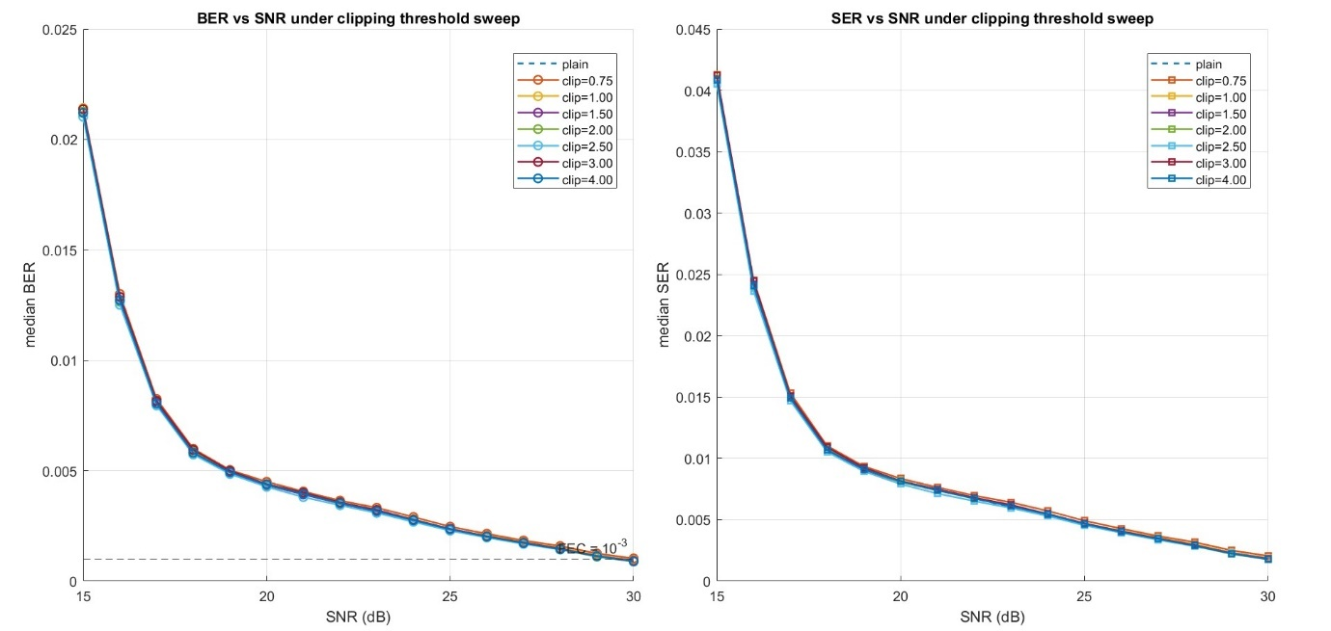
Figure 6.6. BER and SER performance under clipping-threshold sweep.

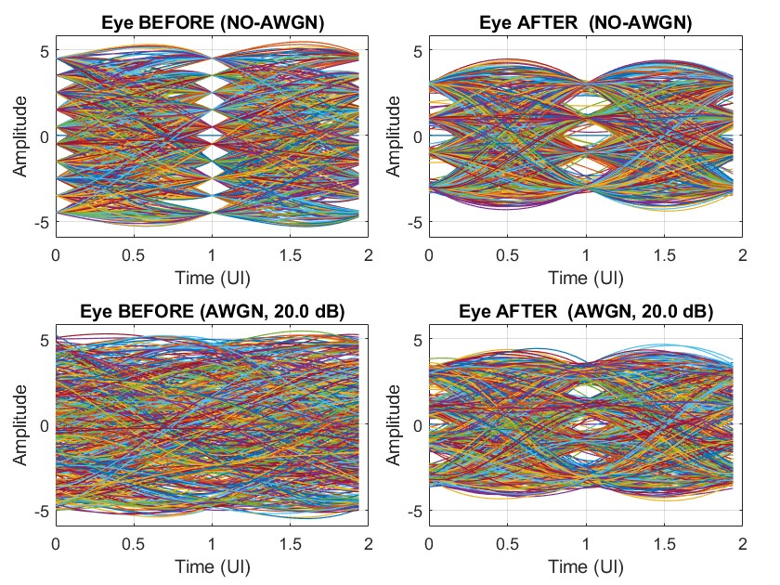
Figure 6.7. Eye-diagram comparison before and after equalization under no-AWGN and AWGN conditions.
This experiment evaluates the signal-level effect of the proposed equalizer using a compact 3-FFE/1-DFE structure. The received PAM-4 waveform is observed before equalization and after the DFE output. Before equalization, the no-AWGN eye diagram is highly closed. The trajectories from different PAM-4 transitions overlap strongly, especially near the decision instant. This indicates that the received signal is mainly degraded by deterministic ISI rather than by random noise. After equalization, the no-AWGN eye diagram becomes more structured and the eye openings around the decision region become clearer. This confirms that the DFE feedback path is able to cancel part of the postcursor interference produced by previous symbols.

6.2. SystemVerilog Implementation and Verification Results
6.2.1. Synthesis results
Configuration | This work | This work  (pipeline) | CLT 12 RNGs [35] | CLT 48 RNGs [35] | Chen Gen. A [34] | Chen Gen. B [34]
Reported FPGA | Intel Cyclone V | Intel Cyclone V | Kintex-7 FPGA board | Kintex-7 FPGA board | Xilinx Virtex-4 | Xilinx Virtex-4
Block RAM | 0 | 0 | - | - | 3 | 6
LUT | 484 | 759 | 419 | 1882 | 347 | 825
$$f_{max}(MHz)$$ | 100.3 | 382.7 | 1034.13 | 846.02 | 341 | 358
DSP | 0 | 0 | 0 | 0 | 0 | 0
Table 6.3. AWGN Generator Comparison.
Table 6.3 summarizes the FPGA synthesis results of the proposed CLT-based AWGN generator and several reference Gaussian noise generators. The pipelined version of this work increases the maximum operating frequency from 100.3 MHz to 382.7 MHz by inserting registers into the adder-tree datapath. This improvement confirms that the adder-tree reduction path is the main timing bottleneck in the non-pipelined design.
Configuration | This work | This work (pipeline) | DLMS [37] | Conventional  multi-bit [38]
Reported FPGA | Intel Cyclone V | Intel Cyclone V | Spartan-6 | Virtex-7
LUT | 791 | 1003 | - | 13,117
Block RAM | 0 | 0 | - | 0
$$f_{max}(MHz)$$ | 24.37 | 91.37 | 42.24 | 56.89
DSP | 16 | 16 | - | 0
Table 6.4. Equalizer Comparison.
Table 6.4 compares the synthesis results of the proposed robust LMS equalizer with reference equalizer architectures. The pipelined implementation improves the maximum operating frequency from 24.37 MHz to 91.37 MHz. The LUT usage increases moderately from 791 to 1003, while the DSP usage remains unchanged at 16 blocks. Compared with the reported DLMS and conventional multi-bit designs, the pipelined equalizer achieves a higher operating frequency and significantly lower LUT usage than the conventional multi-bit design, although it relies on DSP blocks for the multiplier-based datapath.
6.2.2. Functional Verification and Waveform Analysis
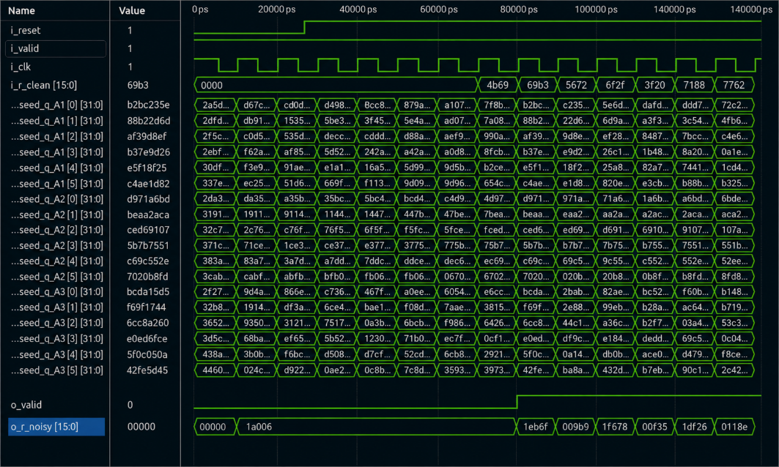
Figure 6.8. Simulation waveform of the pipelined AWGN generator.
The waveform verifies the operation of the pipelined AWGN generator, where the internal Taus88 seed states update on each rising edge of i_clk. The clean input sample i_r_clean[15:0] is combined with the generated AWGN sequence to produce the noisy output o_r_noisy[15:0]. Due to the high-speed pipeline design, the corresponding output appears after an 8-cycle latency.
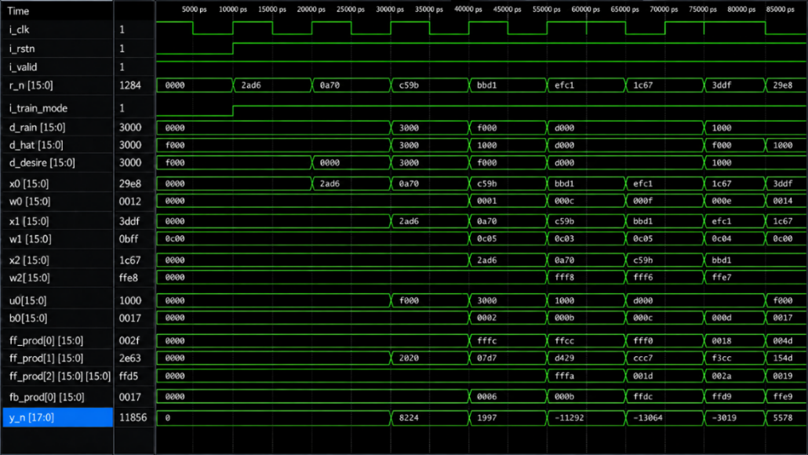
Figure 6.9. Simulation waveform of the pipelined adaptive equalizer.
The waveform verifies the operation of the 3-FFE and 1-DFE LMS equalizer architecture, where the received samples r_n[15:0] are shifted into the FFE delay line as x0, x1, and x2. The FFE products ff_prod[0:2] and the DFE feedback product fb_prod[0] are combined to generate the pre-slicer output y_n[17:0]. The slicer decision d_hat[15:0], desired symbol d_desire[15:0], and adaptive taps w0–w2, b0 update over time, confirming the decision-directed LMS equalizer behavior.
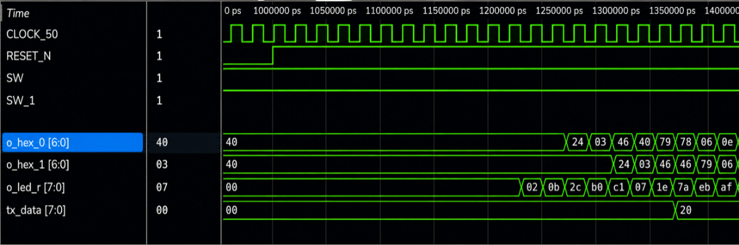
Figure 6.10. Simulation waveform of the full FPGA-based system.
The waveform verifies the top-level FPGA prototype output, where CLOCK_50, RESET_N, and switch signals drive the baseband evaluation chain. The display outputs o_hex_0[6:0], o_hex_1[6:0], and o_led_r[7:0] update over time, indicating that internal recovered/debug data are being routed to the FPGA observation interface. The tx_data[7:0] signal also becomes active later in the waveform, showing that the debug/observation stream can be packetized for external monitoring through the UART/ESP32-S3 visualization path.
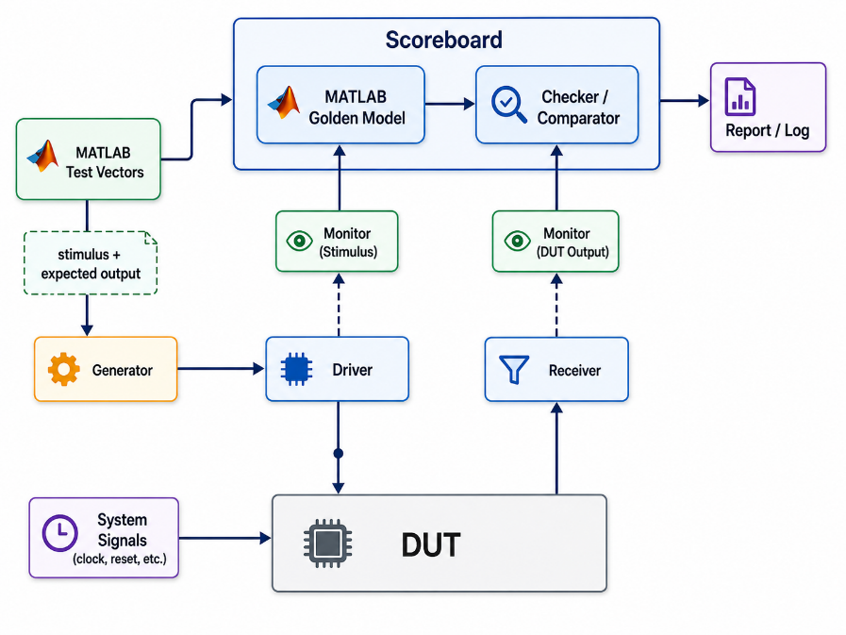
Figure 6.11. Verification testbench architecture with MATLAB golden model and scoreboard.
Figure 6.11 shows the verification testbench architecture used to compare the RTL implementation with a MATLAB golden model. In this verification flow, the MATLAB golden model serves as the algorithm-level reference for the expected behavior of the PAM-4 baseband chain. The same input stimulus is applied to both the SystemVerilog DUT and the MATLAB reference model to ensure that the comparison is performed under identical input conditions. The MATLAB golden model includes the main functional operations of the proposed system, including PAM-4 symbol generation, channel impairment modeling, AWGN injection, LMS-based 3-FFE/1-DFE equalization, PAM-4 slicing, and output-symbol recovery. This model is used to generate the expected reference output sequence for the RTL simulation.
The checker/comparator compares the aligned DUT output with the MATLAB reference output and reports mismatches when the RTL output deviates from the expected behavior. This verification method helps detect possible implementation errors in the AWGN generator, equalizer datapath, PAM-4 slicer, coefficient-update logic, valid-signal propagation, and top-level data path before FPGA synthesis and hardware demonstration. Overall, the MATLAB golden model provides a reference layer between the high-level algorithm simulation and the SystemVerilog RTL implementation. It ensures that the hardware design remains functionally consistent with the algorithm model before being synthesized and tested on the FPGA prototype.
6.3. FPGA Demonstration
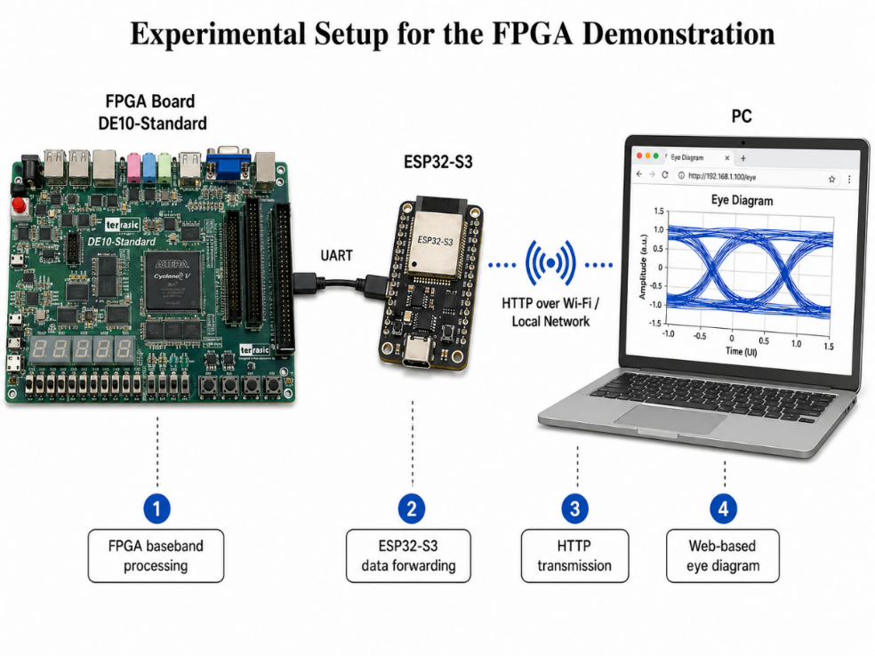
Figure 6.12. Experimental setup for the FPGA-based PAM-4 equalizer demonstration.
Figure 6.12 shows the experimental setup used for the FPGA-based PAM-4 equalizer demonstration. The DE10-Standard FPGA board performs the baseband processing, including PAM-4 signal generation, channel emulation, equalization, and debug sample selection. The selected internal samples are transmitted from the FPGA to the ESP32-S3 through UART, and the ESP32-S3 forwards the buffered samples to the PC through HTTP over a local Wi-Fi network. On the PC side, the received samples are reconstructed and displayed in a browser-based eye-diagram visualization interface.
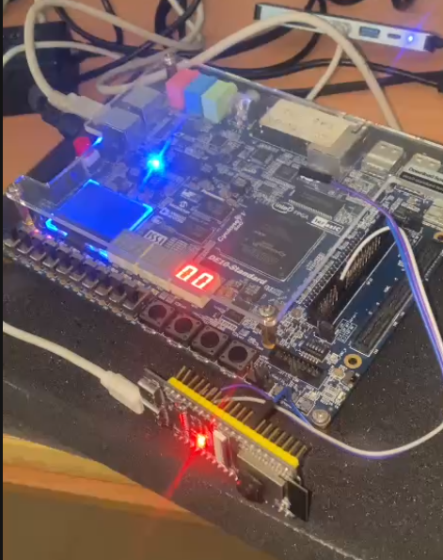
Figure 6.13. FPGA and ESP32-S3 hardware prototype.
Figure 6.13 presents the actual hardware prototype used in the demonstration. The DE10-Standard FPGA board is connected to the ESP32-S3 module through a UART debug interface, allowing internal FPGA samples to be exported for external monitoring. The FPGA board performs the digital baseband processing, while the ESP32-S3 acts as a UART-to-HTTP bridge for data forwarding. The active LEDs and seven-segment display indicate that the hardware prototype is powered and operating during the test.
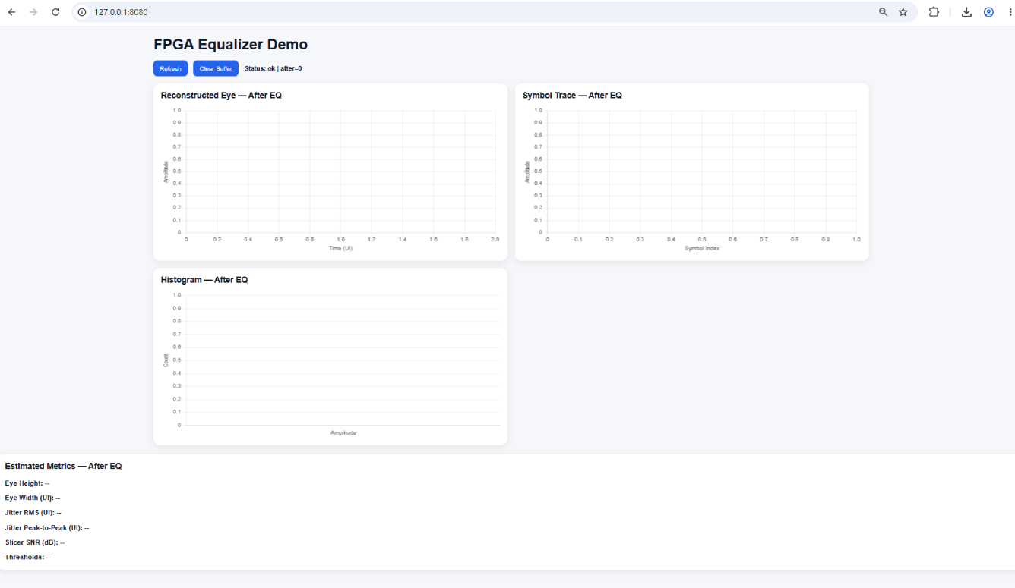
Figure 6.14. Initial web interface of the FPGA equalizer visualization system before data acquisition.
Figure 6.14 shows the web-based visualization interface before and after receiving valid sample data from the FPGA through the ESP32-S3 bridge. Before acquisition, the reconstructed eye diagram, symbol trace, histogram, and estimated metrics remain empty because no complete data frame has been decoded. After valid data is received, the interface displays the post-equalization eye diagram, recovered symbol trace, and PAM-4 output-level histogram as Figure 6.15. The estimated metrics, including eye height, eye width, jitter, slicer SNR, and decision thresholds, are then updated to evaluate the quality of the recovered PAM-4 signal.
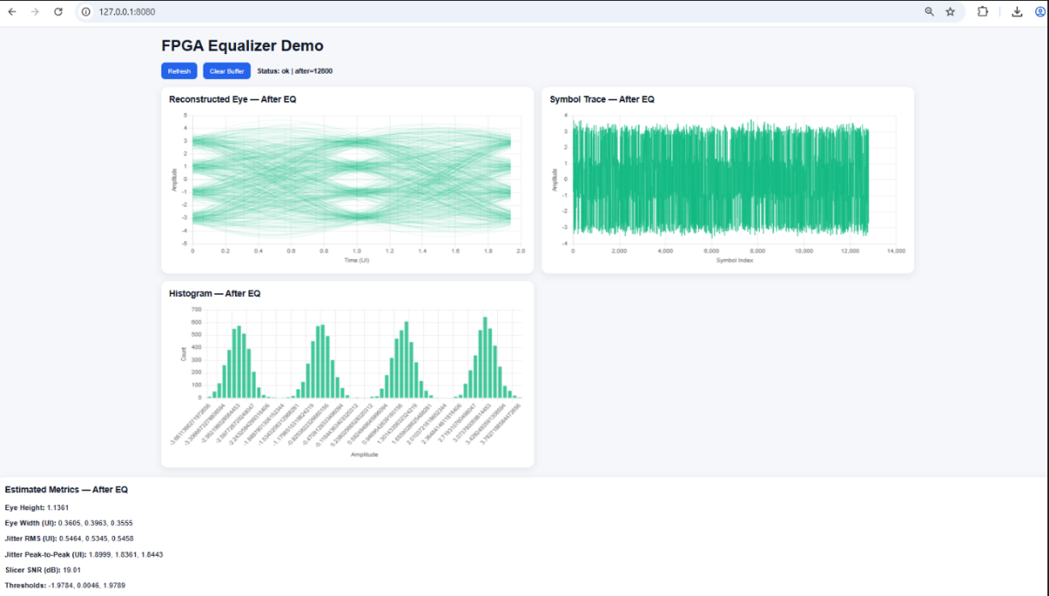
Figure 6.15. Web-based eye-diagram visualization after receiving FPGA equalizer data.

CHAPTER 7: CONCLUSION AND FUTURE WORK

7.1. Conclusion
7.1.1. Proposed AWGN Generator
This thesis designed and validated an FPGA-friendly AWGN generator for channel emulation and equalizer validation under a moderate-tail requirement. The purpose of the generator is not to provide deep-tail Gaussian generation for ultra-low-BER qualification, but deterministic and resource-efficient noise generation is suitable for digital baseband testing.
The proposed AWGN generator was designed using a CLT-based architecture. The implementation includes parallel Tausworthe random lanes, XOR combination, lightweight bit mixing, 12-bit extraction, a pipelined adder-tree summation block, mean-centering, and an output register. This structure avoids transcendental functions and large LUT-based inversion, making it suitable for fixed-point FPGA implementation.
The generator satisfies the main design goals defined in Chapter 3. First, the architecture supports deterministic throughput because the datapath produces one output sample per cycle after the pipeline is filled. Second, the latency is deterministic because the design does not use data-dependent iterations or rejection-based sampling. Third, the output is represented in a 16-bit fixed-point format, which makes it compatible with the rest of the baseband evaluation chain.
For target $σ=1$, the measured standard deviations are 1.00010703, 1.00002705, 1.00005305, and 1.00002050 for m=12, m=24, m=48, and m=96, respectively. The corresponding relative standard-deviation errors are 0.010703%, 0.002705%, 0.005305%, and 0.002050%. These results show that the proposed generator achieves accurate central-region noise scaling for the intended channel-emulation scope.
The synthesis results further confirm the effectiveness of the pipeline design. The non-pipelined AWGN generator achieves $f_{max}=100.3 MHz$, while the pipelined version reaches $f_{max}=382.7 MHz$. The design also uses no DSP blocks and no Block RAM. This confirms that the pipelined adder-tree structure significantly improves the maximum operating frequency while keeping the generator lightweight for FPGA implementation.
Part of the proposed AWGN generation design and its experimental evaluation was published in the proceedings of the 16th Annual Scientific and Technology Conference of the Faculty of Mechanical Engineering, 2025, under the title “PAM-4 Link with LMS-Adapted DFE: Noise Generation and Experimental Evaluation”, presentation code CDT-02. In addition, with the guidance and support of Assoc. Prof. Dr. Truong Quang Vinh, part of this thesis work has been accepted for presentation as a full paper acceptance at the IEEE International Conference on Communication and Electronics (IEEE ICCE 2026), Paper ID: 1571266382, under the title “A Fixed-Point CLT-Based FPGA AWGN Generator Using a Modified Three-Component Combined Tausworthe Backbone.”
7.1.2. Proposed LMS Equalizer
This thesis has designed and validated a compact fixed-point adaptive equalizer for PAM-4 symbol-rate equalization. Its objective is to establish a practical and implementation-consistent baseline for FPGA-based PAM-4 equalization.
The adopted equalizer structure is a 3-FFE + 1-DFE LMS equalizer with decision delay D=1. The feed-forward section processes the current and delayed received samples, while the feedback section cancels the dominant first-postcursor ISI using the previous detected symbol. It provides local ISI cancellation while maintaining low structural complexity.
The simulation results show that the equalizer provides measurable post-equalization improvement. The BER and SER decrease as SNR increases from 15 dB to 30 dB. The clipping-threshold sweep also shows that the robust clipping mechanism preserves the main LMS equalization behavior while slightly improving BER compared with plain LMS. The best clipping threshold is mostly 2.5 across the tested SNR range, with 2.0 selected at 29 dB and 30 dB. At 30 dB, the best median BER reaches $8.875× {10}^{-4}$, which is below the ${10}^{-3}$ FEC reference level used in the result analysis.
The eye-diagram results also confirm the effect of equalization. Before equalization, the received signal has a more closed eye due to ISI and noise. After equalization, the eye opening becomes clearer in both the no-AWGN case and the AWGN case at 20 dB. This shows that the equalizer can reduce channel distortion and improve PAM-4 symbol recovery quality. The synthesis results show that pipelining is also important for the equalizer hardware. The non-pipelined equalizer reaches $f_{max}=24.37 MHz$, while the pipelined version reaches $f_{max}=91.37 MHz$. The LUT usage increases from 791 to 1003, while the DSP usage remains at 16 blocks.

7.2. Future work
Several improvements can be considered for future development.
First, the AWGN generator can be further optimized for different trade-offs between statistical accuracy, hardware cost, and operating frequency. Although the proposed CLT-based generator achieves good standard-deviation accuracy and high frequency after pipelining, additional work can explore alternative random number generation structures, improved bit-mixing methods, and configurable noise variance control for more flexible channel emulation.
Second, the adaptive equalizer can be extended beyond the current 3-FFE + 1-DFE structure. Future designs may include more feed-forward and feedback taps to handle channels with longer ISI memory. More advanced adaptation algorithms, such as normalized LMS, variable step-size LMS, set-membership update, or hybrid robust adaptation methods, can also be investigated to improve convergence speed, tracking ability, and noise robustness.
Third, the current robust clipping and gating mechanism can be improved by using an adaptive clipping threshold. In the current result, the best clipping threshold changes slightly with SNR, where 2.5 is dominant for most SNR values and 2.0 is selected at high SNR. This suggests that a fixed clipping threshold may not be optimal for all channel and noise conditions. A future version can estimate the error statistics and adjust the clipping level automatically.
Fourth, the prototype can be expanded toward a more realistic PAM-4 communication environment. Future work can include a more detailed channel model, measured channel impulse responses, stronger ISI conditions, burst-noise conditions, and hardware-in-the-loop validation. This would help evaluate the equalizer under more practical channel impairments.
Finally, the FPGA demonstration can be improved by integrating a higher-throughput data transfer interface. The current UART-to-ESP32-S3-to-PC path is useful for low-rate debug and visualization, but it is not intended for high-speed continuous data capture. Future work may use faster interfaces such as USB, Ethernet, or direct memory-based transfer to support larger sample buffers and higher-rate eye-diagram monitoring.

REFERENCES
- John G. Proakis and Dimitris G. Manolakis, Digital Signal Processing: Principles, Algorithms, and Applications, 4th ed. Upper Saddle River, NJ, USA: Pearson Prentice Hall, 2007.
- Harold J. Kushner and G. George Yin, Stochastic Approximation and Recursive Algorithms and Applications, 2nd ed., Stochastic Modelling and Applied Probability (SMAP), vol. 35. New York, NY, USA: Springer, 2003, doi: 10.1007/b97441.
- B. Razavi, “A Circuit for All Seasons,” IEEE Solid-State Circuits Magazine, pp. 13–16, 132, Fall 2017, doi: 10.1109/MSSC.2017.2745939.
- Yu Gong and C. F. N. Cowan, "A self-structured adaptive decision feedback equalizer," in IEEE Signal Processing Letters, vol. 13, no. 3, pp. 169-172, March 2006, doi: 10.1109/LSP.2005.862601.
- Hyun-Chool Shin, A. H. Sayed, and Woo-Jin Song, “Variable step-size NLMS and affine projection algorithms,” IEEE Signal Processing Letters, vol. 11, no. 2, pp. 132–135, Feb. 2004, doi: 10.1109/LSP.2003.821722.
- F. Lounoughi and M. Djendi, "Decision Feedback Equalizer based Affine Projection and Normalized Least Mean Square Algorithms," 2023 International Conference on Advances in Electronics, Control and Communication Systems (ICAECCS), BLIDA, Algeria, 2023, pp. 1-6, doi: 10.1109/ICAECCS56710.2023.10105130.
- W. C. Lee, "Space–Time Adaptive Decision-Directed Equalizer Based on NLMS-Like Affine Projection Algorithm Using Iterative Hyperplane Projection," in IEEE Transactions on Vehicular Technology, vol. 56, no. 5, pp. 2790-2797, Sept. 2007, doi: 10.1109/TVT.2007.900394.
- M. Zhang, Y. Wang, X. Tu, F. Qu and H. Zhao, "Recursive Least Squares-Algorithm-Based Normalized Adaptive Minimum Symbol Error Rate Equalizer," in IEEE Communications Letters, vol. 27, no. 1, pp. 317-321, Jan. 2023, doi: 10.1109/LCOMM.2022.3199751.
- J. Li, W. X. Zheng and L. Yang, "Fast Converging Algorithm for Blind Equalization With Gaussian and Impulsive Noises," in IEEE Transactions on Signal Processing, vol. 73, pp. 372-385, 2025, doi: 10.1109/TSP.2025.3525663.
- Y. Yu, L. Lu, Y. Zakharov, R. C. d. Lamare and B. Chen, "Robust Sparsity-Aware RLS Algorithms With Jointly-Optimized Parameters Against Impulsive Noise," in IEEE Signal Processing Letters, vol. 29, pp. 1037-1041, 2022, doi: 10.1109/LSP.2022.3166395.
- Ahmad, J., Zubair, M., Rizvi, S.S.H. et al. Design and Analysis of the Fractional-Order Complex Least Mean Square (FoCLMS) Algorithm. Circuits Syst Signal Process 40, 5152–5181 (2021). https://doi.org/10.1007/s00034-021-01715-8.
- S. M. Shah, R. Samar, N. M. Khan, et al, “Design of Fractional-Order Variants of Complex LMS and NLMS Algorithms for Adaptive Channel Equalization,” Nonlinear Dyn., vol. 88, pp. 839–858, 2017, doi: 10.1007/s11071-016-3279-y.
- S. Wang et al., "Adaptive Bayes-Adam MIMO Equalizer With High Accuracy and Fast Convergence for Orbital Angular Momentum Mode Division Multiplexed Transmission," in Journal of Lightwave Technology, vol. 41, no. 15, pp. 5026-5036, 1 Aug. 2023, doi: 10.1109/JLT.2023.3250969.
- N. Kamiya, "ADMM-Based MIMO Equalization Algorithm for SDM Transmission With High MDL Tolerance," in IEEE Journal on Selected Areas in Communications, vol. 43, no. 5, pp. 1427-1439, May 2025, doi: 10.1109/JSAC.2025.3549888.
- A. Abdelaziz, Y. Cao and T. Musah, "Adaptation Approaches for PAMN Contingent Decision Equalizers," in IEEE Transactions on Circuits and Systems II: Express Briefs, vol. 72, no. 10, pp. 1388-1392, Oct. 2025, doi: 10.1109/TCSII.2025.3596834.
- J. V. G. De Souza, F. D. R. Henriques, N. N. Siqueira, L. Tarrataca, F. A. A. Andrade and D. B. Haddad, "Stochastic Modeling of the Set-Membership-Sign-NLMS Algorithm," in IEEE Access, vol. 12, pp. 32739-32752, 2024, doi: 10.1109/ACCESS.2024.3370439.
- L. C. Dantas et al., "Multi-Objective Optimization of Machine Learning-Based Nonlinear Equalizers for Digital Coherent Optical Interconnects," in IEEE Access, vol. 13, pp. 132782-132792, 2025, doi: 10.1109/ACCESS.2025.3588443.
- Sizhong Chen and Tong Zhang, "Self-timed dynamically pipelined adaptive signal processing system: a case study of DLMS equalizer for read channel," in IEEE Transactions on Circuits and Systems I: Regular Papers, vol. 52, no. 7, pp. 1338-1347, July 2005, doi: 10.1109/TCSI.2005.851694.
- J. Lee, K. Lee, H. Kim, B. Kim, K. Park and D. -K. Jeong, "A 0.1-pJ/b/dB 1.62-to-10.8-Gb/s Video Interface Receiver With Jointly Adaptive CTLE and DFE Using Biased Data-Level Reference," in IEEE Journal of Solid-State Circuits, vol. 55, no. 8, pp. 2186-2195, Aug. 2020, doi: 10.1109/JSSC.2020.2987690.
- J. Wang et al., "FPGA Implementation of a Real-Time Parallel Loop-Unrolled DFE for PAM-4 IM/DD Optical Links," in IEEE Photonics Technology Letters, vol. 38, no. 5, pp. 321-324, 1 March, 2026, doi: 10.1109/LPT.2025.3636126.
- X. Sun et al., "FPGA Real-Time Deployment of Low-Complexity Volterra Equalizer Based on Pruning and Non-Uniform Quantization," in Journal of Lightwave Technology, vol. 43, no. 9, pp. 4183-4192, 1 May, 2025, doi: 10.1109/JLT.2025.3533146.
- Z. Zhu et al., "Real-Time Deployment of Pruned Volterra Algorithm for PAM4 Signals in a W-Band Wireless System," in Journal of Lightwave Technology, vol. 42, no. 20, pp. 7193-7201, 15 Oct. 2024, doi: 10.1109/JLT.2024.3418816.
- P. H. Prajapati and A. D. Darji, “FPGA Implementation of MRMN With Step-Size Scaler Adaptive Filter for Impulsive Noise Reduction,” Circuits Syst. Signal Process., vol. 39, pp. 3682–3710, 2020, doi: 10.1007/s00034-019-01339-z.
- Y. Tian, J. Song, S. Liu, H. He, J. Ming, Y. Mu, R. Wang, X. Pan, X. Xin, and Z. Dong, “FPGA-Based Hardware Implementation of Integrated FEC Equalization in Bandwidth-Efficient IM/DD Optical Interconnection,” Opt. Express, vol. 33, pp. 42005–42012, 2025, doi: 10.1364/OE.572600.
- J. Lee, Y. Chang, J. Yun, S. Seo, Y. -U. Jeong and S. Kim, "MTA-Coded PAM-4 Receiver with Decision Feedback Power Saving Scheme and Partial DFE for Low-Power Memory Interfaces," 2025 IEEE/ACM International Symposium on Low Power Electronics and Design (ISLPED), Reykjavík, Iceland, 2025, pp. 1-6, doi: 10.1109/ISLPED65674.2025.11261813.
- P. L’Ecuyer, “Maximally equidistributed combined Tausworthe generators,” Mathematics of Computation, vol. 65, no. 213, pp. 203–213, Jan. 1996, doi: 10.1090/S0025-5718-96-00696-5.
- D. U. Lee, W. Luk, J. D. Villasenor, G. Zhang, and P. H. W. Leong, “A hardware Gaussian noise generator using the Wallace method,” IEEE Transactions on Very Large Scale Integration (VLSI) Systems, vol. 13, no. 8, pp. 911–920, Aug. 2005, doi: 10.1109/TVLSI.2005.853615.
- D. U. Lee, J. D. Villasenor, W. Luk, and P. H. W. Leong, “A hardware Gaussian noise generator using the Box-Muller method and its error analysis,” IEEE Transactions on Computers, vol. 55, no. 6, pp. 659 – 671, Jun. 2006, doi: 10.1109/TC.2006.81.
- J. Su and J. Han, “An improved Ziggurat-based hardware Gaussian random number generator,” in Proc. 2016 13th IEEE Int. Conf. Solid State Integr. Circuit Technol. (ICSICT), 2016, pp. 1606–1608, doi: 10.1109/ICSICT.2016.7998817.
- J. S. Malik and A. Hemani, “Gaussian random number generation: A survey on hardware architectures,” ACM Computing Surveys, vol. 49, no. 3, Art. 53, Oct. 2016, doi: 10.1145/2980052.
- M. Maamoun, H. Ait Saadi, S. Dahmani, G. Zerari, N. Chabini and R. Beguenane, “An optimized FPGA based Box-Muller Gaussian random number generator architecture for communication applications,” in Proc. IEEE 12th Annu. Inf. Technol., Electron. Mobile Commun. Conf. (IEMCON), 2021, doi: 10.1109/IEMCON53756.2021.9623205.
- K. Puntsri, B. Bunsri, Y. Pittayang, T. Bubpawan, W. Partipralam, and W. Phakphisut, “Reconfigurable AWGN generator using Box Muller method with CORDIC-based square root calculation,” in Proc. 37th Int. Tech. Conf. Circuits/Systems, Comput. Commun. (ITC-CSCC), 2022, doi: 10.1109/ITC-CSCC55581.2022.9894924.
- D. Zou, K. Song, Z. Chen, C. Zhu, T. Wu, and Y. Xu, “FPGA-based configurable and highly flexible PAM4 SerDes simulation system,” IEEE Transactions on Very Large Scale Integration (VLSI) Systems, vol. 31, no. 9, pp. 1294–1307, Sep. 2023, doi: 10.1109/TVLSI.2023.3286803.
- Z. Chen, K. Song, D. Zou, C. Zhu, and Y. Xu, “Flexible FPGA Gaussian random number generators with reconfigurable variance,” IEEE Transactions on Circuits and Systems I: Regular Papers, vol. 71, no. 5, pp. 2384–2397, May 2024, doi: 10.1109/TCSI.2024.3374731.
- A. B. Nair, A. Mondal and S. S. Garani, "A Low-complexity Hardware AWGN Channel Emulator on FPGA using Central Limit Theorem," 2018 IEEE 61st International Midwest Symposium on Circuits and Systems (MWSCAS), Windsor, ON, Canada, 2018, pp. 428-431, doi: 10.1109/MWSCAS.2018.8623918.
- C. A. Gómez-Vega, E. G. Hernández, H. A. Pérez-Guerrero, D. I. Torres-Uresti, J. L. Tecpanecatl-Xihuitl and C. A. Gutiérrez, "Hardware/Software Design for the Simulation of AWGN Communication Channels," 2019 IEEE 39th Central America and Panama Convention (CONCAPAN XXXIX), Guatemala City, Guatemala, 2019, pp. 1-5, doi: 10.1109/CONCAPANXXXIX47272.2019.8977092.
- Gangadharaiah.S. L, Narayanappa C. K., Nuthan Prasad V., Divya M. N. & Anirudha Rao. “FPGA Implementation of Efficient VLSI Architecture of DLMS Adaptive Filter Algorithm.” Turkish Journal of Computer and Mathematics Education (TURCOMAT), 12(14), 478–489, 2021. DOI: 10.17762/turcomat.v12i14.10310.
- A. Pathan and T. D. Memon, “Sigma-delta modulation based single-bit adaptive DSP algorithms for efficient mobile communication,” Circuits, Systems, and Signal Processing, vol. 40, no. 4, pp. 1788–1801, Apr. 2021, doi: 10.1007/s00034-020-01553-0.
- Terasic Inc. (2016). DE10 User Manual (Rev. 1.0). Retrieved from https://www.terasic.com.tw/en/.

Appendix A. Derivation of the excess kurtosis under CLT Gaussianization
The excess kurtosis of a zero-mean, unit-variance random value is defined as $γ_{2}\left(Z\right)=E\left[Z^{4}\right]-3$.
In the central limit theorem of Gaussianization, we get $U_{i} \sim U (0,1)$ i.i.d, and we have the definition below.
$$X_{i}=U_{i}-\frac{1}{2}$$ | A.1
When the value $X_{i}$ is symmetric about 0, so $E\left[X\right]=0$ and odd central moments vanish.
Compute the second and fourth moments:
$$E\left[X^{2}\right]=\int_{0}^{1}{{\left(u-\frac{1}{2}\right)}^{2}du=\frac{1}{12}, σ_{X}^{2}=Var\left(X\right)=\frac{1}{12}}$$ | A.2
$$E\left[X^{4}\right]=\int_{0}^{1}{{\left(u-\frac{1}{2}\right)}^{4}du=\frac{1}{80}}$$ | A.3
Hence the non-excess kurtosis of X is
$$κ\left(X\right)≜\frac{E\left[X^{4}\right]}{σ_{X}^{4}}=\frac{\frac{1}{80}}{{\left(\frac{1}{12}\right)}^{2}}=\frac{144}{80}=1.8$$ | A.4
So, the excess kurtosis is
$$γ_{2}\left(X\right)≜κ\left(X\right)-3=1.8-3=-1.2=-\frac{6}{5}$$ | A.5
Now let $X_{1},...,X_{m}$ be independent and identically distributed copies of $X$, and define the standardized sum.
$$Z_{m}≜\frac{\sum_{i=1}^{m}{X_{i}}}{\sqrt{m}σ_{X}}$$ | A.6
Using independence and zero-mean, the fourth moment of the sum satisfies
$$E\left[{\left(\sum_{i=1}^{m}{X_{i}}\right)}^{4}\right]=mE\left[X^{4}\right]+6\sum_{1≤i<j≤m}{E\left[X_{i}^{2}\right]E\left[X_{j}^{2}\right]}=mE\left[X^{4}\right]+3m\left(m-1\right)σ_{X}^{4}$$ | A.7
Divide by ${\left(Var(\sum{X_{i}})\right)}^{2}={\left(mσ_{X}^{2}\right)}^{2}={m^{2}σ}_{X}^{4}$
$$E\left[{Z_{m}}^{4}\right]=\frac{mE\left[X^{4}\right]+3m(m-1)σ_{X}^{4}}{{m^{2}σ}_{X}^{4}}=\frac{κ\left(X\right)}{m}+3\left(1-\frac{1}{m}\right)$$ | A.8
Therefore
$$γ_{2}\left(Z_{m}\right)=E\left[{Z_{m}}^{4}\right]-3=\frac{κ\left(X\right)-3}{m}=\frac{γ_{2}\left(X\right)}{m}=\frac{-6}{5m}$$ | A.9

Appendix B. Weak-Limit Analysis and Frozen-State ODE Validation
We consider the practical projected update in the design
$$θ\left[n+1\right]=Π_{H}\left(θ\left[n\right]+μ_{n}ψ\left(e\left[n\right]\right)ϕ\left[n\right]\right)$$ | B.1
Define the update field
$$H\left(θ,ξ\right)∶=ψ\left(e\left(θ,ξ\right)\right)ϕ\left(ξ\right)$$ | B.2
Where $ξ$ denotes the internal state of the equalizer.
Then the recursion can be rewritten as
$$θ\left[n+1\right]=Π_{H}\left(θ\left[n\right]+μ_{n}H\left(θ\left[n\right],Ξ_{n}\right)\right)$$ | B.3
Where $Ξ_{n}$ is an augmented internal state containing all variables needed to make the recursion Markov.
For each fixed $θ∈H$, define the frozen state kernel
$$P_{θ}\left(ξ,A\right)∶=Pr\left\{Ξ_{n+1}∈A |{ Ξ}_{n}=ξ,θ_{n}=θ \right\}$$ | B.4
Under the frozen state ergodicity assumption, $P_{θ}$ admits an invariant probability measure $π_{θ}$. Then define the averaged drift
$$\overline{h}\left(θ\right)∶=\int{H\left(θ,ξ\right)π_{θ}\left(dξ\right)}$$ | B.5
Also define the centered fluctuation field
$$\tilde{H}\left(θ,ξ\right)∶=H\left(θ,ξ\right)- \overline{h}\left(θ\right)$$ | B.6
This is the key frozen-state averaging step: under the invariant law $π_{θ}$, the random update field splits into a deterministic averaged part $\overline{h}\left(θ\right)$ and a centered fluctuation $\tilde{H}\left(θ,ξ\right)$.
To isolate the averaged drift in the presence of Markovian dependence, introduce the Poisson equation.
$$v_{θ}-P_{θ}v_{θ}\left(ξ\right)=\tilde{H}\left(θ,ξ\right)$$ | B.7
Here $v_{θ}$ is the Poisson corrector associated with the frozen kernel $P_{θ}$. Using the equation (B.7), one obtains
$$H\left(θ,ξ\right)=\overline{h}\left(θ\right)+v_{θ}-P_{θ}v_{θ}\left(ξ\right)$$ | B.8
Substituting $θ= θ\left[n\right]$ and $ξ=Ξ_{n}$
$$H\left(θ\left[n\right] ,ξ\right)=\overline{h}\left(θ\left[n\right] \right)+v_{θ\left[n\right] }-P_{θ\left[n\right] }v_{θ}\left(Ξ_{n}\right)$$ | B.9
Now add and subtract $v_{θ\left[n\right] }\left(Ξ_{n+1}\right)$
$$H\left(θ\left[n\right] ,ξ\right)=\overline{h}\left(θ\left[n\right] \right)+\underset{telescoping term }{\underbrace{v_{θ\left[n\right]}-v_{θ\left[n\right] }\left(Ξ_{n+1}\right)}}+ \underset{ξ_{n+1}}{\underbrace{{v_{θ\left[n\right] }\left(Ξ_{n+1}\right)-P}_{θ\left[n\right] }v_{θ}\left(Ξ_{n}\right)}}$$ | B.10
By construction,
$$E\left[ξ_{n}+1|F_{n}\right]=0$$ | B.11
So $ξ_{n+1}$ is the corrected martingale-difference fluctuation term, this is the role of the perturbed test function / Poisson correction: it absorbs the state-dependent Markov fluctuation and exposes the averaged drift.
Because $v_{θ}$ depends on $θ$, the change of parameter from $θ\left[n\right]$ to $θ\left[n\right]+1$ produces additional remainder terms.
Define
$$δ_{v_{n+1}​}∶=v_{θ[n+1]}\left(Ξ_{n+1}\right)-v_{θ[n]}\left(Ξ_{n+1}\right)$$ | B.12
Then the update field admits a refined decomposition of the form
$$H\left(θ\left[n\right],Ξ_{n}\right)=\overline{h}\left(θ\left[n\right]\right)+ξ_{n+1}+r_{n+1}+\frac{1}{μ_{n}}\left(v_{θ[n+1]}\left(Ξ_{n+1}\right)-v_{θ[n]}\left(Ξ_{n+1}\right)\right)$$ | B.13
Where $r_{n+1}$ collects the higher-order terms induced by the state dependence of the kernel and the slow variation of $θ\left[n\right]$.
After multiplying by $μ_{n}$ and summing over $n$: the telescoping term cancels in partial sums; the martingale term is controlled using $\sum_{n}{{μ_{n}}^{2}<∞}$ and the remainder term vanishes under the Lipschitz/boundedness conditions.
Hence the recursion may be rewritten as
$$θ_{n+1}=Π_{H}\left[θ_{n}+μ_{n}\left[\overline{h}\left(θ\left[n\right]\right)+ξ_{n+1}+r_{n+1}\right]\right]$$ | B.14
with
$$E\left[ξ_{n}+1|F_{n}\right]=0, r_{n+1}→0$$ | B.15

Using compactness of $H$, boundedness of $ϕ\left[n\right]$, one obtains
$$\left\|H\left(θ\left[n\right],Ξ_{n}\right)\right\|≤C_{H}$$ | B.16
For some constant $C_{H}>0$. Since Euclidean projection onto a convex compact set is nonexpansive
$$\left\|θ\left[n+1\right]-θ\left[n\right]\right\|≤{μ_{n}C}_{H}$$ | B.17
This gives bounded increments. From here, the usual piecewise-linear interpolation of $θ\left[n\right]$ is uniformly bounded and equicontinuous on compact time intervals. By Arzelà–Ascoli, the interpolated family is relatively compact, which gives tightness of the sequence of interpolated trajectories. The argument consists of three standard proof blocks: bounded increments, equicontinuity, and compactness/tightness.
Now move to identification of the weak limit. Let $f∈C_{c}^{∞}$ be a smooth test function. Then we have the equation expanded of $f(θ[n+1])-f(θ[n])$ by using Taylor’s formula as below:
$f\left(θ\left[n+1\right]\right)-f\left(θ\left[n\right]\right)= μ_{n}∇f{\left(θ\left[n\right]\right)}^{T}\overline{h}\left(\left(θ\left[n\right]\right)\right)+μ_{n}∇f{\left(θ\left[n\right]\right)}^{T}ξ_{n+1}+μ_{n}∇f{\left(θ\left[n\right]\right)}^{T}r_{n+1}+o\left(μ_{n}\right)$ | B.18
After summing over time, we get the martingale term vanishes in the weak limit, the remainder term vanishes and only the drift term survives.
$$Lf\left(θ\right)=∇{f\left(θ\right)}^{T}\overline{h}\left(θ\right)$$ | B.19
Without projection, this identifies the limit as the solution of
$$\dot{θ}\left(t\right)=\overline{h}\left(θ\left(t\right)\right)$$ | B.20
Because the practical recursion uses projection onto $H$, the limiting dynamics must also be projected. Therefore, the weak limit is governed by the projected mean ODE.
$$\dot{θ}\left(t\right)=Π_{T_{H}\left(θ\left(t\right)\right)}\overline{h}\left(θ\left(t\right)\right)$$ | B.21
Where $T_{H}\left(θ\right)$ is the tangent cone of $H$ at $θ$.
Equivalently, this may be written as the projected differential inclusion.
$$\dot{θ}\left(t\right)∈\overline{h}\left(θ\left(t\right)\right)- N_{H}\left(θ\left(t\right)\right)$$ | B.22
Where $N_{H}\left(θ\right)$ is the normal cone, this is the final weak-limit object associated with the practical projected recursion.
Now we move to the validation for the weak limit projected recursion.
The adaptive equalizer is a stochastic recursive algorithm. Its update can be written in the generic projected stochastic approximation form:
$$θ_{n+1}=Π_{H}\left[θ_{n}+μ_{n}H\left(θ_{n},Z_{n}\right)\right]$$ | B.23
Where $Z_{n}$ represents the data, channel state, noise realization and decision dependent variables observed by the adaptive receiver.
The ODE method interprets the stochastic recursion through its averaged drift. For a fixed operating condition define
$$\overline{H}\left(θ\right)=E\left[H\left(θ,Z\right)\right]$$ | B.24
The corresponding mean ODE is
$$\frac{dθ\left(t\right)}{dt}=\overline{H}\left(θ(t)\right)$$ | B.25
The implemented adaptive recursion is consistent with the intended stochastic approximation model, then the averaged SA trajectory should follow the ODE mean trajectory under a small or diminishing step size regime.
The algorithmic time scale is defined by the accumulated step size
$$t_{n}=\sum_{k=0}^{n-1}{μ_{k}}$$ | B.26
This time scale is used because stochastic approximation trajectories evolve according to accumulated update strength, not only according to the raw sample index.
To isolate the mean drift behavior, the ODE sanity experiment uses a frozen Markov state. Under a fixed state s, the averaged drift becomes
$${\overline{H}}_{s}\left(θ\right)=E\left[H\left(θ,Z\right)|S=s\right]$$ | B.27
The corresponding frozen state ODE is
$$\frac{dθ_{s}\left(t\right)}{dt}={\overline{H}}_{s}\left(θ_{s}\left(t\right)\right)$$ | B.28
Freezing the Markov state removes the additional variation due to channel state switching. This makes it possible to check whether the local adaptive recursion follows the correct mean direction in each fixed operating state. For each fixed state, multiple stochastic trials are generated from the same initial condition. The SA trajectory is recorded as
$$θ_{j}^{SA}\left(t_{k}\right), j=1,…,N_{trial}$$ | B.29
The empirical SA mean is
$${\overline{θ}}^{SA}\left(t_{k}\right)=\frac{1}{N_{trial}}\sum_{j=1}^{N_{trial}}{θ_{j}^{SA}\left(t_{k}\right)}$$ | B.30
The uncertainty band is represented using the standard error of the mean:
$$SEM\left(t_{k}\right)=\frac{std\left(θ_{1:N_{trial}}^{SA}\left(t_{k}\right)\right)}{\sqrt{N_{trial}}}$$ | B.31
The ODE trajectory is computed using an Euler discretization of the averaged drift:
$$θ^{ODE}\left(t_{k+1}\right)=Π_{H}\left[θ^{ODE}\left(t_{k}\right)+∆t_{k}{\hat{\overline{H}}}_{S}\left(θ^{ODE}\left(t_{k}\right)\right)\right]$$ | B.32
Where,
$$∆t_{k}=\sum_{n=n_{k}}^{n_{k+1}-1}{μ_{n}}$$ | B.33
The SA mean and the ODE mean are then plotted on the same algorithmic-time axis. This comparison is the main visual evidence supporting the ODE interpretation.
To quantify the SA versus ODE agreement, the validation computes normalized path and terminal mismatches.
Let K be the number of sampled time-grid points. The late-path comparisons starts after the early transient
$$k_{0}=max\left(2,\left[0.3K\right]\right)$$ | B.34
A normalization scale is defined as
$$R=max\left\{range\left(θ^{SA}\right),range\left(θ^{ODE}\right),ϵ\right\}$$ | B.35
Where $ϵ$ is a small positive constant preventing division by zero.
The normalized late-path mismatch is
$$M_{path}=\frac{1}{K-k_{0}+1}\sum_{k=k_{0}}^{K}{\frac{\left|θ^{SA}\left(t_{k}\right)-θ^{ODE}\left(t_{k}\right)\right|}{R}}$$ | B.36
The normalized terminal mismatch is
$$M_{term}=\frac{\left|θ^{SA}\left(t_{k}\right)-θ^{ODE}\left(t_{k}\right)\right|}{R}$$ | B.37
In addition to one-dimensional comparison, the validation also visualizes the local projected mean drift field.
Two coordinates of the tap vectors are selected to form a two-dimensional slice of the adaptive space. In the current configuration, the selected coordinates correspond to the main FFE tap and the first DFE tap:
$$\left(i_{1},i_{2}\right)=\left(D+1,N_{f}+1\right)$$ | B.38
A local grid is defined around the reference tap vector
$$\left(θ_{i_{1}},θ_{i_{2}}\right)∈G$$ | B.39
At each grid point, the mean projected drift is estimated
$${\hat{\overline{H}}}_{G}\left(θ_{i_{1}},θ_{i_{2}}\right)=\left[\begin{matrix}{\hat{\overline{H}}}_{i_{1}}\left(θ\right) \\ {\hat{\overline{H}}}_{i_{2}}\left(θ\right)\end{matrix}\right]$$ | B.40
The resulting vector field is plotted together with the decreasing step adaptive trajectory:
$$\left(θ_{i_{1}}\left[n\right],θ_{i_{2}}\left[n\right]\right)$$ | B.41
If the trajectory follows the dominant direction of the drift field and remains inside the feasible region, this supports the claim that the adaptive recursion is not merely producing arbitrary stochastic motion but following a structured mean adaptation law.
The ODE validation is included to answer why the adaptive equalizer can be discussed using stochastic approximation and ODE language. The ODE diagnostic gives a separate structural check that the implemented recursion follows the expected averaged dynamics under controlled conditions.
This interpretation is especially important because the equalizer operates in a decision-directed feedback loop, where the update noise depends on previous symbol decisions.

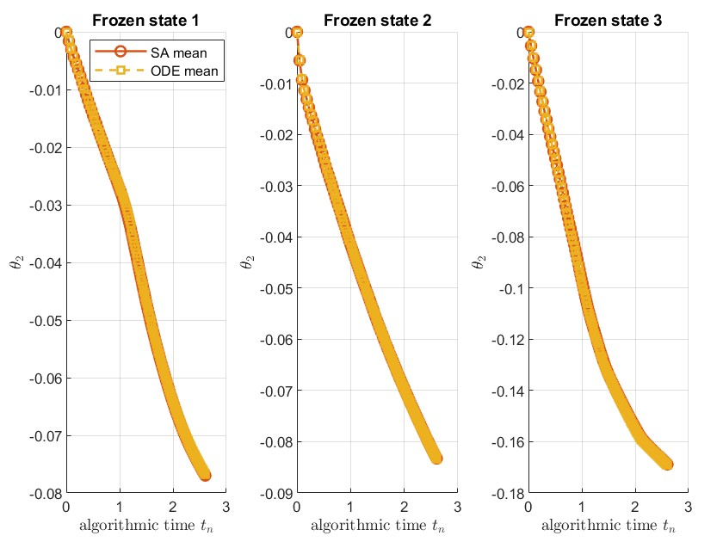
Appendix B.1. SA mean versus ODE mean under frozen states
This experiment validates why the adaptive equalizer can be interpreted using an ODE-based stochastic approximation viewpoint. The 3-FFE/1-DFE adaptive update can be viewed as a projected stochastic recursion of the form.
$$θ_{n+1}=Π_{H}\left[θ_{n}+μ_{n}H\left(θ_{n},Z_{n}\right)\right]$$
Where $θ_{n}$ contains the 3 FFE taps and 1 DFE tap, $Z_{n}$ represents the data/noise/state variables, $μ_{n}$ is the step size and $Π_{H}$ is the projection onto the feasible tap set.
In this experiment, the Markov channel state is frozen. This removes state switching effects and isolates the mean drift of the adaptive recursion in each fixed operating condition. Across frozen states 1, 2 and 3, the SA mean and ODE mean almost overlap. Both curves move in the same direction and show nearly the same trajectory shape. This result indicates that the averaged stochastic equalizer update follows the mean ODE drift under controlled frozen state conditions. Therefore, the ODE method is reasonable as an explanatory tool for the average behavior of the adaptive equalizer.
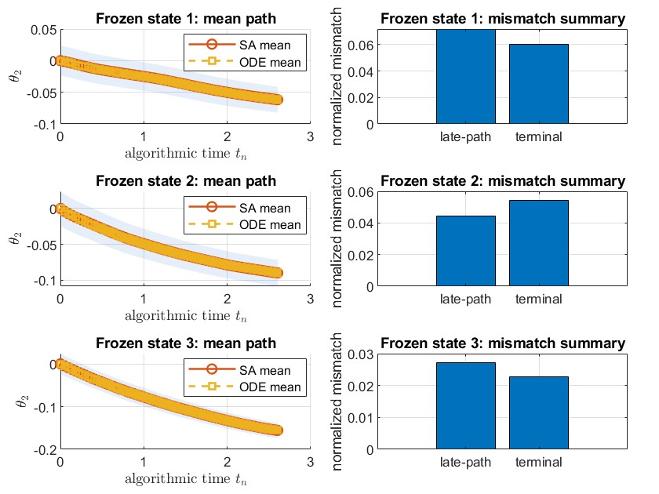
Appendix B.2. Frozen-state ODE sanity check for the adaptive equalizer
This experiment extends the frozen-state ODE validation by using multiple initializations and reporting quantitative mismatch summaries. The left column compares the mean SA path and ODE path for frozen states 1, 2 and 3. The shaded region represents uncertainty around the SA mean. The right column reports two normalized mismatch measures. The late-path mismatch measures the average normalized difference between the SA mean and ODE mean after the early transient. The terminal mismatch measures the normalized difference at the final algorithmic time point. For all three frozen states, the ODE path remains close to the SA mean path. The mismatch bars are small on the normalized scale, indicating that the ODE trajectory approximates the averaged stochastic trajectory well in this experiment. Frozen state 3 shows the smallest visible mismatch among the three states, while frozen state 1 shows a larger but still bounded mismatch. This suggests that the quality of the ODE approximation depends on the frozen operating state, but the overall SA-versus-ODE agreement remains strong.

