**Machine learning:**

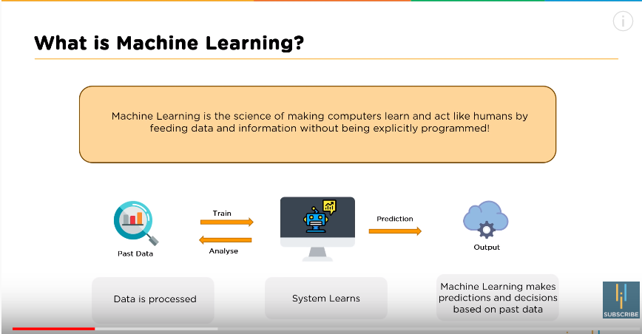

**🡪Supervised machine learning:** It learns under supervison

**Labelled data set:** Means data having both features and and targets(Ex: if we show the image and says it’s a dog to our machine then it’s a labelled data because we are saying the target data to the machine.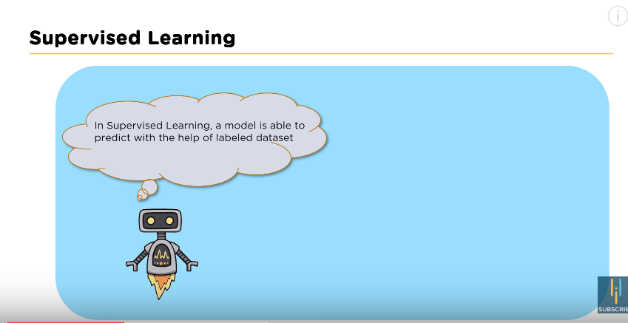

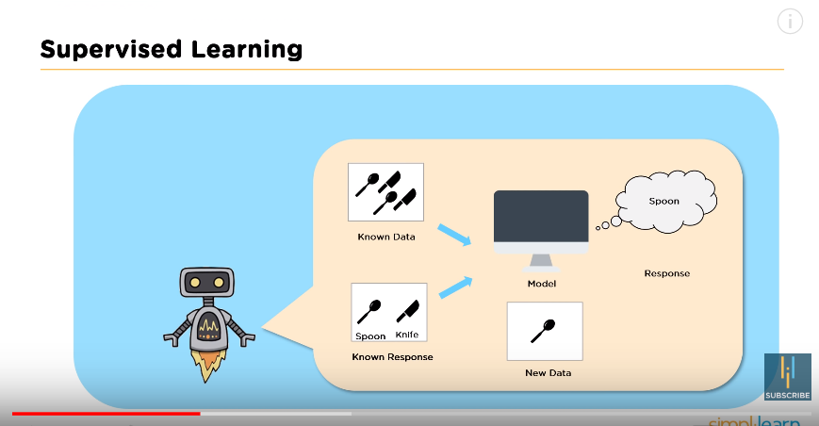

->As shown in above image knife is one label and spoon is another labelled data when we give new data it will predict whether it is a spoon or knife based on parameters(sharpness,thickness) algorithm will predict the spoon based on the labelled data so it is a supervised algorithm.

Supervised classified in to two types:

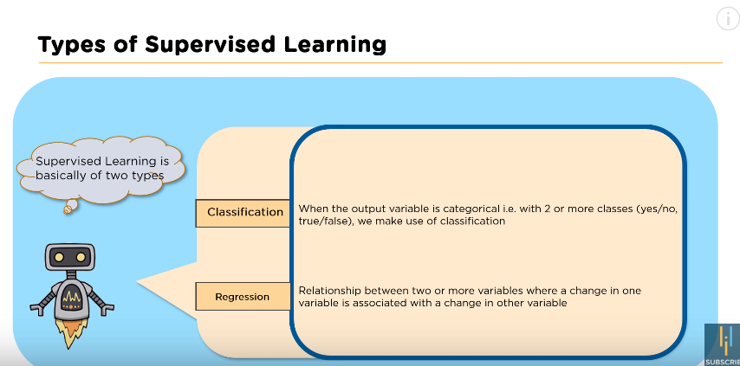

Classification:

Based on the data in which it is trained algorithm determines to which class the data is referring to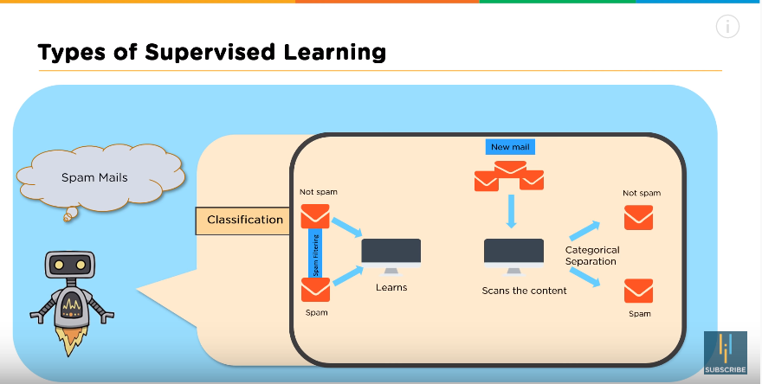

Regression:

->here the weather predictions can be made since our algorithm learns when the temp increases humidity decrease this Is learned by our system and acts on the new data(output depends on the other variable which it is dependent on

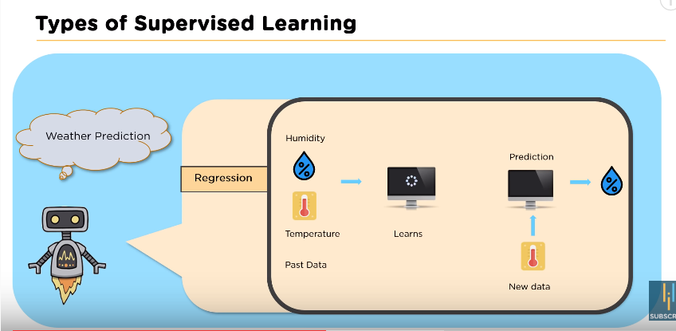

**Where supervised is used:**

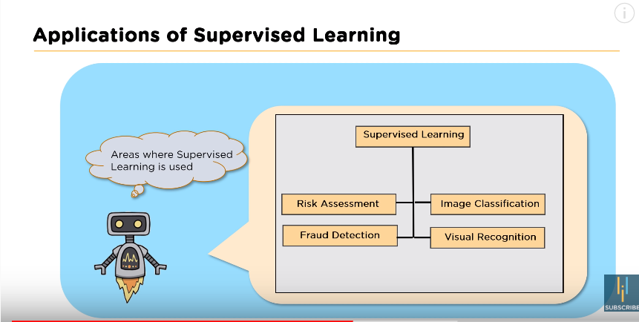

Unsupervised:no supervision allowing the data to learn on the unlabelled data

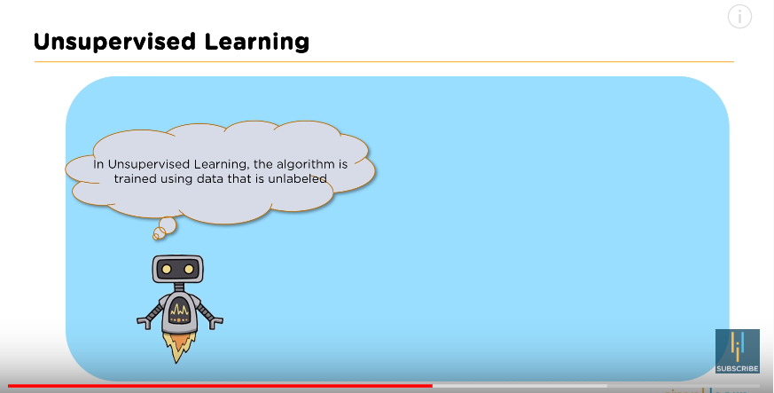

Ex:Here we are not saying that this is knife or spoon but machine will learn based on the data available. 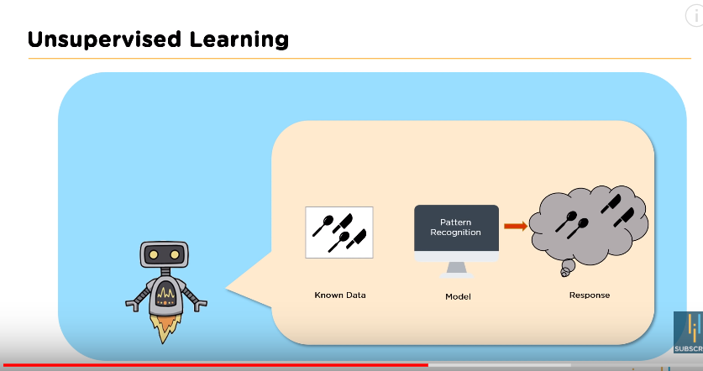

Clustering and Association: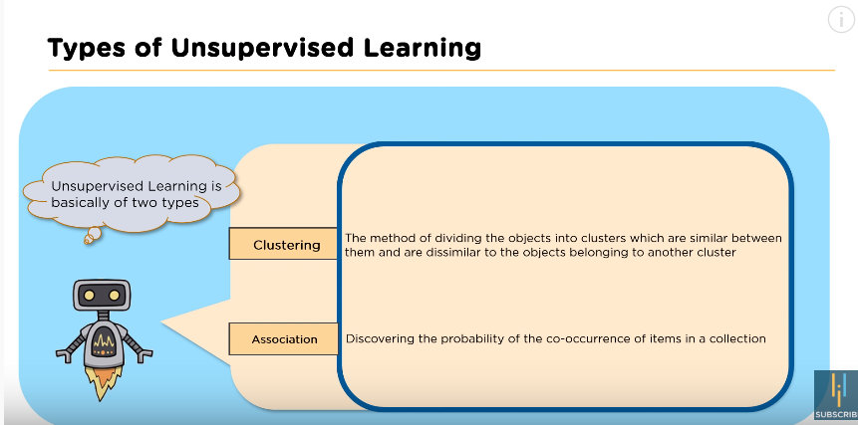

**Clustering:basedon he type of usage plans are given to customers to generate more revenue**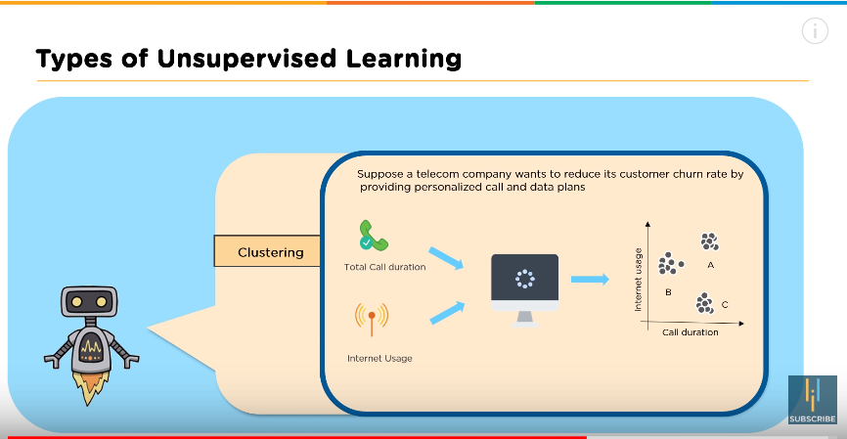

**Association:**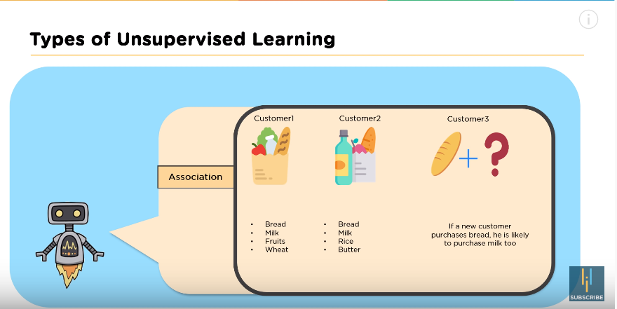

**Applications:**

Semantic clustering best example is based on the type of questions data is splitted(quora)

->used for demand and supply predicting the usage earlier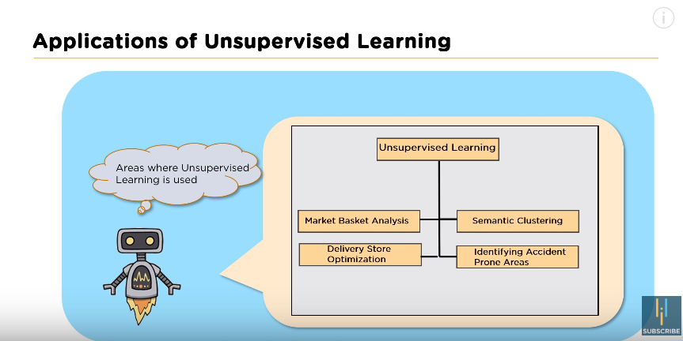

🡪Summmary:

