ΕΘΝΙΚΟ ΜΕΤΣΟΒΙΟ ΠΟΛΥΤΕΧΝΕΙΟ
ΣΧΟΛΗ ΗΛΕΚΤΡΟΛΟΓΩΝ ΜΗΧΑΝΙΚΩΝ ΚΑΙ ΜΗΧΑΝΙΚΩΝ ΥΠΟΛΟΓΙΣΤΩΝ
ΔΠΜΣ ΕΠΙΣΤΗΜΗ ΔΕΔΟΜΕΝΩN ΚΑΙ ΜΗΧΑΝΙΚΗ ΜΑΘΗΣΗ

Διαχείριση Δεδομένων Μεγάλης Κλίμακας
Ακαδημαϊκό έτος 2023-24, Εαρινό Εξάμηνο
Διδάσκοντες: Δημήτριος Τσουμάκος, Ιωάννης Κωνσταντίνου
Υπεύθυνος Εργαστηρίου: Νικόλαος Χαλβαντζής
10 Μαΐου 2024

Εξαμηνιαία Εργασία
Φοιτητές:

Data Description
Los Angeles Crime Data
The main dataset used in this project is the Los Angeles Crime Data, obtained from the public data repository of the City of Los Angeles. This dataset contains detailed records of crime incidents reported in the city, divided into two separate CSV files based on the time period they cover:
File 1: Contains crime data from the year 2010 up to 2019
File 2: Contains crime data from the year 2020 to present.
In addition to the above data, a series of smaller datasets that include information on police station locations, median household income, and ZIP code mappings will be used.

LA Police Stations
This dataset contains the locations of the 21 police stations in the city of Los Angeles. It is sourced from the public data repository of the City of Los Angeles and contains records described by the variables:
- OBJECTID: a unique identifier for each record
- DIVISION: the name of the division
- LOCATION: the address of the police station
- PREC: the precinct code
- x: the longitude coordinate of the police station
- y: the latitude coordinate of the police station
This dataset will help analyze the proximity of crime incidents to police stations and assess if there's any spatial correlation between crime rates and the presence of police stations.
Median Household Income by Zip Code (Los Angeles County):
This dataset contains information on the median household income for various areas in Los Angeles County, broken down by ZIP code. The data is based on census results from the years 2015, 2017, 2019, and 2021. For this project, only 2015 data will be used. Each record in this dataset is described by the variables:
- ZIP Code
- Community
- Estimated Median Income
This dataset will allow for an analysis of the socio-economic factors that may influence crime rates in different parts of Los Angeles.
Reverse Geocoding:
Geocoding refers to translating an address into a location in a coordinate system, while reverse geocoding is the process of mapping a pair of coordinates (latitude, longitude) to an address or a ZIP code. For this project, reverse geocoding is used, and this dataset provides the necessary mapping of coordinates to ZIP codes for the city of Los Angeles. Each record is described by the following variables:
- X: the longitude coordinate
- Y: the latitude coordinate
- FID: a unique identifier for each record
- DIVISION: the police division or precinct name
- LOCATION: the address of the location
- PREC: the precinct code

Task 1
To set up Apache Spark and the Hadoop Distributed File System (HDFS) in a distributed environment, we began by creating two VirtualBox virtual machines (VMs) using a pre-configured Ubuntu Server 22.04 image. One VM was designated as the master node and the other as the worker node. Each VM was allocated 4GB of RAM and 2 CPUs to ensure adequate resources. We configured the VMs with bridged network adapters to facilitate network communication. Unique hostnames were assigned, and IP addresses were obtained for both VMs to ensure proper connectivity. Next, we installed Hadoop on both VMs, configuring the core-site.xml, hdfs-site.xml, mapred-site.xml, and yarn-site.xml files. After formatting the namenode, we started the HDFS services. Following the Hadoop setup, we installed Apache Spark on both VMs. We configured the spark-env.sh and slaves files to define the master and worker nodes, ensuring that the Spark master could recognize the worker nodes. We then started the Hadoop HDFS and YARN services, followed by the Spark master and worker services. Finally, we verified the successful setup by connecting to the VMs via SSH, checking the service statuses, and ensuring that the web interfaces for HDFS and the Spark Job History Server were accessible from a web browser. This process resulted in a fully distributed Apache Spark and HDFS environment with accessible web applications for monitoring and management.

Task 2
To create a directory in HDFS for storing datasets in .csv format, we executed the command hadoop fs -mkdir -p /datasets. This command created the necessary directory structure in HDFS. We then used SCP to copy the dataset files from our local machine to the master VM. Following that, we transferred the files to the HDFS directory using the command hadoop fs -put filename.csv /datasets/ After setting up the HDFS directory, we wrote a Spark application to transform the main dataset from CSV format to Parquet format and store the resulting Parquet files back in HDFS. This involved initializing a Spark session, reading the CSV file from HDFS, and writing the data in Parquet format to a specified HDFS location. This transformation improved the efficiency and performance of data processing tasks. Finally, we verified the status of the file system to ensure that the data was correctly stored and accessible. This setup allowed us to leverage the benefits of both HDFS for distributed storage and Spark for efficient data processing and transformation.
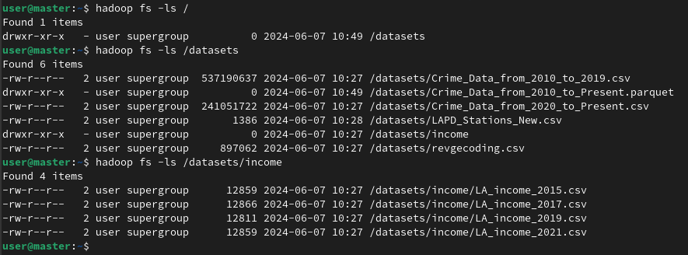
The next screenshot shows the state of the file system with the available data:
Finally, the Spark code below converts the main dataset to Parquet file format and stores the generated Parquet files in HDFS:
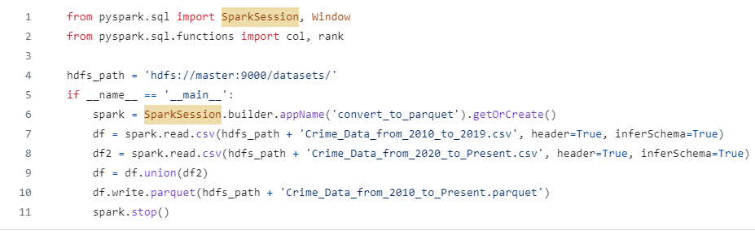
Task 3

Query 1: Top 3 Months with Highest Crime Records by Year

For each year in the dataset, we need to determine the three months with the highest number of recorded crimes. The output should display the year, the month, the total number of crime incidents for that month, and the ranking of that month within the respective year. The results should be sorted in ascending order by year and in descending order by the number of crime records.
We will execute Query 1 using DataFrame and SQL APIs, applying them to both CSV and Parquet format of the datasets. The process for each API will be explained (same logic importing either csv or parquet format), and the results for all four combinations will be presented in a clear and organized manner. After presenting the results, we will discuss our findings, comparing the performance between the different APIs and file types. This analysis will help us understand the efficiency and effectiveness of each approach and file format.
The implementation starts with initializing a Spark session, reading and processing crime data from CSV and Parquet files.

DataFrame API (function/method named spark_sql)
- The method first extracts the year and month from the DATE OCC column. The substr function is used to get the relevant parts of the date string.
- The df is grouped by the year and month columns, and the count of crimes for each group is calculated. The resulting count is renamed to crime_total.
- A window specification is defined to partition the data by year and order it by crime_total in descending order. The rank function is applied over this window to assign a rank to each month within each year based on the number of crimes.
- The DataFrame is ordered by year and crime_total in descending order. Only the top 3 months (where rank is less than or equal to 3) for each year are retained.

SQL API (function/method named sql_api)
- SQL is used to extract the year and month from the DATE OCC column.
- Another SQL query groups the data by year and month and counts the number of crimes for each group, creating a new view called crime_counts.
- Another SQL query ranks the months within each year based on the crime count using the RANK() window function.
- Finally, the top 3 months for each year are filtered out and the result is stored in top3_months_df.

Using Q1_sol function we get the following outputs:

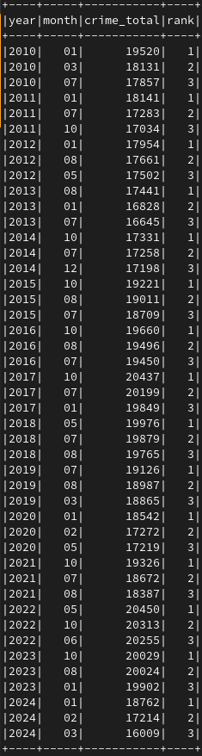

 | CSV | Parquet
Dataframe | 12.04s | 5.79s
SQL | 11.83s | 3.13s

Comments on performance
- CSV vs. Parquet:
The execution time for the DataFrame API using csv files was 12.04 seconds, while using parquet files it was 5.79 seconds. Similarly, the execution time for the SQL API using csv files was 11.83 seconds, while using parquet files it was 3.13 seconds. This shows a significant performance improvement when using parquet files, regardless of the used API.

- DataFrame API vs. SQL API:
Using csv files, the execution time for the DataFrame API was 12.04 seconds, slightly longer than the SQL API, which took 11.83 seconds. The difference is minor, indicating that both APIs perform similarly when using csv files. Using parquet format, the execution time for the DataFrame API was 5.79 seconds, whereas the SQL API was significantly faster at 3.13 seconds. This indicates a more noticeable difference in performance, favoring the SQL API when using parquet files.
In summary, the choice of file format and API has a significant impact on performance. These insights suggest that for large-scale data processing tasks, using parquet files in conjunction with the SQL API could provide the best performance.

Task 4
Query 2: To sort the parts of the day based on the number of crime incidents that occurred on the street ("STREET") in descending order. The parts of the day are defined as follows:
- Morning: 5:00 AM – 11:59 AM
- Midday: 12:00 PM – 4:59 PM
- Evening: 5:00 PM – 8:59 PM
- Night: 9:00 PM – 4:59 AM
We will use both DataFrame and RDD APIs while recording the execution time for each. First, we defined the "find_part_of_day" function, which determines the part of the day (NIGHT, MORNING, MIDDAY, EVENING) based on the time of the crime. Now, let's outline the steps for each API.
DataFrame API Implementation
- Filter the data to include only records where the premise description is "STREET".
- Define a udf to classify the time of occurrence into parts of the day, using the find_part_of_day function.
- Add a new column (day_part) to the DataFrame, group the data by day_part and count the number of incidents in each part of the day.
- Order the results by counts in descending order.

RDD API Implementation
- Filter the RDD to include only records where the premise description is "STREET".
- Map each record to a tuple containing the part of the day and a count of 1.
- Reduce the mapped RDD by key (part of the day) to count the number of incidents in each part of the day
- Sort the results by count in descending order.
- Collect and print the result

It is important to note that we decided to execute the code in two different ways to evaluate the impact of the filtering step on performance. Specifically, we ran the filter operation both before and after adding the day_part column:
- Filter Before Transformation
In the first scenario, we applied the filter to include only incidents occurring on the street (Premis Desc = "STREET") before categorizing the time of day using the day_part column. This method ensures that only relevant records are processed further, potentially reducing the amount of data handled in subsequent steps.
- Filter After Transformation
In the second scenario, we first added the day_part column to categorize the time of occurrence and then applied the filter to include only street incidents. This method processes the entire dataset initially, applying the filter at a later stage.
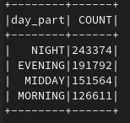
The output of each implementation (which was the same in all cases, as expected) is presented below:

As we can see, parts of the day have been sorted in descending order. The highest number of crime incidents crime on the street occurs during the night, which aligns with the fact that the night hours, typically from 9 PM to 5 AM, are often associated with increased criminal activity. The lowest number of incidents (reported in the street) occurs during the morning hours.

The comparative analysis of execution times reveals that the DataFrame API is significantly more efficient than the RDD API for processing CSV files and performing the required transformations and aggregations. Additionally, applying the filter after the transformation step tends to improve performance slightly for both APIs. These insights highlight the importance of choosing the right API and filtering strategy to optimize performance in big data processing tasks.

Task 5
Query 3: We need to determine the descent of recorded crime victims in Los Angeles for the year 2015 in the three areas (ZIP Codes) with the highest and the three areas with the lowest median household income. The results are presented below, in two separate tables, sorted from the highest to the lowest number of victims per descent.
For the execution of this query, we will need three datasets: "Crime_Data_from_2010_to_2019.csv" (since we are focusing on the recorded crime victims for the year 2015, we don't need to combine the crime datasets for other years), "LA_income_2015.csv," and "revgecoding.csv." We will also use the mapping of descent codes to their descriptions as referenced in the information accompanying the dataset.
After we read the datasets into dataframes, we process/ filter the data. Specifically, we filter out crime data points without victim or descent information and extract the first ZIP code from the revgecoding data when more ZIP codes are present. The “get_bottom_and_higher_3” function retrieves the top 3 and bottom 3 ZIP codes based on income, while the filter_by_double_zipcodes function performs an inner join between income and revgecoding dataframes to match ZIP codes. In the “convert_to_descent “method, the revgecoding dataframe is joined with the crime dataframe based on latitude and longitude coordinates.The join type used is a left join, while the code also allows for specifying different join strategies using hints, since in the main execution we want to use different join strategies (broadcast, merge, shuffle_hash, shuffle_replicate_nl). Next, we convert descent codes, count the number of victims by descent and finally print results for both high and low-income areas.
The join ty[e the Catalyst operatitow

