**CURRICULUM VITAE**

**PERSONAL DATA**

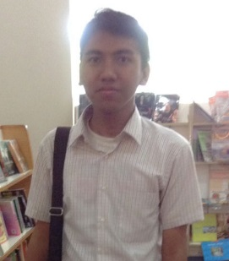Name : Thofik Wiranata

Place & Date of birth : Jakarta, September 15, 1993

Religion : Moslem

Height/Weight : 168 cm

Address : Jl.kampung melayu teluk naga rt 01/01 tangerang.

Handphone : 081287299922

Email : thofikwiranata15@gmail.com

**FORMAL EDUCATION**

1999 – 2005 : SDN 1 Teluknaga

2005 – 2008 : SMPN 1 Teluknaga

2008 – 2011 : SMA Yuppentek 1 Tangerang

2011 – 2015 : Universitas Mercu Buana Jakarta Majoring of Information System

**NON-FORMAL EDUCATION**

**2005 – 2008 : PEC (Pratical Education Center) Program Tingkat Intermediate 2**

**TOEIC Prediction Score : 640**

**WORK EXPERIENCE**

**Arca International**

**Neo Digital Agency**

**ORGANIZATIONS EXPERIENCE**

**HIMSISFO**

**OSIS**

**SKILLS**

**HTML5 = Advanced**

**CSS = Advanced**

**Bootstrap = Advanced**

**PHP = Advanced**

**CI = Intermediate**

**SASS / LESS = Intermediate**

**Git = Intermediate**

**Javascript = Intermediate**

**JQuery = Intermediate**

**Database Processing = Advanced**

**SQL = Advanced**

**Microsoft Excel = Advanced**

**Microsoft Word = Advanced**

**CV ONLINE**

**http://thofikwiranata.com/**