1. When user invoke “BALANCE” command, as per the configuration in code it returned 1500

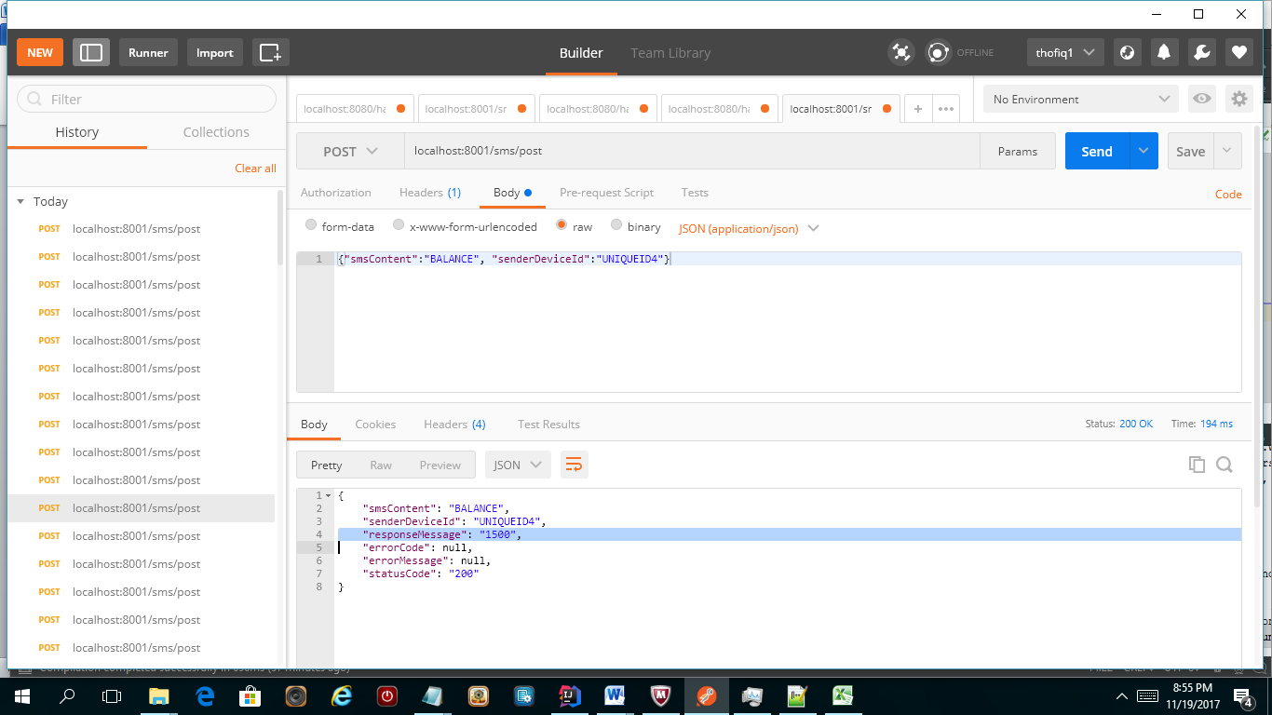

1. When user invoke “SEND-100-FFRITZ” command, “OK” response message displayed

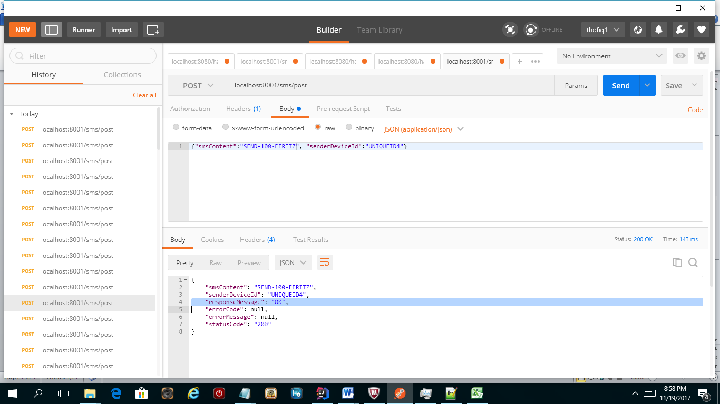

1. When user invoke “SEND-1600-FFRITZ” command, user has only 1500 as balance as per the configuration so error message “ERR – INSUFFICIENT FUNDS” displayed

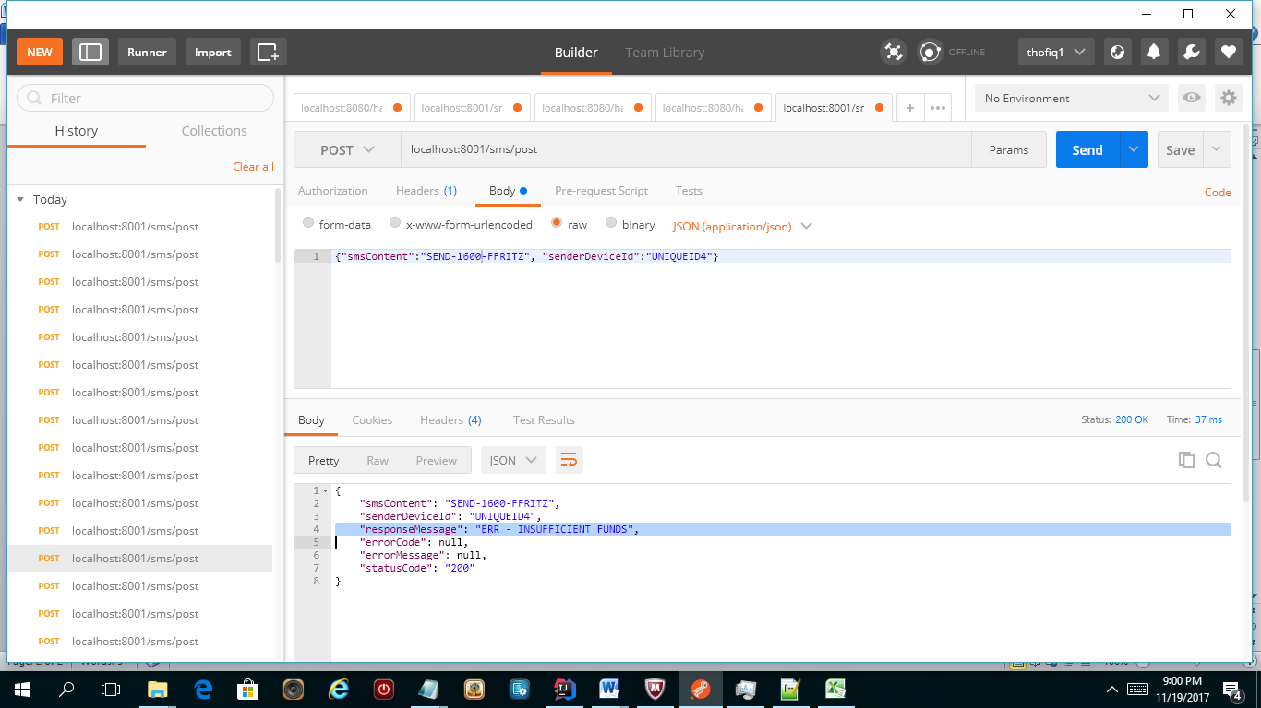

1. When user invoke “SEND-100-XYZ” command, as per the configuration in the code XYZ user not available in the system so ERR – NO USER displayed

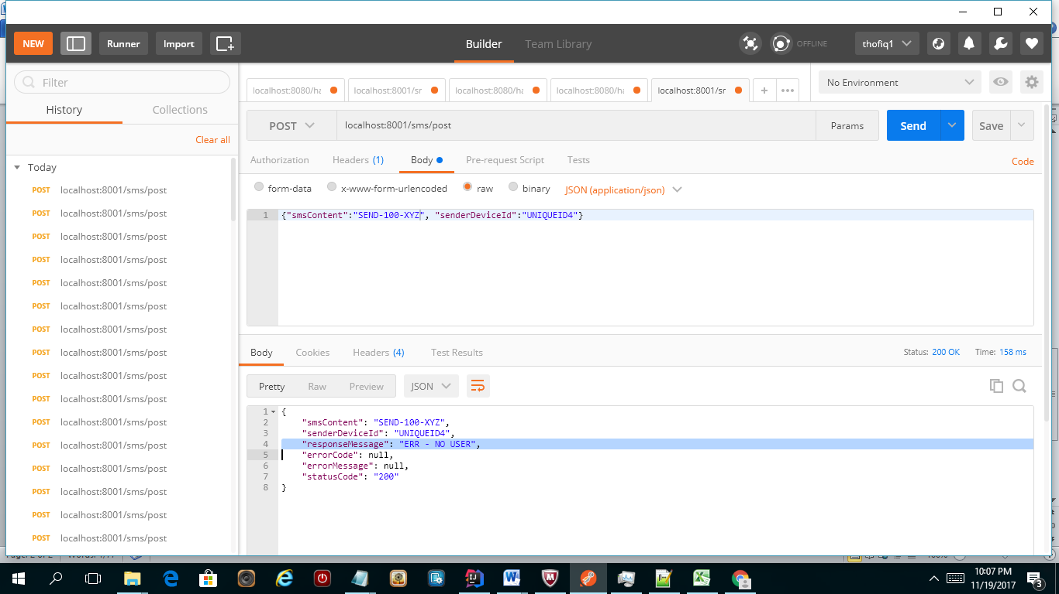

1. When user invoke “TOTAL-SENT-FFRITZ” command, as per the screen shot 2 user has transferred 100 EUR so the result will be 100

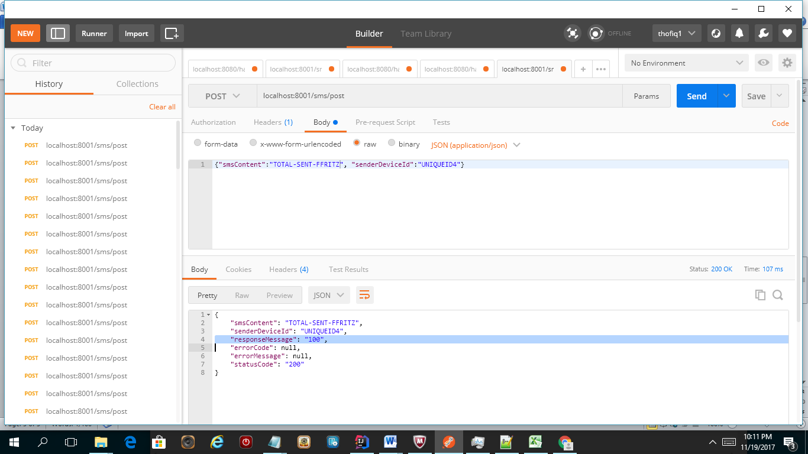

1. When user invoke “TOTAL-SENT-FFRITZ-MSMITH” command, as per the screen shot 2 user has transferred 100 EUR to FFRITZ user and as per below transaction MSMITH received 100 EUR from user so the result will be 100,100

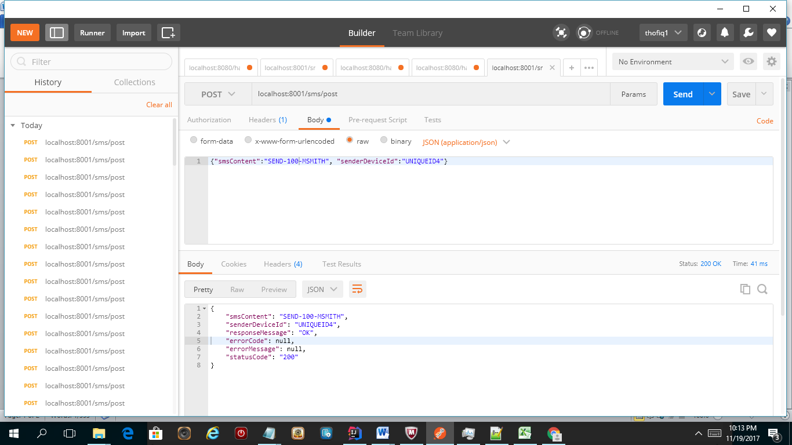

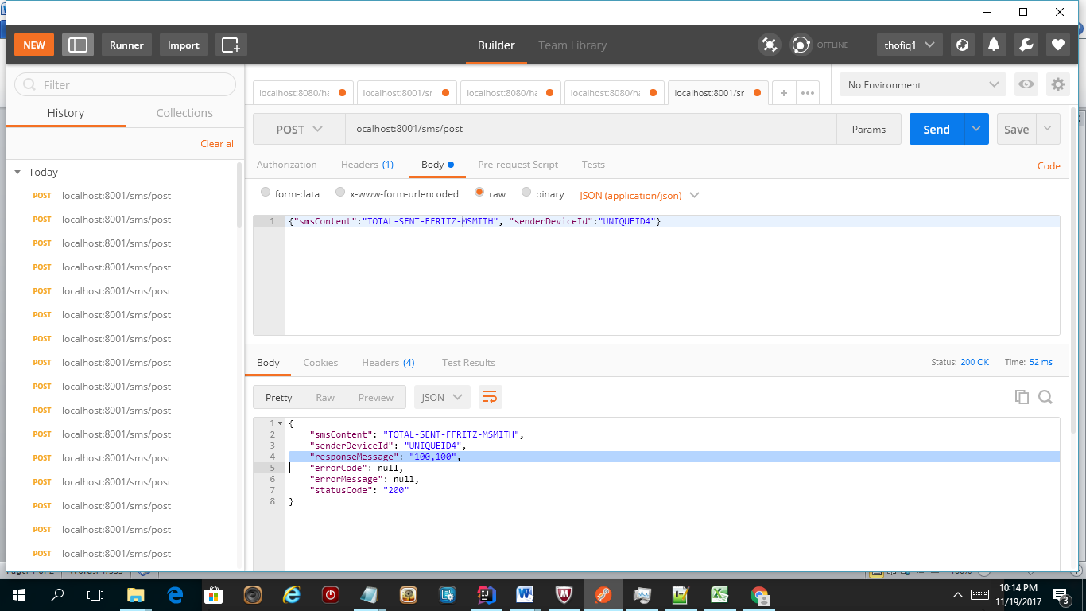

1. When user try to run the command TOTAL-SENT-FFRITZ-XYZ (XYZ user not available in the system) so it return error ERR – NO USER

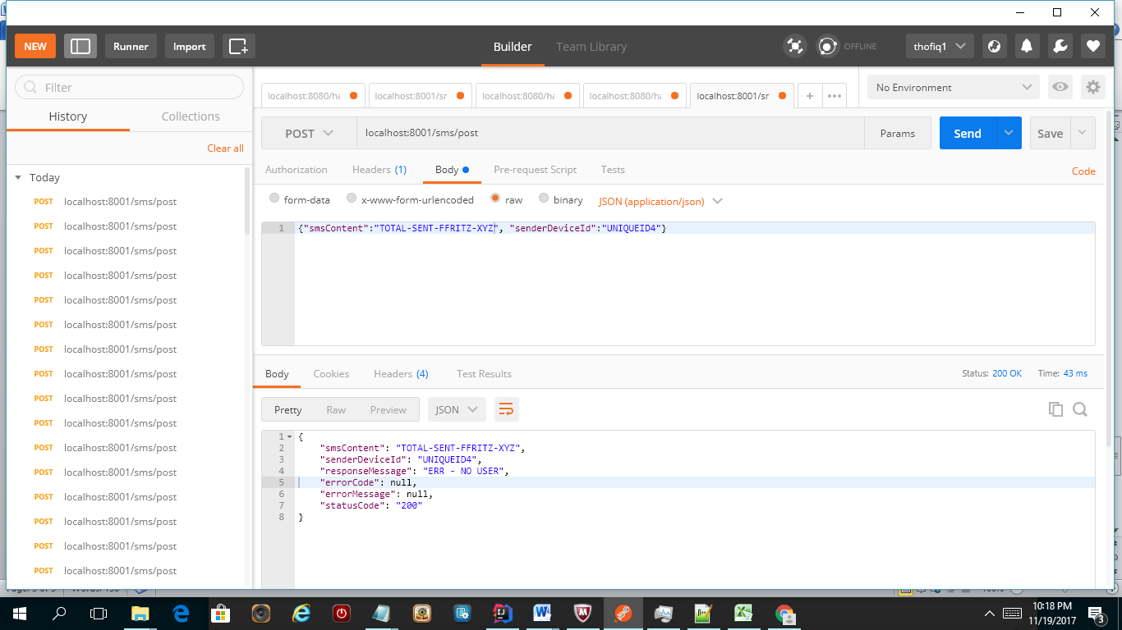

1. When user invoked unknown command ERR – UNKNOWN COMMAND displayed

