Name –Isha Kishor Katariya

Class - SEIT Div - A

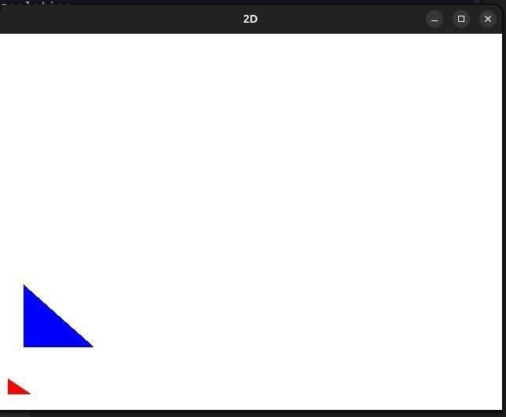

Roll No – 207A056

Experiment - Implement following 2D transformations on the object with respect to axis: i)

Scaling ii) Rotation about arbitrary point iii) Reflection