1 ䷀ 63 - Creation

The pure force of origination and initiative. Like heaven generating existence, this represents the primary creative impulse that initiates all manifestation.
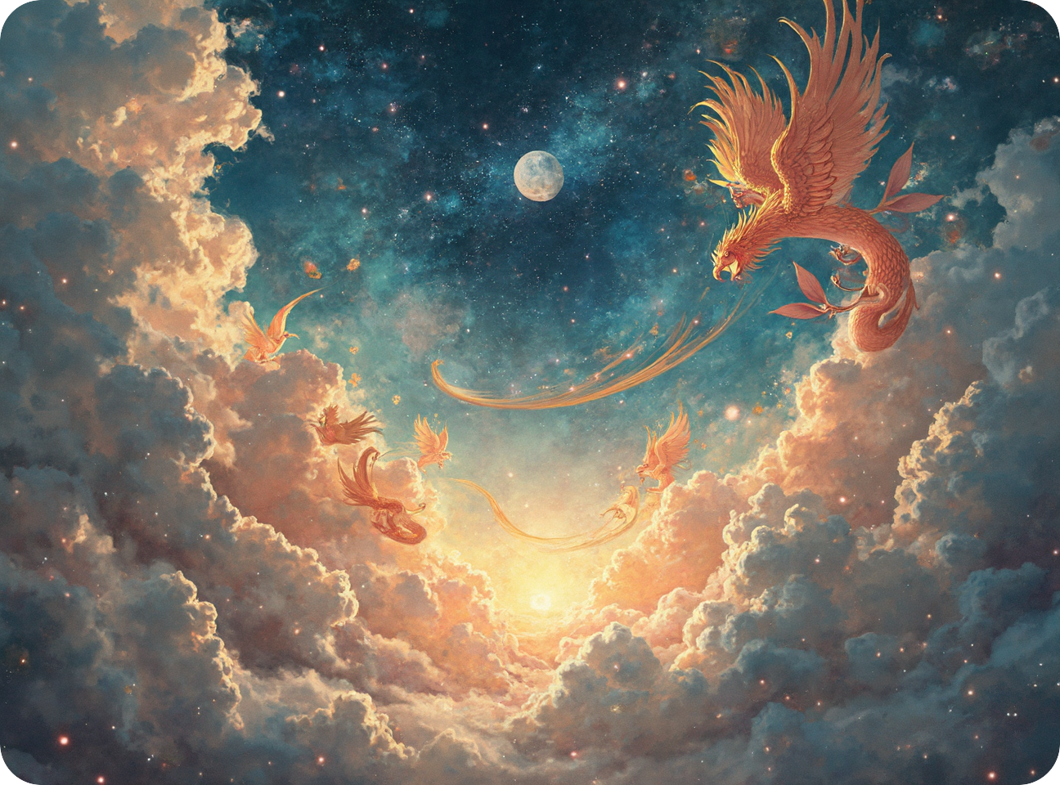

The impressionistic artwork, characterized by fluid strokes and luminous color interplay, embodies Hexagram 01’s "Creation," reflecting pure yang energy’s dynamic essence. Ethereal motion and celestial hues evoke cosmic genesis, while soaring phoenixes symbolize awareness’s evolutionary ascent. Chaotic forms emerging organically mirror the spontaneous creative force, aligning with tholonic principles of awareness and intention. Vibrant harmony resonates with universal love’s balance, bridging chaos and order. The composition illustrates the Tholonic Model’s holarchic interconnectedness, where tholonic energy drives conceptual emergence through negotiation, limitation, and contribution. The style’s fluidity mirrors creation’s unbounded, transformative nature, capturing primordial manifestation within a recursive, self-similar matrix of existence.

"Creation" embodies the primordial spark of existence—the unyielding force of genesis that births cosmos from chaos. Rooted in the I Ching’s cosmology, it represents pure yang energy: dynamic, unopposed, and ceaseless, like heaven itself in perpetual motion. The dragon, an archetype of untamed power and celestial ascent, mirrors this hexagram’s essence—raw potential channeled into form, where divine will initiates order from the void. It reflects universal creation myths, from the Logos speaking light into darkness to the Tao’s nameless origin birthing the "ten thousand things." Here, creation is the eternal principle of becoming, the archetypal foundation upon which all existence rests.

In Tholonic terms, Hexagram 1 signifies awareness manifesting reality through the Primal Point, a singularity of infinite intention. The Thologram’s recursive holarchy unfolds via the triad of forces: negotiation harmonizes chaos and order, limitation carves cosmic structure from boundless potential, and contribution integrates fragments into emergent wholes. Universal love—guiding symmetry and balance—orchestrates this process, ensuring creation aligns with sustainable principles. The hexagram mirrors tholonic energy’s role: consciousness, as both creator and creation, perpetually generates existence through self-referential acts of becoming, where intention sculpts chaos into the first breath of form.

King Wen Order: Ch'ien (The Creative) Binary: 63

Above: Qian (Heaven, Creative Force, Dynamic) Below: Qian (Heaven, Creative Force, Dynamic)

Lines in Transition
6: Transcendent Phoenix: Rebirth complete; Soar with purpose
5: Rising Phoenix: Transformation at its height; Act with clarity
4: Emerging Phoenix: Flames of renewal; Prepare for ascension
3: Kindling Phoenix: Sparks igniting; Work with intention
2: Nestling Phoenix: Strengthening resolve; Gather energy
1: Dormant Phoenix: Embers glowing; Begin with care

Tholonic Analysis
Negotiation: The hexagram represents pure creative force, yet this force negotiates with the constraints of its own infinity. Even in limitless creation, the interplay between what can be and what should be emerges as an intrinsic tension.
Limitation: Structure is provided by heaven above and below, indicating that creation follows cosmic principles. The doubled heaven suggests amplified creative force.
Contribution: This pattern contributes to evolution by initiating new forms. It shows how consciousness manifests reality through directed will.
Significance in the Thologram: In the tholonic system, this hexagram represents pure creative consciousness. It demonstrates how awareness generates existence through focused intention.
No Moving Lines: When no lines are changing, focus on steady creation. Success comes through persistent generation rather than forced manifestation.
All Moving Lines: A complete transformation in how creation functions is indicated. Old patterns of manifestation must give way to new forms of generation. Ensure wisdom guides power while embracing change.

Three Tales of "Creation"

The Storm Weaver (Man vs. Nature)

In the style of Homer
When the Great Drought threatened to destroy her people, Maria discovered she could weave clouds from spider silk and morning dew. Like Athena at her loom, she studied how each strand of moisture caught the light, how wind patterns could be woven into larger forms. First came small clouds, no bigger than basketballs, drifting above her garden. Then came floating rivers of mist, drawn from the earth's deepest breaths. Finally, she learned to weave storm systems that danced across continents. Nature itself watched in wonder as she created weather patterns ancient as time yet new as dawn.

Lines in Context:
6: Global Impact - Continental weather weaving
5: Mastery Shown - Creating storm systems
4: Growing Scope - Expanding to floating rivers
3: Active Development - Daily weaving practice
2: Basic Success - First small clouds
1: Initial Discovery - Learning moisture patterns

The Dream Architect (Man vs. Self)

In the style of Stanisław Lem
In 2157, when consciousness augmentation had reached its limits, Dr. Wei discovered she could build new forms of awareness from pure mathematical structure. Not expanding the mind, but creating entirely new types of thought. She began with simple geometric consciousness – minds that thought in perfect squares and circles. Each iteration grew more complex: consciousness based on wave functions, on prime number sequences, on fractal patterns that thought about themselves thinking. When she finally succeeded in creating a mind based on the mathematics of creation itself, she found she had not built a new consciousness, but discovered how consciousness had built itself.

Lines in Context:
6: Universal Understanding - Discovering consciousness's nature
5: Peak Achievement - Creating self-recursive awareness
4: Complex Development - Building mathematical minds
3: Active Experimentation - Testing different thought forms
2: Basic Structures - Geometric consciousness
1: Foundation Theory - Pure mathematical awareness

The Symphony Maker (Man vs. Man)

In the style of Herman Melville
In a world where music had been standardized to government-approved harmonies, Composer Chen built a secret piano that could play the spaces between notes. Like a whaler pursuing the unseen beneath waves, she hunted the wild melodies that lived in fractional tones. Each night in her basement laboratory, surrounded by modified tuning forks and resonance chambers, she worked to capture sounds no human had heard before. The authorities called it noise, but those who listened closely heard the voice of creation itself. When she finally performed her "Ocean of Stars" symphony, using her quarter-tone piano, she didn't just break the rules of music; she unveiled that they had never truly existed.

Lines in Context:
6: Universal Impact - Redefining the nature of music itself
5: Masterwork Creation - The "Ocean of Stars" symphony
4: Building Power - Developing the revolutionary instrument
3: Persistent Work - Nightly experimentation
2: Foundation Building - Creating modified instruments
1: Initial Vision - Discovering spaces between notes

'Creation' in History

Tesla's Vision of Wireless Power
In 1899, Nikola Tesla established his Colorado Springs laboratory to prove that Earth itself could conduct electrical power. While others focused on incremental improvements to existing systems, Tesla envisioned establishing an entirely new paradigm of global power distribution. In his experimental station, Tesla generated artificial lightning bolts over a hundred feet long and illuminated light bulbs wirelessly at distances up to 25 miles. Each experiment built upon the last, leading to his ultimate vision - the Wardenclyffe Tower project, designed to transmit power and information wirelessly across the globe. Though financial constraints prevented the tower's completion, Tesla's creative vision demonstrated unprecedented scope. He didn't just improve existing technology; he attempted to establish an entirely new relationship between humanity and electricity. His Colorado Springs experiments proved that wireless power transmission was possible, laying groundwork for technologies we're still developing today. Tesla's pursuit mirrors the hexagram’s message: true creation does not merely iterate on existing forms; it redefines the foundation upon which all structures rest.
Source: "Tesla: Man Out of Time" by Margaret Cheney (1981) and "Wizard: The Life and Times of Nikola Tesla" by Marc Seifer (1996)

Lines in Context:
6: Universal Vision - Concept of worldwide wireless power
5: Peak Achievement - Successful long-distance power transmission
4: Growing Capability - Increasingly powerful demonstrations
3: Active Experimentation - Daily testing and refinement
2: Foundation Building - Laboratory establishment
1: Initial Insight - Recognition of Earth's conductive potential

Notes

