Migrating Applications from UDMA to LCDMA using TI-RTOS
Embedded Processing, Processors Business Unit
Abstract
AM64x SOC will have a lighter-weight version of UDMA (Low Cost DMA). UDMA is the DMA engine used to do direct memory access (DMA) between different peripherals like McASP, SPI, UART and memory (DDR, L2, L3, MSMC) without CPU intervention in next generation TI SoCs like AM6x. LCDMA is a new lighter version of DMA architecture and SW applications written for UDMA need to be adapted to use the already existing UDMA APIs. This application note is intended to help SW developers migrate their TI-RTOS based SW applications, device drivers from UDMA based systems to LCDMA based systems. The application note explains the differences between UDMA and LCDMA from a HW perspective. It then compares the SW APIs provided by TI in Processor SDK RTOS for UDMA/LCDMA.
IMPORANT NOTE: This application note provides a simplified description and comparison of HW/SW features so that SW users can effectively migrate typical applications from UDMA to LCDMA. For SoC specific details users should refer to SoC technical reference manual (TRM).

Table of Contents
1 Introduction to LCDMA 2
1.1 LCDMA Overview 2
2 Comparison of UDMA and LCDMA 4
2.1 Top Level Overview 4
2.2 Changes in PKTDMA compared to UDMA-P 5
2.3 Enpoint Spanning Restrictions in BCDMA & PKTDMA 6
3 UDMA SW API for Applications 7
3.1 UDMA SW API Changes 7
3.2 UDMA SW API Beaviour Changes 10
3.3 Unsupported UDMA SW APIs for LCDMA 11
3.4 Using LCDMA with Processor SDK RTOS Drivers 13
4 Summary 13
5 References 13
6 Revision History 13

Figures

Figure 1. AM64x DMSS: LCDMA Top Level Block Diagram 2
Figure 2. PKTDMA Block Diagram 3
Figure 3. Block Copy DMA Block Diagram 4
Tables
Table 1. Comparison between LCDMA and UDMA 4

Introduction to LCMDA

LCDMA Overview
The primary goal of the Low Cost Data Movement architecture is to ensure that data can be efficiently transferred from a producer to a consumer so that the real time requirements of the system can be met. The Data Movement architecture aims to facilitate Direct Memory Access (DMA) and to provide a consistent Application Programming Interface (API) to the host software. Data movement tasks are commonly offloaded from the host processor to peripheral hardware to increase system performance. Significant performance gains may result from careful design of the interface between the host software and the underlying acceleration hardware. In networking applications packet transmission and reception are critical tasks. In general purpose compute, ping pong buffer pre-fetch and store are critical tasks as are general misaligned block copy operations.
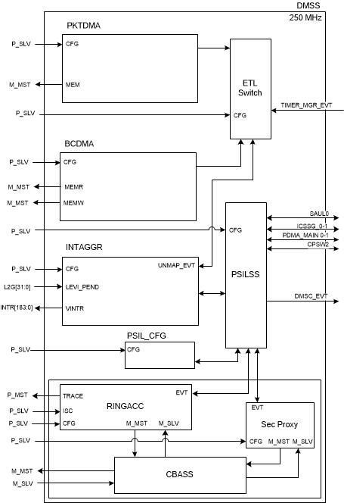
- AM64x DMSS : LCDMA Top Level Block Diagram

The block diagram provides a high level picture of not only the 2 different interconnect fabrics but also some key standard data movement components that have been defined and placed in the various parts of the low cost compliant SoC. The following sections will provide a high level overview of Packet DMA (PKTDMA) and Block Copy DMA (BCDMA):

Packet DMA (PKTDMA)
The PKTDMA is intended to perform similar functions as the packet oriented DMA. The PKTDMA module supports the transmission and reception of various packet types. The PKTDMA is architected to facilitate the segmentation and reassembly of DMA data structure compliant packets to/from smaller data blocks that are natively compatible with the specific requirements of each connected peripheral. Multiple Tx and Rx channels are provided within the DMA which allow multiple segmentation or reassembly operations to be ongoing. The DMA controller maintains state information for each of the channels which allows packet segmentation and reassembly operations to be time division multiplexed between channels in order to share the underlying DMA hardware. An internal DMA scheduler is used to control the ordering and rate at which this multiplexing occurs for Transmit operations. The ordering and rate of Receive operations is indirectly controlled by the order in which blocks are pushed into the DMA on the Rx PSI-L interface.
A block diagram of the PKTDMA Controller is shown below:

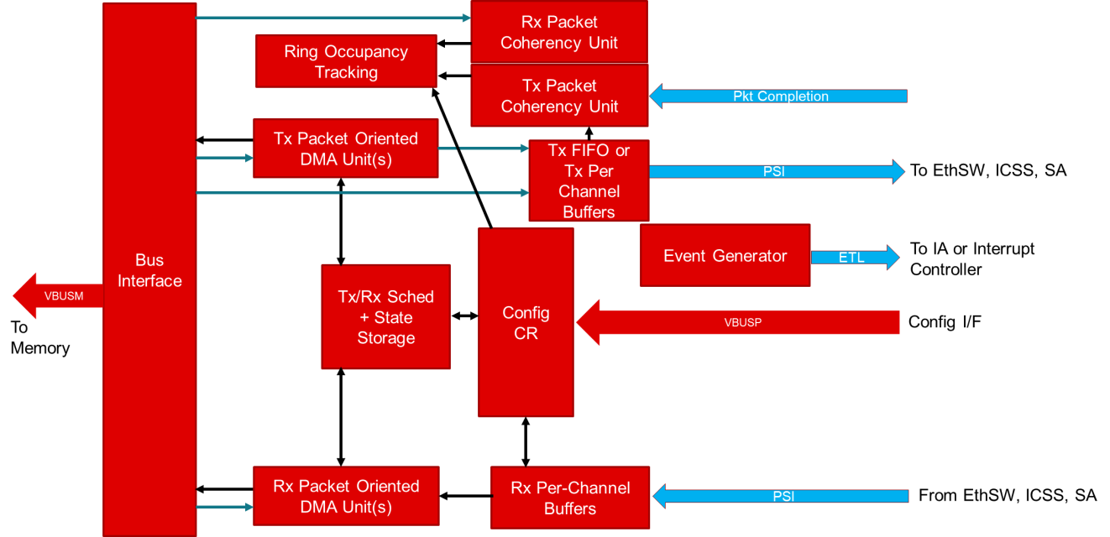
- PKTDMA Block Diagram

Block Copy DMA (BCDMA)
The Block Copy DMA is intended to perform similar functions as the EDMA or the UDMA-P/UTC. The BCDMA module moves data from a memory mapped source address set to a corresponding memory mapped address set. The BCDMA maintains state information for each of the channels which allows data copy operations to be time division multiplexed between channels in order to share the underlying DMA hardware. An internal DMA scheduler is used to control the ordering and rate at which this multiplexing occurs.
A block diagram of the Block Copy DMA Controller is shown below:
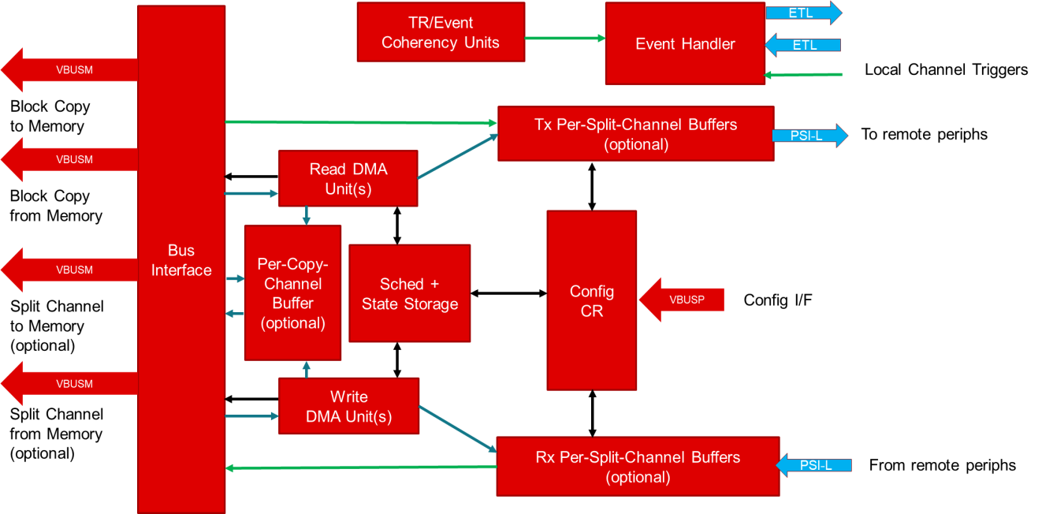
- Block Copy DMA Block Diagram

Comparison of UDMA and LCDMA
This section provides a top level overview of the comparison between UDMA & LCDMA and discuss in detail about the changes in PKTDMA compared to UDMA-P. It also discuss about the endpoint spanning restrictions in BCDMA & PKTDMA.

Top Level Overview
The following table gives an overview of hardware changes in LCDMA compared to UDMA, corresponding changes in UDMA LLD Driver and its impact to applications using UDMA SW API’s.
- Comparison between LCDMA and UDMA
HW Changes | SW Changes | Impact on Applications
Breakout DMA into Block Copy DMA and Packet DMA | Two Instances in LCDMA: BCDMA & PKTDMA | Low Impact.  Instance Id must be modified to UDMA_INST_ID_BCDMA_0 or UDMA_INST_ID_PKTDMA_0
Dedicated Block Copy Channels in BCDMA | TX Channel API’s can be used for Block Copy Channels too. RX Channel APIs bypassed for Block Copy mode. | No Impact
Single ring (instead of 2) for both forward and reverse direction | Completion Queue Ring points to Free Queue Ring itself | No Impact
No teardown descriptor is written back if a channel is disabled while DMA is active | TEARDOWN_PACKET event bypassed | No Impact on teardown Event;  Udma_chDequeueTdResponse()can’t be used
Separate ring accelerator is removed and support for only Exposed RING mode | Other ring modes not supported | Other ring modes such as MESSAGE, CREDENTIAL, QM can’t be used
Changes in PKTDMA compared to UDMA-P. (See Section 2.2) | Handled by UDMA driver or other drivers supported by PDK. (See Section 3.4) | No Impact
DMA channel events moved into an OES table within the Interrupt Aggregator | Channel events from interrupt aggregator are handled in the same way as ring events. | No Impact
No Interrupt Router as part of navigator | IR config is bypassed and IA events directly mapped to core interrupts | No Impact
No Ring monitors | Ring Monitor API’s not supported | Ring Monitor API’s can’t be used
No Proxy and no Clec | Proxy API’s not supported | Proxy API’s can’t be used
For detailed information Ref ‘Section 3 - UDMA SW API for Applications’.

Changes in PKTDMA compared to UDMA-P
The key differences in PKTDMA compared to UDMA-P are:
- Descriptor layout changes :
  - Fields no longer used are marked as reserved.
  - Protocol specific region must be in descriptor.
  - At start of packet option is no longer supported and the descriptor bit controlling this, is now a reserved bit.
- No monolithic descriptor mode (only host mode for PKTDMA)
- Reduced RX flow feature set:
  - No multiple 'free pool' selection based on incoming packet size.
  - Rx flows are hard-wired to the DMA channel. There is no longer a generic pool of flows that can be assigned ad hoc to any channel.
  - No destination ring override; destination ring is hard wired to the flow effectively
- Much less flexibility in packet return mode options.
  - Chained descriptors will be freed still chained.
  - No option to return descriptors to a specific ring.
  - Early return bit no longer used.
- No automatic garbage collection on Tx. There is no early completion or buffer return.
- No prefetching of descriptors. The control fetches are inline with data transfers.
- No Rx chaining of descriptors, but scatter is still supported.
- Packet is received into pre-linked buffer chain provided by Host.
- No pass through of SECURE / PRIV/ PRIVID credentials with each packet. Each flow is locked to a single SECURE / PRIV/ PRIVID.
- Hardcodes output event indices.
- PS words in descriptor only.
- New feature ‘TX-FLOW’ is introduced. It allows separate TX exposed rings to be multiplexed onto one TX channel. Multiplexing done on packet/entire block copy work units. It does not allow interleaving of individual transfers within the DMA operation.
- Channels may be hardwired to peripherals (no dynamic thread mapping)
- Eliminates all ring steering. Rings now dedicated for a single TX or RX flow. i.e., There are no free flows.

Enpoint Spanning Restrictions in BCDMA & PKTDMA
Spanning endpoints means logical banks of the same memory or even between different memories. This section discusses in detail the restriction in spanning endpoints on BCDMA & PKTDMA.

BCDMA Endpoint Spanning Restrictions
The endpoint spanning restrictions for BCDMA are summarized below:
- Descriptors:
  - Descriptor reads for BCDMA cannot span multiple endpoints.
  - Individual Descriptors can be at different endpoints.
  - Descriptors and Data buffers can be at different endpoint.
- BCDMA – block copy reads cannot cross end points. This is for a single TR regardless of dimensioning. The write phase of the block copy does not have this restriction.
- All writes to memory by BCDMA (RX transfers) have no restrictions.
- All reads to memory by BCDMA (TX transfers) cannot cross end points (straddle multiple OCSRAM banks).

PKTDMA Endpoint Spanning Restrictions
The endpoint spanning restrictions for PKTDMA are summarized below:
- Descriptors:
  - Descriptor reads for PKTDMA cannot span multiple endpoints.
  - Individual Descriptors can be at different endpoints.
  - Descriptors and Data buffers can be at different endpoint.
- All writes to memory by PKTDMA (RX transfers) have no restrictions.
- All reads to memory by PKTDMA (TX transfers) have no restrictions.
- Chained buffers in the same packet can be at different endpoints
- A buffer can span endpoints

UDMA SW API for Applications
This section provides an overview of the changes in UDMA SW APIs, details on APIs that are unsupported by LCDMA and the behavioral changes in UDMA SW APIs when used for LCDMA as compared to that for UDMA.

UDMA SW API changes
This section provides details about the changes in using UDMA SW APIs for LCDMA as compared to that for normal UDMA. Here we compare the changes with respect to the overview of UDMA SW APIs for normal UDMA described in the previous section.

BCDMA and PKTDMA instances
One of the key differences in LCDMA as compared to normal UDMA is the Instances. The two instances that are present in LCDMA are Packet DMA (PKTDMA) and Block Copy DMA (BCDMA). In contrast to this, the two instances in normal UDMA were the MAIN NAVSS and the MCU NAVSS.
The Instance ID’s in LCDMA are:

  - UDMA_INST_ID_BCDMA_0 /* For Block Copy DMA */
  - UDMA_INST_ID_PKTDMA_0 /* For Packet DMA */

This change does impact UDMA SW API’s. The application must be updated with the correct instance ID for LCDMA.

instId = 1) UDMA_INST_ID_BCDMA_0; /* or 2) DMA_INST_ID_PKTDMA_0*/

Dedicated Block Copy Channels
LCDMA introduced dedicated Block Copy channels in BCDMA apart from the Split TR TX and RX Channels. The main impact of this in UDMA SW API is that, for Block copy mode there is no need to configure RX channel (which was implicitly paired to TX channel in case of UDMA for block copy mode). But even if the application tries to configure RX channel, the UDMA Driver internally bypass configuring the RX channel for block copy mode. i.e., the Udma_chConfigRx() API returns gracefully, without doing anything. This is to ensure backward compatibility with normal UDMA.
UDMA Driver is designed such that, the new Block Copy channels uses the existing TX flavors of UDMA SW API’s itself. i.e., when channel type is UDMA_CH_TYPE_TR_BLK_COPY, the UDMA channel TX API’s make use of the Block Copy channels.
For example,
- UdmaChTxPrms_init() API, initialize the params for block copy channel
- Udma_chConfigTx() API, configures the block copy channel. (etc.)

As a result, this change doesn’t impact the usage of UDMA SW API’s. So the existing application for UDMA will work for LCDMA without any issues. Hence the following lines of codes are optional for LCDMA (no effect) [only for Block Copy Mode]
Udma_ChRxPrms rxPrms;
/* Config RX channel - which is implicitly paired to TX channel in block copy mode */
UdmaChRxPrms_init(&rxPrms, chType);
retVal = Udma_chConfigRx(chHandle, &rxPrms);

Absence of Completion Ring
In LCDMA there is only one single ring (instead of 2) for both forward and reverse direction. So the common ring ID itself must be programmed in the TR Descriptor instead of the completion ring ID. UDMA SW API internally handles this by pointing the same ring ID to completion ring ID. That is, since there is no separate completion queue, completion queue ring handle points to forward queue ring itself. So programming the TR Descriptor either way will work fine.
Hence Completion queue ring params is not used, but even if the application sets this it will be ignored. But it’s not required to be set. Here completion queue ring object is also not used.
This change doesn’t impact the usage of UDMA SW API’s, since it’s handled inside the driver itself. So the existing application for UDMA will work for LCDMA without any issues. Hence the following lines of codes are optional for LCDMA (no effect):
static uint8_t gTxCompRingMem[UDMA_TEST_APP_RING_MEM_SIZE] __attribute__((aligned(UDMA_CACHELINE_ALIGNMENT)));
chPrms.cqRingPrms.ringMem = &gTxCompRingMem[0U];
chPrms.cqRingPrms.elemCnt = UDMA_TEST_APP_RING_ENTRIES;

Teardown unsupported and absence of Teardown Ring
In LCDMA, there is no teardown ring and NO teardown descriptor is written back if a channel is disabled while DMA is active. So the TEARDOWN_PACKET event is not supported in LCDMA.
Hence Teardown completion queue ring params is not used, but even if the application sets this it will be ignored. But it’s not required to be set. Teardown completion queue ring object is also not used.
And there is no need to register teardown ring completion callback. But even if the application tries to register the teardown ring completion callback, the UDMA Driver internally bypass registering the TEARDOWN_PACKET event. This is to ensure backward compatibility with normal UDMA.
As a result, this change doesn’t impact the usage of UDMA SW API’s. So the existing application for UDMA will work for LCDMA without any issues. Hence the following lines of codes are optional for LCDMA(no effect) :

- static uint8_t gTxTdCompRingMem[UDMA_TEST_APP_RING_MEM_SIZE]
__attribute__((aligned(UDMA_CACHELINE_ALIGNMENT)));
chPrms.tdCqRingPrms.ringMem = &gTxTdCompRingMem[0U];
chPrms.tdCqRingPrms.elemCnt = UDMA_TEST_APP_RING_ENTRIES;
- struct Udma_EventObj gUdmaTdCqEventObj; /* MUST be global */
- /* Register teardown ring completion callback */
eventHandle = &gUdmaTdCqEventObj;
UdmaEventPrms_init(&eventPrms);
eventPrms.eventType = UDMA_EVENT_TYPE_TEARDOWN_PACKET;
eventPrms.eventMode = UDMA_EVENT_MODE_SHARED;
eventPrms.chHandle = chHandle;
eventPrms.masterEventHandle = &gUdmaCqEventObj;
eventPrms.eventCb = &App_udmaEventTdCb;
retVal = Udma_eventRegister(drvHandle, eventHandle, &eventPrms);
- eventHandle = &gUdmaTdCqEventObj;
retVal += Udma_eventUnRegister(eventHandle);
- static void App_udmaEventTdCb(Udma_EventHandle eventHandle,
uint32_t eventType,
void *appData)
{
CSL_UdmapTdResponse tdResp;
if(UDMA_EVENT_TYPE_TEARDOWN_PACKET == eventType)
/* Response received in Teardown completion queue */
Udma_chDequeueTdResponse(&gUdmaChObj, &tdResp);
return;
}

Unsupported Ring Modes
In LCDMA the separate ring accelerator for DMA is removed and support for just Exposed RING mode is moved in with DMA. LCDMA doesn’t support other ring modes such as MESSAGE, CREDENTIAL and QM.
As a result of this, applications using LCDMA must use only Exposed RING mode. If other ring modes are passed, the driver will return Error.

Changes in PKTDMA comapred to UDMA-P
The PKTDMA instance is majorly used by peripherals, whose drivers are supported by PDK in Processor SDK RTOS. So the changes in PKTDMA compared to UDMA-P don’t impact the applications. For this Ref section 3.4 - Using LCDMA with Processor SDK RTOS Drivers.

UDMA SW API beaviour changes
This section describes about the behavioral changes in UDMA SW API when used for LCDMA, as compared to that for UDMA.

Dedicated Block Copy Channels
Due to the presence of dedicated Block Copy Channels in BCDMA, there are some behavioral changes for the following API’s when used for LCDMA:

- Udma_chConfigRx() for event Type = UDMA_CH_FLAG_BLK_COPY
- won't do any operation and will return gracefully without returning any error

- Udma_chConfigTx() for event Type = UDMA_CH_FLAG_BLK_COPY
- configure Block Copy Channel instead to TX Channel

Absence of Completion Ring
Due to the absence of Completion Ring, there are some behavioral changes for the following API’s when used for LCDMA:

- Udma_chGetCqRingHandle() - Returns the default common ring handle of the channel, since there is no separate completion queue ring.

- Udma_chGetCqRingNum() - Returns the default common ring number to be programmed in descriptor, since there is no separate completion queue ring.

Teardown unsupported
In LCDMA, since there is no need to register TEARDOWN_PACKET event and dequeue the teardown response, the following API’s have some behavioral changes for LCDMA:

- Udma_eventRegister() for event Type = UDMA_EVENT_TYPE_TEARDOWN_PACKET
- won't do any operation and will return gracefully without returning any error

- Udma_eventUnRegister() for event Type = UDMA_EVENT_TYPE_TEARDOWN_PACKET
- won't do any operation and will return gracefully without returning any error

- Udma_chDequeueTdResponse() - won't do any operation and will return gracefully without returning any error

Channel Events moved to Interrupt Aggregator
In LCDMA, all DMA channel events have been moved into an OES table within the IA peripheral. As a result, these channel events must be handled instead of the ring events.
In case of LCDMA, while registering these event using Udma_eventRegister(), the UDMA Driver configures the channel events from IA instead of the ring events. It also unregisters these events during Udma_eventUnRegister() in a similar fashion. So the channel events from interrupt aggregator are handled the same way as ring events.

No Interrupt Router
In LCDMA, there is no Interrupt Router as part of navigator. i.e., The DMSS IA has no IR’s between itself and the destination cores. As a result there is no need to configure the IR’s in case of LCDMA.
In case of LCDMA, UDMA Driver bypasses the configuration of IR’s during Udma_init(), and the IA events are directly mapped to the corresponding core interrupts.

Unsupported UDMA SW APIs for LCDMA
Some of the UDMA SW APIs is not supported by LCDMA, due to unsupported ring modes, absence of various modules like Ring Monitor, Proxy, Clec etc. These API’s if called for LCDMA, will return Error.

Teradown unsupported
In LCDMA, No teardown descriptor is written back if a channel is disabled while DMA is active. Due to this, the UDMA SW API to dequeue teardown response Udma_chDequeueTdResponse() is unsupported and will return error if used.

Unsupported Ring Modes
Since LCDMA doesn’t support ring modes such as MESSAGE, CREDENTIAL and QM, Udma_chOpen() will return error when the following modes are used for Udma_RingPrms->mode

- TISCI_MSG_VALUE_RM_RING_MODE_MESSAGE
- TISCI_MSG_VALUE_RM_RING_MODE_CREDENTIALS
- TISCI_MSG_VALUE_RM_RING_MODE_QM

Absence of Ring Monitors
In LCDMA, since there are no Ring Monitors present, the following ring monitor API’s are unsupported for LCDMA. If these API’s are called, the driver will return error.
- Udma_ringMonAlloc()
- Udma_ringMonFree()
- Udma_ringMonConfig()
- Udma_ringMonGetData()
- Udma_ringMonGetNum() – will always return UDMA_RING_MON_INVALID
Even the event related to Ring Monitor is also not supported due to its absence and the following will return error in case of LCDMA:
- Udma_eventRegister() for event Type = UDMA_EVENT_TYPE_RING_MON
- Udma_eventUnRegister() for event Type = UDMA_EVENT_TYPE_RING_MON

Absence of Proxy
Due to the absence Proxy in LCDMA, the following proxy API’s are unsupported for LCDMA. If these API’s are called, the driver will return error.
- Udma_proxyAlloc()
- Udma_proxyFree()
- Udma_proxyConfig()

Using LCDMA with Processor SDK RTOS Drivers
If the usage of UDMA is intended for peripherals whose drivers are supported by PDK in Processor SDK RTOS, the configuration/setup is limited to the initialization of UDMA driver. In this case the change required to migrate to LCDMA is to update the instance id before initialization.
For example in Block Copy DMA mode:
#include <ti/drv/udma/udma.h>
Udma_InitPrms initPrms;
uint32_t instId;
instId = UDMA_INST_ID_BCDMA_0;
UdmaInitPrms_init(instId, &initPrms)
struct Udma_DrvObj gUdmaDrvObj; /* MUST be global */ retVal = Udma_init(&gUdmaDrvObj, &initPrms);

This is because PDK drivers already configures and uses UDMA internally. The application would only need to perform the UDMA driver initialization. Please refer to the driver unit level tests and/or examples present in Processor SDK RTOS for sample usage.

Summary
This application note gave an overview of UDMA and LCDMA from a HW and SW perspective. It described and compared the programming model, SW APIs of UDMA. Migrating applications from UDMA to LCDMA involves having a brief understanding the HW characteristics of LCDMA as compared to UDMA. An application writer should identify the sequence of UDMA SW APIs used in his application during the various phases of driver usage like DMA driver initialization, DMA channel open, DMA transfer setup, DMA transfer trigger and wait. Users can then make the required changes to use the existing UDMA SW APIs for LCDMA as described in this app note. Finally refer to TRMs and API guide for more details about UDMA programming.

References
- AM6x Technical Reference Manual – NavSS / DMA controller chapter
- AM6x Processor SDK RTOS User Guide – UDMA LLD section

Revision History
Date | Revision | Changes
28 Apr 2020 | 1.00 | First draft

