Flame Front Depth Determination and

Background Thermal Radiation Examination

Ed Thomas

January 5, 2021

My initial attempt to fit a line to the active flame contour area was not a good approach. As I should have expected, the fitted line did not correspond to the fire progression direction in many cases. Instead, I used the origination points for the fireline progression normals for the line fitting and this worked well. In figure 1, the fitted line is blue and the series of normal vectors are orange. Thus, for each point, in 1 pixel increments, on the blue line two opposing normals and their contour intersections calculated. The sum of the magnitudes provides the flame front width at that point. Note that intersections with the imagery edges are excluded from processing.

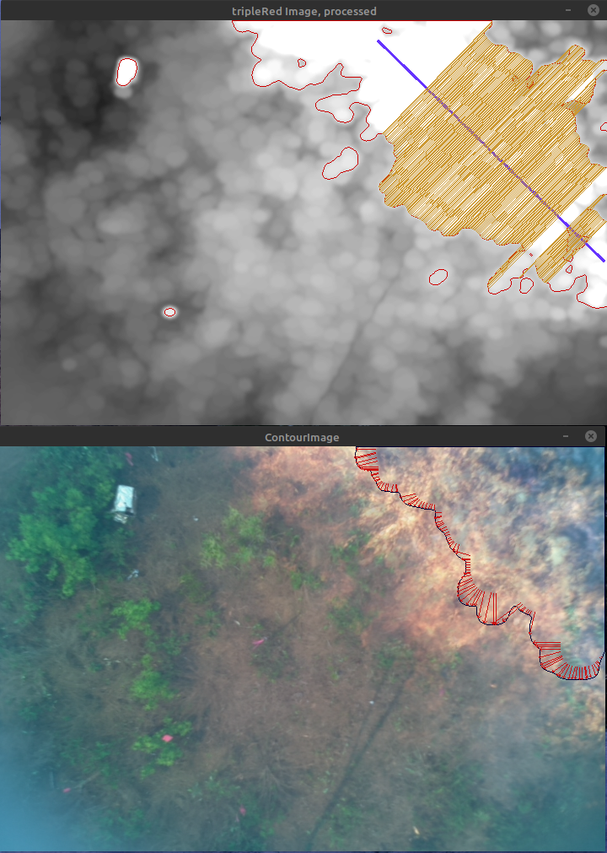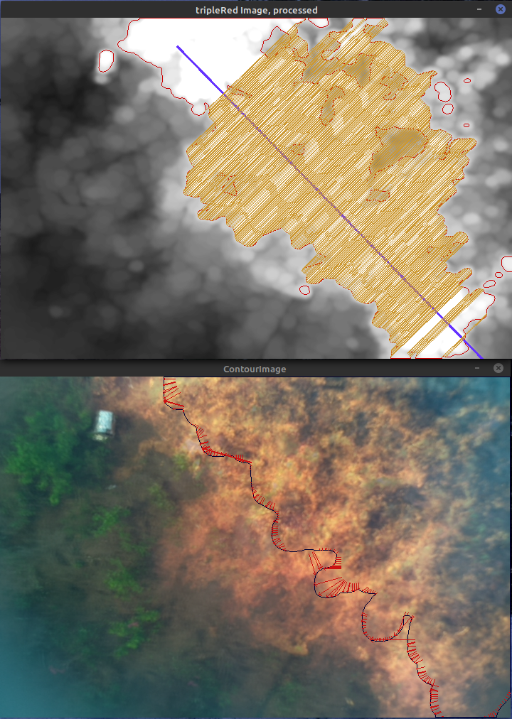

Figure 1. Two sample time frames with progression vectors and flame depth cross-sectional analysis lines.

The contour approach to determining flame front width handles the convoluted nature of the fire front and trailing fire edge behind the flame front in most cases. In the later frames of the analysis, the trailing edge becomes broken in the example and multiple small contours are detected there (Figure 2). I expanded the contour level used to detect the flame front in the red imagery to a 55 pixel value range. This reduced the broken nature of the contours and allowed a more contiguous flame front characterization. However, in some images with full sun on a brownish-red soil, the wider range would cause false positive detection of flame in the red imagery. To solve this issue, I wrote a mask function that used the median background thermal imagery value. This removed most of the false positive issues. With the exception of early in processing and late in processing. Given the nature of the thermal camera and the initial value flare, and the later saturation when most of the image is of a burning or heated area (Figure 3), I had to make the masking process dynamic with a specified bottom limit. This further reduced the flame front false positives.

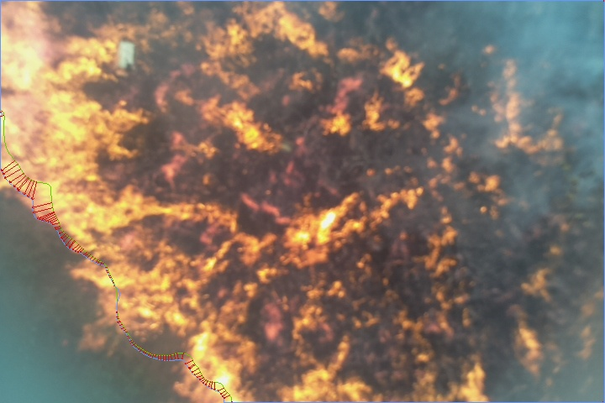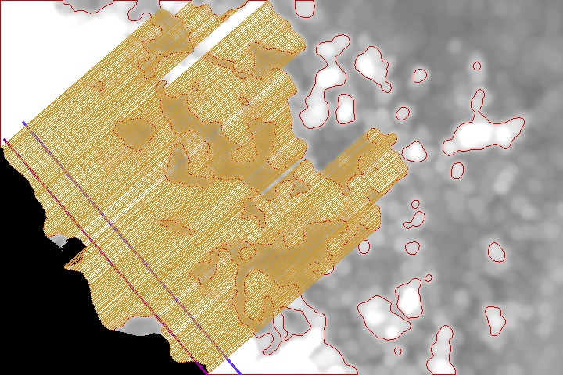Figure 2. Flame front contour with small burning areas discovered as separate contours.

It might be possible to further expand the threshold level for flame front detection. At the moment, there are still small areas excluded from the analysis. These might be able to be included into the major contour using more aggressive erode/dilate operations and/or different contouring thresholds these areas could be included in the main front. However, this will likely create other issues with the processing like those discussed above.

Figure 3. Median thermal thermal pixel value over time. ( 4-21-2017 Cam1 image series)

In all of the image sets examined late in image series after the fire has swept across all or most of the field of view, the algorithm will fail to have a defined progression direction. When this occurs the analysis is no longer valid. I include Figure 4, only to show what happens to the analysis when this occurs. Note that the progression vectors are facing in opposite directions.

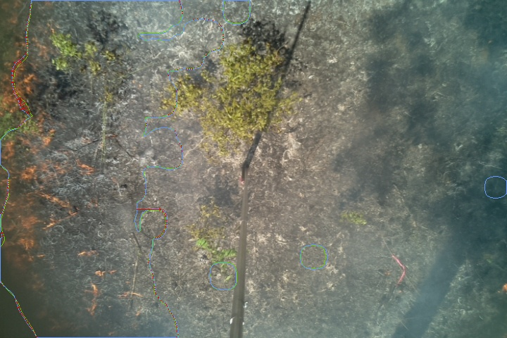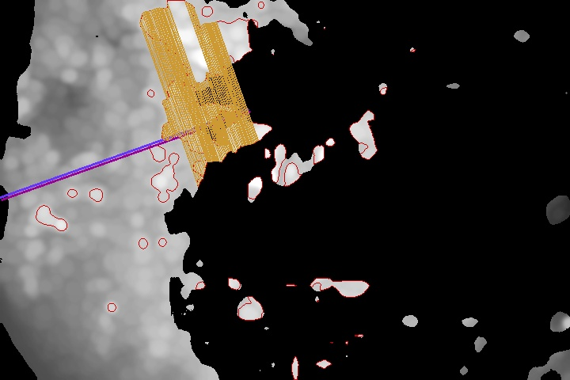

Figure 4. Frame 410 of 4_20_2017-Cam3 Image set. Flame has swept across image and flame front analysis degenerates due to absence of fire line. Actual flame front is approx. perpendicular to the fitted line in the right image.

***These methods were developed and tested using the following image sets:***

4-18-2017-Cam3

Good Analysis

4-18-2017-Cam4

Good Analysis

4-19-2017-Cam6

Good Analysis

4-20-2017-Cam3:

Fire spread occurred on two fronts. Current approach does not handle multiple fronts well.

Poor camera alignment in this series. Thermal and visual alignment off by ~40 pixels in X

direction. I have not made a special case adjustment for this set.

4-20-2017-Cam4

Later in analysis small backward moving fire line confuses analysis.

4-21-2017-Cam1

Good Analysis

4-21-2017-Cam5

Low intensity fire. Overall poor analysis results.

Other items that cause issues for the analysis are series with very low level level fires and bright sun. This creates issues for the processes that use the red-channel to locate flame. In some images, heavy smoke obscured the flame with similar results.

**Thermal Imagery Statistics.**

For the sample imagery, the first frame thermal image (Figure 5) statistics are:

Med. thermal background: 28

Mean thermal background: 28.9

Min. thermal background: 10.0

Max. thermal background: 255.0

Note that even though there is no active fire in the image, the thermal image has some pixels at their maximum value (lower right). The oncoming fire line is slightly evident in the upper left corner. Remember that 3 consecutive images are averaged together in order to smooth imagery and reduce the noise from the moving flames. Thus, the thermal image statistics for the first frame in the report will not exactly agree with the single frame numbers above. If you examine the thermal values at the end of this report, you will see them decrease as the flame front arrives, then increase as the burning and hot area increases. This behavior, figure 3, is present to some degree in all imagery. You mentioned that the thermal camera auto scales. Is this the amount of scaling you expected? I’m not sure how reliably I can process the thermal information with regards to fractional fire area and intensity.



Figure 5. First thermal image from the /Florida_TTRS_Data_Processed/4_19_2017Cam6 photo series

**Summary Report**

In the sample report attached at the end of this report, the flame front depth for each frame is an average of the intersecting lines. Based on the defined FOV in meters, the pixel measurements are converted to meters. The report assumed an interval 4 seconds (this is just a placeholder number used for testing), and the progression rate is based on this and the specified FOV.

If you’re interested, I can send you the source code for the three c++ methods that perform the flame front depth analysis.

Image Width (meters): 6.3

Image Height (meters): 4.2

Meters Per pixel: 0.0088

Flame Front

Time Fireline Center* Progression Speed Depth ----------- Thermal -----------

Frame (seconds) x pos. y pos Direction meter/sec (meters) Mean Median Min Max

1 0.00 0.3 3.8 52.0 0.01 I_D 28.5 27 11 255

2 1.00 I-D I-D I_D I_D I_D 27.7 26 10 255

3 2.00 I-D I-D I_D I_D I_D 23.1 22 7 218

4 3.00 I-D I-D I_D I_D I_D 20.1 19 5 190

5 4.00 I-D I-D I_D I_D I_D 16.8 15 5 186

6 5.00 I-D I-D I_D I_D I_D 18.2 17 6 184

7 6.00 I-D I-D I_D I_D I_D 17.5 16 6 204

8 7.00 I-D I-D I_D I_D I_D 16.3 15 4 215

9 8.00 5.8 0.2 233.0 0.07 I_D 13.9 12 3 206

10 9.00 I-D I-D I_D I_D I_D 12.2 10 1 208

11 10.00 5.7 0.2 226.0 0.04 I_D 10.2 8 1 211

12 11.00 6.0 0.4 203.0 0.02 I_D 10.0 8 0 229

13 12.00 5.9 0.3 214.0 0.03 I_D 9.7 8 0 235

14 13.00 5.9 0.4 211.0 0.03 I_D 10.3 8 0 238

15 14.00 5.8 0.4 219.0 0.02 I_D 10.7 8 0 236

16 15.00 5.8 0.4 216.0 0.05 0.70 11.7 9 1 240

17 16.00 5.8 0.5 227.0 0.03 0.81 13.0 10 2 253

18 17.00 5.8 0.5 219.0 0.06 0.81 13.2 10 1 245

19 18.00 5.9 0.6 196.0 0.04 0.79 13.8 9 1 241

20 19.00 5.8 0.7 229.0 0.07 0.69 14.6 9 1 240

21 20.00 5.8 0.8 202.0 0.06 0.85 16.2 10 2 250

22 21.00 5.8 0.9 237.0 0.07 1.31 16.0 9 2 253

23 22.00 5.8 1.1 230.0 0.08 1.28 17.8 9 2 253

24 23.00 5.7 1.1 231.0 0.15 1.22 18.1 8 2 252

25 24.00 5.4 0.9 243.0 0.05 1.15 20.6 10 2 252

26 25.00 5.5 1.1 211.0 0.07 1.11 21.6 10 1 251

27 26.00 5.4 1.0 238.0 0.06 1.33 22.9 12 2 251

28 27.00 5.4 1.1 219.0 0.07 1.51 23.8 11 2 247

29 28.00 5.5 1.4 209.0 0.05 1.56 24.5 11 2 236

30 29.00 4.7 0.7 250.0 0.08 1.53 27.7 12 2 224

31 30.00 5.0 1.3 226.0 0.12 1.72 29.7 13 3 209

32 31.00 5.2 1.5 211.0 0.09 1.86 32.2 13 3 200

33 32.00 4.7 1.3 224.0 0.11 1.80 35.1 14 2 200

34 33.00 4.9 1.6 224.0 0.15 1.73 37.3 15 2 212

35 34.00 5.0 1.9 203.0 0.12 1.89 44.1 20 3 214

36 35.00 4.7 1.9 225.0 0.12 1.98 44.9 20 3 212

37 36.00 4.5 2.0 222.0 0.06 1.86 50.2 24 2 211

38 37.00 4.5 2.1 226.0 0.14 1.94 50.7 23 3 215

39 38.00 4.0 1.8 227.0 0.09 1.93 58.5 30 2 229

40 39.00 5.2 2.9 210.0 0.12 2.12 60.7 34 0 228

41 40.00 4.1 2.3 235.0 0.07 2.19 66.1 43 0 223

42 41.00 3.6 2.0 231.0 0.11 2.11 71.7 51 1 228

43 42.00 3.6 2.3 222.0 0.13 1.95 77.8 63 1 234

44 43.00 3.3 2.2 224.0 0.08 1.80 84.1 74 1 240

45 44.00 3.0 1.8 219.0 0.07 1.71 84.2 83 3 246

46 45.00 3.0 2.3 229.0 0.10 2.11 89.2 96 3 245

47 46.00 2.6 2.0 224.0 0.09 2.34 91.2 106 0 241

48 47.00 2.7 2.4 233.0 0.08 2.62 99.2 122 0 247

49 48.00 2.4 2.2 228.0 0.09 2.62 106.0 131 0 253

50 49.00 2.3 2.3 231.0 0.13 2.25 113.3 139 0 249

51 50.00 2.1 2.3 220.0 0.07 2.21 119.1 144 0 249

52 51.00 2.0 2.3 235.0 0.04 2.12 119.1 144 3 239

53 52.00 1.9 2.1 243.0 0.06 2.07 122.5 149 2 241

54 53.00 1.6 2.0 231.0 0.08 2.25 124.5 152 3 240

55 54.00 1.6 2.0 228.0 0.06 2.46 128.1 153 3 242

56 55.00 2.0 2.6 239.0 0.03 2.37 127.2 149 3 240

57 56.00 1.9 2.6 227.0 0.09 2.29 123.7 144 5 227

58 57.00 2.1 2.9 236.0 0.03 2.30 127.7 150 1 233

59 58.00 1.8 2.4 244.0 0.05 1.95 124.8 146 1 227

60 59.00 1.7 2.4 237.0 0.04 1.93 134.4 156 0 234

61 60.00 1.8 2.7 229.0 0.03 1.97 133.3 153 0 235

62 61.00 1.8 2.6 228.0 0.02 2.05 137.8 158 0 238

63 62.00 1.6 2.5 238.0 0.04 2.02 132.6 151 0 236

64 63.00 1.5 2.4 232.0 0.05 2.05 137.6 157 0 243

65 64.00 1.5 2.5 222.0 0.06 2.12 142.8 162 0 243

66 65.00 1.5 2.8 220.0 0.05 2.16 149.1 169 0 248

67 66.00 1.4 2.8 227.0 0.03 2.29 151.1 172 1 241

68 67.00 1.2 2.5 231.0 0.03 2.51 155.3 176 0 249

69 68.00 1.3 2.7 226.0 0.04 2.55 154.6 176 0 247

70 69.00 1.5 3.0 226.0 0.02 2.79 152.7 173 0 242

71 70.00 1.3 2.8 222.0 0.02 2.45 147.2 166 0 232

72 71.00 1.3 2.8 226.0 0.04 2.70 145.2 164 1 232

73 72.00 1.2 2.9 227.0 0.05 3.08 148.5 166 0 232

74 73.00 1.2 2.9 228.0 0.04 2.25 151.4 168 0 244

75 74.00 1.3 3.2 223.0 0.06 1.87 152.7 168 1 238

76 75.00 1.3 3.2 229.0 0.04 2.49 154.8 170 1 239

77 76.00 1.1 3.1 219.0 0.04 2.05 156.2 170 2 243

78 77.00 1.2 3.2 232.0 0.04 2.43 159.2 172 2 250

79 78.00 1.2 3.2 220.0 0.04 2.15 159.1 171 2 250

80 79.00 1.1 3.2 212.0 0.02 2.52 163.9 176 4 242

81 80.00 1.2 3.4 219.0 0.03 2.01 159.0 170 4 236

82 81.00 1.0 3.2 222.0 0.06 1.76 154.2 164 4 231

83 82.00 1.0 3.3 212.0 0.04 1.80 148.4 156 4 235

84 83.00 1.0 3.4 219.0 0.06 1.95 149.6 156 3 252

85 84.00 1.3 3.9 202.0 0.03 2.16 149.5 156 6 246

86 85.00 0.7 3.3 221.0 0.06 2.89 150.4 157 3 240

87 86.00 0.7 3.4 223.0 0.07 2.76 157.5 163 7 249

88 87.00 0.6 3.4 233.0 0.08 2.57 164.2 169 10 242

89 88.00 0.5 3.5 233.0 0.04 2.07 164.2 167 10 244

90 89.00 0.7 3.7 220.0 0.05 3.40 159.4 161 7 246

91 90.00 0.7 3.8 213.0 0.03 3.23 156.7 158 8 253

92 91.00 0.7 3.8 203.0 0.06 2.74 159.7 161 4 241

93 92.00 0.7 3.9 207.0 0.03 2.26 154.8 156 4 252

94 93.00 0.6 3.9 212.0 0.03 2.85 149.0 149 5 250

95 94.00 0.3 3.7 235.0 0.02 3.28 152.4 152 3 245

96 95.00 0.3 3.7 229.0 0.03 2.38 162.2 163 3 242

97 96.00 0.4 3.8 226.0 0.04 2.77 166.6 168 0 245

98 97.00 1.6 3.2 245.0 0.01 2.77 163.4 165 0 249

99 98.00 0.3 3.9 223.0 0.01 3.19 167.4 171 0 248

100 99.00 1.6 2.8 240.0 0.01 1.82 166.7 171 0 251

**At this point the flame front has swept across the FOV, and the analysis is no longer valid.**

**101 100.00 I-D I-D I_D I_D I_D 166.6 172 0 247**

102 101.00 3.6 1.6 313.0 0.02 1.73 164.9 171 0 253

103 102.00 2.4 2.4 280.0 0.03 2.66 167.8 175 0 254

104 103.00 2.7 2.3 249.0 0.03 2.89 173.1 180 0 246

105 104.00 2.4 2.4 289.0 0.02 1.88 175.0 180 0 244

106 105.00 4.2 1.2 43.0 0.01 0.85 179.4 183 0 255

107 106.00 5.6 0.3 32.0 0.01 I_D 177.5 181 0 255

108 107.00 2.0 2.7 271.0 0.02 1.03 175.3 177 0 253

109 108.00 2.9 2.4 40.0 0.01 1.15 172.0 173 0 250

110 109.00 3.0 2.2 56.0 0.02 1.62 169.9 170 0 253

111 110.00 4.4 1.5 56.0 0.03 2.18 170.7 170 0 251

112 111.00 4.0 1.8 57.0 0.02 1.98 171.6 169 0 250

113 112.00 3.0 2.0 49.0 0.01 0.52 173.0 171 0 253

114 113.00 5.9 0.8 57.0 0.01 I_D 172.2 170 0 254

115 114.00 6.0 0.8 59.0 0.01 I_D 173.5 173 0 254

116 115.00 6.0 0.9 63.0 0.02 I_D 172.8 172 0 254

117 116.00 6.2 1.1 70.0 0.01 I_D 171.6 171 0 253

118 117.00 4.1 2.0 80.0 0.01 1.66 169.5 170 0 254

119 118.00 4.6 1.7 68.0 0.01 1.26 167.1 168 0 254

120 119.00 6.1 1.5 71.0 0.01 I_D 165.6 166 0 255

121 120.00 4.4 2.2 83.0 0.01 1.08 166.2 167 0 254

122 121.00 5.9 0.6 60.0 0.01 I_D 167.5 169 0 253

123 122.00 I-D I-D I_D I_D I_D 168.4 171 0 254

124 123.00 5.9 0.6 56.0 0.01 I_D 166.4 169 0 254

125 124.00 3.1 4.0 175.0 0.02 0.82 166.6 169 0 255

126 125.00 2.6 2.5 279.0 0.01 0.70 165.9 168 0 254

127 126.00 2.9 3.9 194.0 0.01 1.19 166.9 169 0 254

128 127.00 3.4 2.2 194.0 0.01 1.64 166.3 169 0 254

129 128.00 4.1 2.2 99.0 0.01 1.81 165.7 168 0 253

130 129.00 6.0 1.9 75.0 0.01 I_D 164.8 168 0 252

131 130.00 6.0 1.6 64.0 0.02 I_D 164.0 167 0 250

132 131.00 5.2 1.5 63.0 0.02 1.25 164.5 168 0 252

133 132.00 2.2 3.5 227.0 0.01 0.91 164.5 167 0 255

134 133.00 2.9 2.2 232.0 0.01 0.95 165.0 167 0 255

135 134.00 6.0 1.3 64.0 0.01 I_D 165.5 169 0 255

136 135.00 5.9 0.6 57.0 0.01 I_D 165.2 169 0 254

137 136.00 I-D I-D I_D I_D I_D 163.8 168 0 255

138 137.00 0.3 2.2 263.0 0.05 2.74 161.1 165 0 255

139 138.00 0.3 2.3 265.0 0.04 4.51 161.3 165 0 254

140 139.00 2.6 1.6 315.0 0.02 I_D 161.2 165 0 253

141 140.00 4.0 1.5 52.0 0.01 I_D 162.1 166 0 254

142 141.00 5.9 0.7 60.0 0.01 I_D 162.4 167 0 254

143 142.00 2.4 2.1 257.0 0.02 1.27 161.4 166 0 252

144 143.00 0.3 3.3 252.0 0.01 I_D 161.9 166 0 254

145 144.00 0.2 2.6 261.0 0.02 I_D 159.7 163 0 254

146 145.00 2.9 2.0 284.0 0.01 1.34 159.6 163 0 254

147 146.00 2.8 1.6 308.0 0.02 0.67 158.5 161 0 254

148 147.00 2.8 2.1 316.0 0.02 1.21 158.6 161 0 254

149 148.00 0.3 2.4 266.0 0.01 4.73 159.1 161 0 255

150 149.00 0.3 2.4 262.0 0.02 4.84 159.7 162 0 254

151 150.00 2.3 3.8 216.0 0.01 1.36 160.0 162 0 253

152 151.00 I-D I-D I_D I_D I_D 157.9 160 0 254

153 152.00 6.0 1.4 69.0 0.02 I_D 154.8 157 0 252

154 153.00 6.0 1.5 71.0 0.03 I_D 154.6 157 0 254

155 154.00 3.6 1.8 69.0 0.02 2.51 155.9 158 0 253

156 155.00 3.6 2.2 262.0 0.01 1.65 157.4 159 0 253

157 156.00 1.8 2.5 262.0 0.02 1.40 158.1 159 0 252

158 157.00 3.4 2.1 343.0 0.01 1.93 158.5 160 0 254

159 158.00 6.0 1.9 73.0 0.01 I_D 158.9 161 0 254

160 159.00 2.2 3.2 249.0 0.01 1.24 158.4 160 0 252

161 160.00 3.4 2.9 249.0 0.01 1.51 158.5 160 0 252

162 161.00 0.3 2.4 263.0 0.02 I_D 158.9 160 0 253

163 162.00 5.9 2.3 99.0 0.01 0.11 158.5 160 0 253

164 163.00 4.5 1.7 63.0 0.01 I_D 158.0 159 0 253

-------------------------------------------------------------------------------------------------------------------

* Fire line center is in meters from top, left corner of image.

Progression Direction: is compass degree heading of dominant progression.

I-D:: Insufficient data from image processing to determine fire position and progression.