# ROI Pipeline

Steps:

#) Register image (optical image) to ion image (optional)

#) Draw ROI on registered image / ion image

#) Apply analysis on all images (mat files) in a dataset

## Register Image

Register an optical image to another ion image. The sizes of the 2 images can be different.

% Usage:

% [TFORM, transformedImage, transformedImageDetails, opticalImage, ImgPathname, ImgFilename] = register_OpticalImage_with_IonImage(true, use_default_ginput, '', '');

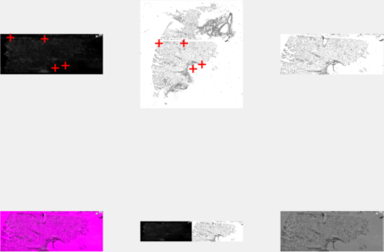

See image above. The red crosshairs show registration points marked on an ion image (top left) and an optical image (top right). The registered image is shown in plot 3. Remaining images are different methods for overlaying the original image on the registered image.

## Draw ROI

%% #) Draw ROIs on registered image

% [flag] = drawROIs(false, 'msg', ImgPathname, ImgFilename, transformedImage, false, use_default_ginput);

#) Draw ROI on registered image / ion image

Basic Requirements:

#) Capability to draw ROIs on optical/ion image.

#) Annotate ROIs

#) Save/Re-load/Replace ROIs, Image files

The user can open up an ion image/optical image and draw ‘n’ number of ROIs which are saved to a separate struct, each named with the annotation given by the user for each ROI. This way if the user decides to re-do a ROI with the same name, it is overwritten. The struct containing all the ROI is saved for later use. Each ROI will be drawn on a fresh image, so the previous ROIs will not be a hindrance. After each ROI, the UI will ask the user if they want to draw more ROIs” and it will keep going until user says no. Once ROIs have been marked, all the ROIs will be populated and overlayed (Overlapping regions will be colored differently) on the ion image (with and without annotation) and saved to a user specified location. The user can also load a previously saved struct and continue working on the same file.

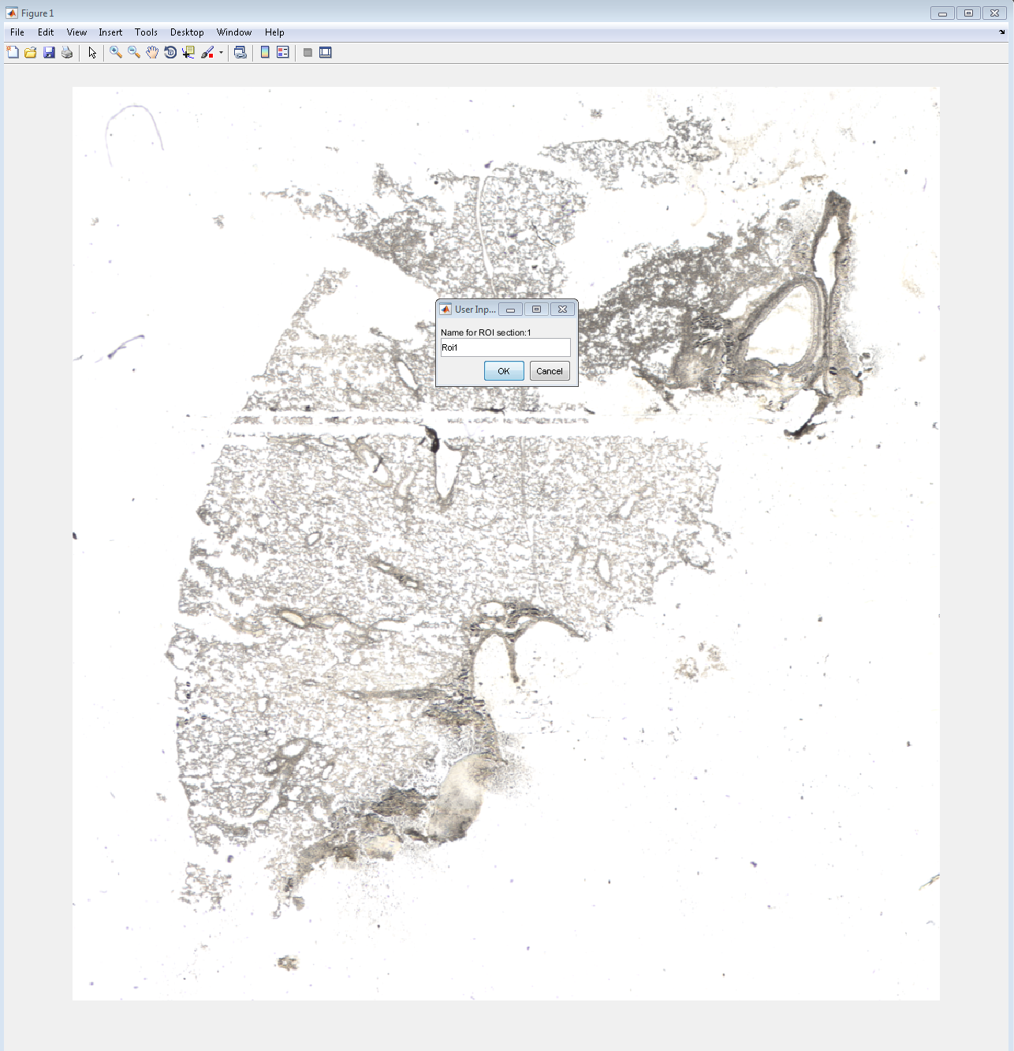

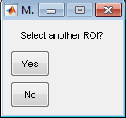

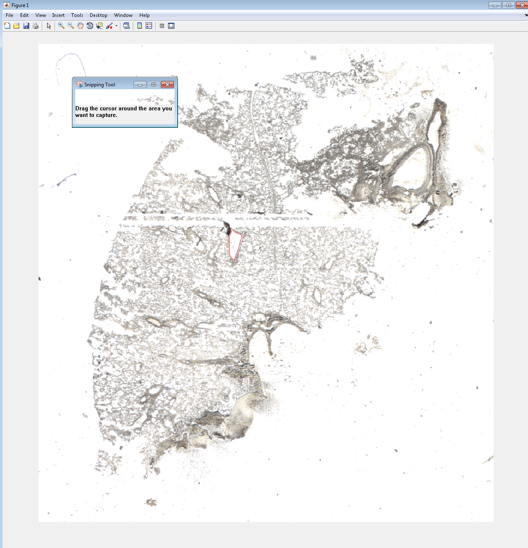

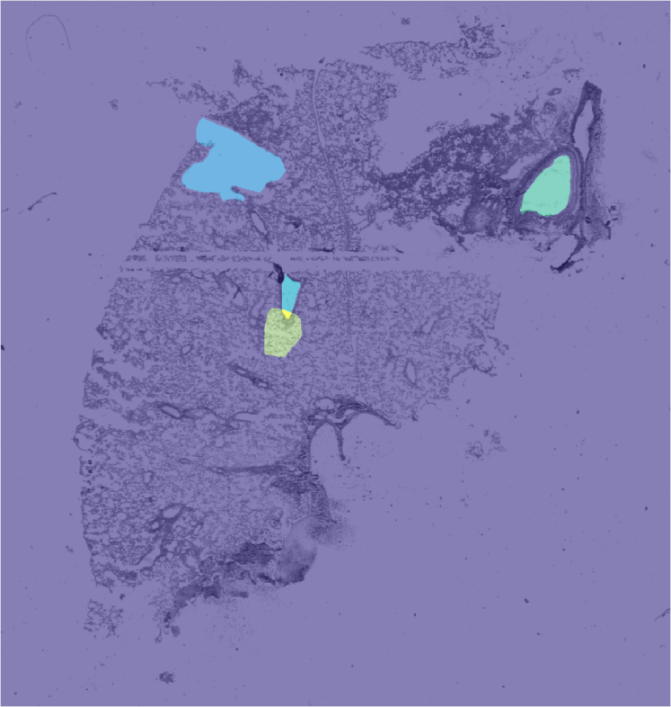

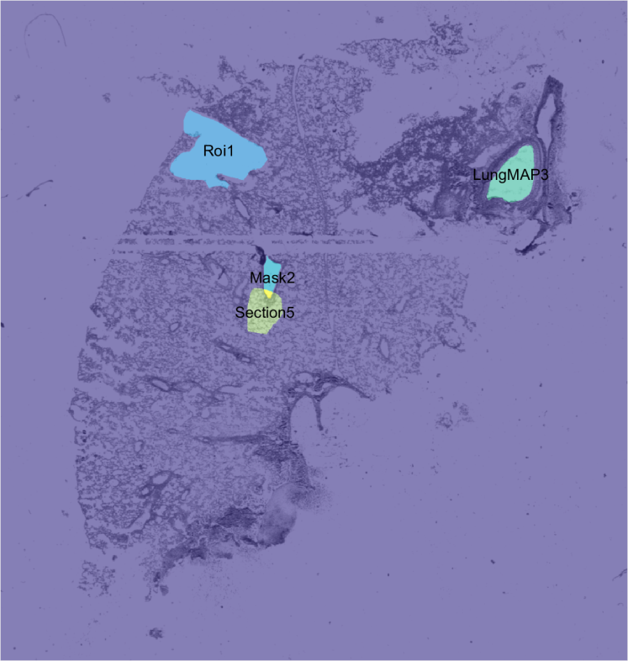

## Apply analysis on all images

All images in a folder called “Images” within a dataset folder is analyzed for all ROIs and saved to either a single struct (‘roiMarkedImages.mat’) or a single folder (‘ROI_Images’) into multiple mat files, one for each image.

%% #) Do necessary analysis on ROIs

% if ~flag || use_default_ginput || ~use_default_ginput; ROI_points_to_Ion_Images(false, false, transformedImage); end