Student Score Analyzer for Teachers

Matthew Thomas

12/6/17

I. Background/Introduction

The goal of this project is to create a tool to analyze students’ scores from a test or some other assessment. Teachers of any grade/subject will be able to utilize this program. They will input scores and be given a list of students in order of how they performed. The Student Score Analyzer for Teachers (SSAT) should assist teachers in targeting their attention to the students who need it. SSAT is going to be a website, created using some already existing tools and systems.

II. Problem Statement

Teachers need an easy way to view and compare student scores.

III. Proposed Approach

The main user of this website is teachers. The website is easy-to-use and understand so that it does not take up a lot of the user’s time. My approach was to create a website that gave users the ability to enter scores. The scores would then be sorted. After receiving the results, users would have the option to create groups of students based on the results.

IV. Design

I adopted the user-centered design method. I sat down with my mom, a first-grade teacher, and asked her what would be helpful to have in a score analyzer. While designing and implementing my website, I repeatedly returned to her and got her opinion on how it was looking. I chose to use ASP.NET with the Model-View-Controller (MVC) design pattern. I utilized Syncfusion and its already existing controls (tables, buttons, textboxes, etc.) in my website. To host my website, I chose Azure since it was free and came recommended by a coworker.

After contemplating the best way to layout my website, I decided to go with two main interaction styles. The two styles I chose were direct manipulation and form fill-in. They seemed to make the most sense for what I was trying to do. Since I decided to use Syncfusion in the development of my website, I was able to start with one of its templates that was already setup. From there, I just modified the pages and content to match what I needed, as well as added a few more pages. However, the layout, navigation, and color scheme were pretty much already there. Unfortunately, I did not have time to research website UI guidelines, but I believe the Syncfusion template should already follow most of them. In terms of the 8 Golden Rules of Interface Design, my website is consistent, it prevents errors, and, for the most part, keeps users in control.

V. Implementation Details and Challenges

Overall, I think I put around 40-50 hours into this project. A majority of that time was spent on the coding/implementation as I had never coded in ASP.NET before. I have also never created a website. Therefore, I had to do a lot of research into how it all worked, which took time. My only testing plan was to have my mom use it and give me her feedback. Since she is a teacher, I figured she would be a good use case. My mom gave me feedback and suggestions throughout the project, and some ideas for future enhancements.

VI. Results

Sample Use Case #1

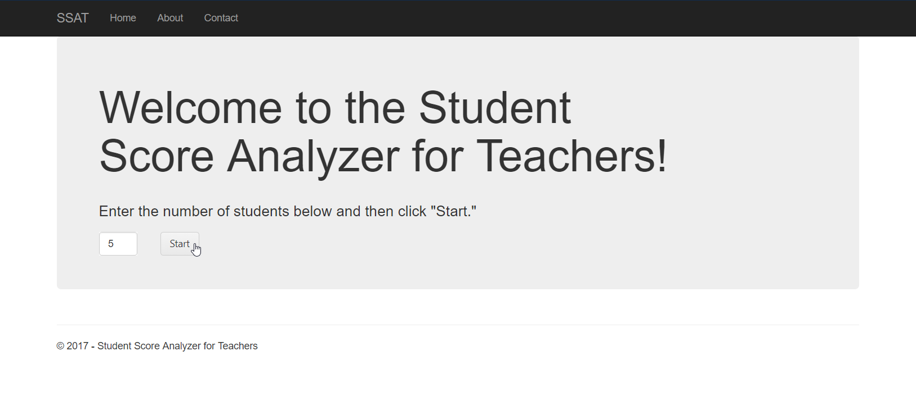

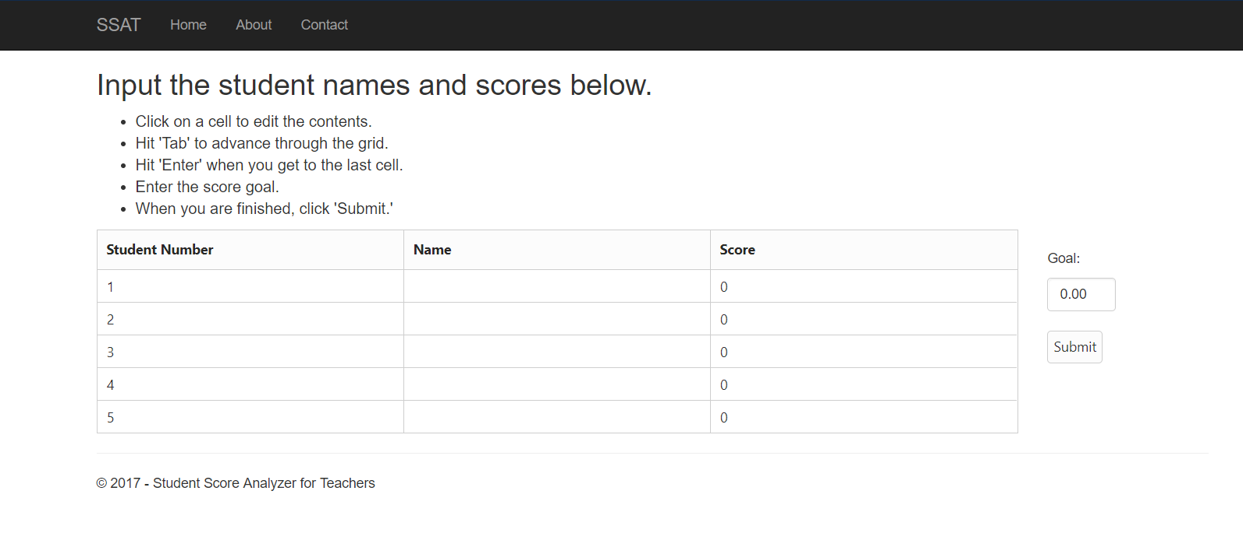

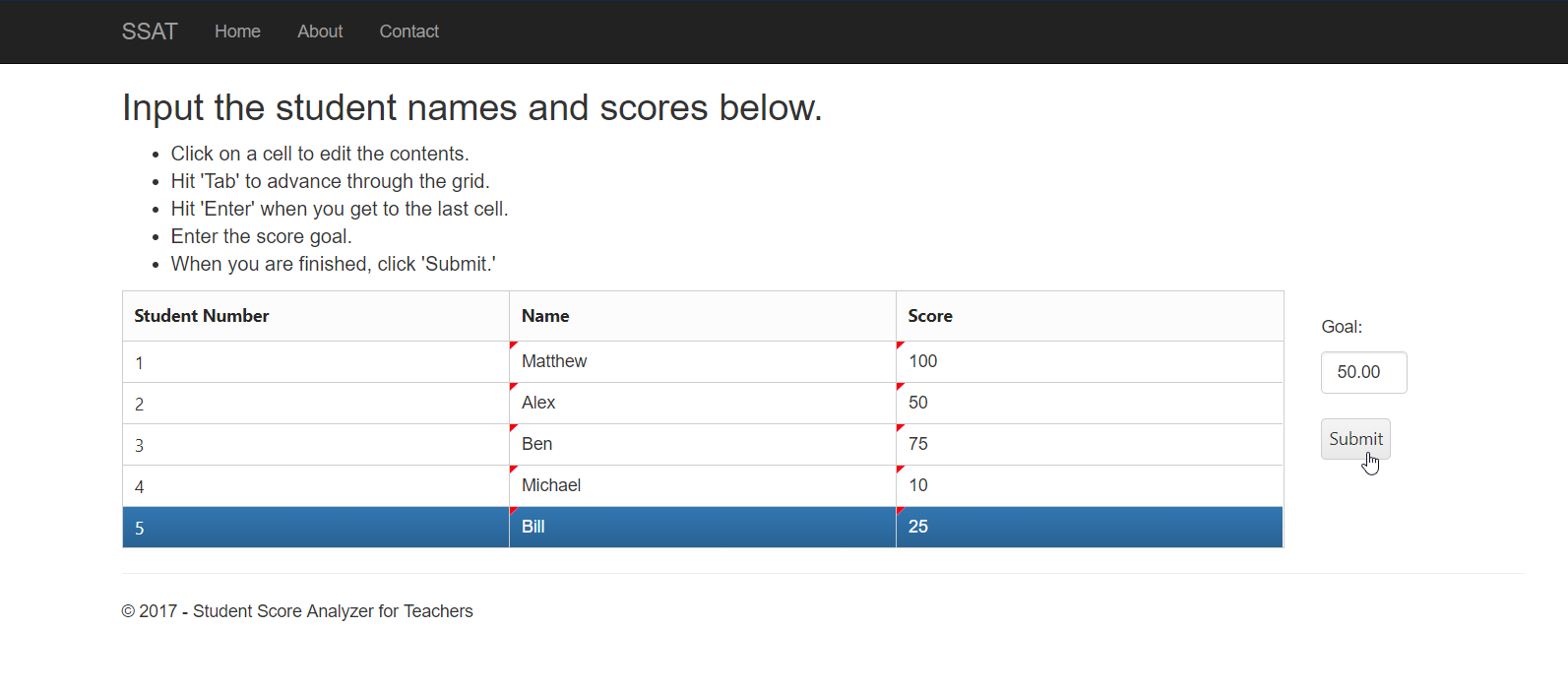

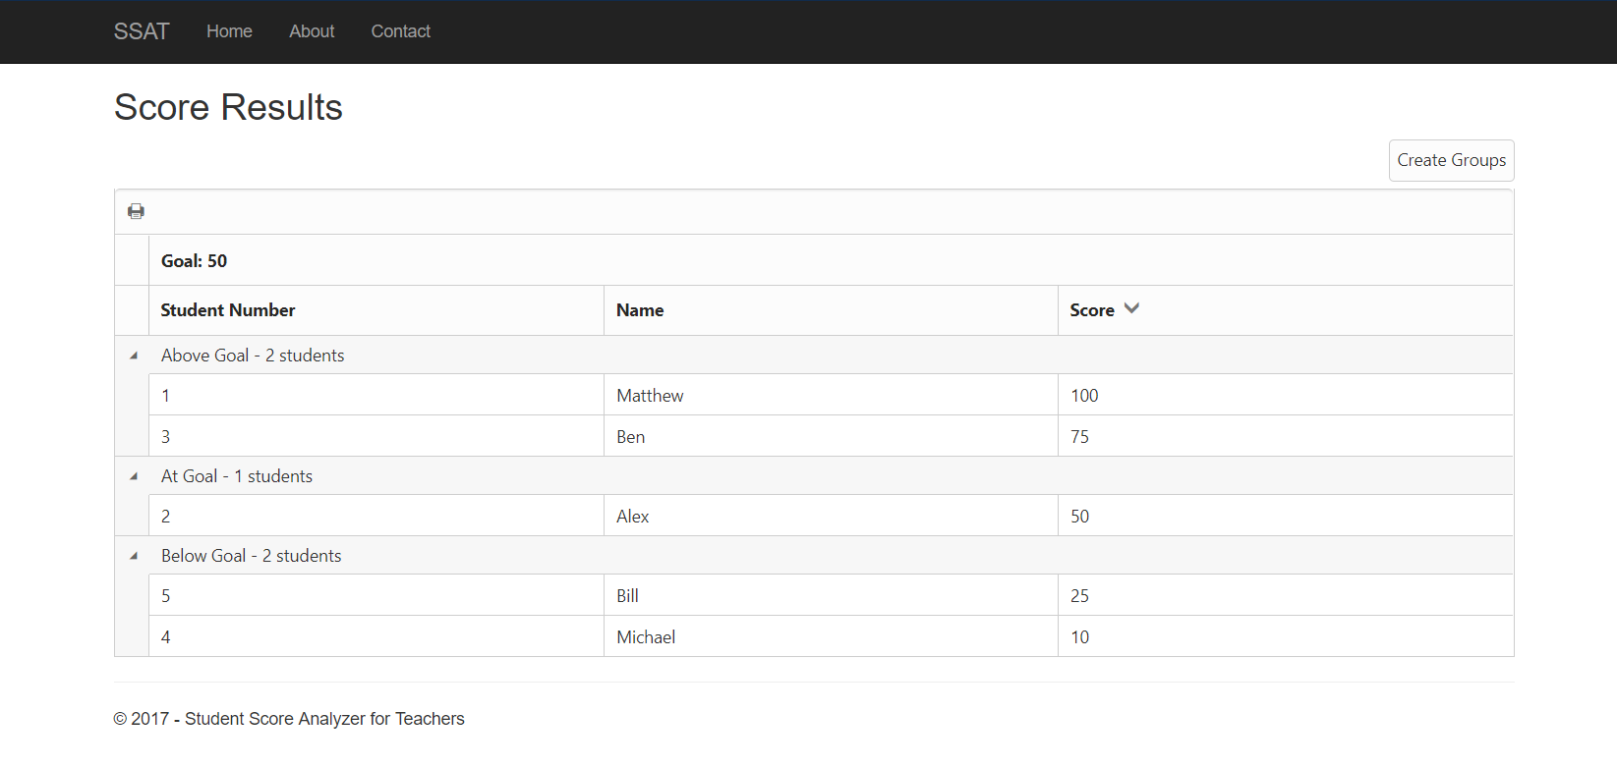

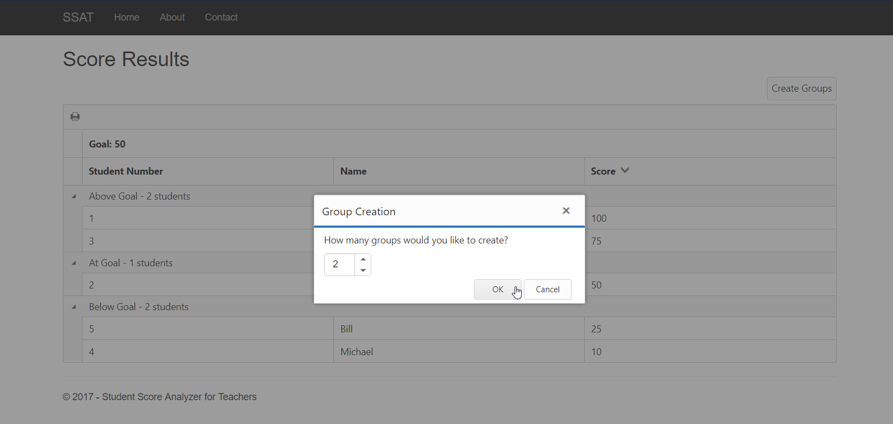

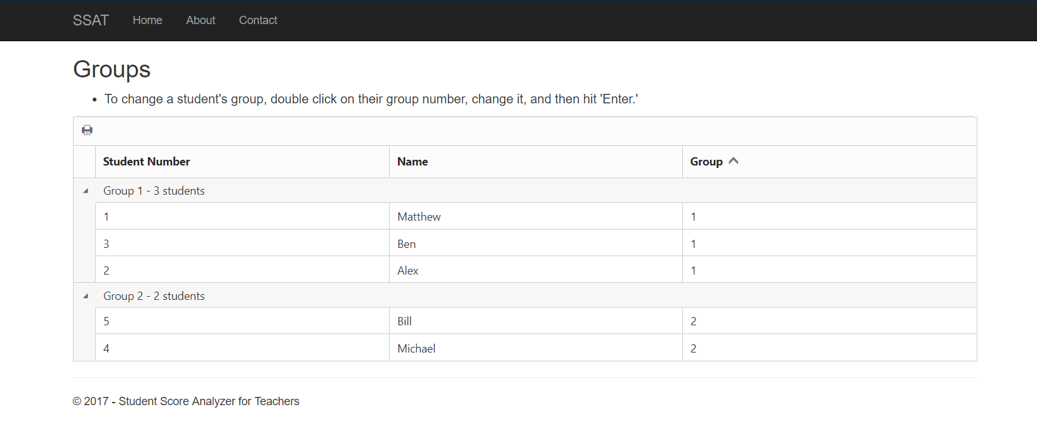

Sample Use Case #2



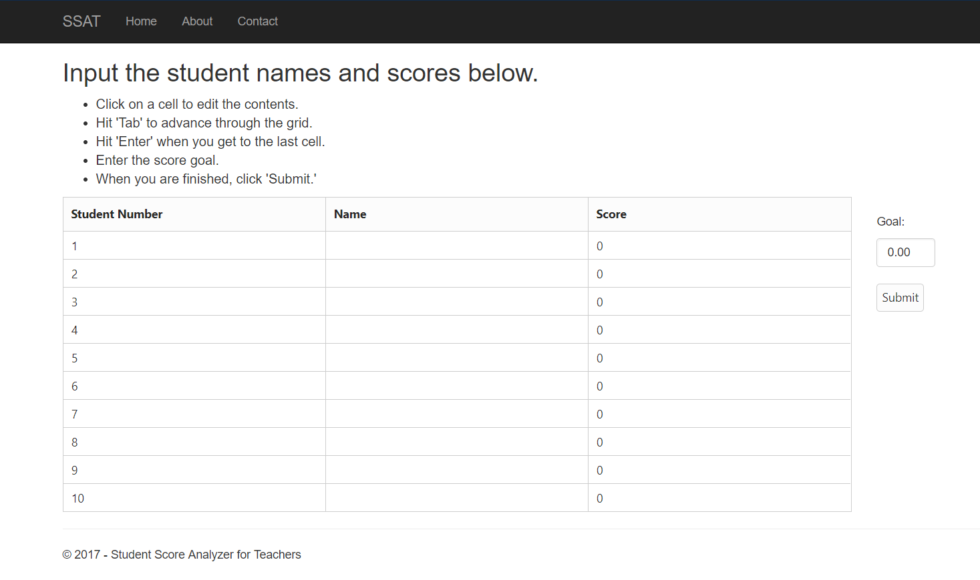

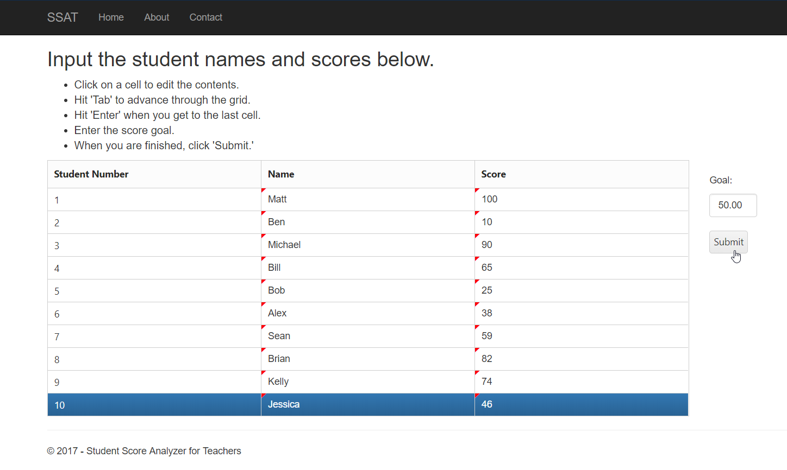

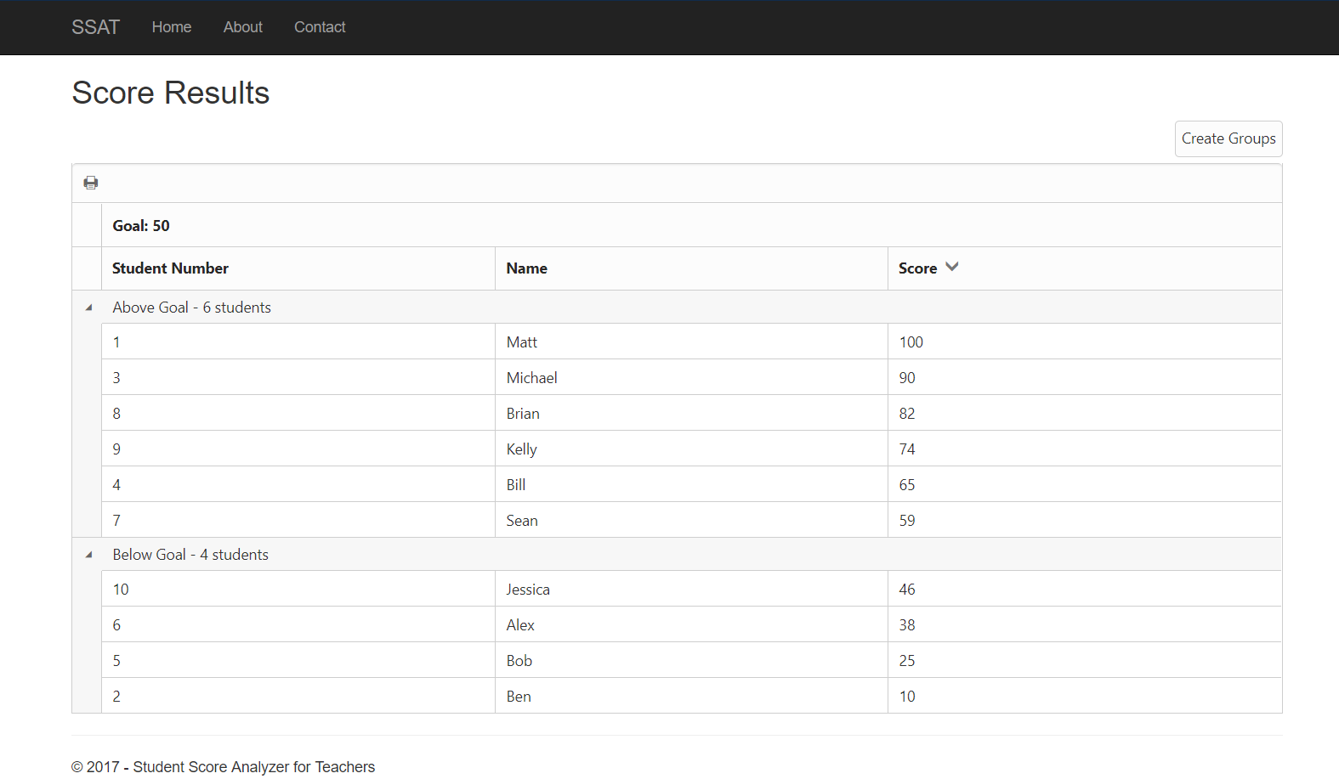

Checklist

* Website created
* Ability to enter scores
* Scores are sorted
* Ability to create groups based on scores

The current version of my website is adequate for use, but can be enhanced in the future. Some plans I have for the future include:

* Add stats to results page (average, median, etc.)
* Add ability to upload data so you don’t have to type it all
* Add ability to export results so you can save them to Excel, etc.
* Design an icon to personalize the website more

I think the UX for the website is good, but could be improved. I believe my website has a consistent style and prevents errors. However, I feel like there may be places I could offer informative feedback. It also occurred to me as I was finishing up the project that maybe I should add a ‘Previous’ button to return to the previous step. There also may be some layouts I could change to make the site’s layout more consistent. This was definitely an interesting and new experience for me. I have never developed my own user experience before, and I liked it. I think I should have looked into usability issues more, but I was too focused on having a final product that worked.

VII. Conclusion

Throughout this course, I learned what to consider and how to think when designing a user experience. I learned to not think as myself, but put myself in the shoes of the user. As I stated in the previous section, some plans for future work include adding stats to the results page, adding the ability to upload data, adding the ability to export the results, designing an icon, and adding a ‘Previous’ button. I am not sure that there are any code modules that are generic enough to be reused by someone else in the future. However, if someone is designing a website and isn’t sure what to use for textboxes, buttons, etc., they could use Syncfusion as it is nice, fairly easy to figure out, and has documentation.

VIII. References

* Syncfusion ASP.NET MVC Documentation
  + <https://help.syncfusion.com/aspnetmvc/introduction>
* Other random links found on Google when I had a problem

The code for this project can be found here: <https://github.com/thoma3mw/StudentScoreAnalyzerForTeachers>