COMP3111: Software Engineering Team Project - Course Scraper

Initial Use-case Specification

# Register for Courses

## Brief Description

This use-case describes the process by which a user registers for a course. The process includes capacities to fetch course and subject information from a course website, to filter displayed course sections, and to change enrollment status for course sections.

## Use-case Diagram

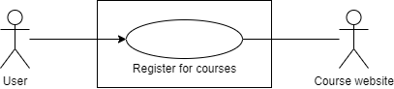

## Flow of Events

1. Fetch Courses from Course Website
2. Fetch Subjects from Course Website
3. Filter Displayed Courses Sections
4. Change Enrollment Status for Course Sections

# Check Timetable

## Brief Description

This use-case describes how a user views a timetable representing the distribution of slots of their enrolled course sections.

## Use-case Diagram

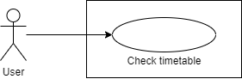

## Flow of Events

1. View Timetable

# 

# Check SFQ Scores

## Brief Description

This use-case describes the process by which a user views the SFQ scores of courses and instructors. The process includes the capacities to fetch and view unadjusted SFQ scores of the user’s enrolled courses, and to view unadjusted SFQ scores of all instructors.

## Use-case Diagram

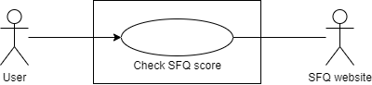

## Flow of Events

1. View Enrolled Courses’ SFQ Scores
2. View Instructors’ SFQ Scores

COMP3111: Software Engineering Team Project - Course Scraper

Use-case Detailed Specification