Name:_________________________________ Date:___________________________________

Coulomb’s Law Lab
The Coulomb constant “k” is named after Charles-Augustin de Coulomb. This constant is associated with the electric force and is also known as the electric force constant. When charged particles interact, a force repels or attracts the particles. For instance, two like charges (such as a proton and a proton) repel each other and travel in opposite directions and two unlike charges (such as an electron and a proton) will be attracted to each other. The electrostatic force equation is shown below:
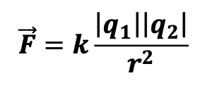
Objective: Find the Coulomb Constant k experimentally.
We will use the simulation below: https://phet.colorado.edu/en/simulation/coulombs-law
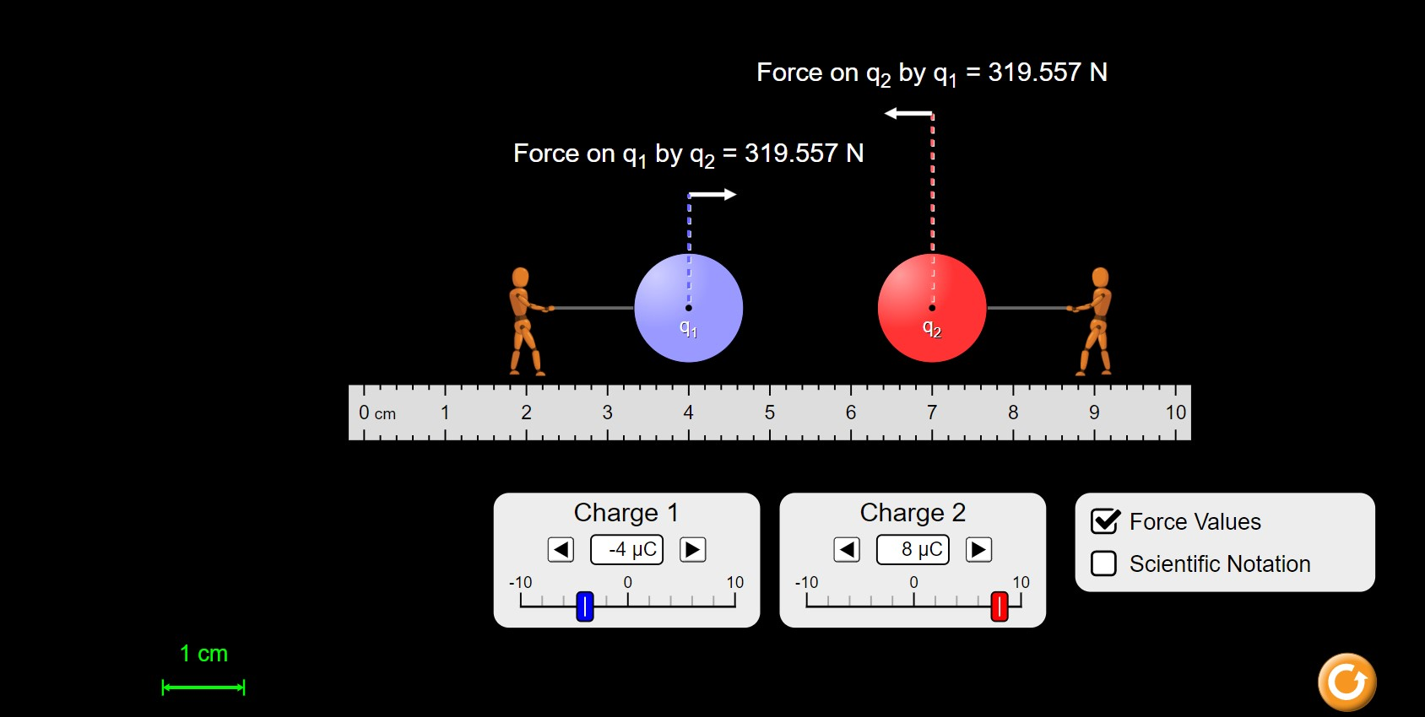
Figure 1: Coulomb’s Law simulation.

Directions: Answer the following questions.
- What is the equation for Coulomb’s Law and define each variable in the equation?

- What is the definition electric charge?

- As the distance between electric charges increase, the electric force:
  - Increases
  - Decreases
  - Remains the same

- As the distance between electric charges decrease, the electric force:
  - Increases
  - Decreases
  - Remains the same

- Like charges:
  - Repel
  - Attract
  - None of these

- Unlike charges:
  - Repel
  - Attract
  - None of these
Problem:
Three-point charges lie along a straight line as shown in figure 1 below, where 𝑞₁ = 6.00 𝜇𝐶,
𝑞₂ = 1.50 𝜇𝐶 , and 𝑞₃ = −2.00 𝜇𝐶. The separation distances are 𝑑₁ = 3.00 𝑐𝑚 and 𝑑₂ = 2.00 𝑐𝑚. Calculate the magnitude and direction of the net electric force on:

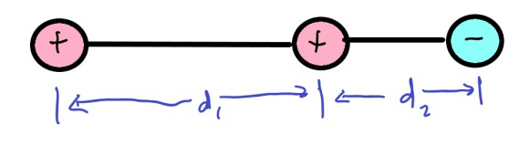
Figure 1
- 𝑞₁
- 𝑞₂
- 𝑞₃

Show your work.
Procedure:
- Go to the following site to access the lab simulation for Coulomb’s Law and download the simulation. https://phet.colorado.edu/en/simulation/coulombs-law
- Open it.
- select Macro Scale.
- Set “charge 1” to 10 𝜇𝐶 and set “charge 2” to 1 𝜇𝐶. Remember 1 𝐶 = 1×10⁻⁶ 𝜇𝐶
- Make sure force value box is checked.
- In data table 1 below the separation distance “r” is given to you. Separate the charges by 10 cm.
- Record the force value in data table 1. It does not matter which force value you use since you are only recording the magnitude of that force.
- Repeat the process for the rest of the values.
- Record the value for the separation distance in meters. Record your values in data table 1.
- Find 1/r². Record your values in data table 1.

Value of 𝑞₁=________________________ 𝑞₂=________________________

r (cm) | r (m) | F (N) | 1/r² (m⁻²)
10
8
6
4
2

Data Analysis
- Once you have completed data table 1 make a graph of Force vs. Separation Distance. You do not need to put an equation and R squared value on this graph.
- Make a second graph of Force vs. 1/r². You MUST put the equation and R squared value on this graph. Search online how to make a scatter plot and add a trendline; this is a helpful skill.
- Use the Force vs. 1/r² graph to find the value of the Coulomb Constant “k”. What is your experimentally determined value of k?
- Calculate the percentage error. Use the following equation to calculate the percentage error.
Show your work.
