Ohm’s Law Lab
Uses these simulations:
https://phet.colorado.edu/sims/html/ohms-law/latest/ohms-law_en.html
https://phet.colorado.edu/en/simulation/resistance-in-a-wire
Ohm’s Law
When combining the variables of voltage, resistance and current, German physicists Georg Ohm developed the formula:
$$V=IR,$$
where V is the voltage in volts, I is the current in amps, and R is the resistance in Ohms (Ω). If the resistance is constant over a range of voltage this law can be used to predict the behavior od the material. Whether or not a material obeys Ohms law, its resistance can be described in terms of the resistivity ρ.
Resistance and resistivity
The component in the resistance which takes into account the nature of the material is the resistivity which is represented by the Greek letter ρ (rho). As you will see in this experiment, resistance is linearly proportional to the length of the conductor and inversely proportional to the cross-sectional area. We can write the resistance formula as
$R=ρ\frac{L}{A}$,
where ρ is the electrical resistivity, $L$ is the length of the conductor and $A$ is the cross-sectional area of the conductor.
In this lab, you will use two simulations to complete the experiments. The two simulations are shown in the figures below.
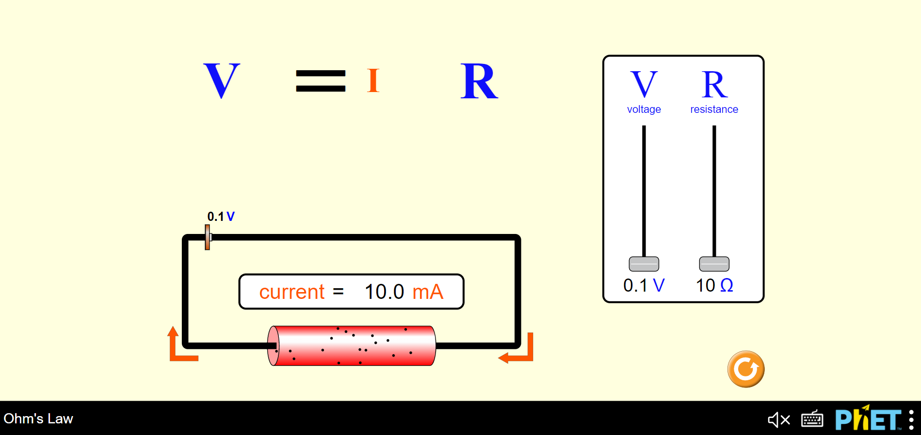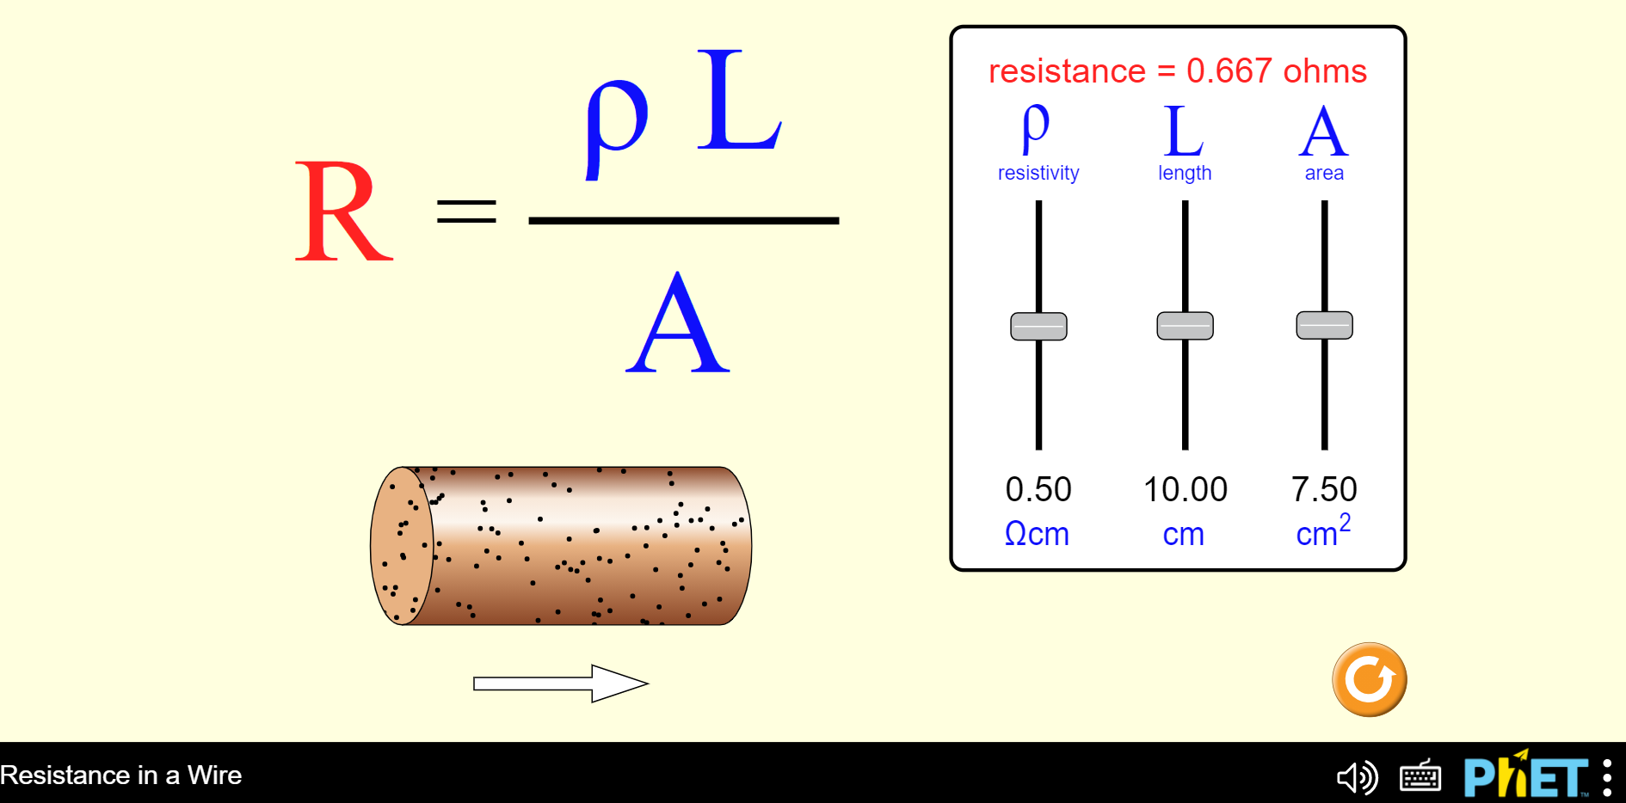
Simulation 1 Simulation 2

Exercise 1
In lecture, we discussed how to determine if a material is Ohmic or nonohmic. Take some time and consider the table below that shows voltage and current data for two different electrical devices. Which of the devices obeys Ohms Law? Refer to the lecture for review of this subject. All graphs must be attached and submitted with this packet to receive full credit for the problem. You can make two graphs or you can plot both on one graph.
Voltage applied to device (V) | Current in Device 1 (A) | Current in Device 2 (A)
1.00 | 0.123 | 0.123
2.00 | 0.249 | 0.250
3.00 | 0.365 | 0.389
4.00 | 0.486 | 0.545
5.00 | 0.621 | 0.701
6.00 | 0.745 | 0.909
7.00 | 0.854 | 1.230
8.00 | 0.984 | 1.550
9.00 | 1.102 | 1.719
10.0 | 1.241 | 1.747
Data Table 1 (Jewett, 2019)
In the space provided below explain how you determined if the device obeyed Ohms Law.

Exercise 2
Procedure:
- Open the Ohms Law simulation with the following link https://phet.colorado.edu/sims/html/ohms-law/latest/ohms-law_en.html
- Move the resistance slider to about 406 V. You will keep the voltage set at this value. Do not move the slider again for this part of the experiment.
- Move the slider to 0.5 V.
- Record the current in mA in the Data Table 2 below.
- Repeat the process in increments of 0.5 V making sure you record the current for each increment.
Analysis of data
- Use Excel or Vernier Graphical Analysis to plot your data. Plot current on the Y axis and plot Voltage on the x-axis.
- The slope of your graph is 1/R. What type of relationship is given by the graph?_____________________

- What is the resistance?_______________________
Voltage (V) | Current (mA)
0.5
1.0
1.5
2.0
2.5
3.0
3.5
4.0
4.5
5.0
5.5
6.0
6.5
7.0
7.5
8.0
8.5
9.0
Data Table 2

Exercise 3
Procedure:
- Open the resistance in a wire simulation with the following link:
https://phet.colorado.edu/en/simulation/resistance-in-a-wire

- Move the resistivity knob to 0.50 Ω cm.
- Move the area knob to 7.50 cm².
- Move the length to 2 cm and take the measurement of the resistance R. Record the results in table 3 below.
- Repeat the step above, increasing the length by 2 cm each time until you have completed all the measurements through 20.00 cm.

Length (cm) | Resistance (Ω)
2.00
4.00
6.00
8.00
10.0
12.0
14.0
16.0
18.0
20.0
Data Table 3
- Use Microsoft Excel or Vernier Graphical Analysis to plot a graph of Resistance vs. Length.
- Record your slope. m=______________________.

- From the slope of the line, find the resistivity ρ.
Show all work.

- Calculate the percentage error.

Exercise 4
Procedure:
- Open the resistance in a wire simulation with the following link:
https://phet.colorado.edu/en/simulation/resistance-in-a-wire
- Move the resistivity knob to 0.50 Ω cm.
- Move the length knob to 10.00 cm.
- Move the area knob to 2 cm² and take the measurement of the resistance R. Record the results in table 4 below.
- Repeat the step above, increasing the length by 2 cm² each time until you have completed all the measurements through 14.0 cm².

Area (cm²) | Resistance (Ω) | 1/A (cm⁻²)
Data Table 4

- Using Microsoft Excel, plot a graph of Resistance vs. Area, then find the slope.
What is the shape of this graph? __________________________________.
- Using Microsoft Excel, plot a graph of Resistance vs. 1/A, then find the slope.
m=________________________.

- From the slope of the line, find the resistivity of the wire ρ.

- Calculate the percentage error of the resistivity.

Upon completion of this assignment, you should have a total of six graphs.

Exercise 1: You should have 2 graphs. You can plot them on the same graph or you can plot them separately for this exercise.

Exercise 2: You should have one graph Current vs. Voltage

Exercise 3: You should have one graph Resistance vs. Length

Exercise 4: You should have two graphs. (1) Resistance vs. Area and (2) Resistance vs. 1/Area.

Make sure all graphs (with the exception of Exercise 1 and the Resistance vs. Area graph) have an equation on the chart and an R-squared value. Ensure all are attached here.

References
Jewett, R. A. (2019). Physics for Scientists and Engineers 10th Edition . Boston: Cengage.

