Name ___________________________ Student ID___________________________ Section ________

This activity is based on materials found in the Tutorials in Introductory Physics and uses the following PhET simulations:
Wave on a String: https://phet.colorado.edu/sims/html/wave-on-a-string/latest/wave-on-a-string_all.html
Waves Intro: https://phet.colorado.edu/sims/html/waves-intro/latest/waves-intro_all.html
Sound Waves: https://phet.colorado.edu/sims/html/sound-waves/latest/sound-waves_all.html

Introduction
In this activity, you will learn about different types of waves. As you work though the activity, think about how the word “wave” can be applied to these different phenomena. Answer all the questions posed in this activity.

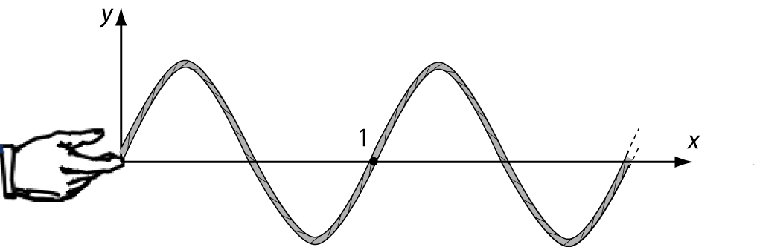
I. Waves on a String
The figure on the right shows a wave on a string propagating to the right. There is a dot painted on the string at point 1. The right end of the string (indicated by the dotted lines) extends off of the page to the right.

A hand steadily wiggles the left end of the string up and down. The figure below shows snapshots of the wave on the string at three instants in time (t₁, t₂, t₃) as the wave travels to the right. The dot painted on the string is indicated at point 1. The pictures below show two possible physical situations. Three students argue about which picture is physically correct.

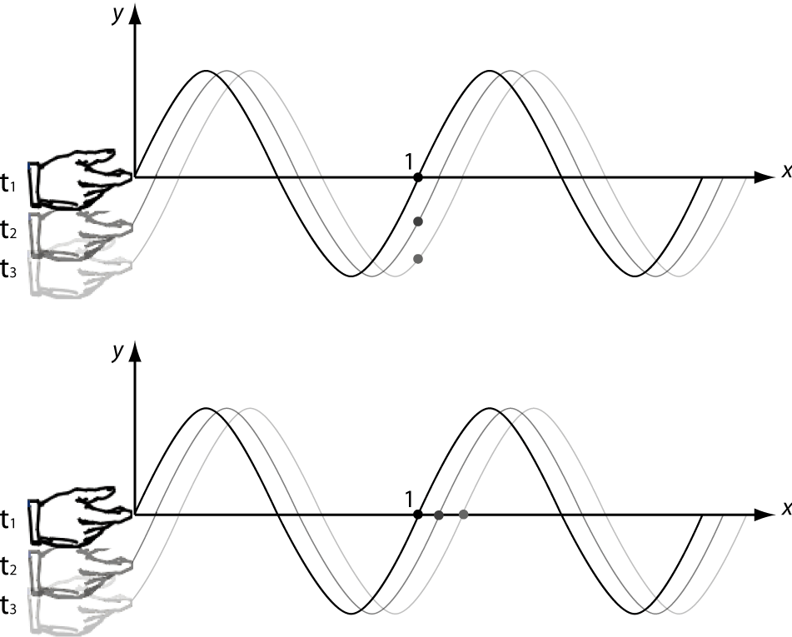
Student A: “The bottom picture is correct, because the wave is traveling to the right. Since the wave and the string look exactly the same, the dot must move with the wave to the right.”

Student B: “The top picture is correct, because the wave is a disturbance of the string, not the string itself. As the wave travels to the right, the string moves up and down. Therefore, the dot moves up and down with the string.”

Student C: “Neither picture is correct. The string’s position is at y=0 at point 1, which means the dot just sits there.”

Which student do you agree with? Explain.

II. Sound Waves
  - Shown below are two representations of a sound wave. Representation 1 uses a sine wave to represent the sound at one instant in time. Representation 2 shows the arrangement of air particles at this instant in time. Note that Representation 2 only shows a section of the air particles – you should imagine that there are more air particles beyond the edges of this picture.
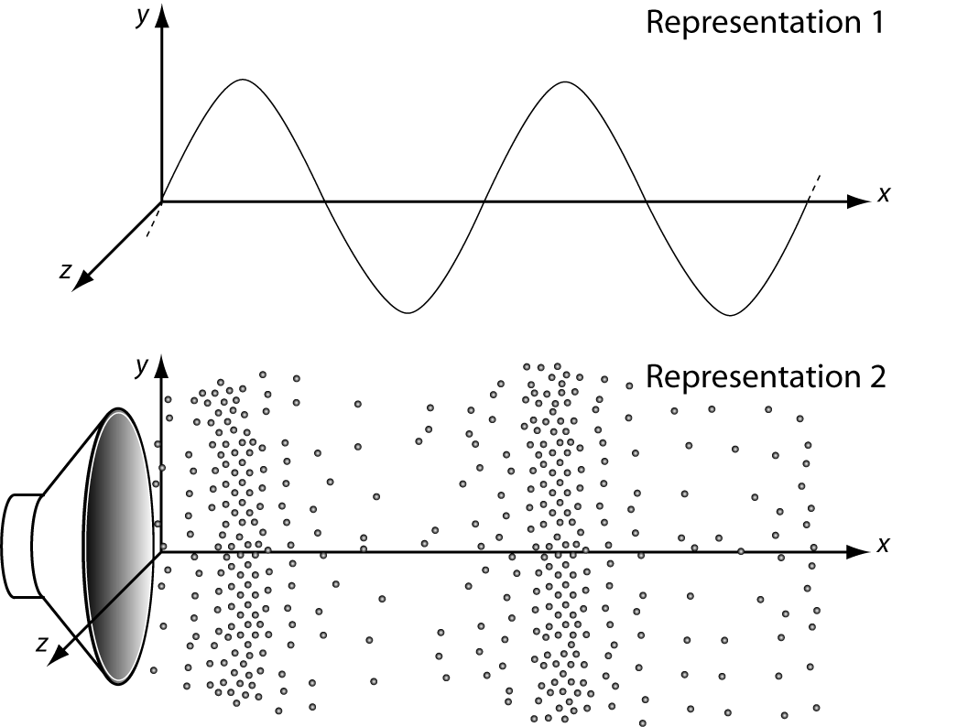
On the diagram, draw the wave in representation 1 on top of the wave in representation 2.

What do the peaks and troughs in representation 1 tell you about the density of the air particles shown in representation 2?

  - The figure below shows a sound wave at one instant in time. Three points in space are labeled 1,2, and 3. Points 1 and 2 lie in the x-y plane; point 3 lies in the x-z plane (coming out of the page in the z-direction). All three points have the same x-coordinate, and are separated by a small distance (less than the size of the speaker cone).

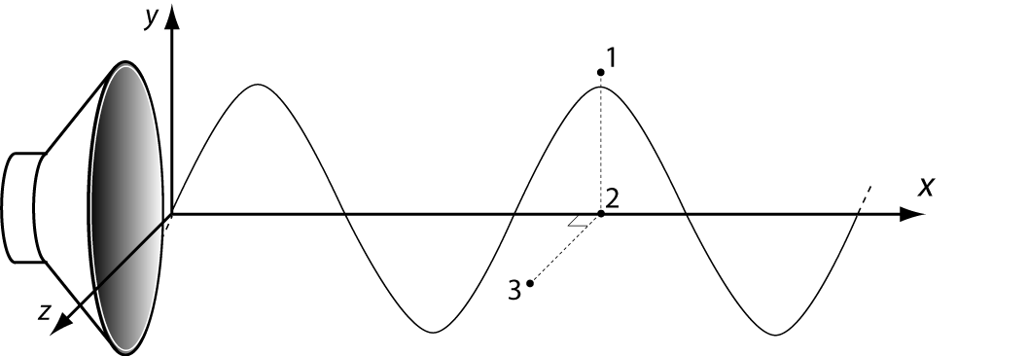
- Compare the sound pressure at each of the three points at this instant in time. Explain how your answer makes sense by relating to the figures above. (Hint: the pressure is proportional to the density of air particles.)

- Would the intensity of the sound averaged over several cycles of the wave at point 2 be:
  - constant and non-zero, (b) constant and zero, or (c) changing with time?
Note the intensity is proportional to the pressure squared. (Hint: if you put your ear at point 2, what would you hear?) How about at points 1 and 3?

III. Electromagnetic Waves
Representations of electromagnetic waves
- Shown below are mathematical and pictorial representations of an electromagnetic plane wave propagating through empty space. Representation 1 uses a sine wave to represent the electric field, , at one instant in time; representation 2 uses a vector field to represent . The magnetic field, , is not shown.
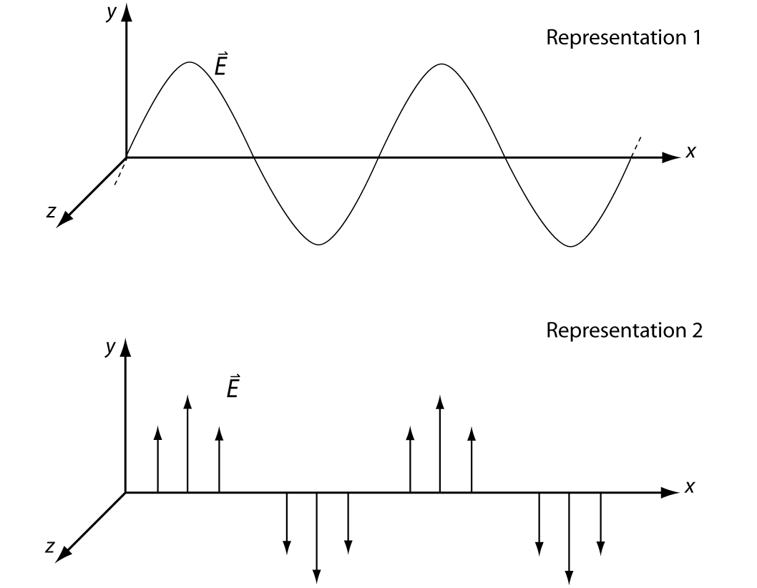

  - On the diagram, draw the wave in representation 1 on top of the wave in representation 2.

What does representation 1 tell you about the the electric field as represented by the vectors in representation 2?

- The figure below shows an electromagnetic wave at one instant in time. Notice that in this figure the E-field is oscillating in the x-z plane, and the B-field is oscillating in the x-y plane. Four points in space (labeled 1,2, 3 and 4) lie in the x-z plane.
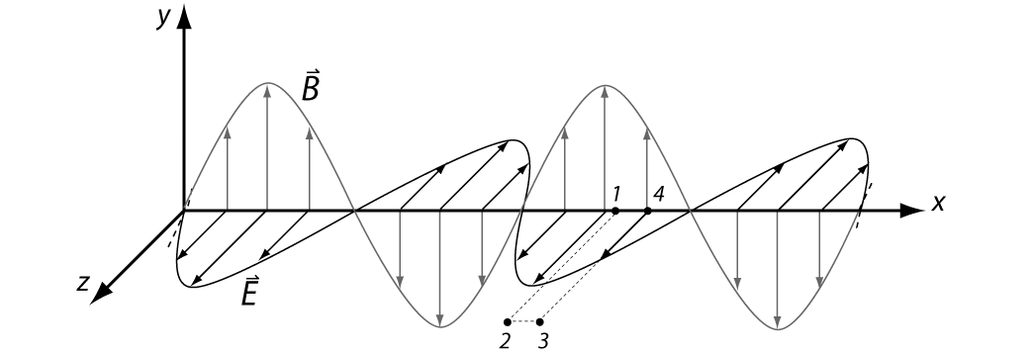
  - In which direction is this wave propagating? Explain how you can tell from the expressions for the electric field and magnetic field.

  - For the instant shown, rank these points according to the magnitude of the electric field. (Hint: if this were a sound wave, what would the pressure be at the four points?)

  - Is your ranking consistent with the mathematical expression for the electric field above? If not, resolve any inconsistencies. (For example, how, if at all, does changing the value of z affect the value of 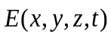?)

  - For the instant shown, rank these points according to the magnitude of the magnetic field. (Hint: if this were a sound wave, what would the pressure be at the four points?) Check that your ranking is consistent with the mathematical expression for the magnetic field.

Detecting electromagnetic waves
- Write an expression for the force exerted on a charge, q, by (1) an electric field, , and (2) a magnetic field, .

If an electric and magnetic field were both present, would a force be exerted on the charge even if the charge were initially not moving? Explain.

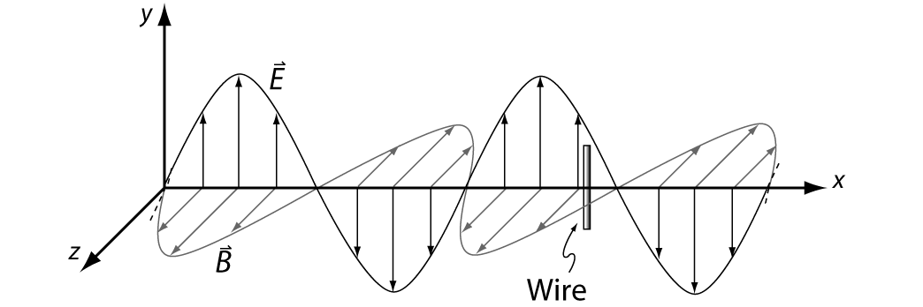
- Imagine that the electromagnetic wave shown at right is a radio wave. A long, thin conducting wire is placed in the path of the wave. Note that the E-field is oscillating in the x-y plane and the B-field is oscillating in the x-z plane.

Suppose that the wire is oriented parallel to the y-axis as shown.

    - As the wave propagates past the wire, would the electric field due to the radio wave cause the electrons in the wire to move? If so, would the electrons move in a direction along the length of the wire? Explain.

How, if at all, would your answer change if the wire were oriented:

- parallel to the z-axis? Explain.

- parallel to the x-axis? Explain.

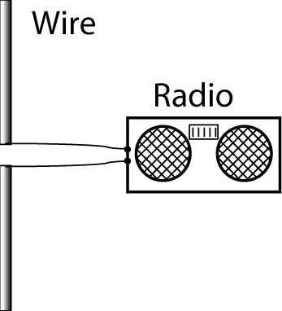
    - Suppose the wire is cut in half and that each half is connected to the terminals of a radio receiver. (A conducting wire or rod used this way is an example of an antenna.)

In order to best detect the oncoming radio wave (that is, to maximize the current through the circuit), how should the antenna be oriented relative to the wave? Explain.

Would the intensity of the field averaged over several cycles of the wave at the antenna be:
  - constant and non-zero, (b) constant and zero, or (c) changing with time?
Note the intensity is proportional to the field squared. (Hint: what sort of sound would you hear coming from the radio?)

