 | 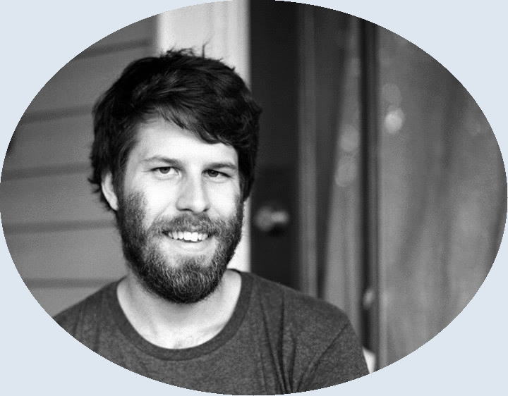 | Thomas Museus Dabay  tmuseusdabay@pm.me  540-529-2003  220 Devrow Court, Franklin, TN 37064  https://github.com/thomas-m-d
 | Core Competencies  ♦ HTML ♦ CSS ♦  ♦ JavaScript ♦ React ♦  ♦ Redux ♦  Experience With  ♦ Node/NPM ♦ SASS ♦  ♦ Bootstrap ♦ d3 ♦  ♦ jQuery ♦  ♦ Git/GitHub ♦  ♦ C ♦ Java ♦ BASH ♦  ♦ Elisp ♦ Vimscript ♦  ♦ VSCode ♦ Emacs ♦  ♦ Vim ♦ Android Studio ♦  ♦ Windows ♦ MacOS ♦  ♦ Linux ♦  Previous Employment  Lecturer at Vanderbilt’s Philosophy Department  (Aug. ‘17 – Aug ‘19)  Education  Ph.D. in Philosophy  (Aug. ‘12 – Aug. ‘17)  B.E. in Electrical Engineering  with High Honor  (Aug. ‘07 – May ‘12)  Full Portfolio  https://thomas-m-d.github.io | Portfolio Spotlight  Learn Polish Calculator React App (https://thomas-m-d.github.io/learn-polish-calc)  Unlike other calculators, it includes a display for the Polish (i.e. Prefix) Notation equivalent of the currently input formula.  Coding Features  - Builds DRY (Don’t Repeat Yourself) in at the outset through reusable React components  - Implements JavaScript’s first-class functions to pass the relevant function into the backspace, clear, and equals buttons’ base component  - Makes use of React’s facility with composition by encapsulating HTML for the app’s title and help button  - Imports React-Redux to connect relevant components to one central location for app-wide state  - Applies recurrsion to correctly evaluate arbitrarily large formulae  UI Features  - Prevents users from typing ungrammatical formulae  - Updates the Polish notation formula field as the user types  - Correctly evaluates arbitrarily large numbers of (embedded) parenthesis pairs  - Implements character input through on-screen buttons and the user’s keyboard  FreeCodeCamp Experience  (Aug. ‘19 – Present)  - Completed the ‘Responsive Web Design’ and ‘JavaScript Algorithms and Data Structures’ Certifications  - Completed all but the projects section of the ‘Front End Libraries’ and ‘Data Visualization’ Certifications  Lessons from Academia  - Writing my dissertation taught me how to perform self-directed and always-ongoing research, culminating in my 212-page final draft.  - I am a quick learner who learns on my feet, a skill that allowed me to defend my dissertation earlier than average for my department.  - My philosophical training instilled in me the importance of clearly communicating complex ideas, both verbally and in writing. This has paid off in numerous well-received presentations and my lengthy publication record.  - I honed my teaching abilities after being the lead instructor for 16 undergraduate-level classes, including many on logic and writing.  - My time as the Philosophy Fellow at Vanderbilt’s Writing Studio taught me how to lead collaborative, one-on-one tutoring sessions.  Current Personal Projects  - Design and build 2 Teensy-based eurorack music synthesis modules  - Install and configure Arch Linux on a Raspberry Pi 4

