 | 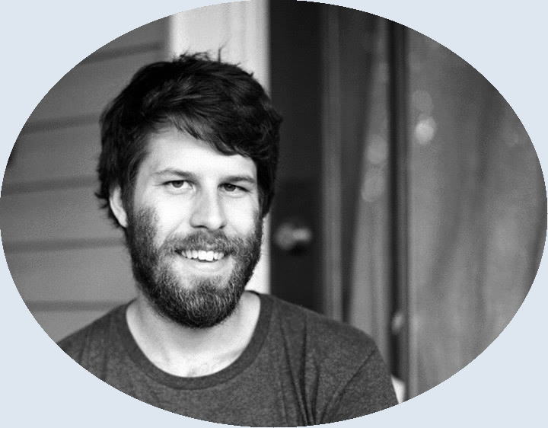 | Thomas Museus Dabay  A+ Certified IT Specialist, Web Developer, Analytic Philosopher
 | Certifications  CompTIA A+  Education  Vanderbilt University  Ph.D. in Philosophy  (Aug. ‘12 – Aug. ‘17)  Stevens  Institute of Technology  B.E. in Electrical Engineering  (Aug. ‘07 – May ‘12)  Professional Experience  Student  ApprentiTN  IT Infrastructure Support Program  (Jun. ‘20 – Present)  Self-Learner  FreeCodeCamp  (Jun. ‘19 – Apr. ‘20)  Lecturer  Vanderbilt Philosophy Department  (Aug. ‘17 – Aug. ‘19) | Information Technology Specialist  Thanks to ApprentiTN’s IT program, as well as my own personal projects and the firm foundation laid by my B.E. degree, I have the expertise needed to succeed in any IT department:  Hardware  - Learned about the basic components of workstation PCs, SOHO servers, laptops, and mobile devices  - Disassembled and reassembled an ApprentiTN workstation  - Spec’d out and built a personal SOHO server  Operating Systems  - Learned and practiced administration skills for Windows and MacOS  - Spent 3.5 years administering Linux as my personal desktop operating system  - Installed Windows and Debian as virtual machines using a type 2 hypervisor  - Installed Arch Linux ARM from scratch on a Raspberry Pi 4 ‘workstation’  - Experience with Debian-, Ubuntu-, Arch-, and RHEL-based Linux distributions  Networking  - Learned SOHO-level network setup and administration skills  - Setup a firewall, VPN, and Apache web server on the ApprentiTN workstation  - Setup and administered a personal git server, NFS server, and ZFS pool  - Installed a personal Ethernet + WiFi LAN using a modem, router, and switch  - Launched a publicly available Nextcloud server using Amazon Web Services  Web Developer  Before entering the ApprentiTN program, I used FreeCodeCamp to teach myself the foundations of web development:  - Completed FreeCodeCamp’s Responsive Web Design, JavaScript Algorithms and Data Structures, Front End Libraries, and APIs and Microservices certifications  - Developed a portfolio of web pages and web apps (https://thomas-m-d.github.io) with publicly available source code (https://github.com/thomas-m-d)  - Most proud of my calculator app (https://thomas-m-d.github.io/learn-polish-calc/)  Analytic Philosopher  My experience in academia allowed me to both display and develop a number of valuable soft-skills:  - Writing my dissertation taught me how to perform self-directed and always-ongoing research, culminating in my 212-page final draft.  - I am a quick learner who learns on my feet, a skill that allowed me to defend my dissertation 1 year earlier than the average for my department.  - My philosophical training instilled in me the importance of clearly communicating complex ideas, both verbally and in writing. This has paid off in numerous well-received presentations and my lengthy publication record.  - I honed my teaching abilities after being the lead instructor for 16 undergraduate-level classes, mostly on logic and writing.  - My time as the Philosophy Fellow at Vanderbilt’s Writing Studio taught me how to lead collaborative, one-on-one tutoring sessions.  Current Personal Project  - Setup and administer a Syncthing server

