({{question_number}}) Fig. 7a shows the curve with the parametric equations

$x=2cosθ$, $y=sin2θ$, $-\frac{π}{2}≤θ≤\frac{π}{2}$.

The curve meets the x-axis at O and P. Q and R are turning points on the curve. The scales on the axes are the same.

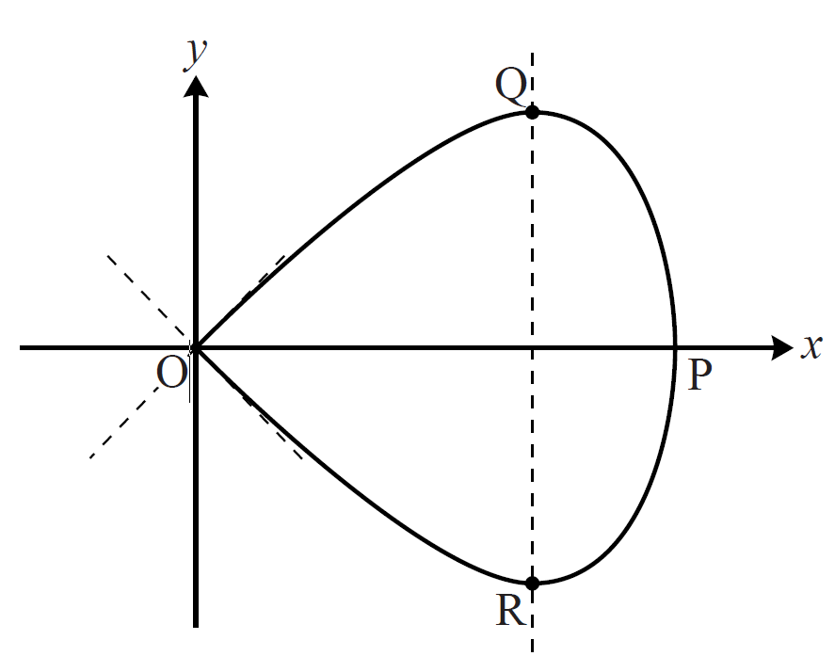

Fig. 7a

**(i)** State, with their coordinates, the points on the curve for which $θ=-\frac{π}{2}$, $θ=0$ and $θ=\frac{π}{2}$. **[3]**

**(ii)** Find $\frac{dy}{dx}$ in terms of $θ$. Hence find the gradient of the curve when $θ=\frac{π}{2}$, and verify that the two tangents to the curve at the origin meet at right angles. **[5]**

**(iii)** Find the exact coordinates of the turning point Q. **[3]**

When the curve is rotated about the x-axis, it forms a paperweight shape, as shown in Fig. 7b.

Fig. 7b

**(iv)** Express $\sin^{2}{θ}$ in terms of $x$. Hence show that the cartesian equation of the curve is $y^{2}=x^{2}(1-\frac{1}{4}x^{2})$. **[4]**

**(v)** Find the volume of the paperweight shape. **[4]**