IGA FEM GUI
IsoGeometric Analysis
Finite Elements Method
Graphical User Interface

A graphical configuration interface to Octave simulation code
Thomas Maurice – v0.2



- Introduction
This software aims to make the use of Phu Vinh Nguyen easier, it enables you to parameter the simulation you want to launch with octave without being forced to go into the file and edit it by hand. Since none of your modifications will alter the original files in any manner, there is no hazard for you to break it.
The principle of the program is very easy, it is based on XML files containing information about the M files you want to launch. For exemple their names, authors, a little description, and the most important : their parameters. So for each M file, an XML file will be provided containing all the parameters which can be modified before running the script, with a small description for every one of them so that you precisely know what you are doing and be sure not to make mistakes.
You can also use the program to launch scripts on a remote server, such as HPC Wales' to enhance your performances.

- Compiling
To compile the software, you need a recent version of the GNU gcc compiler, the Cmake program, and some additional libraries :
- The libxml++ lirary (version >= 2.6 or higher)
- The GTKmm 3 library
- The libssh library (not libssh2!)
- Subversion (SVN) version manager can be useful if you want to update the program from the main repository.

Once you made sure that every needed component is installed, go to the toplevel directory, let's call it igafemgui/

cd igafemgui

Then create the build directory and get in here :

mkdir build
cd build

Then run cmake and compile it

cmake ..
make
make install
The make install command will install all your files in your home by default. If you don't want them to be installed in your home, just call Cmake this way :
cmake .. -DCMAKE_INSTALL_PREFIX=/new/install/path
and then re-run make and make install.
Once everything is compiled and installed, just type igafemgui in your command prompt to launch the software. If there is any problem, all the errors would be output on the prompt so it might be useful for you to keep an eye on it.

- Portability
Unfortunately, this program is for now reserved to GNU/Linux users. This is explained by the fact that the graphical interface library used to create this program is not updated on Windows and will only be availiable on this plateform in a few months, not to say years.
If you want to try to compile this software on Windows anyway, you should edit the CMakeLists.txt file and suppress the line forbidding to try it.
It might be possible to compile the software on an OSX system but it has not been done during the developpement process.

- Usage
The use of this program is pretty much simple. Once you have launched it, you will see the main window, which will look like the image below (it may slightly differ if some updates are performed, but none of the functionnality presented in this manual will change)
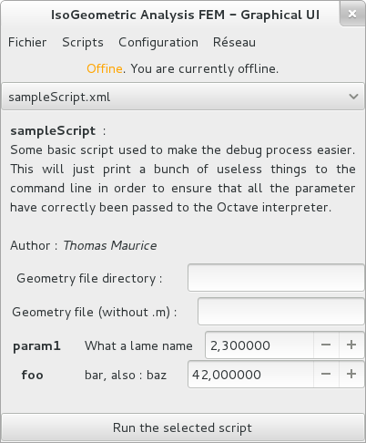

1. The menu zone

2. The script selection zone

3. The script description zone

4. The geometry selection zone

5. The parameter edition zone

6. The script run button

Let us explain each one of these zones.

1. The menu zone
The menu zone is composed of some menus to perform various options.
- « File » contains the quit option.
- « Scripts » enables you to reload the script list, to edit one, create one and remove one
- « Configuration » enables you to edit the program's configuration this will be detailed later.
- « Network » enables you to connect to a remote server. Will be explained later.

2. The script selection zone
This menu enables you to select the script you want to run. As a convention, a file named « someFile.xml » will stand for the Octave script « someFile.m ».

3. The script description zone
This zone is one of the most important, because it contains the important information such as the script name, its author and its description. You should read this field very carefully to understand the purpose of the script you are about to launch.

4. The geometry selection zone
This zone enables you to change the default geometry of the problem. This file will be executed before the script so that you can adapt it any way you want. For example if your script is located in the « geom » folder of the FEM directory, and is called « yourShape.m » then the directory field will be « geom » and the geometry field will be « yourShape ».

5. The parameter edition zone
This zone enables you to edit the parameters used in the script. Each parameter is represented with three fields. First of all it's name, then a small description and finally the value you want to set it to. Usually a default value is provided in order to make a proper demonstration of the script.

6. The script run button
This button simply runs the selected script into the Octave interpreter.

- Configuring the program
The configuration window is accessed via the menu « Configuration > Edit » of the main window. It has the following layout :
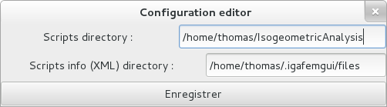

The two fields are quite self explainable. The first one is used to configure the root directory in which is stored Phu Nguyen's Octave code, and the second one is the directory in which the XML scriptinfo files are stored. Note that this configuration file is stored at a very precise place in your system, it is in your /your/home/.igafemgui/config.xml and you can edit it by hand if you feel brave enough.

- Editing script metadatas
You can of course edit the scripts info, and even add yours to the existing collection. This will enables you to change the number of parameter of a script, and to add yout own scripts if you want to. To access these options, go into the « Scripts » menu, and select if you want to add a script info, edit the current one or delete the current one. If you chose not to destroy the current one, then this window will normally appear. This window allows you to change the settings of a script, or to add a new one.
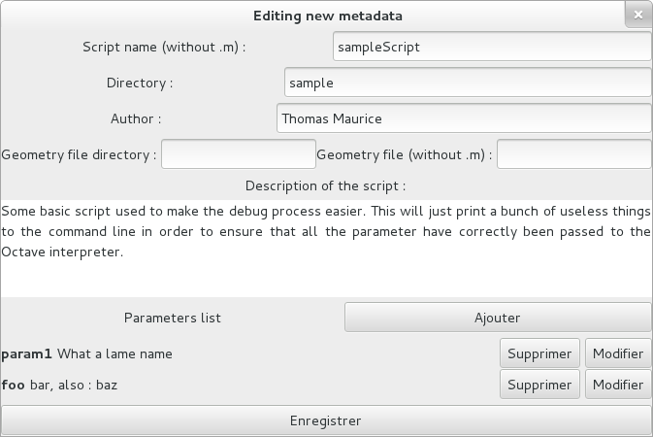
1
2
3
Let us study this window layout. (Some words are here in French, because the system on which the screenshots were taken has it's locales set for the French language, but don't worry, it will adapt to your own language on your system). The first fields are pretty much obvious. The only one which can be disturbing is the « Directory » one, it is actually used to specify in which sub-directory of the IsoGeometric set of M file is the file stored. For exemple, here, we can find the file in /home/thomas/IsogeometricAnalysis/sample/sampleScript.m because « sample » has been specified.

Then you can find the parameter zone, the most important one. To add a parameter, click on the « Add » button and a new parameter will appear. To edit it, just click on the « edit » button. The following dialog will pop up :
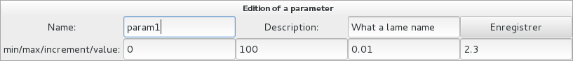

You can change the parameter's name, it's description and it's numerical attributes in the bottom row. First it's minimum value, then it's maximum, then the increment step between each value and finally the default value for the parameter. Press the « save » button to save and quit this window.

If you want to delete it, just press the « Delete » button.

To save your changes, press the « save » button.

- Launching a script
To launch a script, just select it and hit the « Run selected script » button. Then a new window will pop up. Let's see what it looks like.

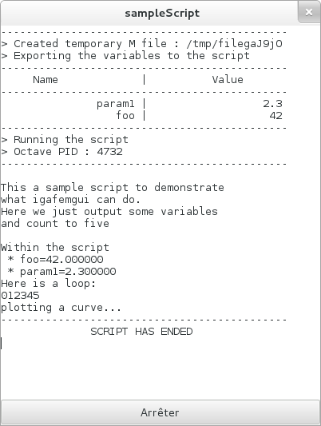

This window can be seen as a console. Every output of the script will be redirected here, you can stop the script at any moment by hitting the « Stop » button at the bottom of the application (once again, here it is localized in French but it will be in your language on your computer) or just exiting this window or the main window of the program.

The major enhancement compared to previous versions of this program is that here the script is run in its own thread, it means that the execution of a script no longer blocks the applications and then nothing stops you from running several scripts at once, just by selecting a new one on the main window.

- Using IGAFEMGUI online
This software is designed to be used online with server clusters endowed with LSF scheduler, such as HPCWales'. In short, it will allow you to do the exact same thing as what you did earlier when ypu ran scripts in your computer, but on a remote server. What for ? To enhance your performances, run several heavy scripts simultaneousely and have a large storage drive !

Once you have run the simulation, you can check its state easily via the program's interface, and download everything the script had produced of files/outputs/graphs. How can we do that ? Let's see !

The special igaoutputroot variable
When using the program online, you will have to use a variable named « igaoutputroot » which represents the directory which is assigned to your script. This directory will be the one you will download when you will get the results from the server, so everytime you want to create a file, use this variable and prepends it the the name of the file you want to create.

Server requirements
In order to make the software working, you should have the following on your HPC Wales session :
- SSH access, of course.
- The module lapack/3.4.2-gnu-4.6.2 octave available
- A directory ~/.igafemgui containing the configuration correctly edited (like for local use except you modify the IGA and metadata file directories to match the server emplacement)
- A directory containing all the IGA code in your /home and correctly referenced in the configuration file.
- The grep and awk commands installed.

Using the software on a remote server
First you have to log in the right server, so go to the « Network » > « Connect » button on the top bar. Then fill in all the needed information. Make sure the host is correct, for instance if you use HPCWales' servers, do not put login.hpcwales.co.uk but cf-log-001.hpcwales.co.uk instead for example. The reason is that you cannot launch jobs on the login server, which makes sens. Make sure your server is able of doing that.

Once you have filled all the information, click « Ok » to log in. The program might pop up a warning window such as this one :

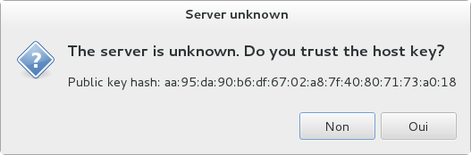
Hit « Yes » if you are 100 % sure this is the good server. In any case of doubt, contact your system administrator to make sure that the fingerprint is correct. If this is the first time you are logging into the server, then this warning is normal, because the fingerprint is not yet in the database so you can hit « Yes ».

Then you will see a popup informing you that you are logged in. Now if you look at the top bar, you will see that the « Scripts » and « Configuration » files are in grey, that's normal, that's because you are not allowed to edit these scripts from your computer, for safety reasons. If you want to upload new scripts into the server you have to use an (S)FTP client.

Now you have in your main window's script selection box all the scripts that are available on the server to run ! Isn't it wondeful ? You can now run one.

If you want to check a launched job, just go to « Network » > « Download results » and this window will pop up :

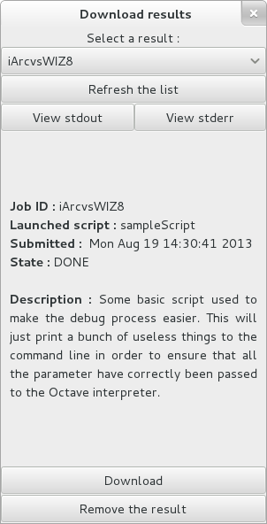

This window enables you to check the launched scripts. Each script is identified with an random 10 character long string. You can select the one you want to track at the top of the window, the « State » option will be refreshed automatically. You can download all the produced files by hitting « Download » and remove them by hitting « Remove the result ». The two « View std(err,out) » are buttons used to view the standard output (i.e. Console output) and the error output of the script. This can be used for debugging or retrieving result.

- Limitations
The software unfortunately suffers from some limitations due to Octave. First, the code will be a little bit slower to run on Octave than on Matlab. Moreover, some plots won't be as nice as they are in Matlab so you should probably export your results to Paraview format in order to process them later.

- General information
Developped by : Thomas Maurice <tmaurice59@gmail.com> for Cardiff University's Intitute of Mechanics and Advanced Materials (IMAM)
Plateforms : Coded/Tested on Linux Fedora 18 (Spherical Cow - 64 bits)
This software is not meant to be run on Windows systems, but it might work on Mac OSX with the proper libraries.
License : This program is released under the terms of the GNU General Public Licence (v3+)

