中北大学
课程设计说明书

学生姓名： 学 号：
学 院： 信息与通信工程学院
专 业： 信息对抗技术专业
题 目： Matlab课程设计
Matlab方程组求解数值计算设计
指导教师：

2016年 1月 11 日

目录
一．简介…………….……………………………………………………………1
1、高斯消去法简介…………….……………………………………………1
2、算法主要思想…………….………………………………………………1
二、高斯消元的设计…………….………………………………………………2
1、消元过程流程图…………….……………………………………………3
2、算法程序设计…………….……………………………………..…..……3
三、GUI界面设计…………….…………………………………………..………7
四、调试…………….……………………………………………………………11
五、参考文献…………….………………………………………………………14
六、附录：GUI界面程序代码…………….………………………..………15

一、简介

1、高斯消去法简介
高斯消去法，又称高斯消元法，实际上就是我们俗称的加减消元法。数学上，高斯消去法或称高斯－约当消去法，由高斯和约当得名(很多人将高斯消去作为完整的高斯－约当消去的前半部分)，它是线性代数中的一个算法，用于决定线性方程组的解，决定矩阵的秩，以及决定可逆方矩阵的逆。当用于一个矩阵时，高斯消去产生“行消去梯形形式”。用高斯消去法求解线性方程组的解是一种
比较常见的解线性方程组的方法，这种方法尤其在利用计算机求解线性方程组时是更是常用。但大多数情况下都是用串行的算法来解方程组，本设计正是基于高斯消元法对方程组求解。
在求解线性方程组的算法中，有两类最基本的算法：直接法和迭代法。在直接方法中最主要的就是高斯消去法，它可以分为消元和回代两个过程，消元过程是将方程组转换为一个等价的三角方程组，而回代过程则是逆反求解这个三角方程组。

2、算法主要思想
设有n元线性方程组 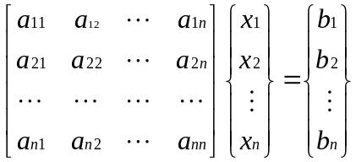
- 对方程组确定，使得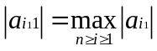 ，选取 作为第一个主元，然后交换第1、第 个方程。
- 令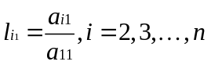 ，用（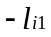 ）乘第一个方程加到第i个方程上（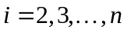 ），得同解方程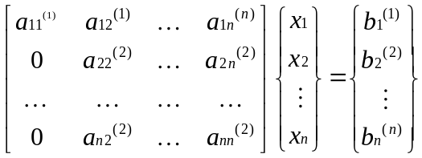 ，其中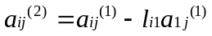， 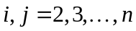， 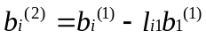 ，
- 对第二个方程组确定 ，使得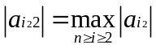 ，选取 作为第二个主元，然后交换第2、第 个方程。
- 令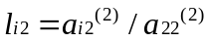 ，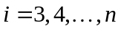 ，用（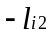）乘第二个方程加到第i个方程上 （），得同解方程组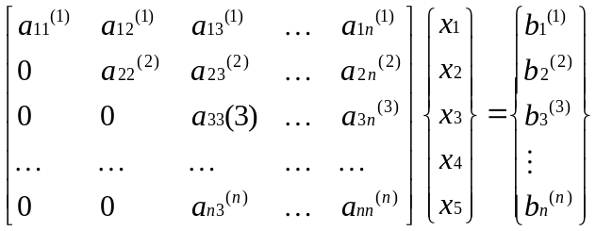 其中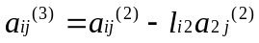，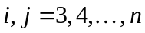， 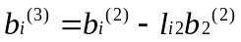 ，。
- 设已完成第k-1步消元，得到同解方程组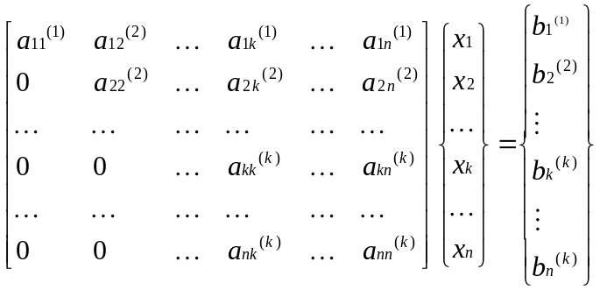 反复进行上述过程，那么，经过n-1步消元，最后便得到如下的与原方程同解的上三角形方程组：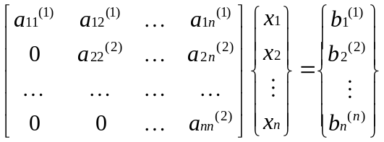 由此可以看出，经过了n-1步逐步消元后，矩阵已经化成上三角形式，此时由（4）的最后一个方程就可求出 ，然后将带入倒数第二个方程，求出 ，以此类推，可求出所有解。最后方程组的解为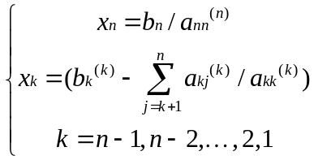 。
- 高斯消元法的缺点是在矩阵的对角线上存在0时，高斯消元将无法进行下去

二、高斯消元的设计

1、消元过程流程图
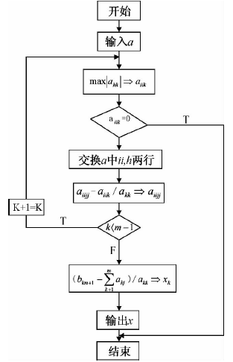

2、算法程序设计
a）、主程序设计
%输入增广矩阵
a=[4,2,5,4;2,-1,3,1;1,2,0,7]
%求出增广矩阵的长度和宽度
[m,n]=size(a);
%
r=zeros(m,2)
if m>n
p=n
else
p=m
end
x=zeros(1,p)
for t=1:p-1
b=a(t,t)
%不进行比较，直接选取矩阵对角线矩阵上的元素为主元，并将所选行的对角
for i=t:n
a(t,i)=a(t,i)/b
end
for k=1+t:n-1
j=a(k,t)
for i=t:m+1
a(k,i)=-a(t,i)*j+a(k,i)
end
end
end
x(1,p)=a(m,n)/a(m,n-1)
for k=1:p-1
x(1,p-k)=a(m-k,n)
for i=1:k
x(1,p-k)=x(1,p-k)-a(m-k,n-i)*x(1,p-i+1)
end
end
b）、判断方程组是否有无穷解
设有n元线性方程组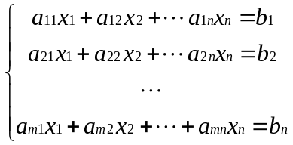 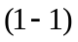

如果方程组有解，就称方程组为相容的，否则就称为不相容的。记 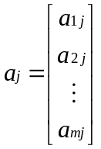,j=1,2,…n , = 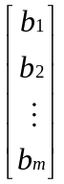 ，X = 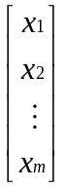
线性方程组 (1-1) 可写成向量方程的形式
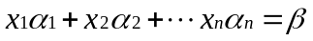
即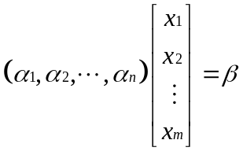，或写成矩阵方程的形式AX=β，其中， A=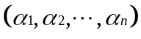是系数矩阵。易见下述结论等价：
（1）线性方程组(1-1)有解;
(2)向量β可以由向量组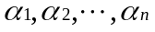线性表示；
(3)向量组与向量组,β等价;
(4)系数矩阵A=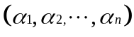与增广矩阵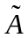=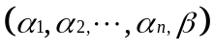的秩相等.
从而我们得到线性方程组(1-1)有解的判别定理 .
定理1.1 线性方程组(1-1)有解的充分必要条件是它的系数矩阵A与增广矩阵有相同的秩.
定理1.1 用行初等变换把化成阶梯行矩阵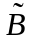 的同时,A也化成了阶梯行矩阵B,并且B就是由的前n列所组成,因此出现“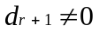”当且仅当R(A) = R() -1,从而方程组无解;否则,一定有R(A)=R(),从而方程组有解。
推论1.2 线性方程组(1-1)有解时,如果R(A)=n,那么方程组只有唯一解;如果R(A) < n,那么,方程组有无限多解.
考虑齐次线性方程组
记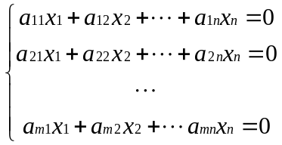 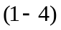
A=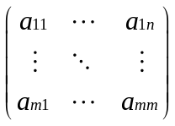 X= , 式可写成AX=0
如果=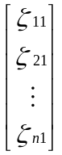是方程组(1-4)的解,那么
X=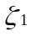=
称为齐次线性方程组 (14-4)的一个解向量,或称为它的一个解.
显然,X=0 就是齐次线性方程组(14-4)的解.因此齐次线性方程组解的集合S=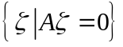是非空的.
推论1.3 齐次线性方程组AX=0有非零解的充分必要条件是R(A)<n .
显然,当m=n时,(14-4)有非零解的充分必要条件是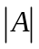 = 0.特别地,当m<n时,(14-4)必有非零解.
c)、判断是否有穷解的代码
z=rank(a);%%求矩阵的秩
if z<m
set(handles.edit3,'string','无穷解')
return
else
set(handles.edit3,'string','有穷解')
end
d)、对结果进行误差分析
即将计算得到的结果带入方程组中，与计算结果进行比较，实现代码如下：
for i=1:m
r(i,2)=a(i,n)
for o=1:z
r(i,2)=r(i,2)-a(i,o)*roundn(x(1,o),-2)
end
end

三、GUI界面设计
1、在主界面键入guide
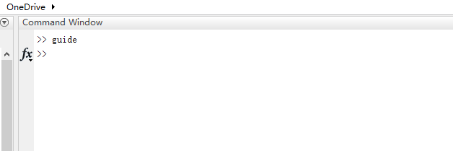
图1 键入guide
2、新建一个GUI
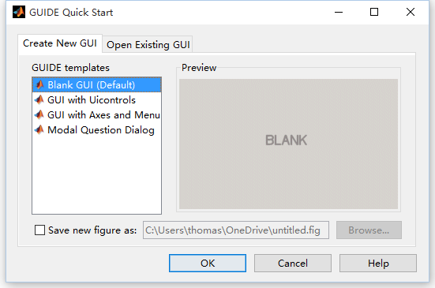
图2 新建一个GUI

3、新建后得到界面如图
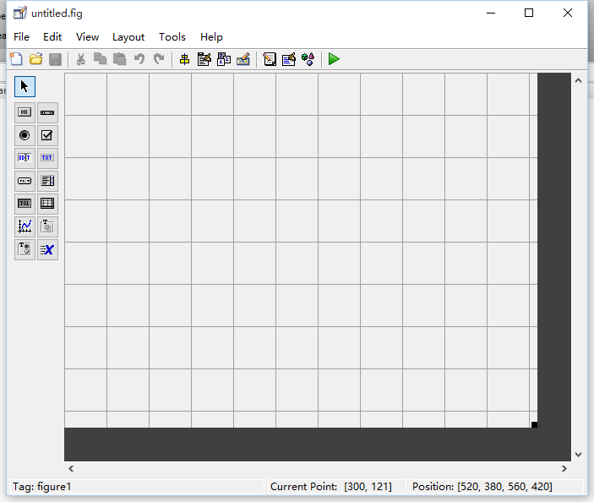
图3 新建界面
4、在面板上依次添加edit、table等控件
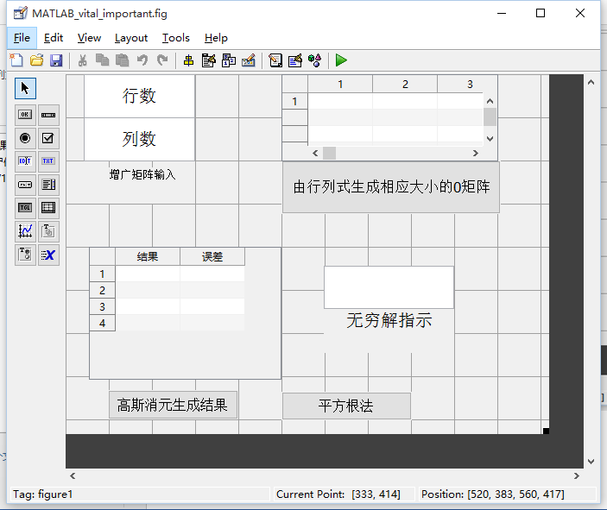
图4 添加edit、uitable和txt

5、编辑回调函数
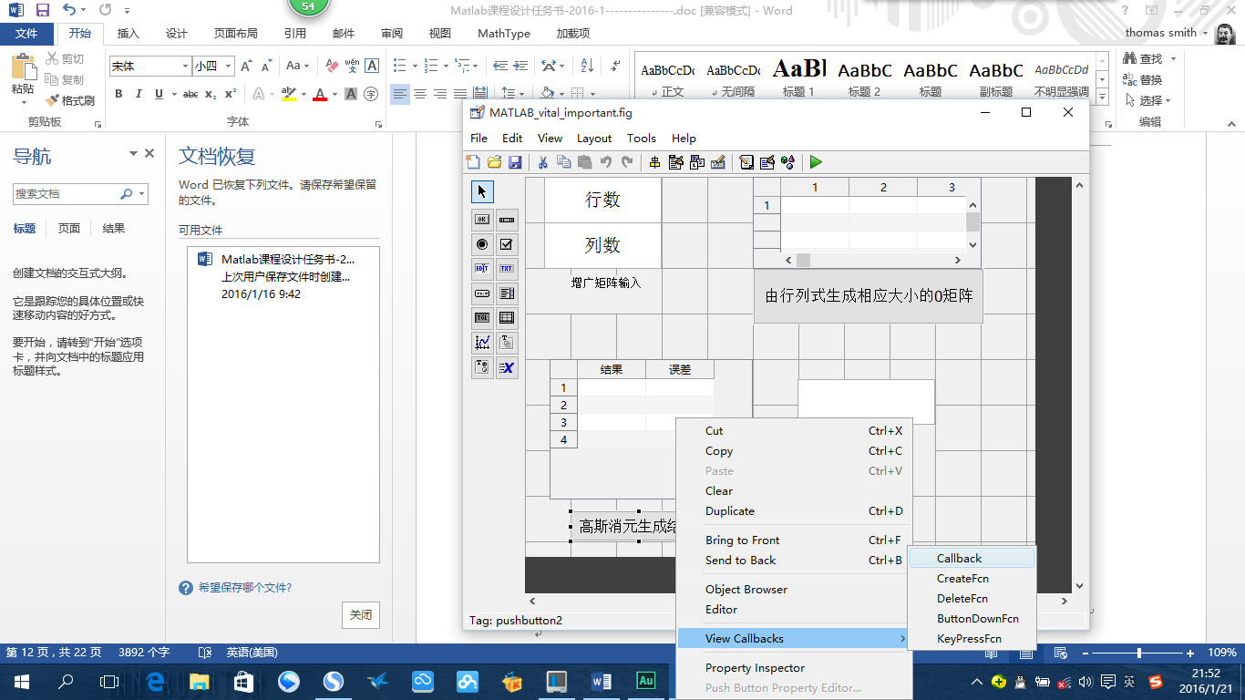
图5 打开回调函数
对按键的回调函数进行编辑
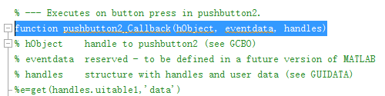
图6 打开回调函数
需要通过按键实现的代码写到该按键的回调函数里面
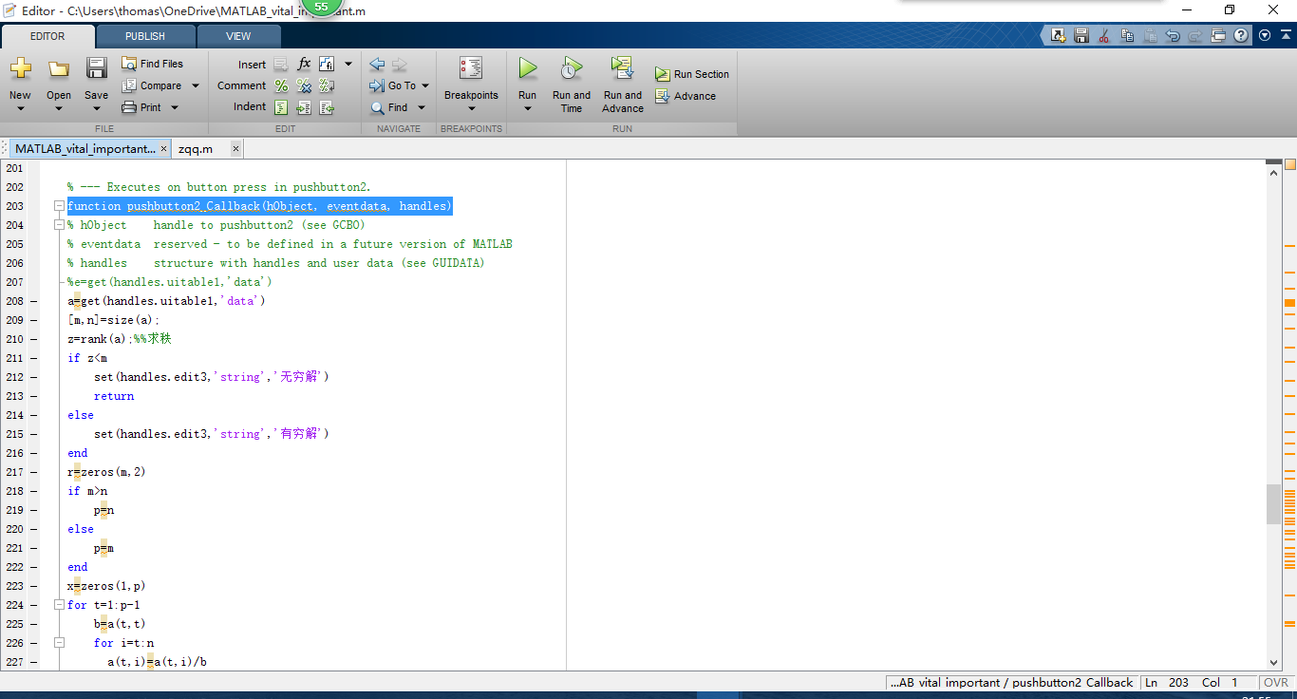
图7 编辑回调函数

四、调试
本设计通过对edit中的数据进行读取，然后根据读取到的数据生成相应的零矩阵放到右边的uitable中，然后将待解方程组的增广矩阵键入到右边的uitable中，按键“高斯消元生成结果”通过对右边uitable中的数据以矩阵形式保存，对保存到的数据进行高斯消元法处理，并判断是否有无穷解，若有无穷解，在edit中会出现无穷解，反之出现有穷解。最终将方程组的解以及误差放在左下角的uitable中。运行结果如图所示。下面还有一个名称为“平方根法”的按键，此按键可以使用平方根法对保存到的数据进行处理，最后得出方程组的解以及误差，并以表格的形式显示在uitable中。
1、先在“增广矩阵输入”的edit中输入增广矩阵的行数和列数，然后点击“由行列式生成相应大小的0矩阵”。如图8。
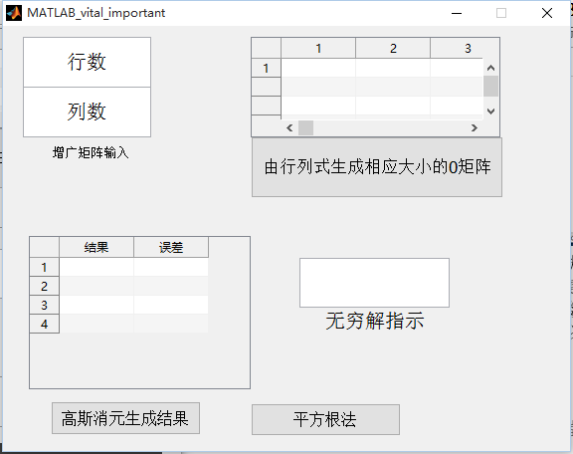
图8
2、在左上的table中生成零矩阵之后，在table中输入待解方程组的增广矩阵，然后点击“高斯消元生成结果”，然后方程的解将会以表格的形式显示在右下角的table中。如图9、图10。

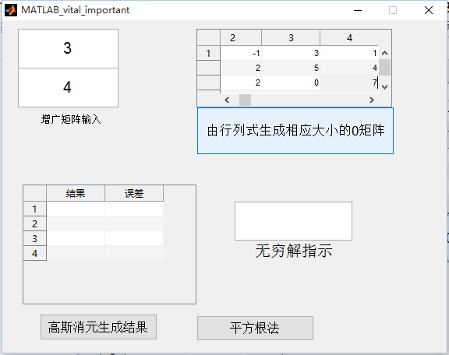
图9
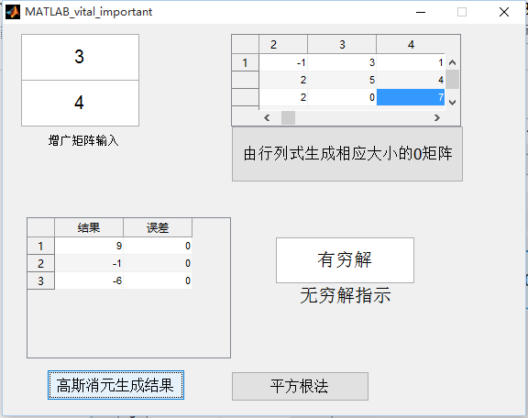
图10

五、参考文献
[1]张鹏.解线性方程组的直接法[D].大连理工大学,2009.DOI:10.7666/d.y1606832.
[2]吴专保.线性方程组的几种数值方法的MATLAB程序[J].荆门职业技术学院学报,2007,22(3):78-81.DOI:10.3969/j.issn.1008-4657.2007.03.021.
[3]张错玲.基于MATLAB的Cholesky分解法解线性方程组[J].长春师范大学学报（自然科学版）,2014,(5):4-8.
[4]赵丹.雅可比迭代法与高斯-塞德尔迭代法研究[J].兴义民族师范学院学报,2012,(2):108-112.DOI:10.3969/j.issn.1009-0673.2012.02.028.
[5]田希山.用部分选主元的高斯消去法并行求解线性方程组[J].电脑知识与技术,2011,07(16):3960-3963,3966.DOI:10.3969/j.issn.1009-3044.2011.16.081.
[6]文传军,许定亮,华婷等.高斯消元五步骤法[J].常州工学院学报,2012,25(6):50-53.DOI:10.3969/j.issn.1671-0436.2012.06.014.
[7]胡尧,罗文俊.改进Gauss消去法求解线性方程组[J].贵州大学学报(自然科学版),2004,21(2):127-131.DOI:10.3969/j.issn.1000-5269.2004.02.005.
[8]赵艳宇.Gauss消去法[J].电大理工,2013,(2):51-52.DOI:10.3969/j.issn.1003-3319.2013.02.020.
[9]燕必成,姜晓强,王哲禄等.高斯列主元消去法在Matlab中的实现[J].桂林航天工业学院学报,2014,19(2):165-167,171.DOI:10.3969/j.issn.1009-1033.2014.02.018.

六、附录：GUI界面程序代码
function varargout = MATLAB_vital_important(varargin)
% MATLAB_VITAL_IMPORTANT MATLAB code for MATLAB_vital_important.fig
% MATLAB_VITAL_IMPORTANT, by itself, creates a new MATLAB_VITAL_IMPORTANT or raises the existing
% singleton*.
%
% H = MATLAB_VITAL_IMPORTANT returns the handle to a new MATLAB_VITAL_IMPORTANT or the handle to
% the existing singleton*.
%
% MATLAB_VITAL_IMPORTANT('CALLBACK',hObject,eventData,handles,...) calls the local
% function named CALLBACK in MATLAB_VITAL_IMPORTANT.M with the given input arguments.
%
% MATLAB_VITAL_IMPORTANT('Property','Value',...) creates a new MATLAB_VITAL_IMPORTANT or raises the
% existing singleton*. Starting from the left, property value pairs are
% applied to the GUI before MATLAB_vital_important_OpeningFcn gets called. An
% unrecognized property name or invalid value makes property application
% stop. All inputs are passed to MATLAB_vital_important_OpeningFcn via varargin.
%
% *See GUI Options on GUIDE's Tools menu. Choose "GUI allows only one
% instance to run (singleton)".
%
% See also: GUIDE, GUIDATA, GUIHANDLES

% Edit the above text to modify the response to help MATLAB_vital_important

% Last Modified by GUIDE v2.5 21-Jan-2016 09:16:31

% Begin initialization code - DO NOT EDIT
gui_Singleton = 1;
gui_State = struct('gui_Name', mfilename, ...
'gui_Singleton', gui_Singleton, ...
'gui_OpeningFcn', @MATLAB_vital_important_OpeningFcn, ...
'gui_OutputFcn', @MATLAB_vital_important_OutputFcn, ...
'gui_LayoutFcn', [] , ...
'gui_Callback', []);
if nargin && ischar(varargin{1})
gui_State.gui_Callback = str2func(varargin{1});
end

if nargout
[varargout{1:nargout}] = gui_mainfcn(gui_State, varargin{:});
else
gui_mainfcn(gui_State, varargin{:});
end
% End initialization code - DO NOT EDIT

% --- Executes just before MATLAB_vital_important is made visible.
function MATLAB_vital_important_OpeningFcn(hObject, eventdata, handles, varargin)
% This function has no output args, see OutputFcn.
% hObject handle to figure
% eventdata reserved - to be defined in a future version of MATLAB
% handles structure with handles and user data (see GUIDATA)
% varargin command line arguments to MATLAB_vital_important (see VARARGIN)

% Choose default command line output for MATLAB_vital_important
handles.output = hObject;

% Update handles structure
guidata(hObject, handles);

% UIWAIT makes MATLAB_vital_important wait for user response (see UIRESUME)
% uiwait(handles.figure1);

% --- Outputs from this function are returned to the command line.
function varargout = MATLAB_vital_important_OutputFcn(hObject, eventdata, handles)
% varargout cell array for returning output args (see VARARGOUT);
% hObject handle to figure
% eventdata reserved - to be defined in a future version of MATLAB
% handles structure with handles and user data (see GUIDATA)

% Get default command line output from handles structure
varargout{1} = handles.output;

% --- Executes on button press in pushbutton1.
function pushbutton1_Callback(hObject, eventdata, handles)
% hObject handle to pushbutton1 (see GCBO)
% eventdata reserved - to be defined in a future version of MATLAB
% handles structure with handles and user data (see GUIDATA)
%c=[-0.0909 0.4825 0.9580 0.6643 0.0350 -0.6224;
% -0.1408 0.3944 0.9718 0.7183 0.0423 -0.6620;
% -0.2500 0.1250 0.9688 0.5000 0.0000 -0.0625;
% -0.2984 0.3037 -0.7801 0.0419 -0.3665 -0.8796]
a=get(handles.edit1,'string')
b=get(handles.edit2,'string')
b=str2num(b)
a=str2num(a)
c=zeros(a,b)
set(handles.uitable1,'data',c)

function edit1_Callback(hObject, eventdata, handles)
% hObject handle to edit1 (see GCBO)
% eventdata reserved - to be defined in a future version of MATLAB
% handles structure with handles and user data (see GUIDATA)

% Hints: get(hObject,'String') returns contents of edit1 as text
% str2double(get(hObject,'String')) returns contents of edit1 as a double

% --- Executes during object creation, after setting all properties.
function edit1_CreateFcn(hObject, eventdata, handles)
% hObject handle to edit1 (see GCBO)
% eventdata reserved - to be defined in a future version of MATLAB
% handles empty - handles not created until after all CreateFcns called

% Hint: edit controls usually have a white background on Windows.
% See ISPC and COMPUTER.
if ispc && isequal(get(hObject,'BackgroundColor'), get(0,'defaultUicontrolBackgroundColor'))
set(hObject,'BackgroundColor','white');
end

function edit2_Callback(hObject, eventdata, handles)
% hObject handle to edit2 (see GCBO)
% eventdata reserved - to be defined in a future version of MATLAB
% handles structure with handles and user data (see GUIDATA)

% Hints: get(hObject,'String') returns contents of edit2 as text
% str2double(get(hObject,'String')) returns contents of edit2 as a double

% --- Executes during object creation, after setting all properties.
function edit2_CreateFcn(hObject, eventdata, handles)
% hObject handle to edit2 (see GCBO)
% eventdata reserved - to be defined in a future version of MATLAB
% handles empty - handles not created until after all CreateFcns called

% Hint: edit controls usually have a white background on Windows.
% See ISPC and COMPUTER.
if ispc && isequal(get(hObject,'BackgroundColor'), get(0,'defaultUicontrolBackgroundColor'))
set(hObject,'BackgroundColor','white');
end

function edit3_Callback(hObject, eventdata, handles)
% hObject handle to edit3 (see GCBO)
% eventdata reserved - to be defined in a future version of MATLAB
% handles structure with handles and user data (see GUIDATA)

% Hints: get(hObject,'String') returns contents of edit3 as text
% str2double(get(hObject,'String')) returns contents of edit3 as a double

% --- Executes during object creation, after setting all properties.
function edit3_CreateFcn(hObject, eventdata, handles)
% hObject handle to edit3 (see GCBO)
% eventdata reserved - to be defined in a future version of MATLAB
% handles empty - handles not created until after all CreateFcns called

% Hint: edit controls usually have a white background on Windows.
% See ISPC and COMPUTER.
if ispc && isequal(get(hObject,'BackgroundColor'), get(0,'defaultUicontrolBackgroundColor'))
set(hObject,'BackgroundColor','white');
end

% --- Executes when entered data in editable cell(s) in uitable1.
function uitable1_CellEditCallback(hObject, eventdata, handles)
% hObject handle to uitable1 (see GCBO)
% eventdata structure with the following fields (see UITABLE)
% Indices: row and column indices of the cell(s) edited
% PreviousData: previous data for the cell(s) edited
% EditData: string(s) entered by the user
% NewData: EditData or its converted form set on the Data property. Empty if Data was not changed
% Error: error string when failed to convert EditData to appropriate value for Data
% handles structure with handles and user data (see GUIDATA)

% --- Executes when selected cell(s) is changed in uitable1.
function uitable1_CellSelectionCallback(hObject, eventdata, handles)
% hObject handle to uitable1 (see GCBO)
% eventdata structure with the following fields (see UITABLE)
% Indices: row and column indices of the cell(s) currently selecteds
% handles structure with handles and user data (see GUIDATA)

% --- Executes during object creation, after setting all properties.
function uitable1_CreateFcn(hObject, eventdata, handles)
% hObject handle to uitable1 (see GCBO)
% eventdata reserved - to be defined in a future version of MATLAB
% handles empty - handles not created until after all CreateFcns called

% --- Executes when entered data in editable cell(s) in uitable1.
function uitable4_CellEditCallback(hObject, eventdata, handles)
% hObject handle to uitable1 (see GCBO)
% eventdata structure with the following fields (see UITABLE)
% Indices: row and column indices of the cell(s) edited
% PreviousData: previous data for the cell(s) edited
% EditData: string(s) entered by the user
% NewData: EditData or its converted form set on the Data property. Empty if Data was not changed
% Error: error string when failed to convert EditData to appropriate value for Data
% handles structure with handles and user data (see GUIDATA)

% --- Executes on button press in pushbutton2.
function pushbutton2_Callback(hObject, eventdata, handles)
% hObject handle to pushbutton2 (see GCBO)
% eventdata reserved - to be defined in a future version of MATLAB
% handles structure with handles and user data (see GUIDATA)
%e=get(handles.uitable1,'data')
%高斯消元法
a=get(handles.uitable1,'data')
[m,n]=size(a);
z=rank(a);%%求秩
if z<m
set(handles.edit3,'string','无穷解')
return
else
set(handles.edit3,'string','有穷解')
end
r=zeros(m,2)
if m>n
p=n
else
p=m
end
x=zeros(1,p)
for t=1:p-1
b=a(t,t)
for i=t:n
a(t,i)=a(t,i)/b
end
for k=1+t:n-1
j=a(k,t)
for i=t:m+1
a(k,i)=-a(t,i)*j+a(k,i)
end
end
end
x(1,p)=a(m,n)/a(m,n-1)
for k=1:p-1
x(1,p-k)=a(m-k,n)
for i=1:k
x(1,p-k)=x(1,p-k)-a(m-k,n-i)*x(1,p-i+1)
end
end
for i=1:m
r(i,2)=a(i,n)
for o=1:z
r(i,2)=r(i,2)-a(i,o)*roundn(x(1,o),-2)
end
end
for i=1:z
r(i,1)=x(1,i)
end
set(handles.uitable2,'data',r)

% --- Executes on button press in pushbutton3.
function pushbutton3_Callback(hObject, eventdata, handles)
% hObject handle to pushbutton3 (see GCBO)
% eventdata reserved - to be defined in a future version of MATLAB
% handles structure with handles and user data (see GUIDATA)
%平方根法
R=get(handles.uitable1,'data')
[m,n]=size(R);
A=zeros(m,n-1)
for i=1:m
for j=1:n-1
A(i,j)=R(i,j)
end
end
b=zeros(1,n)
for i=1:m
b(1,m)=R(m,i)
end
n = length(A);
L = zeros(n);
for k =1:n
delta = A(k,k);
for j =1:k -1
delta = delta - L(k,j)^2;
end
L(k,k) = sqrt(delta);
for i = k +1:n-1
L(i,k) = A(i,k);
for j =1:n -1
L(i,k) = L(i,k) - L(i,j)*L(k,j);
end
L(i,k) = L(i,k) / L(k,k);
end
end
Lx= zeros(n,1);
y = zeros(n,1);
y(1) = b(1) / L(1,1);
for i =2:n
ly =0;
for j =1:i -1
ly = ly + L(i,j)*y(j);
end
y(i) = (b(i) - ly) / L(i,i);
end
x(n) = y(n) / L(n,n);
for i = n -1: -1:1
lx =0;
for j = i +1:n
lx = lx + L(j,i)*x(j);
end
x(i) = (y(i) - lx) / L(i,i);
end
[q,w]=size(x)
U=zeros(w,q+1)
for i=1:w
U(i,1)=x(1,i)
end
set(handles.uitable2,'data',U)

