Questions and Exercises to work out and turn in:

Grading Guidelines (See Appendix):

In general, a right answer will get full credit when:

1. It is right (worth 25%)
2. It is right **AND** neatly presented making it easy and pleasant to read. (worth an **extra** 15%)
3. There is an **obvious and clear link[1]** between 1) the information provided in the exercise and in class and 2) the final answer. A clear link is built by properly writing, justifying, and documenting an answer (worth an **extra** 60%).
4. Calculation mistakes will be minimally penalized (2 to 5% of full credit) while errors on units will be more heavily penalized.

**Late Submission** : as specified in the syllabus. Day counting starts one minute after the deadline.

**Check Your Submission:**  after submitting, download your submission to check whether it is the right version and it is complete.

You are welcome/encouraged to discuss exercises with other groups or the instructor. But, ultimately, **personal** writing is expected.

* USE THIS FILE AS THE STARTING DOCUMENT YOU WILL TURN IN. **KEEP IN THE QUESTIONS** AND INSERT YOUR ANSWERS.
* IF USING HAND WRITING (STRONGLY DISCOURAGED), REWRITE THE QUESTIONS.
* FAILING TO FOLLOW TURN IN DIRECTIONS /GUIDELINES WILL COST A 30% PENALTY.

Objectives of this assignment:

* Initiate you to work on a Unix like system
* Introduction to basic Unix commands.

What you need to do: (Start early: many problems could arise.)

* Execute basic Unix commands on Engineering Tux machines.
* Always document your work by taking/inserting screenshots. To save space, clip out the screenshots to contain only relevant information.
* Insert answers as indicated (right after the question/directions)

Exercise 1 (100 points) (Well written short answers are acceptable for this assignment)

The objective of this exercise is to get familiar with basic commands to create a few directories for this course on the H (Home drive) using a Tux machine.

**Task 1**: (10 points)

Log in remotely on the Engineering Tux machines

**Help to log on**: (See attached **Video**))

**Method 1**: To log in remotely, you must use an **ssh** client such as *SecureCRT* (Windows). The software *SecureCRT* is available on AU Install. It runs only on Windows.

**Method 2**: On Windows 10, you may use from the command prompt the following command (if ssh is available): ssh username@gate.eng.auburn.edu

where username is your Auburn University username.

**Method 3**: On Mac or any Unix machine (Ubuntu...), use the same command

ssh username@gate.eng.auburn.edu on a terminal.

After you successfully succeed to log onto a Tux machine, take and insert a screenshot of the window of SecureCRT or your terminal (on Mac, Windows or any other command terminal).

**Task 2**: (Pay attention to the questions in blue. Answer those questions)

**In order to save space, for this assignment and *FUTURE* ones, clip out the screenshots to contain only the relevant information. *When applicable, ALL screenshots must show the date, the Tux machine you are using for the exercise and the Auburn username*. Make sure that the screenshots are easily readable. Below is template screenshot:**

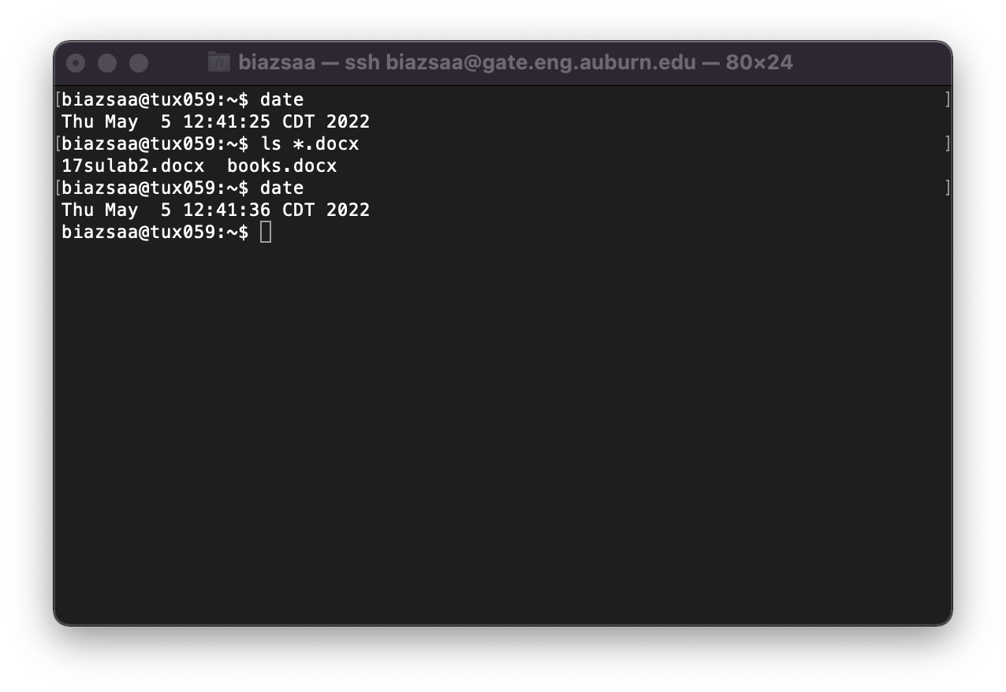

After you log onto a Tux machine, you must create a parent directory named nnnn where nnnn is this course's number. If this course's number is 3270, then you must name the parent directory 3270. You can think of "directory" as a folder (for Windows or Mac OS terminologies). We call the Directory nnnn a *parent* *directory* because this directory will contain all directories and files that you will create for this course. You must create inside the parent directory nnnn seven directories called lab1, lab2, lab3, ....., lab6, and lab7. To help you complete this task, we will guide you through the first steps:

1) As soon as you log in, type on the command line: ls

(5 points) what does the command ls do? You could use the command man ls

The command ls lists files and directories in Unix systems.

(4 points) what does the command man do? You could use the command man man

The command man has a built-in manual for Unix commands.

2) (9 points) type the command ls -al

What is the difference between ls and ls -al?

The difference between ls and ls -al is that ls only lists files and directories in the current directory, while ls -al lists all kinds of hidden files and directories (those with a “.” in it).

3) (9 points) type the command mkdir nnnn (where nnnn is this course's number)

The above command mkdir nnnn will create a directory named nnnn. Type the command ls -al to check that this directory named nnnn was created inside the home directory: the home directory is the default directory you are in when you log on a Tux machine.

Take a screenshot showing the list of files or directories inside the current directory (home).



4) (9 points) type the command cd nnnn (where nnnn is this course's number) (this command will "*move*" you into the directory nnnn

Take a screenshot showing the prompt.



5) (9 points) type the command ls -al

Take a screenshot showing the list of files or directories inside nnnn.

You should see two files (or directories?) named '**.**' and '**..**'

Search on Google what '**.**' and '**..**' are.

What are those "files" (or directories?) '**.**' and '**..**'?

The single dot (.) directory represents the current directory, while the double dot (..) directory represents the parent directory above the current one.

6) (9 points) Create 7 directories named lab1, lab2, lab3, ....., lab6, and lab7 inside the directory nnnn. List below the commands you must type to create 7 directories named lab1, lab2, lab3, ....., lab6, and lab7.

7) (9 points) type the command ls -al

Take a screenshot showing the list of files or directories inside Directory nnnn.

8) (9 points) What command should you type to "*move*" inside the directory lab3

The command you should type to “move” inside the lab3 directory is cd lab3. Typing cd (directory) is used to change the directory of the file, which will move the directory to lab3 in this case.

9) (9 points) type the command ls -al (while inside the directory lab3)

Take a screenshot showing the command line "ls -al" and the content of the directory lab3.

10) (9 points) which command should you type to "move up" to the parent directory of lab3?

The command you should type is cd .. to “move up” to the parent directory of lab3. Typing cd (directory) is used to change the directory, and the two dots signify the parent directory above lab3, which is 3500. Doing this will move it back to the parent directory, 3500.

**Start early**: many problems could arise.

**If you have problems to log in remotely to Tux machines, ask on Piazza for help.**

What you need to turn in:

* Electronic copy of this file (including your answers) (standalone). Submit the file as a Microsoft Word or PDF file.
* Recall that answers must be well written, documented, justified, and presented to get full credit.
* How this assignment will be graded:
* A right answer will get full credit when:
* It is right (worth 25%)
* It is right AND neatly presented making it easy and pleasant to read. (worth 15%)
* There is an obvious and clear link between 1) the information provided in the exercise and in class and 2) the final answer. A clear link is built by properly writing, justifying, and documenting an answer (worth 60%).
* Calculation mistakes will be minimally penalized (2 to 5% of full credit) while errors on units will be more heavily penalized.
* You are welcome/encouraged to discuss exercises with other students or the instructor. But, ultimately, personal writing is expected.

**Appendix**: Grading: What is an OBVIOUS and CLEAR LINK?

Here is an example to explain what an **obvious and clear link** is and how we grade your work.

Consider the following problem:

"(100 points) John travels from Auburn to Atlanta in his car at a speed of 50 mph. Leaving at 8am, at what time will John reach Atlanta".

Here are the answers of three students and their scores:

**Student 1** answers: "10am". Student 1 will get 25 points.

**Student 2**answers : "John will reach Atlanta at 10am". Student 2 will get 25+15 = 40 points

**Student 3** answers: "The time t to travel a distance d at speed v is equal to d/v = d/50mph. The problem does not provide the distance d from Auburn to Atlanta. Based on Google, the distance from Auburn to Atlanta is approximately 100 miles (**document is here**). Therefore, the time t = 100 miles/50mph = 2 hours. Since John left at 8am, he will then reach Atlanta at 8am + 2 hours = 10 am".

**Student 3** will get 25 + 15 + 60 = 100 points

Do you see the **direct** **link** going from the data provided in the question to the final answer, using general knowledge/formula and documents?.... Can you now solve the following problem and get 100 points?

"(100 points) Alice travels from Auburn to Atlanta in her car at a speed of 50 mph. Leaving at 8am, at what time will Alice reach Atlanta assuming that she had a flat tire that delayed her 30 minutes".

**Screenshot: Required Information**

**In order to save space, for this assignment and all *FUTURE* ones, clip out the screenshots to contain only the relevant information. *When applicable, ALL screenshots must show the date, the machine you are using for the exercise and the username of one of the team mates*. Make sure that the screenshots are easily readable. Below is template screenshot:**



1. See on the appendix what an obvious and clear link is.