Exercises to work out and turn in:

Grading Guidelines (See Appendix):

In general, a right answer will get full credit when:

1. It is right (worth 25%)
2. It is right **AND** neatly presented making it easy and pleasant to read. (worth an **extra** 15%)
3. There is an **obvious and clear link[1]** between 1) the information provided in the exercise and in class and 2) the final answer. A clear link is built by properly writing, justifying, and documenting an answer (worth an **extra** 60%).
4. Calculation mistakes will be minimally penalized (2 to 5% of full credit) while errors on units will be more heavily penalized.

**Late Submission** : as specified in the syllabus. Day counting starts one minute after the deadline.

**Check Your Submission:**  after submitting, download your submission to check whether it is the right version and it is complete.

You are welcome/encouraged to discuss exercises with other groups or the instructor. But, ultimately, **personal** writing is expected.

* USE THIS FILE AS THE STARTING DOCUMENT YOU WILL TURN IN. **KEEP IN THE QUESTIONS** AND **INSERT** YOUR ANSWERS **RIGHT AFTER THE QUESTIONS**.
* IF USING HAND WRITING (STRONGLY DISCOURAGED), REWRITE THE QUESTIONS.
* FAILING TO FOLLOW TURN IN DIRECTIONS /GUIDELINES WILL COST A 30% PENALTY.

Objectives of this assignment:

* to work on a Unix based system
* to explore the impact of the memory accesses pattern on the performance

What you need to do:

* to work on a Unix based system
* Review a few Unix commands
* Analyze the time complexity of two algorithms that perform the same number of instructions
* Explore the impact of the memory accesses pattern on the execution time

**Important:**

* *One submission per team.* ***You must complete all tasks on an Engineering Unix Tux machine.***
* *Writing and presentation of your report are considered to grade your hands-on lab. Your conclusions* ***must be supported*** *by the data/measurements you collect. Your conclusions must be correct.*
* ***Questions about this lab must be posted on Piazza if you need timely answers****.*
* ***Work ahead. Do not wait until the last minute.***

Task 1: Basic Unix Commands (20 points)

(Well written short answers are acceptable for this assignment)

The objective of this exercise is to get familiar with basic frequently used commands.

**In order to save space, for this assignment and future ones, clip out the screenshots to contain only the relevant information. Make sure that the screenshots[2] are easily readable.**

1) (4 points) The shell allows *redirection* of the output. By default, the result of your commands is displayed by default on the terminal. You can redirect the "displaying" onto a file. For example, execute these commands in your nnnn directory you created for this course (nnnn is your course #):

- ls

- ls **>** dump

- cat dump

2) (4 points) What does the command wc do?

Execute these commands under the same directory where the file *dump* is:

- wc dump

- wc -l dump

3) (4 points) Download the files poem1.tex and poem2.tex. These are slightly different translations of Rimbaud's poem "*Le Dormeur Du Val*". How do they differ? Here is a command you could use:

- cmp poem1.tex poem2.tex

- cmp -b poem1.tex poem2.tex

4) (4 points) What does the command grep do?

Execute these commands under the same directory where the files poem1.tex and poem2.tex are.

- grep his poem1.tex // no space around "."

- echo po*.tex // no space around "."

- grep his po*.tex // no space around "."

5) (4 points) The ampersand character **&** allows to use the shell (command prompt) while a command or a program is being executed. Execute these commands to see the effect of & (emacs is a popular editor):

- emacs&

- ps

-emacs&

- ps

Kill the two emacs processes

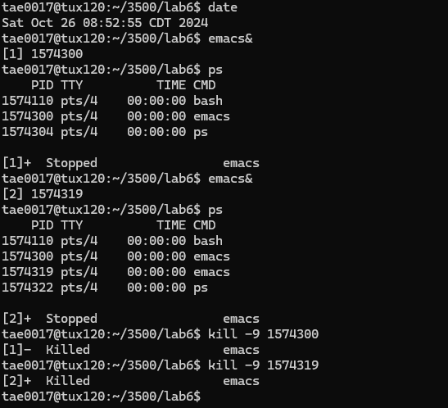

Task 2 (80 points)

The objective of this task is to explore the impact of the pattern of the memory accesses on the execution time of a program. In order to complete this exploration, you must measure the execution time of two algorithms that execute the same job by performing exactly the same number of instructions/operations. After measuring, you must draw conclusions and explain potential differences between the execution time of the two algorithms. You must work these hands-on laboratory exercise on a Tux machine.

# Exercise: For this exercise, you must work with the lab6.c program. This program will allow you to collect data.

1) (5 points) Consider the following algorithm:

**InitializeMatrix0(M,n) // Version 0**

inputs: Matrix $M$ of characters, $n$, the dimension of the nxn M matrix

output: none. Each element of Matrix M is initialized with '0'

for i = 1 to n

for j = 1 to n

Matrix[i][j] = '0';

What is the time complexity of the above algorithm (Version 0) when you count the assignments "Matrix[i][j]='0';". How many of these assignments will be executed? Express this number as a function of $n$.

The inner loop *i* runs n times, and the outer loop *j* runs n times. The total number of assignments that will be executed will be n * n = n2, and the time complexity of this algorithm is O(n2).

2) (5 points) Consider the following algorithm:

**InitializeMatrix1(M,n) // Version 1**

inputs: Matrix $M$ of characters, $n$, the dimension of the nxn M matrix

output: none. Each element of Matrix M is initialized with '0'

for j = 1 to n

for i = 1 to n

Matrix[i][j] = '0';

What is the time complexity of the above algorithm (Version 1) when you count the assignments " Matrix[i][j]='0';". How many of these assignments will be executed? Express this number as a function of $n$.

The inner loop *j* runs n times, and the outer loop *i* runs n times. The total number of assignments that will be executed will be n * n = n2, and the time complexity of this algorithm is O(n2). Even though the variables are switched in Version 1 compared to Version 0, they still have the same time complexity and execute the same total number of assignments.

3) (10 points) Check within the source program lab6.c whether the C code implements "faithfully" the pseudocode for both version to initialize the matrix (Examine the methods InitializeMatrix0 and InitializeMatrix1). Compare the two algorithms: do they perform the same job? do they execute the same number of operations? what is the key difference between the two algorithms? If these two algorithms execute under the exactly same conditions (same hardware, OS, load...), **should** them perform similarly (same execution time)?

Both InitializeMatrix0 and InitializeMatrix1 faithfully implement the pseudocode to initialize the matrix. They both perform the same job of initializing all the matrix elements to 0 and they both execute the same number of operations of n * n = n2. The key difference between the two algorithms is that in InitializeMatrix0, the memory is accessed by rows, while in InitializeMatrix1, the memory is accessed by columns. Even though both algorithms have the same time complexity, InitializeMatrix0 is the more optimal method to execute because it uses a row-by-row method, which leads to a more sequential memory access and faster execution.

4) (5 points) Download the program lab6.c. Compile it by typing cc -o lab6 lab6.c. Execute the program lab6 by typing: ./lab6 maxdimension step Version where maxdimension is the dimension of the largest matrix M to initialize, step is the step of the data points, and Version is the version (0/1) of the algorithm. Below is the pseudocode of lab6.c:

**LaunchExperiment(M, n)**

inputs: Matrix $M$ of characters,

$maxdimension$, the dimension of the largest matrix M to initialize,

step is step between data points (see pseudocode)

Version is the version of the algorithm to use

output: a **file** containing the execution time for a given matrix dimension. File is named **file-maxdimension-step-Version0/1.csv. This** file can be opened with Excel for plotting....

for dimension = step to maxdimension (increasing by step)

if Version == 0

InitializeMatrix0(M,dimension) // Version 0

else

InitializeMatrix1(M,dimension) // Version 1

write in file *dimension* and execution time of InitializeMatrix0/1(M,dimension)

***For example***, if you execute **./lab6 16384 2048 1**, *LaunchExperiment* will initialize the matrices with dimensions 2048, 4096, 6144, 8192, 10240, 12288, 14336, and 16384, respectively. For each initialized matrix, it will collect the execution time and will write the pairs (dimension, execution time) in a file named **file-16384-2048-Version1.csv** (recall **16384** is *maxdimension*, **2048** is the step, and **1** is the version). You will find the data in such a file to build plots. This file can be opened by Excel (csv format).

For this question Execute and time **./lab6 32768 2048 0**, report the time it takes to complete the execution time, take a screenshot of the execution (clip out the screenshot) and **insert it here..**

**Hint**: to time the execution, you can simply type ***time ./lab6 32768 2048 0***

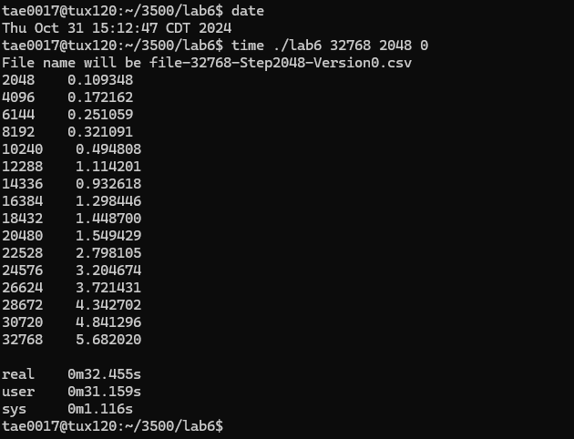

5) (5 points) Execute and time **./lab6 32768 2048 1**, report the time it takes to complete the execution time, take a screenshot of the execution (clip out the screenshot) and **insert it here..**

**Hint**: to time the execution, you can simply type ***time ./lab6 32768 2048 1***

6) (30 points)

a) Execute *time* ***./lab6 65536 4096 0*** and collect the file **file-65536-4096-Version0.csv**

b) Execute *time* ***./lab6 65536 4096* 1** and collect the file **file-65536-4096-Version1.csv**

c) (15 points) Build on the **same** graph the plots of execution time of the two versions of the algorithms (0 and 1) versus the matrix dimension: put the matrix dimension on the x-axis and the execution time on the y-axis

d) (15 points) Build the plot of $\frac{Execution Time (Version 1)}{Execution Time (Version 0)}$ as a function of matrix dimension: put matrix dimension on the x-axis and $\frac{Execution Time (Version 1)}{Execution Time (Version 0)}$ on the y-axis.

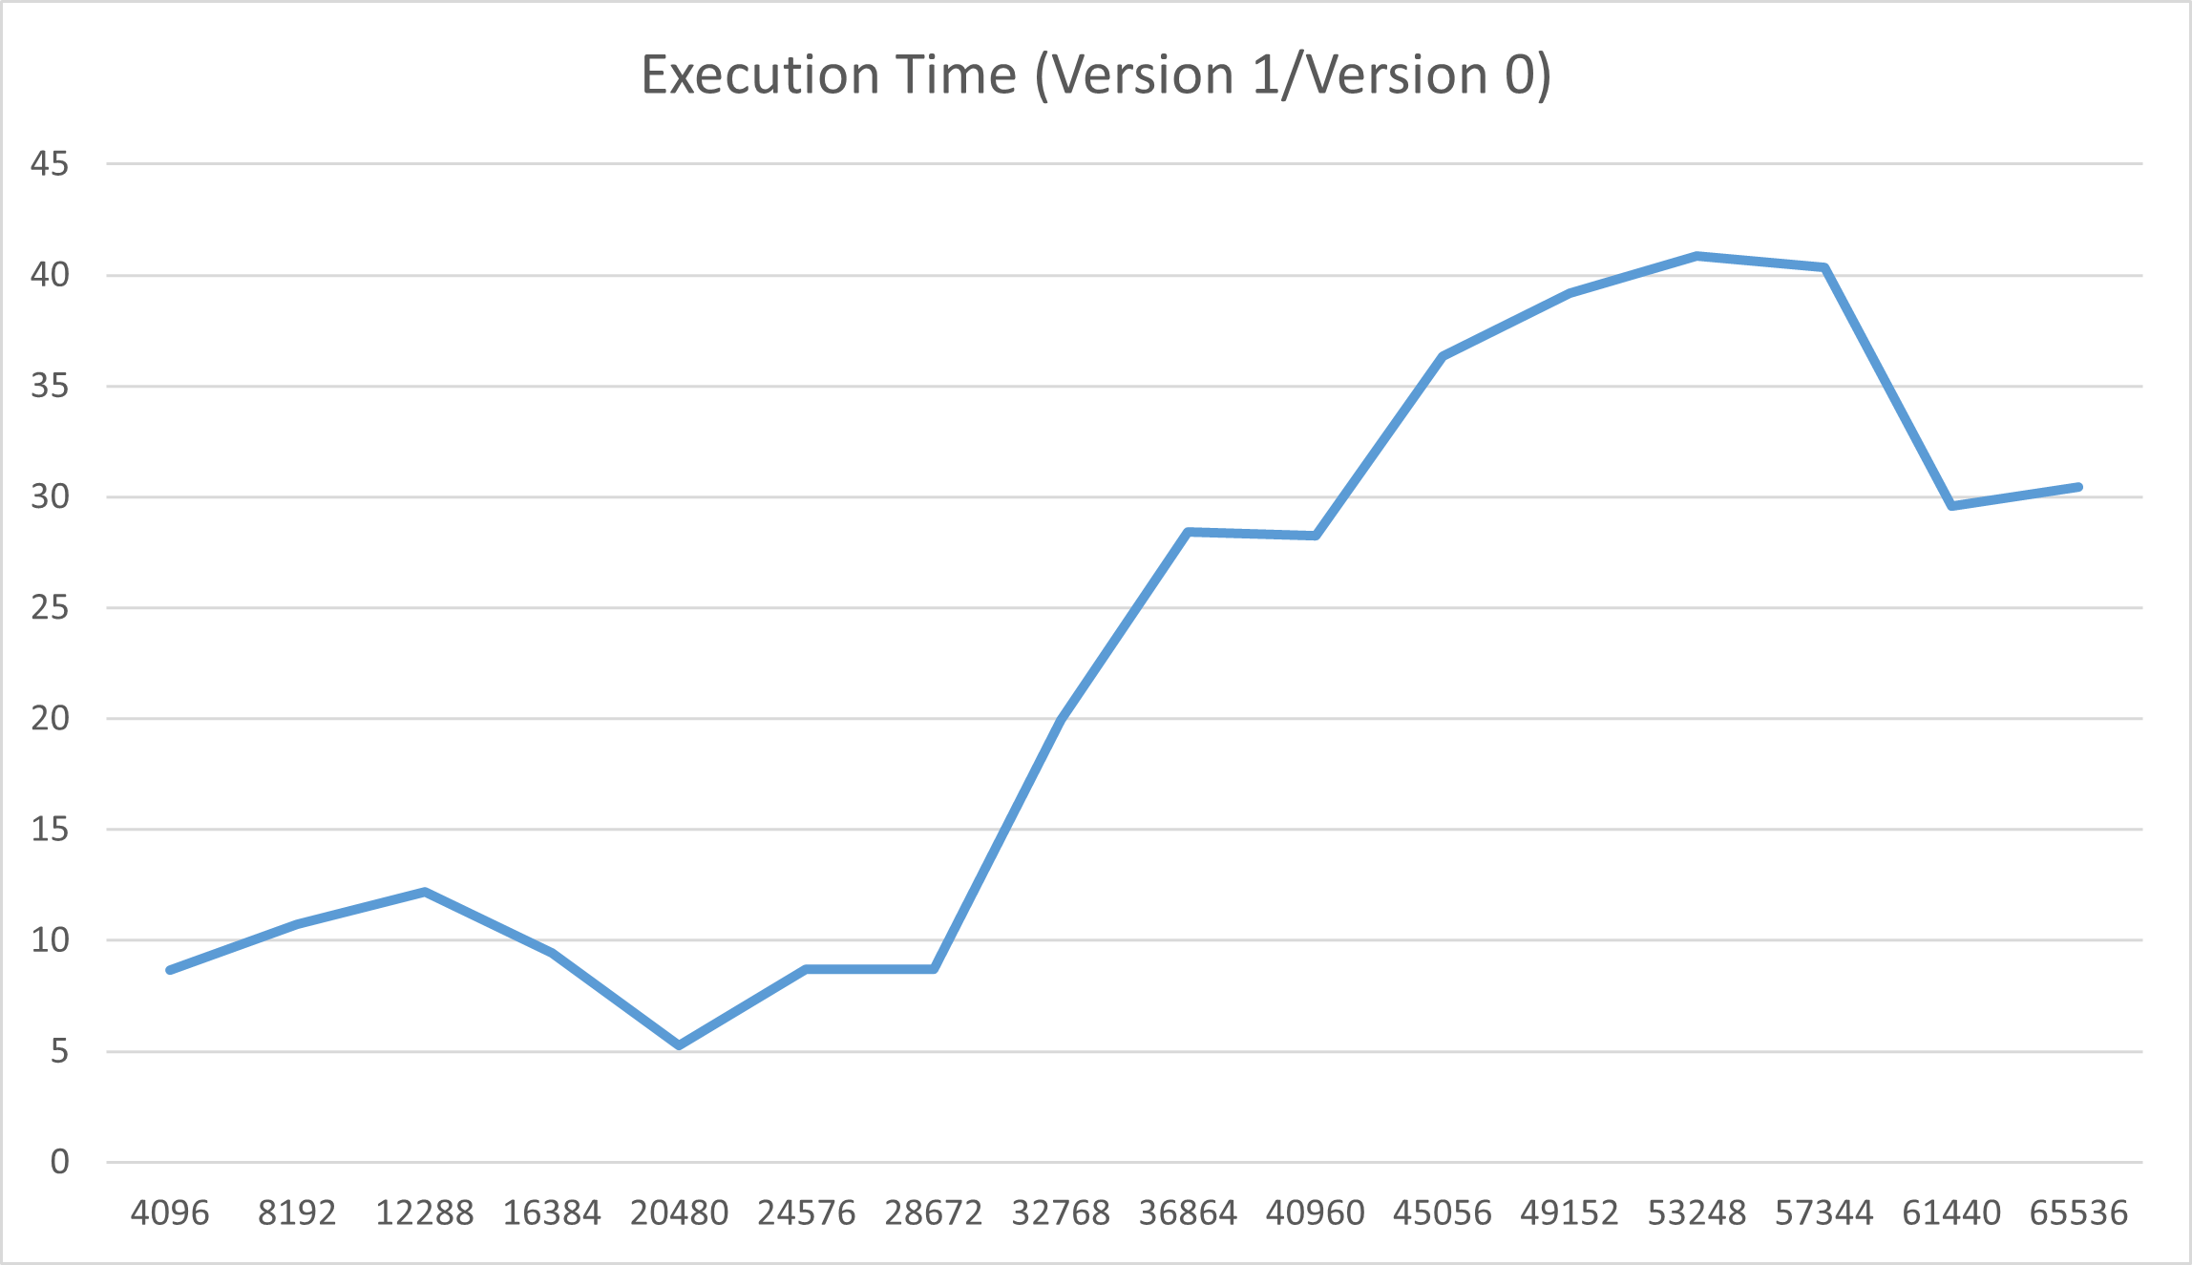

7) (5 points) Comment and discuss the two graphs built above. Highlight the potential differences (execution time) between Version 0 and Version 1 of the matrix initialization algorithm.

Version 0 has a much faster execution time than Version 1 because Version 0 accesses memory row-by-row, which is a quicker and more sequential process (around 5 seconds or so), while Version 1 accesses memory column-by-column, which is a slower and non-sequential process (around 200 seconds or so).

8) (15 points) **Why?** Provide the **reason** of the potential difference in execution times between Version 0 and Version 1 of the matrix initialization algorithm.

The reason behind the potential difference in execution times between Version 0 and Version 1 of the matrix initialization algorithm is related to cache efficiency. Version 0 uses a row-by-row format, meaning that the elements load up together at around the same time, which provides a faster and sequential process for memory access. However, Version 1 uses a column-by-column format, meaning that the elements load up at different times from one another, which leads to a slower and non-sequential process for memory access.

**Do not hesitate to ask questions on Piazza if you have any doubt.**

**Common mistake**

Starting the hands-on lab at the last minute.

**What to turn in?**

One file

a) **Electronic copy** of **this** file that includes your answers. I repeat: you must insert your answers in **this** file. Do not delete anything from this file. This file with your answers must be put posted **separately** on Canvas (not in a zipped folder).

Good writing and presentation are expected.

**In case of doubt, do not hesitate to ask questions on Piazza.**

What you need to turn in:

* Electronic copy of this file (including your answers) (standalone). Submit the file as a Microsoft Word or PDF file.
* Recall that answers must be well written, documented, justified, and presented to get full credit.
* How this assignment will be graded:
* A right answer will get full credit when:
* It is right (worth 25%)
* It is right AND neatly presented making it easy and pleasant to read. (worth 15%)
* There is an obvious and clear link between 1) the information provided in the exercise and in class and 2) the final answer. A clear link is built by properly writing, justifying, and documenting an answer (worth 60%).
* Calculation mistakes will be minimally penalized (2 to 5% of full credit) while errors on units will be more heavily penalized.
* You are welcome/encouraged to discuss exercises with other students or the instructor. But, ultimately, personal writing is expected.

**Appendix**: Grading: What is an OBVIOUS and CLEAR LINK?

Here is an example to explain what an **obvious and clear link** is and how we grade your work.

Consider the following problem:

"(100 points) John travels from Auburn to Atlanta in his car at a speed of 50 mph. Leaving at 8am, at what time will John reach Atlanta".

Here are the answers of three students and their scores:

**Student 1** answers: "10am". Student 1 will get 25 points.

**Student 2**answers : "John will reach Atlanta at 10am". Student 2 will get 25+15 = 40 points

**Student 3** answers: "The time t to travel a distance d at speed v is equal to d/v = d/50mph. The problem does not provide the distance d from Auburn to Atlanta. Based on Google, the distance from Auburn to Atlanta is approximately 100 miles (**document is here**). Therefore, the time t = 100 miles/50mph = 2 hours. Since John left at 8am, he will then reach Atlanta at 8am + 2 hours = 10 am".

**Student 3** will get 25 + 15 + 60 = 100 points

Do you see the **direct** **link** going from the data provided in the question to the final answer, using general knowledge/formula and documents?.... Can you now solve the following problem and get 100 points?

"(100 points) Alice travels from Auburn to Atlanta in her car at a speed of 50 mph. Leaving at 8am, at what time will Alice reach Atlanta assuming that she had a flat tire that delayed her 30 minutes".

**Screenshot: Required Information**

**In order to save space, for this assignment and all *FUTURE* ones, clip out the screenshots to contain only the relevant information. *When applicable, ALL screenshots must show the date, the Tux machine you are using for the exercise and the Auburn username of one of the team mates*. Make sure that the screenshots are easily readable. Below is template screenshot:**

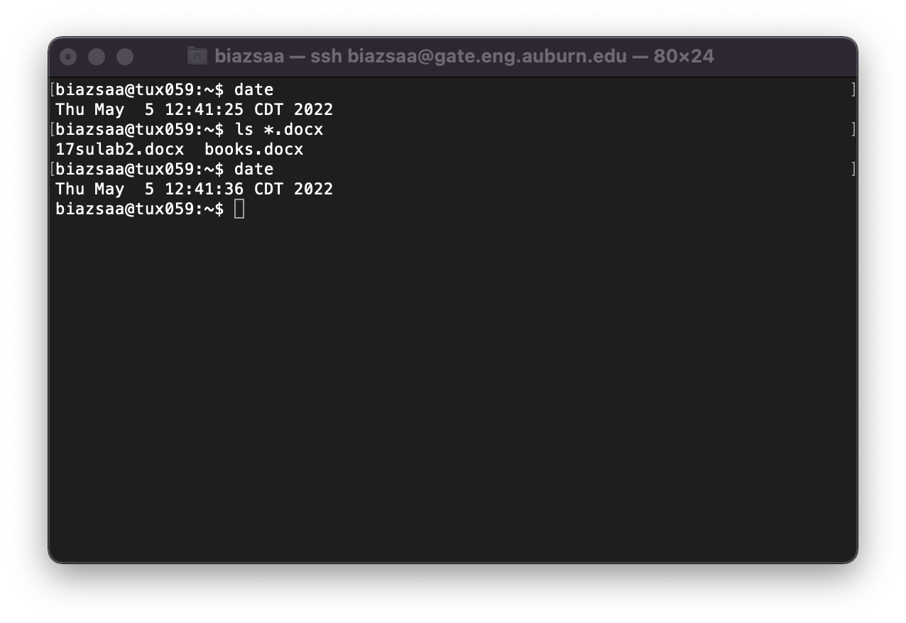

1. See on the appendix what an obvious and clear link is.
2. See Appendix About the REquired Information On All Screenshots