DevoTranscribe - Instruction Manual
Professional Speech Transcription Service

Table of Contents
- DevoTranscribe - Instruction Manual
  - Table of Contents
  - 1. Overview
  - 2. Getting Started
    - Supported File Formats
  - 3. Transcription Configuration
    - Available Options
  - 4. Uploading a File
    - How to Upload
  - 5. Upload Progress
  - 6. Transcription Processing
  - 7. Viewing Results
    - Result Header
    - Original vs. Refined Transcript
  - 8. Transcript Segments
  - 9. Speaker Identification
    - Speaker Transcript Actions
  - 10. Downloading and Copying Transcripts
    - Copy to Clipboard
    - Download as Text File
    - Job Metadata
  - 11. Starting a New Transcription
  - 12. Support & Legal Pages
    - Privacy Policy
    - Terms of Service
    - Support
  - 13. Troubleshooting
    - Common Issues
    - Browser Requirements

1. Overview
DevoTranscribe is a professional speech transcription service that converts audio and video files into accurate text transcriptions. The service is powered by Google Cloud AI and features:
- Fast Upload - Upload audio and video files up to 5GB with progress tracking
- AI-Powered Transcription - High-quality speech transcription using Google Cloud Speech-to-Text
- Speaker Identification - AI-powered speaker detection for Dutch conversations using Gemini LLM
- Refined Transcripts - Light LLM cleanup for improved readability
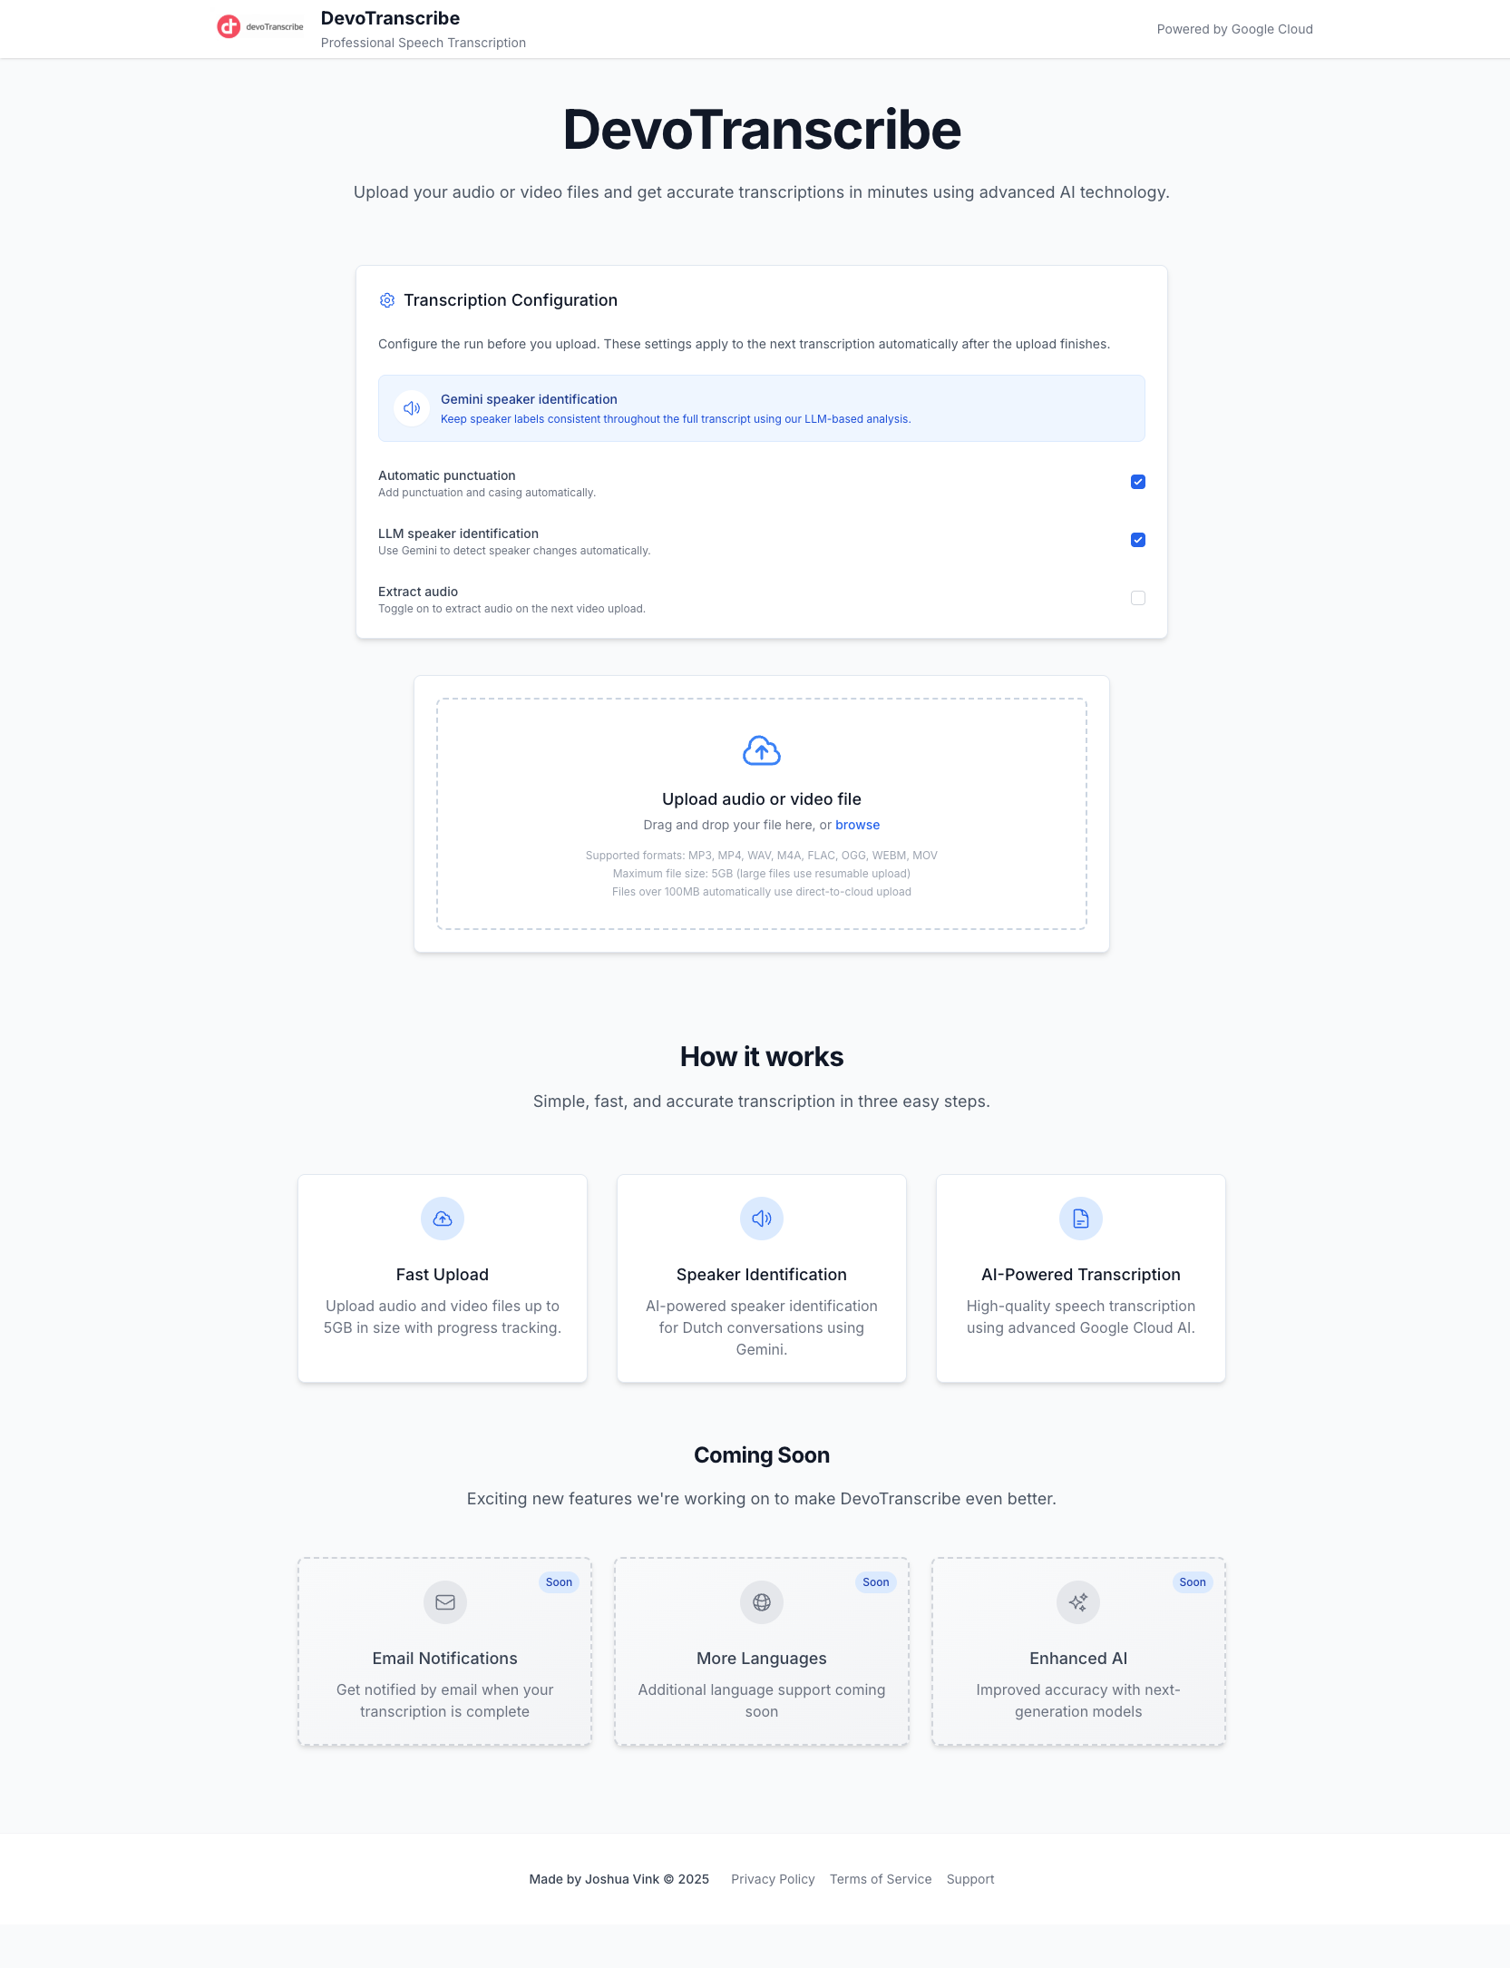
Homepage overview

2. Getting Started
When you open DevoTranscribe, you will see the main page with:
- A header displaying the DevoTranscribe logo and “Powered by Google Cloud” branding
- The hero section with the title and a brief description
- The Transcription Configuration panel
- The file upload area
- How it works and Coming Soon feature cards
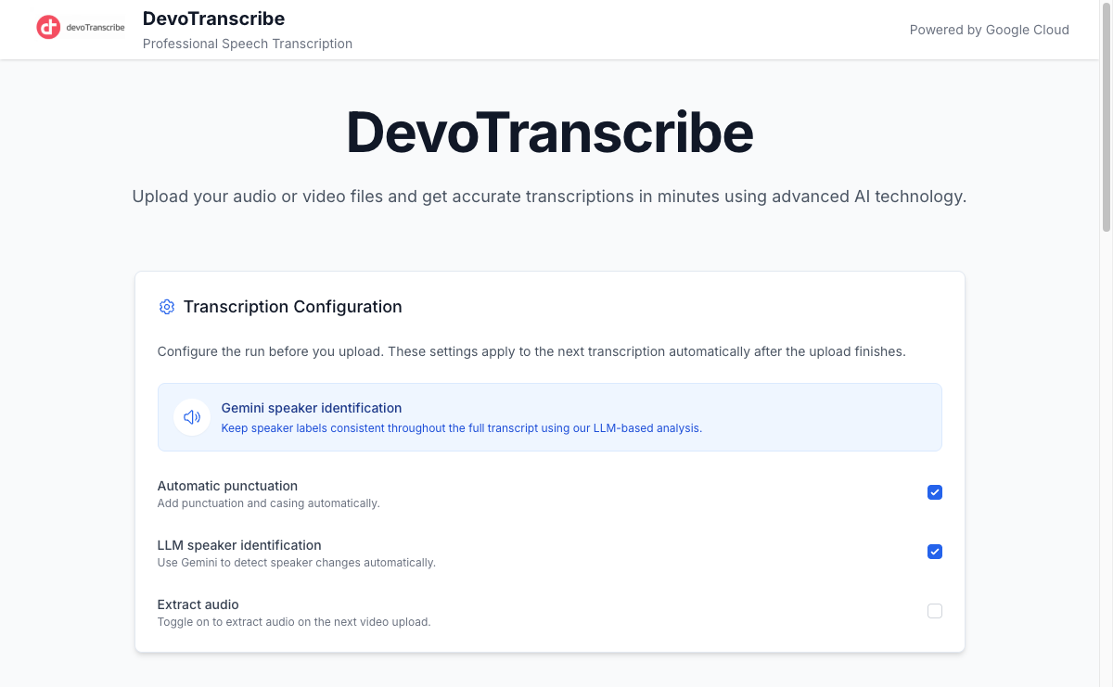
Homepage top section

Supported File Formats
Type | Formats
Audio | MP3, WAV, M4A, FLAC, OGG, WEBM
Video | MP4, MOV, AVI, MKV, WEBM
Maximum file size: 5GB. Files over 100MB automatically use direct-to-cloud upload for reliable transfer.

3. Transcription Configuration
Before uploading a file, configure the transcription settings in the Transcription Configuration panel. These settings are applied automatically once the upload completes.
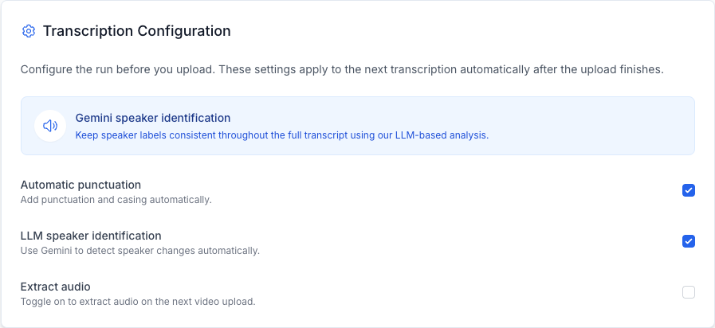
Transcription Configuration panel

Available Options
Setting | Default | Description
Gemini speaker identification | Always on | Uses LLM-based analysis to keep speaker labels consistent throughout the full transcript. This is a core feature and is always enabled.
Automatic punctuation | Enabled | Adds punctuation and casing automatically to the transcribed text.
LLM speaker identification | Enabled | Uses Google Gemini to detect speaker changes automatically within the audio.
Extract audio | Disabled (auto-enabled for video) | Extracts audio from video files before transcribing. Automatically enabled when you upload a video file.
Note: Configuration options are disabled (greyed out) while a file is uploading or a transcription is in progress. Adjust settings before starting an upload.

4. Uploading a File
To upload a file, use the upload area below the configuration panel.
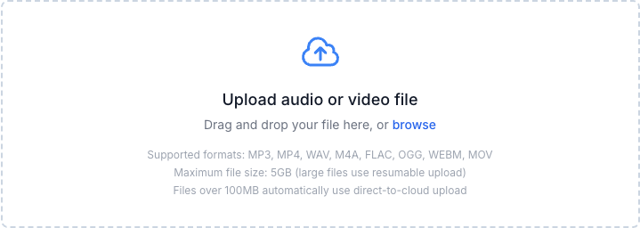
Upload area

How to Upload
There are two ways to upload a file:
- Drag and drop - Drag your audio or video file directly onto the upload area
- Browse - Click anywhere on the upload area or click “browse” to open a file picker dialog
Once a file is selected, the upload begins immediately and the transcription will start automatically after the upload completes.
Tip: If you upload a video file (e.g., MP4), the “Extract audio” option is automatically enabled to convert the video to audio before transcription.

5. Upload Progress
After selecting a file, a progress bar shows the upload status in real time.
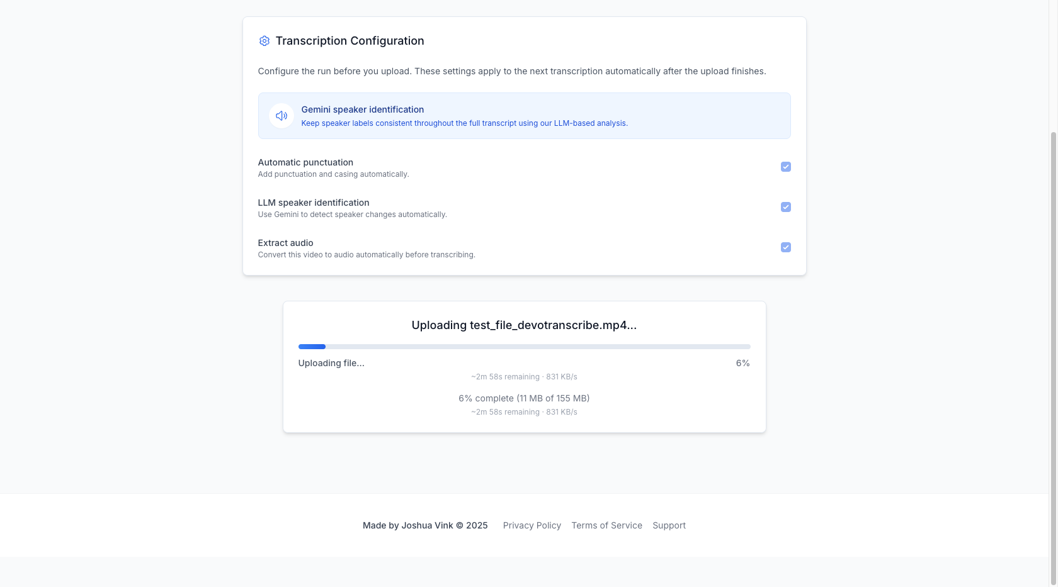
Upload progress
The upload progress card displays:
- File name being uploaded
- Progress bar with percentage
- Upload speed (e.g., 702 KB/s)
- Estimated time remaining (e.g., ~2m 20s remaining)
- Bytes transferred (e.g., 59 MB of 155 MB)
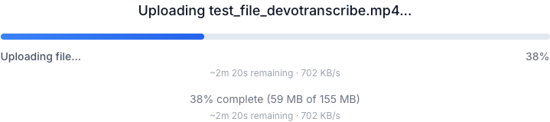
Upload progress detail
Note: Large files (over 100MB) use resumable upload technology, ensuring reliable transfers even on slower connections.

6. Transcription Processing
Once the upload completes, the transcription begins automatically. The progress bar updates to show the current processing stage:
- Preparing transcription… - Initial setup
- Extracting audio from video… - Converting video to audio (if applicable)
- Processing file… - Preparing the audio for transcription
- Transcribing speech… - AI is converting speech to text
- Identifying speakers… - Gemini is analyzing speaker patterns
An estimated remaining time is displayed during processing.
When completed, a green success bar appears with a celebration emoji:
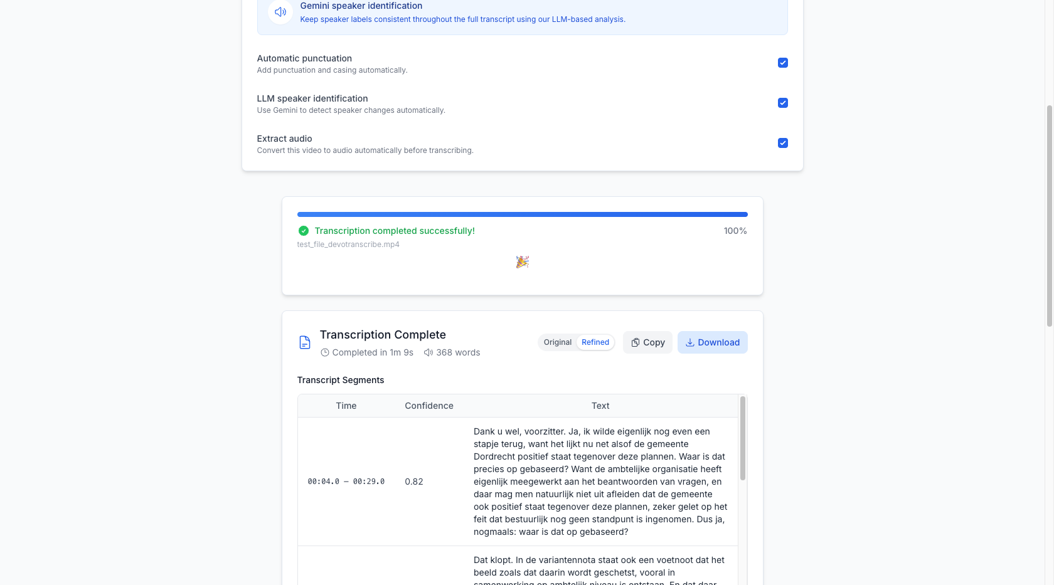
Transcription completed

7. Viewing Results
After the transcription completes, the results page displays several sections:
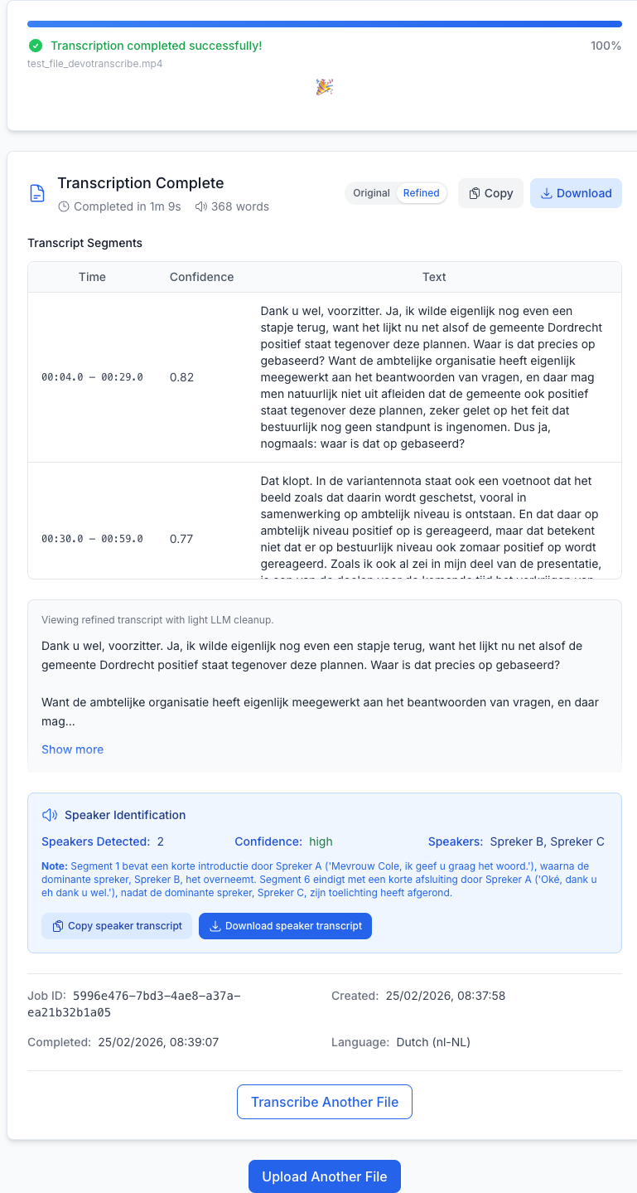
Full results view

Result Header
The header shows: - “Transcription Complete” title - Completion time (e.g., “Completed in 1m 9s”) - Word count (e.g., “368 words”) - Original / Refined toggle to switch between transcript versions - Copy and Download buttons

Original vs. Refined Transcript
DevoTranscribe provides two versions of the transcript:
- Original - The raw transcript returned by the Google Cloud Speech API
- Refined - A cleaned-up version with light LLM processing for improved readability
Use the Original / Refined toggle buttons in the header to switch between views. The refined view is selected by default when available.

8. Transcript Segments
The results include a Transcript Segments table showing the transcription broken into time-based segments:
Column | Description
Time | Start and end timestamp of the segment (e.g., 00:04.0 - 00:29.0)
Confidence | AI confidence score from 0 to 1 (e.g., 0.82)
Text | The transcribed text for that segment
The segments table is scrollable for longer transcriptions.
Below the segments table, the full transcript text is displayed in a grey box. If the transcript is long, it shows a preview with a “Show more” button to expand the full text.

9. Speaker Identification
When speaker identification is enabled, a blue Speaker Identification panel appears below the transcript.
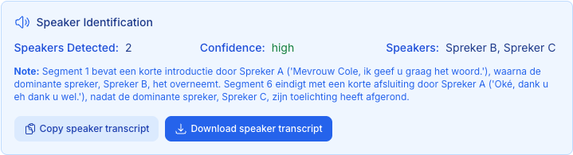
Speaker Identification
This panel shows:
- Speakers Detected - Number of unique speakers found (e.g., 2)
- Confidence - Overall confidence level (high / medium / low)
- Speakers - List of identified speakers (e.g., “Spreker B, Spreker C”)
- Note - Additional context about speaker transitions and patterns

Speaker Transcript Actions
Two dedicated buttons are provided for the speaker-identified transcript:
- Copy speaker transcript - Copies the speaker-labeled transcript to your clipboard
- Download speaker transcript - Downloads a .txt file with speaker labels

10. Downloading and Copying Transcripts

Copy to Clipboard
Click the Copy button in the result header to copy the currently displayed transcript (Original or Refined) to your clipboard. A green “Copied” confirmation appears briefly.

Download as Text File
Click the Download button to save the transcript as a .txt file. The filename follows the format: - transcript-<job-id>.txt (original) - transcript-<job-id>-refined.txt (refined) - transcript-<job-id>-speakers.txt (speaker-identified)

Job Metadata
At the bottom of the results, job metadata is displayed for reference:

Job metadata
- Job ID - Unique identifier for the transcription job
- Created - Timestamp when the job was created
- Completed - Timestamp when the job finished
- Language - The transcription language (Dutch / nl-NL)
Tip: Save the Job ID when contacting support about a specific transcription.

11. Starting a New Transcription
After viewing results, you can start a new transcription in two ways:
- “Transcribe Another File” button - Located at the bottom of the results card
- “Upload Another File” button - Located below the results section
Both buttons reset the page to the initial state, clearing all previous results and resetting configuration options to defaults.

12. Support & Legal Pages
The footer at the bottom of every page provides links to three additional pages:
Footer

Privacy Policy
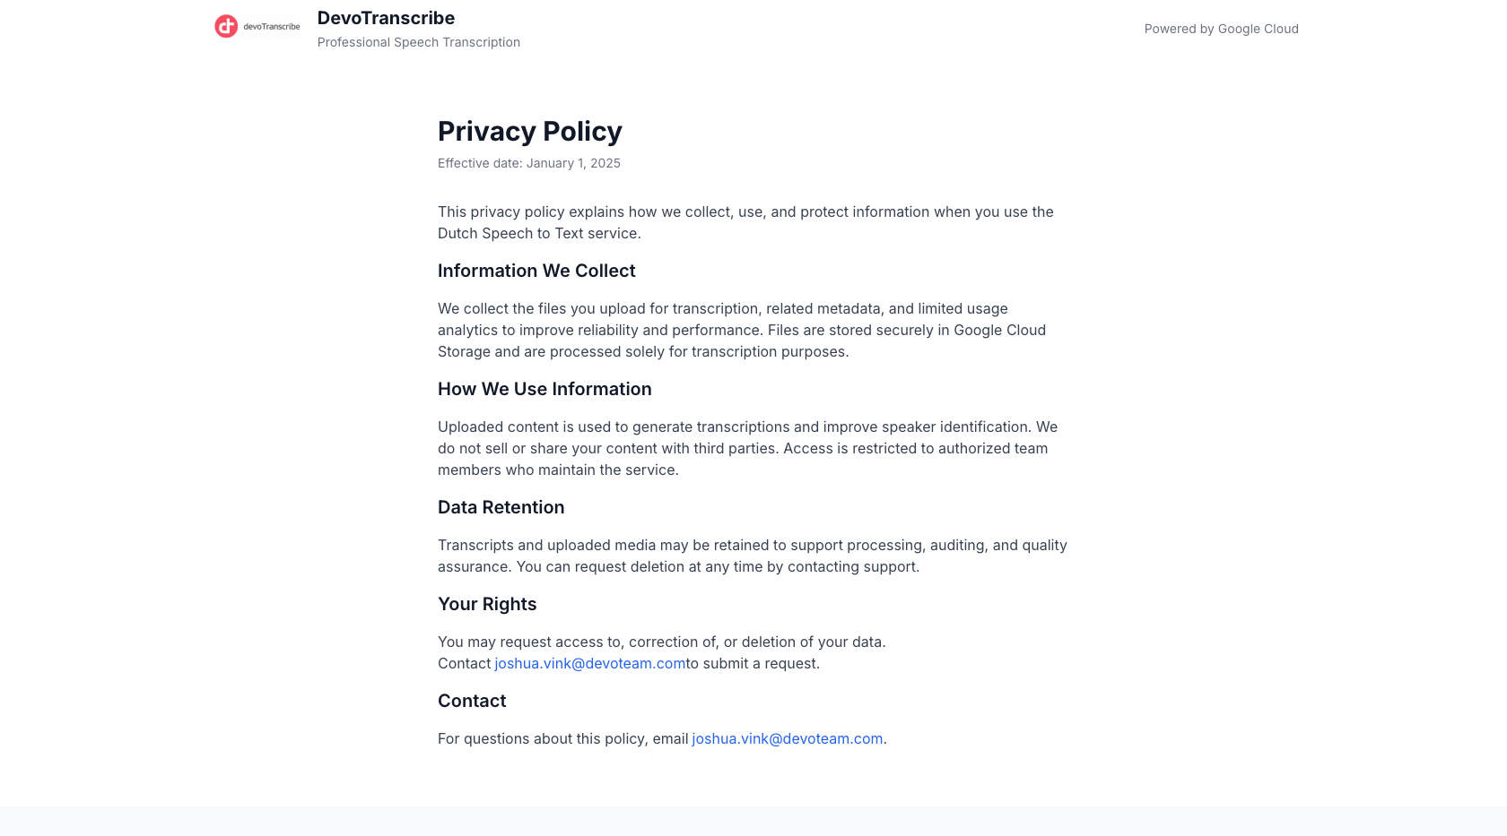
Privacy Policy
The Privacy Policy explains how DevoTranscribe collects, uses, and protects your information. Key points:
- Files are stored securely in Google Cloud Storage
- Content is processed solely for transcription purposes
- No data is sold or shared with third parties
- You can request data deletion at any time

Terms of Service
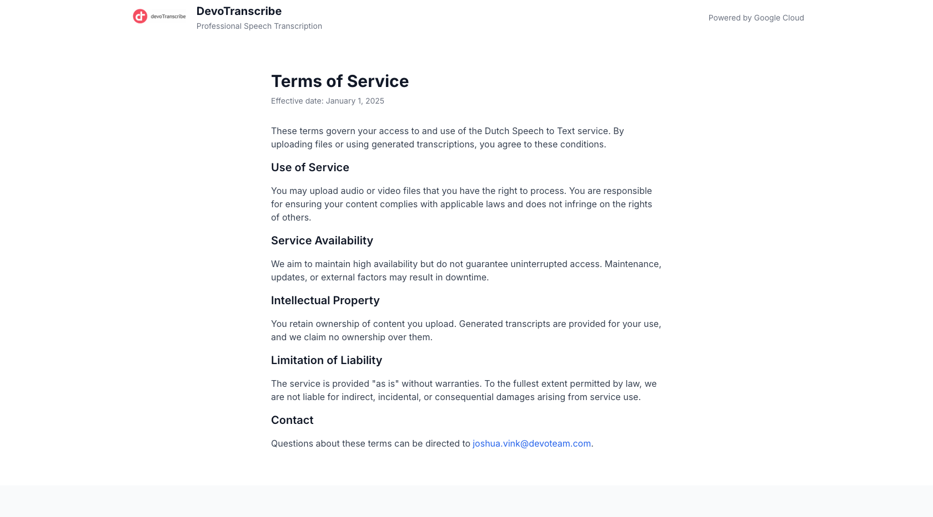
Terms of Service
The Terms of Service cover:
- Acceptable use of the service
- Service availability expectations
- Intellectual property (you retain ownership of your content)
- Limitation of liability

Support
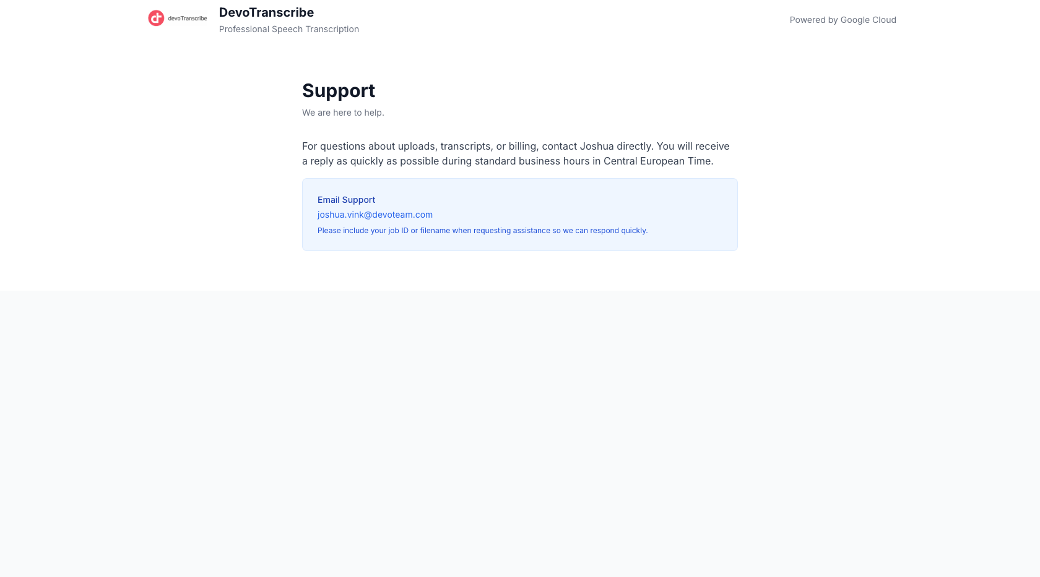
Support page
For questions about uploads, transcripts, or any issues, contact support via email:
Email: joshua.vink@devoteam.com
Tip: Include your Job ID or filename when contacting support to help resolve issues quickly.

13. Troubleshooting

Common Issues
Problem | Solution
File upload fails | Ensure your file is a supported format and under 5GB. Try again on a stable internet connection.
Transcription takes too long | Larger files take longer to process. Video files require audio extraction first, which adds time.
Poor transcription quality | Ensure the audio has clear speech and minimal background noise. The service is optimized for Dutch (nl-NL).
Speaker identification seems inaccurate | Speaker identification works best with clearly distinct voices and minimal overlap. Adjust the speaker count settings if needed.
Configuration options are greyed out | Options are disabled during active uploads or transcriptions. Wait for the current job to complete.
Page refreshed during transcription | DevoTranscribe saves pending transcription state. If a session is interrupted, the app attempts to recover the job status.

Browser Requirements
DevoTranscribe works best with modern browsers: - Google Chrome (recommended) - Mozilla Firefox - Microsoft Edge - Safari

Made by Joshua Vink - Powered by Google Cloud

