PROJECT 4 DOCUMENTATION

Lindley Thomas

CMSC 405-6380

March 7, 2022

Test Plan:

I need to test that all objects are present, animation is working correctly, and all checkboxes and textboxes work correctly. This testing will be done through the following test sets:

* Test Set 1 – Test all 10 objects are present and visible from starting view.
* Test Set 2 – Test animations of objects that are animated and that reset button resets positions of these objects.
* Test Set 3 – Test lights being turned off and on, and test that reset button resets all lights to on.
* Test set 4 – Test overall RGB color changing and that the reset button resets all to values to zero.
* Test set 5 – Test a mix of different options being turned off and on, and test that reset button still works.

Controls for changing the scene:

* Description: these controls turn lights on and off, enable and disable animation, change the overall RGB values for the scene, and reset the scene.

Test Set 1: Test all 10 objects are present and visible from starting view.

|  |  |  |  |  |
| --- | --- | --- | --- | --- |
| Test # | Description | Expected Outcome | Actual Outcome | Pass or Fail |
| 1 | Object 1 present – Sphere with ring around it | Object present | Object present | Pass |
| 2 | Object 2 present – A ship | Object present | Object present | Pass |
| 3 | Object 3 present – Launch platform | Object present | Object present | Pass |
| 4 | Object 4 present – Other ship like object | Object present | Object present | Pass |
| 5 | Object 5 present – Tower that is made of cubes with cylinder base | Object present | Object present | Pass |
| 6 | Object 6 present – Elevator that is a square made from a torus using 4 sides | Object present | Object present | Pass |
| 7 | Object 7 present – Spiked cube | Object present | Object present | Pass |
| 8 | Object 8 Present – Two cones connected at base that act as backplane for ship | Object present | Object present | Pass |
| 9 | Object 9 present – Torus tower, made of cylinders wrapped in torus | Object present | Object present | Pass |
| 10 | Object 10 present – Bubble tower, tower made of spheres and a cone | Object present | Object present | Pass |

Note: I allowed animations to happen while screen capturing objects, because some objects are in front of other objects before animation starts.

Test 1: Object 1

* Description: Object 1 is a pink sphere with a blue ring around it and it is in the upper left corner of the scene

Test 2: Object 2

* Description: Object 2 is my best attempt at a ship, and it is in the bottom left corner of the scene. It starts rested on the orange launchpad. Object is made with cones, a cylinder and a cube. Object translates on the y axis when animation enabled

Test 3: Object 3

* Description: Object 3 is what I call torus tower. It located in the bottom left corner of the scene on the orange launchpad. It is made of a cylinders, torus, and a sphere.

Test 4: Object 4

* Description: Object 4 is another imagination of a ship. It is made of cones and a torus and starts in the top left of the scene. Object translates across the x axis when animation is on.

Test 5: Object 5

* Description: Object 5 is another tower made of cubes and a cylinder base and is in the bottom left of the scene. The elevator object starts at the base of this tower.

Test 6: Object 6

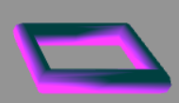

* Description: Object 6 is my imagination of a space elevator. It is located on the object 5 towers base. When animation is enabled, the elevator translates across the y axis, goes out of scene, and then comes back. It is made from a torus that was created with only 4 sides.

Test 7: Object 7

* Description: Object 7 is a spiked cube. It is in the center of the scene and rotates in place. It is made of a cube and cones.

Test 8: Object 8

* Description: Object 8 is a double cone, that acts as a backplane for a ship, located on the launchpad. Made from two cones.

Test 9: Object 9

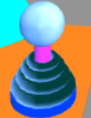

* Description: Object 9 is the torus tower. Made from cylinders, torus, and sphere. It is located in the bottom left corner of the scene on the launchpad.

Test 10: Object 10

* Description: Object 10 is the bubble tower. It is made of a cone and spheres and is located in the bottom center of the scene.

Test Set 2: Test animations of objects that are animated and that the reset button resets positions of these objects.

|  |  |  |  |  |
| --- | --- | --- | --- | --- |
| Test # | Description | Expected Outcome | Actual Outcome | Pass or Fail |
| 1 | Ship animates (object 2) | Should translate across y axis to a certain point then come back to original position. | Translated across y axis to a certain point then come back to original position. | Pass |
| 2 | Other ship animates (object 4) | Should translate back and forth across x axis. | Translated back and forth across x axis. | Pass |
| 3 | Elevator animates (object 6) | Should translate across y axis to a certain point then come back to original position. | Translated across y axis to a certain point then come back to original position. | Pass |
| 4 | Spiked cube animates (object 7) | Should rotate on x and y axis. | Rotated on x and y axis. | Pass |
| 5 | All objects reset to original positions | After animation, when pressing reset, all objects return to original position | After animation, when pressed reset, all objects returned to original position | Pass |

Test 1: Ship (object 2) animation, animation checkbox checked.

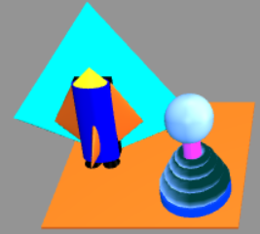

* Description: Object starting at original position

* Description: Object is moving along y axis

* Description: Object is returning to original position

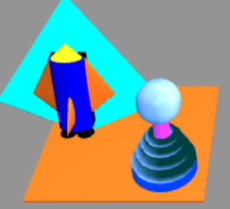

* Description: Object returned to original position while animating.

Test 2: Other Ship (object 4) animation, animation checkbox checked.

* Description: Object at start position.

* Description: Object is moving in positive x direction.

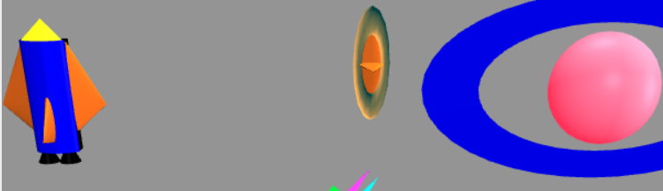

* Description: Object is moving in negative x direction, after reaching furthest positive x position it will go which is obscured by the sphere.

* Description: Object is at position right before starting to move in positive x direction again.

Test 3: Elevator (object 6) animation, animation checkbox checked.

* Description: Object is in start position.

* Description: Object is moving in the positive y direction.

* Description: Object moved of screen reaching point where it starts to move back in the negative y direction.

* Description: Object is coming back to original position.

* Description: Object is back in original position.

Test 4: Spiked Cube (object 7) animation, animation checkbox checked.

* Description: Object in start position.

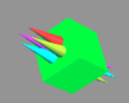

* Description: Object is rotating.

* Description: Object is still rotating, will briefly be back in start position after a certain number of rotations.

Test 5: Reset position, animation checkbox checked.

* Description: All objects have been animated out of start position.

* Description: After pressing reset, all objects returned to start position.

Test Set 3: Test lights being turned off and on, and test that reset button resets all lights to on.

|  |  |  |  |  |
| --- | --- | --- | --- | --- |
| Test # | Description | Expected Outcome | Actual Outcome | Pass or Fail |
| 1 | All lights on | All lights are on | All lights are on | Pass |
| 2 | Turning light 0 off | Light 0 off | Light 0 off | Pass |
| 3 | Turning light 1 off | Light 0 and 1 off | Light 0 and 1 off | Pass |
| 4 | Turning light 2 off | Light 0, 1 and 2 off | Light 0, 1 and 2 off | Pass |
| 5 | Turning light 0 on | Light 0 on | Light 0 on | Pass |
| 6 | Turning light 1 on | Light 0 and 1 on | Light 0 and 1 on | Pass |
| 7 | Turning light 2 on | Light 0, 1 and 2 on | Light 0, 1 and 2 on | Pass |
| 8 | Reset button resets all lights to on | Light 0, 1 and 2 on, after clicking reset. | Light 0, 1 and 2 on, after clicking reset. | Pass |

Test 1: All lights on, all three light checkboxes checked.

* Description: All lights are on

Test 2: Light 0 off, light 0 box unchecked.

* Description: Light 0 was turned off, which is light coming from the z axis.

Test 3: Light 1 off, light 0 and light 1 box unchecked.

* Description: Light from the x axis is turned off, light 0 still off.

Test 4: Light 2 off, light 0, light 1 and light 2 box unchecked.

* Description: Light from the y axis is turned off, light 0 and 1 still off.

Test 5: light 0 on, light 0 box checked.

* Description: Light from z axis is turned back on.

Test 6: Light 1 on, light 0 and light 1 box checked.

* Description: Light from x axis turned on, light 0 still on.

Test 7: Light 2 on, all light boxes checked.

* Description: All lights are back on.

Test 8: Testing reset button on lights

* Description: all lights are off before clicking reset.

* Description: all lights are back on after clicking reset.

Test Set 4: Test overall RGB color changing and that the reset button resets all to values to zero.

|  |  |  |  |  |
| --- | --- | --- | --- | --- |
| Test # | Description | Expected Outcome | Actual Outcome | Pass or Fail |
| 1 | Test red | Scene should have red color applied to it | Scene has red color applied to it | Pass |
| 2 | Test blue | Scene should have blue color applied to it | Scene has blue color applied to it | Pass |
| 3 | Test green | Scene should have green color applied to it | Scene has green color applied to it | Pass |
| 4 | Test teal | Scene should have teal color applied to it | Scene has teal color applied to it | Pass |
| 5 | Test reset of color | Scene should revert to original look | Scene reverted to original look | Pass |

Note: I can not figure out why some of my objects will not change color. I think it has to do with the way I created certain object or colored them.

Original Scene:

* Description: no color change applied

Test 1: Red

* Description: Red color applied.

Test 2: Green

* Description: Green color applied.

Test 3: Blue

* Description: Blue color applied.

Test 4: Teal

* Description: Teal color applied

Test 5: reset

* Description: after pressing reset all changed colors return to original.

Test Set 5: Test a mix of different options being turned off and on, and test that reset button still works.

|  |  |  |  |  |
| --- | --- | --- | --- | --- |
| Test # | Description | Expected Outcome | Actual Outcome | Pass or Fail |
| 1 | Change color, lighting, and turn animation on then click reset. | Changes apply then reset changes everything back to original. | Changes apply then reset changes everything back to original. | Pass |
| 2 | Change color, lighting, and turn animation on then click reset. | Changes apply then reset changes everything back to original. | Changes apply then reset changes everything back to original. | Pass |
| 3 | Change color, lighting, and turn animation on then click reset. | Changes apply then reset changes everything back to original. | Changes apply then reset changes everything back to original. | Pass |

Test 1: Mixed testing

* Description: Changed multiple settings.

* Description: Changed multiple settings, reset turned them all back to original.

Test 2: Mixed testing

* Description: Changed multiple settings.

* Description: Changed multiple settings, reset turned them all back to original.

Test 3: Mixed testing

* Description: Changed multiple settings.

* Description: Changed multiple settings, reset turned them all back to original.

Final Note:

I am missing textures, framebuffers, and I think lighting effects on different materials. I am disappointed that I could not figure these parts of WebGL out even after rereading course material and trying to make sense of provided textbook examples. Hopefully, what I do have is enough to get at least a passing grade and I wish I could do more, but I feel like I would need a whole month just to understand WebGL enough to use it effectively.

References:

University of Maryland Global Campus. (n.d.). diskplay.html. Retrieved from https://learn.umgc.edu/d2l/le/content/628220/viewContent/24574783/View