NTHU STAT 5410 - Linear Models

Assignment 6 Report

105061110 周柏宇

1.

> gala <- read.table("C:/Users/Thomas/Downloads/Linear_models/hw6/crime.txt", header=T)

> name <- gala[,1]

> violent <- gala[,2]

> property <- gala[,3]

> population <- gala[,4]

Regress property crime rate on population

> fit1 <- lm(property ~ population)

Raw residual plot against index

> plot(fit1$res, ylab="Raw residual", main="index plot of residuals")

> identify(1:23,fit1$res, name)

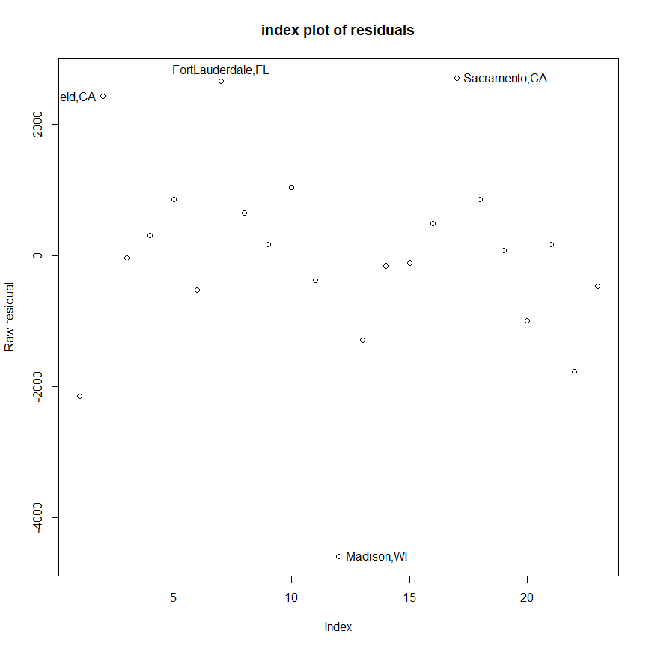

Leverage plot against index

> x1 <- model.matrix(fit1)

> lev1 <- hat(x1)

> plot(lev1, ylab="Leverages",main="index plot of leverages")

> abline(h=2*2/23)

> identify(1:23,lev1, name)

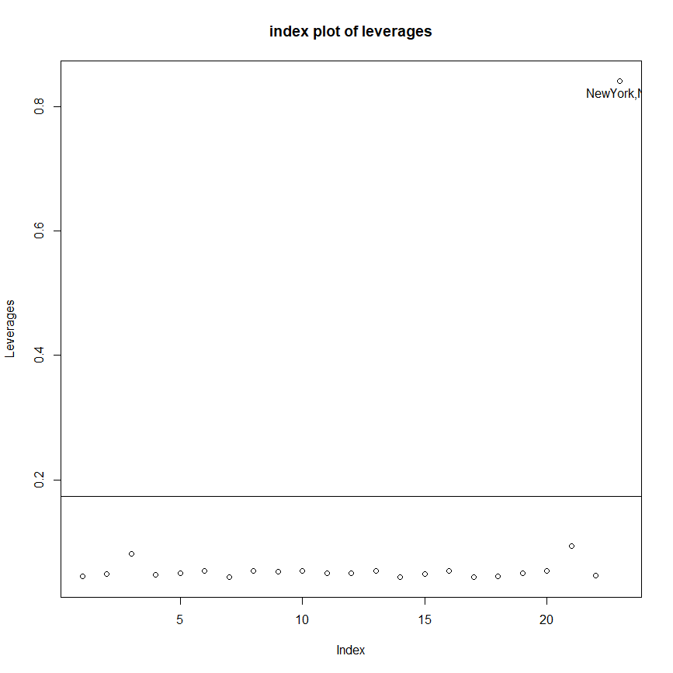

> names(lev1) <- name

> lev1[lev1 > 2*2/23]

NewYork,NY

0.8416482

Studentized residual and Jacknife residual plot against index

> par(mfrow=c(1,2))

> plot(stud1, ylab="Studentized residual", main="index plot of residuals");

> abline(cv1, 0, lty=1);abline(-cv1, 0, lty=1);

> abline(cvBF1, 0, lty=2);abline(-cvBF1, 0, lty=2);

> legend(1, -2, legend=c("raw critical value", "Bonferroni critical value"), lty=1:2, cex=0.8)

> identify(1:23,stud1, name)

> plot(jack1, ylab="Jacknife residual", main="index plot of residuals");

> abline(cv1, 0, lty=1);abline(-cv1, 0, lty=1);

> abline(cvBF1, 0, lty=2);abline(-cvBF1, 0, lty=2);

> legend(1, -2, legend=c("raw critical value", "Bonferroni critical value"), lty=1:2, cex=0.8)

> identify(1:23,jack1, name)

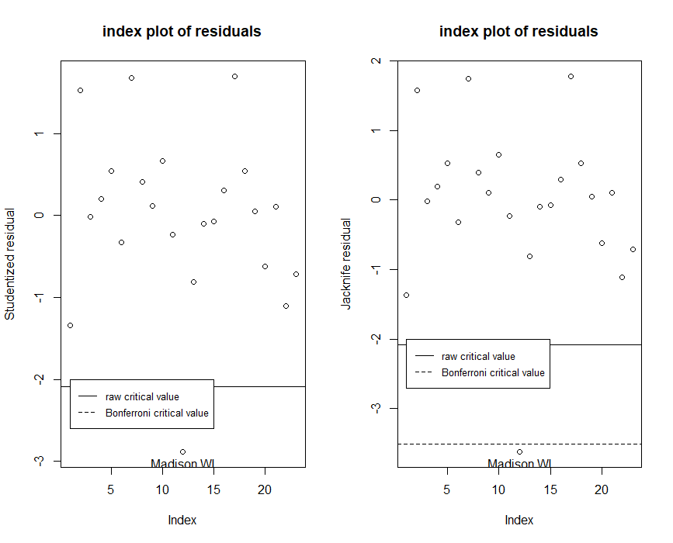

Cook statistics against index

> par(mfrow=c(1,1))

> cook1 <- cooks.distance(fit1)

> plot(cook1, ylab="Cooks distance")

> identify(1:23,cook1,name)

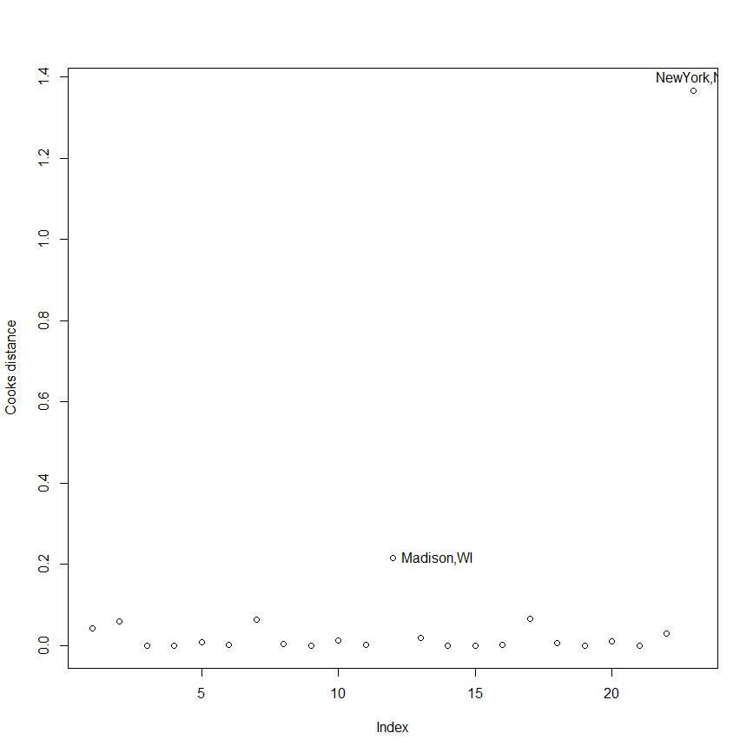

Influence of leave-out-one coefficients

> inf1 <- lm.influence(fit1)

> par(mfrow=c(1,2))

> plot(inf1$coefficients[,2]) # population

> abline(0, 0)

> identify(1:23, inf1$coefficients[,2], name)

> plot(inf1$sigma)

> identify(1:23, inf1$sigma, name)

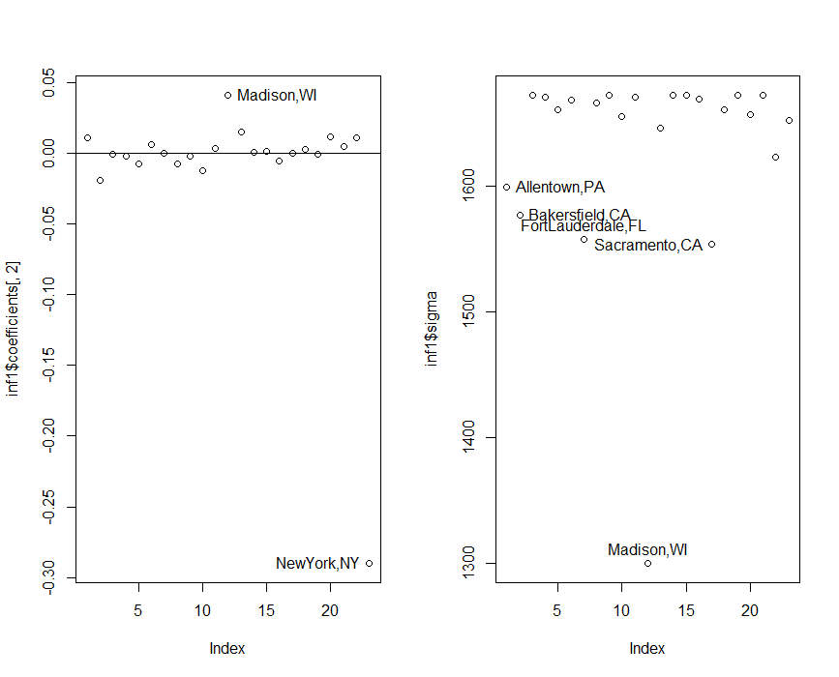

Summary of diagnostics on fit1

|  |  |  |  |  |  |  |  |  |  |  |  |  |  |
| --- | --- | --- | --- | --- | --- | --- | --- | --- | --- | --- | --- | --- | --- |
|  | | NewYork,NY | | Madison,WI | | Sacramento,  CA | | FortLauderdale,  FL | | Bakersfield,  CA | | Allentown,PA | |
| large leverage | | * | |  | |  | |  | |  | |  | |
| studentized residual | |  | |  | |  | |  | |  | |  | |
| jacknife residual | |  | | * | |  | |  | |  | |  | |
| Cook stat. | | ** | | * | |  | |  | |  | |  | |
| diff. in LO1 coef. (population) | | ** | | * | |  | |  | |  | |  | |
| change in LO1 sigma | |  | | ** | | * | | * | | * | | * | |

We would like to fit a model without observations of NewYork,NY and Madison,WI judging by the diagnostics, the new model will then be:

> fit11 <- lm(property ~ population, subset=(name!="NewYork,NY" & name!="Madison,WI"))

> summary(fit11)

Call:

lm(formula = property ~ population, subset = (name != "NewYork,NY" &

name != "Madison,WI"))

Residuals:

Min 1Q Median 3Q Max

-2380.96 -632.54 -91.44 509.00 2413.32

Coefficients:

Estimate Std. Error t value Pr(>|t|)

(Intercept) 5323.0265 375.4223 14.179 1.48e-11 ***

population 0.3462 0.3591 0.964 0.347

---

Signif. codes: 0 ‘***’ 0.001 ‘**’ 0.01 ‘*’ 0.05 ‘.’ 0.1 ‘ ’ 1

Residual standard error: 1319 on 19 degrees of freedom

Multiple R-squared: 0.04663, Adjusted R-squared: -0.003546

F-statistic: 0.9293 on 1 and 19 DF, p-value: 0.3471

Compared with the original

> summary(fit1)

Call:

lm(formula = property ~ population)

Residuals:

Min 1Q Median 3Q Max

-4595.2 -493.9 81.8 753.6 2713.7

Coefficients:

Estimate Std. Error t value Pr(>|t|)

(Intercept) 5198.4645 387.2227 13.425 8.95e-12 ***

population 0.1728 0.1802 0.959 0.348

---

Signif. codes: 0 ‘***’ 0.001 ‘**’ 0.01 ‘*’ 0.05 ‘.’ 0.1 ‘ ’ 1

Residual standard error: 1633 on 21 degrees of freedom

Multiple R-squared: 0.04196, Adjusted R-squared: -0.003662

F-statistic: 0.9197 on 1 and 21 DF, p-value: 0.3485

The coefficient of the predictor “population” has about 100.35% of difference and the range of residual reduces.

Regress violent crime rate on property crime rate

> fit2 <- lm(violent ~ property)

Raw residual plot against index

> plot(fit2$res, ylab="Residual", main="index plot of residuals")

> identify(1:23,fit2$res, name)

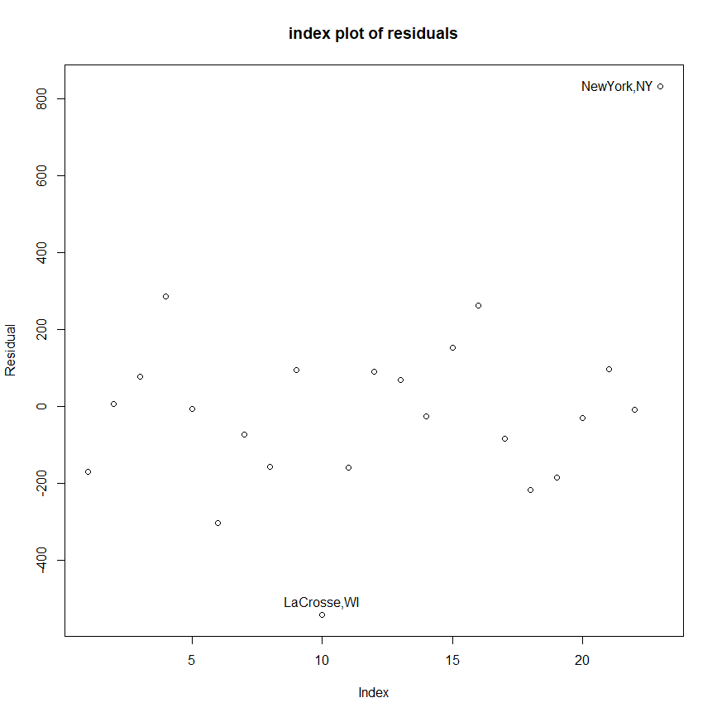

Leverage plot against index

> x2 <- model.matrix(fit2)

> lev2 <- hat(x2)

> plot(lev2, ylab="Leverages",main="index plot of leverages")

> abline(h=2*2/23)

> names(lev2) <- name

> lev2[lev2 > 2*2/23]

Madison,WI

0.4240726

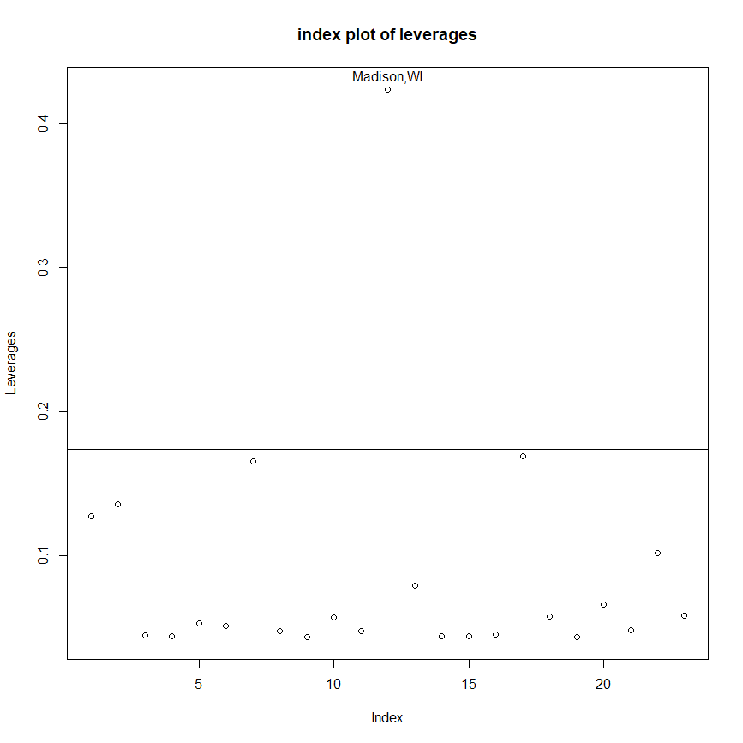

Studentized residual and Jacknife residual plot against index

> par(mfrow=c(1,2))

> plot(stud2, ylab="Studentized residual", main="index plot of residuals");

> abline(cv2, 0, lty=1);abline(-cv2, 0, lty=1);

> abline(cvBF2, 0, lty=2);abline(-cvBF2, 0, lty=2);

> legend(1, 3, legend=c("raw critical value", "Bonferroni critical value"), lty=1:2, cex=0.8)

> identify(1:23,stud2, name)

> plot(jack2, ylab="Jacknife residual", main="index plot of residuals");

> abline(cv2, 0, lty=1);abline(-cv2, 0, lty=1);

> abline(cvBF2, 0, lty=2);abline(-cvBF2, 0, lty=2);

> legend(1, 3, legend=c("raw critical value", "Bonferroni critical value"), lty=1:2, cex=0.8)

> identify(1:23,jack2, name)

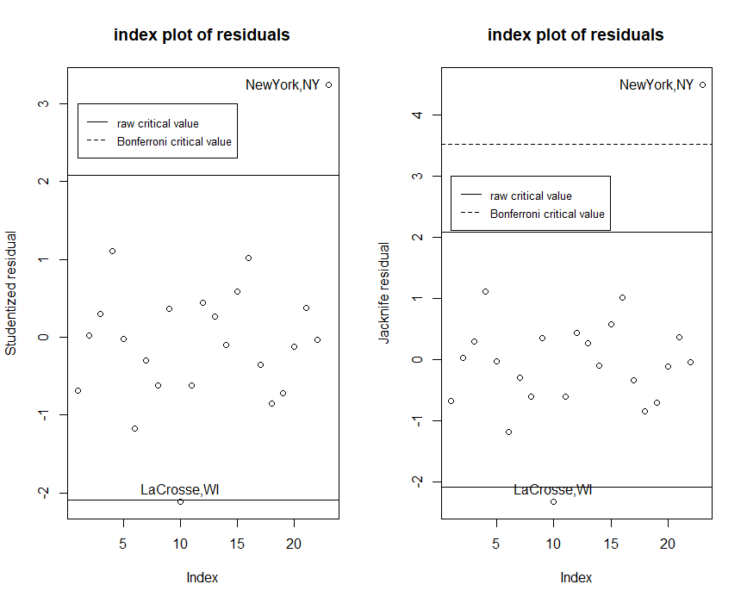

Cook statistics against index

> cook2 <- cooks.distance(fit2)

> plot(cook2, ylab="Cooks distance")

> identify(1:23,cook2,name)

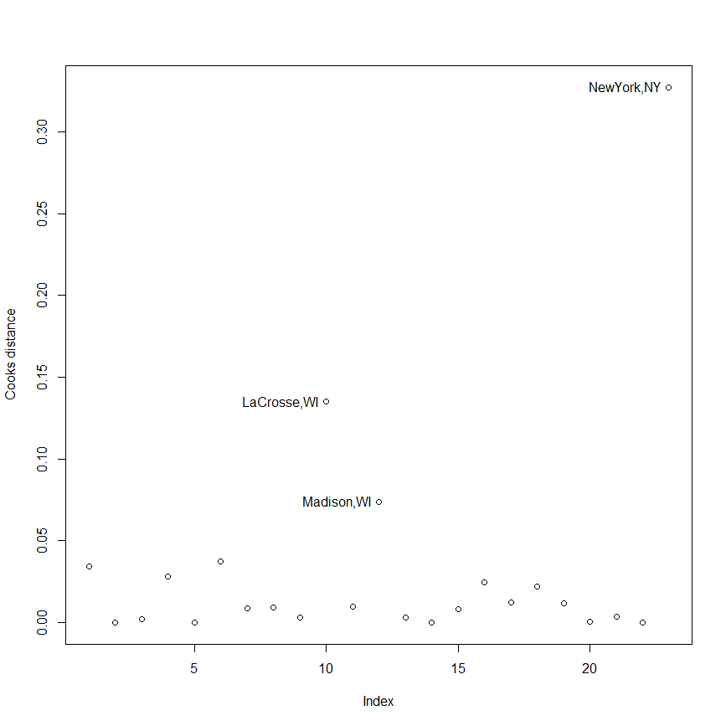

Influence of leave-out-one coefficients

> par(mfrow=c(1,2))

> plot(inf2$coefficients[,2]) # property

> abline(0, 0)

> identify(1:23, inf2$coefficients[,2], name)

> plot(inf2$sigma)

> identify(1:23, inf2$sigma, name)

> par(mfrow=c(1,1))

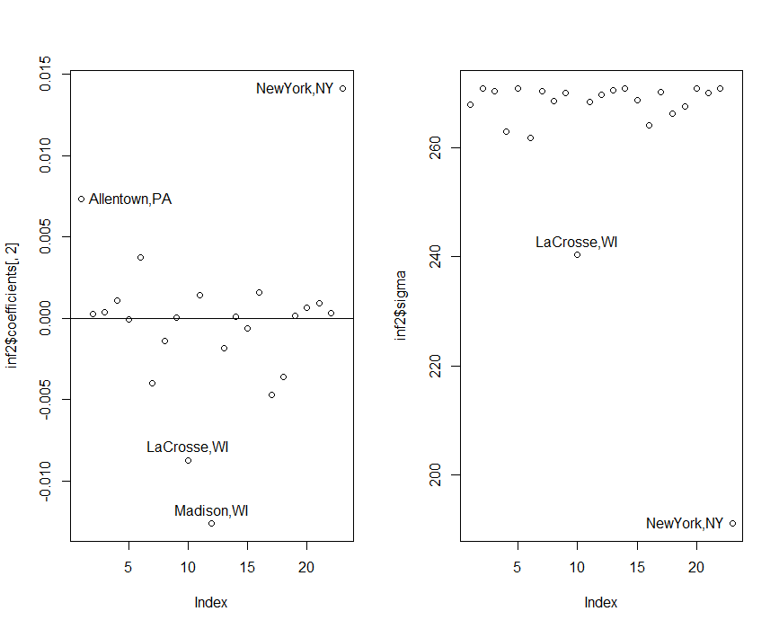

Summary of diagnostics on fit2

|  |  |  |  |  |  |  |  |  |  |
| --- | --- | --- | --- | --- | --- | --- | --- | --- | --- |
|  | | Madison,WI | | NewYork,NY | | LaCrosse,WI | | Allentown,PA | |
| large leverage | | ** | |  | |  | |  | |
| studentized residual | |  | | * | | * | |  | |
| jacknife residual | |  | | ** | | * | |  | |
| Cook stat. | | * | | ** | | * | |  | |
| diff. in LO1 coef. (property) | | * | | ** | | * | | * | |
| change in LO1 sigma | | * | | ** | |  | |  | |

With the result of diagnostics for both fit1 and fit2, we have strong confidence to state that the observations of “NewYork,NY” and “Madison,WI” are outliers to this dataset.

Regression of violent crime rate against property crime rate and population

> fit3 <- lm(violent ~ property + population)

Raw residual plot against index

> plot(fit3$res, ylab="Residual", main="index plot of residuals")

> identify(1:23,fit3$res, name)

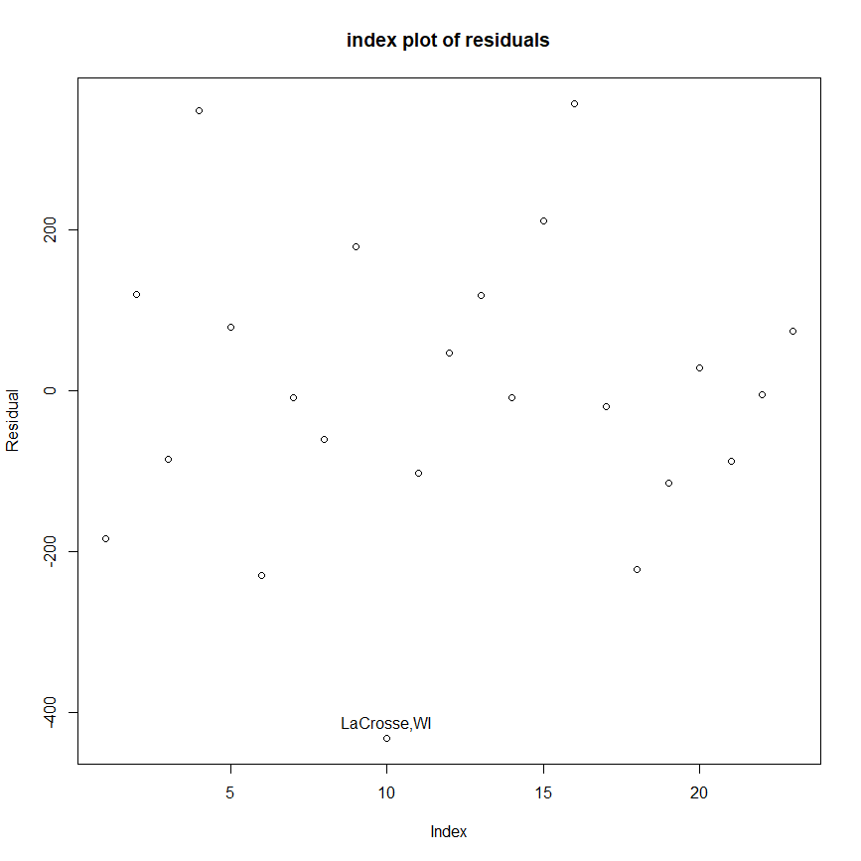

Leverage plot against index

> plot(lev3, ylab="Leverages",main="index plot of leverages")

> abline(h=2*3/23)

> identify(1:23, lev3, name)

> names(lev3) <- name

> lev3[lev3 > 2*3/23]

Madison,WI NewYork,NY

0.4265893 0.8455262

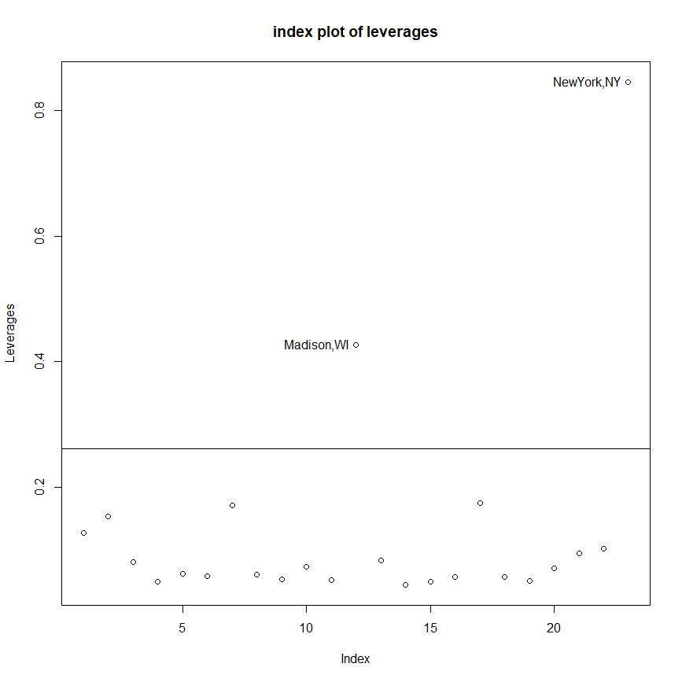

Studentized residual and Jacknife residual plot against index

> cv3 <- qt(0.05/2, 23-3-1)

> cvBF3 <- qt(0.05/(23*2), 23-3-1)

> stud3 <- rstandard(fit3)

> jack3 <- rstudent(fit3)

> par(mfrow=c(1,2))

> plot(stud3, ylab="Studentized residual", main="index plot of residuals");

> abline(cv3, 0, lty=1);abline(-cv3, 0, lty=1);

> abline(cvBF3, 0, lty=2);abline(-cvBF3, 0, lty=2);

> legend(1, -1.5, legend=c("raw critical value", "Bonferroni critical value"), lty=1:2, cex=0.8)

> identify(1:23,stud3, name)

> plot(jack3, ylab="Jacknife residual", main="index plot of residuals");

> abline(cv3, 0, lty=1);abline(-cv3, 0, lty=1);

> abline(cvBF3, 0, lty=2);abline(-cvBF3, 0, lty=2);

> legend(1, -1.3, legend=c("raw critical value", "Bonferroni critical value"), lty=1:2, cex=0.8)

> identify(1:23,jack3, name)

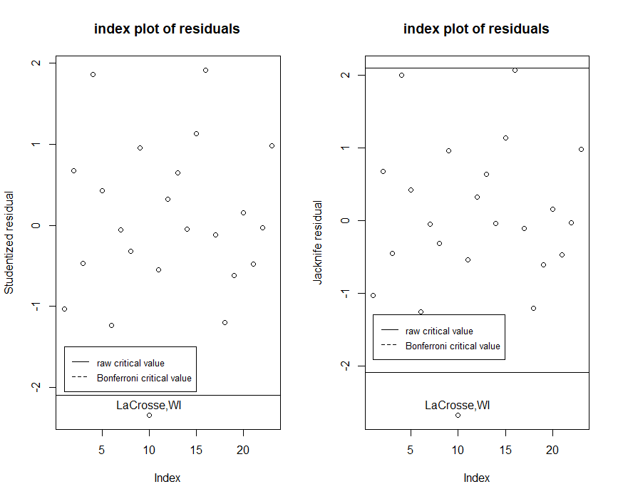

Cook statistics against index

> par(mfrow=c(1,1))

> cook3 <- cooks.distance(fit3)

> plot(cook3, ylab="Cooks distance")

> identify(1:23,cook3,name)

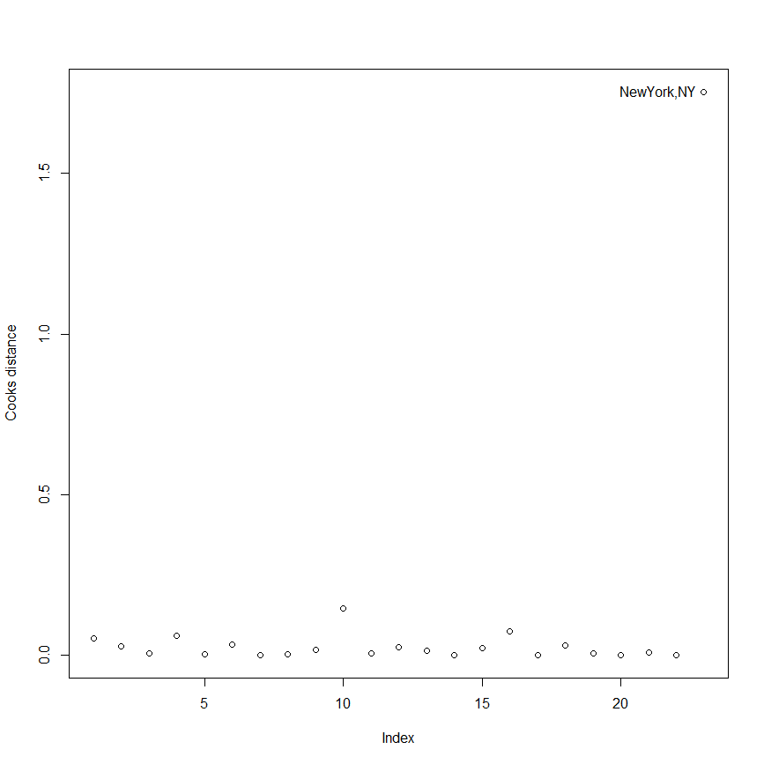

Influence of leave-out-one coefficients

> inf3 <- lm.influence(fit3)

> par(mfrow=c(1,2))

> plot(inf3$coef[,2],inf3$coef[,3],xlab="change in property coef", ylab="change in population coef")

> identify(inf3$coef[,2],inf3$coef[,3],name)

> plot(inf3$sigma)

> identify(1:23, inf3$sigma, name)

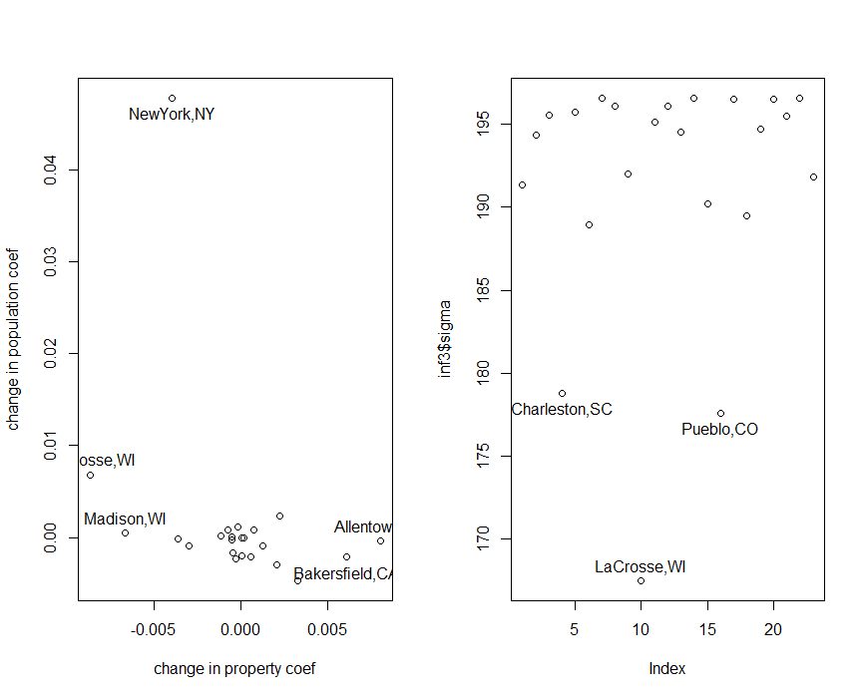

Summary of diagnostics on fit3

|  |  |  |  |  |  |  |  |  |  |  |  |
| --- | --- | --- | --- | --- | --- | --- | --- | --- | --- | --- | --- |
|  | | Madison,WI | | NewYork,NY | | LaCrosse,WI | | Allentown,PA | | Bakersfield,CA | |
| large leverage | | * | | ** | |  | |  | |  | |
| studentized residual | |  | |  | | * | |  | |  | |
| jacknife residual | |  | |  | | * | |  | |  | |
| Cook stat. | |  | | ** | |  | |  | |  | |
| diff. in LO1 coef. (property) | | * | | * | | * | | * | | * | |
| diff. in LO1 coef. (population) | |  | | ** | | * | |  | |  | |
| change in LO1 sigma | |  | |  | | ** | |  | |  | |

change in LO1 sigma: Charleston,SC *, Pueblo,CO *

With this model, we may say that the observations of “NewYork,NY” and “LaCrosse,WI” are outliers.

2.

> gala <- read.table("C:/Users/Thomas/Downloads/Linear_models/hw6/E3.7.txt", header=T)

> y <- gala[,7]

> x1 <- gala[,2]

> x2 <- gala[,3]

> x3 <- gala[,4]

> x4 <- gala[,5]

> x5 <- gala[,6]

(a)

> fit1 <- lm(y ~ x1 + x2 + x3 + x4 + x5)

Q-Q plot

> qqnorm(fit1$res, ylab="raw residuals")

> qqline(fit1$res)

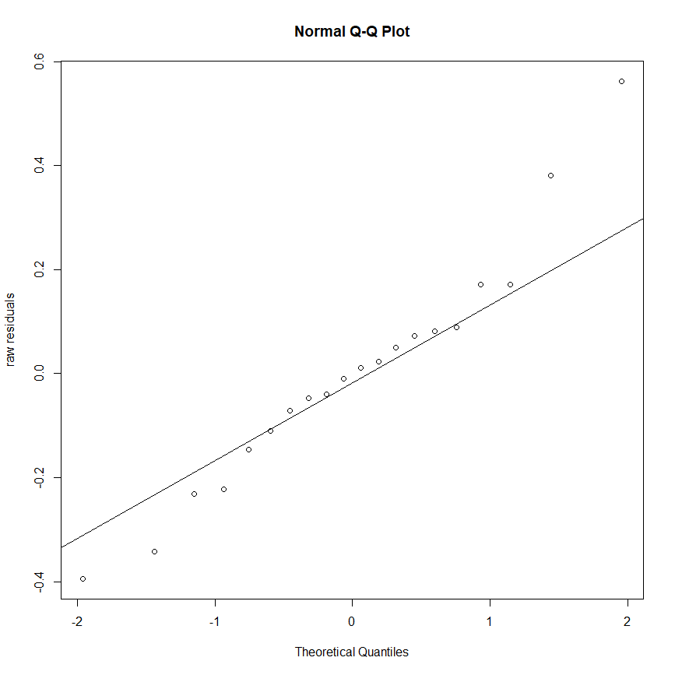

Histogram

> hist(fit1$residuals, breaks=20)

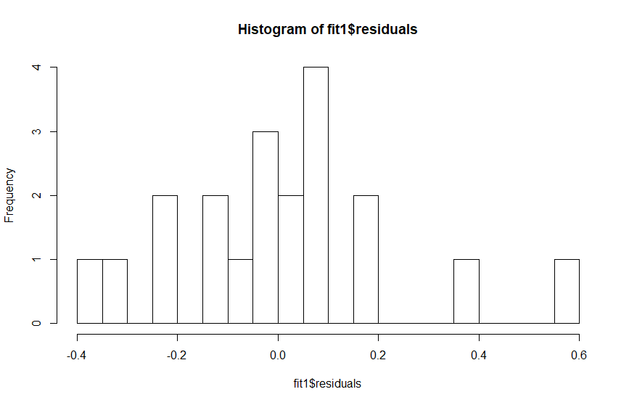

We can see that the low raw residuals are slightly below the line and the high raw residuals are above the line more obviously. This residual distribution is slightly heavy-tailed.

To identify the outlier, we can go through the same procedure in 1.

Laverage

> lev1[lev1 > 2*6/20]

17

0.9182393

Studentized residual and Jacknife residual plot against index

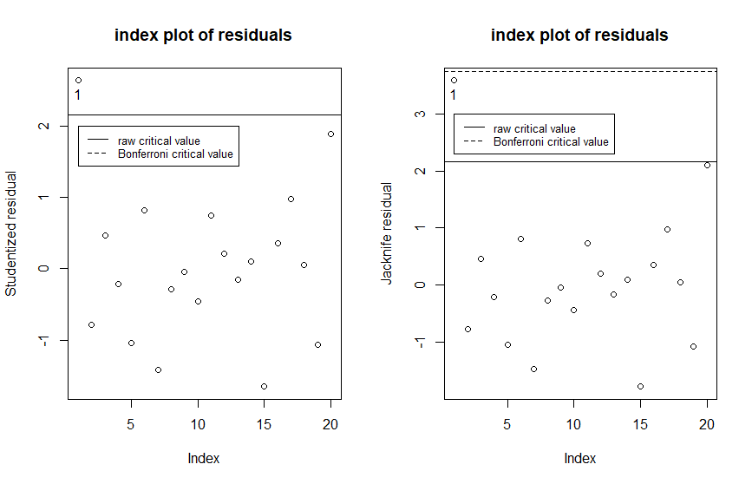

Cook statistics against index

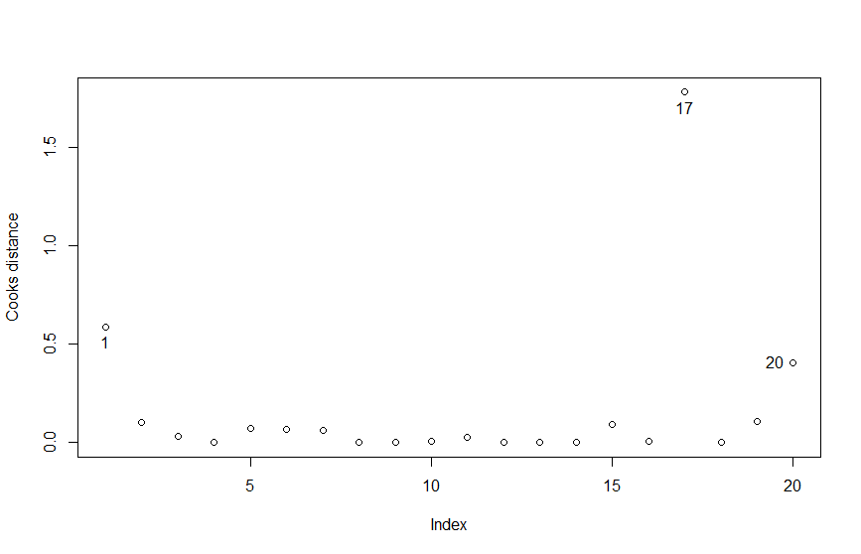

Influence of leave-out-one coefficients

Difference of coefficients for all predictors except “x4” are at a 1e-4 ~ 1e-5 scale, thus omitted.

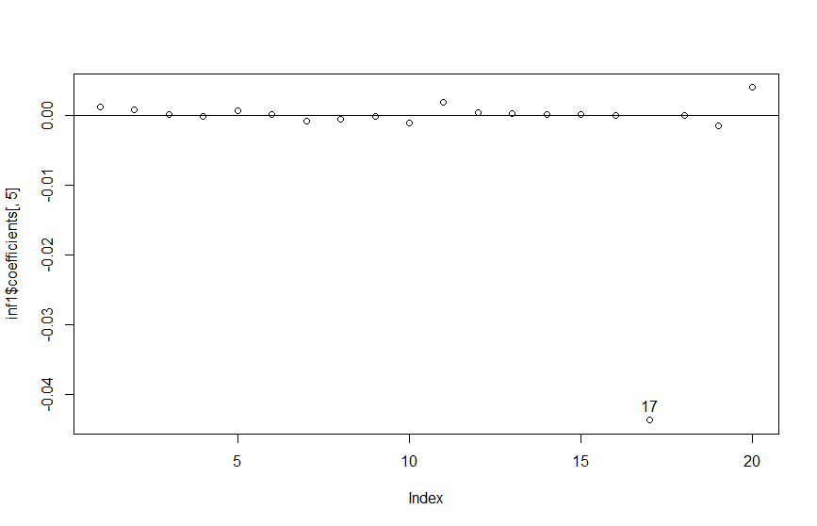

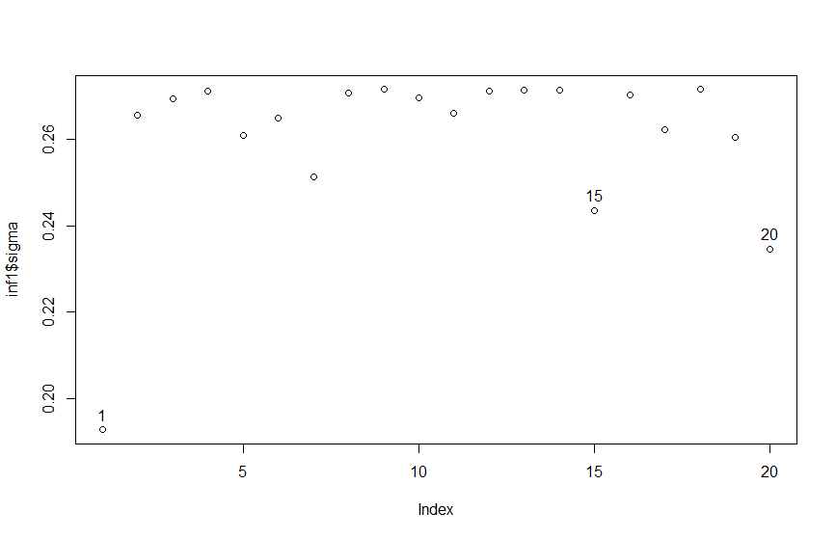

From the result of diagnostics, we may conclude the observation with index 1, 17 and 20 have greater chance of being an outlier.

(b)

> fit2 <- lm(y ~ x3 + x5)

Q-Q plot

> qqnorm(fit2$res, ylab="raw residuals")

> qqline(fit2$res)

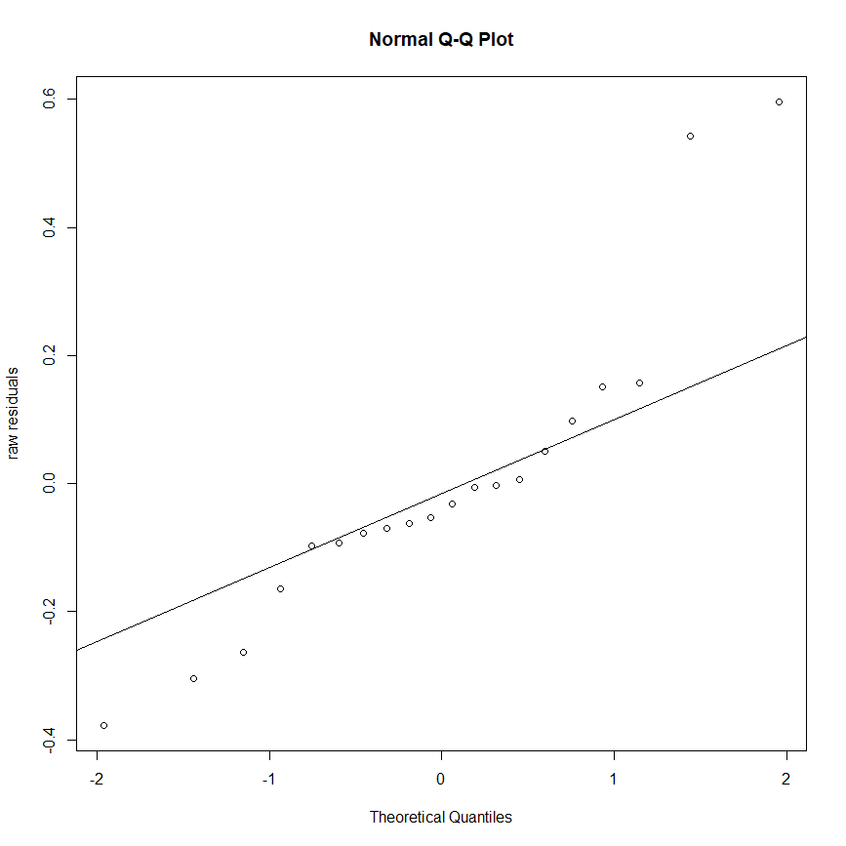

Histogram

> hist(fit2$residuals, breaks=20)

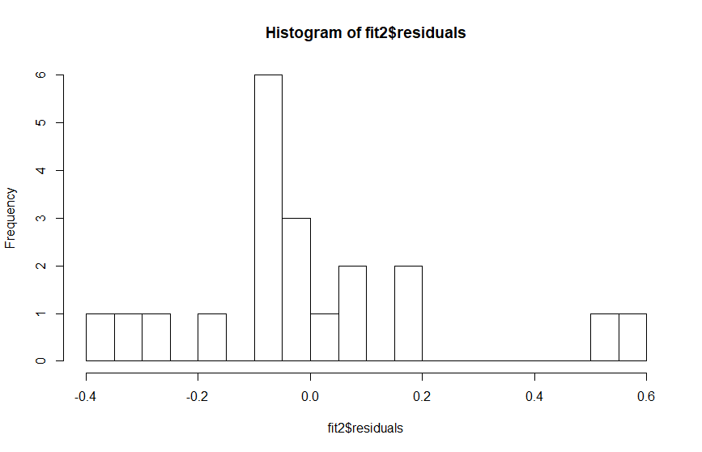

For the distribution of residuals, we can more confidently conclude that it is heavy-tailed from both Q-Q plot and histogram.

Conducting the diagnostics

Leverage

> lev2[lev2 > 2*3/20]

1 2 3

0.3261141 0.3435349 0.4479746

Studentized residual and Jacknife residual plot against index

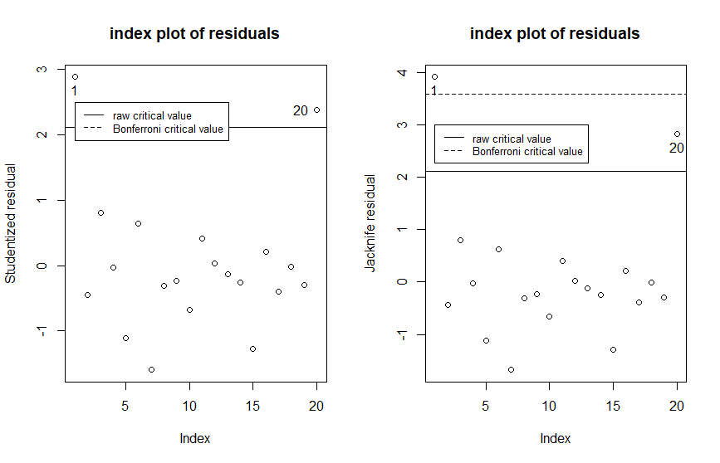

Cook statistics against index

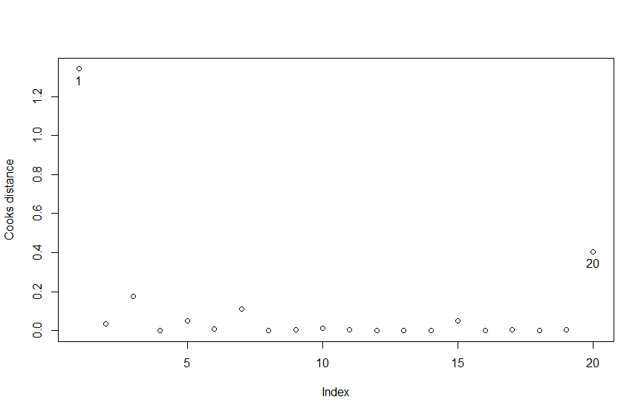

Influence of leave-out-one coefficients

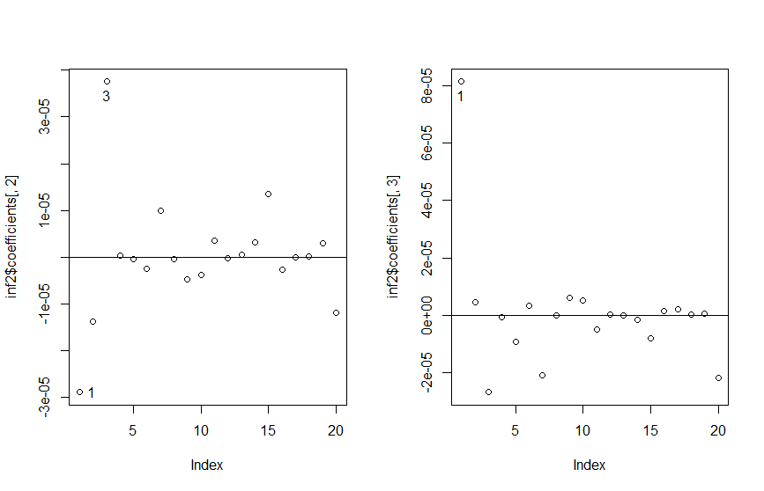

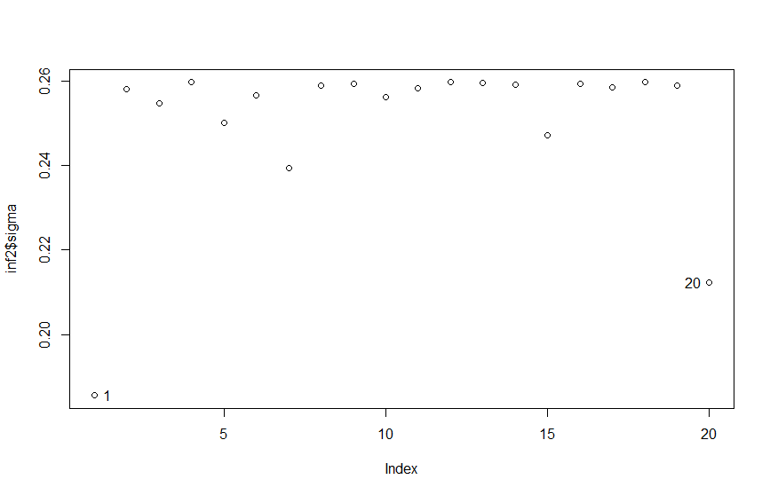

For this model, we can more confidently state that observation with index 1 and 20 are outliers.

3.

> gala <- read.table("C:/Users/Thomas/Downloads/Linear_models/hw6/acc.txt", header=T)

# ACC: acceleration of different vehicles.

# WHP: weight-to-horsepower ratio.

# SP: the speed at which they were traveling.

# G: the grade, G=0 implies the road was horizontal.

(a)

> fit1 <- lm(ACC ~ WHP + SP + G, data=gala)

> mean(fit1$residuals^2) # MSE

[1] 1.988278

Residual against ACC-hat

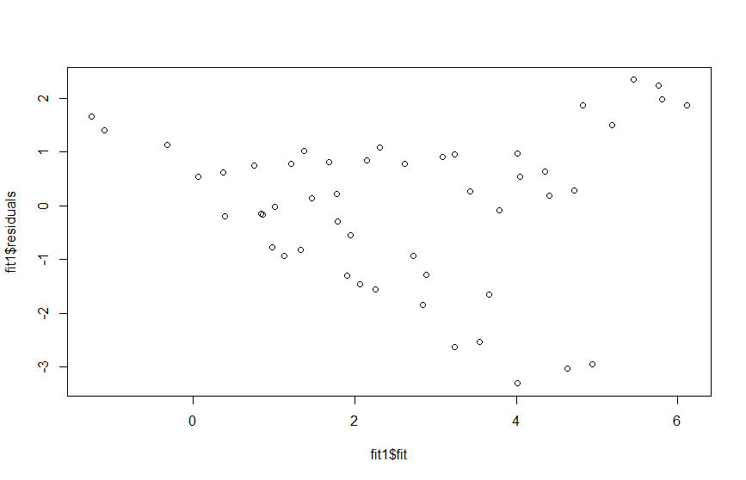

Partial residual plots

> prplot(fit1, 1)

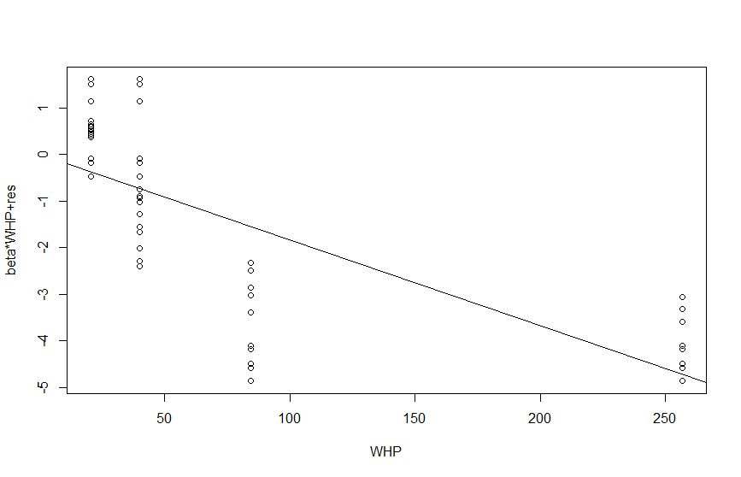

> prplot(fit1, 2)

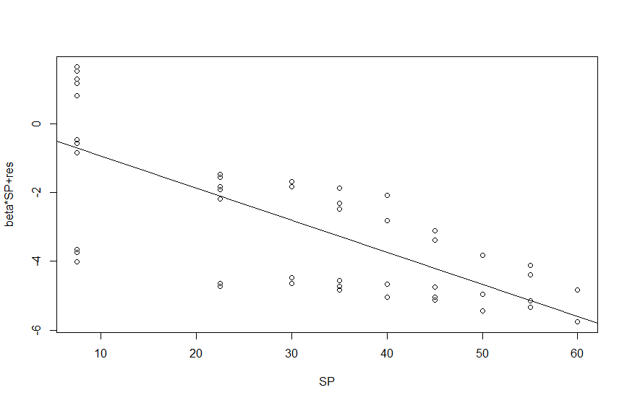

> prplot(fit1, 3)

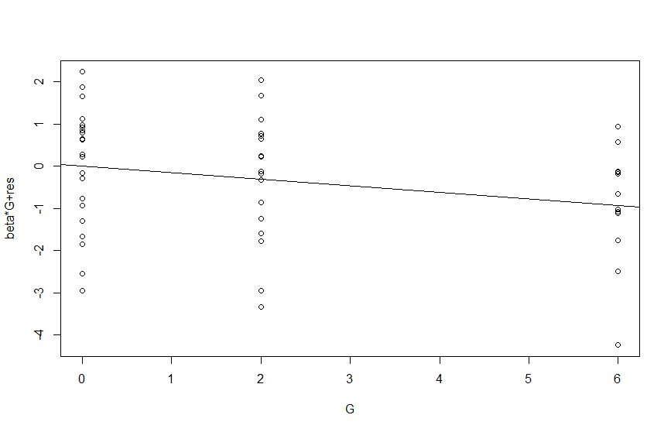

We can observe some kind of curvature of predictor “WHP”’s residual and a decreasing trend of variance for predictor “SP”. We might need to adjust our model to obey the constant variance assumption.

(b)

The best model as far as I can found is transforming the response by taking a square root and reciprocal, and adding a squared term of predictor “WHP”. It successfully eliminated the curvature in “WHP”’s partial residual and the variance of residual for “SP” is much uniform.

> ACCrec <- 1/ACC

> ACCrecsqrt <- ACCrec^0.5

> WHPsq <- WHP^2

> fitop <- lm(ACCrecsqrt ~ WHP + WHPsq + SP + G)

> mean(fitop$residuals^2) # MSE

[1] 0.05860664

Partial residual plots

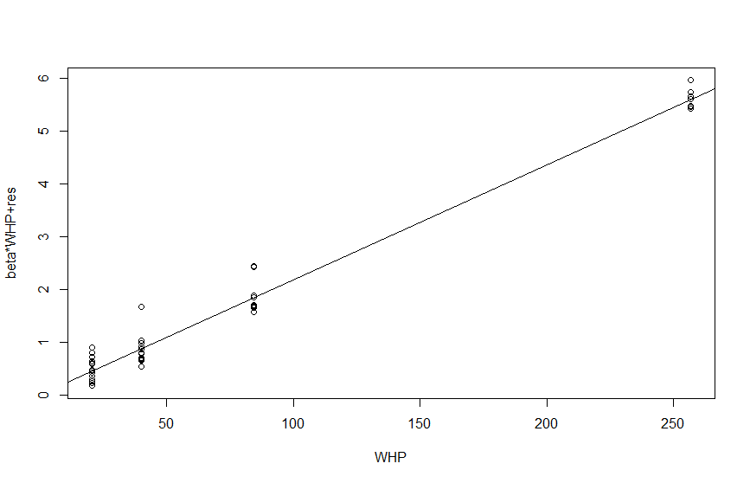

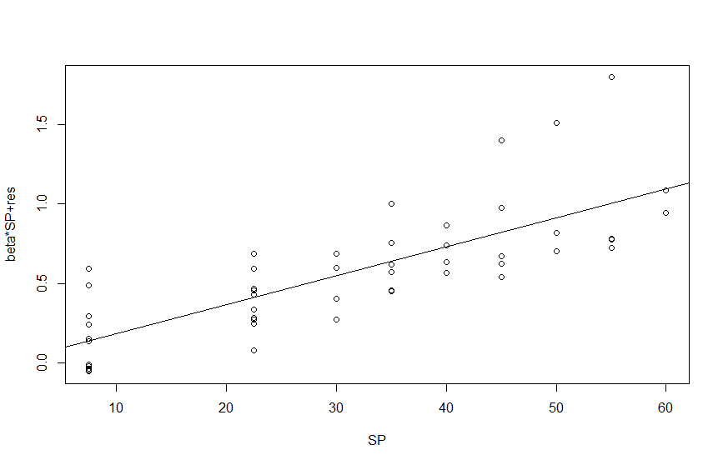

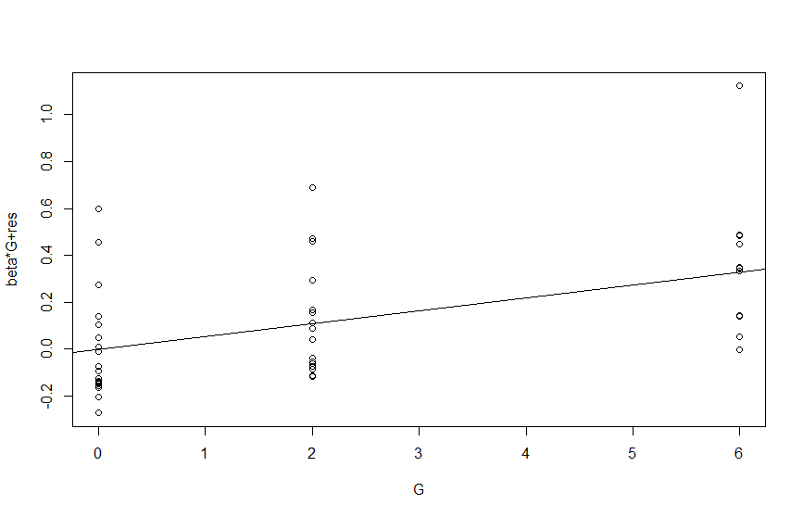

(c)

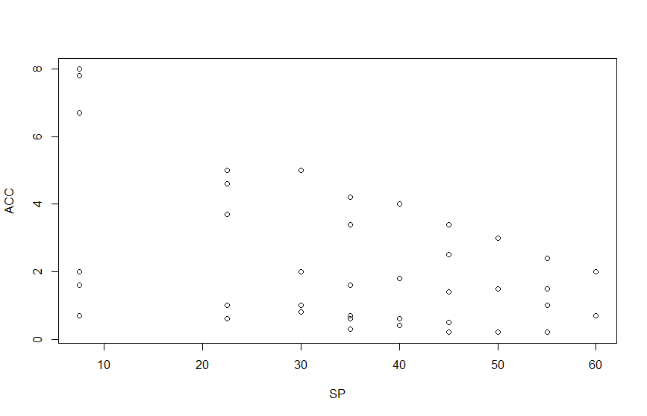

We can see that in the ACC plot against SP, there are lots of replicates. From the replicates we can roughly see the pure error is decreasing along with the mean. Therefore, when we fit a model, the residual will reveal the heteroscedasticity.