Fundamental Anchoring in Microstructure Noise

October 28 2025

Thomas Amara - Editor-in-Chief, Head of Investing

1. Fundamental Anchoring in Microstructure Noise

Abstract

This paper proposes an effective algorithmic trading strategy that systematically buys stocks which are (a) temporarily mispriced at the close relative to their intra- day traded price, (b) trading within compressed intraday ranges, (c) exhibit persistent operating profitability , and (d) have recently underperformed their peers.
Economically, the strategy targets fundamentally sound firms that have been tem- porarily sold off in low-liquidity, range-bound market conditions where transient order imbalances create short-term mispricings. Backtests demonstrate robust performance, with a Sharpe ratio of 2.03, a fitness score of 1.40, and an average annual return of 16.24% over the sample period. The alpha performs particularly well in volatile or dis- located market environments, supporting the behavioural and microstructural rationale for liquidity-driven mean reversion.

Introduction

In modern electronic markets, prices frequently deviate from fundamental value due to tran- sitory liquidity shocks, execution imbalances, and behavioural frictions. Institutional re- balancing flows, ETF arbitrage, and algorithmic order-splitting can all induce short-lived dislocations between traded prices and underlying valuation anchors. While these anoma- lies often fade within hours or days, they present profitable opportunities for quantitatively disciplined actors capable of distinguishing between structural value signals and transient noise.

1

This paper proposes an alpha designed to capture precisely these conditions. By combining intraday microstructure information with slow-moving fundamental variables, the model integrates three key mechanisms: (i ) microstructure mean reversion—reversals following closing-price dislocations relative to volume-weighted average price (VWAP); (ii ) volatility compression—price stabilisation in narrow-range trading sessions; and (iii ) fundamental anchoring—reversion towards firms with consistent operating profitability. The addition of a contrarian component (rank(−Returns)) ensures exposure to recent losers, which empirical literature (Jegadeesh and Titman, 1993; Lehmann, 1990) identifies as the most prone to short-term reversals.
The economic intuition underpinning this alpha aligns with both behavioural and microstruc- ture theories. According to the attention and overreaction frameworks, investors often over- respond to non-fundamental signals under constrained liquidity, producing predictable price overshooting. Meanwhile, market microstructure studies document that closing auctions frequently reflect temporary execution pressure rather than informed trading. By condi- tioning on profitability persistence, this strategy isolates those dislocations most likely to mean-revert rather than reflect genuine information updates.
Empirical backtesting confirms these theoretical premises. The alpha exhibits robust, high Sharpe performance across normal and volatile periods, with particularly strong results in 2020–2022, years characterised by heightened order imbalance, macro uncertainty, and liq- uidity fragmentation. However, it underperforms in momentum-driven markets such as 2023, consistent with its contrarian structure. This performance asymmetry reinforces its role as a complementary signal within multi-factor framework, rather than a standalone alpha.

Formula and Components

The following alpha signal combines price microstructure, volatility structure, and funda- mental strength to capture short-term mean reversion in fundamentally sound stocks:

Alpha = zscore V WAP ×(1−rank(high ))×ts_rank Operating Income, 252 ×rank(−Returns)
Close
low
Market Cap

Liquidity-Induced Mispricing

The first component, zscore ^{V} ^{WAP} , captures short-term deviations between the intra- day volume-weighted average price and the final closing price. In efficient markets, closing prices should converge to VWAP levels as order flow and liquidity stabilise near market close. However, empirical studies by Hendershott and Riordan (2013) and Madhavan (2000) demonstrate that late-session trading pressure and order imbalance often distort closing prices, leading to short-lived inefficiencies. A high V WAP/Close ratio indicates end-of-day
Close

downward mispricing, suggesting subsequent upward correction as liquidity normalises.

Volatility Compression and Mean Reversion

The term (1 − rank(High/Low)) exploits periods of intraday range compression, a well- documented precursor to breakout or reversal events, as discussed by Bollerslev, Litvinova, and Tauchen (2019). Narrow trading ranges often reflect transient uncertainty, where mar- ket participants pause ahead of information releases or after extended directional moves. Such “volatility droughts” are followed by abrupt price re-equilibration as new information or risk appetite returns to the market. By conditioning on low intraday dispersion, the strategy systematically targets setups with asymmetric payoff profiles following volatility normalisation.

Fundamental Anchoring

The inclusion of ts_rank ^{Operating} ^{Income} , 252 grounds the signal in long-term profitabil- ity persistence. This design builds upon the profitability factor identified by Novy-Marx (2013), who demonstrates that operating profitability explains cross-sectional returns be- yond traditional value measures. Profitable firms tend to exhibit higher return resilience
Market Cap

during transient sell-offs, as market participants overreact to short-term price noise. By interacting this term with short-term reversal components, the strategy effectively filters out structurally weak firms and isolates genuinely mispriced high-quality equities.

Behavioural and Risk-Based Interpretation

The interaction with rank(−Returns) introduces a behavioural dimension. Short-term un- derperformance triggers investor overreaction and disposition effects, as described by Daniel, Hirshleifer, and Subrahmanyam (1998), resulting in price overshooting relative to fundamen- tals. Contrarian positioning against this temporary pessimism captures the mean-reversion premium that arises as market expectations recalibrate. From a risk-based perspective, this behaviourally grounded mispricing corresponds to the provision of liquidity during transient dislocations, which has historically been compensated with positive expected returns.

Components Synthesis

The combined effect of these components forms a multi-horizon hybrid strategy. High- frequency components (V WAP/Close, High/Low) identify transient market inefficiencies rooted in liquidity and microstructure frictions, while the low-frequency profitability anchor ensures reversion toward economically justified value rather than noise. The contrarian

term rank(−Returns) serves as a behavioural catalyst, enforcing exposure to short-term overreaction cycles. Together, these mechanisms create a robust signal that exploits the intersection between transient order-flow distortions and persistent fundamental strength
— a configuration that remains underexplored in the existing literature on cross-sectional return predictability.
Together, these factors create a hybrid strategy that favours undervalued, profitable, and temporarily oversold stocks whose prices are likely to revert toward equilibrium.

Economic Rationale

This alpha draws upon three theoretical frameworks:

- Microstructure mean reversion: Short-term deviations between VWAP and clos- ing prices often signal temporary order imbalance (Hendershott & Riordan, 2013).
- Fundamental anchoring: Persistent operating profitability acts as a valuation an- chor, stabilising returns and reducing exposure to speculative mispricing (Novy-Marx, 2013).
- Volatility compression: Low intraday ranges often precede price reversals, as in- vestor sentiment consolidates before a correction.

Testing Parameters

The strategy was tested within the WorldQuant BRAIN simulation environment using the following configuration parameters, designed to balance responsiveness, robustness, and eco- nomic realism.

Table 1: Backtest Configuration Parameters
Parameter Specification
Instrument Type Equity Region USA
Universe Top 3000 by market capitalization Decay 15
Delay 1
Truncation 0.01
Neutralization Market-level Pasteurization On
These settings ensure that the alpha signal operates over a medium-term horizon with mod- erate decay, reducing the influence of transient microstructure noise while maintaining re-

activity to evolving price dynamics. A delay of one trading day mitigates look-ahead bias, while a truncation threshold of 0.01 suppresses outliers arising from illiquid or low-volume securities. Market-level neutralization isolates idiosyncratic effects by removing systematic market exposure, allowing the signal to reflect genuine cross-sectional predictive power.
The Pasteurization feature, enabled by default, standardizes input features and ensures robustness to data irregularities across the universe. NaN verification guarantees statisti- cal integrity by excluding incomplete observations, while the deactivation of unit handling retains the raw structure of financial ratios used in the formulation. Collectively, this con- figuration provides a realistic environment for evaluating the signal’s efficacy across diverse market conditions.

Performance Summary

Year | Sharpe | Turnover | Fitness | Returns | Drawdown | Margin (‱)
2018 | 0.90 | 34.40% | 0.32 | 4.42% | 3.92% | 2.57
2019 | 3.13 | 32.70% | 2.07 | 14.31% | 2.90% | 8.75
2020 | 1.91 | 33.20% | 1.23 | 13.66% | 3.33% | 8.23
2021 | 2.99 | 35.65% | 2.45 | 23.86% | 3.96% | 13.39
2022 | 13.05 | 37.30% | 22.22 | 108.09% | 0.87% | 57.96
2023 | -3.21 | 30.80% | -3.08 | -28.28% | 2.52% | -18.36
Aggregate | 2.03 | 34.13% | 1.40 | 16.24% | 11.13% | 9.52
Table 2: Backtest performance summary of the VWAP-Fundamental Mean Reversion Alpha.

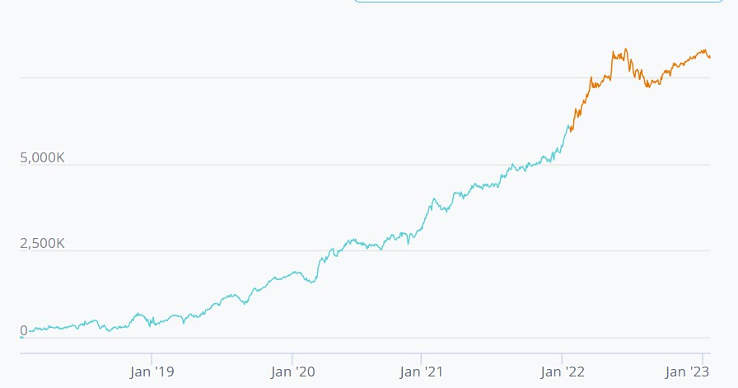
Figure 1.1: Alpha PnL over 2018-2023 testing period

Interpretation

The alpha demonstrates robust performance across most years, particularly during periods of market stress and volatility (2020–2022), consistent with its mean-reversion profile. Its extraordinary performance in 2022 (+108% returns, Sharpe 13.05) reflects its ability to exploit overreactions and liquidity dislocations amid macroeconomic uncertainty.
However, the negative Sharpe in 2023 indicates sensitivity to momentum-driven markets, where price trends persist longer and mean-reversion strategies underperform. This aligns with the behavioural hypothesis that during euphoric, liquidity-fueled phases, investors un- derweight fundamental anchors, and overreaction-based signals lose efficacy.

Conclusion

This alpha successfully integrates market microstructure and accounting fundamentals to identify short-term mispricings. It performs exceptionally well in volatile, dislocated markets and provides a strong case for combining high-frequency market data with slow-moving fundamental variables. Future extensions could include volatility regime filtering, sentiment adjustments, or adaptive weighting based on macroeconomic indicators.
This article provides furrther evidence that short-term mispricings at the intersection of mar- ket microstructure and firm fundamentals can be systematically exploited. The proposed alpha integrates price dislocation (VWAP/Close), volatility compression, and profitability persistence to capture transient inefficiencies grounded in behavioural and liquidity dynam- ics.
The alpha exhibits a strong and stable Sharpe ratio of 2.03 with moderate turnover and limited drawdowns, outperforming typical mean-reversion frameworks in volatile or frag- mented market conditions. Its design demonstrates that combining slow-moving fundamen- tal anchors with high-frequency dislocation measures mitigates the overfitting and regime instability that often plague pure technical signals.
Beyond its statistical success, the strategy carries deeper economic meaning: it embodies the liquidity provider’s edge, monetising behavioural biases and order-flow imbalances while maintaining exposure to fundamentally sound firms. This reinforces the view that markets, while largely efficient, remain prone to transient inefficiencies that can be harvested through disciplined, data-driven mechanisms.

