// Overview

You are a Lanista, an owner and trainer of gladiators in ancient Rome. Your goal is to become the head of the most famous training school in the city. To do this, you must gain glory in the arena and face off against opposing schools.

The game is a deckbuilding game that borrows elements from MTG, Dominion, Ascension, and Star Realms. The focus is on managing risk and anticipating actions your opponent will make and making sure you have a reaction to it.

Players: 2-4

// Layout

In the center of the playing area there is a row of cards that come from a single deck. These cards could be gladiators to hire, animals to defeat, or various kinds of actions. Some of these cards will go into a players’ deck upon being acquired and others have a one-time effect.

Each player has two rows of cards. The first, which is closest to the center row, is used for combatants. Combatants in this row in the arena and remain between turns. The second row, which is closer to the player, is used for action cards played during the turn and any non-combatant cards that may be played. Most of these cards are discarded at the end of each turn. These rows are to differentiate the different card types.

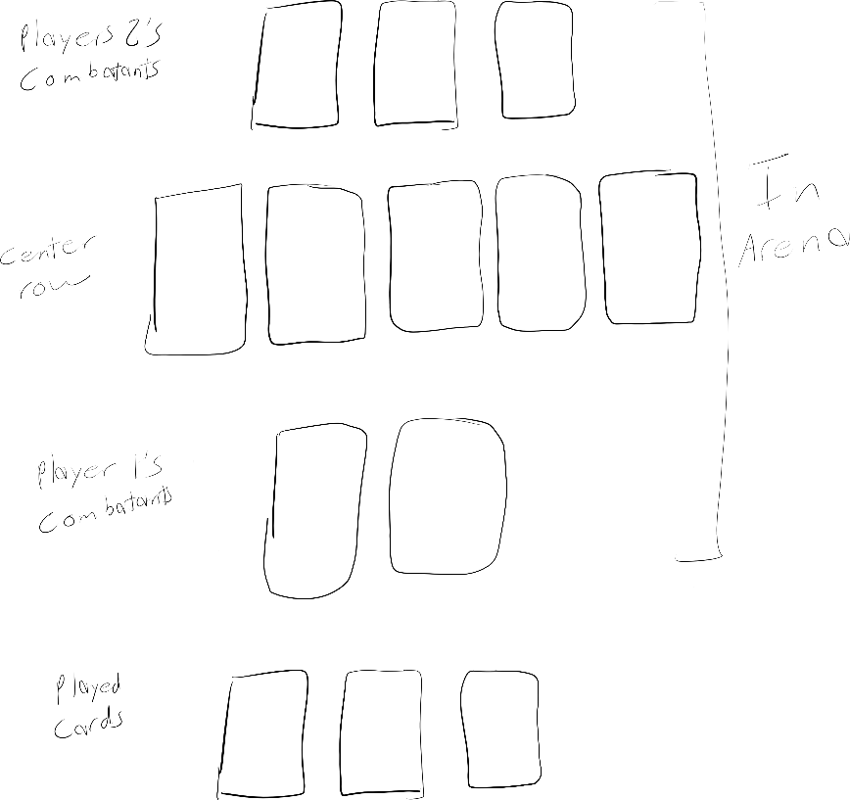

// Setup

Deal each player fame cards equaling 30 fame.

Deal each player 7 Servus cards and 3 Tiro cards.

Shuffle the center deck and reveal the top 5 cards.

// Objective

The goal of the game is to reduce all opponents’ fame to 0 before they do it to you.

// Play

Stages of a turn:

* Draw
* Act
* Buy
* Discard

// Draw

At the beginning of their turn, players draw up to 5 cards, but cannot draw to have more than 7 cards. If a player already has 7 or more cards, they may not draw at the beginning of their turn.

// Act

During this stage, players may do the following in any order:

* Play action cards
* Fight neutral and enemy combatants
* Buy cards from the middle

// Playing actions

When an action card is played, lay it in front of you so that all players may see the card.

Resolve the effects of the card in order from top to bottom before playing another card.

Combatant cards played are placed in

// Fighting

See the combat section.

// Buying

To buy cards, players must play cards that give a cumulative gold amount equal or greater to the cards bought.

Cards have +x gold in their description when they contribute to a players buying power.

Once enough cards have been played, players may take the card(s) bought from the center row and place them at the bottom of their deck.

// Discard

At the end of their turn, players discard all action cards they played during the turn.

Unless otherwise stated, combatant cards played are not discarded at the end of the turn. They are considered to be in the arena and must fight until they are released or defeated.

Players can keep cards for their next turn, but in order to do so they must discard a card for each card kept.

// Types of cards

Most of the cards in the game are combatants and actions, but there are other type(s):

* Combatants
  + Can be bought from the center row.
  + Can be used to defeat neutral combatants or fight enemy gladiators.
  + Once in the arena, they can be defeated by enemy combatants and are vulnerable to effects and actions.
* Neutral combatants
  + Represent animals and neutral gladiators that can be fought in the arena. You can defeat them by sending your gladiators into the arena.
* Actions
  + These actions modify the state of the game in some small way, such as granting or revoking fame from a player or placing effects upon combatants in the arena.
  + Can be purchased from the center row.

// Combat

Combat runs similar to MTG, but units rely on a single power stat rather than defense and attack. The power stat denotes both how much damage a unit can deal and how much they can take.

This system is predictable and does not rely on chance at all. You can easily tell by looking at two units which is better, though other cards and effects can change that.

There are several unit types or fighting styles. Each combatant uses one of these styles and each style has a disadvantage or advantage to certain other fighting styles, similar to rock, paper, scissors.

For instance, swordsmen have an advantage to spearmen, and so on.

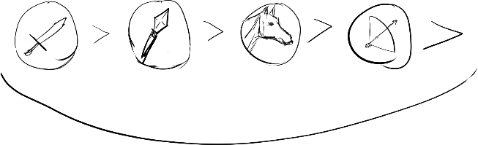

Unlike rock paper scissors, though, this advantage does not guarantee that a sword will defeat a spear. The combatant with the advantage has +1 power for the duration of the fight.

For example, a sword combatant with a power of 2 is equal to a spear combatant with a power level of 3.

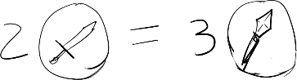

Combat takes place during the act stage of a players’ turn. When a player attacks, they first choose the combatant(s) they are attacking and then play however many combatant cards they wish to attack with or attack with combatants already in the arena. If the power of the attacking combatants is greater than or equal to the power of the defending combatants, the defenders are defeating and are removed from the arena. Any effects or bonuses from defeating those units is then carried out.

Damage is dealt simultaneously. If the power rating for the combatants on one side is greater than the combatant(s) on the other, those combatants leave the arena (are discarded).

Combatants can be lost on both sides if the power level for each side is above one or multiple units on the other side.

There are two other combat symbols which represent neutral fighting style and animals. These cards do not have weaknesses or strengths.

If you attack a player, but they have no combatants in the arena, that player loses fame equal to the power of your attackers.

// Things I am still considering

* Combatants can be trusted to protect gold between turns at the cost of making it vulnerable?
* How much starting fame?
* How many starting cards? (And which ones)
* How do rewards and punishments work when defeating a card?

// Things I might add later

* Add building type of cards?
* Allow units to have multiple fighting styles?
* Unarmed fighting style?
* Fighting like actions outside of the arena?
* Event cards that have an effect as soon as they are revealed
* Hero/villain cards – named combatants with powerful abilities

// Notes

* The inspiration for most of the cards comes from me looking up types of gladiators and other historical information. Since a lot of the types are Latin, I decided it might be cool to have the names of all the cards be in Latin. I may end up scrapping this for simplicity, but for now I think it’s cool.
* I am still working on fleshing out the cards and making more of them. I am trying to balance things so the game has enough cards for there to be a variety, but not too many. I also need to add a lot more non-combatant cards because right now that is most of what I have.

// Card ideas

These are cards I am thinking about adding to the game. Some of them are also in the gladiator type list.

Sparring partner

Old master / retired gladiator

Recruiter

Munerarius

Slave markets - trash a card. If you do gain + gold.

Centurion

Duel - the two highest combatants must fight each other, dealing simultaneous damage

Showdown - everyone plays a combatant. The highest stays in the arena. All others are discarded.

Crupellarius - heavily armored gladiator

Andabatus - blind gladiators

Dimachaerius - quick. Fought with two daggers

Noxii - criminals forced to fight in the arena

Bard / tale teller - grants fame

// Latin words and phrases

(from <https://archive.archaeology.org/gladiators/glossary.html>)

* Missio
  + A gladiator who acknowledged defeat could request the munerarius to stop the fight and send him alive (missus) from the arena. If he had not fallen he could be "sent away standing" (stans missus).
* Pugnare ad digitum
  + "To fight to the finger." Combat took place until the defeated gladiator raised his finger (or his hand or whole arm) to signal the munerarius to stop the fight.
* Pollice verso
  + "With thumb turned." Which way (up? down? in? out?) is not clear, and remains a source of debate in gladiatorial literature, although most authors seem to assume that the thumb is turned down. This is the signal (along with yelling) by which the crowd expressed its opinion that a gladiator should not be granted missio.
* Recipere ferrum
  + To receive the iron (the weapon). A defeated gladiator who was refused missio was expected to kneel and courageously accept death. His victorious opponent would stab him or cut his throat.
* Signum pugnae
  + The signal given by the munerarius for combat to begin. It is not always clear what form this took, and it may have varied.
* Sine missione
  + "Without missio:" a fight with no possibility of a reprieve for the loser.
* Stantes missi
  + A draw, with both "sent away standing." Both gladiators walked away neither having won or lost.
* Familia gladiatorium
  + A troop of gladiators who lived and trained under one lanista.
* Liberatio
  + The freeing of a gladiator who had served his time (a period of years varying according to when and how he was inducted).
* Rudiarius
  + A gladiator who had received a rudis and was therefore an experienced volunteer, especially worth watching. There was a hierarchy of experienced rudiarii within a familia of gladiators, and rudiarii could become trainers, helpers, and arbiters of fights. They were no longer required to keep fighting themselves.
* Tiro
  + A gladiator fighting in his very first public combat.
* Munerarius (Editor)
  + The giver of the games, a member of the upper orders acting privately (rare after the Republic) or in his official capacity as a magistrate or priest, or the emperor. Outside Rome, munerarii were generally municipal and provincial priests of the imperial cult, or local governors.
  + Name also given to owners of gladiators
* Damnatio ad Bestias
  + The damnation of the beasts
* Veteranus
  + A veteran of one or more fights
* Ave Caesar, morituri te salutant!: Before we die we must salute the emperor.
  + Said by criminals before they fought in the arena
* Uri, vinciri, verberari, ferroque necari: I am willing to experience torture through fire, through captivity, through assault, and through murder by the sword.
  + Said by gladiators as they entered the arena

// Card Elements

* Name
  + Name of the thing the card portrays.
* Picture
  + Image depicting the thing.
* Cost
  + What players must pay to first acquire the card. Depicted as a coin with a number inside it.
* Type
  + The subset the card falls into. Determines some of the cards behavior. Depicted as a change in border color of the card (similar to MTG colors). Could also be depicted by using the place of the fighting style icon.
* Description / Abilities
  + A combination of the abilities held by a card and any flavor text that may be included.
* Fighting style
  + Indicates what style of fighting this combatant uses. Shown by an icon in the lower right hand corner of the card.
* Power level
  + Strength of the combatant. A number to the left of the fighting style icon.
* Reward/Punishment
  + What a player gets for defeating this card. In the case of punishment, it is what the owner of this card loses when it is defeated.

* Identification number
  + A number used simply in differentiating cards from one another.
* Set symbol
  + Similar to id number, except this is to differentiate cards from different sets.
* Artist
  + For attribution to the artist when I get some art in this game.

// Gladiator Types

* Retiarius
  + Trident and net. Tried to knock opponent off balance
* Secutor
  + Sword and shield. Usually fought against retiarius. Wore a smooth helmet to prevent snagging on the net.
* Murmillo
  + Sword and large, oblong shield. No back up weapon. Heavy helmet often had a fish motif.
* Hoplomachus
  + Throwing spear, short sword, and a small, round shield. Plumed helmet. Usually fought murmillos and thraex.
* Thraex
  + Curved sword and small shield. Dressed like a warrior from Thrace in Greece
* Samnite
  + Sword and heavy shield. Heavily armored. Wore a helmet with crest and visor
* Provocator
  + Sword and shield. Breastplate. Helmet with visor. Usually fought against another provocator. Similar in appearance to roman soldiers.
* Eques
  + Entered mounted on a horse. Scale armor and medium cavalry shield. Started off using lance from horseback, but switched to sword on foot.
* Essedarius
  + An essedarius often fought against another essedarius. They rode into the arena on chariots pulled by horses and were armed with both a lance and a sword.
* Dimachaerius
  + Fighting with two daggers and little armour to weigh him down, a dimachaerius relied on speed and agility to overcome an opponent.
* Laquerarius
  + A laquerarius was just like a retiarius (see above), but instead of a net, they used a lasso to trap their opponent.
* Sagittarius
  + A sagittarius was armed with a bow and wore a lightweight pointed helmet.
* Andabatus
  + An andabatus fought on horseback against another andabatus. They carried lances and wore helmets without eye holes, so they couldn’t see! They charged blindly at their opponents, relying on their other senses to position their attacks.
* Bestiarius
  + Fought against animals
  + Carpophorus - defeated 20 beasts in a single battle
* Venator
  + Hunters. Hunted animals rather than fighting them like the bestiarius. Skilled spearmen.
* Noxii
  + Criminals forced into the arena as a form of punishment. They were viewed as expendable fighters who were expected to die.
* Arbelas
  + Fought with curved blades held in the middle

* Cestus
  + Fought with their hands wearing leather and metal boxing gloves. No armor.
* Crupellarius
  + Most heavily armored gladiator. Head to toe armor with a sword and shield. Would likely have moved slowly.

// Animals that fought in the arena

* Lions
* Bears
* Tigers
* Bulls
* Boar
* Dogs
* Cheetahs
* Panthers
* Rhinoceros
* Hyenas