­­­TinyBlue: A Bluetooth LE Module for TinyOS

Thomas Bauer

Stanford University

Department of Electrical Engineering

Stanford, USA

tbauer01@stanford.edu

Dave Deriso

Stanford University

Institute for Computational and Mathematical Engineering

Stanford, USA

dderiso@stanford.edu

*Abstract*— Recent advances in Bluetooth low energy (BLE) technology have enabled long term wireless connectivity with extremely efficient power management. This technology has sparked a fast growing trend in small connected sensor-based consumer electronics based on BLE. Most of these devices use the same basic architecture: a sensor, a microcontroller, and a BLE transceiver. Despite the widespread use of this architecture, little research has been released on optimizing the software system to complement the power management of the BLE stack. The present work demonstrates that the integration of Bluetooth low energy and TinyOS, a power efficient operating system for distributed sensing, leads to a very power efficient distributed communication platform.

Keywords—TinyOS; Bluetooth; Low Energy; Rivendale; BLE

# Introduction

Bluetooth Low Energy (BLE), which was introduced as part of the Bluetooth 4.0 specification, is an exciting wireless technology that gives mobile application developers unprecedented access to external hardware and provides hardware engineers with easy and reliable access to their devices from every major mobile operating system. Recent advances in low energy bluetooth (BLE) technology have enabled long term wireless connectivity with extremely efficient power management. This technology has sparked a fast growing trend in small connected sensor-based consumer electronics based on BLE. Most of these devices use the same basic architecture: a sensor, a microcontroller, and a BLE transceiver. Despite the widespread use of this architecture, little research has been released on optimizing the software system to complement the power management of the BLE stack. The present work demonstrates that the integration of Bluetooth low energy and TinyOS, a power efficient operating system for distributed sensing, leads to a very power efficient distributed communication platform.

# A Brief History of Low Energy Radio

## Origins

Norman Abramson, a professor at the University of Hawaii, developed the world’s first wireless computer communication network, ALOHAnet in 1971. The system was based on low-cost Ham radios, and was deployed on seven computers spread across four islands to communicate with the central computer on the Oahu Island without using phone lines. Since then, wireless networking has become smaller, more efficient, and ubiqutous in modern electornics.

## Wi-Fi

In 1991, AT&T invented WaveLAN, the precursor to Wi-Fi, which was intended for use in cashier systems. In 1997, the IEEE developed the 802.11-1997 standards for wireless networks and later branded it as “Wi-Fi,” since it sounded better than “IEEE 802.11b Direct Sequence.” The original specification operated in the 2.4GHz spectrum and provided for 1-2 Mbit/sec, but was later upgraded to 11 Mbit/sec in 1999. The latest standard, 802.11af, was approved in 2014 , occupies 5 channels, and achieves a data rate of 426.7 Mbit/s for 6 and 7 MHz channels and 568.9 Mbit/s for 8 MHz channels. The 802.11ax wifi standard is in the process of proposal by Huawei Corporation, which at the time of writing has demonstrated 10.53 Gbit/sec on the 5 GHz band.  Although Wi-Fi is a very efficient wireless technology, it is optimized for large data transfer using high-speed throughput and is not really suitable for coin cell operation. A Wi-Fi device consumes approximately 116 mA at 1.8 V (116 mA x 1.8 V = 0.210 W) when transmitting a 40 Mbps User Datagram Protocol (UDP) payload, achieveing a power per bit of 0.210/40,000,000 = 0.00525 μW/bit. Unfortunately, current consumption does not reduce when throughput is reduced in a Wi-Fi chipset. Most new power-saving specifications are still being written, or are not in mass production yet, thereby lengthening the time-to-market of such advancements.

## Zigbee

ZigBee® was established in 2003 by a group of 16 companies as a low-power wireless specification based on the IEEE Standard 802.15.4-2003. It was designed for mesh networking deployable sensors, such as smart meters, home automation, and remote control units. A Zigbee device consumes 0.035706 W when transferring 24 bytes of data (192 bits). Assuming 192 bits/sec are transferred, the power per bit = 0.035706/192 = 185.9 μW/bit. In an open environment Zigbee radios have about 100m range, however ZigBee radios do not hop frequencies and are susceptible to interference making them a tough choice for mesh networks.

## Near-Field Communication

Near-field communication (NFC) was established in 2004 by the NFC Forum, founded by Nokia, Sony, and Philips, which specified the ISO 13157 standard as an extension of radio-frequency identification (RFID) that enables with two-way interactions and limits communication range for security purposes.  NFC is very different from other low-power wireless technologies. It works up to a range of approximately 5 cm and consumes relatively more power. Passive NFC tags can be completely unpowered, only becoming active when an NFC field is present, which eliminates NFC from many of the use cases discussed here. NFC operates at 13.56 MHz on ISO/IEC 18000-3 air interface and at rates ranging from 106 kbit/s to 424 kbit/s. NFC consumes approximately 15mA at 1.8 V (15 mA x 1.8 V = 0.027 W) when reading, which achieves a power per bit = .027/424 = 0.064 μW/bit.

## ANT

ANT is a low-power proprietary wireless technology which operates in the 2.4 GHz spectrum. It was established in 2004 by the sensor company Dynastream, and for some reason there is no explanation for what ANT stands for. Typically, the ANT transceiver device is treated as a black box and shouldn't require much design effort to implement into a network. Its primary goal is to allow sports and fitness sensors to communicate with a display unit, for example a watch or cycle computer. It also typically operates from a coin cell. ANT+ has taken the ANT protocol and made the devices interoperable in a managed network, thereby guaranteeing that all ANT+ branded devices work seamlessly. ANT devices may operate for years on a coin cell. ANT devices are not subject to the extensive conformance and interoperability testing applied to other standardized technologies. ANT+ is introducing a new certification process in 2011 which will be chargeable and a prerequisite for using ANT+ branding. An ANT device is configured to transmit 256 bits/second and consumes 61 μA (3 V x 61 μA = 0.183 mW), thus achieving a power per bit = 0.183 mW / 256 bits = 0.71 μW/bit.

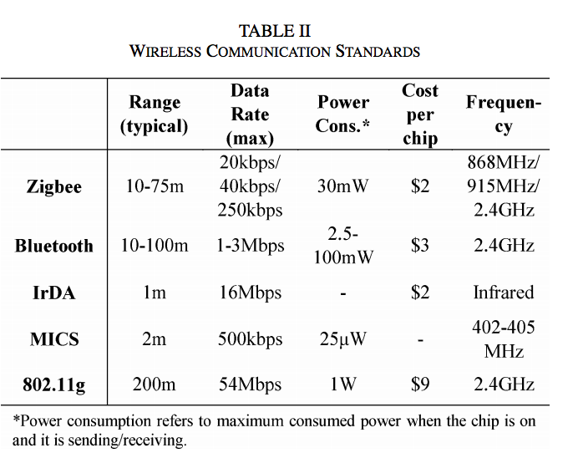

Bluetooth® low energy started in 2006 as a project in the Nokia Research Centre with the name Wibree, and was renamed Bluetooth Ultra-Low-Power and then Bluetooth low energy. The aim of this technology is to enable power sensitive devices to be permanently connected to the Internet while only being powered by a coin cell battery. Bluetooth Low Energy is governed by the Bluetooth v4.0 specification. A device that operates Bluetooth v4.0 may not necessarily implement other versions of Bluetooth; in such cases it is known as a single-mode device. Most new Bluetooth chipsets from leading Bluetooth silicon manufacturers are dual devices that support Bluetooth and the new LE functionality. Connectable advertising packets (adverts) are broadcast every 500 ms. Each packet has 20 bytes of useful payload and consumes 49 μA at 3 V. For this particular setup, adverts are spread across all three channels, with the positive side effect of increasing robustness over a single-channel technology. The typical power consumtion is 49 μA x 3 V = 0.147 mW and bytes per second = 20 x (1 second/500 ms) x 3 channels = 120 bytes/second, achieving a power per bit = 0.147 mW/(120 bytes/second x 8) = 0.153 μW/bit. It should be noted that this configuration uses connectable packets. Therefore, the advertising device is also scanning after each advert. This consumes significant power, but is still lower than its nearest competitor. By increasing the payload to 31 bytes per packet and configuring for broadcast only, power per bit efficiency would be improved further. This would occur due to the increase in protocol efficiency from 20 payload bytes to 31 for the same overhead.

# Bluetooth low energy

## Bluetooth Low Energy vs Classic Bluetooth

Bluetooth Low Energy (BLE, also marketed as Bluetooth Smart) is the centerpiece of the Bluetooth 4.0 Core Specification. While BLE has many similarities with its predecessor, it departs from classic Bluetooth in many ways. The on-air protocol, the upper protocol layers, and the applications are different and incompatible between the two technologies. While Bluetooth classic focused on a strict set of use cases like audio and data transfer, BLE was designed for simplicity and extensibility, so that a developer could interface with any accessory without having to know a great deal about the underlying technology. In addition, BLE was designed to have the lowest possible power consumption, optimized for low cost, low bandwidth, low power, and low complexity and designed to easily exchange data. BLE also has an inherent resource requirement assymetry where masters, such as smartphones and tablets, require more resources, while slaves, such as beacons, use far less resources enabling them to run on inexpensive microcontrollers and radios with smaller power supplies.

## Protocol Stack

The BLE protocol stack consists of three main components: (1) Application manages the actual use case (logic, user interface, and data handling), (2) Host containing the upper layers of the Bluetooth protocol stack, and (3) Controller containing the lower layers of the Bluetooth protocol stack including the physical radio. These can be integrated into the same chip or broken into separate ICs and connected via a standard Host Controller Interface (HCI), which allows interoperability between hosts and controllers produced by different companies.

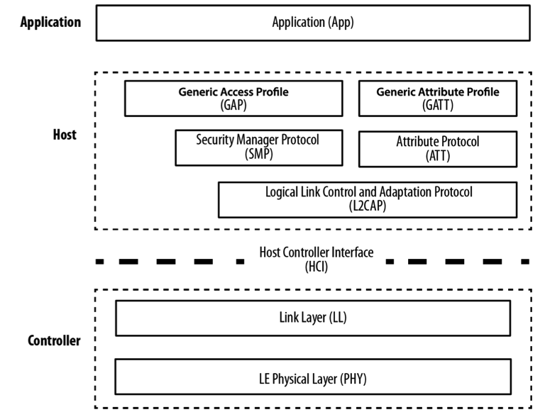

Let’s dive into the details of how the stack functions from the bottom up.

The physical (PHY) layer contains the physical communications circuitry, which modulates and demodulates analog signals into digital symbols at 1Mbit/sec (which fixes the upper bound on the output rate) using Gaussian Frequency Shift Keying (GFSK, which uses  Gaussian filter to smooth positive/ negative frequency deviations, which represent a binary 1 or 0). The digitial signal is over the 2.4 GHz ISM (Industrial, Scientific, and Medical) band, which is divided into 40 channels. To avoid interference from other radios, BLE uses *frequency hopping spread spectrum* where the data channel is shifted by some arbitrary constant whenever it encounters resistance. Since there are 40 channels in the band and 3 are used for the advertiser signal, the shift is calculated as *new channel =* (*current channel + hop*) mod 37.

The Link Layer (LL) is a combination of hardware and software that interfaces with PHY and manages the timing, connection parameters, encryption, advertising, scanning, starting, and stopping connections as well as the “link state,” which characterizes the role of the device. The roles include: Advertiser: blindly sends advertising packets before active connection without knowledge of the presence of a scanner, Scanner: blindly scans for advertising packets before active connection without knowledge of an advertiser, Master: initiates a connection and manages it later, and Slave: accepts a connection request and follows the master’s timing. The LL also checks packets received against a 24-bit CRC, and requested a re-send whenever an error occurs; the LL on the master will resend the packet until it finally passes the test on the receiver.

The Host Controller Interface (HCI) is a standard serial protocol for host-controller communications with a pre-defined set of commands and events, a data packet format, flow control rules, and other procedures that vary by transport, such as UART, USB, SDIO, etc.

The main purpose of the Logical Link Control and Adaptation Protocol (L2CAP) is to break down data from the top layers into chunks that fit in the 30 byte BLE packet size for the link layer. It also recombines chunks of data from incoming packets into a single larger packet to send up the layers to the application.

The Security Manager Protocol (SMP) generates and manages security keys for an encrypted communications link. It stores remote device IDs and hides the public Bluetooth Address to prevent the device from being tracked by unauthorized peers.

The Attribute Protocol (ATT) manages the client and server actions, which do not depend on whether the device is in a master or slave state. The pathway is quite simple: a client requests data from a server and a server sends data to clients, however no additional requests can be sent until a response is received and processed (and vice versa). Processed data is organized into attributes that are indexed by a 16-bit universally unique identifier (UUID), each having a value and a set of permissions (read, write, etc). The Generic Attribute Profile (GATT) is a layer of abstraction on top of the ATT that defines how data in the ATT is organized and transferred between applications.

The Generic Access Profile (GAP) is the topmost layer and ensures interoperability between devices from different vendors. It orchestrates the lower level functions such as device discovery, connection, security, and data transfer.

## Packets

Data packets have a usable data payload of 27 bytes, but are depending on whether upper layers of the stack take up space. The actual amount can be around 20 bytes per packet. For example: the L2CAP packet header takes up four bytes, which means that the effective user payload length is 27 - 4 = 23.

It’s worth noting here that the BLE has two kinds of packets, advertising and data, but only one format, which simplifies the implementation. carry a Advertising packets carry a payload up to 31 bytes of data in addition to basic header information and are sent at a fixed rate defined by the advertising interval, which ranges from 20ms to 10.24s, shorter intervals increase the probability of those packets being received by a scanner with the cost of higher power consumption. The scanner has similar parameters, interval and scan window, that define how often and long a scanner will listen for potential advertising packets, which also has impacts power consumption since it varies the amount of time the radio must be turned on.

Advertising packet types can be classified by three properties: connectability, whether a scanner can connect on receipt; scannability, whether a request scan packet can be sent; and directability, whether a packet is sent to a particular scanner. The scanner also has two distinct modes: passive, where the advertiser is unaware if a packet is received, and active, where the scanner requests a “scan response” packet upon receipt.

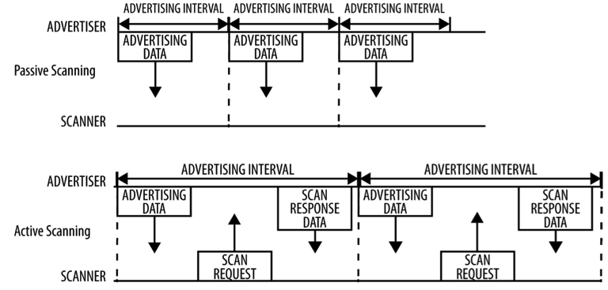

## Finding a Connection

A Bluetooth LE connection has three components: advertising, scanning, and connecting. The process is much like males seeking females at a bar. The slave device (male) sends advertising data (fancy drinks) that indicate a desire to connect. The master device (female) picks up these packets but filters them by Bluetooth Address or the advertising data itself (charming and non-creepiness). If the master is actively scanning (think Thursday night at the Rosewood), it will let the slave know when a connection is desired. In this case, when a suitable slave is detected, the master (female) sends a connection request packet to the slave (telephone number) and, provided the slave responds, establishes a connection (celestial spiritual bond). The master’s connection request packet includes the frequency hop increment (pace of the relationship), which determines the hopping sequence that both the master and the slave will follow during the lifetime of the connection (happily ever after).

## Nordic nRF8001 Hardware

Nordic Semiconductor was a member of the board that defined the core BLE standard from the very beginning and designed one of the first affordable BLE peripheral-mode chips, the nRF8001. Nordic was kind enough to sponsor this project by sending a nRF8001 development kit, which was used to build our system. The firmware is quite complicated and requires a specialized tool chain (Kiel) that costs several thousand dollars a seat. We avoided using this by using the default firmware and sending a pre-defined boot sequence to the chip, which is explained below.

# TinyBlue Module

## TinyOS

TinyOS is an operating system designed for low-power wireless embedded systems. Fundamentally, it is a work scheduler and a collection of drivers for microcontrollers and other ICs commonly used in wireless embedded platforms.

The project originally sought to add BLE chip and corresponding driver to TinyOS platform and allow applications to access it via the familiar active message interface. Once the BLE platform had been constructed the power consumption was to be measured and compared to the original radio. Unfortunately the use scenarios for BLE and the CC2420 style radio do not compare nicely, largely due to differences in protocol.

The projected shifted to integrating the nRF8001 and Nordic BLE stack into TinyOS to allow motes to communicate over BLE, this could not be a substitute for the original radio as was envisioned. TinyOS was built on radios that broadcast openly or to specific nodes but a connection did not have to be established ahead of time in either case. Whereas BLE is a connection based protocol with a client and a server model, albeit an interesting one since the connection it initiated by the server. So rather than attempt to connect the BLE stack into the active message interface and compare power consumption the project focused adding BLE functionality to TinyOS as an expanded feature and not a substitute for the original radio.

## “Micable” Platform

A new platform was constructed, micable, which was an adaptation of the micaz platform to incorporate the new nRF8001. At the time the micaz was selected because it was believed that this was the only mote platform that made SPI lines externally available via the MDA100 expansion board developed by Crossbow for the mica platforms. It was later discovered that the only SPI line on the expansion board was SCLK, so the SPI was bit banged using the GeneralIO interface connected at the platform level the necessary IO lines.

## Bluetooth Application Control Interface

The Nordic stack consisted of 2 main parts(high and low level platform independent software drivers) and 2 parts that were used for data encoding and queuing. Each part of the nRF8001 stack provided by Nordic became a tiny OS interface and a top level driver configuration was used to wire them together and ultimately to the lowest platform dependent layer.

-lib_aci – This was the top level provided by the nRF Bluetooth stack. It was used to determine what commands would be sent to the hal_aci_tl interface.

-hal_aci_tl- This module was the lowest platform independent level of the driver. It was told what command to send by lib_aci and determined how the commands would be sent. It used pins set at the platform level to bit bang spi commands out that were placed in the tx queue and add incoming message to the rx queue.

-acilib – this module encoded standard messages defined by the application command interface.

-aci_queue- This module was used to perform operations of the incoming and outgoing queues to that application command interface.

## TinyOS Demo App

A UART test application was adapted from the Arduino library to run in Tiny OS which allowed the mote to successfully send messages back and forth between an Iphone and the micaz mote. The mote is the client and the iphone is the server in this configuration. Once the server has initiated a connection it can send information over BLE that the mote will print to the terminal via a serial port.

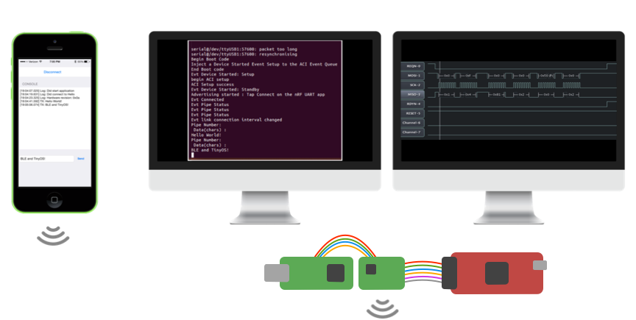

The terminal printout is as follows:

java net.tinyos.tools.PrintfClient -comm serial@/dev/tty.usbserial-XBTGCED5B:micaz

Thread[Thread-2,5,main]serial@/dev/tty.usbserial-XBTGCED5B:57600: resynchronising

Begin Boot Code

Inject a Device Started Event Setup to the ACI Event Queue

End Boot code

//pump in the firmware

Evt Device Started: Setup

begin ACI setup

//set up ACI

ACI Setup success

Evt Device Started: Standby

Advertising started : Tap Connect on the nRF UART app

Evt Connected

Evt Pipe Status

Evt Pipe Status

Evt Pipe Status

Evt link connection interval changed

Pipe Number:

Data(chars) : Hello World!

# Conclusion

1. Table Type Styles

| Table Head | Table Column Head | | |
| --- | --- | --- | --- |
| Table column subhead | Subhead | Subhead |
| copy | More table copya |  |  |

1. Sample of a Table footnote. (*Table footnote*)
2. Example of a figure caption. (*figure caption*)

##### References

1. Abramson, Norman. "THE ALOHA SYSTEM: another alternative for computer communications." In *Proceedings of the November 17-19, 1970, fall joint computer conference*, pp. 281-285. ACM, 1970.