F8: Hook up aimbot
F9: Start aimbot
F12: Open aimbot menu
Right Shift: Shutdown aimbot
F7: Force reset aimbot (if any problem)
F4: Performance check

- Please make sure you need to right click-> Run as administrator to make it works properly
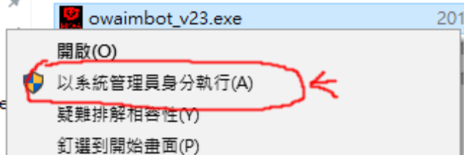

2. You need to hook up the aimbot with F8 first before F9, make sure you should start the aimbot function(F9) only when the game is start and see the game menu, or it will aim randomly. If you have issue like it or see the “Run Overwatch” warning, press right Shift button to close the aimbot function until it can start again.

3. F12 only works once the F9 pressed and aimbot started。

4. Please make sure for the first time, you need to go to “Mouse Settings” under the aimbot F12 menu, in there you need to set the “Ingame sensitivity” as same as the value you have set for the mouse in the game

5. Make sure you didn’t set the brightness or contrast for video in the game, if yes, please set it back to default, your aim crosshair should not be set in RED also. Game should be set in borderless windowed.

6. If you found error after pressed F9, please first: Login Google Drive with IE with “remember login” ticked，hack alreadt run as administrator，Press F7 to reset it，then F8 to hook it up again。You don’t need to press F7 everytime if you don’t have problem。

