NANO-PARTICLE EPOXY FOR SOUND IMPEDANCE
PART
A
By Thomas Jos with the assistance of Dr. Shenghan Wang

INTRODUCTION
The use of polymer composites in acoustic and structural applications has seen increasing interest due to their customizable mechanical properties and versatility. One particular area of application is in backing layers for ultrasonic or acoustic devices, where materials must exhibit a balance between mechanical compliance and acoustic impedance. Epoxy resins, known for their ease of processing and strong adhesion, serve as a promising matrix for such applications. However, the intrinsic stiffness and relatively high acoustic impedance of standard epoxies can limit their effectiveness as compliant backing layers. To address this challenge, this study explores the development of a modified epoxy-based composite with tunable softness and tailored sound impedance characteristics through the incorporation of various additives and nanoparticles.
The research is divided into two major experimental phases:
Part A: Formulation of a Soft Epoxy Matrix
The goal of the first phase is to formulate a base epoxy system with reduced stiffness while maintaining adequate curing and mechanical integrity. Various concentration and ingredient modifications of an existing epoxy formula (Wu) are explored to identify optimal combinations that yield a “soft” epoxy. This section involves systematic variation of formulation parameters and mechanical characterization (e.g., Shore hardness) to determine the most suitable soft matrix composition for nanoparticle integration.
Part B: Nanoparticle Integration and Acoustic Characterization
Once the soft epoxy matrix is established, the second phase focuses on the integration of nanoparticles to modulate the composite’s acoustic impedance. Different nanoparticle species—such as Ytterbium Oxide and Aluminum Oxide introduced at varying concentrations. The resulting composites are characterized by density, compressional wave velocity, and impedance behavior. The aim is to identify nanoparticle types and loadings that enhance acoustic absorption or impedance matching, making the composite suitable for use as a backing layer in ultrasonic systems.
Through this two-phase approach, the study aims to create a multifunctional epoxy-nanoparticle composite that meets both mechanical and acoustic performance criteria, paving the way for its use in precision acoustic devices.

EXPERIMENT 1: EPOXY FORMULA
To develop the base epoxy formulation, a modified version of an established recipe from Wu et al. was selected. Adjustments were made to streamline the preparation process and eliminate nanoparticles, allowing for direct assessment of the mechanical properties of the standard composition.
Recipe and Procedure:
- Pre-mixing Silane:
In a beaker, combine 3.00 g of 97 wt% ethanol–water mixture (2.91 g ethanol, 0.09 g water) with 0.36 g of APTES (3-aminopropyltriethoxysilane). Stir the solution continuously for 5 minutes.
- Addition of Epoxy Resin:
Introduce 1.80 g of bisphenol A-type epoxy resin monomer into the silane solution. Homogenize the mixture using a laboratory mixer at 1800 RPM for 5 minutes.
- Solvent Evaporation:
Transfer the mixture to a hot plate and gently heat at 60–80°C until the ethanol/water fraction is fully evaporated, yielding a viscous silane-modified epoxy resin.
- Incorporation of Curing Agent:
Upon cooling to room temperature, mix in 0.60 g of ternary polyetheramine curing agent. Ensure thorough mixing to achieve homogeneity.
- Casting:
Pour the prepared epoxy mixture into a mold of dimensions 2 cm × 2 cm × 5 mm.
- Curing Process:
Place the mold in an oven and cure overnight due to laboratory time constraints.
Following the curing process, the fabricated samples displayed pronounced rigidity, with mechanical properties closely resembling those of slightly heated glass. This excessive stiffness rendered the published formulation unsuitable for the intended laboratory application, which requires materials with substantially greater flexibility. To further investigate the necessity of the curing agent, a control sample composed solely of compound A was prepared; this sample remained in a liquid state after an entire weekend, thereby confirming the curing agent’s essential role in initiating and sustaining polymerization. Due to the absence of appropriate flexibility measurement equipment in the laboratory, quantitative assessment of hardness or flexibility could not be performed. Based on the observed processing steps, it is suspected that the ethanol-water solution serves no functional purpose in the final product, as it is ultimately evaporated during subsequent processing stages.
Further experimentation involved a systematic variation of aminopropyltriethoxysilane (APTES) concentration within the epoxy matrix. While changes in APTES content had a negligible effect on the flexibility of the cured specimens (p > 0.05), APTES addition significantly lowered the viscosity of the uncured epoxy solution. This reduction in viscosity facilitated more effective degassing, leading to sample sets with minimal voids and greatly enhancing the overall testability and quality of the material.

EXPERIMENT 2: ADJUSTING AND TESTING MODIFIED FORMULAS
The hardness of an epoxy can be altered through various modifications. One approach involves incorporating a plasticizer, a low-volatility buffer that mediates interactions between polymer chains. Another method is to adjust the concentration of the curing agent, which directly influences the stiffness of the epoxy matrix. Similarly, varying the coupler concentration (in this case, APTES) can yield changes in mechanical properties. Additionally, different A compounds may exhibit distinct reactivity with the B compound, necessitating further investigation.

To systematically assess these factors, an experimental matrix was devised, varying the amounts of APTES, curing agent, and different A compounds. The modifications were applied based on the original formulation, adjusting concentrations accordingly.

Sample Variations:
Samples based on scaled weight:
Sample: | Epoxy A | Silane | Epoxy B
1 | 10g | 2g | 2.5g
2 | 10g | 2g | 2.83g
3 | 10g | 1g | 3.33g
4 | 10g | 0g | 3.33g
5 | 10g | 1.5g | 3.33g
6 | 10g | 2g | 3.33g
7 | 10g | 2g | 1.67g
8 | 10g | 2g | 2.50g
9 | 10g | 2g | 3.33g
10 | 10g | 2g | 1.67g
11 | 10g | 2g | 2.50g
- Original formulation with 75% curing agent
- Original formulation with 85% curing agent
- Original formulation with 50% APTES
- Original formulation with 0% APTES
- Original formulation with 75% APTES
- 301-2 A compound with 100% curing agent
- 301-2 A compound with 50% curing agent
- 301-2 A compound with 75% curing agent
- 301 A compound with 100% curing agent
- 301 A compound with 50% curing agent
- 301 A compound with 75% curing agent

General Observations After Curing:
- Stiff formulations: Samples 1–5 exhibited significant rigidity, with only Sample 1 showing slight elasticity and slow recovery.
- Flexible formulations: Samples 6, 8, 9, and 11 demonstrated varying degrees of flexibility, with Sample 11 being notably soft.
- Incomplete curing: Sample 7 remained semi-liquid, while Sample 10 did not solidify, indicating insufficient cross-linking.
Quantitative Hardness Measurements:
To obtain a more precise assessment, Shore D hardness values were recorded using a handheld durometer, courtesy of MRSEC labs in the SME Basement (special thanks to Stephen Horvath). Liquid samples were excluded. However, after later observations and discussions with scholars in the lab, Shore Scale measurement was somewhat flawed due method of measurement of the

Sample | Shore D Hardness
1 | 27
2 | 32
3 | 62
4 | 53
5 | 60
6 | 10
8 | 15
9 | 18
11 | 5

The findings demonstrate that while reducing the concentration of APTES produces a measurable effect on the material properties, its overall impact remains relatively minor. This suggests that APTES is more appropriately utilized as a fine-tuning parameter rather than as a primary factor in material optimization. Repetition of this test in a more controlled laboratory environment yielded similar results, reinforcing the initial observations. In contrast, modifications to the A compound exerted a much more pronounced influence on the material’s characteristics. Notably, Sample 11 successfully achieved the desired level of softness, indicating that targeted adjustments to the A compound can effectively tailor mechanical properties. However, the unexpected rigidity observed in the 301-2 samples, despite their lower concentrations, points to the possibility of experimental error or the presence of an unanticipated reaction mechanism affecting the outcome.
Given these results, future research efforts will focus on further refining the formulation adjustments applied to Sample 11. Specifically, the research will aim to optimize the mechanical properties for the intended application by systematically varying the proportions of both the B component and the 301A compound. This approach is expected to yield a material with enhanced softness and flexibility, better suited to the laboratory’s requirements.
EXPERIMENT 3: OPTIMIZING THE FINAL FORMULA
Building on observations from Samples 9, 10, and 11, the optimization process initially focused on identifying the ideal curing agent concentration. Although adjustments to silane (APTES) were considered, its effects were found to be replicable through modifications to the curing agent. Consequently, APTES became a secondary factor in the refinement process.
To enhance consistency and minimize experimental variability, a bulk APTES/A mixture was prepared prior to further formulation adjustments. Subsequently, a series of experiments were conducted to assess the impact of varying B compound concentrations. The selected percentages were derived from the original modified Wu formulation, with incremental reductions of 5%, while the amounts of A and Silane remained constant.
Sample: | Epoxy A | Silane | Epoxy B
1 | 69.0% | 13.8% | 17.2%
2 | 53.89% | 10.78% | 35.32%
3 | 55.11% | 11.02% | 33.86%
4 | 56.38% | 11.28% | 32.34%
5 | 57.71% | 11.54% | 30.74%
Sample Variations (percentage) : Sample Variation (mass):
Sample | B % | A (g) | Silane (g) | B (g)
1 | 85% | 10 | 2 | 6.96g
2 | 80% | 10 | 2 | 6.55g
3 | 75% | 10 | 2 | 6.14g
4 | 70% | 10 | 2 | 5.73g
5 | 65% | 10 | 2 | 5.32g

Results:
Potential Sources of Error
Several factors may have contributed to discrepancies in the experimental results, particularly when compared to those in Experiment 2. These include:
- Measurement Inaccuracy – The precision of weighing instruments may introduce slight variations in recorded values.
- Human Error – Minor inconsistencies in the mixing process, such as variations in curing agent addition, could affect the final composition.
- Material Transfer Loss – The process of transferring uncured epoxy solutions between containers may result in unintended material loss, impacting sample consistency.
- Instrument Limitations – Professional hardness and flexibility measurement tools generally provide more accurate readings than a handheld durometer. However, given available resources, the durometer was utilized for measurements in this experiment.
These factors highlight inherent uncertainties in the data, which should be carefully considered when interpreting the results. In addition to the measured variables, I suspect that several other factors may influence the production and performance of this material. These include exposure to air during mixing and curing, ambient and reaction temperatures, the thoroughness of degassing procedures, and even the chemical composition and surface properties of the molds used. Each of these variables can introduce subtle but significant variations in the final material properties, such as flexibility, hardness, and the presence of defects like air bubbles or incomplete curing. As such, strict control and documentation of these parameters are essential for ensuring reproducibility and reliability of experimental outcomes.

After conducting numerous iterations and revisiting earlier experimental protocols, I was ultimately able to develop an optimized and replicable formulation for the epoxy mixture: 10 g of 301A epoxy resin monomer, 2 g of APTES silane coupling agent, and 1.88 g of curing agent (ternary polyetheramine) specifically degassed for 30 minutes and specifically cured in an 80C oven. This composition consistently produced samples exhibiting a favorable balance between rigidity and flexibility—stiff enough to resist cracking under stress, yet sufficiently pliable to accommodate the intended laboratory applications. The improved formulation was validated through a series of comparative tests against industry standards such as PDMS (Sylgard 184) and EcoFlex, as well as through systematic variation of curing agent ratios and silane concentrations, as outlined in the attached experimental notes and images. Notably, the optimized samples demonstrated minimal void formation due to enhanced degassing, and the mechanical properties were reproducible across multiple batches, confirming the robustness of the process. This formulation now serves as a reliable baseline for further functionalization, such as the incorporation of nanoparticle fillers (e.g., Al₂O₃ and Yb₂O₃) to tailor acoustic impedance and attenuation properties. Future work will focus on fine-tuning the process parameters—such as mixing time, degassing protocols, and mold selection—to further enhance consistency and performance, as well as benchmarking the new material against established compounds in terms of mechanical and acoustic properties. This iterative approach not only advances the material’s suitability for specific research applications but also establishes a methodological framework for ongoing and future optimization efforts.

EXPERIMENT 4: ACOUSTIC TESTING
The experiment aimed to compare the acoustic impedance and attenuation of an optimized epoxy formulation (72.0% 301 Epoxy A, 14.4% Silane, 13.5% Curing Agent) against various epoxy samples available in the lab.
Material | Process of Production for Sample
PDMS (Sylgard 184) | 10:1 Ratio of A to B
ECOFLEX 00-30 | 1:1 Ratio of A to B
301 WITH ORIGINAL B | 20:3 Ratio of A to B (20:5 originally)
301 WITH 0.75 NEW B | A: 10g, APTES: 2g, B: 1.66g
301 WITH 0.85 NEW B | A: 10g, APTES: 2g, B: 1.88g

Samples were prepared and subsequently measured for volume, thickness, and mass. A picoscope equipped with an ultrasound transmitter and receiver was used to record the propagation time (in microseconds). These measurements, along with volume and thickness, were utilized to calculate sound impedance. The sample labeled 0.75 exhibited unexpected viscosity, rendering it unsuitable for accurate testing; as a result, it was excluded from further analysis.
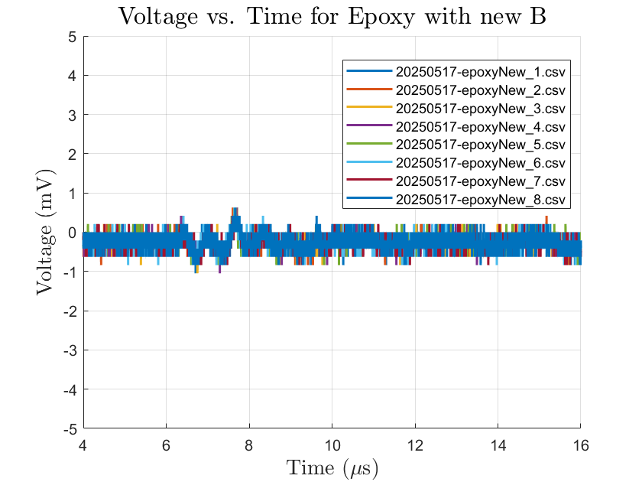
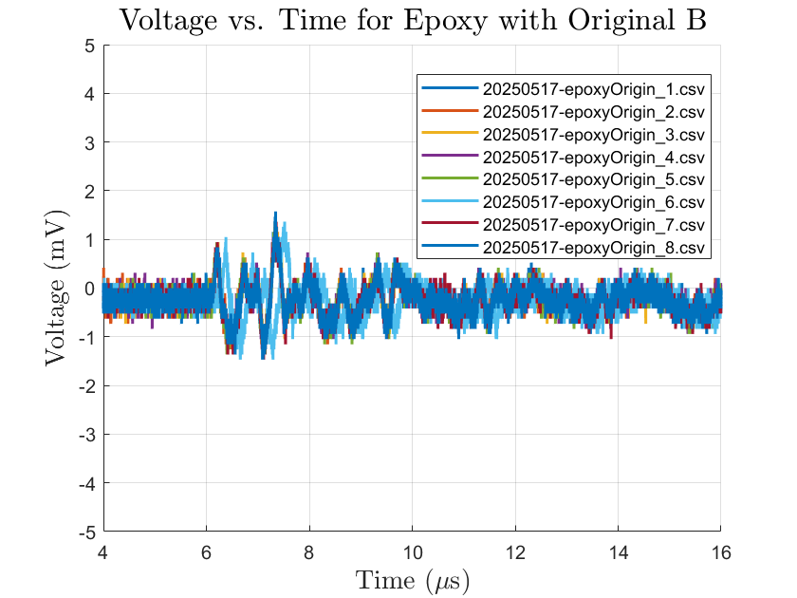
The following graphs depict the measured data for each test material, compiled with the assistance of Dr. Wang..

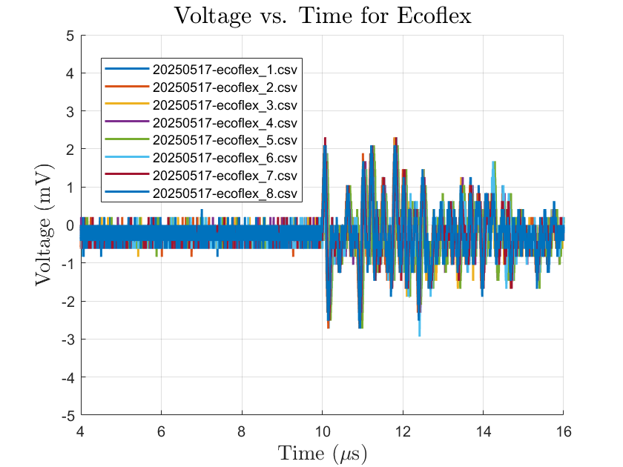
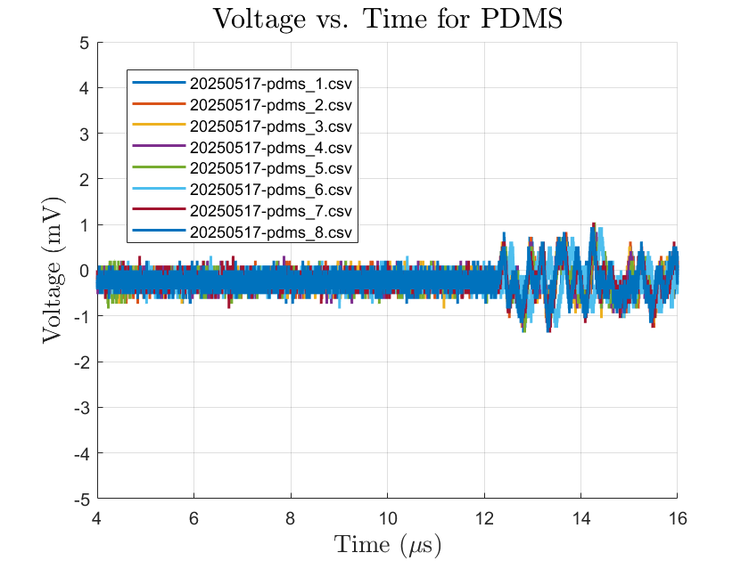

Acoustic impedance (Z) is defined as:
Z=ρ⋅c where Z is the acoustic impedance (Rayls), ρ is the density of the material (kg/m³), and c is the speed of sound within the medium (m/s). The table below presents the calculated values for each material based on these parameters.

Sample | Mass (Kg) | Volume (m^3) | Density: kg/m^3 | Thickness(m) | Time (s) | Velocity of Sound (m/s) | Acoustic Impedance (MRayl)
PDMS | 0.0039Kg | 4.08e-6 | 956 | 0.01019 | 9.37e-6 | 1089m/s | 1.04
ECOFLEX | 0.0031Kg | 3.39e-6 | 915 | 0.00847 | 6.21e-6 | 1364m/s | 1.24
301 OG B | 0.0045Kg | 4.08e-6 | 1104 | 0.01019 | 4.09e-6 | 2491m/s | 2.75
301 NU B | 0.0034Kg | 3.49e-6 | 975 | 0.00872 | 3.82e-6 | 2283m/s | 2.23

Attenuation measurements were initially conducted; however, the resulting data were deemed unreliable and subsequently discarded due to the presence of potential experimental errors. Comprehensive and accurate attenuation testing will be prioritized in future experimental phases to ensure robust and meaningful results.

FUTURE: FLEXIBILITY AND PART B
In future work, particularly during the upcoming fall quarter, I intend to implement a custom flexibility measurement tool that I have been developing, as the existing flexibility measurement instruments in the MRSEC laboratories are not optimized for characterizing extremely flexible materials. Regarding material optimization, I plan to screen various plasticizers to enhance the flexibility of the samples without necessitating precise control over the concentration of component B in each formulation. Additionally, I aim to complete and refine the measurement of particle attenuation. Although I previously conducted attenuation experiments, the results were inconclusive due to experimental flaws, and I therefore plan to repeat these measurements using improved sample preparation techniques to minimize air bubble inclusion.
A significant part of my future research will focus on the development of Part B of the experiment, which involves investigating the incorporation of Al₂O₃ and Yb₂O₃ nanoparticle powders and their effects on acoustic impedance. While I have already tested a range of Al₂O₃ concentrations, the initial samples suffered from excessive air bubbles and high powder-to-epoxy ratios, resulting in suboptimal material properties. These issues will be addressed through optimization of the composite fabrication process and improved nanoparticle dispersion, with similar experimental protocols applied to Yb₂O₃ composites. Finally, I plan to conduct a comprehensive comparative analysis of acoustic properties—specifically impedance and attenuation—across several material systems, including standard laboratory compounds such as PDMS (Sylgard 184) and EcoFlex 00-30, as well as the optimized epoxy formulations and their nanoparticle composites. This comparative study will provide a robust benchmark for evaluating the performance of the newly developed materials in relation to established standards.

Works Cited:
Wu, Jiaqi, et al. “A Fiber-Shaped Ultrasonic Transducer by Designing a Flexible Epoxy/Nano-Zirconia Composite as an Acoustic Matching Layer.” Journal of Materials Chemistry B, The Royal Society of Chemistry, 22 Jan. 2025, pubs.rsc.org/en/content/articlelanding/2025/tb/d4tb02063d#!divRelatedContent&articles.

