Accuracy: 95.1%

Confusion matrix:

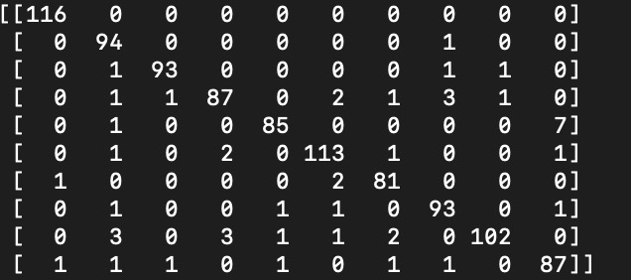

Per-class precision and recall:

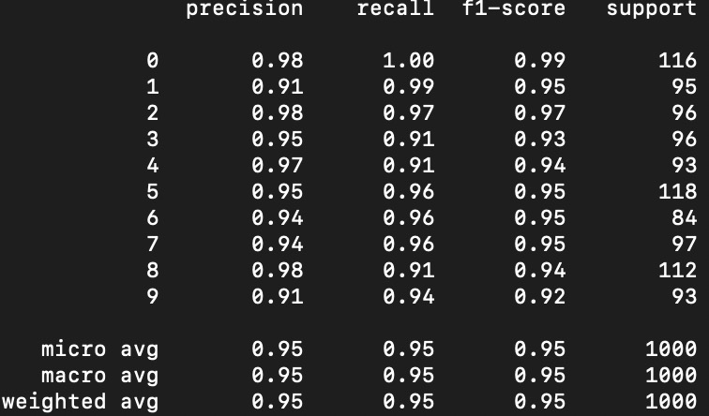

Extra Task:

I have tried different k values, range from 1 to 14:

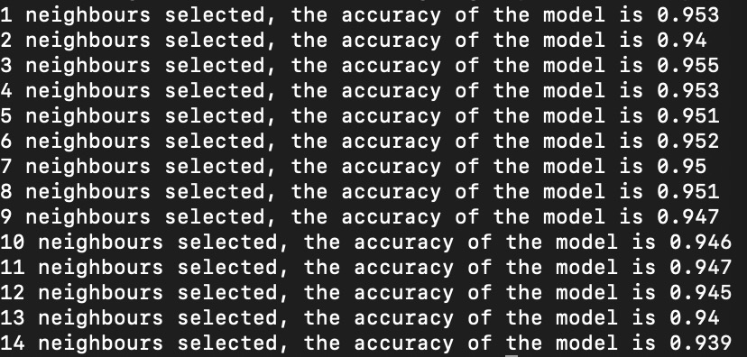

And I realize, that when k = 3, the model has the highest accuracy, the accuracy drops with larger k values selected, as it is likely to be affected by the outliers.