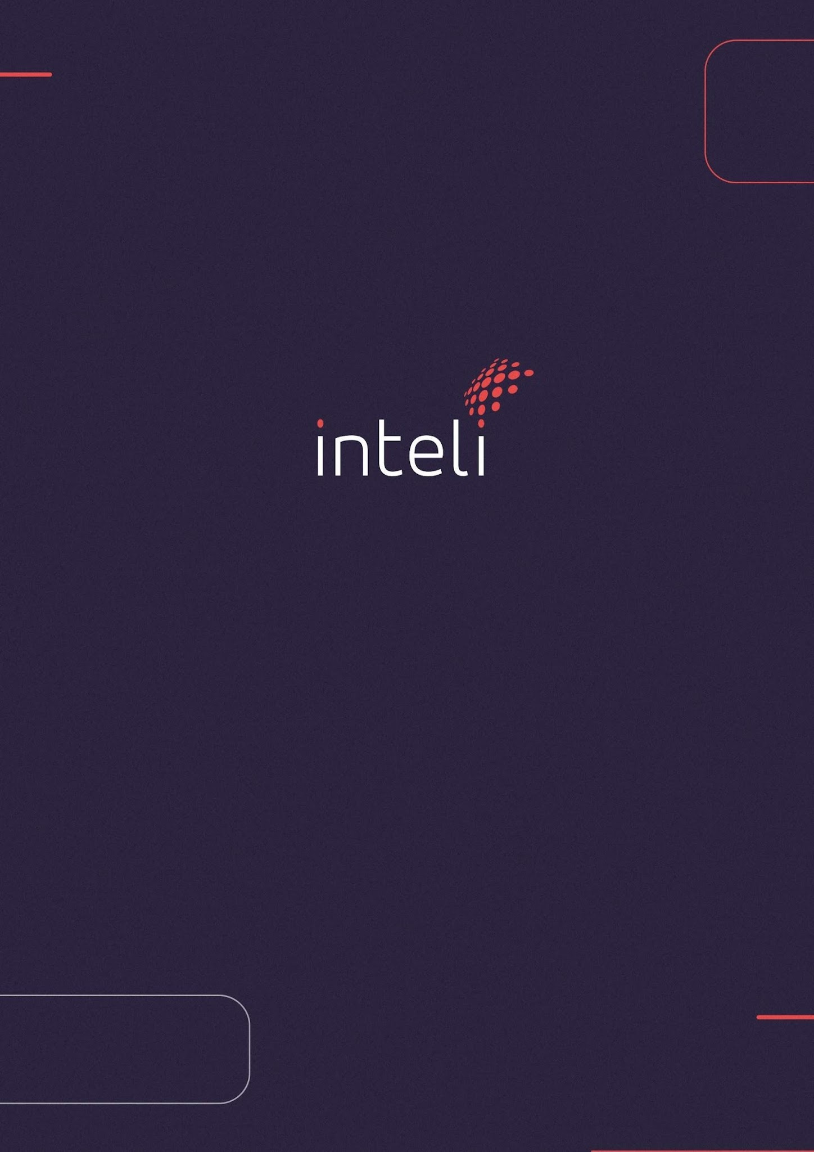

PROJECT PARTNER
YvY Capital

Data Governance Pipeline and Analytics

PROJECT: Data Governance Pipeline and Analytics
COMPANY: YvY Capital Asset Management
BRIEF COMPANY DESCRIPTION / MINI BIO: YvY Capital is a Brazilian asset manager focused on infrastructure, operating across four business verticals: Equity, Private Credit, Infra Studio, and Carbon.
ADVISOR PROFESSOR: (To be filled in by INTELI)

OVERVIEW
- MAIN BUSINESS AREA: BackOffice
- PROJECT LEADER: (Ex: "João de Tal" – Commercial Director)
- BACKUP FOCAL POINT: (To be filled in by INTELI)
- TECHNICAL LEADER: (To be filled in by INTELI)
- BUSINESS LEADER: (To be filled in by INTELI)
- EXECUTIVE LEADER [Executive Onboarding]:
PROJECT OUTLINE
- PROBLEM: YvY lacks a consolidated and automated view of its funds — covering profitability, portfolio composition, and relative performance against comparable market funds. Currently the firm manages 7 funds, each with daily or monthly NAV and portfolio data updated in its fund administration system. However, this information is distributed by email and on an ad hoc basis, with no online dashboard. This generates a high volume of manual reconciliation work for analysts and creates an information gap for leadership in portfolio analysis, management, and decision-making.
- OBJECTIVE: YvY Capital would like INTELI to develop an ETL (Extract, Transform, Load) pipeline that complies with data governance policies (quality, security, and traceability). At the end of this pipeline there will be a DataApp for visualization of hyper-personalized information about YvY’s funds and their market comparables, replacing the daily email distribution with an online dashboard.
- EXPECTED BENEFITS FOR THE PARTNER: Raise the level and quality of information available to fund managers and company leadership, reducing manual reconciliation rework and accelerating portfolio decisions.
- ATTACHED STUDY MATERIALS: Samples of fund administration databases and access/extractions from market databases contracted by YvY (see “Data Provided”).
SHORT PROJECT DESCRIPTION
Data Governance Pipeline and Analytics that consolidate fund performance and market benchmark for leadership.

MACRO SCOPE
The expected outcome is a tool capable of processing different data sources from the fund administration area of an asset manager, as well as market data from comparable funds. This data must be cleaned, processed, and structured through a programmatic pipeline that produces datasets ready for various analyses. Through the structuring of this data, students must extract insights and present them to fund managers and leadership in a practical way, using language appropriate for the audience. Data analyses must be conducted at multiple levels, reaching at minimum the individual fund level so that the information displayed is hyper-personalized. The tool used to represent this information is at the discretion of the students, but should be limited to a web application, mobile application, or BI tool. Along with the tool, students must deliver: a data governance structure, a data flow diagram (intermediate datasets and idealized layers), and a usage and maintenance manual.

MVP
A tool that displays personalized information to fund managers and leadership with the following features:
• Daily NAV and portfolio dashboard for YvY funds, replacing the current email distribution with an online dashboard;
• Performance view per fund, with returns and risk-return indicators;
• Benchmark comparison of each YvY fund against comparable market funds (peers);
• Comparisons across YvY’s own funds;
• Automated reconciliation of databases, eliminating analysts’ current manual workload.
NOTE: Remember the definition of MVP is: MVP stands for Minimum Viable Product. Simply put, we can define MVP as a lean version of a solution, containing only its basic functionalities. It can be a software, service, physical or digital product.

OTHER DELIVERABLES
• Data governance structure;
• Data flow in the processing pipeline (intermediate datasets and idealized layers);
• Usage and maintenance manual for the tool.

PROJECT RESTRICTIONS / THE PROJECT DOES NOT INCLUDE
• The project name “YvY” and the names of its shareholders/partners must not appear in repositories or processed data;
• Project data and challenges must not be shared with third parties outside the project;
• Data subject to the LGPD (Brazilian General Data Protection Law) must be anonymized/masked.

RESTRICTED CONTENT

The project presentation must not be shared on GitHub in a private repository.

STAKEHOLDERS

There are no other stakeholders for this project.

OPERATIONAL IMPACT CHECKLIST AND PROJECT ALIGNMENT WITH THE SUSTAINABLE DEVELOPMENT GOALS (SDGs) OF THE UN 2030 AGENDA

This section evaluates the project's value proposition on two complementary fronts. The first part focuses on operational impacts, seeking to understand the practical benefits for the organization.

The second analyzes the project's alignment with the Sustainable Development Goals (SDGs), the UN's global agenda for a better future, structured in its 5 dimensions: People, Planet, Prosperity, Peace and Partnerships (to learn more, access here).

Evaluate below how your project connects to these two fronts, checking the applicable options and describing the initiative in the observations field.

Operational Impacts of the Project
- Managerial Practice or Contributions (Focus on practical problems)
- Does the project contribute to the resolution or minimization of a practical problem (within the company)?
- Does the project promote competencies for software project practices?
- ☑ Yes — both criteria are met.
Observations (General): The project directly addresses a practical operational problem at YvY Capital: the absence of a consolidated, automated view of fund performance and portfolio data. Today this information circulates by email and requires intensive manual reconciliation by analysts. The ETL pipeline and DataApp replace this workflow, freeing up analyst capacity and providing leadership with timely, accurate data for portfolio decision-making. In parallel, the project develops students’ competencies in data engineering, pipeline architecture, governance frameworks, and business intelligence — core software project practices.

Project Alignment with SDGs
- Dimension 1: People (Focus on dignity, equality and well-being)
- (SDGs 1, 2, 3) Does the project contribute to eradicating poverty, zero hunger, or promoting health and well-being?
- (SDGs 4, 5) Does the project promote quality education or gender equality and the empowerment of women and girls?
- ☐ Not applicable.
Observations (People): The project operates in the financial infrastructure sector and does not directly target poverty, hunger, health, education, or gender equity outcomes.
- Dimension 2: Planet (Focus on protecting ecosystems and combating climate change)
- (SDGs 6, 12) Does the project promote sustainable water management and responsible consumption and production (e.g., circular economy)?
- (SDGs 13, 14, 15) Does the project contribute to climate action or to the protection and recovery of life in water and on land?
- ☐ Not applicable.
Observations (Planet): The project does not directly address environmental sustainability, water management, or climate action. Indirectly, YvY Capital’s focus on infrastructure investment — which includes clean energy and sanitation assets — means that better portfolio intelligence may support more efficient allocation of capital toward these sectors, though this is an indirect effect outside the project’s direct scope.
- Dimension 3: Prosperity (Focus on inclusive economic growth in harmony with nature)
- (SDGs 8, 10) Does the project promote decent work and economic growth, contributing to the reduction of inequalities?
- (SDGs 7, 11) Does the project promote access to clean energy or the development of more sustainable cities and communities?
- ☐ SDGs 8, 10: Not directly applicable. ☑ SDG 9: Applicable — the project represents an innovation in financial infrastructure, strengthening the analytical capabilities of an asset manager dedicated to infrastructure investment in Brazil.
Observations (Prosperity): The platform strengthens institutional infrastructure within the asset management industry by automating data workflows and delivering a data-driven decision support tool. This contributes to the modernization of financial industry practices in Brazil, aligned with SDG 9 (Industry, Innovation and Infrastructure).
- Dimension 4: Peace (Focus on promoting peaceful, just and inclusive societies)
- ☑ (SDG 16) Does the project strengthen institutions ethically and responsibly, promoting transparency, justice and peace? Yes.
Observations (Peace): The ETL pipeline is designed with explicit data governance policies covering quality, security, and traceability. Reconciliation is automated and auditable, replacing ad hoc email-based processes with a transparent, traceable data flow. LGPD compliance (anonymization/masking of personal data) is a formal project constraint. These characteristics directly reinforce institutional integrity, data transparency, and responsible information management — in line with SDG 16.
- Dimension 5: Partnerships (Focus on collaboration to achieve objectives)
- (SDGs 9, 17) Does the project represent an innovation for industry and infrastructure and is it based on strategic partnerships to enhance its impact?
- ☑ Yes — SDGs 9 and 17 are applicable.
Observations (Partnerships): The project is the result of a strategic partnership between INTELI (Instituto de Tecnologia e Liderança) and YvY Capital Asset Management. This collaboration connects academia and the financial industry to co-develop an innovative data intelligence solution applied to infrastructure fund management — directly aligned with SDG 17 (Partnerships for the Goals) and SDG 9 (Industry, Innovation and Infrastructure). The partnership model enables knowledge transfer, real-world application of academic skills, and industry modernization.

