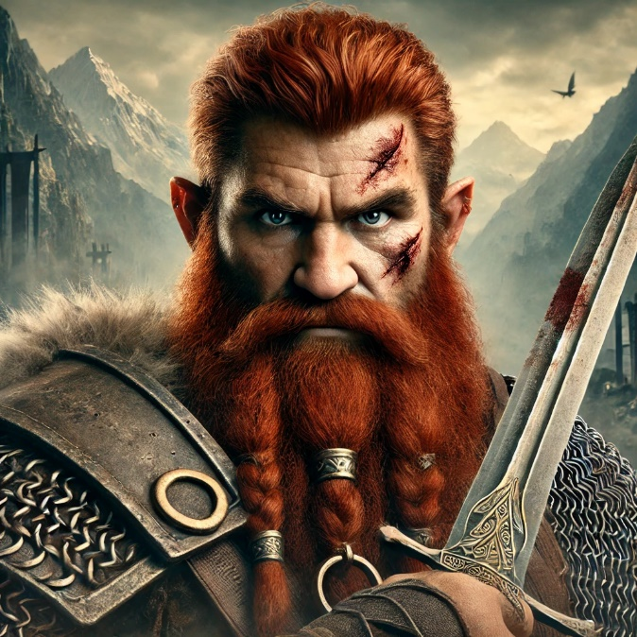
Durin Stoneheart
Character Summary:
- Race: Mountain Dwarf
- Class: Fighter
- Level: 1
- Experience Points: 242
- Armor Class: 16
- Max Hit Points: 13
- Current Hit Points: 13
- Speed: 25 feet
- Proficiency Bonus: +2
Ability Scores:
- Strength: 17 (+3 to hit / +3 to damage)
- Dexterity: 13 (+1)
- Constitution: 16 (+3)
- Intelligence: 10 (+0)
- Wisdom: 12 (+1)
- Charisma: 8 (-1)
Equipment:
- Warhammer
- Battleaxe
- Light crossbow with 20 bolts
- Chain mail
- Explorer’s pack (Includes bedroll, rations, rope, torches, etc.)
- Artisan's tools (e.g., Smith’s tools)
Skills:
- Athletics (Proficient)
- Perception (Proficient)
Background: Soldier

Proficiencies:
- Armor: All armor, shields
- Weapons: All simple and martial weapons
- Tools: Artisan's tools (choose one, e.g., Smith's tools)
- Saving Throws: Strength, Constitution
Fighting Style:
- Great Weapon Fighting: When you roll a 1 or 2 on a damage die for an attack you make with a melee weapon that you are wielding with two hands, you can reroll the die and must use the new roll, even if the new roll is a 1 or a 2. The weapon must have the two-handed or versatile property for you to gain this benefit.
Features & Traits:
- Dwarven Resilience: Advantage on saving throws against poison, and resistance against poison damage.
- Dwarven Combat Training: Proficiency with battleaxes, handaxes, light hammers, and warhammers.
- Dwarven Armor Training: Proficiency with light and medium armor.

Attacks:
- Warhammer:
  - Attack Bonus: +5 (Strength + proficiency)
  - Damage: 1d8+3 bludgeoning (versatile 1d10+3)
- Battleaxe:
  - Attack Bonus: +5 (Strength + proficiency)
  - Damage: 1d8+3 slashing (versatile 1d10+3)
- Light Crossbow:
  - Attack Bonus: +3 (Dexterity + proficiency)
  - Damage: 1d8+1 piercing
  - Range: 80/320 feet
- Shortbow:
  - Attack Bonus: +3
  - Damage: 1d6 + 1 piercing
  - Range: 80/320 feet

