**dualcamera.exe**

Program starts with these 3 options: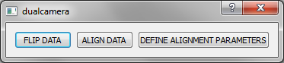

**FLIP DATA**

To only flip some data upside-down, press the first button, then select data files to flip: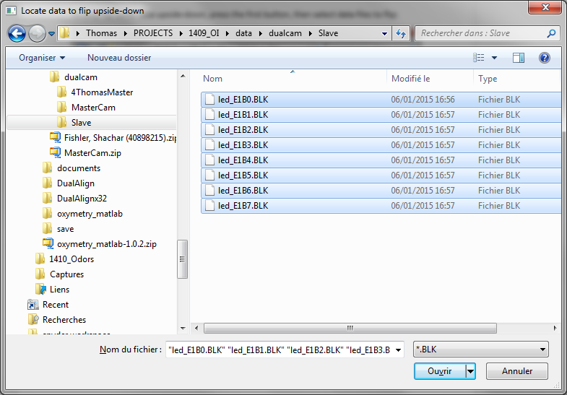

The data is processed then (a progress bar is shown).  
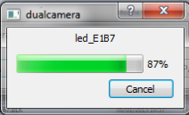

A new folder ‘flip’ has been created with flipped data inside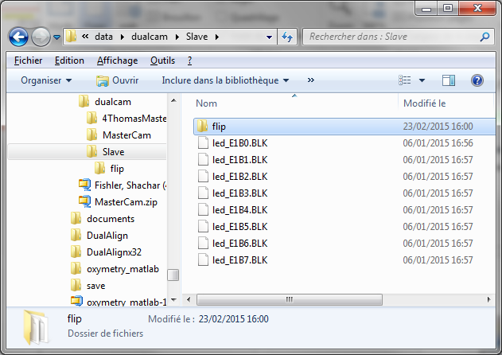

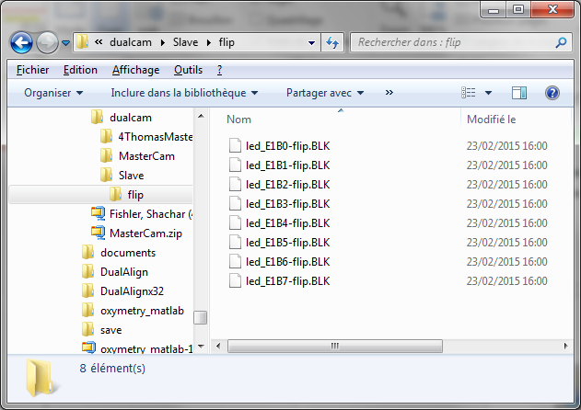

**DEFINE ALIGNMENT PARAMETERS**

To perform a complete registration of one dataset on the other one, first press ‘DEFINE ALIGNMENT PARAMETERS’ button.

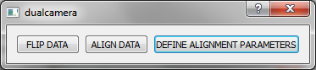

Previously, BMP images must have been saved with each of the two cameras. For easier alignment, the target should have a well-defined structure, so that the images will have good contrast (as the images in the examples below).

First select the BMP image from the camera whose data needs to be aligned onto the data of the other camera:  
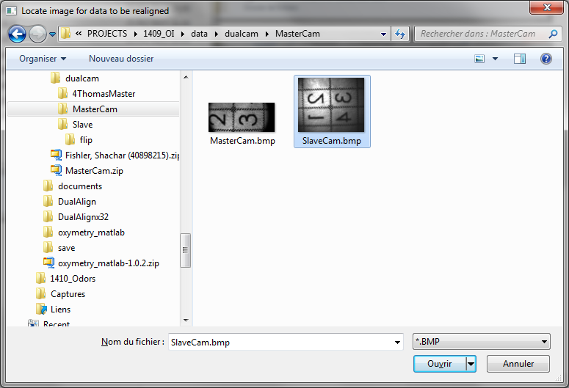

Then select the BMP image from the second, reference, camera:  
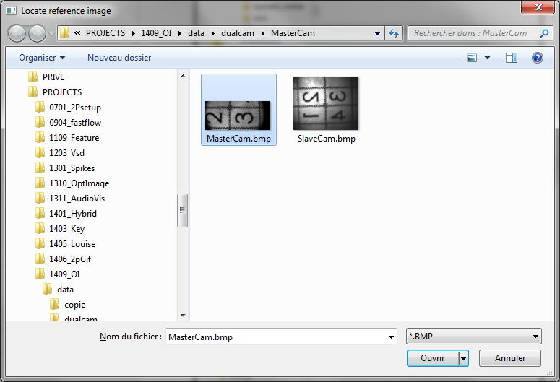

Then a new window opens: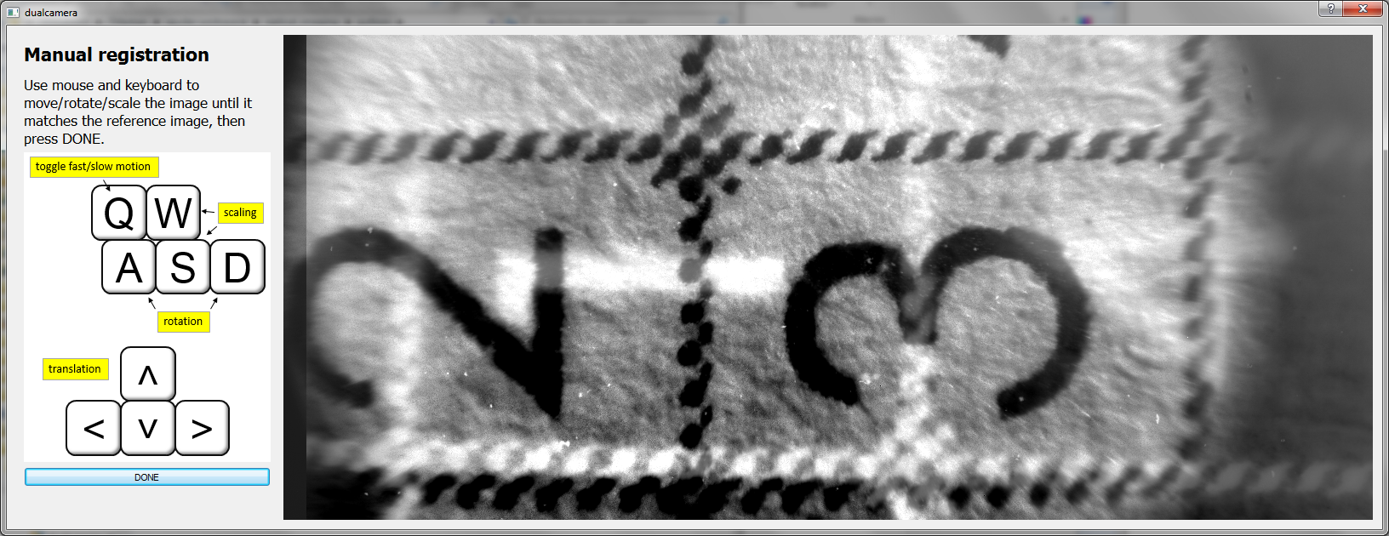

Use mouse and keyboard as illustrated in the left panel to move the first image so as to match the reference image, then press ‘DONE’:

(note: I noticed that the arrows on the keyboard might not work; in that case, it is possible to use arrows on the numbers pad of the keyboard)

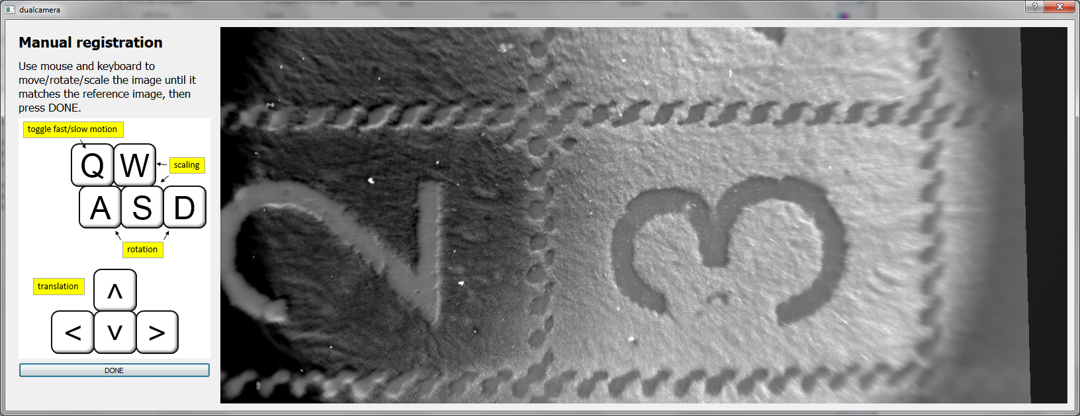

**ALIGN DATA**

The above step needs to be performed only once: then alignment parameters are saved on the disk and the ‘ALIGN DATA’ procedure can be called. (Of course if at a later time one of the camera have moved, it is possible to re-define the alignment parameters):

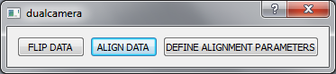

Select the data that needs to be realigned: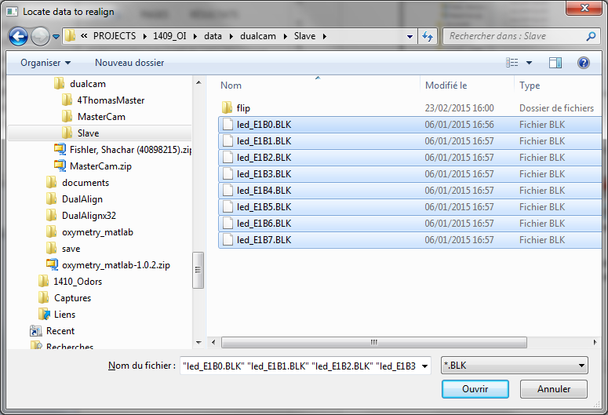

Then select just one trial of the reference data (the program will use it only to detect whether recordings were made from the whole camera view or only from a sub-ROI): 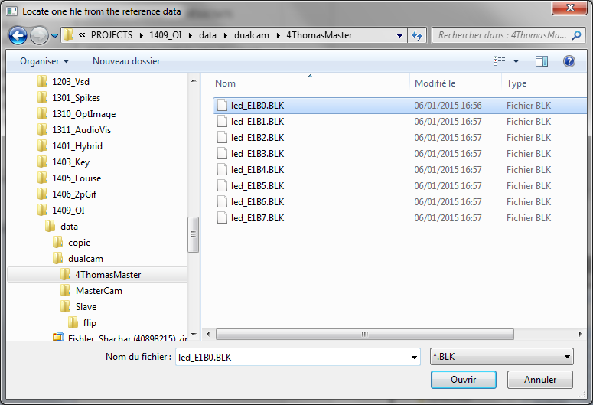

The program performs the realignment.  
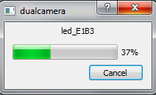

Then a new folder has been created:  
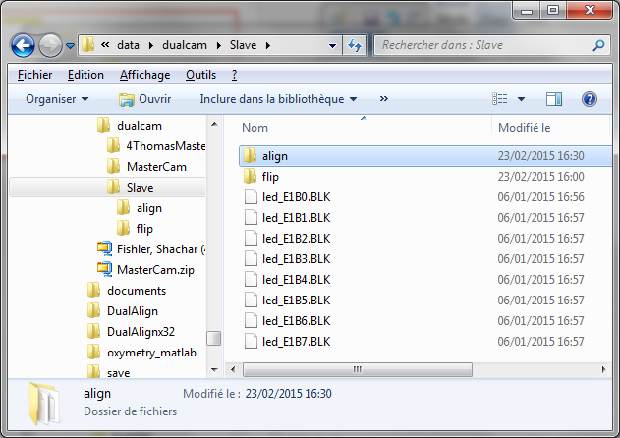

With the realigned data inside it:  
