Thomas Dagier

Quentin Rod

Practical work 01 - 21st of February 2023

Exercice 1: Python installation

Exercice 2: Python language in a nutshell

Exercice 3: Perceptron Learning Algorithm

After implementing the perceptron learning algorithm, we tested out several parameters to see how the decision boundary fit to our dataset.

With 1000 points splitted in half, here is what we expect :

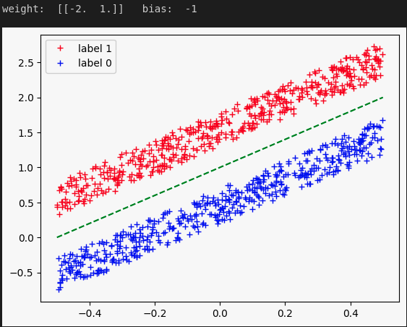

Best decision boundary for 2 x 500 points

and here is what we have :

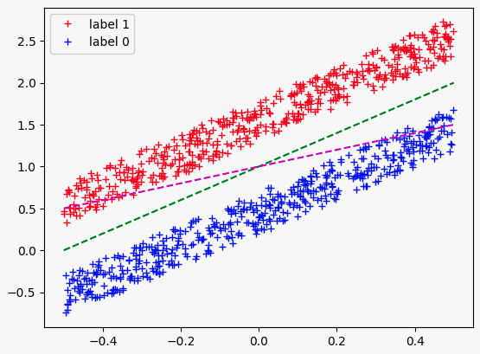

Plot of initial parameters for 2 x 500 points



Number of iterations and trained parameters for 2 x 500 points

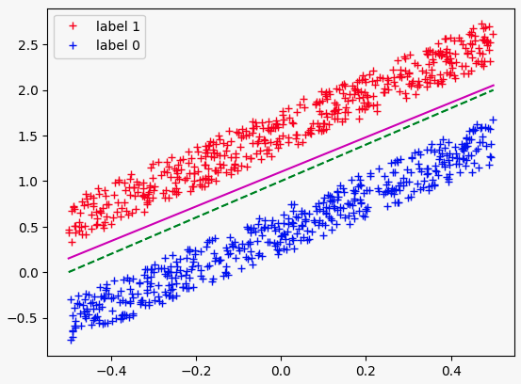

(in purple) Decision boundary after the perceptron learning algorithm for 2 x 500 points

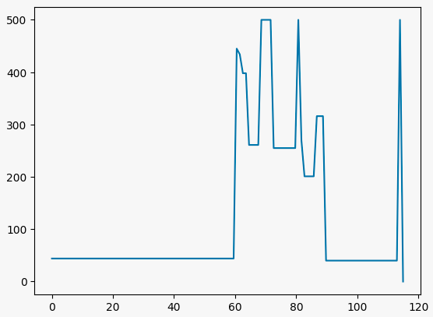

Plot of misclassifications per iterations for 2 x 500 points

An idea to see if it converge would be to test for several number of points and learning rate

* 2 x 50 points and alpha = 0.5

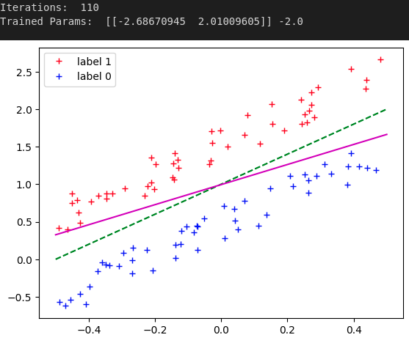

* 2 x 50 points and alpha = 0.1

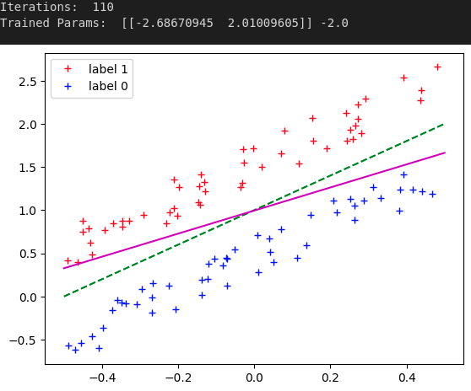

* 2 x 50 points and alpha = 0.01

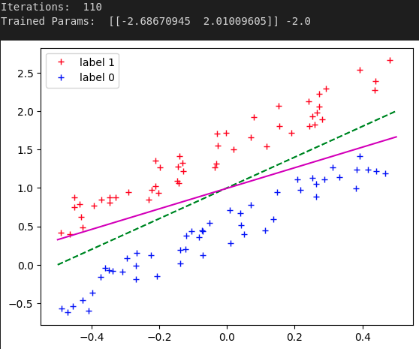

* 2 x 5000 points and alpha = 0.5

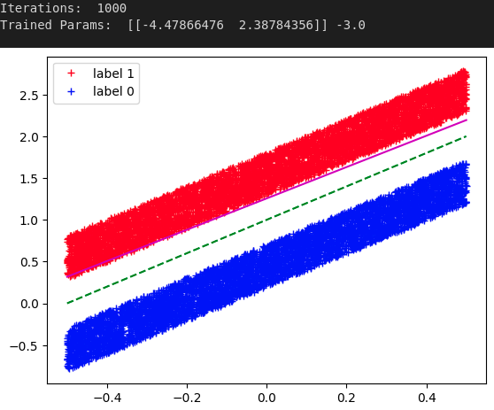

* 2 x 5000 points and alpha = 0.1

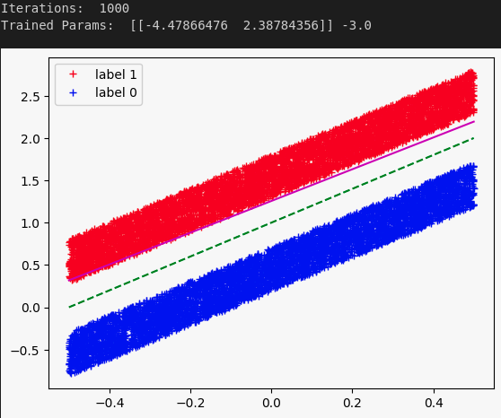

* 2 x 5000 points and alpha = 0.01

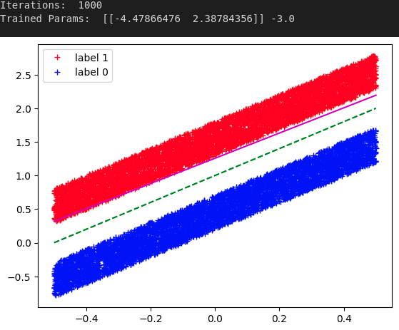

As we see, the decision boundary found using the Perceptron algorithm seems good but changes a bit depending on the learning rate we choose. However, it seems like this algorithm converge no matter the number of points or learning rate