# Quick guide: colour polymorphism

Thomas E. White1, Darrell J. Kemp1

1Department of Biological Science, Macquarie University, Sydney, Australia 2109  
**Phone:** +61 2 9850 6279  
**E-mail:** thomas.white@mq.edu.au

**Keywords:** evolution, adaptation, variation, sensory ecology, communication

***What is colour polymorphism?***

Colour polymorphism is defined by the presence of multiple discretely coloured variants within a single population, the rarest of which is too common to be solely due to recurrent mutation. A requirement that the variation be primarily genetic, that is, highly heritable, is sometimes adopted to distinguish polymorphism from polyphenism---the latter of which describes variation arising from interactions between a single genotype and varied environments. Sexual dimorphism, purely ontogenetic colour change, and reversible colour variation within populations are also implicitly excluded.

The number of morphs withing a population can vary considerably. Dramatic examples include the 'exuberantly' polymorphic Hawaiian happy-face spider *Theridion grallator*, with over 12 morphs coexisting across four Hawaiian islands, and the poison strawberry frog *Oophaga pumilio*, with over 20 true-breeding morphs across their Central American distribution (Figure 1).

***How do they develop?***

The genetic architecture of colour polymorphisms can vary enormously. In the simplest case, as in some damselflies, frogs, and cichlid fish, morphs may be determined by allelic variation at single locus and follow a simple Mendelian inheritance pattern.

Supergenes - heliconius

Genetics, physiology (pigment vs structural). Human eye colour? Wellen. often correlated

***Is it common?***

Yes, polymorphisms are ecologically and taxonomically widespread. They occur in species that inhabit most terrestrial and aquatic habitats, and are found in most major groups of animals, as well as among flowering plants. Since colour is central. Polymorphism are common in sexual systems, and may ... They span terrestrial and marine habitats, and serve functional roles in the contexts of sexual signalling, mutualism, mimicry, aposematism, crypsis, and prey luring. The broader consequences of polymorphism are similarly diverse, and are even known to shape the fundamental processes of speciation and extinction.

***Why are colour polymorphisms puzzling?***

Colour is a conspicuous feature of the natural world, and one that is frequently under strong selection. Colour polymorphism are thus of interest in evolutionary biology because we may naively expect natural selection to erode variation and settle on a single optimum. The persistence of such extreme variation therefore offers a simple visual tool with which we can explore the processes that generate and maintain variation; the fuel for adaptive evolution. This feature of polymorphism has long been exploited---particularly in the pre-molecular era---

***So how is polymorphism maintained?***

Stable polymorphisms are thought to require some form of balancing selection to maintain equal fitness (on average) between morphs, lest a population be driven to monomorphism. The best established mechanism is negative frequency dependent selection, which occurs when rare morphs enjoy a selective advantage. This translates into greater relative fitness which, as a result, increases the rarer morphs' frequency until it becomes the more common variant. The process is particularly common in the contexts of crypsis, in which predators may learn to identify the more common morph, and in sexual systems, in which colour morphs often correlate with distinct mating strategies. The side-blotched lizard *Uta stansburiana* provides a classic example. Males occur in three forms---blue, orange, and yellow throated---that map onto distinct strategies for territory defence. Importantly, each enjoys a rare-morph advantage over only one other morph. Blue males are susceptible to invasion from orange, who lose territory to yellow individuals, who, to complete the rock-paper-scissors dynamic, cede territory to blue males. The relative frequency of morphs predictably oscillates over short time scales, but the three-morph system appears to be evolutionarily stable.

Heterozygote advantage---wherein individuals that are heterozygotic at a given locus are fitter than their homozygous counterparts---is another form of balancing selection, but there are fewer clear examples of it acting to maintain colour polymorphism. Geographic and temporal variation in selection has also been suggested as a possible driver, but it remains unclear whether such variation is sufficient unto itself to maintain stable polymorphisms, or whether it need act in concert with other processes. Ultimately, polymorphisms are often shaped by a suite of selective and neutral processes including secondary contact, hybridisation, gene flow, nonrandom mating, and genetic drift.

***What are the consequences of colour polymorphism?***

We discuss the ecological and evolutionary consequences of polymorphism, such as population structure and ranges, individual behaviour, and rates of speciation and extinction.

Genetic correlation (Mckinnon)

***Where can I find more?***

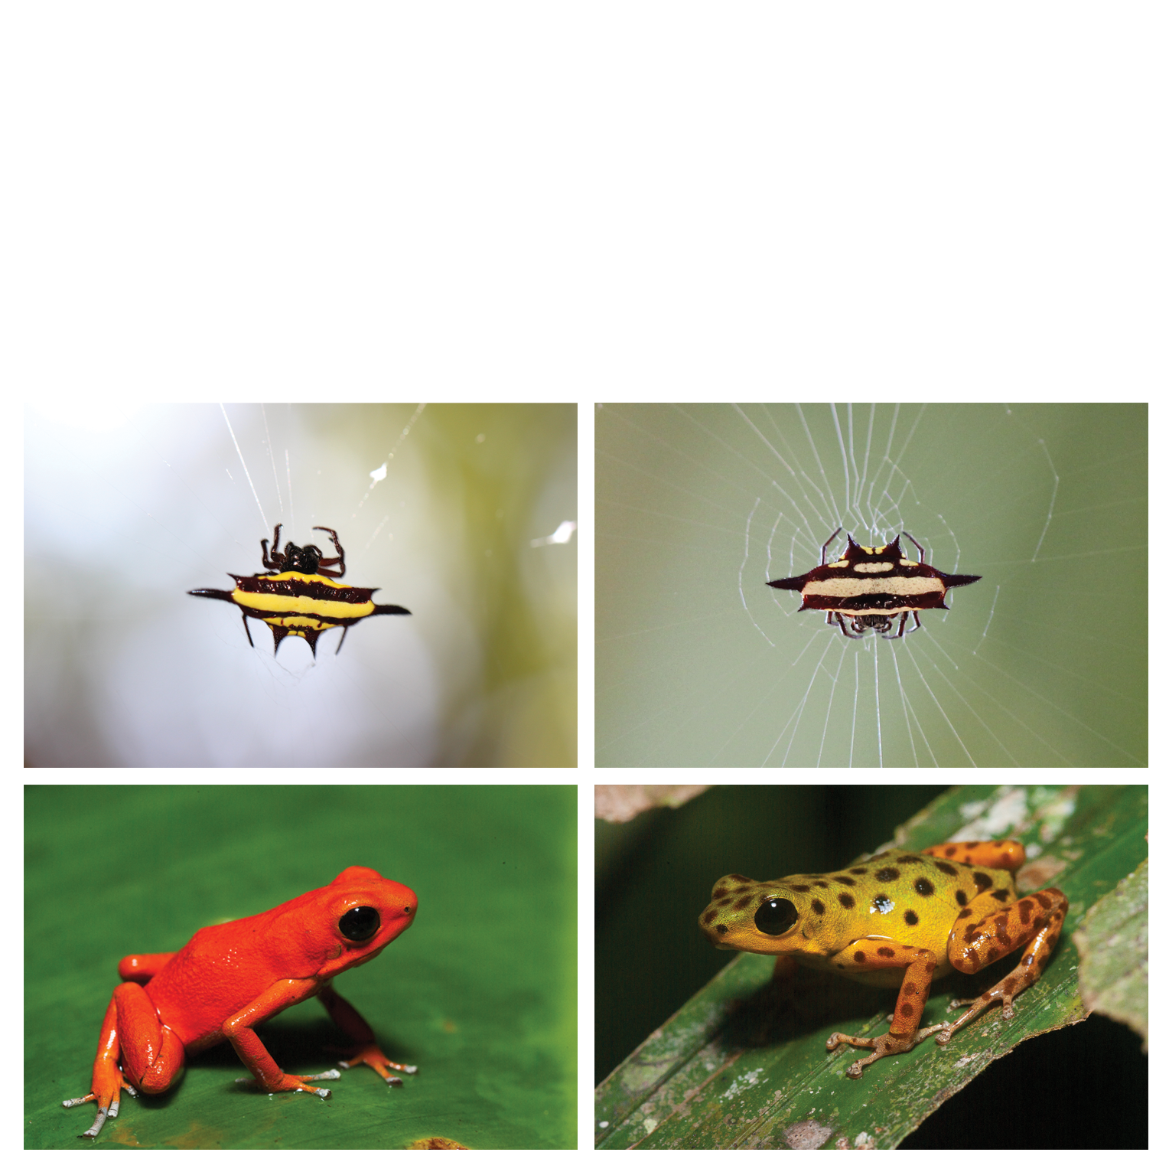

Colour polymorphisms in nature. (a, b) Both morphs of the spiny spider *Gasteracantha fornicata*, whose colour patterns visually lure prey. (c, d) Two of 15 morphs of the aposematic poison frog *Dendrobates pumilio* (photos: Justin Lawrence). (e) Extreme colour and pattern variation in the intensively studied land snail *Cepaea nemoralis*.

# References

1 Bond, A.B. (2007) The evolution of color polymorphism: Crypticity, searching images, and apostatic selection. *Annual Review of Ecology, Evolution, and Systematics* 38, 489–514

2 Gray, S.M. and McKinnon, J.S. (2007) Linking color polymorphism maintenance and speciation. *Trends in Ecology & Evolution* 22, 71–79

3 Wellenreuther, M. *et al.* (2014) Sexual selection and genetic colour polymorphisms in animals. *Molecular Ecology* DOI: <http://doi.org/10.1111/mec.12935>

4 McLean, C.A. and Stuart‐Fox, D. (2014) Geographic variation in animal colour polymorphisms and its role in speciation. *Biological Reviews*

5 Roulin, A. (2004) The evolution, maintenance and adaptive function of genetic colour polymorphism in birds. *Biological Reviews* 79, 815–848

6 Ford, E.B. (1945) Polymorphism. *Biological Reviews* 20, 73–88