**User Experience (UX) Design Case Study - Oxfam**

In this case study, I will be examining the website of the charity organisation Oxfam and then employing user experience (‘UX’) principles and methods to offer suggestions to improve its achievement of user and business goals.

Objectives

To review Oxfam’s existing website from a user experience (UX) perspective; identify any existing pain points or areas of friction to users; to suggest ways to improve the UX; and finally to demonstrate how these suggestions will enable users to achieve their goals more easily as well as enabling Oxfam themselves to better achieve their business goals.

Target users

From material available in the web public domain, I have found that Oxfam classify their supporters into half a dozen or so groups, including Regular giver, Single giver, Campaigner, Shop Purchaser, and Shop Gift Aider. Each of these groups represents one or more use cases that I can use to evaluate existing user journeys through the Oxfam website.

Due to the broad reach of Oxfam’s supporter base, at this stage I have declined to create customer personas that make assumptions about age, gender, ethnicity or other demographic information. For example, a significant portion of charitable donations typically comes from older people, but there is also evidence to suggest that people aged between 20 to 34, the socio-economic tranche known as “millennials”, may have a higher propensity for charitable donation than many of their predecessors.

Business goals

Oxfam is a confederation of numerous businesses and charities that operates throughout the developed and developing world. Its mission is to help some of the most deprived and vulnerable sections of modern society. As a large, multi-national organisation Oxfam has a number of high-level business goals which will be familiar to most - in no particular order:

* Firstly, it needs to publicise and curate its brand’s perception in the eyes of the public.
* Secondly, it needs to keep driving donations in order to sustain itself as a functioning business.
* Thirdly it needs to sustain its charity shop business, which provides a substantial amount of its annual revenue.
* Finally, it needs to attract volunteers to contribute their time, energy and initiative.

Now that we have established a number of Oxfam’s high-level goals, we can translate these into measurements that we can use to assess its current and potential performance. This study is focusing solely on Oxfam’s website, so we need to decide upon key metrics that prove that visitors to the site are completing certain actions. With this in mind, each of the goals stated above suggests the following key performance indicators (KPIs):

Increase brand awareness:

* Time spent on website per session.
* Customer market research surveys.
* Social results such as number of likes/pins/etc, or the number of shares.

Increase donations:

* Volume of donations made.
* Average amount of donation.
* Volume of donators.
* % difference of year-on-year donation amount.

Sustain/increase shop sales:

* Number of visitors.
* Number of website users enquiring about shops.
* Cost of loss prevention (stock loss or cash loss).
* Revenue generated.

Attract and retain volunteers and employees:

* Volume of volunteers.
* Amount of time donated per volunteer.
* Total number of hours volunteer time.
* % difference of year-on-year volunteer numbers.
* Loss rate of volunteers.

As I am primarily focusing on Oxfam’s user experience with their website, I am going to ‘cherry-pick’ several of these KPIs which are most relevant and decide on measurements that can be collected to assess Oxfam’s current and potential achievement of its goals. We must also consider at this stage if we wish to segment our data by geographic area; by new versus returning users; or by some other dimension.

User goals

After considering the business objectives in detail and how to measure them, we must also remember that the users’ objectives will not always be the same. Our primary concern as an organisation may be the achievement of our business objectives, but as a UX practitioner, if we fail to make it easy for users to achieve their specific goals, our business will suffer as a result. With this in mind, I am going to focus on the following user aims:

1. To learn about Oxfam by consuming content from its website.
2. To learn more about volunteering opportunities with Oxfam through its website.
3. To visit an Oxfam shop, as a result of making use of a store locator provided by the Oxfam website.
4. To complete an online financial donation.

We can therefore assess the degree to which our website meets these aims, through the use of some key quantitative metrics, many of which I have already mentioned. Our most important quantitative metrics will therefore be:

1. Average time spent on website per user session.
2. Number of website visitors making use of a feature focused solely around Oxfam shops, such as a store locator.
3. Number of times a so-called ‘micro-conversion’, such as a visitor signing up to receive email, is completed.
   1. Number of website users completing an online donation (a so-called ‘macro-conversion’)*.
   2. Average amount per donation.

Quantitative measurements are extremely useful, but to obtain the most useful feedback on the user experience we must also seek to evaluate the quality of our users’ experience. Questions we should ask our users might include:

1. How engaging and interesting do you find the material available on the Oxfam website?
2. How easy was it to find information about volunteering in your area?
   1. How easy to use did you find the Oxfam website store locator?
   2. How likely are you to visit an Oxfam shop as a result of this feature?
   3. How easy was it to donate through the website?
   4. How likely are you to donate again as a result of your experience with the website?

* The different between macro and micro conversions is that a macro-conversion represents the single task that is most important for users of your website to complete, whereas a micro-conversion represents a step toward that achievement. For example, for an e-commerce store a macro-conversion would be buying something; a micro-conversion could be signing up to receive emails about new offers.

Tasks for users

Before proceeding with user testing sessions, first I planned out two different types of session. I then evaluated both of them to decide which would be more appropriate for this particular case study.

Option 1 - Site Usability Test

To carry out testing of the existing Oxfam site in this way, I would ask several acquaintances to help me by using the Oxfam website under my supervision. None of them will have used it before, so they will be able to approach it with no prior experience or preconceptions about its contents.

I will present each of the testers with a number of tasks that they needed to complete:

1. Firstly, they are to get set up to receive email updates from Oxfam.
2. Find information about volunteering opportunities in your local area, the North-West of England.
3. Use the website to find directions from your current location to the nearest Oxfam store.
4. Complete giving a single online donation of £0.50 to Oxfam (NB for the purpose of this test, the tester can use my payment details to complete this task).

NB An example of how each scenario will be worded is the following: “Imagine that you’re looking for volunteering opportunities in the North West… go ahead and find what Oxfam have to offer.” When directing participants, I will have to bear in mind that it’s important not to sway the user’s behavior by mentioning key words on the site when explaining a scenario (i.e. “Go ahead and use the shop finder” would not be ideal because that offers the user additional direction).

Option 2 - Information Architecture Test

To test in this way, I would ask two more people to take part in an activity to help me assess the layout and organisation of the Oxfam website. To do this, I will already have looked through the main sections of the website, and written out a set of A6-size cards each displaying the title of a section. I will then ask each person to take the deck of cards, randomly shuffled, and to sort them into the grouping that they found most logical. I will use the following list of titles:

|  |  |  |
| --- | --- | --- |
| Sign up for email  Introduction to Oxfam  Impact of our work  Emergency response  About us  Fundraising  Even it up  Festivals  Shop finder  Blogs  Donate in memory | Volunteer with us  Campaign with us  Philanthropy  Minutes to spare  Donate a day  Make it regular  Collections  Monthly donations  Give something in your will  Oxfam treasures  Oxfam unwrapped | Gift aid explained  Pioneers  Donate your time  How we spend your money  Donate to shops  Donate goods  Yemen crisis  Support projects  One-off donation  Teachers  Policy and practice |

After careful consideration I decided to use option 1 for the purpose of this case study.

User feedback

Task 1 - Usability Test

I carried out the usability test with 4 different testers. I have grouped the feedback from the usability tests firstly by tester, and then by each of the tasks they undertook.

Tester 1:

Task 1: Sign up to receive email updates from Oxfam:

* The tester found the ‘sign-up’ link easily from the main page.
* However - they then found a number of small objections to the way the sign-up page was set out.
* “The email sign-up process is confusing - why does it ask me to tick a box saying “Email”? What happens if I don’t tick it - will I then not receive the emails, despite asking for them?”
* “I like the fact that you can forward the first email you receive to a friend…”
* “There was no way of specifying what frequency I am happy to receive email updates at from Oxfam.”

Task 2: Find information about volunteering opportunities in your local area, the North-West of England:

* The tester found several different menus containing the word “Volunteer”, so they found it difficult to find exactly the right area to do this task.
* Eventually, after viewing several different menus, they found the right section, called “Find a volunteering opportunity”.
* “There’s no option for the North-West region - I’ll have to select either North or West.”

Task 3: Use the website to find directions from your location to the nearest Oxfam store:

* This user challenged why the drop-down in the main page’s header was there, because it contained duplicated items.
* They commented that they liked the highlighting of key headings in orange, as this made them stand out from the rest of the page.

Task 4: Complete giving a single online donation of £0.50:

* This user felt there was a lot of information to fill in; too much in fact.

Tester 2:

Task 1: Sign up to receive email updates from Oxfam:

* This user found the option on the homepage called “[Create my Oxfam account](https://www.oxfam.org.uk/account/register/)” and mistook this for the option to sign up to receive emails.
* They proceeded to follow this process to conclusion, because it included a tick-box to indicate whether they wanted to receive email or not.
* She was surprised when I pointed out that there had been another option on the homepage.
* “Why is it all the way down at the bottom of the page? No wonder I didn’t see it!”

Task 2: Find information about volunteering opportunities in your local area, the North-West of England:

* Because of the previous task, this tester was unsure whether she should stay logged in to complete this next task or not.

Task 3: Use the website to find directions from your location to the nearest Oxfam store:

* The tester felt that there was no prominent store locator link on the homepage (there was a link in the header, but it was not very conspicuous).
* She scrolled down to the bottom of the site and then scanned the footer.
* “I’ve often found before that sites list all of their features and pages on the footer, so I’m hoping I’ll find it there.”
* A link to the shop finder was indeed available in the footer.

Task 4: Complete giving a single online donation of £0.50:

* “The donation page is really easy to find because it’s highlighted and in plain sight on the homepage.”
* On the donation page, the user can enter their own amount to donate.

Tester 3:

Task 1: Sign up to receive email updates from Oxfam:

* This tester thought it was bad that he had to scroll all the way down to the bottom of the homepage, before being able to sign up to receive email.
* He did not want to get spammed, and so noticed that there is no way to indicate the volume of email that you’re consenting to receive.
* “As an option, it’s definitely not easy to find.”

Task 2: Find information about volunteering opportunities in your local area, the North-West of England:

* From the homepage, this tester clicked the following links: “Get Involved” > “Volunteer with us” > “Local community”.
* At this point, he realised that he was lost, and so navigated back to the homepage in order to try again. On his second attempt, instead of “Volunteer with us”, he clicked “Find a volunteering opportunity”, which then yielded a menu allowing him to choose his geographic region.

Task 3: Use the website to find directions from your location to the nearest Oxfam store:

* The tester first noticed the drop-down menu contained in the header, which contains a link to the “Shop Finder”.
* He did not notice that the same link was also available in plain sight in the header, beneath the drop-down menu.

Task 4: Complete giving a single online donation of £0.50:

* The tester did not notice that a drop-down field distinguishing between a monthly and single payment, had defaulted to “monthly”; therefore he had to stop the process and return to a previous screen to correct this.
* He felt he had nearly “been duped” into setting up a monthly payment plan.
* “I like how the site shows you causes and activities that your money will be spent on… it really makes you feel like it’s worthwhile.”
* “I don’t think that the choice of three pre-set amounts is helpful. Maybe if they were smaller amounts, I’d be more likely to choose one - but £10, £25 and £50 are just too high to be considered.”

Tester 4:

Task 1: Sign up to receive email updates from Oxfam:

* This tester scanned the whole homepage looking for a field seeking an email address. He commented that the ‘Sign up’ link at the top, could be misinterpreted as this.
* This user commented that there is no way for Oxfam to verify the user’s email address after they’ve submitted it.
* “Why do they have form fields asking for my title, first name and surname, when all they need to capture is my email address? Why do they need this extra information?”

Task 2: Find information about volunteering opportunities in your local area, the North-West of England:

* This tester clicked on the “Get Involved” heading straight away, but once inside this section, became quite confused. He felt that there were a lot of menu options, all containing the word “Volunteer” in the heading, and so it was difficult to navigate to the right place.
* Upon finding the section containing a region selector, this user commented that a postal code lookup service might be better, as it would show more accurate results nearby.
* The user wanted to bookmark an opportunity but there was no way to do this easily.

Task 3: Use the website to find directions from your location to the nearest Oxfam store:

* There is a large section, available from the homepage, entitled “Online shop”, but finding a store locator is not so obvious. This user searched for a little while before finding the link on the homepage. They did not think it was prominent enough, especially compared to some of the other links.

Task 4: Complete giving a single online donation of £0.50:

* This user felt that during the donations setup process, a lot of personal information was requested - possibly too much.
* He felt that under normal circumstances, being asked for all this information might cause him to abandon the process.
* “This is the most obvious link on the homepage - so it’s really the easiest thing to find.”

Tester 5:

Task 1: Sign up to receive email updates from Oxfam:

* The tester immediately clicked the “Create my Oxfam account” link that’s available in header of the homepage.
* When the next page loaded and it became obvious he would need to register and provide some personal information, he didn’t seem sure of whether this was the best way and asked for confirmation.
* Once he decided to continue with this process, he commented that the sign-up process was “pretty straightforward” and didn’t ask for too many pieces of personal data.

Task 2: Find information about volunteering opportunities in your local area, the North-West of England:

* The tester scrolled all the way down to the bottom of the homepage when presented with this task.
* Once at the page footer, he clicked on the following links: Get Involved > Volunteer with us > Find a volunteering opportunity.
* When asked if he would improve this area of the site at all, he commented that he would put the majority of the footer’s content in the header at the top of the page, so that pages would be far easier to be found.

Task 3: Use the website to find directions from your location to the nearest Oxfam store:

* The tester clicked “Get Involved” on the large prominent banner in the homepage header.
* He also mentioned at this point that he had previously seen and used the “Get Involved” link in the page footer too.
* After reviewing the page that loaded from clicking “Get Involved”, he decided he’d made a mistake and clicked on “Shop Online” from the header banner instead.
* When the “Shop Online” page loaded, initially he expressed confusion - but when he scrolled down the page, he noticed a separate section called “Shop, volunteer or donate to Oxfam shops”. This section had a sub-section called “Donate or shop with us”, and under this, there was a link entitled “Oxfam shops”. When this was clicked on, it took him to the Shop Finder page.

Task 4: Complete giving a single online donation of £0.50:

* This tester found it easy to choose and click on the large, orange “Donate” button in the homepage header. He said this was “made very clear and easy”.
* Interestingly, on the donation page, he said he didn’t “think that you can donate just 50 pence, as all the content talks about what a pound gets spent on…” In fact, I believe that any monetary amount would be acceptable.
* The tester ignored the drop-down field indicating whether the payment was a monthly, or single amount. He did not complete the full transaction, otherwise he would have realised that he had selected monthly payment by default, when he intended to select single.

Common findings

After reviewing all of the feedback from these sessions, I found that all of the comments could be grouped into a number of thematic areas:

* Contextual choices
* Duplication
* Fields
* Links
* Navigation
* Organisation

Recommendations

As a result of conducting this user testing, there are a number of potential suggestions that could be enacted. I have organised them below by thematic area, as well as cross-referencing them alongside the user-focused KPI/s that I think they will have an impact on:

|  |  |  |  |  |
| --- | --- | --- | --- | --- |
| ***Area / KPI*** | *KPI 1 - Average time spent on website per user session.* | *KPI 2 - Number of website visitors making use of a feature focused solely around Oxfam shops, such as a store locator.* | *KPI 3 - Number of times a visitor signing up to receive email, is completed.* | *KPI 4 - Number of website users completing an online donation / Average amount per donation.* |
| *1 - contextual choices* | 1a Do not have the ‘type of payment’ option as ‘monthly’ by default. | - | - | 1b Reduce the three example donation amounts presented on the single donation page. |
| *2 - duplication* | - | - | 2a Remove the dropdown at the top of the page that contains duplicates of some of the links from the header. | - |
| *3 - fields* | - | - | 3a Increase the number of frequency options a user has when signing up to receive email. | 3b Remove several fields from the online donation pages. |
| *4 - links* | - | 4a Make the shop finder panel more prominent.  4b Add another prominent link into the accented banner in the header, named “Shop in-store”. | 4c Move certain links from the header to the footer to make others more prominent. | - |
| *5 - navigation* | 5a Simplify the links/nav structure tree around volunteering. | - | - | - |
| *6 - organisation* | 6a Consider demoting or entirely removing the option to register for an account with Oxfam. | - | 6b Move the email sign-up panel to the top of the page so that it is more visible to users. | - |

The current homepage design

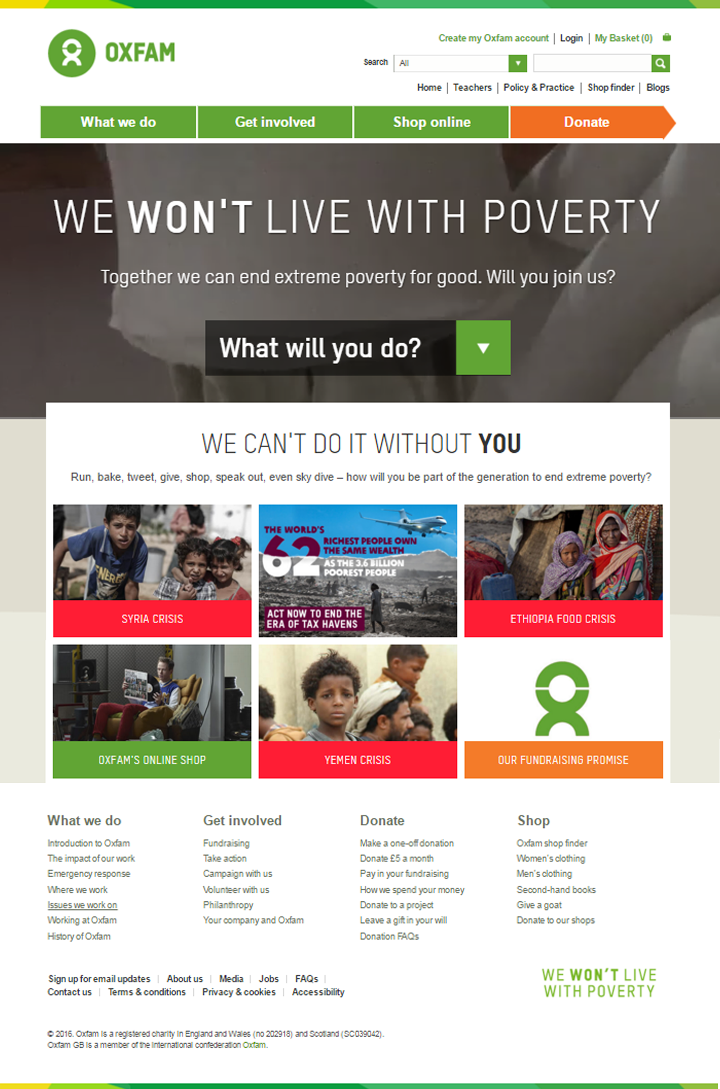

The new proposed homepage design

My proposed new version of the Oxfam homepage contains the following changes:

1. A new prominent item incorporated into the header’s banner called “Shop in-store”.
2. No drop-down in the header, as this was confusing to users and a duplication of links available elsewhere.
3. The email sign-up panel is now in the header so that it is more obvious to users.
4. Both the email sign-up and shop finder panels in the header are far more prominent now.
5. The option to register for Oxfam has been moved down to the page footer, as users were confusing this with signing up to receive emails.
6. Some other links from the header have been moved to the footer to reduce confusion.
7. I have added another large, prominent ‘call to action’ button to encourage donations.

(See overleaf for the new proposed design.)

Conclusion

The Oxfam homepage has a number of vitally important user goals. These goals are overall reasonably easy to accomplish, but when tested with a group of users that had never used the site before, it was found that several elements of the site were arranged sub-optimally.

The proposed new design above, is just one single suggestion of how the site could be altered in order to hopefully improve its performance and overall usability.

However - this is only one of a myriad approaches that could be adopted. I recommend that the owners of this site implement A/B, or ‘split’ testing (by sending users at random to one of several different versions of the site, and then monitoring the overall usage analytics for each different site). This will allow them to experiment with several different changes to the arrangement of page elements, and quickly establish through the use of objective data which is most effective.

I also recommend that the owners of the site be prepared to frequently re-test their site with new users, as frequent customer feedback is one of the most effective ways to continually optimise a website or piece of software.

