Pi Weather Display

WaveShare eInk Display 7.5"  
170 x 111mm

Push Buttons  
69 x 20mm

Ø 8mm drill hole, countersunk to 10mm (inside-out)

Ø 4mm

Version 2023-01-27

Base Plate  
210 x 150mm

Plexiglas Base Plate

Optional Sensor Devices

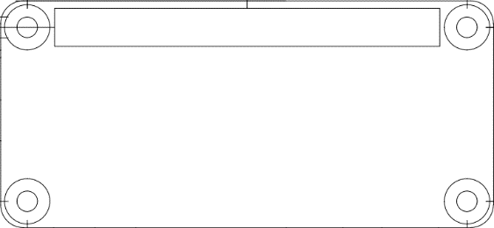

Raspberry Pi Zero 2  
(Optional: PiJuice Battery Controller)  
65 x 30mm



WaveShare Display Controller  
65 x 30mm

Ø 2.5mm

Optional: PiJuice Battery Pack (12000mAh)  
130 x 70 x 10mm

SCD41  
23 x 21mm

Ø 3mm

USB Power Plug  
39 x 16mm

Ø 3mm

|  |  |  |
| --- | --- | --- |
| **Device** | **Picture** | **Drill Template** |
| BME280 |  | BME280 15 x 11mm  Ø 3mm |
| BME680 | BME680 | Joy-IT | BME680 16 x 19mm  Ø 2mm |
| SCD41 |  | SCD41 23 x 21mm  Ø 2.5mm |