Version 2023-03-02

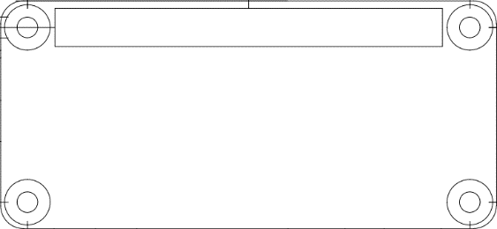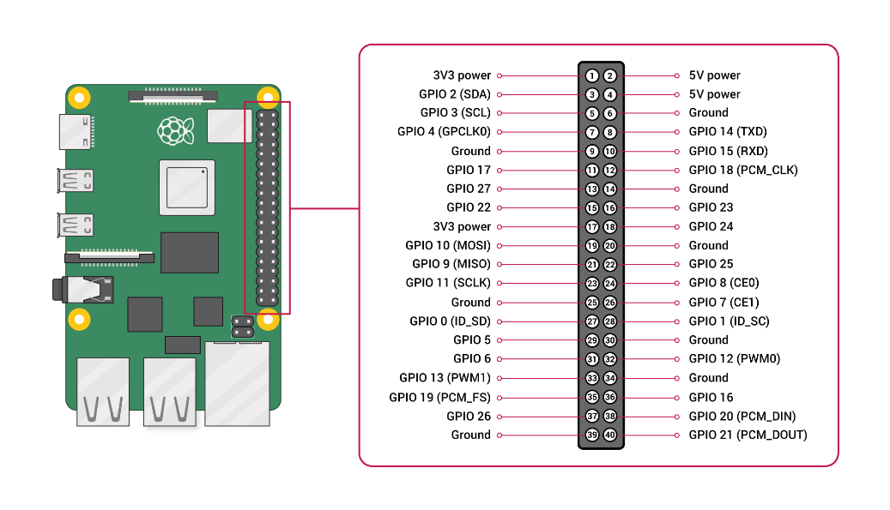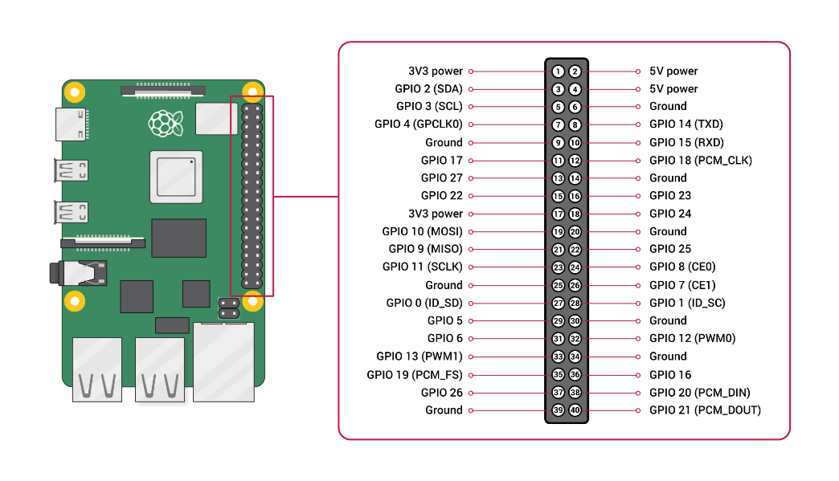

|  |  |  |
| --- | --- | --- |
| **Device** | **Device Pin** | **Raspberry Pi GPIO Pin** |
| Bosch BME680 Environment Sensor | VCC | 1 |
| SDA | 3 |
| SCL | 5 |
| GND | 6 |
| WaveShare 7.5” ePaper Display | RST | 11 |
| VCC | 17 |
| BUSY | 18 |
| DIN | 19 |
| DC | 22 |
| CLK | 23 |
| CS | 24 |
| GND | 39 |
| Push Buttons | Button 2 | 29 |
| GND | 30 |
| Button 1 | 31 |
| Button 3 | 36 |
| Button 4 | 37 |

**Links**<https://www.waveshare.com/wiki/7.5inch_e-Paper_HAT_Manual#Working_With_Raspberry_Pi>   
<https://www.laub-home.de/wiki/Raspberry_Pi_BME680_Gas_Sensor>