Polymorphism is the ability for a child class to inherit abilities from a parent class and adjust the method based on what the child class needs. It can be abstract, where the child class must implement its own version of the method or it can be virtual, where the child class can use the parent method and add its own content as well.

A benefit of polymorphism is that it allows more classes to be shared by child classes in the base even if they need to implement them differently.

An application of polymorphism would be a StartVehicle() method in a vehicle parent class. A GasCar child class may implement StartVehicle() by simply turning a key in the ignition, whereas a DieselCar might implement the same class by putting key in ignition, turning key to on, waiting for coils to warm up, then turning key to ignition.

This code is from the EternalGoal class:

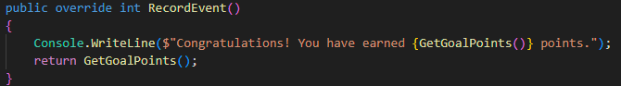

And this is from the ChecklistGoal class:

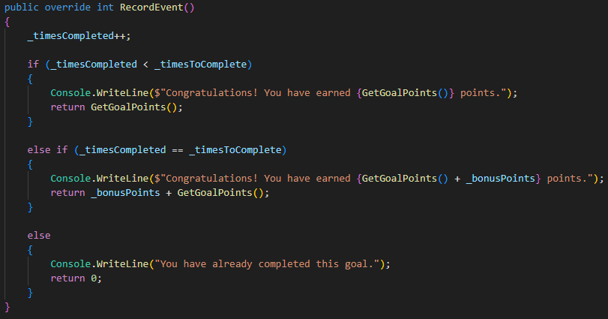

It is the same record event method but implemented differently for each class because different goals have different ways needed to record an event, but because they both need record event RecordEvent() is an abstract class in the base class.