Letter of Credit Management
User Manual
ERPNext / Printechs LC Application

Item | Details
Site | moosa.local
Company | Mohammed Abdullah Almousa Trading Company
Prepared Date | 2026-05-29
Sample LC | LC-2026-00001 / SAMPLE-LC-001
Audience | Accounts, Purchase, Finance, Import/LC Operations, Management

Document Purpose
This manual explains the current Letter of Credit workflow, required setup, user responsibilities, accounting postings, reports, controls, and common troubleshooting steps.

Table of Contents
- 1. Introduction and Purpose
- 2. User Roles and Responsibilities
- 3. Initial Master Setup
- 4. End-to-End LC Business Flow
- 5. Screen-by-Screen User Guide
- 6. Accounting Entries and Posting Buttons
- 7. Reports and Monitoring
- 8. Sample Data
- 9. Controls, Best Practices, and Troubleshooting
- 10. Glossary
Word Tip
To create a live page-numbered table of contents, open this document in Microsoft Word and use References > Table of Contents.

1. Introduction and Purpose
The Letter of Credit Management module manages import Letter of Credit transactions from setup and opening through shipment tracking, document tracking, bank charges, supplier payment, bank settlement, margin release, and closure.
The module is integrated with ERPNext accounting. It uses the company Chart of Accounts, links accounting vouchers back to the Letter of Credit, and provides reports for LC ledger movement, outstanding liability, and upcoming expiries.
Screenshot Placeholder: LC Management Workspace
Show the workspace shortcuts for Letter of Credit, LC Settings, LC Ledger, Outstanding LC Liability, and LC Expiry.

2. User Roles and Responsibilities
Role | Main Responsibilities
Purchase User | Create and maintain procurement-related LC records, link Purchase Orders, and update supplier, shipment, and document information.
Accounts User | Review LC accounts, enter charges, post accounting entries, and monitor liability and settlement.
Accounts Manager | Submit and approve LC records, review accounting impact, manage LC Settings, and close LC records after settlement and margin release.
System Manager | Maintain installation, workspace access, roles, permissions, and master configuration.

3. Initial Master Setup

3.1 Chart of Accounts Setup
Each company should have dedicated LC control accounts. This keeps blocked margin, outstanding bank liability, and LC bank charges visible in reports.
Account Purpose | Example Account | Type / Location
L/C Margin Account | LC Margin Control - MAATC | Asset account, normally under Securities and Deposits or a similar current asset group.
L/C Liability Account | LC Bank Liability - MAATC | Liability account, normally under Loans or Current Liabilities.
Bank Charges Account | LC Bank Charges - MAATC | Expense account, normally under Miscellaneous Expenses or Bank Charges.
Default Bank Account | Alahli Branch 39213528000110 - MAATC | Bank account.

Control Account Note
When LC Ledger should include LC control account movement even if a voucher is not directly tagged, mark the relevant Account as an LC control account if the field is available in the account master.

3.2 LC Settings
LC Settings stores global LC controls and company-wise default accounts. These defaults populate the Letter of Credit account fields when users create a record for the company.
- Open the LC Management workspace.
- Click LC Settings.
- Review email, expiry, maturity, and utilization settings.
- In Company LC Defaults, add one row for the company.
- Select margin account, liability account, bank charges account, and default bank account.
- Save LC Settings.
Screenshot Placeholder: LC Settings - Company Defaults
Show company defaults with margin account, liability account, bank charges account, and default bank account filled.

3.3 Purchase Order Setup
If a Purchase Order is marked as LC required and submitted, a Letter of Credit button appears on the Purchase Order under the Create button group. The system can carry forward company, purchase order, supplier, currency, exchange rate, and LC amount.

4. End-to-End LC Business Flow
The following flow is the recommended operational sequence for creating, accounting, monitoring, and closing an LC.
Stage | User Action | System / Accounting Result
1. Procurement Need | Create and submit the Purchase Order. Mark LC required if applicable. | Purchase Order data can be used to create the LC.
2. Create LC | Create a Letter of Credit with company, supplier, LC type, currency, amount, dates, banks, and accounts. | LC is saved in draft state for review.
3. Submit LC | Submit the Letter of Credit. | If status is Draft, the system changes it to Requested. Accounting buttons become available after submit.
4. Block Margin | Click Block Margin. | Journal Entry debits LC margin account and credits bank account. Status becomes Opened where applicable.
5. Record Charges | Add charge rows and post each unposted charge. | Journal Entry debits bank charges account and credits bank account. Charge row is linked to the Journal Entry.
6. Track Shipment | Add shipment rows with shipped amount, BL, vessel, ports, ETA, and receipt details. | Utilized amount is monitored from linked invoices and shipment amounts. Available amount is recalculated.
7. Track Documents | Add required documents and update document status. | Operations can monitor whether documents are pending, received, verified, or rejected.
8. Confirm Bank Payment | Enable Bank Payment Confirmed and set confirmation date/reference/attachment. | Bank payment confirmation becomes available for supplier payment posting.
9. Bank Paid Supplier | Click Bank Paid Supplier. | Journal Entry debits supplier payable account and credits LC liability account. Outstanding liability is recorded.
10. Company Settles Bank | Click Settle with Bank. | Journal Entry debits LC liability account and credits bank account. Outstanding liability reduces.
11. Release Margin | Click Release Margin. | Journal Entry debits bank account and credits LC margin account. Margin release is recorded.
12. Close LC | Set status to Closed after liability is settled and margin is released. | LC lifecycle is complete.

LC Process Flow Chart
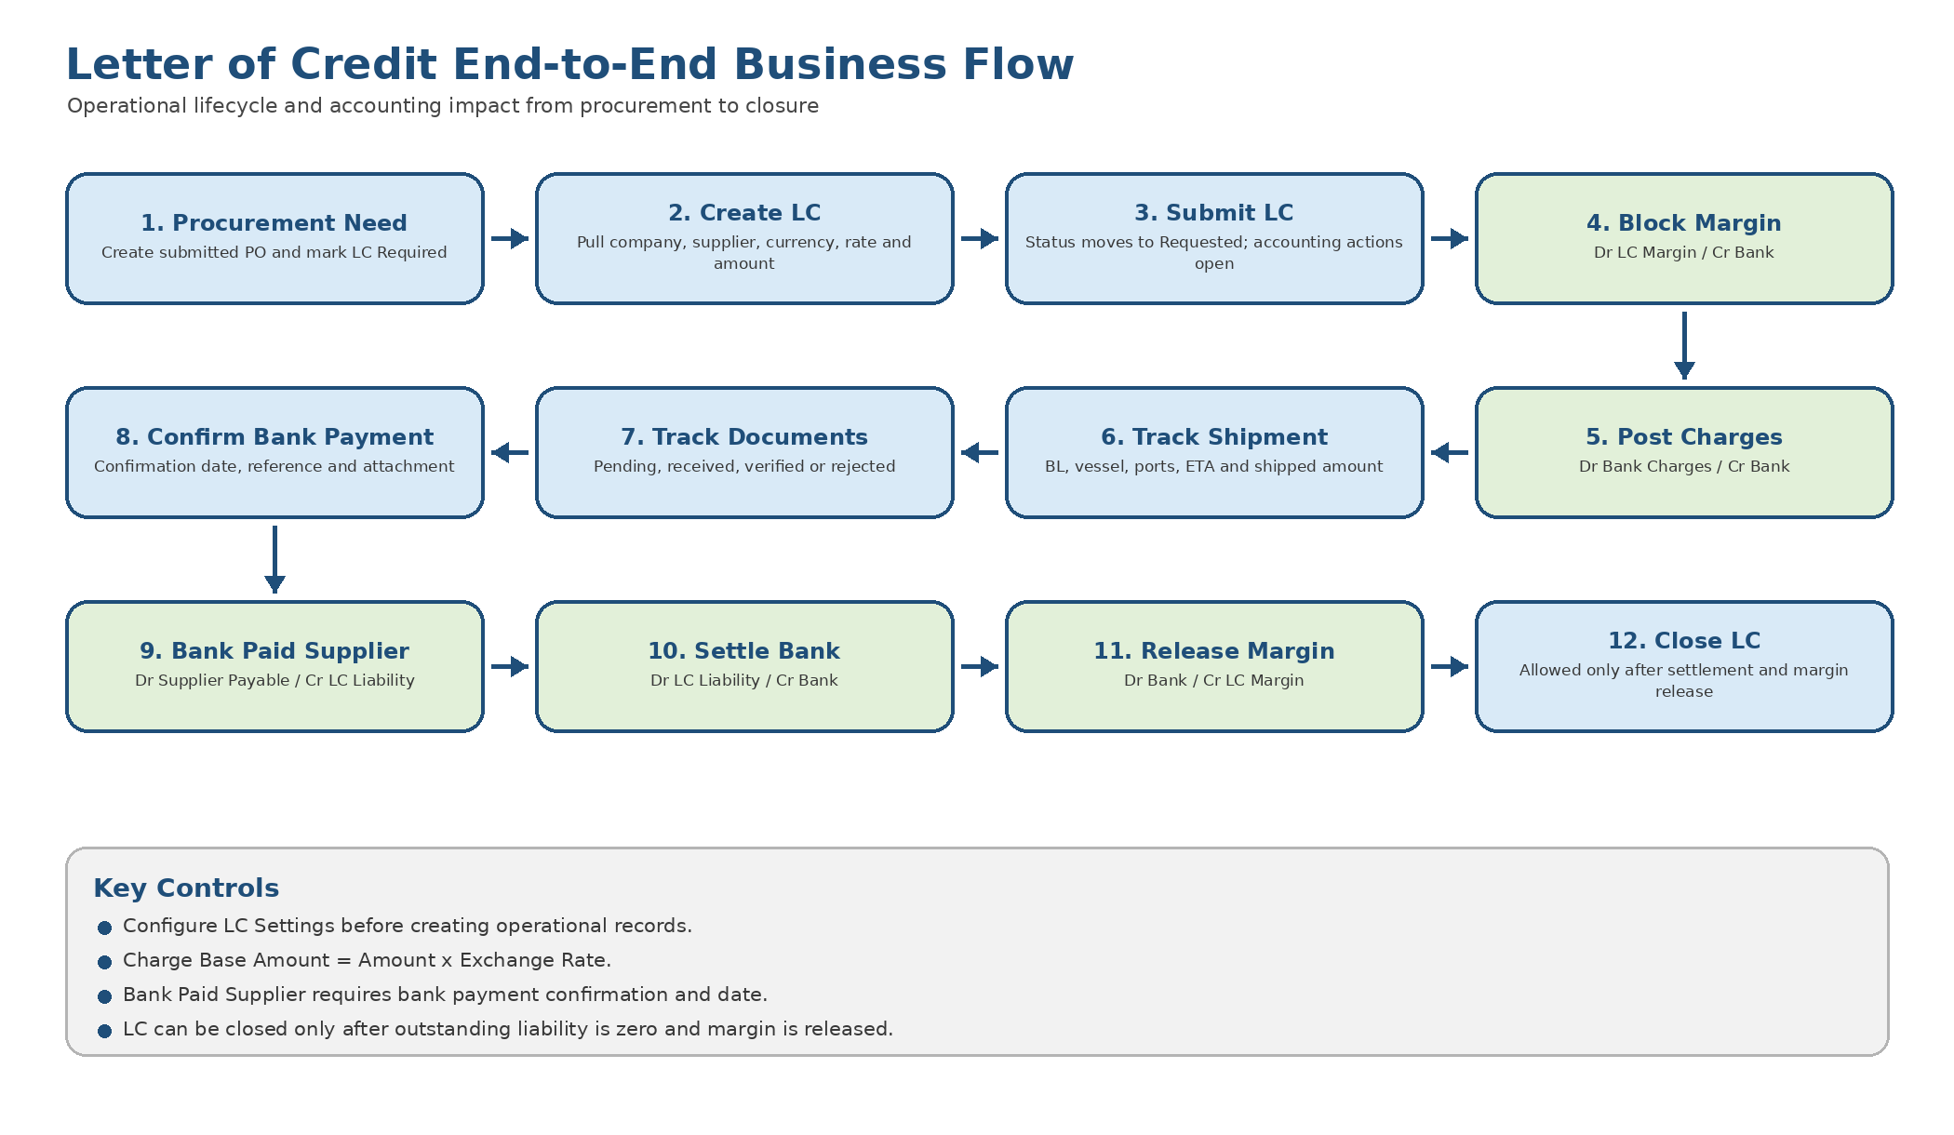

5. Screen-by-Screen User Guide

5.1 LC Management Workspace
The workspace is named LC Management and is labelled Letter of Credit. It contains shortcuts for Letter of Credit, LC Settings, LC Ledger, Outstanding LC Liability, and LC Expiry.
Screenshot Placeholder: LC Management Workspace
Show the workspace shortcut cards for Letter of Credit, LC Settings, and reports.

5.2 Letter of Credit List
The Letter of Credit list shows existing LC records and their current status. Users can filter by company, supplier, status, expiry date, or Bank LC number.
- Open LC Management.
- Click Letter of Credit.
- Use filters to find records by supplier, company, status, or expiry date.
- Open an existing record or click New.
Screenshot Placeholder: Letter of Credit List View
Show records with Bank LC Number, Supplier, Status, LC Amount, and Expiry Date.

5.3 Create a New Letter of Credit
Use this form to capture the full LC lifecycle. Required core fields include company, supplier, LC type, currency, exchange rate, LC amount, margin account, liability account, and bank charges account.
Field / Section | Description
Company | Company for which the LC is opened. Defaults from LC Settings are loaded for this company.
Supplier / Beneficiary | Supplier receiving payment through the LC.
L/C Type | Irrevocable, Sight, Usance, Standby, Revolving, Transferable, Back-to-Back, or Revocable.
Purchase Order | Optional submitted Purchase Order link. When selected, supplier, currency, exchange rate, LC amount, company, and incoterms can auto-fill.
Currency / Exchange Rate | LC currency and conversion rate.
L/C Amount | Total value of the LC.
Margin % / Margin Amount | Margin amount to block with the bank. If margin amount is blank, it can be calculated from margin percent and LC amount.
Utilized / Available Amount | Utilized amount is monitored from linked invoices and shipment rows. Available amount is LC amount minus utilization.
Usance Fields | For Usance LC, enter Usance Days. If acceptance date is entered, maturity date is calculated when blank.
Bank Payment Confirmation | Required before posting Bank Paid Supplier. Includes confirmation flag, date, reference, and attachment.
Accounts | Bank account, LC margin account, LC liability account, and bank charges account.

Screenshot Placeholder: New Letter of Credit Form
Show a new or draft LC with header, amount, date, bank, and account sections filled.

5.4 Submit a Letter of Credit
Before submitting, verify company, supplier, currency, exchange rate, LC amount, dates, LC type, accounts, and margin details. On submit, the system changes Draft status to Requested. Accounting buttons appear on submitted records.

5.5 Shipment Details
Shipment Field | Usage
Shipment Date | Date goods are shipped.
Bill of Lading | BL number received from the shipper or bank documents.
Vessel / Flight | Vessel, flight, or carrier detail.
Port of Loading / Discharge | Origin and destination ports.
ETA | Expected arrival date.
Shipped Amount | LC amount utilized by this shipment.
Received Amount | Amount received or accepted, if tracked.
Purchase Receipt | Optional linked Purchase Receipt.

Screenshot Placeholder: Shipment Rows
Show shipment date, bill of lading, vessel, ports, ETA, shipped amount, and purchase receipt.

5.6 Charges
Charge rows capture bank fees such as opening commission, SWIFT charge, confirmation fee, amendment fee, commission, or other charges.
Charge Field | Usage
Charge Type | Opening, SWIFT, Confirmation, Amendment, Commission, or Other.
Charge Date | Charge date. Defaults to today.
Charge Currency | Currency of the bank charge.
Amount | Charge amount in charge currency.
Exchange Rate | Rate used to convert charge amount to base amount. Defaults to 1.
Base Amount | Calculated as Amount x Exchange Rate. This value is read-only and recalculates on row changes and validation.
Journal Entry | Filled after the charge is posted.
Payment Entry | Reserved link field for payment entry reference where applicable.
Remarks | Charge notes.

Screenshot Placeholder: LC Charge Row
Show charge type, charge currency, amount, exchange rate, base amount, and linked Journal Entry.

5.7 Documents
Document Type | Typical Use
Commercial Invoice | Supplier invoice document.
Packing List | Packing details received with shipment.
Bill of Lading | Shipping document from carrier.
Certificate of Origin | Origin certificate required for customs.
Insurance | Insurance certificate or policy.
Bank Advice | Bank advice or notification.
Other | Any additional LC document.

Document statuses are Pending, Received, Verified, and Rejected.
Screenshot Placeholder: LC Documents
Show document type, document number, received date, status, and attachment.

5.8 Amendments
Amendment Field | Usage
Amendment Date | Date of amendment. Defaults to today.
Amendment Type | Amount, Expiry Date, Shipment Date, Beneficiary, Currency, Terms, or Other.
Previous Value | Value before amendment.
New Value | New agreed value.
Amendment Charge | Bank charge amount for the amendment, if any.
Journal Entry | Linked entry if amendment charge is posted.
Remarks | Amendment notes.

Screenshot Placeholder: LC Amendments
Show amendment date, type, previous value, new value, amendment charge, and remarks.

5.9 Linked Vouchers
The Voucher Links table is read-only and is populated when LC accounting buttons create Journal Entries. It shows posting date, transaction type, voucher type, voucher number, account, debit, credit, and remarks.
Screenshot Placeholder: Linked Voucher Rows
Show voucher rows for margin block, bank charges, bank paid supplier, company settlement, and margin release.

6. Accounting Entries and Posting Buttons
Accounting buttons are available on submitted LC records under the Accounting button group.
Button | Debit | Credit | Purpose
Block Margin | L/C Margin Account | Bank Account | Moves blocked cash into margin control account.
Post Charge | Bank Charges Account | Bank Account | Records one unposted charge row.
Bank Paid Supplier | Company Default Payable Account with Supplier party | L/C Liability Account | Recognizes that the bank paid supplier and the company owes the bank.
Settle with Bank | L/C Liability Account | Bank Account | Clears the bank liability by paying the bank.
Release Margin | Bank Account | L/C Margin Account | Releases blocked margin back to bank account.

Posting Sequence
Recommended sequence: Block Margin > Post Charges > Confirm Bank Payment > Bank Paid Supplier > Settle with Bank > Release Margin > Close LC.

Screenshot Placeholder: Accounting Buttons on Submitted LC
Show the Accounting button group with Block Margin, charge posting buttons, Bank Paid Supplier, Settle with Bank, and Release Margin.

7. Reports and Monitoring
Report | Purpose | Main Columns / Filters
LC Ledger | Shows voucher-wise accounting movement for each LC. | Company, Letter of Credit, Supplier, Account, From Date, To Date. Columns include posting date, account, voucher, transaction type, debit, credit, balance, remarks.
Outstanding LC Liability | Shows submitted LC records where outstanding liability is greater than zero. | LC, supplier, type, outstanding liability, maturity date, status.
LC Expiry | Monitors submitted LC records nearing expiry. | Company and Days filters. Columns include LC, Bank LC No, supplier, expiry date, amount, available amount, status.

Screenshot Placeholder: LC Ledger Report
Show filters for company and Letter of Credit plus voucher-wise debit, credit, and balance rows.

Screenshot Placeholder: Outstanding LC Liability Report
Show LC records with outstanding liability amount and status.

Screenshot Placeholder: LC Expiry Report
Show upcoming expiry dates and status by supplier/company.

8. Sample Data
Item | Value
Sample L/C | LC-2026-00001
Bank L/C Number | SAMPLE-LC-001
Company | Mohammed Abdullah Almousa Trading Company
Supplier | ANHUI PINSTON INTERNATIONAL
Currency | USD
L/C Amount | 50,000
Margin Amount | 10,000
Status | Opened
Shipment Rows | 1
Charge Rows | 2
Document Rows | 2

Screenshot Placeholder: Sample LC Record LC-2026-00001
Show the sample LC record created for testing and training.

9. Controls, Best Practices, and Troubleshooting

9.1 Controls and Best Practices
- Configure LC Settings before users create operational LC records.
- Use separate control accounts for margin, liability, and bank charges.
- Create LC records from Purchase Orders when the procurement flow starts from PO.
- Submit the LC only after checking amount, supplier, expiry date, bank reference, and accounts.
- Record all bank charges as charge rows before posting, so each charge can be traced to its Journal Entry.
- Review LC Expiry and Outstanding LC Liability regularly.
- Close the LC only after outstanding liability is zero and margin is released.

9.2 Common Issues
Issue | Likely Cause | Resolution
Account fields are blank | LC Settings are not configured for the company. | Open LC Settings and fill company defaults.
Block Margin button fails | Margin amount/percent or bank account is missing. | Enter margin percent/amount and bank account.
Bank charge base amount is zero | Amount or exchange rate is blank, or browser is serving old cached JavaScript. | Enter amount and exchange rate. Refresh the browser; if needed, run bench build --app printechs_lc and bench clear-cache.
Bank Paid Supplier fails | Bank payment confirmation is missing. | Enable Bank Payment Confirmed and set confirmation date.
Payable account missing | Company default payable account is not configured. | Set Default Payable Account in the Company master.
Settlement fails | Settlement amount exceeds outstanding liability. | Use an amount less than or equal to outstanding liability.
Cannot close LC | Outstanding liability exists or margin is still blocked. | Settle bank liability and release margin first.
LC not visible to user | Role permission missing. | Assign Purchase User, Accounts User, Accounts Manager, or System Manager role as appropriate.

10. Glossary
Term | Meaning
L/C | Letter of Credit, a bank guarantee used in import/export trade.
Issuing Bank | Bank that opens the LC on behalf of the buyer.
Advising Bank | Bank that advises the supplier about the LC.
Beneficiary | Supplier who receives payment under the LC.
Margin | Amount blocked by the bank as security.
Usance | LC with deferred payment terms.
Sight LC | LC payable upon presentation and acceptance of documents.
Outstanding Liability | Amount the company owes the bank after the bank pays the supplier.
LC Ledger | Report showing LC-linked voucher and account movement.

